sFigure 1. Change in Neuropsychological Performance Among Patients With Schizophrenia and Other Psychoses in Relation to Change in Symptom Severityª.
Schizophrenia Other Psychoses

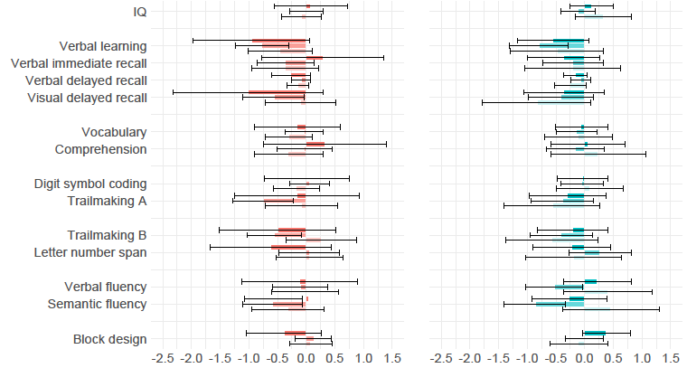

*

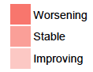
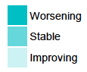

Effect Size Effect Size

ª - Presented are effect sizes and 95% Confidence Intervals of difference in change from baseline to follow up between the diagnostic group and comparison group as a function of change in symptom severity. 95% Confidence Intervals that do not include zero indicate statistical significance level p<0.05. Effect sizes are adjusted for age, sex, ethnicity, level of education, time from baseline assessment and baseline test score. Trailmaking A=Trail Making Test, Part A; Trailmaking B=Trail Making Test, Part B.

