ALEXA WRIGHT

INTRODUCTION
Informed by my own longstanding experience of juggling academic and artistic (theoretical and practice-based) research and teaching, this paper will start by looking at some of the challenges of maintaining a creative practice whilst working in an academic context. I will then go on to introduce three different, but thematically linked projects, all of which explore what we mean by reality through the lens of psychosis: A View From Inside (digitally manipulated photographic portraits and artist’s book, 2012); Piecing it Together (participatory collage project, 2015), and There’s So Much More I Want To Tell You, single screen video, (2015). These are all practical projects, informed by what, in an academic context, we would call ‘primary research’ with participants. In different ways, each of these projects demonstrates the power of visual media to communicate where words fail, particularly when working in a social context.

THE ORDER OF THINGS
With reference to Australian academic and artist, Graeme Sullivan’s excellent 2009 and 2010 works on art practice as research, I will begin with some comments on the ‘established order’ artist-researchers are working within today. As a mode of enquiry historically embedded in scientific methods, academic research has conventionally focused on ideas and theories, with the aim of revealing new ‘truths’ that are unlikely to have immediate practical effects in real life. Diametrically opposed to this is a person-centred and participatory art practice that now also comes under the umbrella of academic research. How do we, as artists working in academia, negotiate the tension between a traditional abstract, logo-centric notion of research and more practical, aesthetic forms of knowledge production? The situation is full of contradictions, both in terms of how art-practice gains credence as academic research, and how it is funded.

In the run up to REF2021 we are all very conscious of the need to present our practice as research, with tangible ‘outputs’ in the public domain. Visual arts exhibitions, performances etc. are now accepted by the REF panel as viable outcomes for research activity, equivalent to books and journal articles, and this is good. But it seems that the required modes of evaluation have still not been fully adapted to fit the kind of research and inquiry that informs contemporary art practice. As Estelle Barrett so rightly puts it, “within the context of studio-based research, innovation is derived from methods that cannot always be pre-determined, and “outcomes” of artistic research are necessarily unpredictable.” Yet arts funding, both academic and non-academic, is increasingly dependent upon the applicant’s ability to convince the panel that their project will contribute to the generation of new knowledge, as well as being of economic and social value from the outset. This seems particularly nonsensical given that truly creative art practice involves working from the unknown to the known, meaning that in many cases the idea can only be fully articulated through the process of making the work. And this inevitably involves an element of risk. As Sullivan clearly explains, within art-practice meaning is arrived at
‘…through experiences that are felt, lived, reconstructed and reinterpreted. These may be personal or public and may result from experiences of art-making processes or outcomes of encounters with artworks. Consequently meanings are ‘made’ from the transactions and narratives that emerge and these have the power and agency to change on an individual or community level.’

As most of us are well aware, the funding situation for artists working in academia in the UK is increasingly bleak. In 2003 the (then) AHRB (Arts and Humanities Research Board) promisingly stated that:
‘Practice-led research is a distinctive feature of the research activity in the creative and performing arts... This type of research… aims, through creativity and practice, to illuminate or bring about new knowledge and understanding, and it results in outputs that may not be text-based, but rather a performance (music, dance, drama), design, ﬁlm, or exhibition.

And their funding decisions bore witness to this. For example, in 2001 I received a small grant from the AHRB to travel to the USA to interview people convicted of murder in jails in the mid-west. The outcome was the audio installation ‘Killers’, a work that examines individual and collective perceptions of self and 'other' as individual users listen to compelling first-person monologues that invite both identification and judgement. At this time there was little pressure to justify the nature of the research, and, although this research trip did lead to a tangible outcome that didn’t stray too far from my original idea, I was free to develop the work in whatever way felt appropriate.

More recently the Arts and Humanities Research Council has established a Practice Research Advisory Group, a body that aims to increase the visibility and accessibility of UK Practice Research and its impact, and to make this research ‘more searchable internationally’. Whilst the PRAC aims ’ to provide HEIs and researchers with tools, guidance and confidence in the submission of Practice Research for RCUK/UKRI funding and in the preparations for the UK’s REF2021‘ the openness of the earlier mandate is lost and the focus has shifted to look pragmatically at how practice-led creative research can contribute to industry and ‘the creative economy’.

So what does all of this mean for artists working in academia, particularly those of us who are dependent on arts funding to realise our projects? To return once again to Sullivan:
“Generally, artists have left the responsibility of assessing the signiﬁcance of what it is that they do to others, preferring to let critics, historians and cultural theorists do the talking. If artists today pursue their art practice within the academy as well as the artworld, then it is necessary that they take on the roles of the practitioner, researcher and theorist, and in some cases, art writer and teacher as well.”

Writing this, I realise that perhaps this increasing pressure to rationalise, describe and quantify has fuelled my interest in human experiences that defy language and logic. Some years ago, revisiting Surrealism, and thinking about how life is organised by a common sense of reality, I became interested in psychosis, which is generally understood to indicate a mental state involving a 'loss of contact with reality'. This has led to an ongoing body of works, including the three projects described below. Collectively the works are informed by eclectic and interdisciplinary theoretical and philosophical research into different psychotic states, and into the nature of reality more broadly. The theoretical research offers a background for ideas arrived at through the process of making, working visually and problem-solving in a practical context. It is important that the theory remains secondary, to enable the practice to develop in its own right, moving beyond illustration of theoretical ideas.

Whilst the practical research methods I use when working with participants might look similar to those of qualitative ethnographic research, it has always been important for me to develop my own research strategies responsively. These are arrived at through experience, and in response to each specific situation rather than following any set methodological approach. For example, I have worked with the personal stories of individuals whose life experiences place them at the margins of society since the mid-1990s. In the process of working with people I have evolved techniques for helping project participants to access and then narrate their internal experiences using visual media so that they are not merely subjects of the work, but active participants in the process of its creation.

A VIEW FROM INSIDE
In 2012, funded by an AHRC fellowship, I first worked with people who experience episodes of psychosis. The result was ‘A View From Inside’, a series of ten digitally manipulated portraits and an artist’s book. The intentions of the project were two-fold, on one hand to explore what we mean by reality, and on the other to question the stigma around mental illness, asking ‘can the phenomenological experiences of people living with episodic psychotic disorders be represented visually in a form that will impact on public perception of the ‘type of people’ depicted?’. The project began as a collaboration with the Maudsley Hospital in South London, but it soon became apparent that working within the NHS it was not going to be possible to achieve anything within the timescale of the grant. So most participants were recruited through the charity Rethink Mental Health, who were extremely supportive. The project was advertised to their members via Facebook, and received over a hundred responses from people wishing to participate.

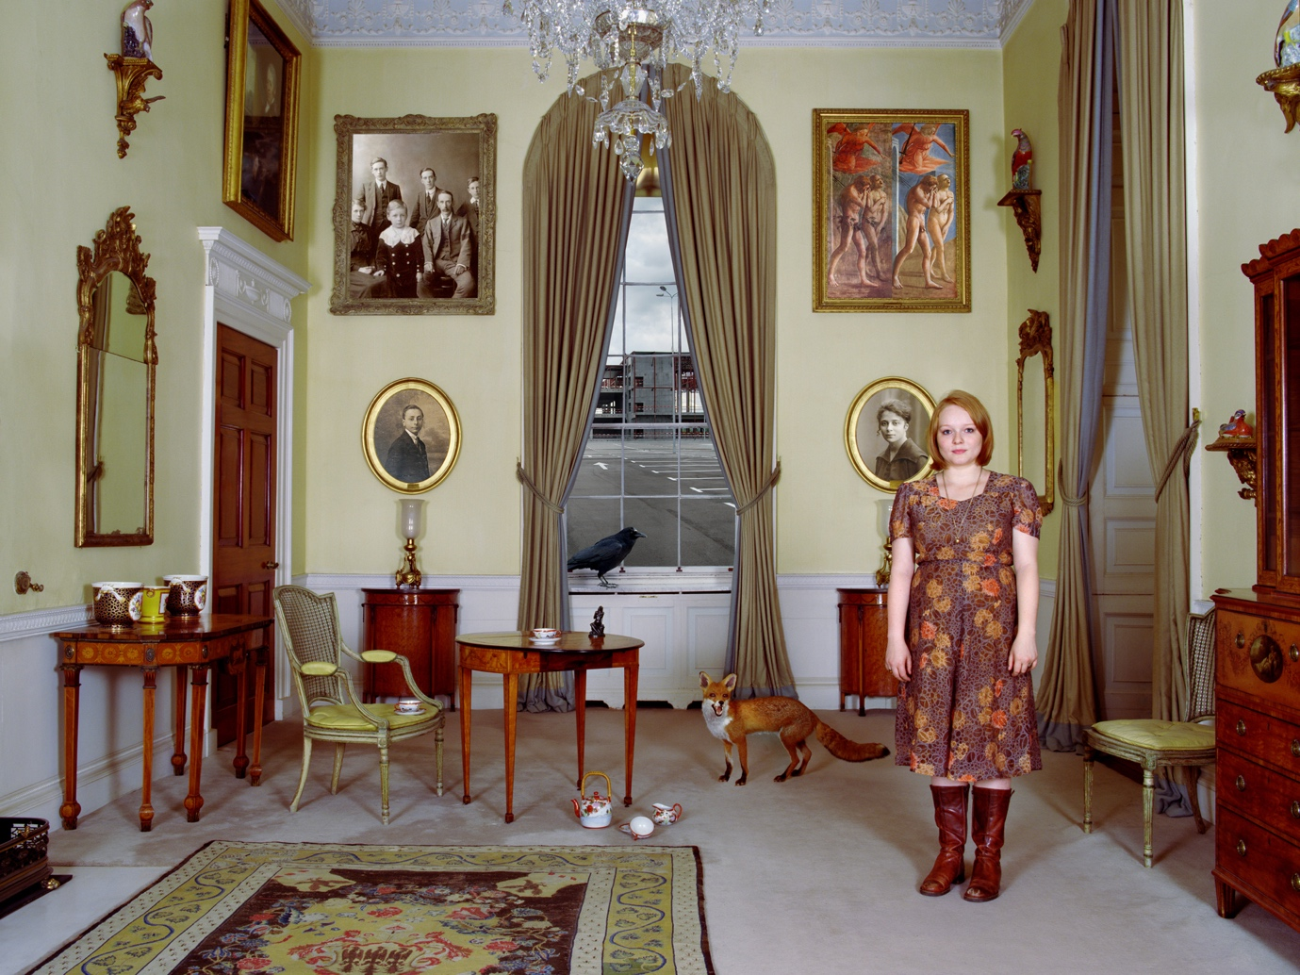
A View From Inside 1 © Alexa Wright, 2012

Whilst I knew that I wanted to make portraits in which the background represented the subject’s inner world, I had little idea of how these might look. The ideas were developed visually, as I met with participants and researched venues over the one-year period of the Fellowship. During this time I held several one-to-one meetings with each person depicted, working closely with them to identify appropriate settings and find a means of accessing imagery that would represent their personal experiences when ‘not in consensual reality’. Quite early on in the process a breakthrough occurred when I showed each participant a picture of a person in an empty room with a window. When I asked what would be in the room and what would be outside the window when they were not in consensual reality everyone was immediately able to give me a detailed description as they visualized the contents of the empty room. Between meetings I researched potential settings and then showed photos of these to each participant, asking them to choose a shortlist of settings that could be used to represent their experiences. This again was a very productive example of visual research that enabled participants to share their experiences with me without the need for a lot of language. I then took digital snapshots of each person and inserted them into some of the locations. These were discussed and refined before the final photo shoots, which took place on location at English Heritage and National Trust properties. The project was collaborative from the outset in that each of the people I photographed played an active role in determining how he or she was represented. In one case I was reprimanded for misunderstanding the scale of some of the objects depicted, and in another for omitting to remove a cupboard from the setting that was deemed inappropriate. The photograph of the streetlamp in the image below was supplied by the person portrayed as she wanted that exact lamp to communicate her experience. I found it reassuring and exciting that several of the participants took ownership of their image to this extent. Each person was given a copy of their finished portrait.

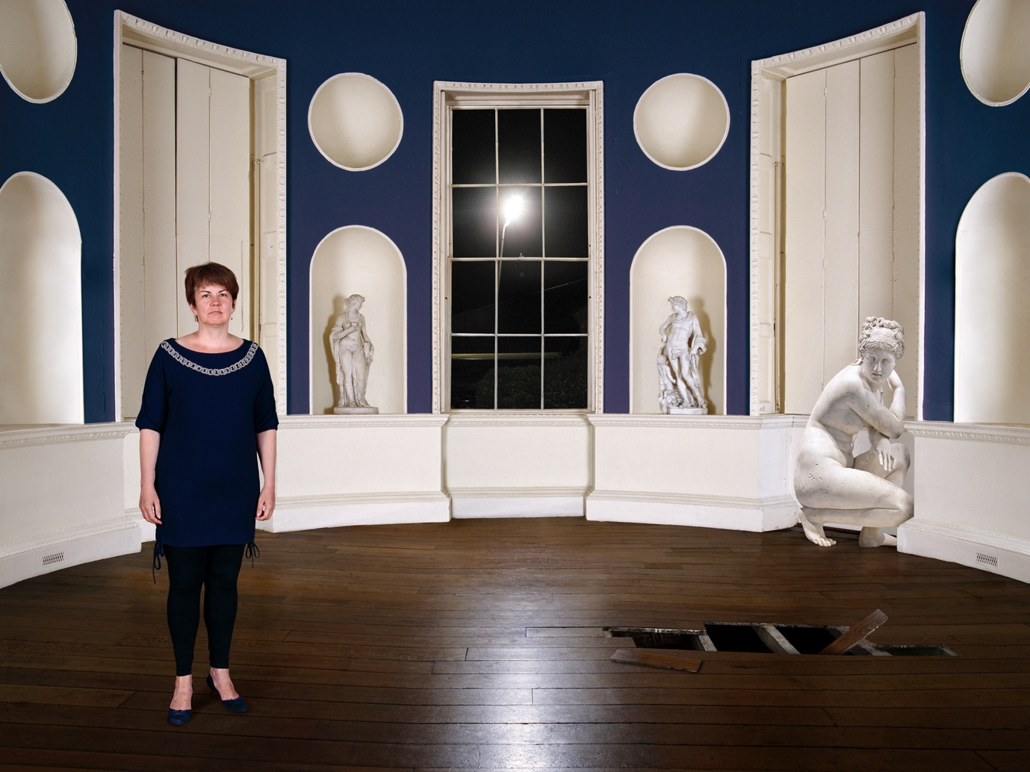
A View From Inside 9 © Alexa Wright, 2012

PIECING IT TOGETHER
During the course of the project described above participants were mostly in good health and were able to reflect back on their psychotic experiences rationally, from a critical distance. In 2015, wishing to engage with people when their illness was more present, I initiated an artist’s residency at two NHS Foundation Trust Mental Health Recovery Centres in North London. The Piecing It Together project was supported by a small grant from the Arts Council. Here I was again hoping to work with people on a 1-1 basis, but, after a year of negotiation with managers, the only option available was to run workshops as part of a regular weekly programme. At first I was unsure how to make this work in a way that would be beneficial for users and to my own research. After a period of observation, I decided to ask people to create collages from magazine cuttings to narrate their recent mental health experiences.

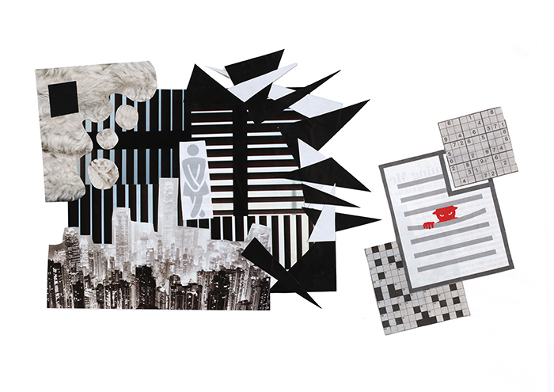
Collage created during Piecing it Together Project, Anon, 2015.

At each centre I ran weekly workshops, where participants literally pieced together a visual narrative. This direct, practical means of communicating their personal experiences proved to be both accessible and very productive for a broad range of participants. At the start of each session I explained that the activity was not art therapy, but was an art project, with a clear remit. More than a hundred collages were produced, some in less than an hour, some painstakingly over several weeks. Very few of the participants had any previous experience of image-making, and yet the degree of visual literacy demonstrated by almost everyone was remarkable. Several participants allowed me to record interviews with them about the meaning and content of their collage. The fact that I was not a service provider offering an activity that positions participants as 'patients', but was instead asking people to make personal contributions to an external project was important and proved to be empowering for many of the participants, visibly improving their self-esteem. Some participants were keen to communicate their experiences in more depth and went on to create small photo-text books. The content was entirely theirs, whilst I acted as ‘curator’ and designer for the books. Exhibitions of the works created were held at St Pancras Hospital in Summer of 2016, and at the Tavistock Centre in London in 2017. Attended by a mix of service users, artists and NHS staff, these exhibitions were a great source of pride for those involved. To date I am still working to develop a series of video works inspired by the content of the interviews I recorded with workshop participants (with permission). The first and simplest of these is documented below.

THERE’S SO MUCH MORE I WANT TO TELL YOU
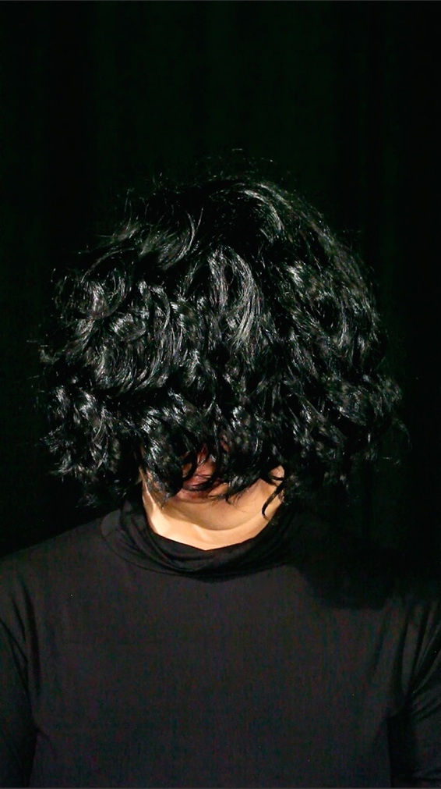
Still from ‘There’s So Much More I Want To Tell You’, © Alexa Wright, 2015.

With the aim of challenging perceptions and preconceptions of otherness, this single-screen video work makes reference to the Theatre of the Absurd, in particular works by Samuel Beckett, Eugene Ionesco and Jean-Paul Sartre, whose ‘No Exit’ (1944) explores the ontological struggle between subjective experience and the objectifying view of others. Based on the first person narrative of one of the ‘Piecing it Together’ participants, the video is a five minute monologue, performed by actress, Isabel Carr and shown on a single vertical monitor, with headphones. Working with a transcript of the original interview and taking care to alter details and remove any identifying features, I scripted the piece with the aim of taking the viewer on a journey of self-reflection as their relationship to the unidentified narrator changes through the course of her narrative. For both pragmatic (the project was unfunded) and creative (I wanted the monologue to feel fresh rather than scripted) reasons I did not ask Isabel to learn the script verbatim, but to internalise it and to narrate as though the experience were her own. The work is available to view on Vimeo here: https://vimeo.com/152952121

CONCLUSION:
I hope the above account has given some indication of the importance of thinking through the visual, both when developing ideas and when working with non-artist participants. My art practice is generally informed by a lengthy research process – typically a work will take from one to five years to complete. But, whilst the practice is generally underpinned by theory, the research process must remain open, free, iterative and responsive. It is always good to pause, reflect on and contextualise any new work in progress, but the pressure to articulate, justify and evaluate an idea before it has fully evolved means that it is not always easy to maintain this essential openness. This is perhaps why I have recently been looking back at Surrealist and other revolutionary, poetic works from the early 20th Century. The Surrealists used automatic writing and automatic drawing to mine the unconscious in order to ‘represent the real process of thought’. They ‘believed in a revolution in experience to be brought about by the mind and the imagination once the fetters of rationalism and of habit had been struck off’. In a similar way, I believe that working visually and practically, acknowledging the process of making, in whatever form it takes, is essential to innovative thinking and therefore to truly creative ‘knowledge production’.

Sullivan, Graeme, (2010) Art Practice as Research : Inquiry in Visual Arts, Thousand Oaks Calif.: Sage Publications, and Sullivan, Graeme, (2009) ‘Making Space The Purpose and Place of Practice-led Research’, in: Practice-led research, research-led practice in the creative arts, Smith, Hazel, Dean, R. T., Edinburgh: Edinburgh University Press.
Barrett, Estelle and Bolt, Barbara (2007) Practice as Research, approaches to Creative Arts enquiry London: IB Tauris, p.3.
Sullivan, 2009, p.50
Arts and Humanities Research Board, (2003): The Arts and Humanities: Understanding the Research Landscape
https://www.alexawright.com/killers
https://prag-uk.org
Sullivan, 2009, p.42
Laing, R D, (1990), The divided self: an existential study in sanity and madness, London: Penguin.
https://www.rethink.org
Documented at https://piecingittogether.org/2015/07/27/442/
https://piecingittogether.org/2015/10/16/books/
Short, Robert, (1966) ‘The Politics of Surrealism, 1920-36’, in Journal of Contemporary History, Vol. 1, No. 2, p.5.

