Elevated levels of naturally occurring autoantibodies to human chorionic gonadotropin (hCG) β core fragment in a female patient with thyroid follicular adenoma: Case report
N. Chikadze¹, M. Tevzadze², N. Gachechiladze¹, N. Porakishvili^{,3}
Division of Immunology and Microbiology Javakhishvili Tbilisi State University, Georgia ¹
Tbilisi Medical Academy, Georgia²
School of Life Sciences, University of Westminster, London, UK³
Abstract:
We report a case of a woman, who had an elevated levels of naturally-occurring autoantibodies to human chorionic gonadotropin (hCG) β core fragment (hCGβcf) one year prior to the development of thyroid follicular lesion. The patient underwent surgery and the histology report demonstrated that the lesion was a follicular adenoma. Further investigations of the role of naturally-occurring autoantibodies (NAAbs) to anti-hCGβcf in the pathogenesis of varioustumours of thyroid gland might be useful in the development of novel diagnostic methods, using anti-hCGβcf NAAbs as a marker for the detection of unsuspected thyroid tumour.
Introduction
In recent years, interest to naturally-occurring autoantibodies (NAAbs) against various tumour associated antigens (TAAs) is rising with regards to their prognostic value as early biomarkers for cancer diagnosis. The advantages of using NAAbs over other protein biomarkers currently used are that they are easily accessible in blood samples, have a long half-life and moreover, often relatively small quantity of antigen is sufficient to trigger an immune response reflected in relative antibody concentrations [1, 2].
Many NAAbs directed against different tumor associated antigens (TAAs) are the subject of intensive studies including autoantibodies to p53, HER-2, MUC1, HSP 90, IGFBP-2, TOPO2α [2, 3 ] and we have been investigating the NAAbs to human chorionic gonadotropin (hCG) and its subunits [4 ]. Recently, we demonstrated for the first time that patients with benign gynecological tumours: fibromyoma and ovarian cyst showed significant levels of serum anti-hCG and anti-hCGβ naturally occurring antibodies of the IgG isotype, whilst patients with malignant tumors (ovarian cancer, ovarian adenocarcinoma, endometrial cancer, cervical cancer) expressed non-appreciable levels of these antibodies [4}.
Secretion and surface expression of hCG/hCGβ molecules have been reported in many neoplasms of both, trophoblastic and nontrophoblastic nature, but only a few studies have shown the role of these molecules in the pathogenesis of the thyroid gland tumours [5, 6, 7] and the presence of NAAbs against hCG/hCGβ in patients with thyroid tumours has never been reported.
The aim of this case study is to report increased levels of NAAbs to human chorionic gonadotropin β core fragment (hCGcf) in a female blood one year prior to the detection of thyroid follicular adenoma.
Case report
A 31-year-old, clinically healthy Caucasian female was involved in a cohort study as a healthy volunteer. The aim of the study was to determine the levels of naturally occurring autoantibodies against hCG and its subunits. The woman has never been pregnant and had no history of autoimmune diseases. Unexpectedly, the titration of her serum using enzyme-linked immunosorbent assay (ELISA), showed increased levels of NAAbs of both, IgG and IgM classes, that bound tohCGβ core fragment (Figure 1), whilst anti-hCG, anti-hCGβ, and anti-hCGα antibody titers were in the same range as for the other healthy volunteers (Figures 2 and 3). Moreover, concentrations of hCG whole hormone and hCGβ subunit were within reference intervals ( 0.206 ng/ml and 0.007 ng/ml, respectively). She was informed about the results and underwent additional examinations under the observation of her Family Doctor, but no signs of any disease were detected. Only a year later, she noticed swelling on the neck and difficulty during deglutition. She was referred to N.Kipshidze Central University Clinic of Tbilisi State Medical University for the assessment of the thyroid gland. Ultrasonography revealed a hypoechoic solid nodule in the thyroid gland and fine needle aspiration cytology (FNAC) of the nodule showed follicular lesion. She subsequently underwent total thyroidectomy with a regional lymphadenectomy on the 30th March 2018. Histopathology of the resected nodule revealed a follicular adenoma. Three month later we checked the anti -hCGβ core fragment antibody titer in her blood again and detected that, the levels of anti – hCGβcf IgG antibodies were reduced for up to 25.5%, but the titer and the concentration of IgM antibodies did not change (Figure 4).
Discussion
Thyroid nodules are very common and can be caused by a variety of disorders. Differential diagnosis between benign or malignant. nature of thyroid tumours represents a particular challenge with many cases designated as being indeterminate or suspicious [8]. The high prevalence and increasing diagnosis of incidental thyroid nodules renders it important to develop additional methods of diagnosis and risk stratification leading to the appropriate treatment [9].
The level of NAAbs against various TAAs have been reported to be informative as prognostic biomarkers for cancer progression. Li et al. reported the diagnostic potential of a panel of 13 autoantibodies against TAAs for the detection of ovarian cancer [10]. This group found that the sensitivity and specificity of antibodies in the detection of ovarian cancer tends to be 62.5% and 85.4%, respectively. [3] Kim et al. evaluated the efficacy of anti-thyroglobulin autoantibody (TgAb) testing in predicting recurrence in differentiated thyroid carcinoma (DTC) patients at 6– 12 months after high dose ¹³¹ I remnant ablation [11]. Yukiko Tabuchiet.al. showed that naturally occurring HER2-Abs have protective effects on the development and metastasis of breast cancer in a clinical setting [12].
It is well known that hCG and especially hCGβ are produced by various non-trophoblastic tumours as autocrine grows factors [13, 14], including cancers of the bladder, kidney, prostate, GI-tract, breast, and lung [15], but little is known about the role of hCG or its subunits in pathogenesis of thyroid gland tumours. Sakaguchiet al. demonstrated that hCG produced from a papillary thyroid cancer cell line (B-CPAP cells) possesses intrinsic thyroid-stimulating and growth-promoting activity on FRTL-5 rat thyroid cells [ 6] and Becker et al. showed that only a minority of anaplastic thyroid carcinoma (ATC) express hCGβ and it can be a unique subtype of ATC the level of the aggressiveness of which is unknown [7]. Generally, the problem with hCG as a tumour marker for non-trophoblastic cancer is that serum levels of hCG in those patients do not correlate with the stage of disease. Therefore, serial measurement of hCG has little prognostic value. We propose, that the measurement of NAAbs to hCG/hCG subunits might have a better prognostic value, than the measurement of the hormone/hormone subunits.
The NAAbs we have detected in thyroid tumour patient bind to the core fragment of hCGβ. This fragment is composed of residues 6-40 and 55-92 of hCG beta subunit bound by the disulfide bonds [17]. It can be found as a free subunit in the blood and urine of pregnant women and some cancer patients [18]. hCGβcf has a shorter half-life as compared to hCG. Although the origin of the free hCGβcf is unknown, two different routes have been suggested: that the hCGβcf is secreted directly by tumour cells or that it is a peripheral degradative product [19, 20].
What is the trigger of the elevation of NAAbs to hCGβcf in this case is unknown and the fact of their presence raises many questions. We believe that future studies should establish: (a) whether the follicular adenoma cells produce hCGβcf; (b) if these NAAbs are produced against thyroid stimulating hormone (TSH) or its core fragment and NAAbs, we have detected, cross -bind to hCGβcf; (c)whether there are any structural changes (such as glycosylation) of TSH in follicular adenoma (d) the role of these antibodies in the pathogenesis of the disease (e) if they are able to protect from malignant transformation of adenoma; (f) whether there are differences in the levels of these NAAbs between the patients with malignant and non-malignant tumours of thyroid gland; (g) if these antibodies can be used as diagnostic or prognostic Indicators of the development of thyroid gland tumours.
In concussion, this study presents an evidence that anti- hCGβcf naturally- occurring autoantibodies may appear in the serum of patients with thyroid follicular adenoma as early as one year prior to the development of clinical symptoms.

Footnotes:
Consent of the patient: The patient has voluntarily signed an informed consent for the publication of personal medical information. The use of clinical specimens was reviewed and approved by the ethics committee of National Center for Disease Control and Public Health of Georgia.
Conflict of Interests: The authors declare no obvious or potential conflicts of interest related to the publication of this article.
Acknowledgement:
This study was supported by a research grant from Shota Rustaveli National Science Foundation of Georgia - Grant ID: 218024; Project Title: “Assessment of natural anti-hCG antibodies in patients with gynaecologicaltumours”
References:
- Chang-KyuHeo,,Young YilBahk, Eun-Wie Cho, Tumor-associated autoantibodies as diagnostic and prognostic biomarkers, BMB Rep. 2012 Dec; 45(12): 677–685.
- Tan HT, Low J, Lim SG, Chung MC, Serum autoantibodies as biomarkers for early cancer detection. FEBS J. 2009 Dec;276(23):6880-904.
- LiuxiaLI et.al. Detection of autoantibodies to multiple tumor-associated antigens in the immunodiagnosis of ovarian cancer, Mol Med Report. 2008 Jul; 1(4): 589–594.
- Chikadze N, Akhvlediani L, Gachechiladze N, Mitskevichi N, Delves PJ, Porakishvili N. Antibodies againsthCG in patients with gynaecological tumors. Proc. 13th World Congress on Controversies in Obstetrics, Gynecology& Infertility (COGI) held jointly with the German Society of Obstetrics & Gynecology. 2010;325-328;
- Alikhan M, Koshy A, Hyjek E, Stenson K, Cohen RN, Yeo KT. Discrepant serum and urine β-hCG results due to production of β-hCG by a cribriform-morular variant of thyroid papillary carcinoma.ClinChimActa. 2015 Jan 1;438:181-5.
- Sakaguchi N. et. al.Paracrine effect of human chorionic gonadotropin ectopically produced from papillary thyroid cancer cells on growth and function of FRTL-5 rat thyroid cells.Thyroid. 1997 Oct;7(5):779-82.
- Becker N, Chernock RD, Nussenbaum B, Lewis JS Jr.Prognostic significance of β-human chorionic gonadotropin and PAX8 expression in anaplastic thyroid carcinoma.Thyroid. 2014 Feb;24(2):319-26.
- Wiltshire JJ et al. Systematic review of trends in the incidence rates of thyroid cancer. Thyroid 2016;26:1541-52.
- Tamhane S, Gharib H. Thyroid nodule update on diagnosis and management. Clin Diabetes Endocrinol. 2016 Oct 3;2:17
- Li L, Wang K, Dai L, Wang P, Peng XX, Zhang JY. Detection of autoantibodies to multipletumor-associated antigens in the immunodiagnosis of ovarian cancer. Mol Med Report. 2008;1:589–594
- Kim WG, Yoon JH, Kim WB, Kim TY, Kim EY, Kim JM, Ryu JS, Gong G, Hong SJ, ShongYK.Change of serum antithyroglobulin antibody levels is useful for prediction of clinical recurrence in thyroglobulin-negative patients with differentiated thyroid carcinoma. J ClinEndocrinolMetab. 2008; 93:4683–4689.
- Tabuchi, Y.; Shimoda, M.; Kagara, N.; Naoi, Y.; Tanei, T.; Shimomura, A.; Shimazu, K.; Kim, S.J.; Noguchi, S.Protective effect of naturally occurring anti-HER2 autoantibodies on breast cancer. Breast Cancer Res. Treat.2016, 157, 55–63.
- Stenman U.-H., Alfthan H., and Hotakainen K., “Human chorionic gonadotropin in cancer,” Clinical Biochemistry, vol. 37, no. 7, pp. 549–561, 2004.
- Cole LA. Human chorionic gonadotropin (hCG) and hyperglycosylatedhCG, seven semi-independent critical molecules: A review. J MolOncol Res. 2017;1(1):22-44.
- Porakishvili N, Jackson AM, de Souza JB, Dalla Chiesa M, Roitt IM, Delves PJ, Lund T. Epitopes of human chorionic gonadotropin (hCG) and their relationship to immunogenicity and cross-reactivity of beta chain mutants. Am. J. Repro.Immunol, 1998, 40: 210-214.
- Kvirkvelia N, Chikadze N, Makinde J, McBride JD, Porakishvili N, HillsFA, et al. Investigation of factors influencing the immunogenicity ofhCG as a potential cancer vaccine. ClinExpImmunol. (2018) 193:73–83.doi: 10.1111/cei.13131
- Berger P, LapthornAJ.Standardization of Epitopes for Human Chorionic Gonadotropin (hCG) Immunoassays.Curr Med Chem. 2016;23(30):3481-3494.
- LustbaderJ. W. et al. (eds.), Glycoprotein Hormones © Springer-Verlag New York, Inc. 1994: 293-320
- Okamoto T. Niu R. Matsuo K. Furuhashi M. Ohsawaa M. Mizutani S. Suzuki H. Human chorionic gonadotropin b-core fragment is directly produced by cancer cells. Life Sciences 2001; 68 861–872
- Okamoto T, Matsuo K, Niu R, Osawa M and Suzuki H. Human chorionic gonadotropin (hCG)-core fragment is producedby degradation of hCG or free hCGβ in gestational trophoblastic tumors: a possible marker for early detection of persistentpostmolar gestational trophoblastic disease. Journal of Endocrinology 2001; 171,435–443

Figures:
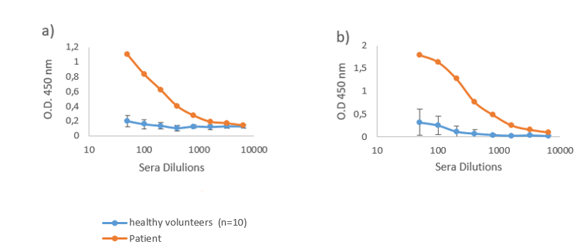
Figure 1: Titration of the serum from the patient with thyroid follicular adenoma to hCGβcf one year prior to the disease diagnosis, compared to the sera of healthy volunteers. a) IgG antibody titres; b) IgM antibody titres. O.D. – optical density.
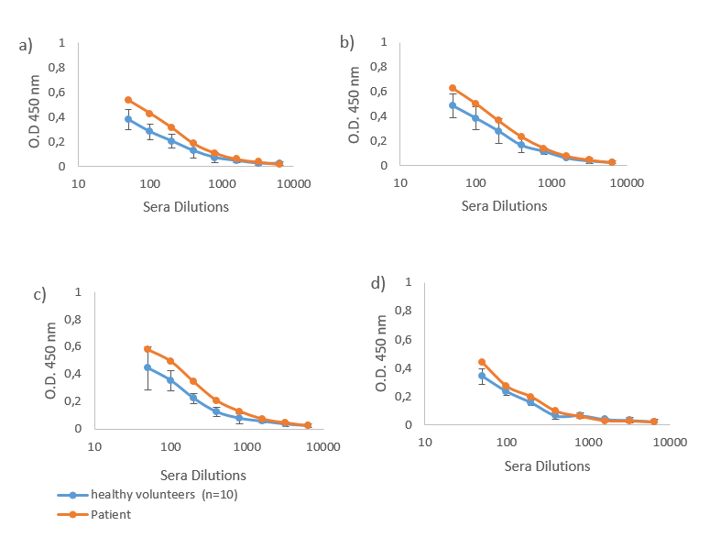
Figure 2: IgG antibody titres in the serum of the patient with thyroid follicular adenoma one year prior to the disease diagnosis, compared to the sera of healthy volunteers. Sera binding to - a)hCG whole hormone (hCGαβ), b)hCG β subunit (hCGβ) c)hCGα subunit(hCGα), d) hCGβ C-terminal peptide (hCGβCTP). O.D. – optical density
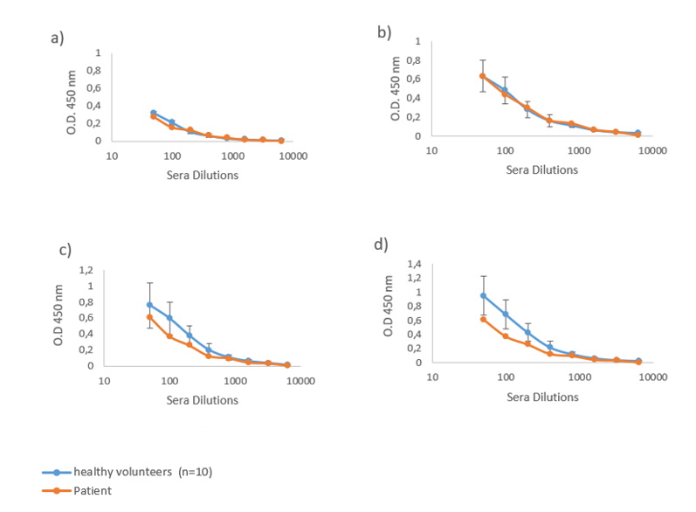
Figure 3: IgM antibody titres in serum of the patient with thyroid follicular adenoma one year prior to the disease diagnosis, compared to the sera of healthy volunteers. Sera binding to - a)hCGαβ, b)hCGβ c) hCGα, d) hCGβCTP. O.D. – optical density
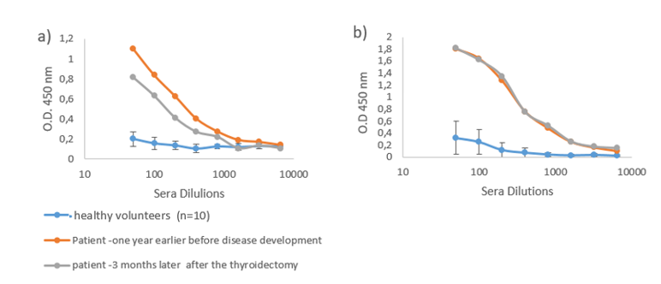
Figure 4: Titration of the serum from the patient with thyroid follicular adenoma to hCGβcfthree year later after the thyroidectomy, compared to the healthy volunteers. a) IgG antibody titres; b) IgM antibody titres. O.D. – opticaldensity

Резюме
Повышенный уровень естественных аутоантител к центральному фрагменту β-хорионического гонадотропина (ХГЧ) у пациентки с фолликулярной аденомой щитовидной железы: Описание случая
Н. Чикадзе¹, М. Тевзадзе², Н. Гачечиладзе¹, Т. Н. Поракишвили^{1,3}
Тбилисский Государственный Университет им. Джавахишвили, Грузия ¹
Тбилисская Медицинская Академия, Грузия²
Вестминстерский Университет, Лондон, Великобритания^{1,3}
Мы представляем случай с пациенткой, у которой был обнаружен повышенный уровень естественных аутоантител к центральному фрагменту хорионического гонадотропина человека (ХГЧ) β (ХГЧ βЦФ) за год до развития фолликулярного новообразования щитовидной железы. Пациентка перенесла операцию по удалениющитовидной железы. Гистологическое исследование показало, что новообразование было фолликулярной аденомой. Дальнейшие исследования роли природных аутоантител к анти-ХГЧ βЦФ в патогенезе различных опухолей щитовидной железы могут быть полезны при разработке новых методов диагностики с использованием природных аутоантител, специфичных к ХГЧ βЦФ в качестве маркера для раннего обнаружения опухолей щитовидной железы.

reziume
adamianisqorionuligonadotropinis (aqg) βcentralurifragmentissawinaaRmdegobunebriviautoantisxeulebismaRalidonefarisebrijirkvlisfolikuluriadenomismqonepacientqalSi: samedicinoSemTxveva
n. WikaZe¹, m. TevzaZe², n. gaCeCilaZe¹, n. foraqiSvili^{1,3}
iv. javaxiSvilissaxelobisTbilisissaxelmwifouniversiteti, saqarTvelo¹
Tbilisissamedicinoakademia, saqarTvelo²
vestminsterisuniversiteti, londoni³
warmogidgenTpacientiqalisSemTxvevas, romelsacaRmoCndaadamianisqorionuligonadotropinis (aqg) βcentralurifragmentis(aqgβcf) sawinaaRmdegobunebriviautoantisxeulebismaRali donefarisebrijirkvlisfolikulurisimsivnisganviTarebamdeerTiwliTadre. pacientsCautardaqirurgiulioperacia da histologiurmaanalizmaaCvena, rom aRmoCenilisimsivnefolikuluri adenoma iyo. aqgβcf-is sawinaaRmdegobunebriviautoantisxeulebisrolisSemdgomiSeswavlafarisebrijirkvlissimsivneebispaTogenezSi, SesaZloagamoyenebuliqnasaxalidiagnostikurimeTodisganviTarebisTvis, romelicdafuZnebuliiqneba anti-aqgβcf bunebriviantisxeulebze, rogorcTireoidulisimsivnisaRmomCenmarkerze.

