Discovering the evolution of urban structure using smart card data: The case of London

Yuerong Zhang ^{a,b}, Stephen Marshall ª, Mengqiu Cao ^{c,d,}*, Ed Manley ^{e,f}, Huanfa Chen ^{b}

a. The Bartlett School of Planning, University College London, United Kingdom
b. The Bartlett Centre for Advanced Spatial Analysis, University College London, United Kingdom
c. School of Architecture and Cities, University of Westminster, United Kingdom
d. Department of Statistics, London School of Economics and Political Science, United Kingdom
e. School of Geography, University of Leeds, United Kingdom
f. The Alan Turing Institute, United Kingdom

E-mail addresses: yuerong.zhang.14@ucl.ac.uk (Y. Zhang), s.marshall@ucl.ac.uk (S. Marshall), m.cao@westminster.ac.uk (M. Cao), e.j.Manley@leeds.ac.uk (E. Manley), huanfa.chen@ucl.ac.uk (H. Chen).

*Corresponding author: Mengqiu Cao, School of Architecture and Cities, University of Westminster, London, United Kingdom. Email: m.cao@westminster.ac.uk

Abstract
Cities are continuing to develop and are grappling with uncertainties and difficulties as they do so. It has therefore become essential to understand how urban spatial structure changes, particularly with the increasingly available sources of ‘big data’. However, most studies mainly focus on delineating the spatial structure and its variations. Only a few have investigated the incentives behind the movement dynamics. To identify the urban structure of Greater London and uncover how it co-evolves with socio-economic and spatial policy factors, this study applies network community detection, using smart card data derived from the years 2013, 2015 and 2017, respectively. Our findings show that, firstly, between 2013 and 2017, London’s urban structure moved towards a more polycentric and compact pattern. Secondly, it is found that Greater London can be clustered into five communities based on the characteristics of passengers’ travel patterns. Thirdly, the dynamics of structural change in different urban clusters differ both in terms of changing intensity and potential motivation. In addition to spatial impact and spatial strategic policies, our results show that employment density and residential densities are also the main indicators that affected the interaction between Londoners in different areas on various levels.

Keywords
Urban structure; Big data analytics; Urban planning; Community detection; Network analysis; London

Highlights
- A technique borrowed from the complex network sciences, namely community detection, is applied using smart card data.
- London’s urban structure moved towards a more polycentric and compact pattern.
- The Greater London can be clustered into five communities based on the characteristics of passengers’ travel patterns.
- The dynamics of structural change in different urban clusters differ both in terms of changing intensity and potential motivation.
- Employment density and residential densities are the main indicators affecting the movement of and interaction between Londoners in different areas.

Introduction
Parr (2014) asserted that “[U]rban structure is concerned with the organisation and functioning of markets for goods and factors of production”. This underscores the fact that the regional economy does not operate at a single point and is distributed unevenly over space. Urban structure, therefore, can be seen as a reflection of the locational characteristics of economic activities. This point echoes studies by economists that have explored the initial motivation for studying urban structure. They aim to explore whether there is an optimal way to organise metropolitan areas to ensure faster economic development. For instance, some studies (Gordon & Richardson, 1997, Richardson, 1969) have found that there is a significant relationship between metropolitan spatial structure and economic growth, depending on metropolitan size and its structural organisation. Inevitably, the trade-off or cost of economic agglomerations can also cause significant problems concerning urban development. Scholars, such as Lee and Gordon (2007), have highlighted that people living in large cities are more likely to suffer from negative externalities. Therefore, the research agenda of the urban structure has shifted towards a more comprehensive interpretation of the ‘optimal’ urban structure. This topic has also attracted great interest from urban planners, geographers and policymakers, particularly in the last two decades, because spatial structure exerts a strong influence on people’s daily life, economic performance (Duranton, 2000, Lee & Gordon, 2007, Wu & Yeh, 1999), social equity (Burton, 2000, Cao & Hickman, 2019, Cao et al., 2019, Cuthill et al., 2019), and sustainable urban development (Anas et al., 1998, Meijers & Burger, 2010, Sun et al., 2016).
Recent debates on urban structure have paid more attention to the relation between urban structure and its potential negative side-effects or external factors. For example, Echenique and his colleagues (2012) studied three English city regions and found the compaction show a very modest effect on making cities more sustainable. Li et al. (2019) investigated how the degree of congestion is associated with the urban structure of 98 Chinese cities. They found that traffic congestion is positively related to the degree of compactness, but negatively related to the degree of polycentricity. This finding throws doubt on the supposed advantages of compactness; as compact city policies may not be as effective as most policymakers expected. Nevertheless, regardless of how our understanding of the optimal urban structure has changed, the underlying objective of analysing urban structure remains the same, that is, providing evidence-based references to help validate urban strategic planning for various purposes, such as urban transformation and/or regeneration (Zhong et al., 2014), infrastructure investment decisions (Barter, 2004), and the identification of opportunity areas (GLA, 2016) for intensification and densification.
However, although the topic of spatial structure has been studied extensively, the primary focus of the existing studies remains on either characterising and typologising spatial structure (Burger & Meijers, 2012, Kloosterman & Musterd, 2001), or on the effects of sub-centres on travel behaviours (Cervero & Kockelman, 1997, Hu et al., 2018, Næss, 2006), housing prices (Cao & Hickman, 2018, Kulish, et al., 2012, Muth, 2017), and pollution (Borrego et al., 2006, Cao et al., 2017, Li et al., 2019). Only a few studies have explored the evolution of spatial structure or the socio-economic variables that drive this shift in structure. In the era of globalisation and informalisation, the fact that the rapid development of cities is changing citizens’ behaviours (Hall & Pain, 2006) highlights the need to understand these changes, because understanding how urban structures evolve is the fundamental prerequisite for restructuring their spatial form in order to plan for ongoing growth (Bogart, 2006).

In the case of London, transit movement seems to be increasingly heterogeneous and complex, with unprecedented challenges, particularly in terms of dealing with another wave of population upsurge (GLA, 2018). Therefore, the primary aims of this paper are to explore how the urban structure in Greater London evolved from 2013 and 2017 by uncovering changes in movement structure characteristics, as well as examining how structural changes coevolve with the key socio-economic factors and strategic planning policies. By achieving these objectives, this paper can contribute to the approach and literature in the following two ways. First, in contrast to current empirical studies on spatial functional structural evolution that use categorical approaches, we provide a finer-grained way to characterise how each of the sub-centres interact with one another. Second, we present an exploratory analysis that can enhance our understanding of how London's urban structure co-evolves with socio-economic factors.

The paper proceeds as follows. After reviewing the morphological and functional interpretations of urban structure, attention turns to discussing how to characterise spatial structure and its changes and what factors may drive urban structure transformation over time. The approach used in the study is then introduced, which is done in the following order: identifying centres; characterising spatial structure and its changes; and constructing a regression model to measure the relationship between structural change and socio-economic indicators. The empirical analysis then draws on research into exploring the structural evolution of Greater London, by using longitudinal data from 2013 and 2017. The conclusion pulls together the results of the analysis and considers the policy implications.

2. Literature review

2.1 Morphological and functional urban structure
The fuzzy concept of urban structure remains uncertain. Current dominant interpretations can be categorised into two types (Green, 2007): morphological structure; and functional structure, which can also be differentiated from the data sources and the ways of interpreting urban structures. Building on the morphological perspective, the first strand views spatial structure as a series of areal distributions. The morphological approach draws upon traditional survey data to extract the concentrations of populations and employment, i.e. the central business districts (CBD) and sub-centres. Essentially, applying this approach involves identifying the spatial distribution of dense residential areas or employment areas, but little consideration is given to socio-economic activities. For example, a similar distribution of residential areas may have substantively heterogeneous movements, thus causing different impacts on traffic congestion. A working definition of centres is a cluster of analytical units that have a higher density of population, employment or business than surrounding areas. To identify urban centres, different criteria (e.g. population size, employment size and land use mix), measured using different spatial units (e.g. census tract, regular grids), have been proposed. The most commonly used approaches are: adapted criteria (Lee & Gordon, 2007); the spatial statistical method (McMillen, 2001); spatial clustering methods (Vasanen, 2012); and exploratory spatial data analysis (Arribas-Bel & Sanz-Gracia, 2014). A detailed discussion of the various approaches can be found in Liu and Wang’s (2016) work.
A morphologically monocentric region can also be a more functionally polycentric region, such as in the case of Greater London (Hall & Pain, 2006), and vice versa. Additionally, because of the multi-scalar attribute, polycentricity on one scale can lead to monocentricity on another (Hall & Pain, 2006). That is to say, cities are no longer viewed as mere morphological entities with clear and detectable boundaries (Vasanen, 2012), but as functional urban regions with intangible linkages between distinctive functional sub-centres. In contrast to the morphological method, the functional approach puts more emphasis on describing the patterns of clusters of economic activities and the urban socio-economic associations between urban areas, e.g. two distant areas can be included in one community because of their strong connections of functional flows. This network-based insight could reflect ideas about how close or how segregated people are in cities (Chowell et al., 2003, McMillen, 2001), the dimension of which has arguably become increasingly important (Kloosterman & Musterd, 2001). The functional structure strand highlights the importance of using functional or relational linkages in interpreting spatial structure. It utilises the network-based approach with dynamic functional data to delineate the spatial interactions between communities within cities, which can shed light on the organisation of and hierarchical relations between, sub-regions. The commonly used flow proxies are: daily commuting flow (Goddard, 1970, Green, 2007, Manley, 2014, Roth et al., 2011, Vasanen, 2012, Zhong et al., 2014); strength of business (Beckers et al., 2017); trade flows or capital movement (Parr, 2014); the intensity of knowledge cooperation (Li & Phelps, 2018); or combined functional flows (Burger et al., 2014). An important point that needs to be noted here is that, as Burger et al. (2014) argued, the structural spatial organisation depends on the lens through which it is assessed. That is to say, a polycentric and spatially integrated structure can also be a monocentric and loosely connected structure, from the perspective of different functional flows and networks. However, both the functional and morphological approaches draw on the same principle; that is, both characterise polycentric areas as consisting of a group of urban centres that are relatively equal in terms of their importance (Burger & Meijers, 2012). Although a functionally polycentric network is not tied to a physical location (Green, 2007), the morphological and functional way of delineating urban structure usually have a positive relationship to some extent (Burger & Meijers, 2012).

2.2 Characterising urban structure and its evolution
The seminal study of the characterisation of spatial structures can be traced back to Anas et al. (1998), who argued that an urban structure could be centralised or decentralised and clustered or dispersed. Lee and Gordan (2007) discussed two dimensions of urban spatial structures, namely centralisation and polycentricity. The former reflects the extent to which employment or population is concentrated in the city centre, and the latter measures how employment is disproportionately clustered in a few locations. Meijers and Burger (2010) proposed the classic two-dimensional diagrams (Fig. 1a) which generalise urban structure into four scenarios according to the number of centres (polycentric or monocentric) and the level of centralisation or compactness (concentrated or dispersed). Building on the argument that the importance of urban centres is not only decided by the size but also the ability to be a provider for both its population and other places (Burger et al., 2014), an extension diagram (Fig. 1b) was proposed by Burger and Meijers (2012) to link the morphological and functional structure.
Based on this two-dimensional framework, several measures have been proposed, particularly in terms of polycentricity. Table 1 outlines several indicators that are commonly used to characterise morphological and functional urban structure, such as the population share of a city’s sub-centres in relation to all its centres (Lee and Gordon, 2007), Gini coefficient (Li & Phelps, 2017), and rank-size distribution of nodality scores (Burger & Meijers, 2012). By collating the available structural measures, it was found that relatively little research has been done on compactness compared to polycentricity, especially in the area of functional compactness. This can be explained by the fact that conventional approaches from a functional perspective rarely use network analysis and thus have limited ways to identify sub-centres and to calculate compactness. One point needs to be highlighted here is that there are more indicators characterising compactness from a geometric perspective. For instance, Marshall et al. (2019) reviewed over 30 indicators of geometric compactness and developed a new geometric interpretation of compactness. In addition, we found that there are some shared measures of morphological and functional structural characterisation, but with different names and interpretations. For instance, in the functional context, the primacy index is calculated on the basis of the internal centrality scores, which is similar to the idea of the measure - proportion of employment in sub-centres in relation to all of a city’s centres (Lee & Gordon, 2007) - in the morphological context. Both indicators are essentially investigating the distribution of importance (Burger et al., 2011, Kloosterman & Musterd, 2001).

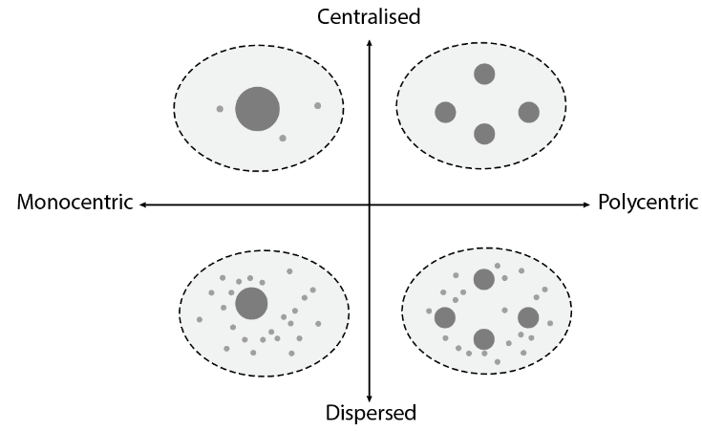 | 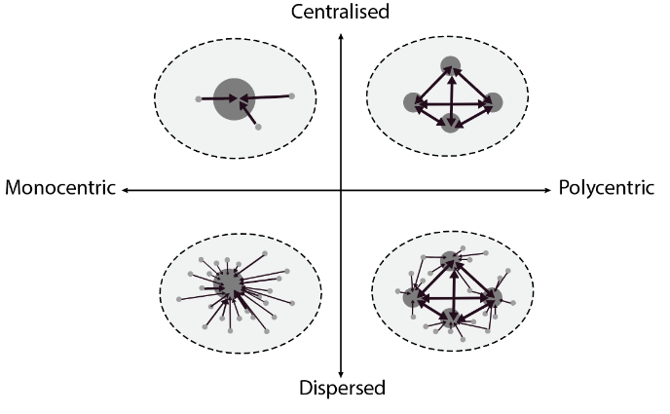
a) Morphological spatial structure | b) Functional spatial structure

Fig. 1. Characterising urban structure using two dimensions with two interpretations.
(adapted from Burger et al., 2014, Meijers & Burger, 2010).

Table 1
A selection of measures used to characterise urban structure
 | Morphological spatial structure characterisation | Functional spatial structure characterisation
Polycentricity | - The population share of a city’s sub-centres in relation to all its centres (Lee & Gordon, 2007);  - The number of centres in a city;  - The average distance between a city’s sub-centres and its main centre. | - Special functional polycentricity, general functional polycentricity (Green, 2007);  - Network density, primacy index, and outward openness (Burger et al., 2011);  - Rank-size distribution of nodality scores (Burger & Meijers, 2012);  - The connectivity field method (Vasanen, 2012);  - The Gini coefficient (Li & Phelps, 2017);  - Network centrality and community detection analysis (Chopra et al., 2016, Shen & Batty, 2019, Zhong et al., 2014).
Compactness | - The proportion of the population in all of a city’s centres in relation to its total population. | N.A.

In recent years, there has been some debate over urban structural evolution. Urban spatial structure is more than a static structure; it is constantly changing with increasing complexity, and this trend has been particularly noticeable in recent decades. Previous studies (Gordon & Richardson, 1997, Parr, 2004) have found that most developed countries firstly experienced spatial concentration with a rapid increase in employment in a city’s main centre and then decentralisation with a rapid increase in the rate of employment in sub-centres. While no consensus has been reached on the trend towards polycentricity, it has been argued that polycentricity is a common trend in the U.S. (Gordon & Richardson, 1997). Shearmur et al. (2007) argued that all of the processes involved could occur on different scales, noting that over a period of change in spatial structure, the two dimensions may be associated but are distinctive and do not necessarily evolve in the same direction (Cutsinger et al., 2005, Li et al., 2019).
Because longitudinal data is not available, very few studies have focused on characterising the evolution of urban structure. In recent decades, increasingly diverse methods of data collection and the availability of large datasets have enabled us to explore different types of interactions within urban systems. Among them, Hu et al. (2018) categorised Jiedao (the census or tract spatial unit) into three types: 1) persisting centre areas (PCAs); 2) emerging centre areas (EMAs); and 3) non-centre areas (NCAs). This categorisation is based on the changes in employment density in Beijing between 2000 and 2008. According to the previous discussion regarding the two dimensions of urban structure, this approach can be categorised as belonging to the morphological function strand per se, because the categorisation is based on the morphological structures.
In parallel with morphological structural evolution, one representative study on temporal structural change, that comes within the functional structural strand, is by Zhong et al. (2014). They attempted to use network modularity analysis to detect and depict urban structural evolution in Singapore from 2010 to 2012. The results showed that, even within three years, Singapore seemed to be rapidly developing into a polycentric urban structure. The exclusive advantage of community detection of network modular analysis lies in its ability to provide fine-grained details of the structural evolution progress. Rather than describing structural change in a categorical way like PCAs, EMAs and NCAs, the network approach can describe the composition of temporary sub-centres by labelling structural shifts. It can detail how, for instance, one sprawling or emerging sub-centre can be attributed to growing interactions between specific sub-centres. Another attempt to use the network lens to explore the evolution of urban structure is Barthelemy’s research which has examined the spatial distribution of centrality (Barthelemy, 2016). For example, by observing changes in the spatial distribution of the most central street intersections in Paris, Barthelemy et al. (2013) identified several radical reorganisations of urban structure between 1789 and 2010, in particular a major redistribution of centrality during the Haussmann period (1853-1870). Although the Paris case used street networks rather than functional flows, it highlighted the potential of applying network knowledge to characterise urban structural evolution. It also emphasised the strength of the functional network approach in that it could not only help to identify the boundaries of the centre and sub-centres, but also to capture the hubs within different centres.
In addition to the two strands discussed above, Burger and Meijers (2012) proposed a third strand that links both morphological and functional approaches and discusses the way in which both can be measured and compared. The regression model, based on the rank-size distribution of cities’ connectivity, has been developed to measure the degree of polycentricity. In other words, the distribution inequalities of functional and morphological attributes are used as proxies to reflect the degree of polycentricity. In line with this idea, Li and Phelps (2017) drew upon the concept of the Gini coefficient to estimate the evolution of knowledge polycentricity from 2000 to 2014 in the Yangtze River Delta.
The existing discussion on evolving urban structure has largely remained at the descriptive and characterising level. A few studies have examined the dynamics that change with the urban structure, or at least the co-evolving factors that change with it. For example, Ramachandra et al. (2012) argued that changes in urban dynamics depend on the nature of land use and the level of spatial accumulation. The former relies on the activities that take place in specific areas and the latter relies on the intensity and concentration. Stanilov (2013) found the preurban spatial as well as the planning and development policies play an important role in shaping the patterns of urban evolution. To the best of our knowledge, no research has explored the relationship between the change in urban structure and the key factors influencing them in London. It is crucial to understand their relationship, particularly in the case of London where previous empirical research has shown that intra-urban movement patterns are heterogeneous and have become more rich and complex (Roth et al., 2011). A better knowledge of the dynamics of urban structural change could not only help strategic planners to recognise the opportunity areas for diversification and intensification, but also to assess whether policies or actions have delivered as effectively as planned.

3. Data and methods

3.1 Study areas and datasets
This study relies on three sets of data. The first set uses the Oyster card travel data from Transport for London (TfL) as the proxy of human movement. Although there are many other functional flows that can be used to reflect the dynamics within a city, commuting represents an important lubricant for both labour-market flexibility and that of residence and workplace (Parr, 2014). Specifically, this data is based on the Rolling Origin & Destination Survey (RODS) (which can be found at https://tfl.gov.uk/info-for/open-data-users/our-open-data?intcmp=3671). The data contains detailed information including the origin and destination (O-D), the passenger volume between each pair of OD stations and boarding and alighting time, encompassing on average a total of 4.88 million journeys per weekday in 2013, 2015 and 2017. In this study, we only focus on the travel data for peak time (7 AM-10 AM; and 4 PM-7 PM) on weekdays (excluding public holidays) in 2013, 2015 and 2017.
The second dataset used consists of the metro geographical coordinates and metro timetable data from OSM (OpenStreetMap) and Transport for London (TfL) (downloadable from http://timetables.data.tfl.gov.uk/). Based on the passenger flow data about origins and destinations and the spatial relation between stations, an undirected weighted graph is constructed to represent the overall travel on every pair of metro stations in the city during weekdays. Formally, the network can be defined as an undirected weighted graph as G = (N, L, W1, W2), where N refers to the set of metro stations, L represents the set of links, W1 indicates the Euclidean distance of each link respectively, and W2 indicates the total passenger volume of a link, including both directions between each pair of stations.
The third dataset is a socio-economic dataset of neighbourhood-level data for 2013 and 2017. The selection of proxy variables is largely based on the preceding literature review and constrained by the availability of data in the corresponding years (2013 and 2017). The population density data was obtained from Greater London Authority (downloadable from http://data.london.gov.uk/dataset/gla-population-projections-custom-age-tables), the median house price data came from the Land Registry (downloadable from https://data.gov.uk/dataset/land-registry-monthly-price-paid-data), and the data on jobs and job density was obtained from the Office of National Statistics (ONS) (downloadable from http://www.ons.gov.uk/ons/rel/regional-trends/regional-economic-analysis/index.html). In addition to these three variables, this study also includes two binary indicators to reflect planning policy and spatial location (see in Appendix A). One variable indicates whether the areas are located in the London Opportunity Areas Planning Framework (OAPF) that have significant capacity to accommodate new housing, commercial and other development linked to existing or potential improvements in public transport accessibility (GLA, 2013, GLA, 2016). Opportunity areas can typically accommodate at least 5,000 jobs or 2,500 new homes, or a combination of the two. The other binary variable indicates whether the areas are located within Inner London.

3.2 Identifying sub-centres
A wide range of approaches have been used to identify urban centres, using different criteria (e.g., population, employment, size-distribution of nodality scores) and different spatial units (Liu & Wang, 2016). Vasanen’s (2012) detailed review of approaches assessed the identification of centres through both the morphological and functional strands. In line with the functional network strand, this study draws upon community detection analysis to determine the borders of each sub-centre. The principle of identifying communities is according to the density and interaction flows within each community that are stronger and greater in terms of volume than those between communities (Zhong et al., 2014). One point that needs to be highlighted here is that the number of communities does not necessarily indicate the actual number of centres and sub-centres, particularly when the number of sub-centres is defined by the distribution of employment or residents. In fact, network community detection is scale-dependent. When the resolution (or scale) varies, the structural partition, and thus the number of communities (also known as clusters), change accordingly.
Passenger flow within the same community has stronger connections and interactions compared to the flows between communities. Specifically, the study employs five of the most commonly used community detection methods to analyse the transit movement network in 2013, 2015 and 2017, namely: edge betweenness (Girvan & Newman, 2002); Infomap (Rosvall & Bergstrom, 2008); Louvain (Blondel et al., 2008); spin glass (Reichardt & Bornholdt, 2006); and fast greedy (Newman, 2004). The modules are then identified by maximising their modularity (Girvan & Newman, 2002, Guimera et al., 2004, Newman, 2004). The optimal result with the highest modularity determines the community subdivision, and each station node is then assigned to a new attribute (Newman, 2004), that is, the community memberships.

Characterising sub-centres and describing the changes in urban structure
After identifying the community memberships of each station, we describe the changes in movement structure through: 1) the change in the degree of polycentricity; 2) the change in the degree of compactness; and 3) the change in structural community membership. Functional polycentricity reflects whether the centres are equally essential in terms of their network position measured by network centrality (Burger et al., 2014). In line with Li and Phelps’ (2017) approaches to describe the change in the degree of polycentricity, this study applies the Gini coefficient to estimate the passenger flow inequality, ranging from 0 (perfect equality) to 1 (perfect inequality). The degree of polycentricity is calculated by Eq. (1).

DP = 1 - G_{PF} (1)

where DP refers to the degree of transit movement polycentricity ranging from 0 to 1, and G_{PF} indicates the Gini coefficients of the distribution of passenger flows for each transit station. Higher DP values reflect a higher degree of polycentricity in the transit movement systems, indicating a more equal distribution of passenger flow between all stations.
Compactness is represented by DC, which refers to the degree of compactness. Based on Lee and Gordon’s (2007) assertion that employment dispersion reflects the extent to which employment is disproportionately clustered in a few locations, the degree of compactness defined by Eq. (2), the opposite of dispersion (Li et al., 2019), can be reflected by the share of the sum of intra-community commuting flows to its total passenger flow.

DC= $\sum_{1}^{i}{f_{i}}$ / F (2)

where $i$ denotes the index of communities, $f_{i}$ is the sum of intra-flows within the same community, and F is the total flow. In terms of dispersion, the degree of functional dispersion can be understood as the proportion of intra-community commuting flow in relation to the total passenger flow.
It should be noted that the degree of compactness and the degree of polycentricity describe the characteristics of structure on a general level. Therefore, apart from using the traditional indicators that characterise the structure along two dimensions (polycentricity and compactness), the study also uses the change in community identities to depict how the relations and interactions alter between different stations and communities. As discussed above, network community detection could help to specify cluster identities through the intensity of interactions between different stations; therefore, the change in community identities could provide more detailed in-depth information. For instance, if one station belonged to community a in 2013 but was found to belong to community b in 2017, then it indicates that the station is experiencing more intense functional interaction within community b compared to the other communities. Conversely, if one station remained in the same cluster between 2013 and 2017, then it can be deemed that the functional dynamics between this station and others has not changed significantly.

Multinomial logistic regression
Although several indicators have been proposed to describe the changes in movement structure between 2013 and 2017, this paper mainly focuses on one aspect - the change in (sub-) centres at the sub-centre level. As discussed in the previous section, the change of community provides granular information about the structural change, compared to using the change of compactness degree or the change of polycentricity degree at the whole city scale. Here, we employ the multinomial logistic regression model (MNL) to explore how the changes in (sub-) centres coevolve with socio-economic factors. MNL is a statistical method for analysing the relationship between one dependent nominal variable (with more than two alternatives) and multiple independent variables (e.g. Cao & Hickman, 2019; Shen & Wu, 2013; Zhao, 2013). The multinomial logistic regression estimates $k_{i}$ as a multiple linear regression function defined as shown in Eq. (3).

$logit\left(y=k_{i}\right)=\ln\left( \frac{P \left( prog=k_{i}\right)}{P\left(prog=unchanged\right)} \right)=β_{i}+β_{i1 }(Oppor)+β_{i2 }(Inner)+β_{i3 }(JobR)+β_{i4 }(ResR)+β_{i5 }(HouPriR)+ε_{i}$ (3)

where $k_{i}$ represents the change from one group to another, $i=1…n,$ while $n$ is the number of potential changes. $β$ is the set of regression coefficients associated with each of the explanatory variables.
Our dependent variable is unchanged (sub-) centres with several changed alternatives, and there are five independent variables: ‘Oppor’ indicates whether the station areas are located within the London Opportunity areas, representing a high potential for intensification and diversification development. ‘Inner’ indicates whether the areas are located within Inner London. The third variable is ‘JobR’ (Alpkokin et al., 2008), which indicates the change in the rate of job density between 2013 and 2017. The fourth variable, ‘ResR’ (Cervero & Duncan, 2006, Ewing & Cervero, 2001), represents the change in the rate of population density. The fifth variable, ‘HouPriR’ (Anas & Chu, 1984), indicates the change in the rate of median house prices.

4. Results

4.1 Shifts in the urban structure of Greater London
As stated in the method section, the study applies five network community detection algorithms to identify clusters. The Louvain (Blondel et al., 2008) algorithm yields the best results (with the highest modularity value of 0.57) out of the five community detection algorithms. As shown in Fig.2, London’s transit movement O-D network exhibits a modular community structure and can generally be subdivided into five communities: the movements within the south-western (SW) community and west-central (WC) community are mainly concentrated in the western, northern and central areas. The north-southern (NS) community spans a larger area compared to the north-central (NC) community; both the NS and NC communities play very important roles in organising travel between the northern and southern areas of London. What stands out is that the west-eastern (WE) community, which spans the width of London from the west to the east, has the largest travel volume. As the largest community, the intra-flow of the WE community accounts for around 22.21% of the total travel volume in 2017. Each community consists of one or more underground lines, or parts of underground lines. For example, the NC community (shown in green) comprises the whole of the Victoria line plus the northern part of the Piccadilly line.
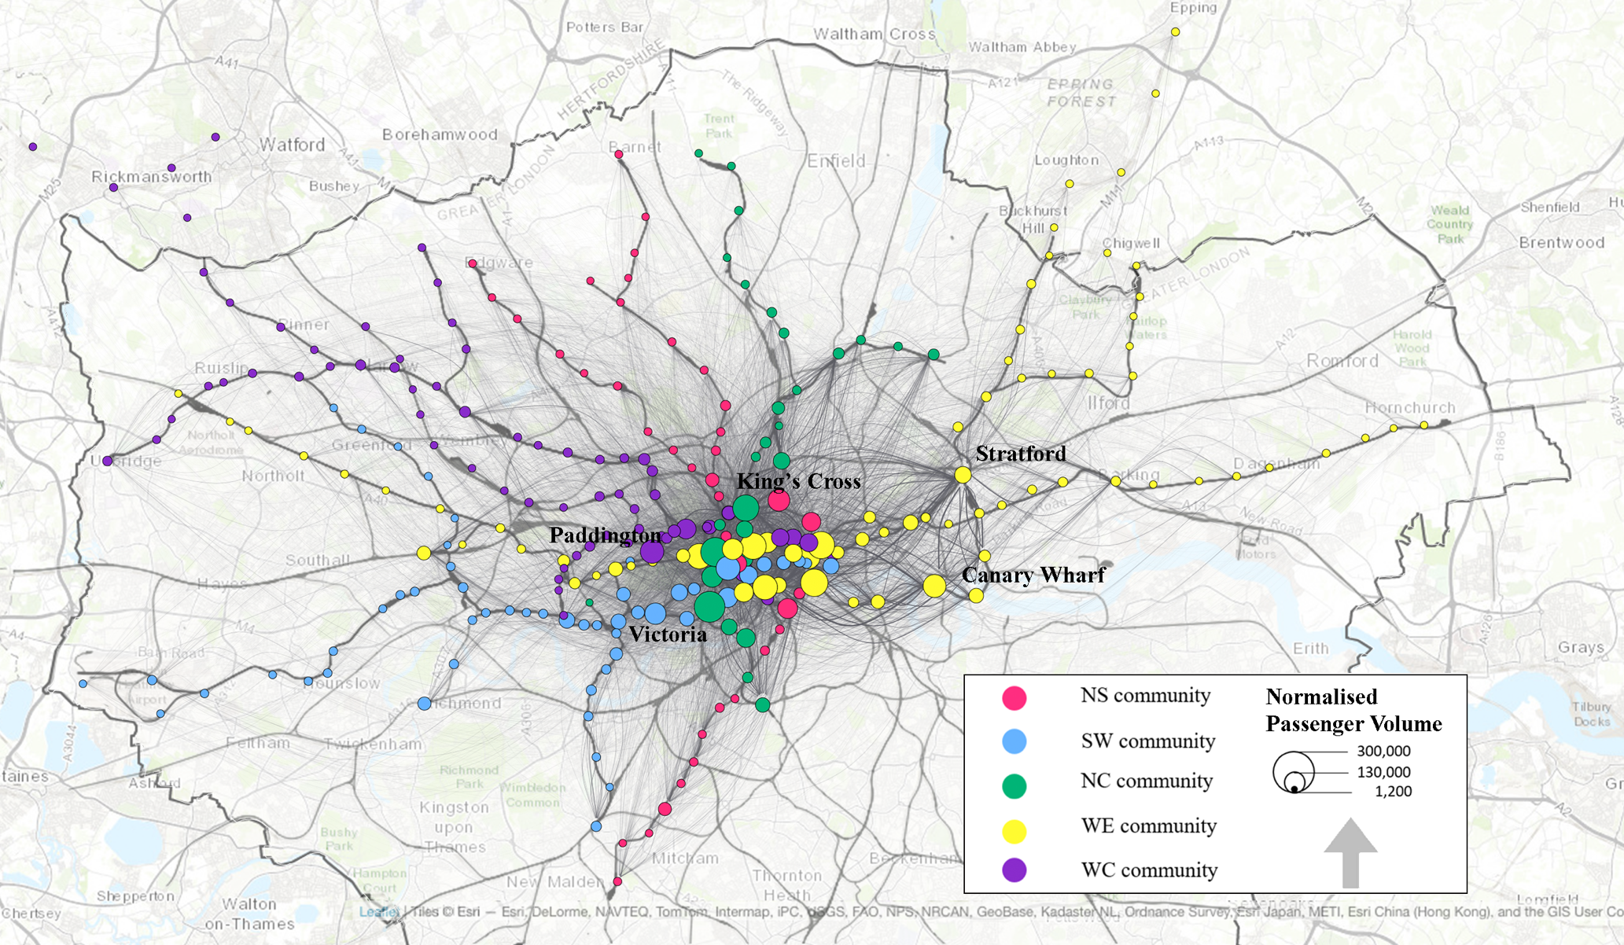
Fig. 2. Distribution of the five transit movement communities in terms of passenger volume in 2017 (the stations shown in the same colour are in the same community).

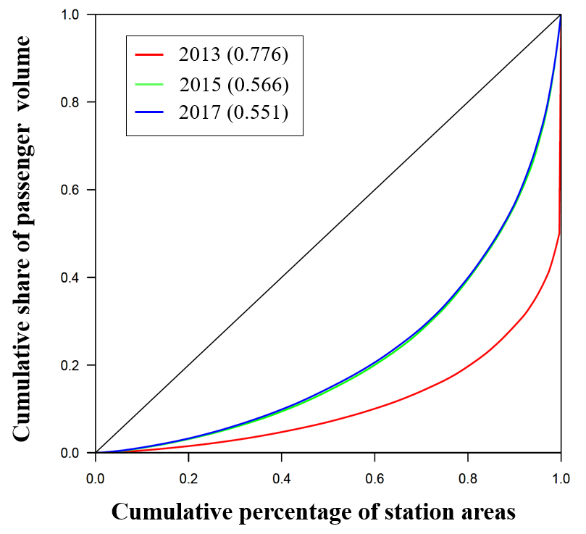
Fig. 3. The Lorenz curves and Gini Coefficients of passenger volume for Greater London from 2013 to 2017.

As well as creating a general picture of the London structure, we are interested in how it changes from 2013 to 2017. To quantitatively characterise the structural shift, the study utilises the change in the degree of polycentricity, the change in the degree of compactness, and the change in community membership. As shown in Fig. 3, the Gini coefficients of passenger volume for 2013, 2015 and 2017 are 0.776, 0.556 and 0.551, respectively. In terms of the degree of polycentricity, we can see that there has been a substantive increase in the degree of polycentricity between 2013 and 2015 from 0.224 to 0.434, and a slight increase in the degree of polycentricity from 0.434 to 0.449 between 2015 and 2017. These results indicate that the structure is becoming more polycentric with a more equal distribution of passenger flows between stations.
When looking at the travel movement shares of the top three stations between 2013 and 2017 (Table 2), two points need to be made. Firstly, the change in structure varies between different communities. The NC and SW communities experienced only very slight change according to the composition of the top three stations within these communities. For example, Piccadilly Circus, South Kensington and Hammersmith Stations are the top three stations with the highest share of travel volume in the SW community, and their ranking has remained the same over the five years. Conversely, the NS, WC and WE communities have experienced major changes, either in terms of the composition of the top three stations or in terms of the ranking order. For instance, Waterloo and Bank/Monument were the top two stations in the NS community in 2013, but in 2017 they ranked as the top two stations in the WE community. This shift in community membership indicates that Waterloo and Bank/Monument stations had more intense travel interactions with the WE community than the NS community.
Secondly, the variation in movement structure over two different time periods (from 2013 to 2015 and from 2015 to 2017) also reveals differences. The composition of the top three stations and share of travel volume of the NC, WE, and WC communities remained almost the same with just a few changes between 2013 and 2015, while there was a dramatic difference in these communities between 2015 and 2017. Taking the WC community as an example, King’s Cross station and Liverpool Street station played key organising roles within the western and central areas of London between 2013 and 2015, but in 2017, King’s Cross station had developed a stronger connection with the NC community while Liverpool Street station had established a closer connection with the WE community.

Table 2.
The top three transit stations and their shares of travel movement between 2013 and 2017.

Cluster | 2013_Top three | Share (%) | 2015_Top three | Share (%) | 2017_Top three | Share (%)
NS | Waterloo | 3.06% | Waterloo | 3.01% | Leicester Square | 1.02%
 | Bank/ Monument | 2.60% | Bank/ Monument | 2.78% | Old Street | 0.90%
 | Leicester Square | 1.17% | Tottenham Court Road | 1.27% | Elephant & Castle | 0.64%
Total share |  | 6.83% |  | 7.06% |  | 2.56%
NC | Victoria | 2.84% | Oxford Circus | 2.76% | King’s Cross | 3.05%
 | Oxford Circus | 2.77% | Victoria | 2.55% | Victoria | 2.48%
 | Euston | 1.22% | Euston | 1.28% | Oxford Circus | 2.47%
Total share |  | 6.83% |  | 6.59% |  | 8.00%
SW | Piccadilly Circus | 1.28% | Piccadilly Circus | 1.24% | Piccadilly Circus | 1.21%
 | South Kensington | 1.04% | South Kensington | 1.04% | South Kensington | 1.02%
 | Hammersmith | 0.98% | Hammersmith | 0.87% | Hammersmith | 0.88%
Total share |  | 3.3% |  | 3.15% |  | 3.11%
WE | Stratford | 2.63% | Stratford | 2.48% | Waterloo | 2.99%
 | London Bridge | 2.30% | London Bridge | 2.38% | Bank/ Monument | 2.97%
 | Canary Wharf | 1.90% | Canary Wharf | 1.94% | Stratford | 2.88%
Total share |  | 6.83% |  | 6.80% |  | 8.84%
WC | King’s Cross | 3.13% | King’s Cross | 2.85% | Paddington | 1.60%
 | Liverpool Street | 2.35% | Liverpool Street | 2.38% | Moorgate | 1.07%
 | Paddington | 1.72% | Paddington | 1.61% | Baker Street | 0.97%
Total share |  | 7.2% |  | 6.84% |  | 3.64%

Table 3.
The share of intra-flow and degree of compactness of the transit movement network between 2013 and 2017.

 | The share of intra-flow |  |  |  |  | DC (%)
Year | NS | NC | SW | WE | WC
2013 | 6.94% | 6.92% | 7.39% | 15.16% | 8.97% | 45.36%
2015 | 6.31% | 7.26% | 6.94% | 16.44% | 8.96% | 45.90%
2017 | 3.73% | 9.90% | 6.43% | 22.21% | 6.78% | 49.04%

In terms of the variation in compactness, we calculated the sum of the intra-flow of all the communities to the total travel flow by degree of compactness to measure the extent to which the transit movement flow is concentrated within the five communities. As shown in Table 3, the degree of compactness of increased by 3.68% from 2013 to 2017, experiencing a particularly rapid increase between 2015 and 2017. In 2017, the intra-flow between clusters accounts for nearly 49.04% of the total travel flow. This result indicates that the urban structure has developed a more compact form. The increasing degree of compactness or decreasing degree of dispersion of London seems to be in conflict with Lee and Gordon’s (2007) finding that there has been an increasing trend towards dispersion in US metropolitan areas, and that more dispersion leads to higher growth rates as areas grow larger. In fact, however, a morphologically dispersed structure can also be functionally compact, and vice versa. The morphological aspect gives a static picture of the distribution of employment or residents; the functional aspect describes the interactional intensity between these static clusters of employment and residents from a dynamic perspective.
At city level, the degree of polycentricity and compactness show that London’s structure has developed a more polycentric and compact pattern. At the sub-centre level, we also identified some of the inter-dynamics between the five communities through the exchange of flows. First, the structure moved more towards the eastern areas of London between 2013 and 2017. From the intuitively visual impression (of Fig. 4a), there is no obvious change in the spatial distribution of station memberships (differentiated by five colours). When we look at the Sankey diagram (Fig. 4b), it can be seen that the pattern of flow shifted mainly from the NC to SW communities between 2013 and 2017, and from the NS to WE and WC communities between 2015 and 2017. For example, Bank and Waterloo stations, which were previously key transport hubs in the NS communities, became more important for the WE community in 2017. Additionally, stations within the Central Activities Zones (Fig. 4c) experienced more changes in their community memberships. From 2013 to 2017, nearly 4.5% of all stations changed their cluster memberships and 67% of them are within the zone. So far, we are still at the stage of description and characterisation, in terms of the city level and sub-city level. In the next part, we start to look at the spatial and socio-economic factors that may affect these structure shifts.

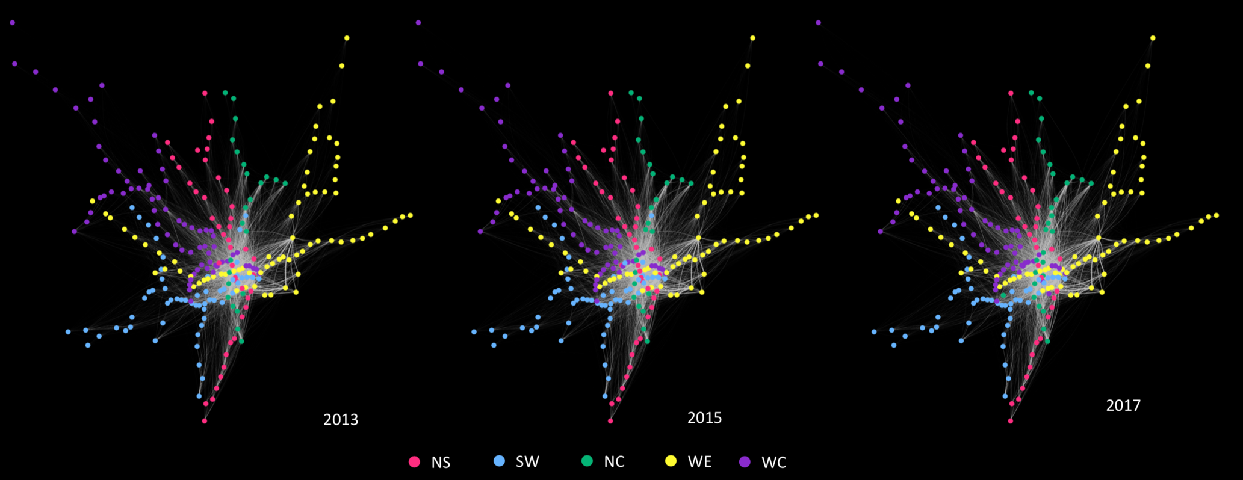
(a)
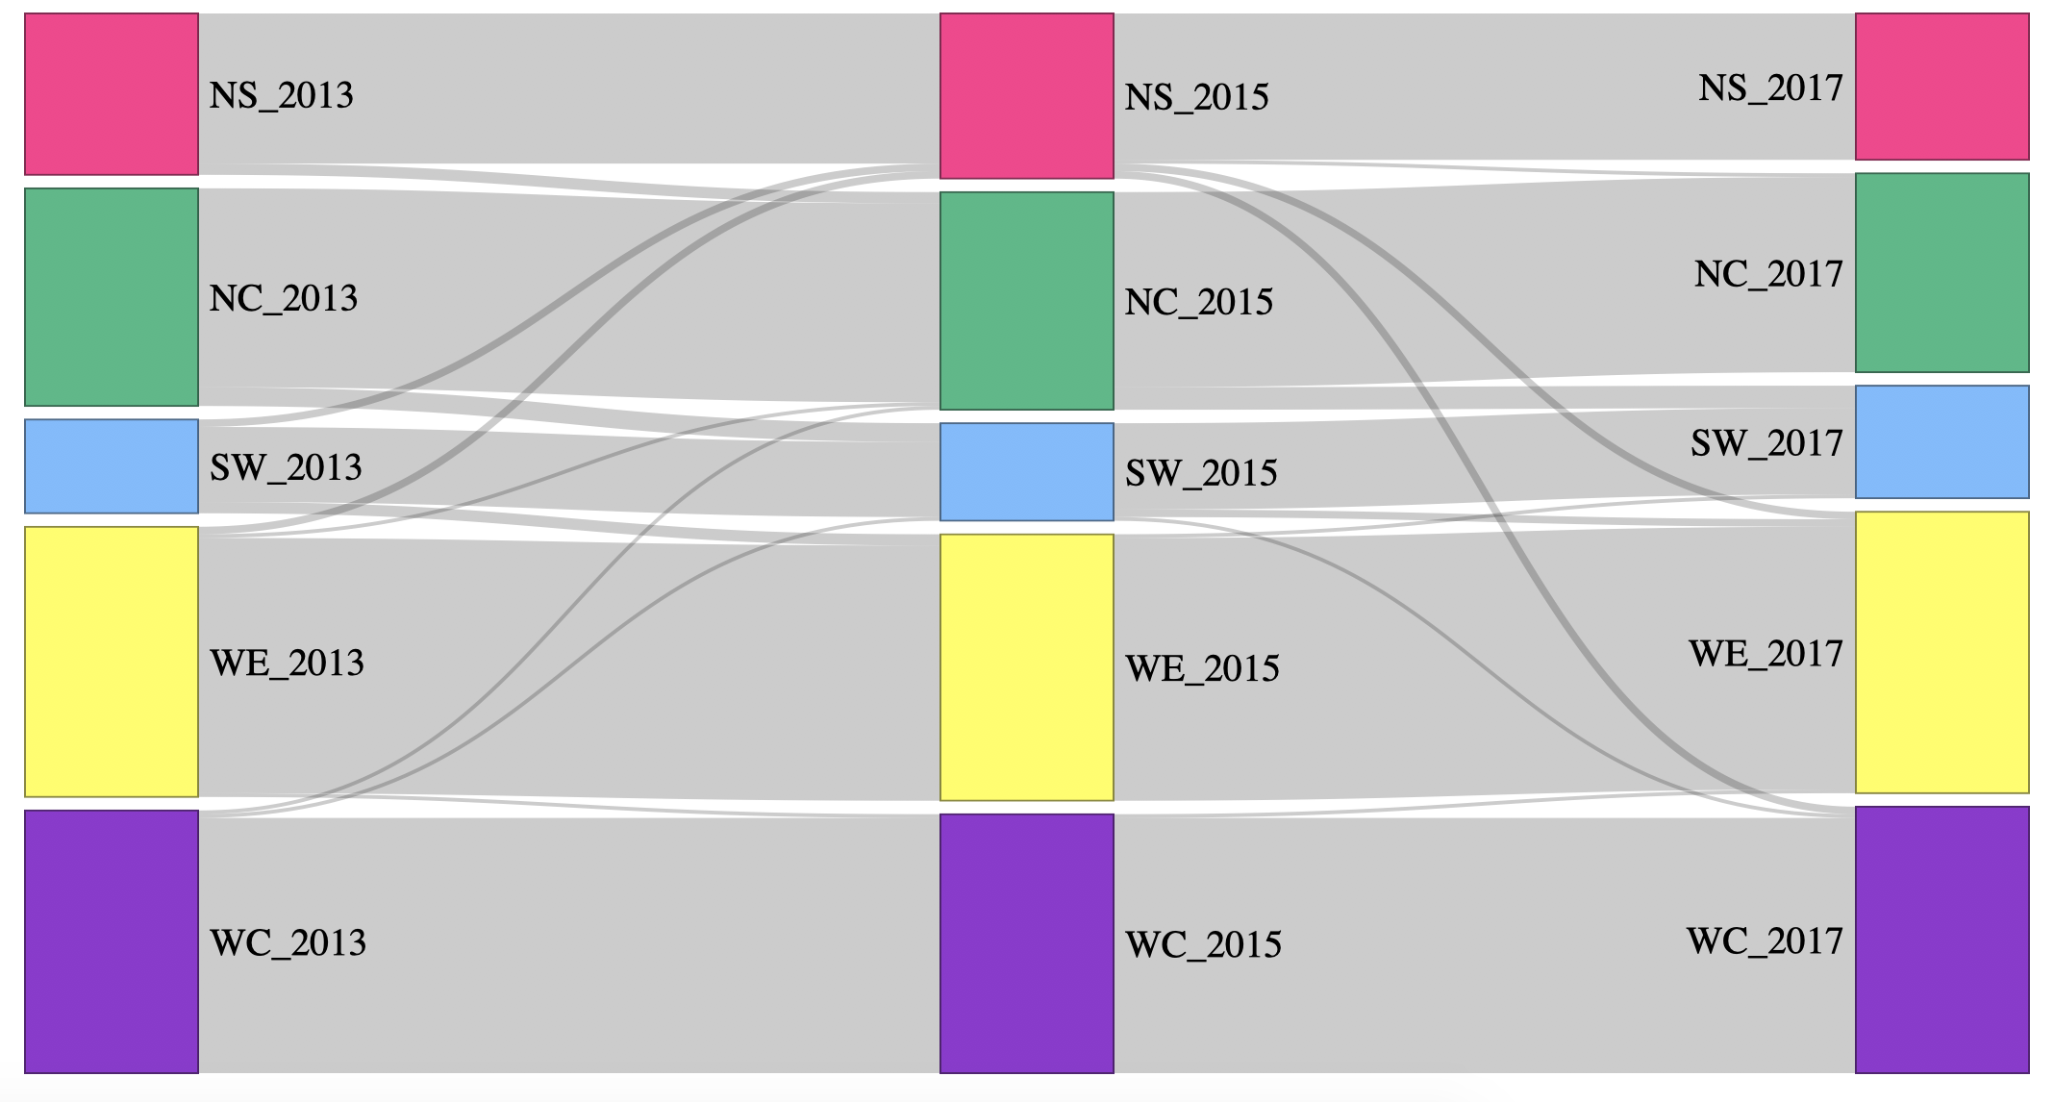
(b)
Fig. 4. The changing structure of Greater London in 2013, 2015 and 2017. (a) Community memberships of transit stations; (b) Sankey diagram of structural change.

4.2 The coevolution of urban structure and socio-economic demographic factors
Table 4 shows the multinomial regression results for the changes in the structure between 2013 and 2017. The odds ratio measures the ratio of the probability that the area has changed its structural identity to the probability that the area has remained in the reference group (unchanged areas) for a one unit increase in the value of the independent variable. Based on the changes in the transit structures, the structural shifts can be categorised into four general cases. When undertaking the regression, the study chose the unchanged areas as the reference group. The alternative groups are: 1) NS-WE: the change from the North-south group to the West-east group relative to unchanged; 2) NS-WC: the change from the North-south group to the West-central group relative to unchanged; 3) SW-WE: the change from the South-west group to the West-east group relative to unchanged; and 4) other cases of change relative to unchanged. This multinomial regression analysis can help us to gain deeper insights into how several of the socio-economic indicators coevolved with the changes in urban structure between 2013 and 2017 in London.

Table 4
Multinomial logistic regression for changes in urban structure between 2013 and 2017.

Variable | NS-WE |  | NS-WC |  | SW-WE |  | Others
 | Odds Ratio | Sig. | Odds Ratio | Sig. | Odds Ratio | Sig. | Odds Ratio | Sig.
If in opportunity areas (True = 1) | 0.004*** | 0.002 | 0.000*** | 0.001 | 0.001* | 0.053 | 0.236** | 0.033
If in Inner London (True = 1) | 0.000** | 0.021 | 0.017** | 0.043 | 0.000** | 0.038 | 0.02** | 0.024
Change in job density | 1.293 | 0.428 | 0.002** | 0.043 | 0.031 | 0.291 | 3.550 | 0.767
Change in residents’ density | 0.001 | 0.408 | 0.981 | 0.488 | 0.991 | 0.398 | 0.990 | 0.432
Change in median house prices | 0.919** | 0.023 | 0.299 | 0.694 | 0.391 | 0.529 | 0.170* | 0.095
Model Fitting information | Log-likelihood: -181.2  Likelihood ratio test: Chi-Square = 35.30 (P value=0.004)
(Note: *P < 0.1, **P < 0.05, *** P < 0.01)
The regression analysis shows that, first, the main indicators that coevolved with the changes in structure vary on a case-by-case basis. The NS-WE area coevolved with the change in median house price, and it is strongly associated with the key planning strategy-opportunity areas and spatial location. In the case of the NS-WC area, the likelihood of change is largely associated with the change in job density rather than change in median house price.
Second, the spatial location (if within Inner London) has a significant impact on the likelihood of structural change. From an urban planning perspective, this finding also highlights the need to evaluate station roles within the transit network as a whole to ensure the roles and settings of stations.
Third, although the variables that coevolved with the change in structure are different, the opportunity areas planning policy, and spatial location, are associated with an increased likelihood of changing structural identities compared to remaining unchanged. For instance, for areas identified as opportunity areas, the likelihood of moving from the north-south group to the west-east group increased by a factor of 0.004. This means that the opportunity areas planning policy has a relatively strong relationship with the changes in transit movement structures.

5. Conclusions
In this paper, we examined the evolution of London’s urban structure between 2013 and 2017 and its coevolving factors through the lens of functional spatial structure. In relation to temporal structural change, we investigated the change in degree of compactness and the change in degree of polycentricity at city level, and looked at the variations in the composition and ranking of stations within different clusters at sub-centre level. To understand the coevolution process, we employed logistic regression analysis to explore how changes in cluster membership are associated with changes in employment density, housing price, spatial location, and spatial planning policy.
This study offers three key findings. Firstly, London’s urban structure shifted towards a more polycentric and compact pattern between 2013 and 2017. Within four years, the degree of compactness had increased by 3.68% and the degree of polycentricity had increased by 22.5%. Secondly, the study identified five communities in London and found that there were some changes in the interactions between different areas, especially between 2015 and 2017. One substantive change emerged in the West-east (WE) areas which saw an increase in commuting interaction with other areas. Thirdly, building on Lee and Gordon’s (2007) argument that different cities would experience a gradual and nonlinear change in urban structure due to varying factors at different development stages, we found that dynamics of structural change in different communities are also different. The differences can be understood in two ways: (i) the changing intensities of the five clusters are distinct. For example, several stations changed their cluster memberships to the WE community but none of the stations shifted to membership of the NS communities. This finding indicates that the WE community experienced more dynamics than other communities; and (ii) the forces behind, or motivation for, the structural changes varied in different areas. The change in the western sub-centres is strongly associated with the change in residential densities, while the eastern areas showed a significant statistical relation with the change in employment density. In addition, the factors associated with the opportunity areas policy and spatial location showed a strong statistical significance with an increased likelihood of a change in structural identity compared to remaining unchanged.
Our empirical results provide some implications for urban policy. The approaches outlined in this paper provide another perspective on exploring urban change, and we suggest these approaches may be useful in the context of making decisions for spatial strategic planning. This may be from a prospective planning point-of-view, such as using structure analysis to help identify and validate the town centres’ classifications (GLA, 2016) based on their roles in organising territorial economic activities. It is clear that greater attention should be paid to exploring variations in travel patterns related to opportunity areas. In the case of London, the opportunity area policy has had significant impacts on structure change, indicating a likely mismatch between travel demand and supply. That is to say, real-time or periodic information on structure shift could aid transport provision due to acute change in land use development and the intervention of planning policies. The approach may also help to broaden the evaluation of integrated land use and transport interventions, by assessing the degree to which interventions and investments have resulted in changes.
This study is mainly limited by the absence of different kinds of longitudinal data, such as other types of travel data or socio-economic and socio-demographic data. In terms of future work, firstly, a wider range of socio-economic and demographic indicators could be analysed to compare how they co-evolve with the urban structure, because these would provide solid evidence with which to guide spatial planning policy and strategy, thereby promoting economic and social cohesion and balanced and sustainable development (ESDP, 1999). Secondly, a more comprehensive picture of spatial structure and its temporal changes could be obtained by including other types of public transport data, such as data on buses, although the tap-out data for bus users in London is not recorded. Thirdly, it would be interesting to look at the evolution of the urban structure using different spatial scales and time scales. Fourthly, more different types of functional linkages, such as knowledge flow and logistics flow, could be studied together to complement a multi-dimensional interpretation of urban structure. As discussed above, a functionally compact structure does not conflict with a morphologically dispersed structure. Similarly, a city can have very different types of functional network structure with different combinations of degrees of polycentricity and compactness.

Acknowledgements
The authors would like to thank the editor and the anonymous reviewers for their valuable comments to improve the draft of this paper.

References

Alpkokin, P., Cheung, C., Black, J., & Hayashi, Y. (2008). Dynamics of clustered employment growth and its impacts on commuting patterns in rapidly developing cities. Transportation Research Part A: Policy and Practice 42(3) 427-444.
Anas, A., Arnott, R., & Small, K.A. (1998). Urban spatial structure. Journal of economic literature 36(3) 1426-1464.
Anas, A., & Chu, C. (1984). Discrete choice models and the housing price and travel to work elasticities of location demand. Journal of Urban Economics 15(1) 107-123.
Arribas-Bel, D., & Sanz-Gracia, F. (2014). The validity of the monocentric city model in a polycentric age: US metropolitan areas in 1990, 2000 and 2010. Urban Geography 35(7) 980-997.
Barter, P. (2004). Transport, urban structure and'lock-in'in the Kuala Lumpur Metropolitan Area. International Development Planning Review 26(1) 1-24.
Barthelemy, M. (2016). The Structure and Dynamics of Cities: Cambridge University Press.
Barthelemy, M., Bordin, P., Berestycki, H., & Gribaudi, M. (2013). Self-organization versus top-down planning in the evolution of a city. Scientific reports 3 2153.
Beckers, J., Vanhoof, M., & Verhetsel, A. (2017). Returning the particular: Understanding hierarchies in the Belgian logistics system. Journal of Transport Geography 76 315-324.
Blondel, V.D., Guillaume, J.L., Lambiotte, R., & Lefebvre, E. (2008). Fast unfolding of communities in large networks. Journal of statistical mechanics: theory and experiment 10 P10008.
Bogart, W. T. (2006). Don't Call it Sprawl: Metropolitan Structure in the 21st Century: Cambridge University Press.
Borrego, C., Martins, H., Tchepel, O., Salmim, L., Monteiro, A., & Miranda, A.I. (2006). How urban structure can affect city sustainability from an air quality perspective. Environmental Modelling and Software 21(4) 461-467.
Burger, M. & Meijers, E. (2012). Form follows function? Linking morphological and functional polycentricity. Urban studies 49(5) 1127-1149.
Burger, M.J., de Goei, B., Van der Laan, L., & Huisman, F.J. (2011). Heterogeneous development of metropolitan spatial structure: Evidence from commuting patterns in English and Welsh city-regions, 1981–2001. Cities 28(2) 160-170.
Burger, M.J., Van Der Knaap, B., & Wall, R.S. (2014). Polycentricity and the multiplexity of urban networks. European Planning Studies 22(4) 816-840.
Burton, E. (2000). The compact city: just or just compact? A preliminary analysis. Urban Studies 37(11) 1969-2006.
Cao, M., & Hickman, R. (2018). Car dependence and housing affordability: An emerging social deprivation issue in London. Urban Studies 55(10) 2088-2105.
Cao, M., & Hickman, R. (2019). Understanding travel and differential capabilities and functionings in Beijing. Transport Policy 83 46-56.
Cao, M., Chen, C-L., & Hickman, R. (2017). Transport emissions in Beijing: A scenario planning approach. Proceedings of the Institution of Civil Engineers Transport 170(2) 65-75
Cao, M., Zhang, Y., Zhang, Y., Li, S., & Hickman, R. (2019). Using Different Approaches to Evaluate Individual Social Equity in Transport. In: Hickman, R., Mella-Lira, B., Givoni, M. & Geurs, K. (eds.), A Companion to Transport, Space and Equity. Cheltenham: Edward Elgar, 209-228.
Cervero, R. & Duncan, M. (2006). Which reduces vehicle travel more: Jobs-housing balance or retail-housing mixing? Journal of the American planning association 72(4) 475-490.
Cervero, R. & Kockelman, K. (1997). Travel demand and the 3Ds: density, diversity, and design. Transportation Research Part D: Transport and Environment 2(3) 199-219.
Chopra, S.S., Dillon, T., Bilec, M.M., & Khanna, V. (2016). A network-based framework for assessing infrastructure resilience: a case study of the London metro system. Journal of The Royal Society Interface 13(118) 20160113.
Chowell, G., Hyman, J.M., Eubank, S., & Castillo-Chavez, C. (2003). Scaling laws for the movement of people between locations in a large city. Physical Review E 68(6) 066102.
Cuthill, N., Cao, M., Liu, Y., Gao, X., & Zhang, Y. (2019). The association between urban public transport infrastructure and social equity and spatial accessibility within the urban environment: An investigation of Tramlink in London. Sustainability 11(5) 1229.
Cutsinger, J., Galster, G., Wolman, H., Hanson, R., & Towns, D. (2005). Verifying the multi-dimensional nature of metropolitan land use: Advancing the understanding and measurement of sprawl. Journal of Urban Affairs 27(3) 235-259.
Duranton, G. (2000). Urbanization, Urban Structure, and Growth. In: Thisse, J.F. and Huriot, J.M, (eds.), Economics of Cities. Cambridge University Press, Cambridge, 290-317.
Echenique, M.H., Hargreaves, A.J., Mitchell, G., & Namdeo, A. (2012). Growing cities sustainably: does urban form really matter? Journal of the American Planning Association, 78(2) 121-137.
ESDP (1999). European spatial development perspective: towards balanced and sustainable development of the territory of the European Union. European Commission.
Ewing, R., & Cervero, R. (2001). Travel and the built environment: a synthesis. Transportation Research Record: Journal of the Transportation Research Board (1780) 87-114.
Girvan, M., & Newman, M. E. (2002). Community structure in social and biological networks. Proceedings of the National Academy of Sciences 99(12) 7821-7826.
GLA (2013). The London Plan. London, Greater London Authority.
GLA (2016). The London Plan. London, Greater London Authority.
GLA (2018). The Lonodn Plan.London, Greater London Authority.
Goddard, J. B. (1970). Functional regions within the city centre: A study by factor analysis of taxi flows in central London. Transactions of the Institute of British Geographers 161-182.
Gordon, P., & Richardson, H.W. (1997). Are compact cities a desirable planning goal? Journal of the American Planning Association 63(1) 95-106.
Green, N. (2007). Functional polycentricity: a formal definition in terms of social network analysis. Urban Studies 44(11) 2077-2103.
Guimera, R., Sales-Pardo, M., & Amaral, L. A. N. (2004). Modularity from fluctuations in random graphs and complex networks. Physical Review E 70(2) 025101.
Hall, P. G. & Pain, K. (2006). The polycentric metropolis: learning from mega-city regions in Europe: Routledge.
Hu, L., Sun, T., & Wang, L. (2018). Evolving urban spatial structure and commuting patterns: A case study of Beijing, China. Transportation Research Part D: Transport and Environment 59 11-22.
Kloosterman, R. C., & Musterd, S. (2001). The polycentric urban region: towards a research agenda. Urban studies 38(4) 623-633.
Kulish, M., Richards, A., & Gillitzer, C. (2012). Urban structure and housing prices: Some evidence from Australian cities. Economic Record 88(282) 303-322.
Lee, B., & Gordon, P. (2007). Urban spatial structure and economic growth in US metropolitan areas. 46th annual meetings of the western regional science association, at Newport Beach, CA.
Li, Y., & Phelps, N. (2018). Megalopolis unbound: Knowledge collaboration and functional polycentricity within and beyond the Yangtze River Delta Region in China, 2014. Urban Studies 55(2) 443-460.
Li, Y., & Phelps, N. (2017). Knowledge polycentricity and the evolving Yangtze River Delta megalopolis. Regional Studies 51(7) 1035-1047.
Li, Y., Xiong, W., & Wang, X. (2019). Does polycentric and compact development alleviate urban traffic congestion? A case study of 98 Chinese cities. Cities 88 100-111.
Liu, X., & Wang, M. (2016). How polycentric is urban China and why? A case study of 318 cities. Landscape and urban planning 151 10-20.
Manley, E. (2014). Identifying functional urban regions within traffic flow. Regional Studies, Regional Science 1(1) 40-42.
Marshall, S., Gong, Y., & Green, N. (2019). Urban Compactness: New Geometric Interpretations and Indicators. In D’Acci, L. (ed.), The Mathematics of Urban Morphology. Birkhäuser, Cham. 431-456
McMillen, D.P. (2001). Nonparametric employment subcenter identification. Journal of Urban Economics 50(3) 448-473.
Meijers, E. J., & Burger, M. J. (2010). Spatial structure and productivity in US metropolitan areas. Environment and Planning A 42(6) 1383-1402.
Muth, R. F. (2017). The Spatial Structure of the Housing Market. Readings in Urban Analysis. Routledge. 11-26.
Næss, P. (2006). Urban Structure Matters: Residential Location, Car Dependence and Travel Behaviour: Routledge.
Newman, M. E. (2004). Detecting community structure in networks. The European Physical Journal B 38(2) 321-330.
Parr, J. B. (2004). The polycentric urban region: a closer inspection. Regional Studies 38(3) 231-240.
Parr, J. B. (2014). The regional economy, spatial structure and regional urban systems. Regional Studies 48(12) 1926-1938.
Ramachandra, T., Aithal, B. H., & Sanna, D. D. (2012). Insights to urban dynamics through landscape spatial pattern analysis. International Journal of Applied Earth Observation and Geoinformation 18 329-343.
Reichardt, J., & Bornholdt, S. (2006). Statistical mechanics of community detection. Physical Review E 74(1) 016110.
Richardson, H. W. (1969). Regional economics. Location theory, urban structure and regional change. Regional economics. Location theory, urban structure and regional change.
Rosvall, M., & Bergstrom, C. T. (2008). Maps of random walks on complex networks reveal community structure. Proceedings of the National Academy of Sciences 105(4) 1118-1123.
Roth, C., Kang, S.M., Batty, M., & Barthélemy, M. (2011). Structure of urban movements: polycentric activity and entangled hierarchical flows. PloS One 6(1) e15923.
Shearmur, R., Coffey, W., Dube, C., & Barbonne, R. (2007). Intrametropolitan employment structure: Polycentricity, scatteration, dispersal and chaos in Toronto, Montreal and Vancouver, 1996-2001. Urban Studies 44(9) 1713-1738.
Sheng, J., & Wu, F. (2013). Moving to the suburbs: Demand-side driving forces of suburban growth in China. Environment and Planning A: Economy and Space 45 1823-1844.
Shen, Y., & Batty, M. (2019). Delineating the perceived functional regions of London from commuting flows. Environment and Planning A: Economy and Space 51(3) 547-550.
Stanilov, K. (2013). Planning the growth of a metropolis: factors influencing development patterns in west London, 1875–2005. Journal of Planning History 12(1) 28-48.
Sun, B., Zhou, H., Zhang, T., & Wang, R.(2016). Urban spatial structure and commute duration: An empirical study of China. International Journal of Sustainable Transportation 10(7) 638-644.
Vasanen, A. (2012). Functional polycentricity: Examining metropolitan spatial structure through the connectivity of urban sub-centres. Urban Studies 49(16) 3627-3644.
Wu, F., & Yeh, A. G.-O. (1999). Urban spatial structure in a transitional economy: The case of Guangzhou, China. Journal of the American Planning Association 65(4) 377-394.
Zhao, P. (2013). The impact of the built environment on individual workers’ commuting behavior in Beijing. International Journal of Sustainable Transport 7(5) 389-415.
Zhong, C., Arisona, S.M., Huang, X., Batty, M., & Schmitt, G. (2014). Detecting the dynamics of urban structure through spatial network analysis. International Journal of Geographical Information Science 28(11) 2178-2199.

Appendix
Supplementary figure: Opportunity areas in the London plan
