Abstract
This article investigates the role of the darkroom in the experiences of British amateur photographers whom, between the 1880s and 1900s, chose to process their negatives themselves while travelling. It focuses, in particular, on the reasons underpinning the development of a network of facilities for changing and developing plates available to tourists, and on how photographers’ engagement with this infrastructure expanded its function in ways that implicitly challenged dominant approaches to both photography and travel. It does so by examining the darkroom, first, as an alternative tourist bureau that put travelling photographers in contact with local knowledge, and secondly, as the site of a material culture that empowered photographers. These experiences demonstrate that close to the heart of these practitioners was not simply photographic mobility but, most importantly, photographic autonomy.

Keywords: amateur photography, bricolage, craftsmanship, darkroom, infrastructure, network, photographic autonomy, tacit knowledge, tourism, travel photography

Introduction
Following the marketisation of gelatine dry plates from the late-1870s, which had greatly simplified the taking of photographs, a growing number of middle-class photographers began using cameras in their leisure time. The availability of celluloid film from the late-1880s simplified the process further, which created a new market and leisure culture for photography. As this well-known overview indicates, the progressive simplification of camera technology and tourist photography are closely linked. In this article I explore how the relationship between camera portability and photographic mobility that new technologies enabled was, however, not without its losses. Indeed, the experiences of a group of amateur photographers operating between 1880s and 1900s, who insisted on processing plates themselves while travelling, complicates the narrative of linear development: what motivated them to pursue complex and rather dangerous darkroom work when simpler and safer alternatives were available? What values did they see in pursuing such practice?
The aesthetic ambitions of late nineteenth-century amateur photographers have been extensively studied. Loosely aligned with the aesthetic movement in Britain that promoted photography as a fine art, these enthusiastic practitioners preferred plates because generally more sensitive and finer grained than film, and thus capable of delivering the desired aesthetic effects and, through this, to testify to one’s cultural capital and moral worth. For many who read the photographic press, were members of photographic clubs and societies, exhibited their prints, or took part in photographic competitions, glass plates continued to be the preferred technology well into the mid-1910s. Working with it required regular access to light-tight environments in order to change plates, which could be done in a darkroom or by using a changing bag. Printing was considered to be integral to their practice and, although plates could be dealt with at any point after exposure, many still chose to process them themselves while travelling in order to test plates’ exposure and response to local light conditions. Starting from the second half of the 1880s, these demands instigated the establishment of darkroom services both in Britain and abroad: hotels, cruise ships, chemists, photographic dealers, commercial photography studios, photographic clubs and societies began providing darkroom facilities to tourists. Photographers could obtain lists of darkrooms when planning a tour, and know to improvise makeshift arrangements where these facilities were unavailable. By the mid-1900s, the ubiquity of these darkrooms meant that photographers did not have to locate one before departure: this infrastructure had faded into the background of their leisure lives.
As this overview shows, there were practical reasons behind photographers’ need to change or process plates en route. The darkroom, however, offered more than technical support. First, it acted as a nodal point of contact between local and travelling photographers, a space that facilitated the sharing of knowledge and, consequently, a bespoke experience of place. Second, it empowered photographers by enabling their direct participation in photographic production through a hands-on approach that included improvising darkroom facilities and relied on tacit knowledge to process plates. As we will see, these experiences were treasured because they afforded a degree of independence to one’s experience of both photography and travel. In doing so, this investigation also examines the meanings and values that photographers ascribed to the darkroom, a topic that has been largely underappreciated. Historical accounts of this space are sparse, and critical discussions largely limited to the darkroom as the site of photographic manipulation. This article makes a first step towards addressing this gap by exploring the socio-cultural significance of darkroom practices in the context of increasing photographic mobility.
I approach this investigation from a perspective informed by new directions in media and infrastructure studies. Media, Lisa Gitelman writes, are “socially realized structures of communication, where structures include both technological forms and their associated protocols, and where communication is a cultural practice, a ritualized collocation of different people on the same mental map.” This makes media “unique and complicated historical subjects. Their histories must be social and cultural, not the stories of how one technology leads to another.” This definition is particularly fruitful for an investigation of amateurs’ photographic practices because it encourages an holistic view of photography, one that dislodges canonical understandings of the medium from the analysis of the visual product alone, that overcomes both linear photographic historiographies and the technological isolationism that too often defines them, and that demonstrates the centrality of photographic practices to the study of media and systems of modernity more generally. Specifically, one that situates the understanding of photography within the technical and the socio-cultural, and that questions what makes photographic practices possible in the first place. “Expanding our unit of analysis” from media to the structures and operations that enable them, Shannon Mattern observes, “helps us appreciate the intermingling of various systems. For their production, distribution, and consumption,” media depend on other structures, what she terms a “‘constellation’ involving myriad other nonmedia-related networks.” The system of darkrooms that developed to cater for amateurs’ needs was, in this sense, part of that constellation of material and cultural elements that shaped the practice of touring amateur photographers in this period. Crucially, photographers did not simply benefit from the services offered by darkroom providers but, most importantly, were integral to their constitution - as Jordan Frith writes, infrastructures “constrain and enable in consequential ways.” If the need to attend to plates limited these photographers’ experiences, it also allowed them to shape the system itself. In other words, if the making of physical things shapes people’s relationship with one’s world, then darkroom practices enabled photographers to expand the function of this space in order to meet their own ideas of what photographing and travelling should be like: autonomous.
In order to explore this thesis, what follows asks how amateur photographers’ participation in this network fostered the development of a mobile photographic practice that did not compromise their desire for photographic autonomy. I focus on the period from the mid-1880s, when amateur photographers began to voice the need for a system of darkrooms, to the mid-1900s, by which time the infrastructure was ubiquitous and thus unworthy of notice. I start by mapping the demand for and establishment of darkrooms for tourists as the articulation of a desire for independence in travelling and photographing, then move to investigate the significance of photographers’ integral participation within this system by exploring, first, their social interactions, and second, the bricolage and craftsmanship ethos of their practices. As I will argue, their use of the darkroom system implicitly resisted the regulation and standardisation of leisure that defined this period, simultaneously envisioning a model of photography and travel that valued the autonomous engagement with both cultural practices.

Through darkrooms: accessing local (photographic) knowledge
The development of a network of darkrooms was closely entangled with a range of other technologies and infrastructures that facilitated photographers’ movements. These included the railway and the postal systems, which allowed photographers to move camera equipment and to receive new or send home processed plates; transport technologies such as the train and the bicycle, which brought more locations within people’s reach; a plethora of travel publications, from illustrated guidebooks and maps to the routes promoted by the photographic press; and conducted camera tours. At local level, amateur photographers could also rely on their own photographic society or camera club, which normally provided amongst its services the organisation of photographic excursions. Some of these supports offered a regulated form of movement: travelling by train, for example, meant visiting a limited area and adhering to a predetermined timetable, a format shared by organised tours. Others fostered instead an experience of independence: cycling allowed photographers to reach less known destinations and to do so at their own pace, which was enhanced by the possibility to mail and receive packages at any point during one’s journey. To touring photographers, however, feeling in control of one’s own experiences also meant being able to take and process photographs while away from home: as many came to agree, crucial support for this was missing. Modern infrastructures are “by definition invisible, part of the background of other kinds of work,” and “we notice them mainly when they fail” or, as in this case, when “that scaffolding is simply absent.”
The photographic press, which provided a forum for photographers to exchange ideas, offers many examples of how this absence came to be expressed and possible solutions articulated. In May 1885, Wilkinson (a photographic dealer) wrote in the Photographic News (PN) that as a result of “the difficulty that tourists have to find suitable accommodation for changing their plates … I will set apart a dark room for changing and developing dry plates” in Wharfedale (North Yorkshire). A few weeks later, Herring proposed this be extended: “if photographers in the country and small towns were to place a card in their window, stating that the use of their dark-room could be had for changing plates for the charge of, say 3d., or for developing 6d, it would be a source of comfort to amateurs, and also a slight income to themselves.” A similar discussion took place in the Amateur Photographer (AP) in October 1886, when James Bateson suggested the formation of a “National Amateurs’ Photographic Touring Club” with the threefold object to secure reduced fares with railway companies and hotel proprietors; to “put in communication one [photographer] with another” as a “way of mutually co-operating and helping one another”; and to arrange for local photographers in charge of “supply[ing] information to tourists as to the most interesting localities suitable, and of free access to photographers, the best means of getting to and from such places, to provide dark rooms, etc.” His letter prompted a flurry of concurring responses.
These examples reveal the desire for an infrastructure that could enhance independent travel without compromising photographers’ work nor their sense of community, and the advantages this was expected to bring to different groups in the photographic world. Bateson and his interlocutors, writing from the perspective of tourists, wished to be able to attend to their plates anywhere and to connect with likeminded local photographers in order to have a bespoke experience of place. Bateson’s welcomed suggestion that, by joining forces, they could negotiate with transport and accommodation providers also shows an awareness of their growing number. Wilkinson and Herring, writing in the trade oriented PN, noted instead how dealers and commercial studios could profit from attracting touring photographers. While the blanket reduction of railway fares proved unattainable, and the idea of obtaining reduced hotel tariffs for amateur photographers only was not pursued, the vision for an infrastructure that would facilitate the intertwinement of cooperation and unfettered photographic practice took hold.
By the spring of 1887, the Cyclists Touring Club (CTC), a national organisation formed in 1878 with the aim of supporting leisure cyclists and which numbered amongst its members a significant number of photographers, began listing in its annual handbook those hotels and inns with changing cupboards or darkrooms available to tourists. The following year the AP, always alert to amateurs’ demands, began making its own arrangements by contacting not only hotel proprietors but also local photographers, which then proceeded to put in contact with touring amateurs. The journal explained: “We wish to make the list as universal as possible, and hope our readers will kindly send in their consent at once. Also secretaries of photographic societies, clubs, etc. whose committees are willing to allow touring amateurs the use of dark-rooms.” As Bateson, Wilkinson, and Herring before them, Charles Hastings and Thomas Hepworth, the joint editors of the AP, recognised the different interests that such infrastructure could meet (including, by increasing its readership, the journal’s). “Everyone can help,” they enthused in 1890, “both amateurs, professionals, and dealers. To the two latter it means business, to the former the intercourse with ‘contemplative men’ in pursuit of ‘modern recreation’.” Similarly, in order to encourage photographic societies to let tourists use their darkroom, they noted: “there is the mundane consideration of increased revenue, and … the interchange of ideas and dissemination of information interesting to workers in photography.”
Summoning the help of the wider photographic community in mapping and connecting the darkrooms already present in Britain, the AP launched into a venture that soon extended to both the Continent and the British colonies. The interest in such service was significant: “During last season,” the AP commented in 1890, “we had as many as forty applications for introductions on one morning.” “The applications for their use,” it noted elsewhere, “is continuous.” By 1890, The “Amateur Photographer List of Dark-Rooms” included 302 darkrooms (Figure 1), four times the number publicised in 1888.
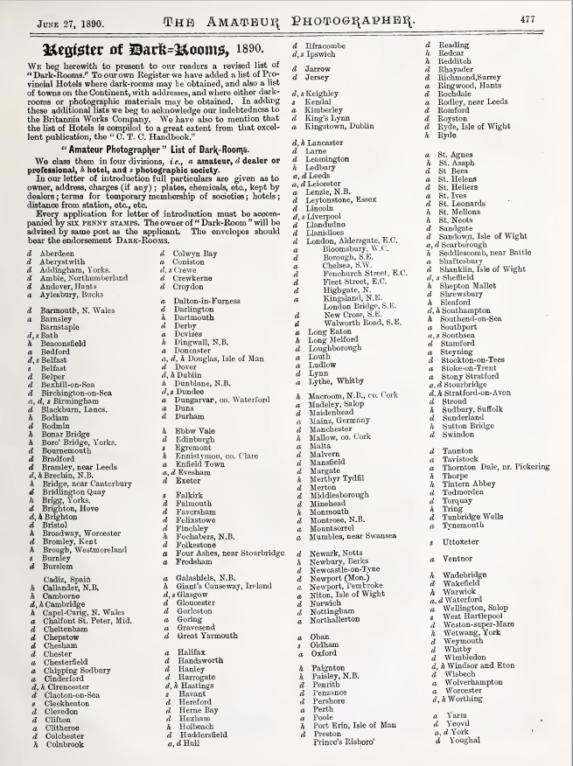
Fig. 1. List of darkrooms available to tourists arranged by the Amateur Photographer (27 June 1890), 477. © British Library Board. Shelfmark: LOU.LON 329. low resolution holding image
The AP also published a “List of Hotels in the United Kingdom placing a Dark-Room at the disposal of guests,” copied from the CTC’s handbook and totalling 207 establishments, and a “List of Dark-Rooms, etc., on the Continent”, totalling 73. This is a startling list: it includes darkrooms in Austria, Belgium, Egypt, France, Germany, Greece, Holland, Italy, Malta, Norway, Sweden, Portugal, Russia, Spain, Switzerland, and Turkey, offering a glimpse of the extent of photographic networks at this time. In September, the list included darkrooms in Australia and Japan too. The following year the editors announced that “[we] can give a private letter of introduction to subscribers practicing photography in practically every city of any size on the Continent and in our English colonies.” By 1893, the AP had developed an extended network in India too. Tourists could soon find darkrooms almost everywhere. As the AP noted in 1900, “Practically all hotels have dark-rooms now.” “Thousands of chemists and druggists throughout Britain” reported the British Journal of Photography in 1902, “have installed a dark-room, where the ubiquitous amateur can change or develope [sic] his plates.” This made listing darkrooms redundant (the last compiled by the AP included over 1,000 facilities): the infrastructure had faded into the background of amateurs’ travels.
Clearly, darkroom experiences in Britain, the Continent, or the colonies would have to be understood as part of very distinctive photography and travel practices influenced by particular social, cultural, and colonial relations (amongst others). Yet, the possibility of visiting a darkroom almost anywhere in the British world both revealed and reinforced the idea that amateur photographers were part of the same community, one that shared a set of “values … embodied and articulated through the actions and practices of photographers.” Because the darkroom played such an important role in their practices, it is perhaps unsurprising that it came to be seen as ‘the place to go’ not simply in order to process one’s plates, but also to meet with fellow photographers: embedded in this infrastructure was the vision of an interconnected and mutually supporting community that could enrich photographers’ experiences both home and abroad. Let us consider, for example, the following accounts: in 1883, reporting on an acquaintance’s visit to local darkrooms while touring Italy, the editor of PN commented that “he always found a ready disposition to oblige. Introducing himself in a few words was quite sufficient, and the circumstance of his being a foreigner added to the warmth of welcome.” Similarly, writing in 1890 about his own experience of using darkrooms on the Continent, Atkinsons noted: “I regret extremely that my very imperfect acquaintance with foreign languages has prevented me from obtaining much valuable information which I found our foreign confreres were always ready to impart.” Those travelling closer to home had similar experiences. In 1891, Jeffreys, back from an holiday in Llandudno (Wales) where he had used the darkroom of the local photographic society, commented that “the members with whom I came into contact were most courteous, and gave me many useful hints regarding the photographing of the neighbourhood.” Writing about their use of a darkroom in Bournemouth West (South West of England), another tourist explained that “what I found an almost greater benefit than the use of his dark-room was his ability and readiness to give me information with regard to interesting localities in the neighbourhood, and the best time for photographing the various ‘bits of scenery.” “Having just returned from a holiday tour in the Isle of Man,” another observed in 1892, “I venture to think that it will interest my fellow-workers to know that I found an excellent dark-room and a stock of every variety and mark of plates at Harrison’s photographic stores, Walpole Avenue, Douglas. The dark-room is on the shop floor, and they will find Mr. Harrison and his son, who is an excellent photographer, very willing to give them every kind of information.” To the owners of darkrooms themselves, these encounters could also mean more than business. As Baker noted, while “most of those who are on the dark-rooms register are … ready, willing, and glad to give every information, and frequently to act as guide,” what really interested them was not access to local information (which they already had), but the sharing of photographic knowledge: “How very useful it is for amateurs and others not only to try and get but give information, and it has several times proved useful to hear an amateur say - Have you seen this make of shutter? Or, How do you like this focus? For, however much or little any of us have done, we all feel how much we have to learn.”
These examples illustrate how, for growing numbers of touring photographers, the darkroom offered a familiar space when in an unfamiliar place. Paul Edwards observes that one of the properties of infrastructure is that they “function for us, both conceptually and practically, as environment, as social setting,” and that “belonging to a given culture means, in part, having fluency in its infrastructures.” Susan Leigh Star similarly writes that “participants [in an infrastructure] acquire a naturalized familiarity with its objects, as they become members.” Likewise, photographers’ ability to use the system of darkrooms relied on their ‘fluency’ and ‘familiarity’ with its workings; this, in turn, was shaped by photographers’ direct participation in the constitution itself of this system. First, as this section demonstrates, access to the network allowed tourists to visit a location through the recommendations of fellow photographers, and thus to “‘break’ … far from the ‘madding crowd’ of holiday-making cockneys” (a problem felt especially when in Britain). The function of this infrastructure was expanded by users themselves, who turned it into a tool to navigate new surroundings autonomously and, in doing so, to preserve an individualist cultural experience that protected them - or, at least, this was the promise - from becoming part of the ‘mass’ culture. Second, this space also empowered photographers by enabling them to exercise photographic autonomy at the processing level. As I explore in the following section, it was photographers themselves who effected darkroom work, both because in the absence of suitable facilities tourists routinely improvised makeshifts structures in order to change or develop plates, and because the darkroom required them to take direct action in order to fulfil its technical function.

In the darkroom: material culture and tacit knowledge
Before the widespread establishment of a darkroom infrastructure, and then also where local facilities were considered to be inadequate, many touring photographers relied on portable darkrooms. The advertising and review columns in the photographic press show the many different contraptions that were on offer. For example, “Claringbull's portable changing bag and developing tent,” which as the illustration that accompanied the review implies could be used anywhere and in broad daylight (Figure 2), was praised by PN in 1891 for responding to “what is wanted by the modern photographer. … a large-sized plate can be developed in this portable dark-room ... The tent is well ventilated, thoroughly light-tight, and provision is made for carrying off wastes during development.” “The Tourist’s Developing Tent” and “Baker’s Changing Tent,” reviewed by the AP in 1893 and shown as both in use and closed (Figure 3), were praised for making the tourist “absolutely independent of any dark-room,” which implies that they allowed tourists to compensate for the lack of local facilities. Similarly, Rouch’s dark tent (Figure 4) was advertised as late as 1898 as an “invaluable … Travelling Dark-room for Developing or Changing Plates.” As the objects that surrounded photographers’ operations in figures 3 and 4 indicate, processing plates while travelling also meant having to carry trays for developing, fixing, and washing, related chemicals, and a darkroom lamp. Fallowfield’s “Developing Set,” which “has been specially designed with the view of keeping one’s Developing Tackle altogether, and ready to be taken away at any moment,” exemplifies what ‘portability’ actually entailed (Figure 5).
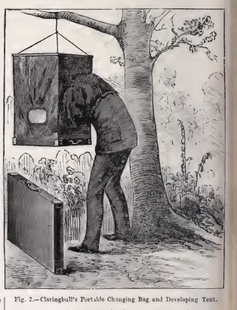
Fig. 2. Illustration of Claringbull's portable changing bag and developing tent, reviewed in PN (29 May 1891), 398. © British Library Board. Shelfmark: P.P.1912.d. low resolution holding image
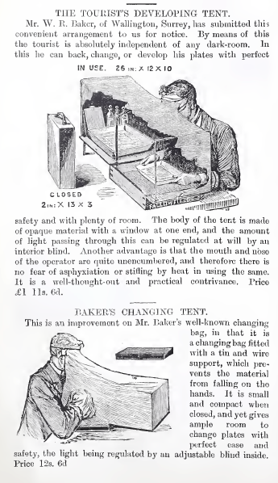
Fig. 3. Illustration of W.R. Baker’s “Tourist’s Developing Tent” and “Baker’s Changing Tent,” reviewed in AP (21 July 1893), 40. © British Library Board. Shelfmark: LOU.LON 296. low resolution holding image

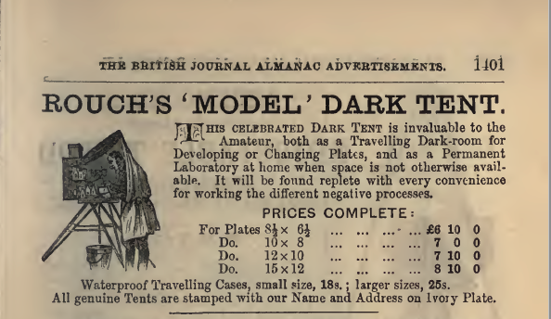
Fig. 4 Advertisement for Rouch’s “Dark Tent” in British Journal Photographic Almanac and Photographer’s Daily Companion (1898), 1401. © British Library Board. Shelfmark: P.P.2468.v. low resolution holding image
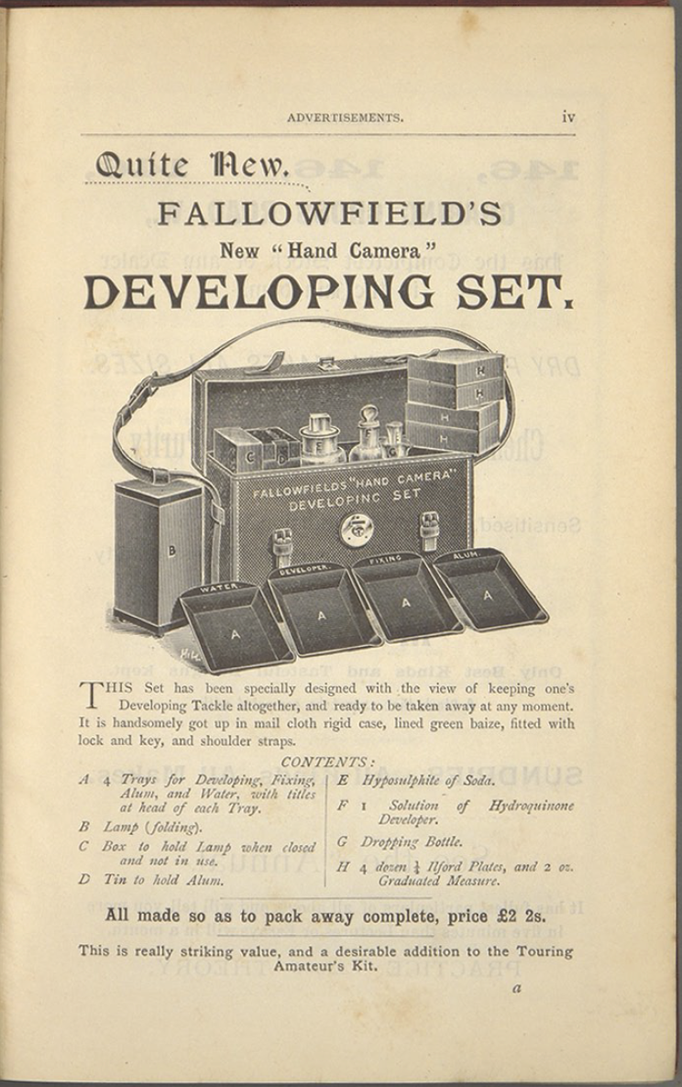
Fig. 5. Advertisement for Fallowfield’s “Developing Set” in Amateur Photographer Annual (1892), iv. © British Library Board. Shelfmark: P.P.2495.cac. low resolution holding image
Working under what would appear as challenging conditions, however, did not deter amateur photographers. To the contrary, their accounts suggest a pride in being able to set up a darkroom almost anywhere, even without the aid of one of the commercially available developing or changing tents. In 1883, writing about visiting the Engadin Valley (Switzerland), a photographer narrated how one night the only accommodation they could find was in the village of Pontresina, which “is naturally very cold in the winter time; hence walls are built very thick, and the windows are very small. This latter circumstance, however inconvenient to many people, favours the photographer immensely; and however much one might grumble at the cell-like nature of the apartment, it had one recommendation to the photographer - it was a capital dark-room.” Reviewing the “Carrier” tricycle, Ernest Shipton observed in 1887 that “nothing would be easier than to erect upon such a machine a dark tent, suitable not only for changing plates, but also for developing, and which should fold into the smallest space when not in use.” In a letter published in 1891, Mooney shared the “easily rigged-up contrivance” they had themselves devised, a canvas-stretcher covered with fabric which could be hooked to a “wall or the branch of a tree, if outside.” In 1892, speaking to the North London Photographic Society about “his own experiences with various dark-rooms, from the traditional cupboard under the stairs, to a distinct room in the house,” Edgar Clifton suggested “[a] mode of improvising a dark-room when travelling.” He explained: “Carrying a sheet of waterproof cloth among one’s luggage, with a portable lamp, a jug, and two pails, which could always be obtained in one’s temporary abode, any plates may be developed in comfort at an ordinary table in the evening.” While photographers could increasingly rely on local facilities for what concerned access to developing materials, their still relatively limited presence on the territory and the fact that some were considered to be inadequate meant that many continued to draw on their own ingenuity. As Cecil Hepworth asserted in 1897, “It is all very well to say that dark-rooms are to be found in every town of any importance, but one does not always want to keep to places of that description." On developing plates while in Spain in 1899, Elizabeth Main was reported explaining that “the good shutters with which almost every room is furnished make your hotel apartment a good dark room at night; but a piece of non-actinic fabric and a few drawing pins must be taken in order to cover up the little window over the door which helps to light the passage.” “The amateur of to-day,” sentenced the editor of Practical and Junior Photographer in 1903:

can almost put all he wants in his pockets. A dark-room lamp may be improvised out of a sheet of non-actinic paper bent in the form of a cylinder and placed over a candle. For trays plate boxes answer admirably, especially if a piece of grease proof paper is carefully folded at the corners and placed in them as a loose waterproof lining. For fixing borrow a pie-dish. Developers and fixers in the cartridge or tablet form are sold by every dealer. Even a celluloid measuring-glass is not absolutely necessary, for a practiced hand can guess pretty well how much water is needed.

These examples illuminate the extent of this practice at a time and in a context generally discussed as dominated by the advent of compact cameras, an undercurrent so ordinary that has largely escaped historical scrutiny. “An infrastructural approach to media,” Frith explains, “involves researching the hardware and software that make media possible … it involves studying the mundane and making the invisible visible.” Doing so allows us to recognise, as in this case, photographers’ direct actions as the ‘software’ that created what Mattern describes as “pockets of informal or shadow infrastructural development - practices of jury-rigging, pirating, bricolaging, and kludging.” The critical role of these seemingly banal acts in “generating systems, environments, and objects and cultivating subjects and communities that embody the values we want to define our society” highlights an important element for reflecting on photographers’ constitutive participation in this infrastructure as productive of new ways of thinking about photography and travel: the radical potential of that “practiced hand” introduced above by the editor of Practical and Junior Photographer.
As Richard Sennett writes, “the craft of making physical things provides insight into the technique that can shape our dealings with others. Both the difficulties and the possibilities of making things well apply to making human relationships.” The approach adopted by many amateur photographers, whom as seen used materials taken from their immediate environment, brings them closer to Claude Lévi-Strauss’ “bricoleur,” “someone who works with his hands and uses devious means compared to those of a craftsman.” Like the latter, however, the bricoleur “‘speaks’ not only with things … but also through the medium of things: giving an account of his personality and life by the choices he makes between the limited possibilities,” in other words, they create new meanings out of a diverse range of available things. In this sense, the skill of improvisation and complex gestures that the photographer was expected to master - their “practiced hand” - were not simply a modality (i.e. means of developing or printing) but, most importantly, a way to engage with one’s world.
Central to this process was the acquisition of a form of knowledge that pertained to darkroom work only, one gained through bodily practice. Let us consider, for example, the instructions about development given in 1892 by John Hodges:

We commence by mixing our developer … stirring the mixture well with a clean glass rod. … The plate which we first exposed should then be removed from the dark slide, and, after its surface has been lightly brushed with the broad camel-hair brush, laid, with its sensitive surface upwards, in the ebonite tray which we have prepared for developing negatives. … The developer is now poured, with a gentle sweep, over the plate, in such a manner as to cover its entire surface with one flow of the solution; the operation requires a little knack to perform it successfully, but it is easily acquired. … It is better not to allow the solution to remain stationary, but to rock the dish with a slight oscillating motion, which will cause the developer to flow in even waves to and from over the plate, and will ensure uniform development and an immunity from stains. … [A]fter giving it a slight rinse under the tap, to avoid the formation of stains, we proceed to examine it more closely by holding it up to the orange light of the non-actinic screen, not, however, for too long, for under exposure, even now, might cause a slight veiling or fog. … The negative may now be removed from the alum bath, and after another thorough wash under the tap, should be placed in the fixing bath. … The plate should then be most thoroughly washed to remove all traces of the fixing solution, for if any traces of hypo be left in the film, it will in time cause the negative to become discoloured … Although in the course of the foregoing operations it will be impossible to avoid handling the negative to some extent, the tyro should understand the right way in which to do it. The plate whilst wet must never be held between the thumb and fingers, as an indelible impression of them in the gelatinous film would result, which would, of course, be duly recorded in each print made from that negative. When it becomes necessary to examine the plate during development, it should be raised from the bottom of the dish by cautiously slipping the nail of the forefinger underneath it, when, its edges being held between the forefinger and thumb of the other hand, it may be readily lifted from the solution.

Because he was addressing beginners, Hodges felt he had to spell out something that experienced photographers did instinctively; in other words, he sought to disclose tacit knowledge by “bringing to the surface of consciousness that knowledge which has become so self-evident and habitual that it seems just natural.” His attention to the role of unquantifiable bodily gestures in explaining “the right way in which to do it” is striking: “stirring the mixture well,” “lightly brushed,” “gentle sweep,” “[an] operation [that] requires a little knack to perform it successfully,” “rock the dish,” “holding it up … [but] not for too long,” “cautiously slipping the nail of the forefinger underneath it.” As many others noted, working in a darkroom required the acquisition of a bodily knowledge that came with practice, a far more complex skill than that required for exposing a negative. Child Bailey, for instance, explained to beginners that “[a]fter a few trials it becomes much easier to perform the various operations in the dark-room than was the case at first, and a little preliminary practice will be found of the greatest service.” “In every stage of photographic work,” Fortuné Nott likewise commented, “skill, knowledge, care, and patience are absolutely essential - in the developing-room, perhaps more than anywhere else.” Or, as Richard Penluke remarked, “no absolute rule can be given, experience alone will teach.” Mastery of bodily knowledge applied to the changing of plates also, which was normally described as something that photographers did “by feel,” or “by the sense of touch … a knack easily acquired.”
As seen in the previous section, benefiting from an infrastructure means “having fluency” or a “naturalized familiarity” with its workings, an assessment that closely mirrors Gitelman’s definition of media, outlined in the introduction, as structures of communication that rely on participants sharing the same understanding of forms and protocols. In the context of darkroom work, amateur photographers’ signification of this space as the expression of a shared set of values relied on the acquisition, as the examples reviewed in this section illustrate, of a set of bodily practices. This had two, related, effects. First, mastering these gestures allowed photographers to feel part of a community of practice. While the network created new links amongst photographers, one’s ability to set up a darkroom and the particular requirements of processing negatives oneself empowered photographers by enabling direct and full participation in this part of photographic production, which was not the case when using developing and printing services. We can say that the infrastructure enabled cooperation without compromising autonomy; these were social practices that defined photographers’ collective identity. Second, it was a transformative practice. Knowledge, Lissa Roberts explains, “needs a physical carrier, whether a human, a book, an illustration, a machine or an instrument. … Not only does it afford knowledge mobility, it also has a formative or transformative impact on that which it embodies.” One reason for this is that, once tacit knowledge is engrained, “going over an action again and again … enables self-criticism”; people, Sennett posits, “can be enriched by the skills” that they acquire especially if these skills are complex. In this sense, while travelling through the network allowed photographers to share photographic knowledge, direct participation in photographic production that darkroom work enabled provided a powerful tool through which tourists could engage with their world. Their understanding of both photography and travel was thus filtered through a hands-on approach that, by affording a sense of control over their experiences, foregrounded the value of autonomous participation in both practices.
Mattern has noted that the moment people “serv[e] as infrastructures themselves” this “create[s] another role for individual and collective human agency: that of the engaged, critical consumer and, perhaps more important, citizen.” Thinking about photographers’ actions in these terms frames the significance of their choice for what might seem like a counter-intuitive photographic practice when travelling as a response to the conditions they lived in. This gives us new insights on their understanding of their world: within an increasingly standardised and uniformed leisure culture, the determination with which these photographers pursued darkroom work should be understood as a mundane form of subversiveness that implicitly critiqued the dominant models of photography and travel practices promoted within the emerging mass consumer culture. This means that their practices not only created group cohesion, as Durkheim has influentially argued, but, most importantly, allowed photographers to take into their own hands (literally and metaphorically), and thus to express, how they sought to live their (leisure) lives.

Conclusion
The market narrative of liberation and progress that presented compact cameras as freeing photographers from the restrictions that had defined earlier iterations of the medium - an ethos encapsulated in George Eastman’s well-known “You press the button, we do the rest” slogan - has largely been understood as the expression, or recognition, of people’s desire for unfettered movement. Huhtamo, for example, observes that a “manifestation of a desire for mobile media was the outburst of amateur photography in the late nineteenth century. Indeed, the easy-to-use box cameras loaded with celluloid roll film could well be described as the first true mobile medium.” While it is certainly the case that photographic mobility was a shared intent for the leisure classes, not everyone felt this should come at the price of photographic autonomy. This article has demonstrated that the market-led proposition that enjoying one’s holidays and spending time processing one’s photographs were two incompatible activities was, for some, simply untrue. Although this view came to dominate public perception - the likely result of the rampant role of capital in modern society and its commodification of increasing aspects of our lives - the analysis of tourists’ engagement with the darkroom infrastructure at the end of the Victorian age has revealed that some photographers sought to resist this force. This was a desire for autonomy that, as with other pockets of photographic practice at this time, was fuelled by the middle-class’ resoluteness to conform with the project of modernity while simultaneously asserting themselves as independent subjects. Reflecting on how they did that allows us to reassess the genealogy of tourist photography and, more broadly, the significance of photography in people’s lives. As seen, the need to attend to one’s plates while travelling created opportunities to pursue an experience of photography and travel that these amateurs felt a degree of control over: if this system constrained them, it also created new opportunities through which they could express themselves. Importantly, it was the high levels of technical skill that darkroom practices required, and which the industrialisation of photographic processes was depriving them of, that engendered that sense of achievement that many photographers genuinely seemed to treasure. This illustrates how amateur photographers transformed their world through mundane interventions in seemingly banal aspects of their life, which is crucial because it exemplifies the radical possibilities of everydayness: it reassesses the transformative and potentially subversive possibilities nesting in commonplace and often improvised (photographic) actions.
This assessment also casts new light on the darkroom itself, a space that has been largely untheorised. Specifically, it draws attention to the performative aspect of darkroom work - the tacit knowledge of embedded rituals - and the central role played by the coordination of tactile and sensory bodily gestures. Photographers’ accounts indicate that being able to internalise these movements brought one a sense of confidence and self-empowerment, a practice that made one feel at home in the places they visited. This engenders a shift in focus from the role of vision to the sense of touch in our perception of photographers’ experience. Studies of how photography as a practice of representation has influenced perceptions of the world are plentiful, but I posit that attention should also be paid to how the technical skills that darkroom work demanded of the photographers’ body impacted on one’s own sense of self and of one’s environment, and on how this contributed to the emergence of a bodily consciousness and its medical and societal understanding. “Who we are,” Sennett muses, “arises directly from what our bodies can do.” It is certainly the case, as this article shows, that by foregrounding the body as a medium the darkroom affected photographers as social agents, thus creating the conditions for the production of more than photographs.

References
[Advertisement]. Amateur Photographer Annual (1892): iv.
[Advertisement]. AP (21 July 1893): viii.
[Advertisement]. British Journal Photographic Almanac and Photographer’s Daily Companion (1898): 1401.
AP (1 May 1891): 309-310.
AP (11 April 1890): 250.
AP (18 August 1893): 106.
AP (21 July 1893): 40.
AP (26 November 1886): 254.
AP (28 March 1890): 211.
AP (3 January 1890): 1.
AP (4 September 1891): 157.
AP (5 September 1890): 164-165.
Atkinson, J.T. “Letters to the Editor.” AP (30 May 1890): 390-391.
Baillie, J. “Homemade Gadgets and Makeshift Darkrooms: Skilled Amateur Photography in 1930s Britain.” In Recording Leisure Lives: Everyday Leisure in 20th Century Britain, edited by S. Robert, H. Pussard and M. Constantine, 149–164. Leisure Studies Association, 2012.
Baker, T. “How to Make Photographic Rambles Remunerative.” AP (4 July 1890): 6-7.
Bann, S. “Against Photographic Exceptionalism.” In Photography and Its Origins, edited by T. Sheehan and A.M. Zervigón, 94-103. London: Routledge, 2015.
Barton Road, “Letters to the Editor.” AP (30 September 1892): 224.
Bateson, J.W. “Letters to the Editor.” AP (22 October 1886): 197.
Berman, M. All that is Solid Melts into Air: The Experience of Modernity. London: Verso, 1983.
Buzard, J. The Beaten Track: European Tourism, Literature, and the Ways to Culture 1800–1918. Oxford: Clarendon, 1993.
Child Bayley, R. “Dry Plate Making at Home.” AP (12 May 1893): 318.
“Cycle & Camera.” Amateur Photographer and Photographic News (29 June 1909): 621.
“Dark-Rooms.” Amateur Photographer (AP) (29 June 1888): 407.
“Developing on Tour.” Practical and Junior Photographer (April 1903), 263.
Di Bello, P. Women's Albums and Photography in Victorian England: Ladies, Mothers and Flirts. Aldershot, Burlington, VT: Ashgate, 2007.
Dominici, S. Travel Marketing and Popular Photography in Britain, 1888–1939: Reading the Travel Image. New York: Routledge, 2018.
Dominici, S. “‘Cyclo-Photographers’, Visual Modernity, and the Development of Camera Technologies, 1880s–1890s.” History of Photography 42, no. 1 (2018): 46-60.
Dominici, S. “The Postal Service, Circulating Portfolios, and the Cultural Production of Modern Networked Identities.” History of Photography, forthcoming.
Dominici, S. “New Mobile Experiences of Vision and Modern Subjectivities in Late Victorian Britain.” Science Museum Group Journal 12, (Autumn, 2019). http://journal.sciencemuseum.ac.uk/browse/issue-12/new-mobile-experiences-of-vision/
Durkheim, É. The Elementary Forms of the Religious Life. New York: Free Press, 1995(1915).
Edwards, E. “Out and About: Photography, Topography and Historical Imagination.” In Double Exposure: Memory and Photography, edited by O. Shevchenko, 177-210. New Brunswick: Transaction Publishers, 2014.
Edwards, E. “The Amateur Excursion and the Sociable Production of Photographic Knowledge.” In Either/And, edited by A. Pollen and J. Baillie. National Media Museum, (2013). Accessed July 20, 2020. http://eitherand.org/reconsidering-amateur-photography/amateur-excursion-and-sociable-production-photogra/
Edwards, P.N. “Infrastructure and Modernity: Force, Time, and Social Organization in the History of Sociotechnical Systems.” In Modernity and Technology, edited T.J. Misa, P. Brey and A. Feenberg, 185-225. Cambridge, MA: MIT Press, 2002.
F.R.C.S. “Hand-Cameras.” AP (18 April 1890): 273-274.
Fortuné Nott, J. “Development.” AP (6 March 1891): 168-169.
Frith, J. (2020) “Building a more Infrastructural Media Studies.” MAST. The Journal of Media Art Study and Theory 1, no. 1 (April, 2020): 23-26
Geimer, P. Inadverted Images: A History of Photographic Apparitions. Chicago: University of Chicago Press, 2018.
Gibson, T.B. “Touring with the Camera.” Practical and Junior Photographer (April 1903): 260.
Gitelman, L. Always Already New: Media, History, and the Data of Culture. London: MIT Press, 2006.
Gunn, S. The Public Culture of the Victorian Middle Class: Ritual and Authority and the English Industrial City 1840-1914. New York: Manchester University Press, 2000.
Harris, J. Private Lives, Public Spirit: A Social History of Britain, 1870–1914. Oxford: Oxford University Press, 1993.
Hepworth, C. “The Idler’s Notes.” AP (23 April 1897): 334.
Herring, R.D. “Correspondence.” PN (3 July 1885): 429.
Hodges, J. “Elementary Photography.” AP (18 March 1892): 229-230.
Huhtamo, E. “Pockets of Plenty: An Archaeology of Mobile Media.” In Mobile Audience: Media Art and Mobile Technologies, edited by M. Rieser, 23-38. Amsterdam: Rodopi, 2011.
Jay, B. Cyanide & Spirits: An Inside-Out View of Early Photography, Munich: Nazraeli, 1991.
Jeffreys, A. “Letters to the Editor.” AP (21 October 1892): 282.
Jenkins, R.V. “Technology and the Market: George Eastman and the Origins of Mass Amateur Photography.” Technology and Culture 16, no. 1 (1975): 1-19.
Leat, H.C. “The Camera on the Cycle.” AP (10 August 1906): 632.
Leonardi, N. and S. Natale, eds. Photography and Other Media in the Nineteenth Century. State College, PA: Penn State University Press, 2018.
Lévi-Strauss, C. The Savage Mind. Chicago: University of Chicago Press, 1996.
“List of Dark Rooms in India.” AP (9 June 1893): 382.
Mattern, S. “Deep Time of Media Infrastructure.” In Signal Traffic: Critical Studies of Media Infrastructures, edited by L. Parks and N. Starosielski, 94-111. Urbana-Champaign: University of Illinois Press, 2015.
Mattern, S. “Scaffolding, Hard and Soft: Media Infrastructures as Critical and Generative Structures.” In The Routledge Companion to Media Studies and Digital Humanities, edited by J. Sayers, 318-326. London: Routledge, 2016.
McKay, G. DIY Culture: Party & Protest in Nineties Britain. London and New York: Verso, 1998.
Mooney, L. “Letters to the Editor.” AP (18 September 1891): 192-193.
Osborne, P. Travelling Light: Photography, Travel and Visual Culture. Manchester: Manchester University Press, 2000.
Penluke, R. “Lantern Slides by Contact.” Junior Photographer (10 November 1894): 86-87.
“Pharmacists and Photography.” British Journal of Photography (11 July 1902): 44.
PN (15 June 1883): 376.
PN (29 May 1891): 398.
Pritchard, M. “Who Were the Amateur Photographers?” In Either/And, edited by A. Pollen and J. Baillie. National Media Museum, (2013). Accessed October 27, 2020. http://eitherand.org/reconsidering-amateur-photography/who-were-amateur-photographers/
Quick, J., ed. Analog Culture: Printer's Proofs from the Schneider/Erdman Photography Lab, 1981-2001. New Haven: Yale University Press, 2018.
“Register of Dark-Rooms, 1890.” AP (27 June 1890): 477-479.
“Register of Dark-Rooms, 1890.’ AP (12 September 1890): 193.
Roberts, L. "The Circulation of Knowledge in Early Modern Europe: Embodiment, Mobility, Learning and Knowing." In History of Technology: Volume 31, edited by Ian Inkster, 47–68. London: Bloomsbury Academic, 2012.
Ryan, J. Picturing Empire: Photography and the Visualization of the British Empire. London: Reaktion, 1997.
Sennett, R. The Craftsman. New Haven: Yale University Press, 2008.
Shipton, E. “The Wheel and the Camera.” AP (11 March 1887): 118–121.
Simone, A. “Infrastructure: Commentary by AbdouMaliq Simone.” Cultural Anthropology Online (2015). Accessed July 9, 2020. https://journal.culanth.org/index.php/ca/infrastructure-abdoumaliq-simone
“Societies’ Meetings.” AP (22 January 1892): 70.
Star, S.L. “The Ethnography of Infrastructure.” American Behavioral Scientist 43, no. 3 (1999): 377–391.
“Suggestion for Continental Tourists.” AP (29 June 1900): 516.
“The Tourist Photographer.” Photographic News (PN) (24 August 1883): 532-533.
“Tourist and Half-Holiday Notes.” AP (6 October 1899): 264.
Tucker, J. Nature Exposed: Photography as Eyewitness in Victorian Science. Baltimore: John Hopkins University Press, 2006.
“Two Novelties.” PN (29 May 1891): 398-399.
Wilkinson, W.T. “Correspondence.” PN (29 May 1885): 350.

ENDNOTES

– Edwards, “Out and About.”
– Jenkins, “Technology and the Market.”
– Osborne, Travelling Light.
– This cause was embodied in the aesthetic of pictorialism, which argued that photographs could be artistic and not merely mechanical objects.
– For a discussion of the role of culture in middle-class life, see Gunn, The Public Culture of the Victorian Middle Class. For a discussion of amateur photographers, see Pritchard, “Who Were the Amateur Photographers?”
– Exceptions include Baillie, “Homemade Gadgets and Makeshift Darkrooms;” Jay, Cyanide & Spirits; Tucker, Nature Exposed.
– See for example Geimer, Inadverted Images; Quick, Analog Culture.
– Gitelman, Always Already New, 7.
– Ibid.
– Bann, “Against Photographic Exceptionalism;” Leonardi and Natale, eds. Photography and Other Media.
– Mattern, Shannon. “Scaffolding,” 320-321.
– Frith, “Building a more Infrastructural Media Studies,” 25. See also Simone, “Infrastructure.”
– Sennett, The Craftsman.
– Dominici, “The Postal Service.”
– Dominici, “New Mobile Experiences.”
– Edwards, “Out and About.”
– Dominici, Travel Marketing and Popular Photography, 59.
– Edwards, “The Amateur Excursion.”
– Dominici, “The Postal Service.”
– Star, “The Ethnography of Infrastructure,” 380.
– Edwards, “Infrastructure and Modernity,” 185.
– Mattern, “Scaffolding” 321.
–Wilkinson, “Correspondence,” 350.
– Herring, “Correspondence,” 429.
– Bateson, “Letters to the Editor,” 197.
– Ibid.
– These letters, too many to be listed here, appeared weekly until December 1886. In November, the editor summarised the main contributions: AP (26 November 1886), 254.
– Founded as the Bicycle Touring Club, it was re-titled Cyclists’ Touring Club in 1883 and Cycling UK in 2016. University of Warwick (MRC/UW), MSS.328/C/3/4/1.
– Dominici, “New Mobile Experiences.”
– C.T.C. British and Irish Handbook & Guide (1887), 6. MRC/UW, MSS.328/C/4/HAN/3.
– “Dark-Rooms,” 407.
– AP (28 March 1890), 211.
– AP (11 April 1890), 250.
– AP (3 January 1890), 1.
– AP (5 September 1890), 164-165.
– “Register of Dark-Rooms, 1890,” (June), 477.
– “Dark-Rooms,” 407.
– “Register of Dark-Rooms, 1890,” (June), 478.
– Ibid., 478-479.
– “Register of Dark-Rooms, 1890,” (September), 193.
– AP (1 May 1891), 309-310.
– “List of Dark Rooms in India,” 382.
– “Suggestion for Continental Tourists,” 516.
– “Pharmacists and Photography,” 44.
– [Advertisement]. AP (21 July 1893), viii.
– See, for example, Harris, Private Lives, Public Spirit; Ryan, “Picturing Empire.”
– Edwards, “The Amateur Excursion,” n.p.
– PN (15 June 1883), 376.
– Atkinson, “Letters to the Editor,” 390.
– Jeffreys, “Letters to the Editor,” 282.
– AP (4 September 1891), 157.
– Barton Road, “Letters to the Editor,” 224.
– Baker, “How to Make Photographic Rambles Remunerative,” 6-7.
– Paul Edwards, “Infrastructure and Modernity,” 186.
– Ibid., 189.
– Star, “The Ethnography of Infrastructure,” 381.
– AP (18 August 1893), 106.
– For a discussion of the debate between ‘vulgar’ tourists and (self-appointed) sensitive travellers, see Buzard, The Beaten Track.
– “Two Novelties,” 398.
– Ibid., 398-399.
– [Advertisement]. British Journal Photographic Almanac and Photographer’s Daily Companion, 1401.
– Advertisements, Amateur Photographer Annual, iv. Fallowfield produced portable developing tents as well, see F.R.C.S., “Hand-Cameras,” 273-274.
– “The Tourist Photographer,” 532-533.
– Shipton, “The Wheel and the Camera,” 119.
– Mooney, “Letters to the Editor,” 192-193.
– “Societies’ Meetings,” 70.
– Ibid.
– See for example Gibson, “Touring with the Camera,” 260.
– Hepworth, “The Idler’s Notes,” 334.
– “Tourist and Half-Holiday Notes,” 264.
– “Developing on Tour,” 263.
– Frith, “Building a more Infrastructural Media Studies,” 25.
– Mattern, “Scaffolding,” 321.
– Ibid., 323.
- Sennett, The Craftsman, 289.
– Lévi-Strauss, The Savage Mind, 16-17.
– Ibid., 21. Original emphasis.
– Hodges, “Elementary Photography,” 229-230.
– Sennett, The Craftsman, 183.
– Child Bayley, “Dry Plate Making at Home,” 318.
– Fortuné Nott, “Development,” 169.
– Penluke, “Lantern Slides by Contact,” 86-87.
– Leat, “The Camera on the Cycle,” 632.
– “Cycle & Camera,” 621.
– Roberts, “The Circulation of Knowledge," 52.
– Sennett, The Craftsman, 37-38, 289.
– Mattern, “Deep Time of Media Infrastructure,” 106.
– Mattern, “Scaffolding,” 321.
– Durkheim, Elementary Forms of the Religious Life.
– Huhtamo, “Pockets of Plenty,” 27.
– Elsewhere, I have explored this thesis in relation to photographers’ engagement with cycling and with the parcel post. Dominici, “‘Cyclo-Photographers’” and “The Postal Service.”
– Berman, All That is Solid.
– The transformative potential of everyday practices is often discussed in relation to the do-it-yourself (DIY) cultural forms that developed in Britain after the Second World War; precursors have been identified in women’s cultural practices too. See, for example, McKay, DIY Culture; Di Bello, Women's Albums and Photography.
– Sennett, The Craftsman, 290.

