**From Weissenhof to IBA’27: international building exhibitions as (world) stages for innovation** *[feature] [article title] [possible pull quotes in* **red bold***]*

Although relatively unknown outside the German speaking world, some international building exhibitions (IBA) have profoundly influenced international design styles and city and regional scale regeneration. Given the need to ‘push the boundaries of both conventional thinking and action’ to adapt to climate change and move quickly towards a circular economy and the creation of circular places, what role might the forthcoming IBA'27 StadtRegion Stuttgart play in changing the way we create and use buildings and places? **Johannes Novy** explains. *[article intro]*

[

**In 2027, visitors to Stuttgart and its surroundings will step into a fascinating experiment of urban reinvention**. Throughout the region, they will encounter dozens of projects, some large, some small. Several will introduce innovative urban housing models or building typologies that combine industry with other uses. Others will breathe new life into aging monofunctional housing estates from the 1960s and 1970s, or pioneer novel solutions to re-energise struggling town centres and redevelop and densify locations around transport nodes. Many will showcase cutting-edge construction methods minimising environmental impacts and several will feature urban designs aimed at reimagining the region’s identity and forging new connections between its built-up environment and remaining open spaces.

Of these projects, some will be completed, while others will still be in various stages of construction, reflecting the multiple recent and current crises impacting the property and construction sectors. All, however, will be energised by the IBA'27 StadtRegion Stuttgart,1 an international building exhibition (IBA, from the German *internationale bauausstellung*) that celebrates the centenary of the famous *Weißenhofsiedlung* (Weissenhof estate),2 a housing estate built for the *Deutscher Werkbund* (the German Association of Craftsmen) exhibition *Die Wohnung* (the dwelling) held in Stuttgart in 1927.

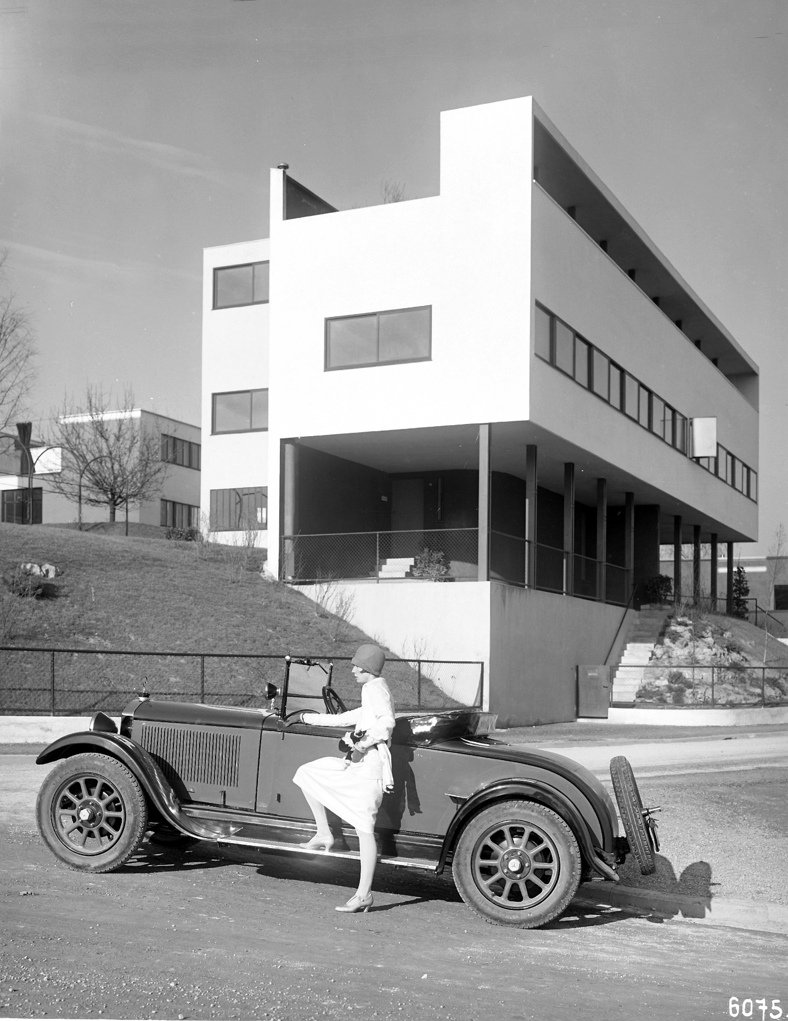**The Weissenhof Estate, 1927** *[credit: Daimler]*

**Legacy**

Often celebrated as one of the first international building exhibitions (though it was never officially called that), the 1927 exhibition was not only a pivotal event for Stuttgart, putting the city on the map of global architecture. It was also a pivotal event for architecture itself,3 bringing together some of the most prominent avantgarde architects at the time to showcase their visions for affordable, efficient, high-quality housing and playing an instrumental role in popularising what would later be termed the ‘international style’. Of the original 21 buildings that made up the Weissenhof Estate, 11 still exist, including two buildings by Le Corbusier that have been declared world heritage sites by The United Nations Educational, Scientific and Cultural Organization (UNESCO).4

As part of the IBA, work is currently underway on a new visitor centre5 to be built at the entrance of Weissenhof, marking the first substantial change to the listed ensemble in decades and forming a spatial connection between the new IBA and its historical inspiration.

Spearheaded by the city and region of Stuttgart, the main ambition of the IBA'27 is to echo the 1927 event. That means not to merely theorise but to bring to life practical solutions to pressing built environment challenges through the realisation of tangible model projects, ranging from state-of-the-art buildings to entire neighbourhoods. It differs, however, in the way it goes about this. Overseen by Mies van der Rohe, widely regarded a pioneer of modernist architecture, the 1927 event involved a select number of handpicked architects including JJP Oud, Walter Gropius, Bruno and Max Taut, Le Corbusier and van der Rohe himself, showcasing their visions for the future of architecture on a single site.

The IBA'27 meanwhile has adopted a decentralised and collaborative approach. It covers the entire metropolitan area and actively involves residents and stakeholders in a collective effort to ‘reinvent the urban region’6 and develop practical and transferable solutions to a broad array of urban challenges.

**History**

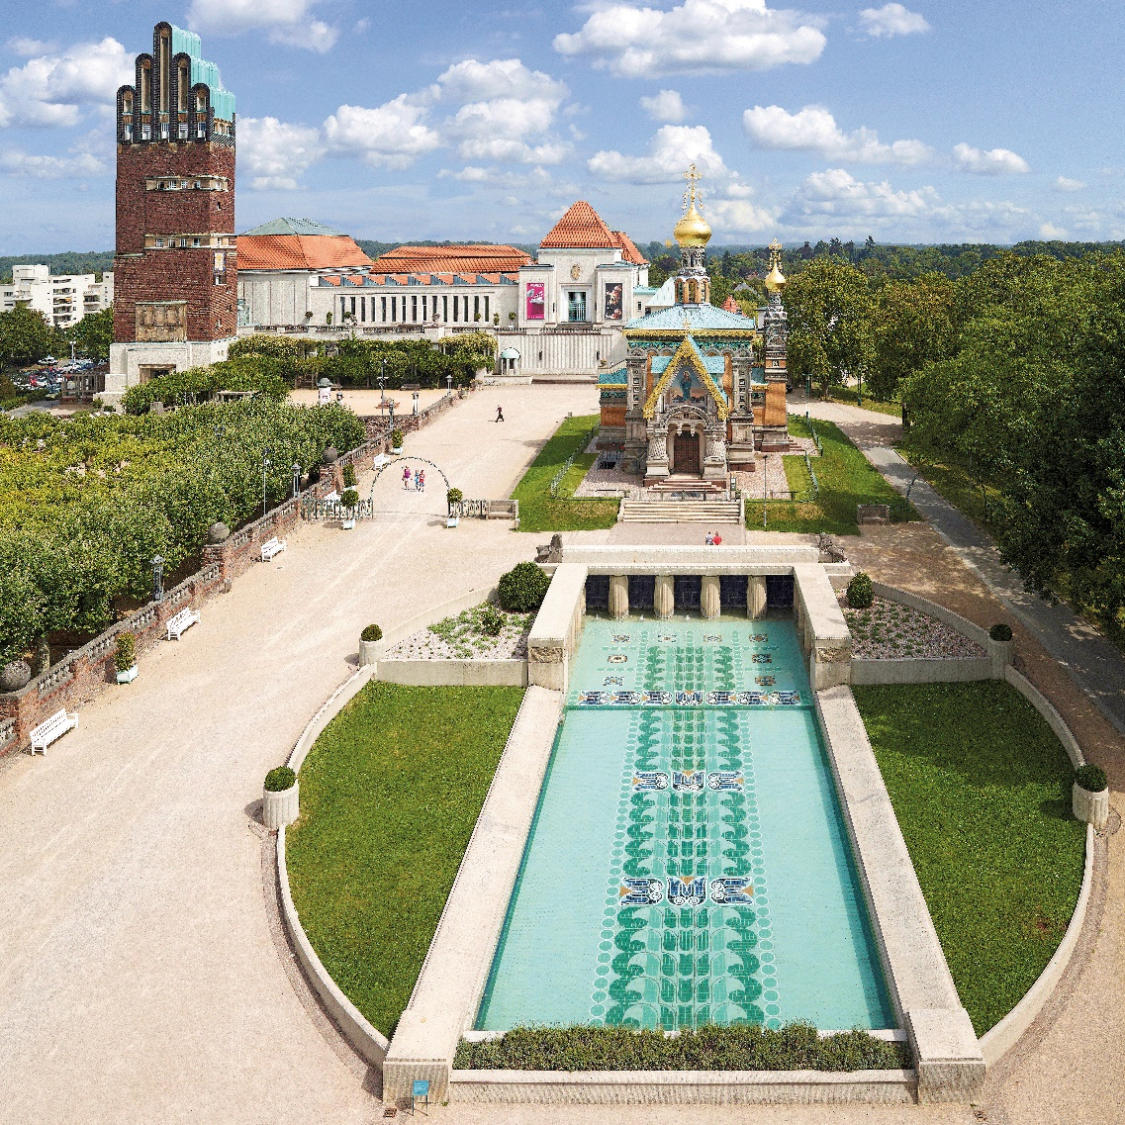It is peculiar that the IBA format - despite its international ambitions and the participation of renowned architects in many of the exhibitions that have taken place over the years - remains relatively unknown outside the German-speaking world. Originating in the early 20th century with the pioneering Art Nouveau project Mathildenhöhe7 in Darmstadt from 1901 often regarded as its first, IBAs stand out as an internationally unique planning and development tool.8 Unlike policy tools such as the World Expo or the European Union’s competition for a European Capital of Culture, there is no awarding body overseeing them and there are few if any formal rules organising cities or regions need to adhere to. In fact, it was only in 2009 following the establishment of an ‘IBA Expert Council’ by the German government that a set of guidelines was adopted in the form of a memorandum.9

**Mathildenhöhe, Darmstadt** *[credit: BY ND © Nikolaus Heiss]*

While IBAs have predominantly taken place in Germany, recent iterations have expanded into Switzerland (IBA Basel, 2010-2020), the Netherlands (IBA Parkstadt, 2013-2021), and Austria (IBA Wien, 2016-2022), with each exhibition adopting a different form and thematic focus, reflecting the diverse ambitions, circumstances and challenges of the cities or regions that organised them. What all IBAs have in common is that they are time-bound events. Historically, as in the case of the Weissenhof, they concentrated around a single ‘exhibition’ year. More recent versions meanwhile typically span seven to ten years,10 with the final year serving as a climax and to showcase what has been achieved. To this day, physical architectural projects are what set IBAs apart from other formats, but this is not to say that their focus rests solely upon their delivery.

Reflecting a more general trend in architecture, urban planning, and related fields, IBAs in recent decades have become increasingly process-orientated. **The focus is no longer solely upon what gets build. It now extends to pioneering, testing, and showcasing innovative planning tools and methods** and on effecting enduring changes in local planning practices by creating a temporary ‘state of the extraordinary (or ‘emergency’) pushing the boundaries of both conventional thinking and action’ 10 and inspiring stakeholders and civil society to come together, reflect, learn and find common ground.

As a result, the years leading up to the final exhibition year have become increasingly important, a fact that is particularly evident in Stuttgart. Even before its official launch in 2017, the IBA had already engaged extensively with stakeholders and the wider public to forge its foundational memorandum of understanding11 and the years since have been marked by countless public events and collaborative formats, reflecting the IBA's ambition to offer ‘open, dialogue-oriented format for everyone’.12

**Knowledge exchange**

In addition to the IBA’27, other exhibitions such as the recently completed IBA Heidelberg13 operate under the principle that effecting change requires bringing people along; that innovation thrives on collaboration, and that changing established planning practices and cultures necessitates changing how individuals engage with their environment and one another. At the same time, today's collaborative approach is also driven by financial realities. **Unlike earlier IBAs, which often had substantial budgets, modern exhibitions typically rely upon external partners to realise projects**. In Stuttgart, for instance, the IBA delivers not a single project on its own. Rather, it called upon property developers, municipalities, community organisations and other stakeholders to propose projects after identifying its key objectives and priorities and developing a list of criteria. Once these projects are accepted, they receive support 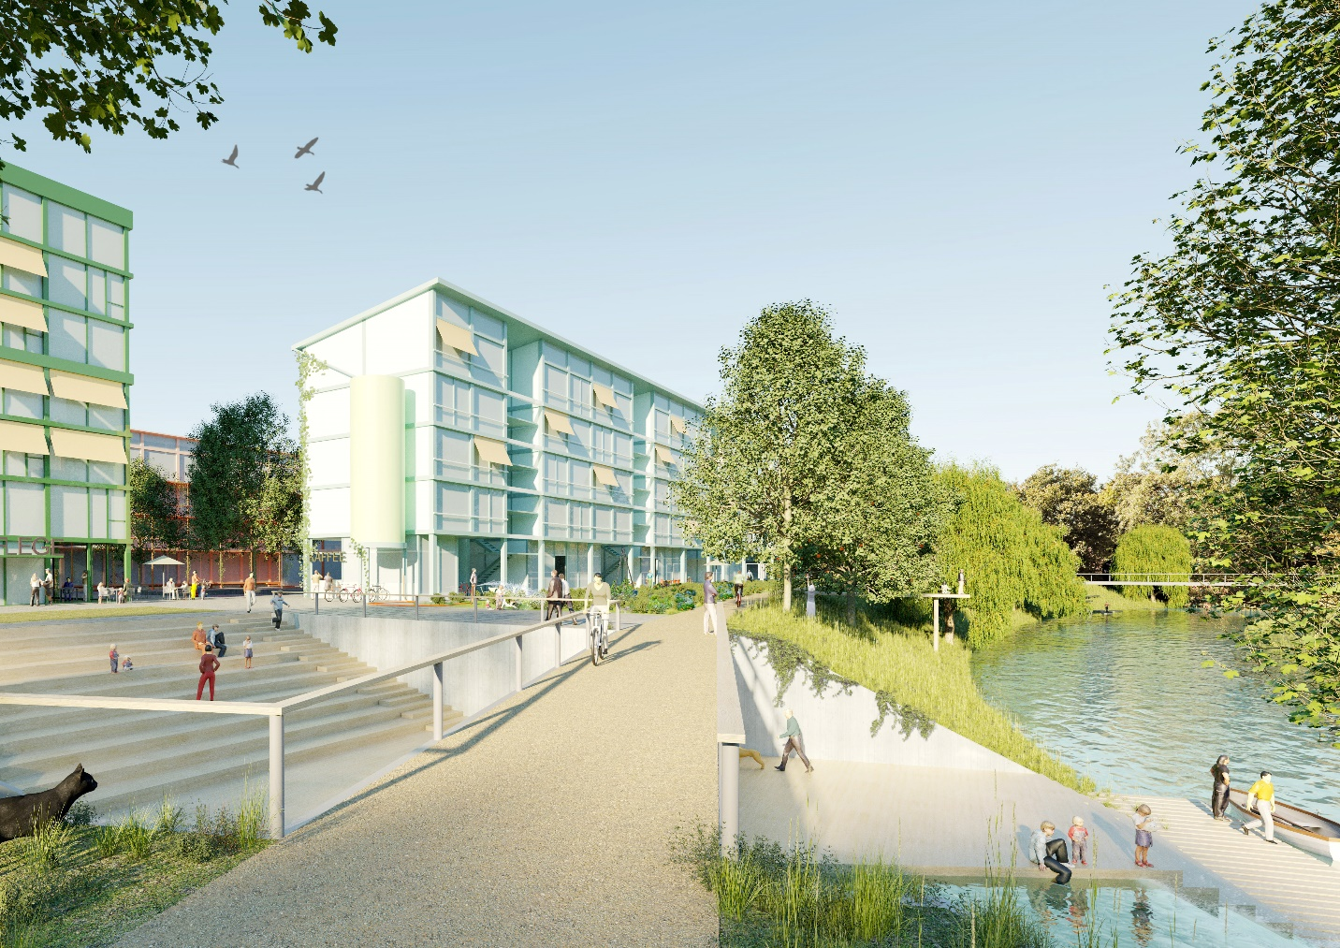through guidance and know-how, but without any direct financial contribution.

**IBA’27 project: multigenerational living in the 'Urban Quarter 27', Schorndorf** *[credit:* *© IBA’27]*

**Hundreds of projects were initially proposed and and, at the time of writing, around 30 of them have been shortlisted** as official IBA projects14 and are being realised in collaboration with the IBA. Additionally, there are dozens of other projects that make up a broader ‘IBA network’.15 Although developed independently from IBA’27, they too exemplify innovation in various forms. This could be through conserving resources in the use of space and materials; achieving minimal energy consumption during construction and operation, or inventively reorganising urban mobility.

This approach has not been without its challenges. In contrast with historical IBAs like the 1927 exhibition or, say, the famous 1957 INTERBAU exhibition16 in Berlin, **the organisers of the IBA’27 have limited influence over the development of ‘their’ projects**. Numerous projects have been cancelled, put on hold, or delayed – hardly surprising given the current difficult climate in construction and property development – casting doubt on the ultimate line-up to be presented in 2027. Moreover, ensuring that all projects going forward adhere to the quality benchmarks set at the time they were awarded IBA status is a challenge, especially in light of recent increases in construction costs. Ultimately, the outcomes of IBA'27 will depend largely upon those it is intended to influence. Despite Stuttgart and its surroundings being wealthy and technologically advanced, the region’s architectural ambition has traditionally lagged behind its economic success. Against this backdrop, the IBA’27s success hinges on the readiness of developers, politicians, bureaucrats, and other stakeholders to not only break from conventional paths and adopt innovative practices and perspectives, but also to remain committed to them in the face of adversity.

How successful the IBA has been will become clearer once it concludes in 2027 and the public can inspect what has been achieved. However, its impact is already palpable, as evidenced by the lively discussions that it has inspired, the collaborations and relationships it has helped establish, and the enthusiasm and interest it has generated in the region. With its climax still ahead, **the IBA has already reached thousands of people through a multitude of events**, spanning from workshops to large-scale conferences, alone and discussions are already underway on how to maintain this momentum after the exhibition has come to an end.

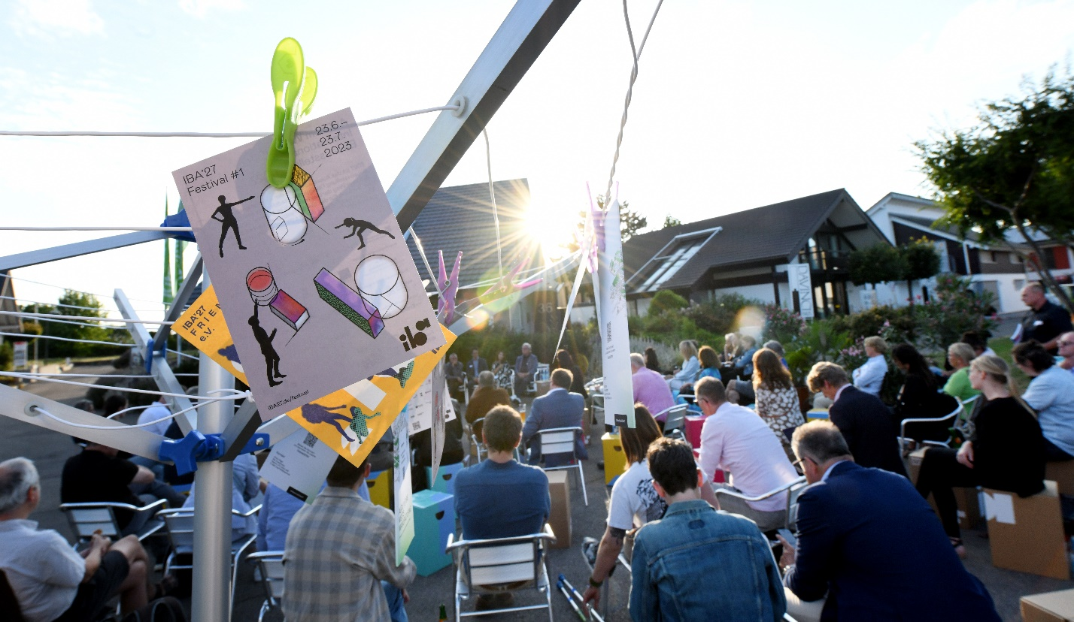**What remains an open question is how much international interest IBA'27 will generate**. By design, IBAs aim to be international platforms. They not only seek participation from experts from around the world but also strive to attract international audiences and influence global debates. However, with the increasing number of IBAs of late, there is growing concern that this could diminish individual IBAs’ ability to attract the kind of global interest that previous exhibitions such as the mentioned INTERBAU in Berlin; the IBA Emscher Park (1990-1999)17 or, of course, the Weissenhof (1927) were able to generate.

**IBA outreach event, 2023** *[credit:* *© IBA’27 Franziska Kraufmann]*

With the exception of the 1920s and 1930s, when the Deutscher Werkbund organised no fewer than six exhibitions bringing together radically new forms of housing, design and construction, building exhibitions were until recently a rather rare occurrence. However, since the turn of the millennium, there has been a notable increase in their frequency, with several events occurring back-to-back and even overlapping. Most recently, in late 2023, the Metropolregion München kickstarted its own IBA,18 bringing the total to ten since 2000 and underscoring the need for a discussion on the potential dilution of their impact.

At the same time, even without the recent flurry of IBAs it would be unreasonable to expect the Stuttgart IBA to replicate the global resonance achieved by forerunners like the 1927 event. The Weissenhof, emerging from a period of immense social and technological upheaval, captivated audiences worldwide with its radical vision. IBAs today rarely boast spectacles of radical, even revolutionary architectural innovation. They rather present spectrums of possibilities, finely tuned to their particular contexts and balancing innovative fervour with practicality. The challenge current IBAs face is to showcase this shift in ways that capture the wider public’s imagination. This is no easy feat, especially considering today’s fast-paced, (social-)media-saturated environment and the abundance of other architectural events – festivals, *biennales*, you name it – vying for the attention of global audiences. However, while the IBA in Stuttgart has some time left to claim its share of the spotlight, this alone should not be the yardstick by which to judge it. The quality of the architectural output and dialogue it will have produced; the extent of lasting local change it will have achieved, and the innovative solutions to current urban challenges it will have trialled and inspired – these factors, not fleeting global attention, are the kind of metrics that will define its true success.

***Dr Johannes Novy*** *is an urban planner, researcher, and author, based in London and Berlin. He works as a senior lecturer and course leader for the MA Urban and Regional Planning at the University of Westminster in London. As a member of its curatorial board, he acts in an advisory capacity for the Internationale Bauausstellung 2027 StadtRegion Stuttgart (IBA’27). All views expressed are personal.*

**Notes**

1 ‘IBA’27 on the way to the exhibition year’. Press release. Internationale Bauausstellung 2027 StadtRegion Stuttgard GmbH. [https://www.iba27.de/en/home/#](https://www.iba27.de/en/home/)!

2 ‘Weissenhof Museum Im Haus Le Corbusier’. Website. <https://weissenhofmuseum.de/en/siedlung/>

3 R Pommer, CF Otto: *Weissenhof 1927 and the modern movement in architecture*. University of Chicago Press, 1991.

4 ‘Maisons de la Weissenhof-Siedlung’. Webpage. Fondation Le Corbusier, 2019. <https://lecorbusier-worldheritage.org/en/maisons-de-la-weisenhof-siedlung/>

5 ‘Open urban planning ideas competition »Weissenhof 2027« decided’. Press release. Internationale Bauausstellung 2027 StadtRegion Stuttgard GmbH. <https://www.iba27.de/en/open-urban-planning-ideas-competition-weissenhof-2027-decided/>

6 ‘Internationale Bauausstellung 2027 StadtRegion Stuttgart: Reinvention of an urban region’. Webpage. Internationale Bauausstellung 2027 StadtRegion Stuttgard GmbH. <https://www.iba27.de/en/iba27/the-iba27/>

7 ‘The Mathildenhöhe – A Total Work of Art’. Webpage. Wissenschaftsstadt Darmstadt. <https://www.mathildenhoehe-darmstadt.de/en/>

8 N Adams, PL Pinch: ‘The German Internationale Bauausstellung (IBA) and Urban Regeneration: Lessons from the IBA Emscher Park’. In: ME Leary, J McCarthy (Eds.): *The Routledge Companion to Urban Regeneration*. Routledge, 2013, pp. 230–241

9 ‘Memorandum on the Future of International Building Exhibitions’. Webpage. Internationale Bauausstellungen. [https://www.internationale-bauausstellungen.de/en/iba-memorandum/#:~:text=The%20IBA%20meets%20IBA%20Network,the%20implementation%20of%20an%20IBA](https://www.internationale-bauausstellungen.de/en/iba-memorandum/" \l ":~:text=The%20IBA%20meets%20IBA%20Network,the%20implementation%20of%20an%20IBA).

10 T Becker, M Hesse: ‘A Temporary Space Where Development and Planning Emergencies Meet? Notes on an International Building Exhibition (IBA) in the Cross-Border Territories of France and Luxembourg’. *Planning Theory & Practice*, 2021, Vol. 22(1), 148-154. <https://www.tandfonline.com/doi/full/10.1080/14649357.2020.1842588>

11 *Memorandum: IBA 2027 StadtRegion Stuttgart – Outcomes of the IBA Platform Process*. Wirtschaftsförderung Region Stuttgart GmbH (WRS). <https://www.iba27.de/wp-content/uploads/memorandum_iba_2027_english.pdf>

12 ‘Internationale Bauausstellung 2027 StadtRegion Stuttgart: IBA’27 belongs to the people’. Webpage. Internationale Bauausstellung 2027 StadtRegion Stuttgard GmbH. <https://www.iba27.de/en/iba27/the-iba27/>

13 ‘Knowledge Creates Cities 2012-20’. Webpage. IBE Heidelburg. <https://iba.heidelberg.de/en>

14 ‘IBA’27 Projects’. Webpage. StadtRegion Stuttgart. Internationale Bauausstellung 2027 StadtRegion Stuttgard GmbH. <https://www.iba27.de/en/projects/iba27-projects/>

15 ‘Project structure: IBA’27 Network and IBA’27 Projects’. Webpage. Internationale Bauausstellung 2027 StadtRegion Stuttgard GmbH. <https://www.iba27.de/en/projects/project-structure/>

16 ‘Berlin Interbau (1957)’. Webpage. Architectuul, 26 Aug. 2021. <https://architectuul.com/architecture/berlin-interbau-1957>

17 ‘International Building Exhibition’. Webpage. Landschaftspark Duisburg-Nord. <https://www.landschaftspark.de/en/background-knowledge/international-building-exhibition/>

18 ‘The IBA Munich Metropolitan Region’. Webpage. International Building Exhibition Metropolregion Munich GmbH. <https://iba-m.de/>