Jacqui Grainger (Royal United Services Institute for Defence and Security Studies (RUSI) and University of Westminster)
The RUSI Journal in 1922
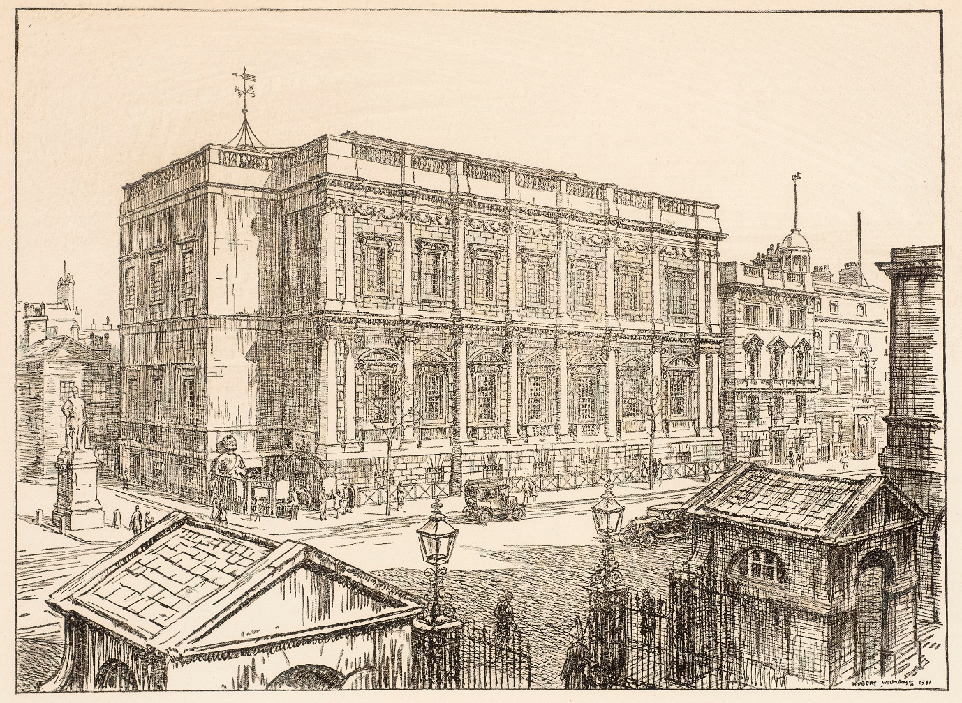
The RUSI Journal is the journal of the Royal United Services Institute for Defence and Security Studies (RUSI). It has been in continuous publication since 1857 and provided a semi-authorised voice on the military and geopolitical concerns of Whitehall and Westminster until the 1980s. As its funding landscape has changed, the institute and its journal have transformed to provide independent research and analysis.
RUSI was founded as the Naval and Military Library and Museum in 1831 as a scientific organisation for the services. It had significant support and status from the start as its patrons were King William IV and the Duke of Wellington. Its first home was Vanbrugh House in Whitehall Yard, now Horse Guards Avenue. With the redevelopment of Whitehall Yard in 1895 Queen Victoria granted a lease on Banqueting House, the surviving fragment of Whitehall Palace, for the institute’s museum and a plot of land next to Banqueting House for a building to contain a lecture hall, library, and staff offices. RUSI still occupies this building, 61 Whitehall, and its location gives it considerable convening power.
The RUSI Journal’s launch was part of the strategy for redefining the institute’s mission as a professional society and a means of increasing its membership from across the British Empire rather than just London-based members. The majority of serving officers were based outside of Britain and in 1922 an agreement to ship the journal in the services overseas mail system was renewed. This kept the journal, and membership fees down, and encouraged subscriptions just as the British Empire reached its largest extent.

The content of the RUSI Journal throughout 1922 is mainly concerned with analysis of World War One with articles that focus on the campaigns and actions of 1917-1918. These articles are interspersed with discussions of more recent events and by late 1922 feature the genocide of Greek communities in Anatolia during the Greco-Turkish War and the final months of the Ottoman Empire.

From the contents of the RUSI Journal for 1922 five key topics emerge:
Colonial policing and the Jallianwala Bagh Massacre, 1919
The fourth issue of the journal for 1922 contains an article by Major-General Nigel Woodyatt on the deployment of infantry in India from 1914-1920. It discusses the deployment of the infantry for the ‘policing’ of civil unrest and sedition, as well as the Third Anglo-Afghan War and the proximity of Soviet Russia. Kim Wagner (Queen Mary University of London) describes the rule of the British Raj as one of brutality. There was widespread unrest in India after World War One as it had exacted a huge cost in people and resources. A peaceful protest held in the Jallianwala Bagh, an enclosed square with a single entrance and exit, against the arrest of pro-Indian Independence campaigners ended in a massacre – a decisive step towards Indian independence. The British response, as the journal illustrates, was a tightened control of the population.
Nesta Webster – anti-bolshevism and fascism in British society
The first article in the first issue of the RUSI Journal for 1922 is ‘Bolshevism and Secret Societies’ by Nesta Webster. It is a transcription of a talk she gave at the Institute on 3rd November 1921. Webster was a conspiracy theorist; she was also deeply antisemitic and a fascist. She had been praised by Winston Churchill for her 1920 article, ‘Zionism versus Bolshevism: A Struggle for the Soul of the Jewish People’ which argued that a global Jewish conspiracy sought to overthrow civilisation. She also gave a lecture at the Royal Artillery Institution in 1921 titled, ‘The Past History of the World Revolution’, which implies there was a sympathetic audience for her views in military circles. This is evidenced by the ‘Letters Book’ for 1921 in the RUSI Archive. There are two entries concerning Webster: the first is a request from the Director of Naval Intelligence to reserve seven seats for his officers, and the second, a request for the repeat of ‘her very successful lecture’ for the Officers of the Fleet at Nore Command, Chatham.
New Technology
There are four articles on the use of aircraft, two on tanks, two on machine guns and one on film. World War One found the British army unprepared for the use of aircraft in combat. The earliest proposed uses had been for air ambulances and reconnaissance but not deployment with fixed machine guns. Trench warfare instigated an increased use of machine guns. This, and the increased deployment of tanks, challenged the traditional use of the cavalry and infantry. Film, or the cinematograph, also offered new opportunities for reconnaissance and subsequently staff training. In the long term, colonial rule was also consolidated by railways and wireless telegraphy which provided more efficient logistics and communications.
Australia – on the world stage
There are three articles that deal with the deployment of Australian forces across different arenas of World War One: Gallipoli, Strazeele, northern France, and Palestine. Australia’s and New Zealand’s contribution to the British war effort put them on the world stage and contributed to the forming of national identity. The Australian Light Horse made a significant contribution to the Sinai and Palestine campaigns that was elided in official histories but has been written about subsequently. They took their own horses with them; the Australian Waler horse was accustomed to desert conditions. Unusually for the Australian Armed Forces, Indigenous men served in the Light Horse and received equal pay which they wouldn’t have done in civil society.
Mandates – a wider colonial sphere
Mandates were territories deemed unable to govern themselves. There was an article in the second 1922 issue titled ’The new Responsibilities of the British Empire created by the Assumption of mandates in the Middle East, and their Strategic Significance, with Special Reference to the Defence of India’. If the impeachment of Warren Hastings, Governor of Bengal, in the late Eighteenth Century polarised debates about empire around the interests of the colonisers and the rights of the colonised, we can see that widening colonisation has settled clearly with the former. The Mandate of Palestine was approved by the League of Nations in 1922.
The notable absence from the journal’s pages is the conflict closest to home, Ireland. 1922 was the year of the Irish Civil War, the assassination of Michael Collins (Irish revolutionary soldier and politician), Irish Republican Army attacks on the mainland, the founding of the Royal Ulster Constabulary and the establishment of the Irish Free State.
World War One exacerbated calls for independence from across the British Empire - 1922 was also the year Mohandas Gandhi was arrested for sedition in Bombay. In the year that the British Empire was at its greatest extent, it was also beginning to break up.

The RUSI Journal is published and archived by Taylor & Francis
Its membership was open to officers of the services and the East India Company services, senior civil servants, and diplomats.
The RUSI Museum closed in 1962.
Wagner, Kim A. (2019), Amritsar 1919: An Empire of Fear and the making of a Massacre. New Haven, CT.: Yale University Press.
Griffiths, Richard. ‘Webster (née Bevan), Nesta Helen (1875-1960)’ in Oxford Dictionary of National Biography (2004), https://doi.org.lonlib.idm.oclc.org/10.1093/ref:odnb/71529 [accessed 20 July 2022]
The RUSI Library catalogue can be accessed through the RUSI website https://rusi.org/about/our-work/rusi-library

