Evaluation of the Westminster REFRAME Workshop for North Kensington General Practitioners: 2019

Prepared by:
Ilham Sebah (Research Fellow)
Philippa Shaw (Doctoral Student)
Anna Cheshire (Research Fellow)
April 2020

Contact
Dr Anna Cheshire
University of Westminster
115 New Cavendish Street
London
W1W6 UW
Email: a.cheshire@westminster.ac.uk

Contents

Executive summary 2
Introduction 2
Methods 2
Key findings 2
Participant quotes 2
Conclusions 3
Acknowledgements 3
Background 4
Evaluation methods 7
Participants 7
Data collection 7
Evaluation procedure 8
Data analysis 8
Findings 9
Participants 9
Experiences of the Westminster REFRAME workshop 10
References 16

Executive summary

Introduction
General Practitioners (GPs) in the UK are a subset of healthcare professionals who are particularly at risk of poor mental health and burnout. In the changing landscape of the NHS the prevalence of occupational illness, including burnout, is high. With widespread physician distress and the negative associated consequences for both the GP and their patients, there is a now a consensus that organisational change is essential, to ensure the sustainability of the NHS workforce. Resilience training, which provides GPs with a space for reflection and learning self-regulation skills has potential for mitigating the impact of occupational stress. This report presents an evaluation of the Westminster REFRAME workshop, a half day, intensive resilience-training programme that was provided for GPs and practice staff in the North Kensington Clinical Commissioning Group (CCG) area in 2019.

Methods
GPs and practice staff in the North Kensington CCG area were invited to attend workshops. All attendees were asked to take part in the evaluation. Questionnaires were used to collect quantitative and qualitative data from participants at three time points: immediately prior to the workshop (baseline), immediately after the workshop (post workshop), and two months after the workshop (follow-up). Outcome measures collected included perceived stress and positive well-being. Additionally, participants were asked to rate six statements about the workshop (e.g. ‘the workshop was useful to me’; ‘the ideas and concepts were communicated clearly’). Open-ended questions collected written data regarding participants’ experiences and perceptions of the workshop.

Key findings
- Thirty-six General Practitioners (GPs) attended REFRAME workshops, and twenty-nine completed questionnaires immediately pre and post workshop in the time period.
- GPs reported high stress levels, but typical levels of positive well-being.
- All of the participants agreed that the workshop was useful. Eighty-six percent said that the topics covered would be useful for work, and all 86% said that they intended to use some of the techniques they had learnt, including breathing techniques, the resilience matrix and mindfulness.
- Participants reported that they found the interactive elements of the session engaging and several noted the practical aspects to be highly useful and enjoyable. It was noted that the ability to share experiences was beneficial and made the stressful experiences feel less isolating.
- Participants had various ideas for improvement, with a key theme being the inclusion of more practical scenarios and role play.

Participant quotes
“Experienced facilitator, understood perfectly our day to day obstacles and the impact of these”
“Style of presentation. Humour/ science balance. Opportunities for interaction”
“Better understanding of stress and relievers. Simple method of relaxation/ mindfulness”
“Useful to hear/ share experiences across the board. Feels less isolating”
“Interactive. Using different modalities. Very engaging”
“Using resilience matrix - SMARTER. Intend to practise mindfulness techniques as demonstrated”

Conclusions
Westminster REFRAME appears to be useful and acceptable to GPs. Overall, GPs who participated in the Westminster REFRAME workshop reported finding their session beneficial and planned to use the tools and techniques taught and practiced. Results from this evaluation demonstrate the potential for the REFRAME workshop to help GP cope better with the impact of occupational strains and improve their resilience. Further evaluation and follow-up with larger samples will aim to provide evidence for the effectiveness of this workshop at individual and organisational levels.

Acknowledgements

We would like to thank:
- The Westminster REFRAME workshop facilitators: Professor David Peters and Justin Haroun
- Julian Groves and the Point of Care Foundation who delivered the Schwartz Round
- The North Kensington Recovery Team
- Dr Oisin Brannick and the West London Clinical Commissioning Group
- Dr Yasmin Razak and staff at North Kensington CCG who supported the delivery of workshops and evaluation
- All the doctors and other staff who participated in the workshop and completed the evaluation assessments
- Kathryn Hewson for her help with data entry
- With particular thanks to the late and much missed Prof George Lewith who co-initiated this training, for his untiring enthusiasm for the project.

Background

Medicine is both a highly demanding and rewarding profession (McKinley et al., 2020). Some doctors thrive within their challenging role, finding fulfilment in seeing patients, providing care and celebrating the small wins (Stevenson, Phillips, & Anderson, 2011). Yet the landscape of the NHS continues to change with an accumulation of negative factors making the work of being a healthcare provider more difficult. Consequently, many doctors have said that they are not thriving. This has become particularly apparent in sectors such as primary care, with general practice reported as under “historically unprecedented pressures” (Cheshire et al., 2017b) and the NHS workforce characterised as being ‘in crisis’ (Baird, Charles, Honeyman, et al., 2016). The pressure on primary care is currently at its highest ever, and is predicted to increase in the future (Riley et al., 2018). These pressures have contributed to low job satisfaction and low morale among staff, in addition to stress, burnout and early retirement (Dewa et al., 2014) which in turn impacts workforce shortages (NHS, 2014).

Working within the healthcare system is now more commonly associated with organisational pressure, a poor occupational culture and doctor distress (Carrieri et al., 2020). Increasing pressures are often linked to the changes in workload – such as increasing volume and change in the type of work (Croxson, Ashdown & Hobbs, 2017; Fisher, Croxson, Ashdown, & Hobbs, 2017); increasing work complexity (Cheshire et al., 2017b); and challenges with workload distribution (Branson & Armstrong, 2004). All these factors can have an adverse effect on adverse effect on physical and mental wellbeing (Garbarino, Lanteri, Durando, Magnavita, & Sannita et al., 2016). Doctors are batting these changes in workload whilst working in challenging environments linked with poor communication (Matheson, Robertson, Elliott, Iversen & Murchie, 2016) and a culture of bullying, isolation and fear (Riley et al., 2018). The increasing pressures paired with organisational issues is leading to a lack of job satisfaction (Dale et al., 2015) and increased vulnerability to mental health issues for healthcare professionals (Feeney et al., 2016). This is echoed by Vijendren, Yung, and Sanchez (2015), who found through their literature review that greater job constraints, managerial issues, difficulty with clinical cases and lack of job satisfaction were associated with a diminished mental wellbeing in British doctors. Additionally, compared to the general population, doctors and medical students are subject to elevated levels of alcohol and substance misuse, suicide, stress, depression and burnout (Brooks, Chalder, & Gerada, 2011; Firth-Cozens, 2006; Imo, 2017; Newbury-Birch, Walshaw, & Kamali, 2001; Rotenstein et al., 2016).

Particularly prominent within the current literature is the high prevalence of burnout among healthcare professionals (Imo, 2017). Leiter, Maslach and Frame (2014), define burnout as emotional depletion and a loss of motivation as a consequence of prolonged exposure to chronic interpersonal and emotional stressors at work. They view burnout as a syndrome with three dimensions - emotional exhaustion, depersonalisation and lack of personal accomplishment (Maslach, Jackson, Leiter, Schaufeli, & Schwab, 1986). A recent survey of 1651 UK doctors found that around one third were suffering from burnout and secondary traumatic stress (McKinley et al., 2020). A review of the literature exploring burnout among UK doctors found levels were often reported as high, with prevalence of emotional exhaustion ranging from 31 to 54.3% (Imo, 2017). Burnout prevalence has been reported to be particularly high in medical students (Cecil, McHale, Hart, & Laidlaw, 2014) Such high prevalence is concerning, yet some researchers from the United States argue that burnout in doctors is still under recognised and under diagnosed (Lacy & Chan, 2018).

Burnout is associated with an increased risk of psychiatric morbidity, but can also impact on quality of patient care and patient safety (such as reduced ability to listen, feel and show empathy), reduced cognitive functioning and increased inappropriate referrals (Hall et al., 2017). Due to such associations with burnout there has been an increase in research interest exploring the impact of doctor burnout on patient care (Hall, Johnson, Watt, Tsipa, & O’Connor, 2016), with findings showing an association between poor doctor wellbeing and worse patient safety outcomes, such as medical errors and poorer quality of patient care (Panagioti et al., 2018). Although important, this is contributing to the dominant narratives created through publicised research and the media suggesting that the health of the doctors is of concern predominantly because of the potential negative impact for patients (Spiers et al., 2016).

Consequently, there have been calls for action (George & Gerada, 2019; Patterson, 2016) for all healthcare practitioners to be valued, supported and cared for and to improve the sustainability of healthcare roles (Baird, Charles, Honeyman, Maguire, & Das, 2016). This drive for change is not confined to the UK, for example in the USA there are calls to extend their framework for delivering high value care from the Triple Aim to the Quadruple Aim (Bodenheimer & Sinsky, 2014). The Triple aim refers to a three-pronged approach to improving healthcare by targeting improvements in patient’s experience of care, improving the population’s health, and reducing the healthcare costs (Berwick, Nolan & Whittington, 2008).The Quadruple Aim would also include improving the experience of providing care (Sikka, Morath, & Leape, 2015). There is a consensus being reached that there is great need for healthcare organisations to take responsibility and implement organisation changes, in order to make real progress (Lemaire & Wallace, 2017; Wright & Katz, 2018). However, it is recognised that these changes will take time and there is still a need for both reactive and preventative interventions designed for healthcare professionals (Brooks, Gerada, & Chalder, 2011). So far UK doctors’ access to new NHS initiatives to support their health and well-being via occupational health services have been found to be inconsistent and sometimes non-existent (Sauerteig, Wijesuriya, Tuck & Barham-Brown, 2019).

It is consistently reported that doctors are not good at help-seeking (Úallacháin, 2007), with many explanations provided - perceptions that doctors are impervious to illness (Spiers et al., 2016), doctors normalising or trivialising their experience of stress (Thompson, Corbett, & Welfare, 2013), and doctors have difficulty accessing appropriate support (Kay et al 2008). Dobbin (2014), argues that with the major systemic problems with the NHS, the need for doctors “to be resilient, to foster better coping and creative solutions, has never been more pressing” (p. 497). The current report is an evaluation of a preventative intervention which aims to do just that, build resilience in the NHS workforce.

Psychological resilience encompasses both the ability to manage and adapt to adversity (Lown, Lewith, Simon, & Peters, 2015), as well as the growth of an individual after encountering stressful experiences (Dobbin, 2014). Peters, Lynch, Manning, Lewith, and Pommerening (2016) promote that doctors need to have considerable personal resilience due to their intensely stressful and challenging occupation. Building resilience is often seen as most beneficial, and is most often used, as a preventative strategy against burnout amongst doctors (Johnson, Panagioti, Bass, Ramsey, & Harrison, 2017; Tregoning, Remington, & Agius, 2014), in order to reduce the impact of stress and promoting effective coping and healthy behaviours (Kumar, 2016).

It has been reported that doctors perceive resilience training as a potentially worthwhile strategy to improve wellbeing (Hall et al, 2017), yet are concerned that those most likely to benefit are least likely to participate (Cheshire et al., 2017b). Furthermore, resilience training deployed in isolation has been argued to have potentially limited impact if the workplace environment and organisational culture which causes low morale, burnout and intentions to leave, are not also targeted (Kumar, 2016). Nevertheless, improved quality of care provided for the patients and reduced medication errors have been associated with doctors who are more resilient (Epstein, 2014; Lown et al., 2015). Furthermore aspects of resilience training such as the educational component informing doctors about stress and coping techniques have been suggested to be helpful, for example de Visser (2009) argues that the biopsychosocial model of distress and the understanding of neurobiology of emotions are poorly covered in medical school. Dobbin (2014) suggests such education leads to practitioners, who have little idea of the origins or ramifications of distress, to not only help their patients but to also help themselves.

Westminster REFRAME workshop
The Westminster REFRAME workshop is a half day, intensive resilience-training programme for doctors and frontline health professionals. It was designed by Professor David Peters and Professor George Lewith at the Westminster Centre for Resilience. The workshop is highly interactive and focuses on self-regulation and self-care, as well as exploring work-habits, lifestyle, mind-set, strategies for controlling workload, setting goals, planning, prioritizing, and saying no to unreasonable requests. The event is designed for groups of up to 20. It aims to engage participants both in sharing experiences and solutions and, with the help of facilitators, to try out self-regulating techniques (e.g. mindfulness, slow breathing). Attendees are encouraged to set themselves SMART goals, for experimenting with small positive changes that could boost their resilience.

The workshop sets out to reduce the negative impact on doctors and frontline health professionals from their work, and to promote more effective recovery from the adversity and setbacks that they are likely to experience. Improved resilience should enhance well-being, improve job satisfaction, support retention within the UK profession, and support staff to cope and perform safely and competently.

Westminster REFRAME workshops were initially designed for Foundation Year (FY) doctors, and have been delivered to FY1 doctors at Guy’s and St Thomas’ Hospital since 2014. Initial evaluation data showed that participants valued the workshops and found them useful (Lynch, Peters, & Lewith, 2016). In order to widen participation further, REFRAME workshops have now been developed for a range of hospital staff, with studies showing equally positive results (Cheshire, 2017; Shaw & Cheshire, 2018). Similar workshops designed and delivered for GPs, have also reported positive findings (Lynch et al., 2016). During 2018/19, Westminster REFRAME workshops were delivered to GPs and practice staff in the North Kensington area of London. This report presents the evaluation findings for these workshops.

Evaluation methods

Participants
In 2019 North Kensington CCG provided three Westminster REFRAME workshops to GPs and practice staff who wished to attend on a voluntary basis. Staff were recruited via North Kensington CCG. Two of the workshops were held specifically in response to the Grenfell Tower disaster, to support staff caring for the effected community. In addition to the usual REFRAME format, one workshop also included a Schwartz Round.

Data collection
Those who participated in the workshop were asked to complete questionnaires at three time points: immediately before the workshop (baseline), immediately after the workshop (post workshop), and two months after the workshop (follow-up). The questionnaires allowed for the collection of both quantitative and qualitative data. A more detailed account of the data collected is presented below.

Baseline questionnaire (immediately prior to the workshop)
The questionnaire asked participants to provide demographic data including their sex, age and ethnicity. Following this, two validated scales were used to measure baseline stress and well-being of the participants.

Perceived stress was measured using the Perceived Stress Scale (PSS) (Cohen, Kamarck & Mermelstein, 1983). The PSS was designed to measure the degree to which participants appraise situations in their lives as stressful. Thus, the authors designed it to be a direct measure of the stress experienced by the respondent, not a measure of psychological symptomology. The 10 PSS items explore feelings and thoughts during the last month and respondents are asked how often they felt a certain way. Each item is scored on a scale of 0 to 4, which are summed to give a total score of between 0 and 40. Higher scores indicate increased stress. A score of around 13 is considered average, and scores of 20 or higher are considered to reflect high stress. The PSS has established validity and reliability (Cohen et al., 1983).

Positive well-being was measured using the Warwick-Edinburgh Mental Well-being Scale (WEMWBS) (Tennant et al., 2007). The WEMWBS is a measure of positive mental well-being encompassing items which assess both the hedonic (pleasure) and eudemonic (virtue, using one’s potential and skills) perspectives of happiness. We used the shorter 7-item version of the scale which not only is quicker to complete but may also be more robust than the 14-item version (Stewart-Brown, Tennant, Tennant, Platt, Parkinson & Weich, 2009). Items have five response categories (none of the time, rarely, some of the time, often, all of the time). Responses are scored from 1 to 5, providing a total score ranging from 7 to 35. The scaling properites of the seven items are superior to the 14 items, therefore, the raw scores were transformed into metric scores. The cut points for 7-item WEMWBS are 17 or less for probable depression, 18-20 for possible depression, 21-27 for average mental wellbeing and 28-35 high mental wellbeing (Warwick Medical School, 2021). The scale has established validity and reliability (Tennant et al., 2007).

Post-workshop questionnaire (immediately after the workshop)
Open-ended questions were used to collect participants’ perceptions of the workshop, encouraging qualitative feedback. Questions asked are as follows:

- Please tell us what made you attend this course?
- What did you like about the course?
- What could be improved about the course?
- Do you intend to try to do anything differently after attending this course?
- Any other comments?

The Westminster Quantitative Feedback Questionnaire, a 6-item measure, was used to ascertain participants’ ratings of satisfaction with the workshop. Participants are asked to rate the below statements on a 5-point Likert scale (a score of 1 indicated strongly disagree, 2 disagree, 3 neither agree nor disagree, 4 agree and 5 strongly agree):

- The workshop was useful to me
- The ideas and concepts were communicated clearly
- The pace of the day was just right
- The balance between theory and experiential learning was just right
- The content and topics covered were useful for me for work
- I will use some of the techniques learnt

Evaluation procedure
A researcher explained the evaluation to all attendees at the beginning of each Westminster REFRAME resilience workshop via a video. This video explained the evaluation to participants and invited them to participate, the facilitator was on hand to answer any questions. Evaluation packs were provided to those who wished to participate, which included a participant information sheet, consent form, the baseline questionnaire and post-workshop questionnaire. Participants were given time to read the information sheet, ask questions, sign the consent form and to complete their baseline questionnaire.
At the end of the workshop participants were asked to complete their post-workshop questionnaire. Participants then placed both their completed questionnaires and consent form into an envelope and returned them to the workshop facilitator, who then returned all envelopes to the researcher.

Data analysis
To analyse the quantitative data the researcher used SPSS version 25, to calculate means, frequencies and other summary statistics.

The researcher analysed the qualitative findings from the open-ended questions using the thematic analysis framework, as outlined by Braun and Clarke (2006). However, it must be noted that the depth of data received on the feedback forms did not allow for a full thematic analysis. The researcher first read all the text, familiarising herself with the content of the feedback, highlighting key sections of text and words. Following this, the researcher then re-read the text line by line, focusing on one section at a time (one section was defined as all the answers to one question), noting key elements and codes from the feedback. From these codes reoccurring aspects of the feedback were isolated and collated into themes. Quotes typical of the themes are used to illustrate the findings of this analysis within this report.

Findings

Participants
Thirty-six GPs attended the Westminster REFRAME workshop during the 2018/19 academic year and 29 completed baseline and post-workshop questionnaires.

Demographics and baseline scores
Participants who completed a baseline questionnaire (n=29) had a mean age of 42 years (range 28-63). The majority of the participants were female (86%); there was a range of ethnicities, with the largest groups being South Asian (38%) and White-British (21%), see Table 1.

Participants reported high stress levels pre workshop: mean PSS score was 21.2, existing cut-off figures suggest that a score of 20 or above is indicative of high stress (Cohen et al., 1983). With regards to pre-workshop positive well-being, average WEMWBS score was 26.6, which falls within the ‘average’ mental health range (Warwick Medical School), see Table 2.

Table 1: Participant demographics

 | Total
Age: Mean (range) | 42 (28-63)
Sex: Number (%)
Male | 4 (14)
Female | 25 (86)
Ethnicity: Number (%)
White – British | 6 (21)
White – European | 2 (7)
White – other | 2 (7)
Chinese | 2 (7)
Mixed ethnicity | 2 (7)
Arabic | 1 (3)
Asian (South Asian) | 11 (38)
Black/Afro-Caribbean | 2 (7)
Missing | 1 (3)

Table 2: Participant stress and well-being scores immediately before the workshop

 | Total (n=29)
Pre-workshop PSS  mean (range)  scores range 0-40, ↑ = worse | 21.2 (7-31)
Pre-workshop WEMWBS  mean (range)  scores range 7-35, ↑ = better | 26.6 (11-35)

Experiences of the Westminster REFRAME workshop

Westminster evaluation scales
The Westminster Evaluation Scales overall presented a positive picture of participants’ experiences of the workshop: the majority of responses rated different aspects of the workshop with the maximum scores of 4 and 5 (agree or strongly agree), see Figures 1 to 6. 89% of GPs agreed or strongly agreed that the workshop had been useful, although 11% were unsure whether or not the workshop had been useful. Overall, 89% said the topics covered would be useful for work and 93% felt that the concepts and ideas were communicated clearly. 86% of the GPs stated that they intended to use some of the techniques learned, with 50% answering strongly agree to this statement.

Figure 1: The workshop was useful to me

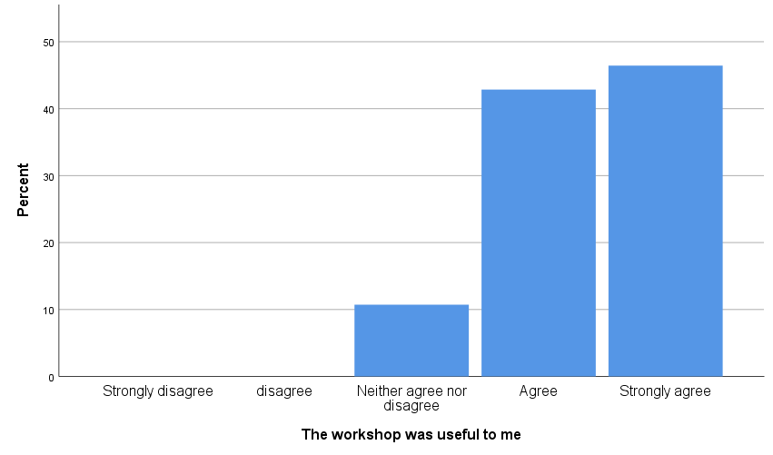
Figure 2: The ideas and concepts were communicated clearly

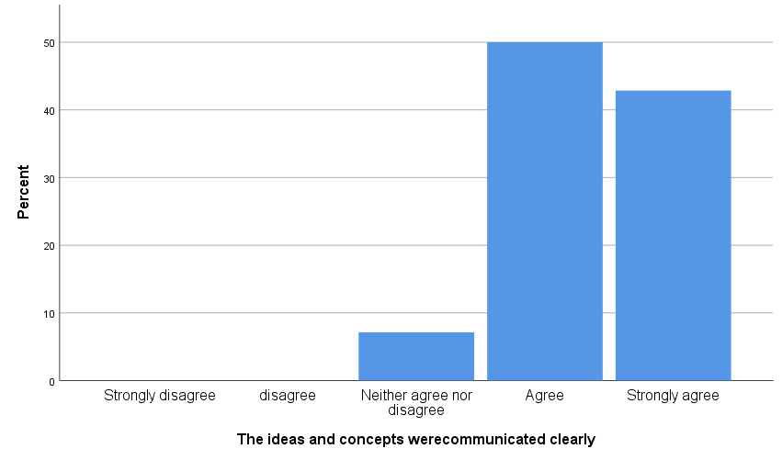

Figure 3: The pace of the day was just right

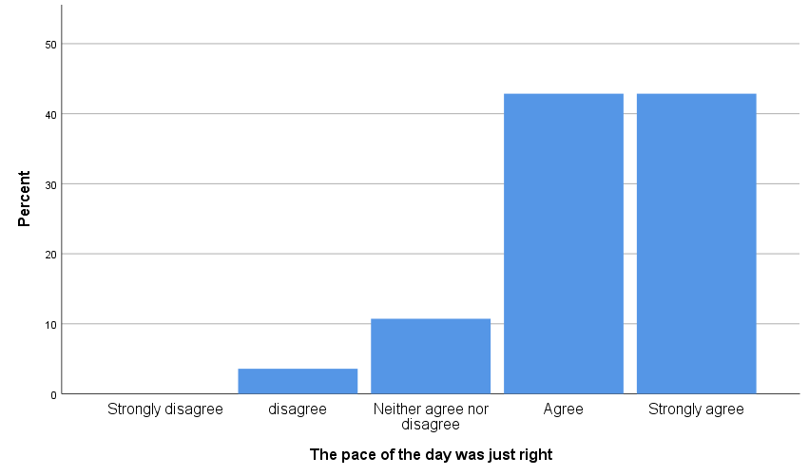

Figure 4: The balance between theory and experiential learning was just right

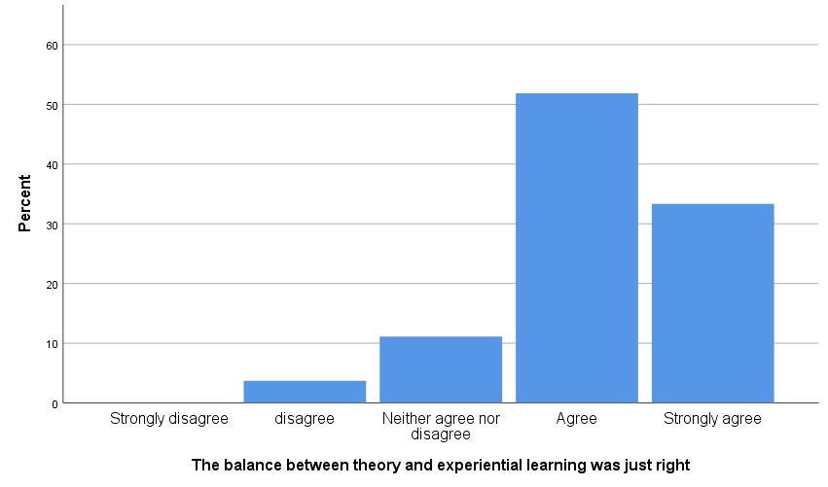

Figure 5: The content and topics covered were useful for my work

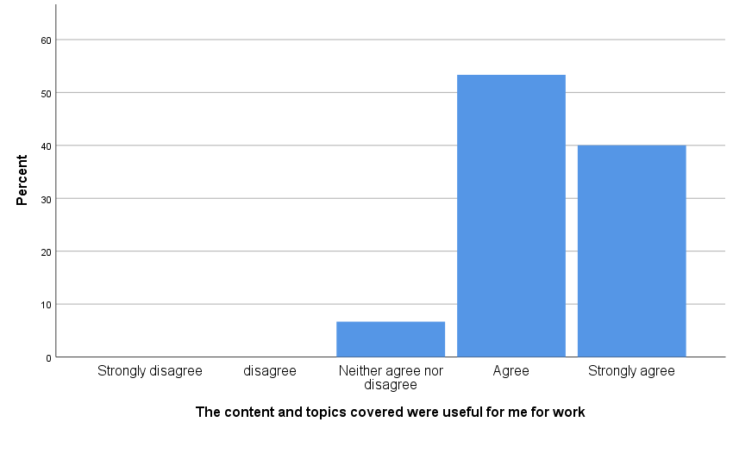

Figure 6: I will use some of the techniques learnt

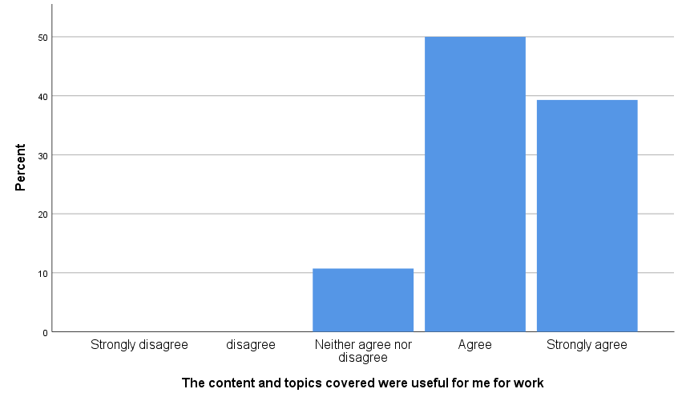

Qualitative Feedback on Westminster REFRAME workshop (post workshop)

Attendance
Many GPs said that they were attending the course due to the levels of work-related stress that they were experiencing, with some raising concerns that they were feeling overwhelmed and were at risk of burning out.

“Concerned I am at risk of burnout. Thinking about leaving general practice.”
“Stress at work. Risk of burnout.”
“I'm worried I am going to burnout”

GPs were interested in learning ways to deal with the stress they were experiencing and understanding how to be more resilient.

“I wanted to learn tips about resilience”
“I wanted to acquire skills to deal with stress better”
“Interested to reduce work stressors and improve work life balance.”

A few of the participants mentioned that the course had been recommended by a colleague or a GP partner, which also supported attendance.

“Feeling overworked and stressed from the job. Recommendation by my Practice Manager”

Responses to the session
Overall, the feedback indicated that participants found the session interesting and useful. Participants enjoyed how the workshop had been delivered, particularly the interactive nature of the workshop that allowed them to hear and share experiences with others in similar situations. This could result in GPs feeling less isolated.

“Useful to hear/ share experiences across the board. Feels less isolating.”
“Style of presentation. Humour/ science balance. Opportunities for interaction”
“Interactive. Using different modalities. Very engaging”
“Interactivity. Listening to other people experience”

Several of the participants reflected on the knowledge and understanding gained from the workshop, such as the neurophysiology of stress. A few participants felt that the various activities had offered them the opportunity to self-reflect on their strengths and weaknesses and set personal goals for improvement. Others appreciated learning specific techniques, such as mindfulness meditation and breathing exercises, to help them deal with stress.

“The scientific principles - especially vagal responses, RSA, lizard brain monkey brain human brain.”
“Better understanding of stress and relievers. Simple method of relaxation/ mindfulness”
“Discussion of evolutionary neurobiology. Use of mindfulness. Need to have SMART goals to improve control”

A few of the participants enjoyed the group discussion and interactive elements within the session. Many noted the enjoyable nature of being able to talk to colleagues in the field and learn from others, and reported on the conducive nature of these discussions. Some mentioned that this allowed for more sensitive subject matters to be explored and commented on the therapeutic nature of the discussions.

“Useful to see evidence base and to discuss things with other GPs.”
“Other people felt the same. My anxieties are anxieties experienced by other doctors.”

Whilst the experiences of taking part in the workshop were positive overall, there were some suggestions on how the session could be improved. Several of the participants suggested incorporating more tips and tools for managing stress. A few of the participants mentioned the need for more practical suggestions that they could apply to everyday life, with the suggestion of including role play. These suggestions mirror the reasons cited for attending the workshop – many participants would like to learn practical skills to help cope with the challenges of work.

“Role play practical/ real situations to see how we react.”
“More interactive.”
“More stressful scenarios (examples) and methods/ suggestions how to combat this.”

Whilst the majority of the participants enjoyed learning about the neurophysiology of stress, some felt that too much time was spent on this and did not find this aspect relevant. One participant suggested a reduction of time spent covering the neurophysiology of stress to allow for time on learning about practical approaches.

“Maybe less of biological/ science.”

A number of GPs said that they would have liked a full day workshop, so that they could focus more exclusively on the training.

“Felt rushed getting here from surgery and having to get back on time to practice! More practical techniques would be useful.”
“Start at 1pm very stressful to get to if working in morning - better 1 day course”
“A full day workshop would be helpful”

Intentions
The majority of the participants specified what they intended to do differently after attending the course, with many reporting how they intended to apply specific tools from the session into their everyday lives. For example, a large number of the participants stated their intention to incorporate the breathing exercises and mindfulness meditation into their practice. Others felt inspired to try to be more organised at work, whilst another sought to make more general improvement to their lifestyle.

“Breathing techniques, apps, housekeeping between difficult consultations.”
“Yes, I will involve meditation and mindfulness in my daily practice.”
“Mindfulness technique/ meditation pre/post AM/PM surgery.”

Some of the participants specified making changes based on their assessed strengths and weaknesses, derived from the resilience matrix, and mentioned their intention to act on their goals set with the SMART tool.

“Using resilience matrix - SMARTER.”
“SMART goal. Use and look at some resources.”

References

Baird, B., Charles, A., Honeyman, M., Maguire, D., & Das, P. (2016). Understanding pressures in general practice. London: King's Fund.
Berwick, D. M., Nolan, T. W., & Whittington, J. (2008). The triple aim: care, health, and cost. Health Affairs, 27(3), 759-769.
Bodenheimer, T., & Sinsky, C. (2014). From triple to quadruple aim: care of the patient requires care of the provider. The Annals of Family Medicine, 12(6), 573-576.
Branson, R., & Armstrong, D. (2004). General practitioners' perceptions of sharing workload in group practices: qualitative study. BMJ, 329(7462), 381.
Brooks, S. K., Chalder, T., & Gerada, C. (2011). Doctors vulnerable to psychological distress and addictions: treatment from the Practitioner Health Programme. Journal of Mental Health, 20(2), 157-164.
Brooks, S. K., Gerada, C., & Chalder, T. (2011). Review of literature on the mental health of doctors: are specialist services needed? Journal of Mental Health, 20(2), 146-156.
Carrieri, D., Mattick, K., Pearson, M., Papoutsi, C., Briscoe, S., Wong, G., & Jackson, M.
(2020). Optimising strategies to address mental ill-health in doctors and medical students: ‘Care Under Pressure’ realist review and implementation guidance. BMC Medicine, 18(1).
Cheshire, A. (2017). Westminster REFRAME workshops for foundation year doctors 2016-2017: Evaluation report.
Cheshire, A., Ridge, D., Hughes, J., Peters, D., Panagioti, M., Simon, C., & Lewith, G. (2017). Influences on GP coping and resilience: a qualitative study in primary care. British Journal of General Practice, bjgp17X690893.
Cheshire, A., Hughes, J., Lewith, G., Panagioti, M., Peters, D., Simon, C., & Ridge, D. (2017). GPs’ perceptions of resilience training: a qualitative study. British Journal of General Practice, bjgp17X692561.
Cohen, S., Kamarck, T., & Mermelstein, R. (1983). A global measure of perceived stress. Journal of Health and Social Behavior, 385-396.
Croxson, C. H., Ashdown, H. F., & Hobbs, F. R. (2017). GPs’ perceptions of workload in England: a qualitative interview study. British Journal of General Practice, bjgpfeb-2017.
Dale, J., Potter, R., Owen, K., Parsons, N., Realpe, A., & Leach, J. (2015). Retaining the general practitioner workforce in England: what matters to GPs? A cross-sectional study. BMC Family Practice, 16(1), 140.
de Visser, R. (2009). Psychology in medical curricula:" need to know" or" nice to know"? European Health Psychologist, 11(2), 20-23.
Dewa, C., Loong, D., Bonato, S., Thanh, N., & Jacobs, P. (2014). How does burnout affect physician productivity? A systematic literature review. BMC Health Services Research, 14(1).
Dobbin, A. (2014). Burnt out or fired up? Helping recovery in distressed patients can increase our own resilience. British Journal of General Practice, 497-498.
Doran, N., Fox, F., Rodham, K., Taylor, G., & Harris, M. (2016). Lost to the NHS: a mixed methods study of why GPs leave practice early in England. British Journal of General Practice, bjgpfeb-2016.
Epstein, R. M. (2014). Realizing Engel's biopsychosocial vision: resilience, compassion, and quality of care. The International Journal of Psychiatry in Medicine, 47(4), 275-287.
Feeney, S., O’brien, K., O’keeffe, N., Iomaire, A. N. C., Kelly, M. E., McCormack, J., ... & Evans, D. S. (2016). Practise what you preach: health behaviours and stress among non-consultant hospital doctors. Clinical Medicine, 16(1), 12-18.
Firth-Cozens, J. (2006). A perspective on stress and depression. In J. Cox, J. King, A. Hutchinson, P. McAvoy (Eds), Understanding doctors’ performance (pp22-25). Radcliffe Publishing.
Fisher, R. F., Croxson, C. H., Ashdown, H. F., & Hobbs, F. R. (2017). GP views on strategies to cope with increasing workload: a qualitative interview study. British Journal of General Practice, 67(655): e148-e156.
Garbarino, S., Lanteri, P., Durando, P., Magnavita, N., & Sannita, W. (2016). Co-Morbidity,
Mortality, Quality of Life and the Healthcare/Welfare/Social Costs of Disordered Sleep: A Rapid Review. International Journal of Environmental Research And Public Health, 13(8), 831.
Hall, L. H., Johnson, J., Heyhoe, J., Watt, I., Anderson, K., & O’connor, D. B. (2017). Strategies to improve general practitioner well-being: findings from a focus group study. Family Practice, 35(4), 511-516.
Hall, L. H., Johnson, J., Watt, I., Tsipa, A., & O’Connor, D. B. (2016). Healthcare staff wellbeing, burnout, and patient safety: a systematic review. PloS one, 11(7), e0159015.
Hobbs, F., Bankhead, C., Mukhtar, T., Stevens, S., Perera-Salazar, R., Holt, T., & Salisbury, C. (2016). Clinical workload in UK primary care: a retrospective analysis of 100 million consultations in England, 2007–14. The Lancet, 387(10035), 2323-2330.
Imo, U. O. (2017). Burnout and psychiatric morbidity among doctors in the UK: a systematic literature review of prevalence and associated factors. BJPsych Bulletin, 41(4), 197-204.
Johnson, J., Panagioti, M., Bass, J., Ramsey, L., & Harrison, R. (2017). Resilience to emotional distress in response to failure, error or mistakes: a systematic review. Clinical Psychology Review, 52, 19-42.
Kay, M., Mitchell, G., Clavarino, A., & Doust, J. (2008). Doctors as patients: a systematic review of doctors' health access and the barriers they experience. British Journal of General Practice, 58(552), 501-508.
Kumar, S. (2016). Burnout and doctors: prevalence, prevention and intervention. In Healthcare (Vol. 4, No. 3, p. 37). Multidisciplinary Digital Publishing Institute.
Lacy, B. E., & Chan, J. L. (2018). Physician burnout: the hidden health care crisis. Clinical Gastroenterology and Hepatology, 16(3), 311-317.
Lee, F.J., Stewart, M. & Brown, J.B. (2008). Stress, burnout, and strategies for reducing them: what’s the situation among Canadian family physicians? Canadian Family
Physician, 54, 234–5.
Leiter, M. P., Maslach, C., & Frame, K. (2014). Burnout. The Encyclopaedia of Clinical Psychology, 1-7.
Lemaire, J. B., & Wallace, J. E. (2017). Burnout among doctors. BMJ: British Medical Journal (Online), 358.
Lown, M., Lewith, G., Simon, C., & Peters, D. (2015). Resilience: what is it, why do we need it, and can it help us?. British Journal of General Practice, 65(639), e708-e710.
Lynch, S., Peters, D., & Lewith, G. (2016). FY1 REFRAME evaluation report 2015/16.
Matheson, C., Robertson, H. D., Elliott, A. M., Iversen, L., & Murchie, P. (2016). Resilience of primary healthcare professionals working in challenging environments: a focus group study. British Journal of General Practice, 66(648), e507-e515.
McKinley, N., McCain, R., Convie, L., Clarke, M., Dempster, M., Campbell, W., & Kirk, S.
(2020). Resilience, burnout and coping mechanisms in UK doctors: a cross-sectional study. BMJ Open, 10(1), e031765.
Newbury-Birch, D., Walshaw, D., & Kamali, F. (2001). Drink and drugs: from medical students to doctors. Drug and Alcohol Dependence, 64(3), 265-270.
NHS (2014). Securing the future GP workforce delivering the mandate on GP expansion: GP Taskforce Final Report.
Panagioti, M., Geraghty, K., Johnson, J., Zhou, A., Panagopoulou, E., Chew-Graham, C., & Esmail, A. (2018). Association between physician burnout and patient safety, professionalism, and patient satisfaction: a systematic review and meta-analysis. JAMA internal medicine, 178(10), 1317-1330.
Patterson, D. (2016). Damaged doctors: it’s time for a binding covenant of care between the NHS and its doctors. British Journal of General Practice, 66 (645): 174-175.
Peters, D., Lynch, S., Manning, C., Lewith, G., & Pommerening, D. (2016). The Day After Tomorrows Doctors: UK Undergraduate Medical Student Resilience, Reports on the Symposium 2016
Riley, R., Spiers, J., Buszewicz, M., Taylor, A. K., Thornton, G., & Chew-Graham, C. A. (2018). What are the sources of stress and distress for general practitioners working in England? A qualitative study. BMJ Open, 8(1), e017361.
Rotenstein, L. S., Ramos, M. A., Torre, M., Segal, J. B., Peluso, M. J., Guille, C., ... & Mata, D. A. (2016). Prevalence of depression, depressive symptoms, and suicidal ideation among medical students: a systematic review and meta-analysis. JAMA, 316(21), 2214-2236.
Sauerteig, S., Wijesuriya, J., Tuck, M. & Barham-Brown, H., 2019. Doctors’ health and wellbeing: at the heart of the NHS’s mission or still a secondary consideration?. International Review of Psychiatry, 31(7-8), 548-554.
Shaw, P., & Cheshire, A. (2018). Westminster REFRAME workshops for Guy’s and St
Thomas’ Hospital staff 2017-2018: Evaluation report.
Shanafelt, T.D., Boone, S., Tan, L. et al. (2012). Burnout and satisfaction with work-life
balance among US physicians relative to the general US population. Archives of Internal Medicine, 172, 1377–85.
Sikka, R., Morath, J. M., & Leape, L. (2015). The Quadruple Aim: care, health, cost and meaning in work. BMJ Quality & Safety, 24:608-610.
Spiers, J., Buszewicz, M., Chew-Graham, C., Gerada, C., Kessler, D., Leggett, N., ... & Riley, R. (2016). Who cares for the clinicians? The mental health crisis in the GP workforce. British Journal of General Practice, 66(648), 344-345.
Stevenson, A. D., Phillips, C. B., & Anderson, K. J. (2011). Resilience among doctors who work in challenging areas: a qualitative study. British Journal of General Practice, 61(588), e404-e410.
Tennant, R., Hiller, L., Fishwick, R., Platt, S., Joseph, S., Weich, S., ... & Stewart-Brown, S. (2007). The Warwick-Edinburgh mental well-being scale (WEMWBS): development and UK validation. Health and Quality of life Outcomes, 5(1), 63
Thompson, N., Corbett, S., & Welfare, M. (2013). A qualitative study of how doctors use impression management when they talk about stress in the UK. International Journal of Medical Education, 4, 236-246.
Tregoning, C., Remington, S., & Agius, S. (2014). Facing change: developing resilience for staff, associate specialist, and specialty doctors. BMJ: British Medical Journal, 348, g251.
Úallacháin, G. N. (2007). Attitudes towards self-health care: a survey of GP trainees. Irish Medical Journal, 100(6), 489-491.
Vijendren, A., Yung, M., & Sanchez, J. (2015). Occupational health issues amongst UK doctors: a literature review. Occupational Medicine, 65(7), 519-528.
Warwick Medical School (2021). Collect, score, analyse and interpret the WEMWBS. https://warwick.ac.uk/fac/sci/med/research/platform/wemwbs/using/howto/ Accessed 7.1.21.
Wright, A. A., & Katz, I. T. (2018). Beyond burnout—redesigning care to restore meaning and sanity for physicians. New England Journal of Medicine, 378(4), 309-311.

A structured session which aims to support clinical and non-clinical staff, by providing space for them to discuss and share the emotional/social aspects of their work.

