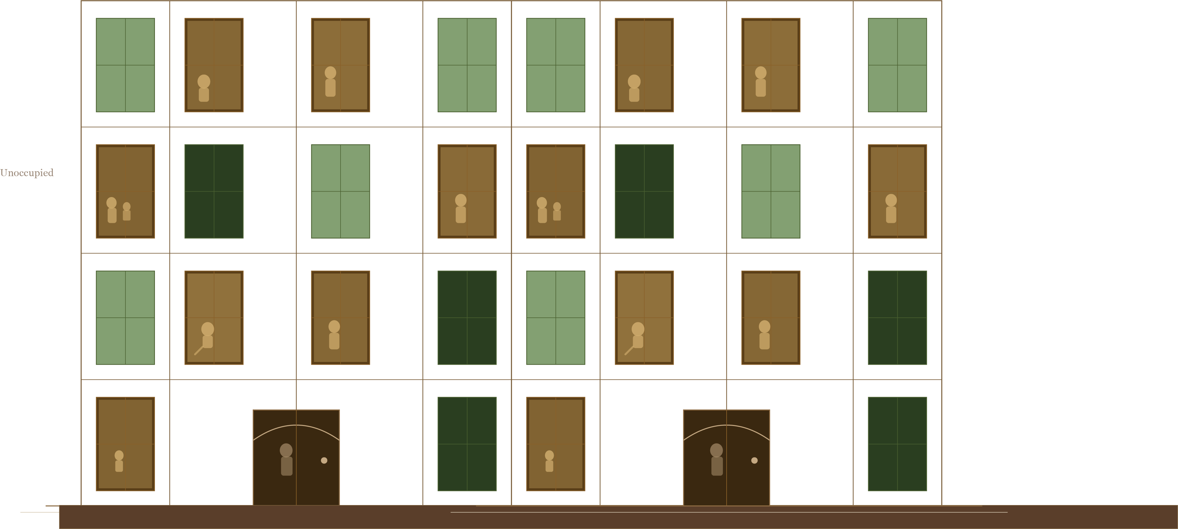

Defining Healthy Homes: Towards a Human-Centred Framework for Defining and Delivering Healthy Homes


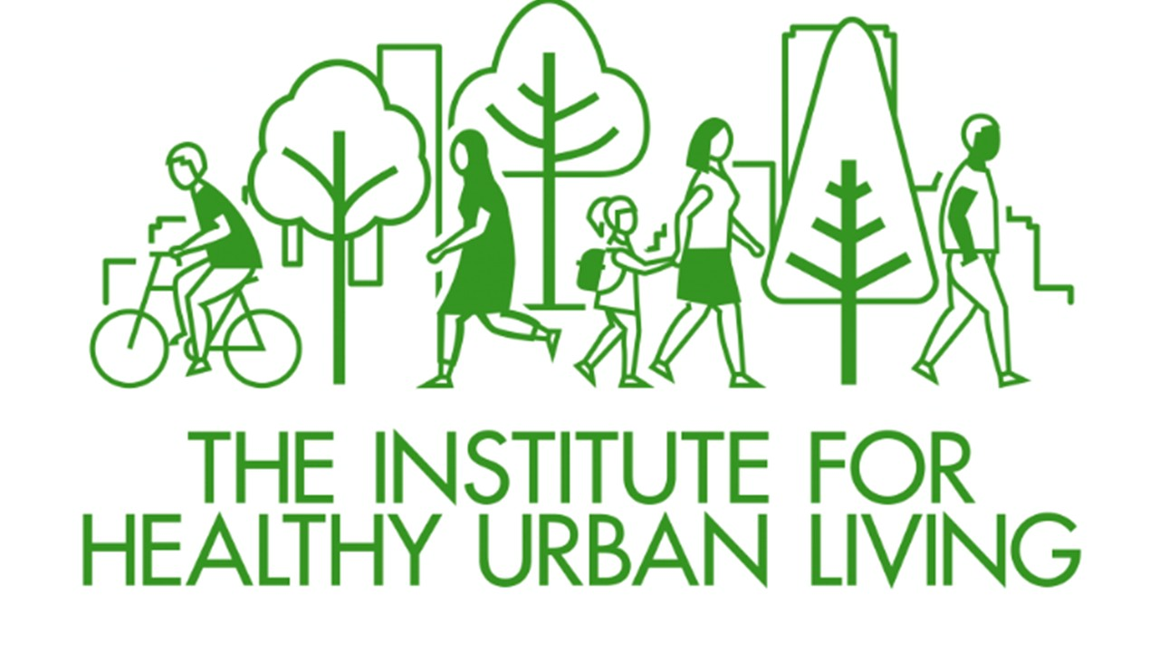


Table of Contents
Table of Abbreviations 3
Executive Summary 4
Introduction 6
Research Methodology 7
1.0. Defining Healthy Homes: Literature Review 9
1.1. Direct determinants of a Healthy Home : Measurable Risks 10
1.1.1 Indoor Temperature and Thermal Comfort: 11
1.1.2 Relative Humidity and Moisture Risk 11
1.1.3 Ventilation and Indoor Air Quality 11
1.1.4 Building Fabric and Energy Performance 12
1.1.5 Light 13
1.1.6 Noise 13
1.2 Regulatory frameworks for Housing Health in the UK 14
1.3 Beyond the Building: 15
1.3.1 Affordability, Access to Healthy Housing and Tenure: 15
1.3.2 Occupational Behaviour and Co-Production of Indoor Conditions: 17
1.4 Summary 18
2.0. Case Studies 20
2.1. Case Studies Part One 21
2.1.1 Poplar HARCA and HomeLINK 21
2.1.2 L&Q in partnership with ZapCarbon 23
2.1.3 Barrhead Housing and Aico - Scotland 24
2.2 Case Studies Part Two 26
2.2.1 Breathe Easy at Home (BEAH) 26
2.2.2 ECO4 Flex 29
2.2.3. Safe and Healthy Homes (SHH) - United Kingdom 31
2.2.4. Home Care for Patients with Dirty Homes 35
2.3. Discussion 37
3. Proposed interventions: Upgrading the systems of Poplar HARCA & L&Q 38
3.1 Healthy Homes Intervention Catalogue: Poplar HARCA Application 38
3.3. Feedback from Focus Study 40
Way Forward 43
Bibliography 44

Table of Abbreviations

AART | Admission Avoidance Resource Team
APPG | All-Party Parliamentary Group
BEMS | Building Energy Management Systems
EHS | English Housing Society
ECP | Emergency Care Practitioners
ECO | Energy Company Obligation
EPC | Energy Performance Certificate
DCLG | Department for Communities and Local Government
HHSRS | Housing Health and Safety Rating System
IAQ | Indoor Air Quality
IoT | Internet of Things
MEES | Minimum Energy Efficiency Standards
MHCLG | Ministry of Housing, Communities and Local Government
VOCs | Volatile Organic Compounds
WHO | World Health Organisation

Executive Summary

Housing has long been recognised as a primary determinant of health, yet despite nearly two centuries of legislative effort, more than 7.9 million people in the UK continue to live in homes classified as not decent, and those in poor quality housing are twice as likely to report poor general health (Institute of Health Equity, 2024; TCPA, 2025). This report, commissioned as the first stage of a broader research programme, sets out to develop a research-informed, stakeholder-validated framework for defining what constitutes a healthy home, and to identify the practical investment priorities most likely to improve resident health outcomes. The research is part of the University of Westminster’s Students as Researchers program, which encourages cross-collaboration among students from various fields, ranging from architecture to digital health and biomedical science as well as mentorship by academics and industry experts.
The report is structured around three interconnected stages. The first is a literature review examining international definitions, national regulatory frameworks, physical environmental indicators, structural inequalities, and occupant behaviour as they relate to housing and health. The second is a structured analysis of seven case studies drawn from the UK, the United States, and the Netherlands, selected to illustrate how housing-health interventions are designed and delivered across different institutional and geographical contexts. The third stage, to be completed in July 2026, involves a stakeholder focus group at which the findings of this report will be tested, refined, and translated into practical investment priorities.The literature review establishes that a healthy home cannot be defined through physical indicators alone. The literature further establishes that structural factors, including housing affordability, tenure insecurity, and the condition of the existing housing stock, shape who is exposed to housing-related health risks and to what degree, while occupant behaviour co-produces indoor environmental conditions in ways that neither regulatory inspection nor modelled assessments can adequately capture. Taken together, the evidence points to a persistent gap between what is known about housing-related health risk and the fragmented, reactive systems through which it is currently identified and addressed.
The case study analysis is organised into two groups reflecting distinct models of intervention. The first group, demonstrates how continuous IoT-based environmental monitoring can shift hazard identification from reactive to proactive, bypassing the systemic barrier of tenant under-reporting and enabling earlier, more targeted intervention. The second group, comprising demonstrates how cross-sector collaboration between various actors like housing officers, clinicians, inspectors, and community workers can produce genuinely integrated responses to housing-related health risks, operationalising a systems-level approach that no single professional or data source can achieve alone. The analysis reveals that neither model alone is sufficient, and the most effective model, implied by the evidence but not yet fully realised in any single case, would combine continuous environmental monitoring with integrated clinical referral pathways and proactive professional engagement, producing an approach that is not merely more efficient but fundamentally more human-centred.
Through these findings the research defines Healthy Home as one in which the conditions of the built environment are understood not only through measurable physical indicators but through the lived experience of the people within it, and in which the seamless integration of data across housing, health, and social care systems enables a coordinated, proactive response that places the occupant at the centre of every intervention. The forthcoming focus group will bring together housing providers, industry practitioners and leaders, environmental academics, local authority representatives, and resident advocates to test and refine this definition and to identify where targeted investment in sensor infrastructure, workforce development, data integration, regulatory enforcement, and building fabric improvement is most likely to produce meaningful and sustainable improvements in resident health.

GenAI Declaration:
ChatGPT (OpenAI, GPT-5.5), Google Gemini and Claude (Anthropic) were used to support literature discovery through keyword generation and exploratory searches, facilitate brainstorming of report structure and themes, and provide grammar and spelling suggestions. ResearchRabbit was used to identify related academic literature and citation networks during the literature search. All sources identified through these tools were independently verified by students, and all analysis, interpretation and final written content are the students' own.

Contributors :
Lead External Partner: Jenny Danson, Healthy Homes Hub
Lead Academic Advisor: Professor Rosa Schiano-Phan, School of Architecture and Cities, University of Westminster
Partnership Manager: Annalise Johns, Institute for Healthy Urban Living.
Programme Sponsor: Comfort Moye, University of Westminster.
PhD Student Lead: Kanaka Thakker, School of Architecture and Cities, University of Westminster.
Masters Students: Babatunde Balogun, MSc Artificial Intelligence and Digital Health, University of Westminster.
Nasir Yusuf, MSc Global Public Health with Data Science, University of Westminster.
Undergraduate Student: Safiya Muhammad-Bande, BSc Biomedical Science, University of Westminster.

Introduction
Housing is one of the most powerful determinants of human health, shaping physical wellbeing from birth through to old age. Its consequences extend far beyond the individual. Poor housing costs wider society at least £18.5 billion a year through poor educational achievement, loss of productivity, and on-costs to health and care services, including £1.4 billion a year to the NHS alone (Institute of Health Equity, 2024; TCPA, 2025). Yet despite this scale of impact, the concept of a healthy home remains contested, spanning physical, psychological, social, and economic dimensions that resist simple definition.
This report recognises that healthy homes is a vast and multi-faceted topic. In order to produce findings that are rigorous, actionable, and grounded in measurable evidence, the scope of this research is deliberately focused on the physical health dimension of housing quality. Within this defined scope, the report examines what physical conditions make a home healthy, how those conditions are currently measured and regulated, and what the evidence from real-world interventions tells us about how housing-related physical health risks can be most effectively identified, prevented, and addressed.

Objectives
The aim of this report is to produce a research-informed, stakeholder-validated framework for defining what constitutes a healthy home. To achieve this aim, the objectives of the research are as follows:
1. To co-produce a working definition of a "healthy home", starting from international literature and stakeholder input.
2. To engage with stakeholders via a focus group to test and refine this definition.
3. To identify practical investment priorities that improve resident health.

Research Methodology

The research design followed three stages:
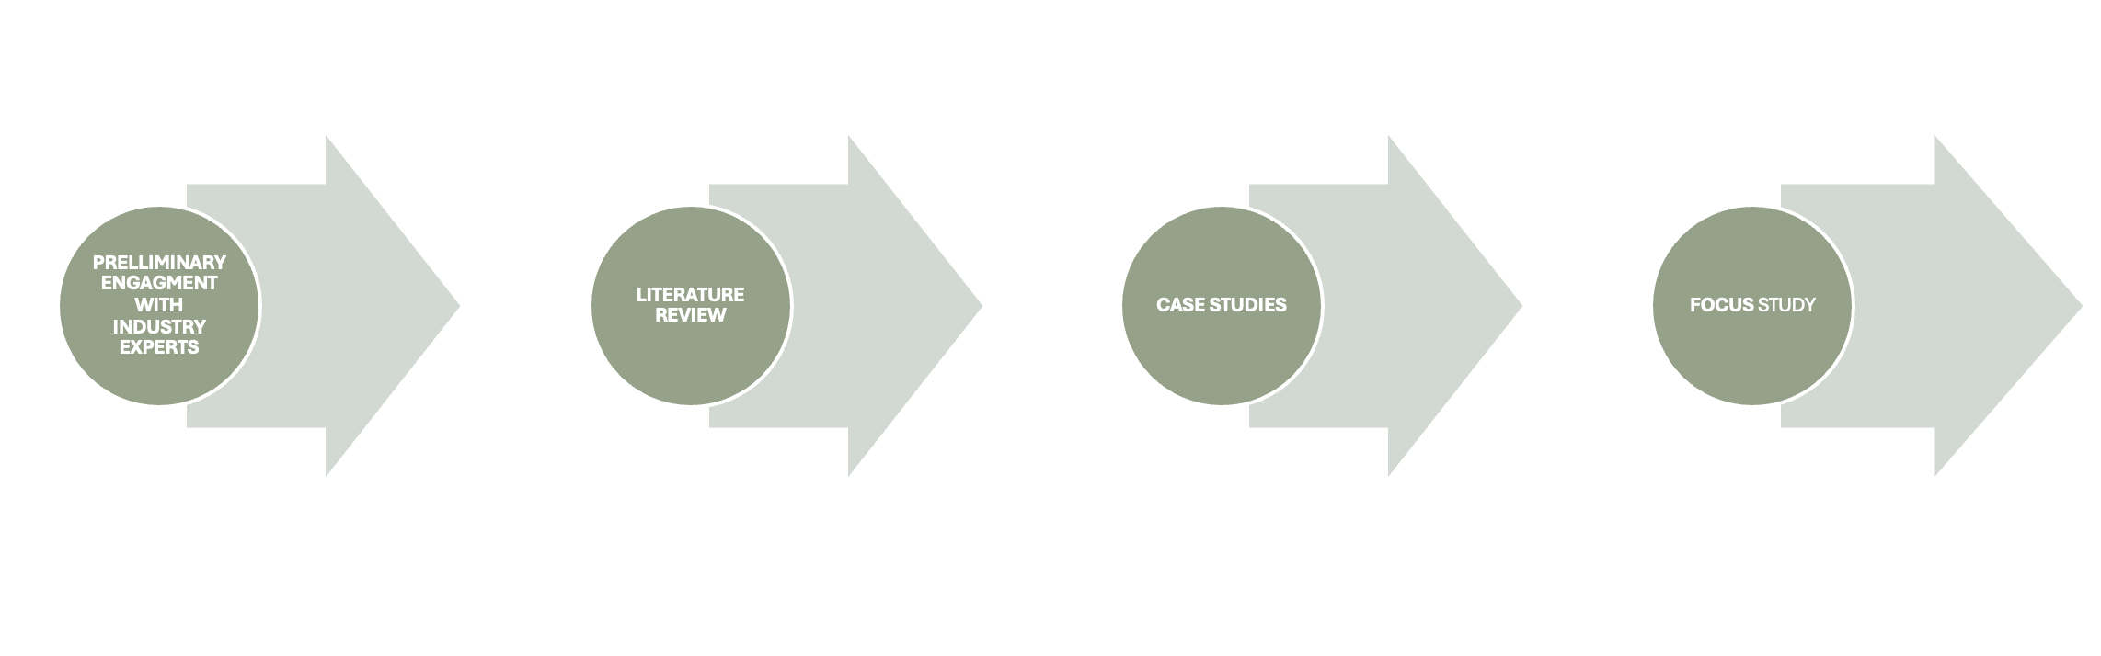
As the umbrella of ‘healthy home’ is broad, the first stage involved a preliminary engagement with the industry experts to seek guidance on conducting a literature review. Alongside prioritising the study of building codes, policies, and frameworks, a key suggestion from these discussions was to expand our perspective beyond the building industry and consider other actors, such as the health industry, in promoting the creation of a healthy home.
The second stage involved a literature review to understand the various arguments around healthy housing and was guided by the stage one. It was also influenced by the diverse expertise of the student team members in digital health, biomedical sciences and the built environment. The research reviewed literature spanning international debates and academic publications on what constitutes a healthy home, to national and local policies and regulatory frameworks that regulate them. These included, but were not limited to, the WHO Housing and Health Guidelines (2018), APPG for Healthy Homes and Buildings (2017), Housing Health and Safety Rating System (HHSRS), the Decent Homes Standard, and recent legislative developments such as Awaab's Law (2023). It also examined the approaches used to measure indoor environmental conditions, from regulatory inspection frameworks to high-resolution sensor monitoring, and assessed the limitations of each in capturing how homes actually perform under real-world occupancy. This review established a working definition of a healthy home and identified the key physical determinants of housing-related health risk as well as the impact of the lived experience of inhabitation.
The third stage involved analysing seven case studies drawn from the UK, the United States, and the Netherlands. These were selected to illustrate how housing-health interventions are initiated, structured, and delivered across different contexts. Cases included the Poplar HARCA and HomeLINK sensor pilot, L&Q's partnership with ZapCarbon, Barrhead Housing's 5G sensor programme, Breathe Easy at Home in Boston, ECO4 Flex in Wales, the Safe and Healthy Homes initiative in North Tyneside, and a Dutch qualitative study on home-care nursing in poor housing conditions. Each case was assessed for its approach to hazard identification, the mechanisms linking housing conditions to health outcomes, the role of different professional actors, and the extent to which it moved from reactive to proactive intervention. The learnings from the analysis were applied to suggest interventions to improve housing health.
The fourth stage involved a stakeholder focus group, which was held online on 29th June 2026 at which these preliminary findings were presented for critical discussion and validation. Participants included academics, housing practitioners, local authority officers, and representatives from health and voluntary sector organisations. Their feedback was used to refine the report's recommendations.

1.0. Defining Healthy Homes: Literature Review

Housing is increasingly recognised in the public health and policy literature as not just a form of shelter but as a primary determinant of health. The formal establishment of this link dates to the mid-19th century (1840s–1860s) during industrialisation. Pathologist Rudolf Virchow and social reformers like Friedrich Engels highlighted that poor, crowded housing led to infectious disease outbreaks, such as cholera (Harvey, 2021). Legislative responses followed, beginning with the Nuisances Removal and Disease Prevention Act of 1846 and continuing through a series of Public Health Acts in 1848, 1872, and 1875, each of which progressively formalised the state's responsibility for regulating the conditions in which people lived (Razaq and Baybutt, 2024).

Despite this long history of recognition, the problem persists at scale: more than 7.9 million people in the UK today live in homes that are classified as 'not decent', and people living in poor quality housing are twice as likely to report poor general health than those who do not (Institute Of Health Equity, 2024; TCPA, 2025). Evidence shows that individuals spend approximately 70-90% of their time indoors. This prolonged exposure increases the impact of these environmental conditions, reinforcing their relevance as primary determinants of health (APPG for Healthy Homes and Buildings, 2017; Bentley et al., 2025). It is therefore important that this research examines the conditions of the home environment through the lens of established health and regulatory frameworks, to better understand how specific housing characteristics contribute to health outcomes and to inform standards that reflect the full complexity of what it means to live in a healthy home.

Internationally, the WHO defines a healthy home as a structurally sound physical environment that actively promotes health by providing adequate shelter, comfortable temperatures, sanitation, and protection from pollutants, moisture, and pests (WHO, 2018). The UN Office of the High Commissioner for Human Rights extends this definition beyond the physical, framing the right to adequate housing as encompassing security of tenure, cultural adequacy, and access to appropriate services, schools, and employment (UN OHCHR, 2020). Research demonstrates that exposure to housing conditions such as indoor temperature, air quality, and moisture has direct effects on physical health outcomes, including respiratory and cardiovascular conditions (Bentley et al., 2025; Rolfe et al., 2020).

In the UK context, regulatory frameworks define healthy homes in terms of specific hazards. The Housing Health and Safety Rating System (HHSRS) identifies 29 categories of housing-related hazards, including damp and mould, excess cold, and indoor pollutants, all of which are assessed based on their potential impact on health (MHCLG, 2006). Similarly, the Decent Homes Standard establishes minimum requirements for housing quality, including thermal comfort, structural repair, and safety compliance (MHCLG, 2006). In addition to national standards, government-led and policy-oriented frameworks link housing design, construction, and maintenance to environmental performance outcomes. For example, the All-Party Parliamentary Group (APPG) for Healthy Homes and Buildings published a white paper, titled ‘Building Our Future: Laying the Foundations for Healthy Homes and Buildings’, which advocates a holistic, integrated approach to housing standards. Specifically, this approach indicates that housing upgrades must not be executed in isolation. For example, improving a home's thermal efficiency to meet energy targets without simultaneously addressing ventilation can trap moisture and create severe mould hazards (APPG for Healthy Homes and Buildings, 2018). However, alongside these regulatory frameworks, the Healthy Homes Principles, developed by a coalition of housing, health, and development organisations and published by the TCPA broadens the definition of a healthy home beyond minimum building standards to encompass affordability, tenure security, access to nature and amenities, climate resilience, and protection from air, light, and noise pollution, reflecting a growing consensus that housing quality cannot be reduced to physical hazards alone (TCPA, 2025). Taken together, these frameworks reveal that defining and achieving a healthy home requires not only meeting minimum physical standards but adopting a systems-level approach that recognises the interconnected nature of housing, health, and the wider social and environmental context in which people live. The sections that follow examine the measurable physical conditions through which housing affects health, before considering the broader contextual factors that shape the environments in which people live.

1.1. Direct determinants of a Healthy Home : Measurable Risks

This section defines a healthy home in practical terms by identifying indicators that can be objectively measured, monitored, and acted upon. The Department for Communities and Local Government UK defines measurable, preventable physical risks in housing as identifiable environmental hazards, such as damp, excess cold, and indoor pollutants, that can be quantified through inspection or assessment tools and mitigated through maintenance, repair, or regulatory intervention (MHCLG, 2006). Baily Garner defines measurable, preventable physical risks as environmental conditions within the home, such as elevated humidity, poor ventilation, and inadequate temperature control, that can be monitored using physical indicators and reduced through appropriate design, ventilation, and heating strategies (Baily Garner, 2023). Empirical evidence further supports this relationship between housing conditions and health outcomes. Longitudinal studies have shown that improvements in housing quality, particularly in heating, insulation, and structural conditions, are associated with reductions in hospital admissions and improvements in health outcomes (Rodgers et al., 2018). Similarly, housing upgrade programmes have been linked to improved housing satisfaction, demonstrating that changes in measurable housing conditions can produce observable health benefits (Poortinga et al., 2017). International and national frameworks consistently identify temperature, humidity, ventilation, air quality, and structural integrity as the core parameters through which housing conditions can be objectively assessed and linked to adverse health outcomes (WHO, 2018; DCLG, 2006). The following subsections examine each of these indicators in turn.

1.1.1 Indoor Temperature and Thermal Comfort:
Indoor temperature is one of the most fundamental and well-evidenced indicators of housing quality. Exposure to low indoor temperatures is associated with increased cardiovascular and respiratory risks, particularly where homes are unable to retain heat due to poor insulation or inefficient heating systems (WHO, 2018). In UK policy contexts, excess cold is identified as a Category 1 hazard under the Housing Health and Safety Rating System, reflecting the measurable risk posed by sustained low indoor temperatures (Department for Communities and Local Government, 2006). Temperature is therefore a fundamental indicator that can be continuously monitored and directly linked to building performance and energy efficiency. The WHO recommends a minimum indoor temperature of 18°C for healthy adults, with higher thresholds of 20-21°C recommended for households containing elderly residents, young children, or those with pre-existing health conditions (WHO, 2018). Thermal vulnerability also extends to overheating; CIBSE TM59 imposes a severe Sleep Safety standard, classifying an unhealthy dwelling as having bedroom temperatures above 26°C for more than 1% of the night (CIBSE,2022

1.1.2 Relative Humidity and Moisture Risk
Relative humidity is the second critical indicator, and it is particularly important in relation to the formation of damp and mould within homes. Empirical and technical guidance indicates that sustained indoor humidity above approximately 70% significantly increases the likelihood of condensation and mould growth on internal surfaces, while levels between approximately 45% and 60% are considered optimal for minimising these risks (Bailey Garner, 2023). Temperature and humidity interact directly to shape indoor moisture conditions; lower indoor temperatures reduce the capacity of air to hold moisture, increasing the likelihood of condensation forming on cold surfaces such as external walls and windows, an effect that is particularly pronounced in poorly insulated homes (DCLG, 2006). The interaction between low temperature and high humidity therefore represents a key mechanism through which housing conditions translate into measurable health risks, particularly respiratory illness. Damp and mould are classified as Category 1 hazards under the HHSRS, reflecting the strength of evidence linking moisture-related housing conditions to adverse health outcomes (ibid). WHO has identified sufficient evidence of a causal association between indoor dampness and respiratory conditions, estimating that approximately 15% of new childhood asthma cases in Europe are attributable to indoor dampness, representing over 69,000 potentially avoidable disability-adjusted life years annually and increasing the overall risk of respiratory conditions by approximately 30 to 50% (WHO, 2018).

1.1.3 Ventilation and Indoor Air Quality
Ventilation performance, is commonly assessed using carbon dioxide (CO₂) concentrations as a proxy. Elevated CO₂ levels indicate inadequate air exchange, which contributes to the accumulation of indoor pollutants and moisture. UK guidance suggests that CO₂ concentrations above 1500 ppm are associated with poor ventilation conditions, while lower levels indicate more effective air circulation (Department for Education, 2026). As a continuous, quantifiable metric, CO₂ provides a practical indicator of ventilation efficiency in occupied spaces.
Unlike CO₂, which acts as an indirect proxy, IAQ indicators directly measure pollutant concentrations, providing a more comprehensive assessment of exposure risk within indoor environments. Indoor air quality (IAQ) extends beyond ventilation performance to encompass a broader range of pollutants, including particulate matter, volatile organic compounds (VOCs), and biological contaminants such as mould spores and dust mites. NICE guidance identifies poor indoor air quality as a significant health risk, particularly in homes affected by damp, overcrowding, and inadequate ventilation (NICE, 2020). The WHO highlights that prolonged exposure to indoor air pollutants is associated with respiratory and cardiovascular conditions, and estimates that in 2016, 3.8 million deaths globally were attributable to household air pollution, almost all of which occurred in low- and middle-income countries (WHO, 2018). Frameworks like PAS 2035 underscore the necessity for homes to function as precisely ventilated systems; renovating a structure to achieve high airtightness for energy efficiency without incorporating sufficient background ventilation can trap everyday moisture, leading to the spread of hazardous mould (Rickaby, 2023). However, ventilation strategies must also account for the quality of outdoor air, particularly in urban areas where traffic-related pollution may compromise indoor environmental quality. Healthy homes should therefore not only remove indoor-generated pollutants but also reduce occupants' exposure to outdoor air pollution. The death of nine-year-old Ella Kissi-Debrah in Lewisham, the first in the UK to have air pollution formally recognised as a contributing cause of death, underscores the severe health impacts of prolonged exposure to traffic-related pollutants and highlights the importance of considering outdoor air quality alongside indoor environmental conditions when assessing healthy homes (Rondel, 2025).

1.1.4 Building Fabric and Energy Performance
Underpinning all of the environmental indicators discussed in the preceding subsections is the physical condition and energy performance of the building itself. Architects, planners, and surveyors shape key environmental factors such as insulation, ventilation, and structural integrity, which directly affect indoor temperature, moisture levels, and air quality. Insulation quality, the condition of the building fabric, and the efficiency of heating systems collectively determine a dwelling's capacity to maintain stable indoor temperatures and prevent moisture ingress, directly shaping the environmental conditions that temperature, humidity, ventilation, and air quality indicators seek to capture. Building surveyors play a diagnostic role in identifying structural issues that contribute to these conditions, assessing defects such as damp penetration, inadequate insulation, or ventilation failures that may not be visible without technical inspection (Parrett, 2016). Architects and planners similarly shape key environmental factors through decisions about insulation, ventilation design, and structural integrity, all of which have direct downstream effects on indoor temperature, moisture levels, and air quality within occupied dwellings. The HHSRS and the Decent Homes Standard both incorporate building fabric condition as a central component of housing quality assessment, recognising that structural deficiencies such as disrepair, inadequate insulation, and failing heating systems are primary drivers of the hazards they seek to regulate (DCLG, 2006).
Energy Performance Certificates (EPCs) provide the primary standardised measure of a building's energy efficiency in the UK, rating properties from A to G based on insulation quality, heating system performance, and construction characteristics (UK Government, 2012). EPC provides a standardised measure of housing energy efficiency, rating properties from A to G based on energy use, insulation, and heating performance. Under the MEES, rental properties in England are required to meet a minimum EPC rating of E, with policy proposals aiming to increase this to C by 2030 (UK Government, 2012; UK Government, 2023).

1.1.5 Light
Light is a fundamental physical determinant of a healthy home, with important implications for both physiological functioning and psychological well-being. Baker and Steemers (2019) trace this relationship from ancient heliotherapy practices to modern understandings of circadian biology, arguing that because people spend approximately 70% of their lives at home, access to natural light should be considered a core principle of healthy housing rather than a peripheral design feature. A systematic review by Osibona, Solomon, and Fecht identifies lighting as a central component of housing quality, highlighting that daylight supports visual performance, safety, alertness, and healthy sleep-wake cycles by influencing circadian rhythms and melatonin secretion. Reflecting this evidence, key living spaces should be designed to receive adequate daylight and direct sunlight wherever possible. It is also important to consider that excessively illuminated interior spaces, may reduce comfort and create glare (Baker and Steemers, 2019). Together, these findings suggest that healthy homes should maximise access to daylight during the day while minimising inappropriate light exposure at night, thereby supporting sleep quality, comfort, and overall well-being (Baker and Steemers, 2019; Osibona, Solomon, and Fecht, 2021).

1.1.6 Noise
Noise is an important physical determinant of a healthy home because the acoustic environment can influence residents' well-being, comfort, and ability to rest. Baker and Steemers describe the sound climate of a dwelling as ranging from positive sounds, such as birdsong, to unwanted environmental noise that may contribute to stress and sleep disturbance. Similarly, the WHO (2018) identifies environmental noise as a significant housing-related health hazard, originating from external sources such as road traffic, railways, aircraft, and industry, as well as internal sources including building services and neighbouring occupants. Because people spend prolonged periods within the home, both sources emphasise the importance of considering acoustic conditions during housing planning and design, including measures to assess and reduce residential noise exposure (Baker and Steemers, 2019; WHO, 2018).
Evidence from residential settings demonstrates that noise disturbances are common and associated with adverse health outcomes. In a national study of Swedish multi-family housing, Wang and Norbäck found that noise disturbance from neighbours and road traffic were among the most frequently reported sources of residential noise. All forms of noise disturbance were associated with an increased prevalence of tiredness, headaches and difficulty concentrating, suggesting that noise can directly affect daily functioning and well-being (Wang and Norbäck, 2021). The authors further found that living in rented accommodation, residing in older buildings, and living in densely populated areas were associated with greater noise disturbance (Wang and Norbäck, 2021). These findings support WHO guidance recommending reductions in environmental noise exposure, particularly at night, to prevent sleep disruption and other adverse health effects (WHO, 2018). Collectively, the evidence suggests that a healthy home should minimise exposure to both internal and external noise sources to support sleep quality, cognitive functioning, and long-term health outcomes (WHO, 2018; Wang and Norbäck, 2021).

1.2 Regulatory frameworks for Housing Health in the UK

UK housing policies mandate health through regulations focusing on safety, sanitation, and repair, primarily enforced via the Homes (Fitness for Human Habitation) Act of 2018 and the HHSRS under the Housing Act of 2004 (Chartered Institute of Housing, 2019). These mandate that rental properties are free from serious hazards. These hazards are assessed using a risk-based methodology, which links measurable environmental conditions, such as temperature and moisture levels, to potential health outcomes.
A significant recent development in the regulatory landscape is the introduction of Awaab's Law, implemented under the Social Housing (Regulation) Act 2023. The legislation was introduced following the death of two-year-old Awaab Ishak in 2020, whose death was directly attributed to prolonged exposure to damp and mould in a social housing property, and represents a legislative response to evidence that hazards were not being addressed with sufficient urgency within existing frameworks (DLUHC, 2025). Awaab's Law introduces legally binding timeframes for social landlords to investigate and remediate hazards posing risks to tenant health. Specifically, landlords are required to make emergency hazards safe within 24 hours, to investigate reported damp and mould within 10 working days, to provide findings to tenants within 3 days of completing the investigation, and to complete remedial works within specified timeframes determined by the severity of the hazard (DLUHC, 2025).This legislation represents a meaningful shift in the regulatory approach to housing health, moving from a framework based on broad obligations towards one with specific, enforceable timelines that create direct accountability for outcomes. The introduction of time-bound requirements reflects a recognition that the speed of response is itself a health determinant, and that prolonged exposure to hazards during lengthy remediation processes carries independent health consequences.
Beyond national legislative frameworks, local authorities play a critical role in operationalising housing health regulation through inspection, enforcement, and property licensing schemes. Local councils have powers under the Housing Act 2004 to issue improvement notices and prohibition orders requiring landlords to address identified hazards within specified timeframes, with enforcement action available where compliance is not achieved (DCLG, 2006). Property licensing schemes represent a further mechanism through which local authorities seek to raise and maintain housing standards within their areas. For example, Newham London Borough Council has implemented one of the most extensive property licensing schemes in England, requiring landlords to meet minimum housing standards and to respond to hazards within specified timeframes as a condition of their licence (Newham London Borough, 2023). Selective licensing approaches similarly emphasise collaborative enforcement mechanisms that link housing regulation with broader public health objectives, reinforcing accountability for housing conditions at the local level (Oatt, 2019)

1.3 Beyond the Building:

While the preceding sections established the measurable physical indicators through which housing conditions affect health, the extent to which individuals can access and maintain healthy indoor environments is shaped by a broader set of structural and behavioural factors. These indirect determinants, including housing affordability, tenure security, habitability, and occupant behaviour, do not operate independently but interact to produce unequal health outcomes across populations. This section examines each of these factors in turn before considering how they combine to shape lived experience within the home.

1.3.1 Affordability, Access to Healthy Housing and Tenure:
Affordability refers to households' financial capacity to secure and maintain adequate housing without compromising other essential needs. Affordability also determines the type and quality of housing that households can access, often leading lower-income groups to occupy properties with pre-existing environmental hazards, including poor insulation, inadequate ventilation systems, and structural defects that contribute to damp and mould (Bentley et al., 2025). Evidence shows that households in financially constrained situations are more likely to live in substandard housing, where landlords may underinvest in maintenance and improvements (Rolfe et al. ,2020). As a result, affordability shapes both housing access and exposure to measurable environmental risks, reinforcing existing inequalities. In the context of healthy homes, affordability also acts as a primary driver of inequality by limiting access to housing that meets basic environmental standards, such as adequate heating, insulation, and ventilation (Rolfe et al., 2020). In homes affected by fuel poverty, occupants may heat only specific rooms or for limited periods, resulting in uneven temperature distribution and prolonged exposure to cold indoor environments. Households facing high energy costs may reduce or avoid heating usage during winter, resulting in indoor temperatures falling below safe levels and increasing exposure to excess cold and damp conditions. For example, households with children who had asthma frequently maintained lower indoor temperatures during winter due to financial constraints, even when aware of the associated health risks, resulting in indoor environments that were colder and more humid than recommended and increasing the likelihood of respiratory symptoms. (Tod et al., 2016). Affordability therefore shapes not only access to housing but also the ability to sustain healthy indoor environments once housed.
Addressing fuel poverty therefore requires structural improvements to the housing stock rather than solely reducing energy costs. Much of the UK's existing housing stock has poor thermal performance due to inadequate insulation and inefficient building fabric, requiring greater energy consumption to maintain healthy indoor temperatures and placing disproportionate financial pressure on low-income households. Consequently, improving the energy efficiency of existing homes has become a critical priority for both reducing fuel poverty and achieving net-zero targets. The Committee on Climate Change (2018) estimated that approximately 29 million UK homes will require retrofitting by 2050, representing one of the largest infrastructure challenges facing the country (CCC, 2018).
At the European level, evidence shows that these pressures are increasingly difficult to address due to rising housing costs. Approximately 10% of households in European cities spend more than 40% of their disposable income on housing, a level widely considered unaffordable, while in some countries such as Greece, housing costs account for over one-third of average household income (Eurostat, 2025). These pressures extend beyond Europe. Comparative studies across Europe and North America show that housing affordability pressures are driven by structural factors including constrained housing supply, rising construction costs, and increasing demand in urban areas, with housing prices growing faster than wages and reducing access to adequate housing (UN-Habitat, 2023). The global housing trends presented in Farha et al. (2022) further reinforce this structural dimension, illustrating the widening gap between house prices and wage growth across multiple regions. Data from countries including Germany, New Zealand, Chile, and Mexico show that nominal house prices had risen to index levels above 130 to 145 by 2020, while wages in the same period increased only marginally, often remaining close to 100 to 110, indicating that housing is becoming progressively less affordable even across the Global North (Farha et al., 2022).
Tenure shapes both housing quality and the ability of occupants to address hazards when they arise. Findings from Farha et al. (2022) indicate that tenants in the private rented sector are more likely to experience poor housing conditions due to weaker control over repairs and reliance on landlords' compliance with regulatory standards. Tenure therefore influences not only access to housing but also the degree of agency that occupants have over their indoor environment, making it a key structural driver of housing-related inequality.The slowing of social housing construction, coupled with the financialisation of the housing market, has forced a larger share of vulnerable tenants into the private rented sector, often the most expensive and least well-maintained form of tenure (Farha et al., 2022). This is particularly evident in London, where 30.1% of households are now privately rented, the highest proportion since 1971, reflecting how the financialisation of housing in major urban centres has driven a significant shift away from owner-occupation and social housing, increasing exposure to measurable risks such as overcrowding, inadequate heating, and poor ventilation (Trust for London, 2024). Tenants in high-cost rental markets may also accept substandard housing conditions due to limited alternatives, reinforcing the connection between tenure insecurity and sustained exposure to measurable environmental hazards (Rolfe et al., 2020).
Habitability refers to the physical condition of a dwelling and its ability to provide a safe and healthy living environment, encompassing measurable factors such as indoor temperature, humidity, air quality, structural safety, and protection from hazards such as damp and mould (DCLG, 2006). In practice, habitability is assessed through frameworks such as the HHSRS, which evaluates whether housing conditions pose risks to health. For example, sustained indoor humidity above recommended thresholds can lead to mould growth, while inadequate heating systems can result in excess cold (Bailey Garner, 2023). In the UK context, this physical risk is further compounded by the country's architectural history. The UK possesses an exceptionally high proportion of pre-1919 homes, which often lack modern moisture-proofing and thermal efficiency standards, placing a disproportionate environmental and financial burden on vulnerable tenants and effectively embedding health inequalities into the physical housing stock itself (Building Research Establishment, 2020).Habitability therefore translates housing inequality into observable and assessable physical risks, providing the link between the structural factors discussed above and the environmental indicators examined in section 1.1. The intersection of affordability, tenure, and habitability produces compounding disadvantage for the most vulnerable households. A low-income household renting privately may face high rents that limit its ability to move to better-quality housing, while simultaneously relying on a landlord to address environmental hazards. This creates a situation in which affordability constraints, tenure insecurity, and poor habitability reinforce one another, leading to sustained exposure to unhealthy housing conditions (Rolfe et al., 2020; Bentley et al., 2025).

1.3.2 Occupational Behaviour and Co-Production of Indoor Conditions:
Housing conditions are not determined solely by physical structures but are significantly shaped by the everyday behaviours and practices of occupants. Internet of Things (IoT) technologies comprise networks of interconnected sensors and computing systems that continuously collect, transmit and visualise real-time environmental data. Within the built environment, IoT systems have been successfully integrated with Building Energy Management Systems (BEMS) to monitor environmental parameters such as temperature, relative humidity, carbon dioxide, illuminance and noise levels, providing high-resolution data that supports building performance assessment, occupant awareness and informed decision-making (Hossain et al., 2020). For example, Carbon dioxide levels serve as a quantitative indicator of indoor air quality, but their temporal variation also provides qualitative insight into occupant behaviour, including ventilation practices and occupancy patterns (Ratcliffe, 2026). Households where cooking and bathing generate short-term humidity spikes illustrate this clearly; without adequate ventilation, these spikes accumulate over time, leading to persistent damp conditions(Bailey Garner, 2023). In homes where occupants close windows to conserve heat during winter, reduced air exchange results in increased accumulation of moisture and pollutants, while drying clothes indoors without sufficient ventilation causes repeated humidity spikes that contribute to mould growth over time. (Tod et al., 2016). These patterns demonstrate that indoor environmental conditions are co-produced through the interaction between building systems and occupant practices.
Understanding how indoor conditions develop and fluctuate in response to occupant behaviour requires data of sufficient granularity and temporal resolution. High-resolution monitoring, such as 10-minute-interval sensor data, enables the detection of short-term fluctuations in temperature, humidity, and CO₂ that accumulate into long-term health risks but would remain invisible to periodic inspection or static assessment tools (Ratcliffe, 2026). CIBSE TM68 formalises this position, asserting that assessments of indoor environmental quality need to be performed during the operational stage and for a prolonged period, ideally over weeks or months, or integrated as a permanent feature of the building system, precisely because occupant-driven conditions cannot be captured through one-time visits or modelled predictions (CIBSE, 2022). BS 40101 similarly specifies that building performance evaluation should integrate physical measurements alongside observation and user experience, recognising that the interaction between building systems and occupant behaviour produces conditions that no single static measure can adequately represent (BSI, 2022). By contrast, tools such as EPCs, which are issued only at the point of transaction and based on modelled assumptions rather than operational data, have been shown to diverge consistently from actual energy performance, with between 36% and 62% of certificates containing errors sufficient to misclassify a property's efficiency band (Gram-Hanssen and Georg, 2018; Hardy and Glew, 2019). Granular, continuous monitoring therefore represents not merely a technical enhancement but a fundamental shift in how housing conditions are understood, moving assessment from a snapshot of what a building is designed to do towards an evidence-based picture of how it actually performs under real occupancy.

1.4 Summary

The literature reviewed in sections above establishes that housing-related health risk is produced through the interaction of measurable physical conditions, regulatory frameworks, structural inequalities, and occupant behaviour. Taken together, these dimensions reveal that understanding and addressing poor housing requires more than identifying individual hazards; it demands an integrated approach that connects environmental evidence to clinical outcomes, regulatory action, and lived experience. The following section applies this understanding to a set of real-world case studies, examining how housing-health interventions are designed and delivered in practice, and the extent to which they reflect the integrated, proactive, and evidence-based approach that the literature calls for. It does so through a framework that draws on four interconnected mechanisms established in the preceding literature review:
The first mechanism examines hazard identification, specifically the extent to which each case moves beyond static, point-in-time assessment tools such as EPC ratings and periodic inspections towards dynamic, continuous approaches capable of capturing the fluctuating indoor environmental conditions that accumulate into long-term health risks (Hardy and Glew, 2019; CIBSE, 2022; BSI, 2022).
The second mechanism examines the mechanisms linking housing conditions to health outcomes, assessing whether each case is grounded in the specific physical pathways, including the interaction between temperature, humidity, ventilation, and air quality, through which housing conditions translate into respiratory, cardiovascular, and other adverse health outcomes, (WHO, 2018; Bailey Garner, 2023; NICE, 2020).
The third mechanism examines the role of professional actors and institutional frameworks, considering how different professionals, including housing officers, surveyors, clinicians, and community workers, collaborate or operate in silos, and how regulatory frameworks such as the HHSRS, Awaab's Law, and local authority licensing schemes enable or constrain effective intervention (MHCLG, 2006; DLUHC, 2025; Chartered Institute of Housing, 2019).
The fourth mechanism positions each case on a reactive to proactive spectrum, examining the extent to which intervention anticipates and prevents housing-related health harm rather than responding to it after it has already occurred, and considering how structural factors including affordability, tenure insecurity, and digital exclusion shape the feasibility of proactive approaches across different contexts (Rolfe et al., 2020; Tod et al., 2016; DLUHC, 2025).

2.0. Case Studies

Given the substantive differences in approach and institutional context across the chosen seven case studies, the analysis is organised into two groups that reflect meaningfully distinct models of housing-health intervention.
Part One examines three cases in which IoT sensor technology is the primary mechanism for identifying and responding to housing-related health risks: Poplar HARCA in partnership with HomeLINK, L&Q in partnership with ZapCarbon, and Barrhead Housing in partnership with Aico. These cases share a common logic of continuous monitoring and data-driven, proactive outreach, and collectively represent the most technologically advanced end of the intervention spectrum examined in this analysis. They are drawn primarily from the social housing sector.
Part Two examines four cases in which various actors, including clinicians, housing officers, home-care nurses, and community workers, are the primary mechanism through which housing-related health risks are identified and addressed: Breathe Easy at Home in Boston, ECO4 Flex in Wales, the Safe and Healthy Homes initiative in North Tyneside including the direct referral pathway to ECP and AART services, and the Dutch qualitative study on home-care nursing in poor housing conditions. These cases are characterised by cross-sector collaboration, relationship-based referral, and human observation rather than continuous data, and they sit closer to the reactive end of the intervention spectrum, though with meaningful variation between them.
Figure 1: Two-Part Structure for Analysis of case studies, Image Courtesy: Author
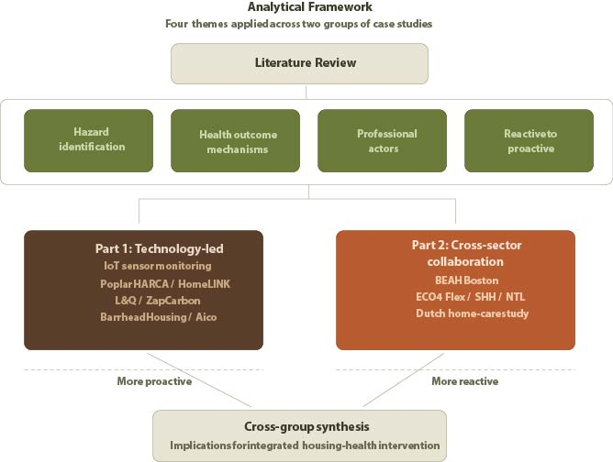

This two-part structure (Fig. 1) is not intended to rank one approach above the other. Rather, it reflects a recognition that technology-led and people-led models of intervention operate according to different logics, engage different professional actors, and address different dimensions of the housing-health relationship. Examining them separately before drawing cross-group comparisons allows the strengths and limitations of each approach to be assessed on their own terms, before considering what a more integrated model might look like.

2.1. Case Studies Part One

2.1.1 Poplar HARCA and HomeLINK

Location: London,
Year of implementation: 2018/2019.
Poplar HARCA identified persistent damp and mould problems in one of the most densely populated areas of East London, where long-standing overcrowding and damp and mould affected sections of its predominantly 1960s post-war housing stock. Initially, housing management relied largely on reactive responses to tenant complaints, requiring surveyors to investigate issues after problems had already emerged. To reduce this reactive approach and identify risks earlier, Poplar HARCA partnered with HomeLINK and deployed IoT environmental sensors capable of monitoring temperature, humidity and carbon dioxide levels, enabling earlier intervention before mould became severe or visible property damage occurred (Healthy Homes Hub, 2024; IoT Now, 2023).

Intervention:
- Pilot and Scale-up: The initiative began as an innovation project trialling sensors in 50 homes, later scaling up with a commitment to install the technology in nearly two-thirds of its 10,000 homes.
- Real-time Monitoring: Smart sensors continuously track metrics such as humidity and temperature and link directly to a resident app.
- Dual-Alert System: Rag-rated alerts are sent simultaneously to the resident and the landlord when specific thresholds indicate a risk of a damp, mould, or cold home.
- Preventive Maintenance: The landlord uses algorithms to identify the root causes of moisture accumulation, enabling preventive maintenance rather than reactive cleaning.

Safeguarding Outreach: When sensor data flags a cold home risk, the landlord's safeguarding team proactively contacts the resident to offer support and guidance on fuel poverty schemes.

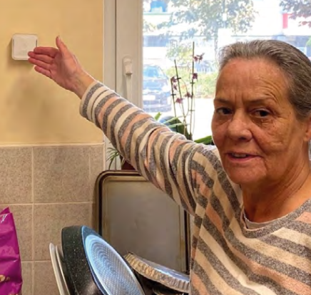
Figure 2: Smart IOT sensor installed in a resident home, Image courtesy: Healthy Homes Hub

Table of Pros and Cons:
S/N | Pros | Cons
1 | Shifts the landlord from reactive repairs to preventative maintenance by addressing the root causes of mould before residents are put at risk. | Initial rollout faced resistance from residents who felt the sensors were a Big Brother surveillance tool, requiring significant ongoing engagement to build trust.
2 | Transparent data sharing means both landlord and resident see the same alerts, helping residents understand their home and building trust. | Purchasing the sensors is only the first step; extracting value requires total business transformation, staff training, and the creation of entirely new internal processes.
3 | Delivers co-benefits by using temperature data to identify vulnerable residents struggling with fuel poverty, triggering proactive safeguarding interventions.

2.1.2 L&Q in partnership with ZapCarbon
Location: London
Year of implementation: 2018.
L&Q, a large urban housing provider, faced widespread issues with dampness and mould across its ageing stock, compounded by limited resources and competing post-Grenfell fire safety priorities. The landlord previously treated mould on a case-by-case basis with wash kits, without understanding the root cause or the true scale of the problem, as residents often failed to report issues early. After ZapCarbon identified a strong correlation between fuel poverty, underheating, and severe mould outbreaks, the two organisations launched an investigative pilot that eventually scaled to nearly 17,000 homes. The initiative uses a four-phase methodology to not only treat mould but also actively prevent its return (Healthy Homes Hub 'Pioneering Data-Driven Housing Solutions').
Interventions:
- Installation and Monitoring: ZapCarbon installs smart IoT sensors (requiring no mains or WiFi) to provide round-the-clock data on air quality, temperature, and humidity.
- Proactive Assessments: Sensor data triggers specially trained staff to conduct bespoke home checks and assess risks before the resident even reports a problem.
- Treatment and Shielding: Identified mould is cleaned and treated with a patented, non-toxic HealthyHomes Shield that kills the mould and delays its return, buying time for structural repairs.
- Ongoing Resident Support: Through the Healthy Homes Empower programme, residents receive a tailored action plan, phone support, and face-to-face education to help them manage their indoor environment over the long term.


Figure 3: Residents receive personalised guidance and a targeted action plan to tackle mould and create a healthier home environment, Image courtesy: Healthy Homes Hub
Table of Pros and Cons:
S/N | Pros | Cons
1 | Bypasses tenant under-reporting by automatically flagging unhealthy environments, enabling data-driven triage of widespread problems. | The mold shield serves as a temporary preventive measure, meaning the landlord must still fund and execute permanent structural repairs to address the root cause.
2 | Provides a holistic, end-to-end service combining digital monitoring with physical treatments and highly valued face-to-face resident support. | Generating automated risk alerts across 17,000 properties risks overwhelming an already strained maintenance workforce.
3 | Improved tenant-landlord trust through hands-on, empathetic support from operatives who assisted vulnerable residents with practical tasks during assessments. | The final empowerment phase places significant responsibility on the resident to execute the tailored action plan and maintain the environment.

2.1.3 Barrhead Housing and Aico - Scotland
Location: Scotland,
Year of implementation: 2024.
Barrhead Housing aimed to reduce fuel poverty, increase energy efficiency, and improve indoor health for tenants living in sheltered housing. The project faced significant socioeconomic challenges, as 72% of the housing stock is located in Scotland's most deprived areas. Before the intervention, only 4% of residents reported not worrying about energy costs, and digital literacy was extremely low. Barrhead partnered with Aico to install 236 smart 5G sensors across 50 properties, focusing heavily on hands-on tenant engagement to overcome digital barriers and address tenants' concerns about surveillance (Healthy Homes Hub 'Combating fuel poverty and improving energy efficiency).
Intervention:
- Target Identification and Installation: 5G environmental sensors were installed to monitor carbon dioxide, temperature, and humidity within highly vulnerable sheltered housing properties.
- Overcoming Digital Barriers: Barrhead hosted regular drop-in sessions and provided on-site support to help elderly tenants and their families install the user app and interpret the data.
- Proactive Interventions: Staff utilised the data to spot tenants at risk of fuel poverty or hazardous CO₂ levels from overheating, enabling faster, targeted support.
- Evaluation and Scale-up: The project tracked qualitative and quantitative shifts in tenant anxiety and energy management, laying the groundwork for a planned expansion to 1,000 homes.

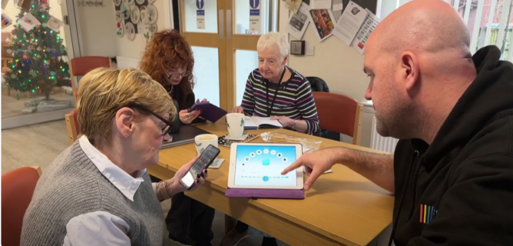
Figure 4: Barrhead staff providing ongoing support and educating residents on how to use the resident app effectively, Image Courtesy: Healthy Homes Hub

Table 3.
Pros and Cons:
S/N | Pros | Cons
1 | Demonstrated a massive, quantifiable reduction in resident anxiety regardingheating bills, with the percentage of residents not worried jumping from 4% to 45%. | Overcoming deep digital literacy barriers (e.g., lack of smartphones) required heavily resourced, continuous face-to-face support and family intervention.
2 | Successfully transitioned residents' perception of the technology from "intrusive surveillance" to an empowering tool, with 70% recommending the sensors. | The initiative faced significant funding and resource constraints, as Scotland lacks the same national funding support for these projects as England and Wales.
3 | Directs resources specifically toward highly vulnerable demographic groups disproportionately impacted by the intersection of fuel poverty and poor habitability. | The implementation was complicated and delayed by the need to navigate several layers of local authority approvals.

2.2 Case Studies Part Two

2.2.1 Breathe Easy at Home (BEAH)
Location: Boston, US
Year of implementation: 2006.
Breathe Easy at Home (BEAH) is a city-wide healthy homes program in Boston that brings together pediatric healthcare and housing enforcement. It was launched in 2006 as an ongoing city program rather than a short-term trial. When a child’s asthma seems to be linked to their living conditions, healthcare professionals such as doctors, nurses, or community health workers can submit a referral through a secure online system. This referral is passed on to Boston’s Inspectional Services Department (ISD), the city agency responsible for enforcing state sanitary codes and local housing and building laws, where inspectors arrange to visit the home and examine it for issues like dampness, visible mold, leaks, pests, poor ventilation, or inadequate heating. The program focuses on children aged 2–17 years with asthma (Rosofky et al., 2016).
Through its Housing Inspection Division, ISD identifies health and safety violations and enforces compliance under the Massachusetts sanitary code and Boston housing ordinances (City of Boston, no date). Landlords must legally rectify any identified problems. If landlords delay or fail to complete repairs, ISD can issue violations, impose fines, and escalate the case to housing court. What makes BEAH distinct is how it connects different systems, with healthcare providers acting as the starting point for identifying housing-related health risks, while ISD ensures that action is taken through its legal enforcement authority (Rosofky et al., 2016). Rosofsky et al. explored how the program works in practice in their qualitative evaluation. They used semi-structured interviews and focus groups with clinicians, housing inspectors, and other Stakeholders include 10 clinicians, 9 housing inspectors, and 13 other stakeholders. The aim was to understand how people actually used BEAH, what challenges they faced, and how effective they felt it was for families (Rosofky et al., 2016).
In the discussion questions, clinicians were asked how they decided which patients to refer and whether the online system was easy to use. There were also questions about whether families allowed inspectors into their homes, how landlords responded to repair requests, and whether participants felt the program made a difference to asthma outcomes like symptoms, emergency visits, or medication use. The researchers also looked at communication between healthcare and housing teams and gathered suggestions on how to improve referrals, feedback, and family engagement (Rokosfy et al., 2016).

Interventions
Identifying Eligible Patients : Pediatric clinicians identify children and youths aged 2-17 whose asthma isn’t well-controlled and where housing might be a trigger, like mold, pests, dampness, or poor ventilation. Whether a child gets referred depends on the clinician’s judgement rather than strict criteria, which means referral practices can vary.
Submitting Referrals Online : Clinicians send referrals through an online portal to the Boston Public Health Commission. This initiates the process of linking healthcare services with housing enforcement. The study noted that the system has workflow issues and gives little feedback to clinicians.
Case Review : Referrals are checked and sent to the city’s Inspectional Services Department (ISD). Inspectors then reach out to families to arrange a home visit. Family engagement matters here because missed appointments or communication problems can cause cases to drop off.
Home Inspections : Inspectors assess the home for environmental triggers that affect asthma, including the following: Dampness and visible mold, Pests like cockroaches or rodents, Leaks or structural damage, Poor ventilation and inadequate heating. If violations are found, landlords are legally required to remedy them under housing codes.
Enforcement and education : Landlords must make the necessary repairs within a set time. If they don’t, the case can go to housing court. This enforcement step sets BEAH apart from purely educational programs because it forces real changes in the living environment.
Follow-Up : Clinicians are ideally meant to check back with families to see how asthma symptoms respond after repairs. But the study found there’s limited integration between inspection updates and clinical records, so doctors often don’t know whether housing issues have actually been fixed.
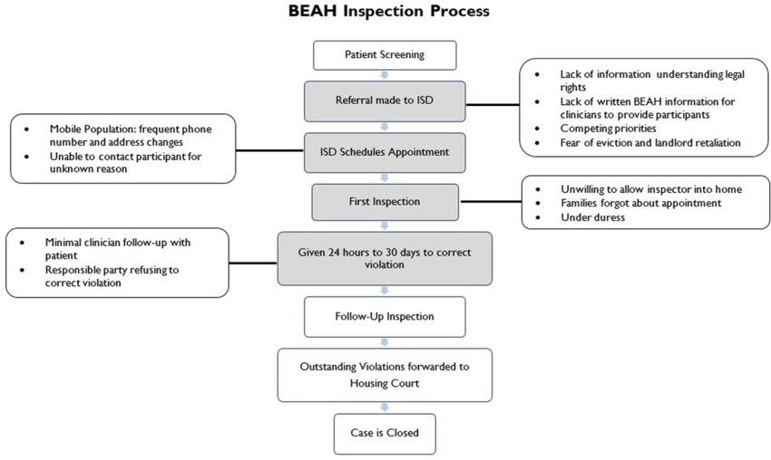
Figure 5: The BEAH inspection process, Image Courtesy Rosofsky et al. (2016)
Table of Pros and Cons:
S/N | Pros | Cons
1 | Tackles the root causes of asthma | The first point of contact only happens when the patient goes to the hospital.
2 | Uses legal housing enforcement to ensure landlords address problems. | The online portal had usability issues, confusing forms, and unclear updates, and the portal was not fully integrated into clinicians’ electronic health records (EHR). So, this meant Double documentation, extra login steps and time burden in busy clinics
3 | Strong collaboration between healthcare providers, public health, and housing inspectors. | Some families dropped out due to fear of landlord retaliation, language barriers, or other personal life stressors.
4 | Recognizes housing as a key social determinant of health. | Inspection updates were not fully integrated into electronic medical records, limiting follow-up by clinicians.
5 | Stakeholders reported perceived improvements in asthma symptoms and reduced emergency visits. | Does not outline a formalised pathway to integrate this environmental data directly with clinical healthcare providers or electronic health records.
6 | Clinicians varied in who they referred, how they explained the program, and follow-up, and evidence is qualitative and based on stakeholder perceptions; actual measurable health improvements are confirmed by their expertise.

2.2.2 ECO4 Flex
Location: Wales, United Kingdom
Year of implementation: 2022.

The Energy Company Obligation (ECO4) is a UK government scheme aimed at reducing fuel poverty and improving the energy efficiency of homes occupied by low-income or vulnerable households. Large energy suppliers must fund energy efficiency improvements under this scheme, which helps households reduce energy consumption and heating costs. One component of the scheme, ECO4 Flexible Eligibility (ECO4 Flex), allows local authorities in Wales to expand eligibility beyond standard income-based criteria by referring households that may still be vulnerable to cold homes (Ofgem, 2022; ECO, no date).To take part in ECO4 Flex, Welsh local authorities must publish a Statement of Intent (SoI) outlining how they will identify and refer eligible households. This document explains the criteria the council will use to determine eligibility (Welsh Government, 2023). Through this approach, households that may not qualify through traditional benefit routes can still receive support if they are considered at risk of fuel poverty or living in cold homes.
An important pathway within ECO4 Flex is the health-based referral route, which allows healthcare professionals to identify patients whose medical conditions may worsen due to living in cold or poorly insulated homes. Under this route, healthcare providers such as general practitioners (GPs), hospital clinicians, or other NHS health professionals can refer households if a resident has a serious health condition that may be aggravated by cold environments. Common conditions considered in these referrals include respiratory diseases, cardiovascular diseases, weakened immune systems, and limited mobility, as these conditions are often worsened by low indoor temperatures (Ofgem, 2022).The referral process usually begins when a healthcare professional provides written confirmation stating that the patient’s health condition is likely to be negatively affected by living in a cold home. The local authority then reviews the referral and determines whether the household meets the eligibility criteria set out in the Statement of Intent. If the household is approved, energy suppliers participating in the ECO scheme fund and arrange the installation of energy efficiency improvements in the property (Ofgem, 2022).The upgrades provided through ECO4 Flex aim to improve the home’s overall energy efficiency and reduce heat loss. Common improvements include loft insulation, cavity wall insulation, solid wall insulation, boiler replacements or heating upgrades, and the installation of heat pumps or improved ventilation systems (Cyngor Gwynedd, 2024). These measures are intended to increase the home’s Energy Performance Certificate (EPC) rating, particularly for properties currently rated D–G, which are considered less energy efficient. Improving insulation and heating systems helps households maintain warmer indoor temperatures while also lowering energy bills (Welsh Government, 2023).Unlike BEAH, ECO4 Flex does not rely on enforcement. Instead, the program operates through financial incentives and subsidies funded by energy companies to encourage participation. While this approach can significantly improve thermal comfort and reduce energy bills, participation remains voluntary and often requires consent from both tenants and landlords.
Table of Pros and Cons:
S/N | Pros | Cons
1 | Addresses fuel poverty by improving home energy efficiency and reducing heating costs. | Participation is voluntary; households and landlords must agree to upgrades.
2 | Health-based referrals allow vulnerable individuals with chronic illnesses to access support. | Administrative requirements such as medical referral letters can delay access.
3 | Improves thermal comfort, which can reduce cold-related health risks such as respiratory and cardiovascular conditions. | Responsibility is fragmented between councils, suppliers, and installers.
4 | Local authorities can tailor eligibility criteria to local needs through Statements of Intent.
5 | Energy upgrades provide long-term benefits through lower energy bills and improved housing quality.

2.2.3. Safe and Healthy Homes (SHH) - United Kingdom
Location: North Tyneside, United Kingdom
Year of implementation: 2013
The Safe and Healthy Homes (SHH) initiative in North Tyneside was set up after the 2013 Joint Strategic Needs Assessment highlighted just how important housing is for public health (Cook et al., 2016). Research from the Building Research Establishment (BRE) shows that poor housing costs the NHS is between £1.4 and £2.5 billion each year, so the program aimed to tackle health issues linked to unsafe or unsuitable living conditions (Cook et al., 2016). It focuses especially on people in private housing, who often don’t get the same level of support as those in social housing. The SHH team is made up of trained officers who visit homes to check for hazards such as damp, poor heating, electrical dangers, or risks of falling. After assessing each home, they provide tailored advice and connect residents with a range of support services (Cook et al., 2016).
These include organizations such as Age UK, North Tyneside Warmzones, NPower’s Health Through Warmth scheme, the Fire Service, Mears Home Improvement Agency, and local council services like Care and Connect or Select and Direct, which help with home adaptations and additional support. The program mainly focuses on people living in private rented or owner-occupied housing, where residents often have less direct support than those in social housing. In cases where hazards are linked to property conditions, the SHH team may also work with private landlords or property owners to encourage necessary repairs or improvements. However, if residents live in social housing, they are usually referred back to their housing association or the relevant council housing service so that maintenance issues can be addressed by the responsible landlord or housing provider (Figure 4) .Since it started, the program has received over 960 referrals and carried out more than 700 home visits. Referrals come from various sources, including adult social care, NHS community teams, voluntary organizations, and even emergency services. To strengthen the link between health and housing, SHH also worked with local GP practices to pilot a new referral system using the EMIS web platform. This system uses automatic pop-up alerts to flag patients with conditions like COPD, asthma, or depression, where poor housing could be making things worse (Figure 6). With patient consent, GPs can then send referrals directly and quickly. This approach has been both time-saving and cost-effective, while also helping more healthcare professionals consider housing as part of patient care (ibid).

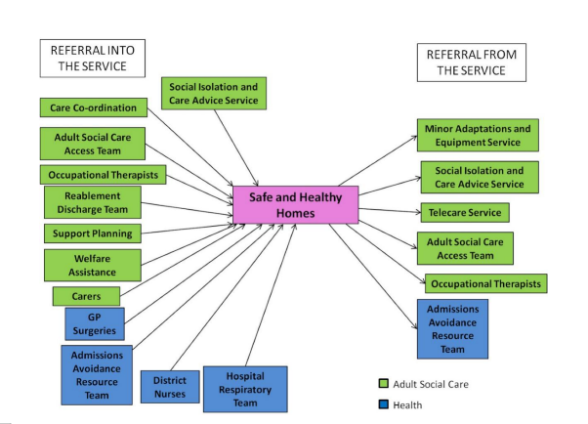
Figure 2: Adult social care and health service referrals with the safe and healthy homes service, Image Courtesy Cook et al., 2016

Figure 7. shows how an EMIS Web Clinical Services Hub works within a Primary Care Network (PCN). The hub is a central system that links GP practices to NHS national services, labs, pharmacies, and platforms that patients can use. Through this system, patient information can be securely shared, appointments can be booked across different services, test results can be received, and prescriptions can be sent electronically. This integration allows healthcare providers to work together more efficiently and ensures that patients receive more coordinated and continuous care, adapted from Harley (2025).
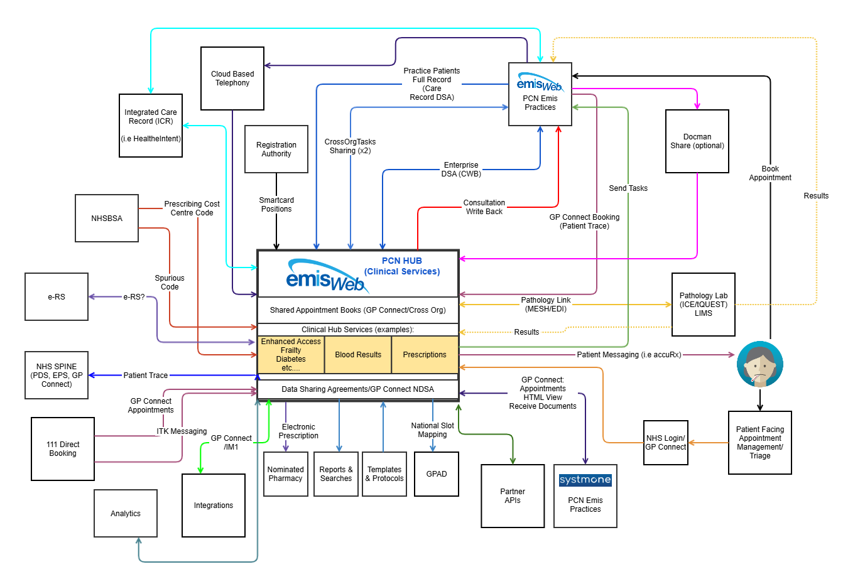
Figure 7: Diagram of how an EMIS Web Clinical Services Hub works within a PCN, Image Courtesy Harley (2025)
Interventions
Referral: Residents have the option to self-refer or receive referrals from health professionals, social workers, or partner services if their housing conditions are impacting (or could impact) their health.
Home Visit : A trained SHH officer visits the home and conducts a housing assessment, identifying hazards such as dampness, mould, or leaks; cold homes/inadequate heating; Slip, trip, or fall risks; Fire safety concerns and General disrepair affecting physical or mental health
Education : Officers provide face-to-face guidance, helping residents understand the risks in their home and how they relate to health. Materials are culturally sensitive, using simple language and visual aids to support low literacy and diverse language needs.
Support : SHH officers connect families to appropriate partner services for practical solutions, including energy efficiency and heating support programs, fire safety and minor home adaptations, benefits advice and social services, and health and well-being services addressing wider social determinants. Officers may check back to see if residents accessed the recommended services or implemented safety measures.
Outcome Focus: Improves residents’ knowledge of housing support options and their confidence to address housing problems impacting health. Encourages access to services that indirectly support physical and mental well-being.

Table of Pros and Cons:
S/N | Pros | Cons
1 | Offers personalized, in-home advice, support, and guidance to residents whose housing is affecting their health, especially in private rented or owner-occupied accommodation where support is usually limited. | As an advice and referral service rather than a home repair program itself, SHH depends on partner services to deliver solutions, which can vary in accessibility and effectiveness.
2 | Helps residents access practical solutions and referrals to a wide range of services, including fire safety, energy efficiency, heating support, benefits advice, and minor adaptations that can improve safety and comfort. | The program does not systematically track long-term health outcomes or collect follow-up data to evaluate sustained effects across a large sample.
3 | The facework and trust relationship with named SHH officers were highly valued by participants, helping them navigate complex systems and increase confidence in seeking help.
4 | Qualitative evidence indicates that users reported perceived enhancements in well-being and self-reported health outcomes following the utilization of the service.
5 | Allowing residents to self-refer means people do not have to wait for a professional to identify the problem so issues can be reported more quickly.

2.2.4. Home Care for Patients with Dirty Homes

Location: Netherlands
Year of implementation: July-September 2020
The Dutch study Home Care for Patients with Dirty Homes explores how unhealthy living conditions are often identified through routine home visits rather than through a dedicated housing program. This was a qualitative research study rather than an ongoing service, conducted over a short period between July and September 2020, with the findings later published by De Veer et al. in 2022. The study examined what happens when home-care nurses enter homes that are very dirty, cluttered, or unsafe while providing care to patients in the community.According to De Veer et al., these home environments can pose serious health and safety risks, including infections, food poisoning, and respiratory issues caused by mold or bacteria, as well as increased risks of falls and fire. The authors also highlight that many healthcare professionals, such as hospital or clinic staff, rarely see the conditions in which patients actually live. In contrast, home-care nurses visit patients directly in their homes, meaning they are often the first professionals to identify unsafe or unhealthy domestic conditions, particularly following hospital discharge or a GP referral (De Veer et al. in 2022).
The study used a qualitative design to better comprehend these experiences and involved two phases of data collection. In total, 43 participants took part across the study, including patients, home care nurses, and other community professionals such as social workers and municipal staff. Specifically, 8 home-care nurses were involved in the first interview phase, and 7 nurses participated in the second phase through interviews and focus groups, making 15 nurses in total. The first phase focused on identifying the problems nurses faced, while the second phase explored possible solutions and validated the themes that had emerged.The discussions explored how nurses recognised when a home was considered dirty or unsafe, what actions they took when faced with issues such as clutter, hoarding, mold, or poor hygiene, and how they balanced patient autonomy with concerns for safety and well-being. The researchers also looked at the emotional and practical challenges nurses experienced, including discomfort, fear, helplessness, and uncertainty about how far to intervene. Further questions examined when nurses involved other agencies, what support or guidelines were missing, and what types of training, collaboration, or formal protocols could help them manage these situations more effectively (De Veer et al. in 2022).
Recommendations
Improving collaboration between different services, such as home-care nurses, social workers, mental health professionals, and housing authorities.
Development of clear guidelines and protocols so that nurses know how to respond when they encounter unsafe living environments.
Specialized training for home care workers to help them recognize underlying problems such as hoarding behaviour or neglect and to communicate effectively with patients in sensitive situations.
Stronger organizational support and case coordination, where one professional oversees communication between services to ensure that patients receive comprehensive support.
Table of Pros and Cons:

S/N | Pros | Cons
1 | Shows the importance of cooperation between healthcare workers, social services, and sometimes housing authorities to address complex living conditions. | The definition of “dirty” is based on the nurses' interpretation. Although the study included some patient representatives, most perspectives came from professionals, meaning the experiences and views of patients living in dirty homes may be underrepresented.
2 | By identifying dirty or neglected homes during home visits, healthcare workers can intervene early to prevent worsening health or unsafe living conditions | Does not replace the need for routine primary care
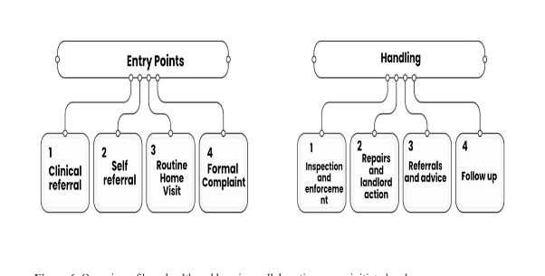
Figure 8: Overview of how health and housing collaborations were initiated and implemented, Image Courtesy De Veer et al. in 2022

2.3. Discussion

Read together, the two groups reveal a fundamental tension at the heart of housing-health intervention. Viewed through the lens of hazard identification, the technology-led cases demonstrate that continuous, high-resolution sensor monitoring can genuinely shift assessment from static to dynamic, bypassing the systemic barrier of tenant under-reporting that undermines both periodic inspection and complaint-driven regulatory frameworks (Hardy and Glew, 2019; CIBSE, 2022). Poplar HARCA and L&Q both show that identifying hazardous humidity and temperature conditions before residents report them results in earlier, more targeted intervention, representing a meaningful advance on the reactive model that has historically characterised housing health management. Barrhead further demonstrates that real-time data can serve not only as a technical monitoring tool but as a mechanism for identifying and reaching the most vulnerable populations, translating sensor intelligence into proactive safeguarding outreach.
The cross-sector collaboration cases then reveal a complementary and equally important dimension of effective housing-health intervention. What distinguishes BEAH, SHH, and the North Tyneside pathway is not the sophistication of their data collection but the depth of their professional integration. By bringing together clinicians, housing officers, inspectors, and community workers within shared referral and response systems, these cases demonstrate that housing-related health risk can be identified and acted upon through the relationships and institutional knowledge of frontline professionals, directly operationalising the systems-level approach the literature calls for (TCPA, 2025; Rolfe et al., 2020). BEAH in particular shows how clinical judgement can trigger legal housing enforcement, creating a pathway from health presentation to environmental remediation that no sensor system alone could replicate.
The two groups, taken as a whole, point towards a model that is greater than the sum of its parts. The technology-led cases contribute the environmental intelligence needed to identify risk before it becomes harm, while the cross-sector collaboration cases contribute the professional relationships, clinical judgement, and institutional accountability needed to ensure that data translates into meaningful action for the people living in those conditions. Combining both would not simply produce a more efficient system; it would produce a fundamentally more human-centred one, in which continuous monitoring serves not as an end in itself but as a tool for understanding and responding to the lived realities of occupants, and in which professional collaboration ensures that the right people receive the right support at the right time. It is this integrated, human-centred model that the concluding section of this analysis considers in more detail. To conclude, a Healthy Home is one in which the conditions of the built environment are understood not only through measurable physical indicators but through the lived experience of the people within it, and in which the seamless integration of data across housing, health, and social care systems enables a coordinated, proactive response that places the occupant at the centre of every intervention.

3. Proposed interventions: Upgrading the systems of Poplar HARCA & L&Q
Although Poplar HARCA and L&Q operate at different organisational scales, the two programmes demonstrate a high degree of similarity in both their objectives and operational approaches. Both organisations have moved beyond traditional complaint-led responses to damp and mould by adopting proactive housing management strategies that utilise environmental monitoring, preventative maintenance, and resident engagement. In both cases, housing conditions are assessed before visible deterioration occurs, allowing interventions to be targeted earlier and reducing reliance on reactive inspections. (Healthy Homes Hub, 2024a; Healthy Homes Hub, 2024b). This section attempts to use the learnings from the Part 2 case studies and suggest interventions to the technology led Poplar HARCA & L& Q model. Given the substantial overlap between the two models, the intervention catalogue presented in this report focuses on Poplar HARCA as the primary implementation case. This decision does not reflect a belief that the recommendations are unique to HARCA. Rather, HARCA provides a more manageable setting in which proposed interventions can be conceptualised and tested due to its geographically concentrated housing stock and established local partnerships. The interventions identified through the literature are equally applicable to L&Q. However, their implementation within L&Q would require deployment across a significantly larger organisational and geographical footprint. In practice, the distinction between the two organisations is therefore one of scale rather than direction.

3.1 Healthy Homes Intervention Catalogue: Poplar HARCA Application

Intervention /  Strategy | Source Case Sudies | Target Application (Poplar HARCA Improvement) | Agency / Level | Policy Tweak & System Integration
Clinical Interoperability via EMIS Hubs | Integration from Safe and Healthy Homes (SHH) | Feed Poplar HARCA's existing HomeLINK sensor alerts (which currently track damp and mould risk) directly into the local Primary Care Network’s EMIS Web Clinical Services Hub. The GP is treating a resident with respiratory condition, would have access to the data, that could help provide them an idea of the housing conditions. Bridging the gap between housing data and electronic health records. | Housing Association / Health Services (NHS) / Local Authorities, Resident. | Regional/National:Mandate interoperability standards between housing IoT systems and NHS health records. Update the HHSRS to formally recognise data from integrated clinical-housing dashboards as evidence of Category 1 hazards.
Bi-directional  Clinical-Housing Enforcement | Integration from Breathe Easy at Home (BEAH) | Enhance HARCA's preventative maintenance in addition to the suggestion above by creating a unified online portal for pediatricians and nurses. If a clinician flags a patient's uncontrolled asthma, it triggers an immediate physical inspection by HARCA, which is then cross-referenced against the home's historical sensor data to find the root cause. | Health Services / Housing Association / Local Authority | National/Regulatory:Expand Awaab's Law compliance frameworks so that a formal medical referral regarding housing conditions automatically triggers the legally binding 10-day investigation timeframe, treating it with the same urgency as a direct tenant complaint.
Automated  Health-Based  Funding  Referrals | Integration from ECO4 Flex | Use HARCA's predictive algorithms (which already identify fuel poverty via temperature drops) to automatically generate eligibility profiles for energy efficiency funding. This bypasses the administrative burden of requiring vulnerable residents to actively seek out medical referral letters to prove their home is too cold. | Department for Energy Security and Net Zero (DESNZ)  / Ofgem / Energy Suppliers/ Local Councils/ Trustmark | National: At present, EcoFlex energy efficiency funding is limited to private landlords. However, expanding this provision to include public housing would ensure more residents benefit from these improvements.
Blending Qualitative Observation with Quantitative Data | Integration from Dutch Home-Care Study | While HARCA’s sensors measure quantitative air quality, they cannot see physical barriers. Train visiting home-care nurses/ home inspectors to log qualitative risks (e.g., hoarding, blocked ventilation systems) directly into HARCA's safeguarding system, combining predictive algorithmic monitoring with human observation. | Community Health Workers / Housing Association | Regional: Establish standardised data-sharing agreements between local health trusts and housing associations to create a formalized, legal pathway for nurses to report habitability issues without breaching patient confidentiality protocols.
Closing the  Clinical  Feedback Loop | Integration from Breathe Easy at Home (BEAH) | A major limitation in the BEAH case was that inspection updates were not integrated into medical records, leaving clinicians in the dark about whether a home was fixed. HARCA must ensure its HomeLINK system automatically pushes a notification back to the referring GP once preventative maintenance is completed, officially closing the case in the patient's medical file. | Housing Association / Health Services (NHS) | National: Integrate data completion loops into Awaab's Lawguidelines. Mandate that the required 3-day investigation finding and final remediation updates are not only provided to the tenant but officially logged with any referring healthcare provider.

3.3. Feedback from Focus Study

The focus study, held online on 29th June 2026, brought together stakeholders from the housing, health, built environment and technology sectors to critically reflect on the findings of the literature review, case studies and proposed interventions. While there was broad support for the overall direction of the research, the discussion generated several important insights that refined the framework and highlighted practical considerations for its implementation. The following themes summarise the key areas of consensus that emerged from the discussion, emphasising the need for integrated, evidence-based and resident-centred approaches to delivering healthier homes:
From Data Collection to Proactive Intervention
Stakeholders agreed that while IoT technologies offer significant potential for improving housing conditions, the greatest challenge lies not in collecting data but in ensuring that it leads to timely action. A recurring concern was that organisations continue to operate in silos, with housing providers, contractors, maintenance teams and other stakeholders often managing information through separate systems. This fragmentation limits opportunities for collaboration and delays effective intervention. It was noted that environmental data frequently remains confined to digital dashboards, requiring manual review before maintenance teams are informed. This reliance on emails, phone calls and periodic monitoring creates unnecessary delays in addressing issues such as ventilation failures or damp. Participants therefore suggested that healthy home interventions should move beyond passive monitoring by integrating automated workflows that directly notify contractors and trigger maintenance responses when predefined thresholds are exceeded. Such an approach would support the transition from reactive housing management to a preventative model, ensuring that environmental risks are identified early and acted upon before they develop into health hazards.
Integrating Data Across Disciplines and Organisations
Building on this, stakeholders consistently identified fragmented information systems as one of the principal barriers to delivering healthy homes. Valuable information is currently collected independently by housing providers, contractors, retrofit assessors and maintenance teams, yet these datasets are rarely integrated to support informed decision-making. Participants argued that environmental sensor data should be interpreted alongside inspection reports, retrofit assessments and maintenance records within a shared data environment, enabling earlier identification of risks and more coordinated interventions. It was further suggested that commissioning practices should evolve to require more comprehensive condition surveys that collect both observational and environmental data, supporting a more holistic understanding of building performance and occupant health.
Ensuring the Reliability of IoT Data
While stakeholders expressed strong support for the use of IoT technologies in healthy homes, concerns were also raised regarding the reliability and consistency of the data generated by these systems. Participants highlighted that the quality of IoT technologies varies considerably across the sector, with some platforms utilising sophisticated multi-sensor systems and robust algorithms, while others are more prone to inaccurate readings or false negatives. Such inconsistencies may result in environmental risks being overlooked or inappropriate interventions being triggered. The discussion therefore highlighted the need for greater standardisation of IoT technologies, including minimum performance requirements, quality assurance processes and regular validation of sensor outputs, to ensure that environmental data can be used with confidence in informing housing interventions and policy decisions.
Broadening the Definition of Indoor Environmental Quality
The discussion challenged the current emphasis on damp and mould as the primary focus of healthy home monitoring. Stakeholders argued that indoor environmental quality should be understood more comprehensively, with IoT technologies capable of monitoring a wider range of indicators including carbon dioxide (CO₂), carbon monoxide (CO), volatile organic compounds (VOCs), particulate matter (PM₂.₅ and PM₁₀), overheating and humidity. Recent periods of extreme heat were cited as examples of why overheating should be considered alongside traditional housing hazards, particularly as climate change increases the frequency of high-temperature events. At the same time, participants cautioned that expanding IoT monitoring must be accompanied by appropriate quality assurance measures. Variations in sensor quality, installation practices and calibration, together with the potential for inaccurate readings under extreme conditions, were identified as important considerations for ensuring that decisions are based on reliable evidence.
Recognising the Role of Building Fabric and Context
Stakeholders further emphasised that healthy homes cannot be evaluated solely through indoor environmental monitoring. The physical characteristics of the building,including construction type, thermal performance, orientation, window configuration and ventilation potential, were considered equally important in determining indoor environmental quality. Examples were provided illustrating how Victorian solid-wall properties, cavity-wall construction and the orientation of a dwelling influence overheating, heat retention and natural ventilation. Consequently, participants argued that sensor data should be interpreted alongside information about the building fabric and its wider environmental context, enabling interventions to address not only the symptoms of poor housing conditions but also their underlying structural causes. This reinforces the need for interdisciplinary collaboration between building professionals, environmental specialists and housing providers when assessing healthy homes.
Combining Digital Evidence with Professional and Resident Knowledge
While stakeholders strongly supported the increasing use of IoT technologies, there was broad agreement that digital monitoring should complement rather than replace professional expertise and resident knowledge. Participants observed that quantitative sensor data alone cannot fully explain the underlying causes of poor housing conditions or how occupants experience their homes. Instead, sensor outputs should be interpreted alongside qualitative observations gathered through housing inspections, retrofit assessments and resident feedback. The discussion also highlighted the importance of post-occupancy evaluation and occupant engagement in validating environmental data, recognising that residents' behaviours, experiences and patterns of occupancy provide valuable context for understanding indoor environmental conditions. Integrating technological evidence with professional judgement and lived experience was therefore considered essential for developing meaningful and effective healthy home interventions.
Placing Residents at the Centre of Healthy Homes
Although much of the discussion focused on technological innovation, stakeholders also questioned whether the proposed framework sufficiently accounted for differences between occupants. Participants asked whether the research had considered different user groups such as older adults, younger households and individuals with varying health conditions. It was suggested that environmental conditions and housing interventions may be experienced differently across these groups. It was further noted that factors such as cultural practices, occupancy patterns and overcrowding may influence how homes are inhabited and should therefore be considered when assessing healthy homes. One suggestion was that future AI-enabled systems could move beyond monitoring environmental conditions to provide personalised, user-centred recommendations, tailoring advice to the needs of individual occupants. For example, recommendations could advise residents whether to improve ventilation by opening windows or using mechanical ventilation, depending on their health status, household characteristics and prevailing indoor environmental conditions. These observations highlighted the importance of ensuring that healthy home assessments are informed not only by environmental monitoring but also by the diverse needs and lived experiences of occupants.

Way Forward

The analysis presented in this study draws on the literature review and a structured examination of seven case studies to develop an understanding of what constitutes a healthy home and how housing-health interventions are initiated, structured, and delivered in practice. However, literature review and case study analysis alone are insufficient to translate these findings into actionable change. The focus group served two interconnected purposes. The first was to test and refine the definition of a healthy home developed through the literature review. The second purpose is to identify practical investment priorities that improve resident health. The case studies demonstrate that the most effective interventions combine continuous environmental monitoring with cross-sector professional collaboration, but they also reveal that resource constraints, organisational capacity, and fragmented accountability frequently limit what is achievable in practice.
These findings suggest that future investment should extend beyond technological innovation alone. Although continuous environmental monitoring was widely recognised as an important component of preventative housing management, stakeholders consistently emphasised that technology is most effective when embedded within integrated systems of care, maintenance and decision-making. Consequently, investment priorities should focus not only on sensor infrastructure but also on strengthening cross-sector collaboration, improving data governance and interoperability, supporting comprehensive building assessments, enhancing workforce capacity, and addressing wider social determinants such as energy affordability. Together, these priorities provide a practical foundation for developing healthier homes that are proactive, evidence-based and centred on the needs of residents.

Bibliography

All-Party Parliamentary Group (APPG) for Healthy Homes and Buildings (2018). Building our Future: Laying the Foundations for Healthy Homes and Buildings - White Paper. London: APPG. Available at: https://healthyhomesbuildings.org.uk/wp-content/uploads/2018/10/HHB-APPG-White-Paper-V1.pdf
Baily Garner (2023). Damp and Mould: A Practical Toolkit for Diagnosis and Treatment. Issue 1. London: Baily Garner. Available at: https://www.bailygarner.co.uk/wp-content/uploads/2025/06/Damp-and-Mould-Practical-Toolkit-Issue-1.pdf[Accessed: 5 March 2026].
Baker, N. and Steemers, K. (2019) Healthy homes : designing with light and air for sustainability and wellbeing. Riba Publishing.
Bentley, R., Mason, K., Jacobs, D., Blakely, T., Howden-Chapman, P., Li, A., Adamkiewicz, G. and Reeves, A. (2025) ‘Housing as a social determinant of health: a contemporary framework’, The Lancet Public Health. Available at: https://www.thelancet.com/journals/lanpub/article/PIIS2468-2667(25)00142-2/fulltext [Accessed: 5 March 2026].
British Standards Institution (2022) BS 40101: Building Performance Evaluation of Occupied and Operational Buildings Using Data Gathered from Tests, Measurements, Observation and User Experience — Specification. London: BSI. ISBN: 978 0 539 16340 7
Building Research Establishment (BRE) (2020). The Housing Stock of the United Kingdom. Bracknell: BRE Press. Available at: https://files.bregroup.com/bretrust/The-Housing-Stock-of-the-United-Kingdom_Report_BRE-Trust.pdf, [Accessed: 26 May 2026].
Chartered Institute of Housing (2019). What you need to know about the Homes (Fitness for Human Habitation) Act 2018. Coventry: Chartered Institute of Housing. Available at: https://www.cih.org/media/neeflfwu/wyntk-about-the-homes-fitness-for-human-habitation-act.pdf [Accessed: 26 May 2026].
Chartered Institution of Building Services Engineers (2022) TM68: Monitoring Indoor Environmental Quality. London: CIBSE.
City of Boston, (n.d.) ‘Inspectional Services Department’. Available at:https://www.boston.gov/departments/inspectional-services (Accessed: 4 April 2026).
Cook, G., Aitken, D., Hodgson, P., Marston, R., Binks, E., Peach, R., Mcmillan, C., Herman, L., Burke At North, W., Council, T., Park, K., Conway, S., Graham, H., Blood, G., Cossar, P. and Mckinnon, D. (2016) ‘Approaches to integrated housing, health and social care services: case studies from North Tyneside Council and Northumbria Healthcare’ Housing Learning and Improvement Network [online]. Available at: https://www.housinglin.org.uk/_assets/Resources/Housing/Practice_examples/HLIN_Case-Study-Report_Northumbria_FINAL.pdf
Committee on Climate Change (CCC) (2018). UK housing: Fit for the future? London: CCC. Available at: https://www.theccc.org.uk/publication/uk-housing-fit-for-the-future/, [Accessed: 26 May 2026].
Coyne, B., Denny, E. and O'Malley, M. (2021) ‘Mind the energy performance gap: testing the accuracy of building Energy Performance Certificates in Ireland’, Energy Efficiency, 14. Available at: https://pmc.ncbi.nlm.nih.gov/articles/PMC8550629/ [Accessed: 26 May 2026].
Cyngor Gwynedd, (2024) ‘Statement of Intent for ECO4 Flex and Great British Insulation Scheme Cyngor Gwynedd ECO4 and Great British Insulation Scheme Flexible Eligibility Statement of Intent’, (4). Available at: https://www.gwynedd.llyw.cymru/en/Residents/Documents-Residents/Housing-documents/Great
De Veer, A.J.E., de Groot, K. and Verkaik, R. (2022) ‘Home care for patients with a “dirty home”: a qualitative study of the problems experienced by nurses and possible solutions’, BMC Health Services Research, 22(1), pp. 592–603. Available at: https://doi.org/10.1186/s12913-022-07956-4 [Accessed: 5 March 2026].
DEFRA (2022) Indoor Air Quality Report. Available at: https://uk-air.defra.gov.uk (Accessed: 4 April 2026).
Department for Communities and Local Government (2006) A Decent Home: Definition and guidance for implementation. London: DCLG. Available at: https://www.gov.uk/government/publications/a-decent-home-definition-and-guidance [Accessed: 8 February 2026].
Department for Education (2026) Ventilation and air quality in education and childcare settings. Available at: https://www.gov.uk/government/publications/ventilation-and-air-quality-in-education-and-childcare-settings [Accessed: 4 April 2026].
Department for Levelling Up, Housing and Communities (2025) Awaab’s Law: Guidance for social landlords. Available at: https://www.gov.uk/government/publications/awaabs-law-guidance-for-social-landlords [Accessed: 23 March 2026].
Energy Company Obligation (ECO4), (n.d.) ‘ECO4 Guidance: Supplier Administration’. Available at: https://www.ofgem.gov.uk/sites/default/files/2025 12/eco4_guidance_supplier_administration_g uidance.pdf.
European Parliament (2026) Housing crisis: why prices are rising and what the EU is doing about it. Available at:https://www.europarl.europa.eu/topics/en/article/20241014STO24542 [Accessed: 3 April 2026].
Eurostat (2025) Housing in Europe – 2025 edition. Available at: https://ec.europa.eu/eurostat/web/interactive-publications/housing-2025 [Accessed: 3 April 2026].
Farha, L., Freeman, S. and Gabarre de Sus, M. (2022). The Shift Directives: From financialised to human rights-based housing. Ottawa: The Shift. Available at: https://www.make-the-shift.org/directives/ [Accessed: 7 February 2026].
G., Cossar, P. and Mckinnon, D. (2016) ‘Approaches to integrated housing, health and social care services: case studies from North Tyneside Council and Northumbria Healthcare’ Housing Learning and Improvement Network [online]. Available at:https://www.housinglin.org.uk/_assets/Resources/Housing/Practice_examples/HLIN_Case-Study-Report_Northumbria_FINAL.pdf.-British-Insulation-Scheme-and-ECO4-Flex-Statement-of-Intent-Live-V4.0-09.05.24.pdf [Accessed 4 Apr. 2026].
Harley, J. (2025) ‘Setting up an EMIS Clinical Services Hub’, James Harley Consultancy. Available at: https://jamesharleyconsultancy.freshdesk.com/support/solutions/articles/101000433679 -setting-u p-an-emis-clinical-services-hub (Accessed: 4 April 2026).
Harvey, M. (2021). 'The Political Economy of Health: Revisiting Its Marxian Origins to Address 21st-Century Health Inequalities', American Journal of Public Health, 111(2), pp. 293-300. Available at: https://pmc.ncbi.nlm.nih.gov/articles/PMC7811101/
Healthy Homes Hub 'Pioneering Data-Driven Housing Solutions' Available at: https://healthyhomeshub.uk/ [Accessed: 2 April 2026].
Healthy Homes Hub's 'Proactive damp and mould solutions: Real-time data helps address damp, mould, and fuel poverty in housing'. Available at: https://healthyhomeshub.uk/ [Accessed: 2 April 2026].
Healthy Homes Hub 'Combating fuel poverty and improving energy efficiency: Innovative tech records vital data for sheltered housing residents to manage and control their own living conditions' Available at: https://healthyhomeshub.uk/ [Accessed: 2 April 2026].
Hossain, M., Weng, Z., Schiano-Phan, R., Scott, D., Lau B. (2020). Application of IoT and BEMS to Visualise the Environmental Performance of an Educational Building. Energies.13, 4009.
Institute Of Health Equity (2024) Building Health Equity: The Role of the Property Sector in Improving Health. (Accessed: May 26, 2026).
Ministry of Housing, Communities and Local Government (MHCLG) (2006). A Decent Home: Definition and guidance for implementation. London: MHCLG. Available at: https://www.gov.uk/government/publications/a-decent-home-definition-and-guidance, [Accessed: 25 May 2026].
Newham London Borough (2023). Update on Property Licensing and Private Housing Projects. Available at: https://www.newham.gov.uk/downloads/file/6349/update-on-property-licensing-and-private-housing-projects-2023, [Accessed: 23 March 2026].
NICE (2020) Indoor air quality at home (NG149). Available at: https://www.nice.org.uk/guidance/ng149 [Accessed: 4 April 2026].
Oatt, P. (n.d.) Selective Licensing: The Basis for a Collaborative Approach to Addressing Health Inequalities. Available at: https://doi.org/10.1201/9781003000136 [Accessed: 23 March 2026].
Ofgem (2025) ‘Energy Company Obligation 2022-26 (ECO4) Guidance: New Measures and Products’. Available at: https://www.ofgem.gov.uk/publications/energy-company-obligation-2022-26-eco4-guidance-new -measures-and-products [Accessed 4 Apr. 2026].
Okoro, C. (2023). Sustainable Facilities Management in the Built Environment: A Mixed-Method Review. Available at: https://www.researchgate.net/publication/368445266_Sustainable_Facilities_Management_in_the_Built_Environment_A_Mixed-Method_Review [Accessed: 23 March 2026].
Osibona, O., Solomon, B.D. and Fecht, D. (2021) ‘Lighting in the Home and Health: A Systematic Review’, International Journal of Environmental Research and Public Health, 18(2), p. 609. Available at: https://doi.org/10.3390/ijerph18020609.
Parrett, M. (2016). Building Surveying: Diagnosing the Physical Structure. London: RICS Publishing.
Poortinga, W., Jones, N., Lannon, S. and Jenkins, H. (2017). 'Social and health outcomes following upgrades to a national housing standard: a multilevel analysis of a five-wave repeated cross-sectional survey', BMC Public Health, 17(1), p. 927. Available at: https://bmcpublichealth.biomedcentral.com/articles/10.1186/s12889-017-4928-x
Razaq, A. and Baybutt, M. (2024). 'Creating healthy homes fit for future generations', International Journal of Health Promotion and Education, 62(2), pp. 65-67. Available at: https://www.tandfonline.com/doi/full/10.1080/14635240.2024.2302660
Ratcliffe, J. (2026) ‘Why most healthy home advice fails without measurement’. Available at: https://www.healthyhomeshub.uk/articles/why-most-healthy-home-advice-fails-without-measurement [Accessed: 8 March 2026].
Rolfe, S., Garnham, L., Godwin, J., Anderson, I., Seaman, P. and Donaldson, C. (2020) ‘Housing as a social determinant of health and wellbeing’, BMC Public Health, 20(1138), pp. 1–19. Available at: https://pmc.ncbi.nlm.nih.gov/articles/PMC7370492/ [Accessed: 8 February 2026].
Rodgers SE, Bailey R, Johnson R, et al Emergency hospital admissions associated with a non-randomised housing intervention meeting national housing quality standards: a longitudinal data linkage study J Epidemiol Community Health 2018;72:896-903. Available at: https://jech.bmj.com/content/72/10/896
Rondel, L. (2025). ‘Fighting for breath’: Inhabiting uninhabitable places. European Journal of Cultural Studies, 28(5), 1341-1361
Rosofsky, A., Reid, M., Sandel, M., Zielenbach, M., Murphy, J. and Scammell, M.K. (2016) 'Breathe Easy at Home: A Qualitative Evaluation of a Pediatric Asthma Intervention', Global qualitative nursing research, 3, pp. 2333393616676154–Dec Available at: 10.1177/2333393616676154.
The Physiological Society (2024). Physiological considerations for maximum indoor temperatures. Available at: https://www.physoc.org [Accessed: 4 April 2026].
TCPA (2025) 'Healthy Homes – what’s the evidence?', Available at: https://www.tcpa.org.uk/wp-content/uploads/2023/02/HH-principles-and-evidence-V2.pdf.
Tod, A.M., Nelson, P., Cronin de Chavez, A., Homer, C., Powell-Hoyland, V. and Stocks, A. (2016) ‘Understanding influences and decisions of households with children with asthma regarding temperature and humidity in the home in winter’, BMJ Open, 6(1), e009636. Available at: https://bmjopen.bmj.com/content/6/1/e009636 [Accessed: 5 March 2026].
Trust for London (2024). Housing tenure over time. Available at: https://trustforlondon.org.uk/data/housing-tenure-over-time/, [Accessed: 25 May 2026].
UK Government (2004). Housing Act 2004. Available at: https://www.legislation.gov.uk/ukpga/2004/34/contents, [Accessed: 25 May 2026].
UK Government (2012) The Energy Performance of Buildings (England and Wales) Regulations 2012. Available at: https://www.legislation.gov.uk/uksi/2012/3118/contents/made [Accessed: 5 April 2026].
UK Government (2018). Homes (Fitness for Human Habitation) Act 2018. Available at: https://www.legislation.gov.uk/ukpga/2018/34/contents, [Accessed: 25 May 2026].
UK Green Building Council (2023). Data and insights on UK housing stock. Available at: https://www.ukgbc.org [Accessed: 5 April 2026].
UK Government (2017) A guide to Energy Performance Certificates for the marketing, sale, and letting of dwellings. Available at: https://assets.publishing.service.gov.uk/media/5a821a74ed915d74e3401be1/A_guide_to_energy_performance_certificates_for_the_marketing__sale_and_let_of_dwellings.pdf [Accessed: 6 April 2026].
UN OHCHR (2020). The Right to Adequate Housing. Fact Sheet No. 21/Rev.1. Geneva: Office of the United Nations High Commissioner for Human Rights. Available at: https://www.ohchr.org/en/special-procedures/sr-housing/human-right-adequate-housing, [Accessed: 25 May 2026].
UN-Habitat (2023). Affordable Land and Housing in Europe and North America. Available at: https://unhabitat.org/affordable-land-and-housing-in-europe-and-north-america-2 [Accessed: 3 April 2026].
Wang, J. and Norbäck, D. (2021) ‘Home environment and noise disturbance in a national sample of multi-family buildings in Sweden-associations with medical symptoms’, BMC Public Health, 21(1). Available at: https://doi.org/10.1186/s12889-021-12069-w.
World Health Organisation (2018) WHO Housing and Health Guidelines. Geneva: WHO. Available at: https://www.who.int/publications/i/item/9789241550376 [Accessed: 5 March 2026].
Yuan, M. and Choudhary, R. (2023) ‘Energy Performance Certificate renewal—An analysis of reliability of simple non-domestic buildings’ EPC ratings and pragmatic improving strategies in the UK’, Energy Policy, 178, p. 113581. Available at: https://doi.org/10.1016/j.enpol.2023.113581, [Accessed: 6 April 2026].

The data were collected through one-on-one telephone interviews with clinicians from three Boston-based healthcare institutions, including three medical doctors, three nurse practitioners, two registered nurses, and two community health workers.
The data collection method also included a focus group with housing inspectors who had experience working on BEAH cases.
The data collection method also included a focus group with stakeholders representing organizations directly involved in the BEAH program. Participants included pediatric nurse practitioners, community health workers, attorneys, the Inspectional Services Department (ISD) housing director, healthy housing advocates, parents of children with asthma, and representatives from the Boston Public Housing Commission.
Stakeholders involved in the ECO4 Flex health-referral pathway include Welsh local authorities, the Welsh Government, NHS healthcare professionals (such as GPs, hospitals, and health boards), energy suppliers obligated under the ECO scheme, approved installation contractors, Ofgem (the UK energy regulator), and households receiving the improvements.

