|  |  |  |
| --- | --- | --- |
|  |  | |
|  | D3.1 Business and Regulatory Scenarios Report | |
|  | Deliverable 3.1 | |
|  | Vista | |
|  | Grant: | 699390 |
|  | Call: | H2020-SESAR-2015-1 |
|  | Topic: | Sesar-05-2015 Economics and Legal Change in ATM |
|  | Consortium coordinator: | University of Westminster |
|  | Edition date: | 28 February 2017 |
|  | Edition: | 01.00.00 |

|  |
| --- |
| EXPLORATORY RESEARCH |



|  |  |  |
| --- | --- | --- |
| Authoring & Approval | | |
| Authors of the document | | |
| Name/Beneficiary | Position/Title | Date |
| Luis Delgado / University of Westminster | Consortium Member | 24 February 2017 |
| Gérald Gurtner / University of Westminster | Consortium Member | 24 February 2017 |
| Andrew Cook / University of Westminster | Project Leader | 24 February 2017 |
| Hans Plets / Belgocontrol | Consortium Member | 24 February 2017 |
| Denis Huet / EUROCONTROL | Consortium Member | 24 February 2017 |
| David Perez / Innaxis | Consortium Member | 24 February 2017 |
| Samuel Cristóbal / Innaxis | Consortium Member | 24 February 2017 |
| Andreas Triska / SWISS | Consortium Member | 24 February 2017 |
| Stig Patey / Norwegian | Consortium Member | 24 February 2017 |
| Einar Ingvi Andrésson / Icelandair | Consortium Member | 24 February 2017 |

|  |  |  |
| --- | --- | --- |
| Reviewers internal to the project | | |
| Name/Beneficiary | Position/Title | Date |
| Graham Tanner / University of Westminster | Consortium Member | 26 February 2017 |
|  |  |  |

|  |  |  |
| --- | --- | --- |
| Approved for submission to the SJU By — Representatives of beneficiaries involved in the project | | |
| Name/Beneficiary | Position/Title | Date |
| Andrew Cook / University of Westminster | Project Leader | 27 February 2017 |

|  |  |  |  |
| --- | --- | --- | --- |
| Rejected By - Representatives of beneficiaries involved in the project | | | |
| Name/Beneficiary | | Position/Title | Date |
| N/A |  | |  |

|  |  |  |  |  |
| --- | --- | --- | --- | --- |
| Document History | | | | |
| Edition | Date | Status | Author | Justification |
| 01.00.00 | 28 February 2017 | Release | Vista Consortium | New document for review by the SJU |
|  |  |  |  |  |

|  |
| --- |
| The opinions expressed herein reflect the authors’ views only. Under no circumstances shall the SESAR Joint Undertaking be responsible for any use that may be made of the information contained herein. |

Vista

Market forces trade-offs impacting European ATM performance

This deliverable is part of a project that has received funding from the SESAR Joint Undertaking under grant agreement No 699390 under European Union’s Horizon 2020 research and innovation programme.



Abstract

Vista examines the effects of conflicting market forces on European performance in ATM, through the evaluation of impact metrics on four key stakeholders, and the environment. Regulatory and business factors are classified between foreground and background factors. For each of these factors the possible values to be considered in Vista are described. Background factors are grouped to generate background scenarios onto which the foreground factors will be tested. The foreground factors may be grouped to facilitate their analysis. A qualitative analysis of the impact of the factors in the model components is carried out. This allows us to identify the impact of the factors on the exogenous variables of the different layers of the model.

Table of Contents

Abstract 4

Executive summary 7

1 Introduction 8

1.1 Objectives of Vista and of this deliverable 8

1.2 Foreground factors, background factors and scenarios 8

1.3 Vista model 9

2 Foreground factors 12

2.1 Regulatory foreground factors 12

2.2 Business foreground factors 15

3 Background factors 17

3.1 Regulatory background factors 17

3.2 Business background factors 19

4 Definition of scenarios 22

4.1 Background scenarios 23

4.2 Foreground factors grouping 25

4.3 Scenarios definitions 27

5 Effect of factors on the model 29

5.1 Effect of SESAR-related factors 29

5.1.1 Primary effect of KPIs on the model 29

5.1.2 Sublayers affected by KPIs 30

5.2 Effect of business and regulatory factors on the components of the model 31

5.3 Description of the preliminary expected effect of the factor in the model 34

5.3.1 Economic model 34

5.3.2 Schedule mapping 38

5.3.3 Passenger assignment 39

5.3.4 Flight plan generation 40

5.3.5 ATFM regulation generation 41

5.3.6 Mercury 42

6 Next steps and look ahead 45

Table of Tables

**Table 1. Foreground regulatory factors** 13

**Table 2. Foreground business factors** 15

**Table 3** **Background regulatory factors** 17

**Table 4** **Background business factors** 19

**Table 5** **Background scenarios** 23

**Table 6** **Grouped foreground factors** 25

**Table 7** **Effect of KPIs** 30

**Table 8** **Model components affected by SESAR KPIs** 30

**Table 9** **Model components affected by business and regulatory areas** 31

**Table 10** **Model components affected by business and regulatory factors** 32

**Table 11. Effect of factors on economic model** 34

**Table 12. Effect of factors on schedule mapping** 38

**Table 13. Effect of factors on passenger assignment** 39

**Table 14. Effect of factors on flight plan generation** 40

**Table 15. Effect of factors on ATFM regulation generation** 41

**Table 16. Effect of factors on Mercury** 42

Table of Figures

**Figure 1. Factors classification and scenarios definition** 9

**Figure 2. Vista high-level packages architecture** 10

**Figure 3. Vista layers** 10

**Figure 4. From factors to scenarios** 22

**Figure 5. Process to define a scenario for the Vista model** 28

Executive summary

Vista examines the effects of conflicting market forces on European performance in ATM, through the evaluation of impact metrics on four key stakeholders, and the environment. The project comprises a systematic, impact trade-off analysis using classical and complexity metrics, encompassing both fully monetised and quasi-cost impact measures. To achieve these objectives, Vista models the current, 2035 and 2050 timeframes based on various factors and their potential evolution.

This deliverable presents work regarding the market forces to be considered in the model as well as the construction of the scenarios to be run.

While Deliverable 2.1 presents an exhaustive list of business and regulatory factors potentially affecting the future air transport system, this deliverable focuses on how to handle them with respect to the model. The main objective of Vista is not to find the most likely scenario for the future, but rather to test the impact of the decisions of the different actors.

The project thus takes an empirical approach of ‘test and assess’, aiming at finding the effect of several foreground factors, on a fairly constant background canvas composed of all the remaining (background) factors. Sections 2 and 3 respectively present these factors and justify the choices thereof.

The choice of values for the background factors allows us to define different background scenarios for the time horizons of 2035 and 2050, and to establish the current scenario. On these background scenarios, different combinations of the foreground factors will be tested. The construction of these scenarios and the definition of the background scenarios are presented in Section 4.

The values potentially assigned to the different factors are quite qualitative in this deliverable. Indeed, only the start of the model implementation itself will allow Vista to define the effect of the factors on the layers (e.g. strategic, pre-tactical and tactical phases; impact trade-offs) of the system and on the exogenous variables (those which are input into the model, as opposed to the variables shared by the different blocks within the model).

However, at this stage it is already possible to forecast the qualitative impact of the factors on each part of the model. This is done in Section 5. Finally, we present in Section 6 the next steps, comprising in particular the definition of the output/input of each sublayer of the model and the beginning of the high-priority implementation tasks.

# Introduction

## Objectives of Vista and of this deliverable

Vista examines the effects of conflicting market forces on European performance in ATM, through the evaluation of impact metrics on four key stakeholders, and the environment. The project comprises a systematic, impact trade-off analysis using classical and complexity metrics, encompassing both fully monetised and quasi-cost impact measures. To achieve these objectives, Vista models the current, 2035 and 2050 timeframes based on various factors and their potential evolution. These factors influence the choices of the actors in the ATM system: prices of commodities and services, regulations from national and supranational entities, and new technologies are all part of a complex socio-economic system that results in evolving business models, passenger choices, etc.

Some of these factors, foreground factors, will be analysed in detail in order to understand their impact on the system’s metrics. The others, background factors, will be grouped giving them predefined possible values to generate future background scenarios (and to establish the current scenario) onto which to test the foreground factors. This approach allows us to model possible future evolution of the system while understanding the impact of individual parameters.

Deliverable 2.1 (“Supporting data for business and regulatory scenarios”) identified these regulatory and business factors considered in Vista and their possible evolution. The objective of this deliverable is to classify the factors between foreground and background and to group the background factors into scenarios identifying the possible scenarios to be considered in Vista. Finally, a preliminary identification of which part of the model is impacted by the individual factors is also carried out.

## Foreground factors, background factors and scenarios

Regulatory and business factors have an impact on the stakeholders’ behaviour and/or on the system affecting the different KPAs and KPIs that are of interest in Vista. Some of those factors define the background onto which the individual factors are assessed. As shown in **Figure 1**, the regulatory and business factors identified in D2.1 are divided between foreground and background factors. In this deliverable, the possible values considered for the foreground factors are identified. The background factors are grouped with their possible values to define the scenarios.

In some cases, instead of testing each of the individual factors independently, these can be grouped to test higher-level policies (such as environmental impact mitigation strategy) that might affect more than one factor at once. In these cases, the effect of applying these grouped factors can be compared with their “default” evolution, defined as the expected change based on the current momentum of the corresponding processes and/or supporting legislation(s) (where applicable), without any significant new shift in support or enablement.

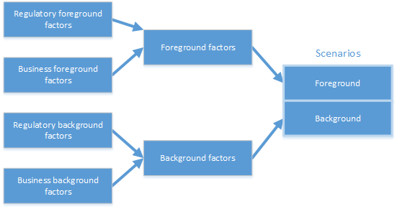

**Figure 1. Factors classification and scenarios definition**

It is worth noting that regulatory factors might be different from business factors in the fact that some of them play the role of enablers of technology or operational concepts to be deployed, while others have a direct impact on the stakeholders/system. For example, regulation of ATCO interoperability is required in order to develop the concept of FABs with seamless management of traffic, but the regulation itself does not have a direct impact on the Vista model, the regulation might be implemented, but its translation into technological and/or operational changes might not materialise. Compare the regulation defining passenger compensation in case of disruption. This must be followed by all aircraft operators and the regulation has a direct impact on airlines’ costs of delay and hence on their behaviour when dealing with disrupted itineraries or planning flights. All the regulations that are considered as **enablers** will be part of the **background factors** and it is assumed that regulation will allow corresponding business factors to be implemented.

## Vista model

The different factors considered are meaningless unless they are considered in the model. For this reason, it is paramount to identify which blocks in the model are impacted by the different factors. In this deliverable a preliminary relationship between factors and model layers and sub-layers is presented. This relationship allows us to isolate the impact of the factors to just the layers and sub-layers that are affected. The detailed impact on the model will be developed in parallel to the model and considering stakeholders’ consultations, where applicable.

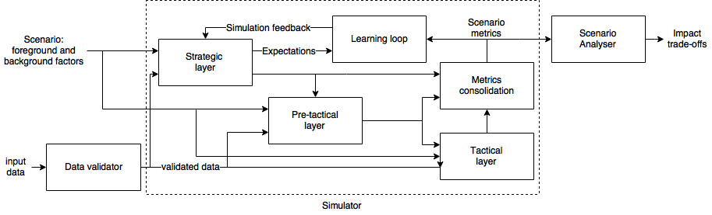

**Figure 2. Vista high-level packages architecture**

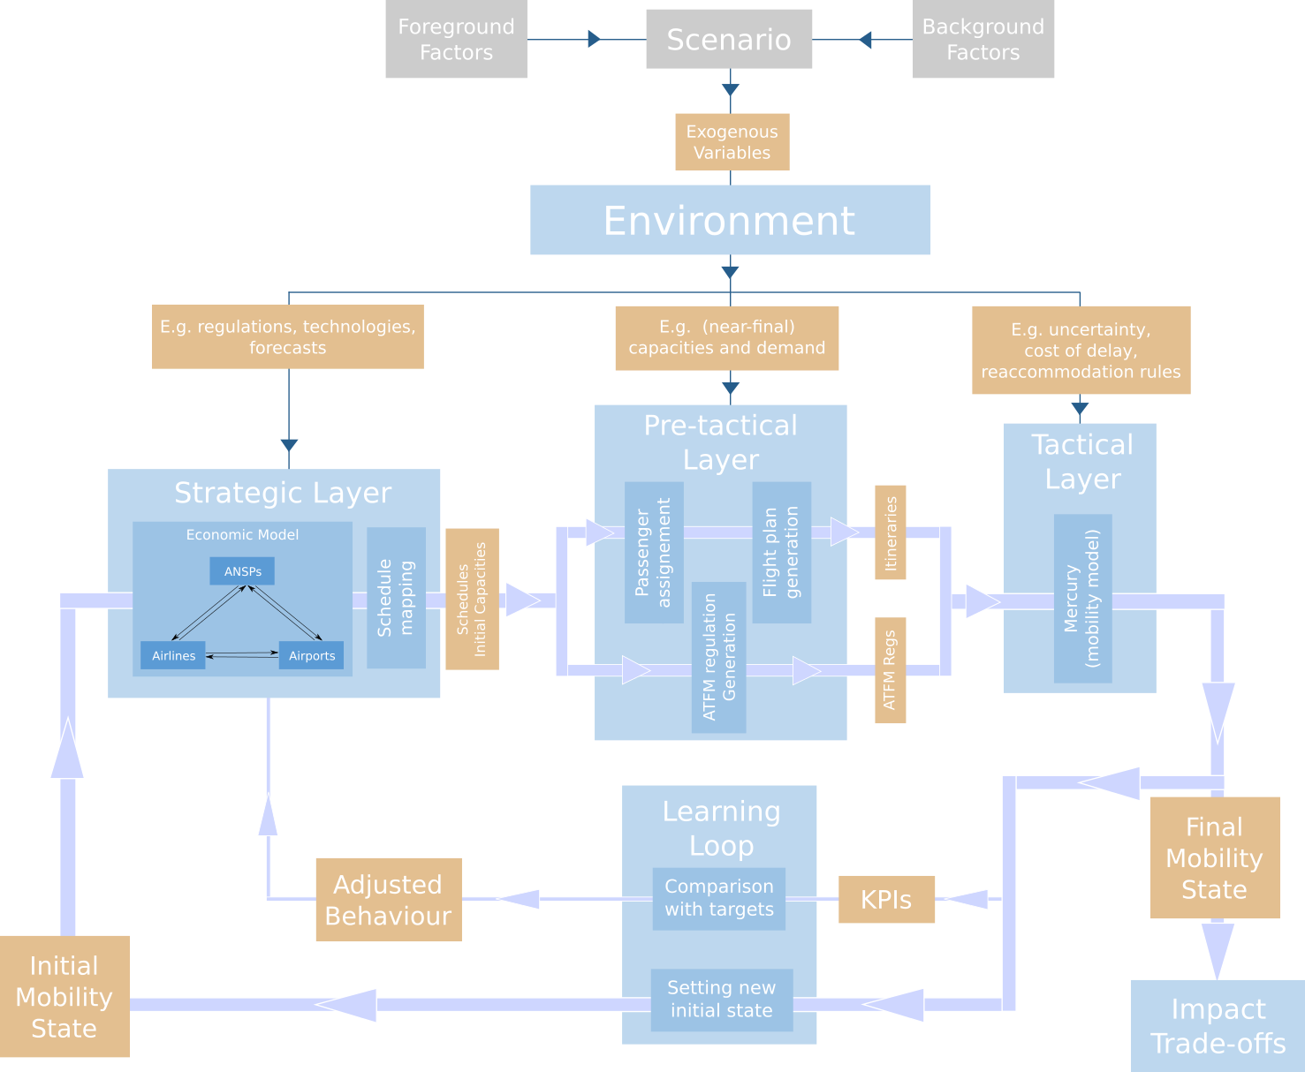

**Figure 3. Vista layers**

As reported in D4.1 (“Initial framework definition”), Vista will model the different phases of the ATM process from the strategic to the tactical phase. **Figure 2** presents the high-level view of the different packages that will be developed in Vista. **Figure 3** shows a detailed view of the different layers of the model with their sub-layers. As presented in the figure, a selection of values for the foreground and background factors together describe a scenario, which thus defines exogenous variables for the environment, on which the air traffic model is run. The strategic layer defines, based on an economic model, the modifications to the schedules to generate the demand in the system and the initial capacities. The pre-tactical layer assigns passengers’ itineraries to flights and defines the individual flight plans; ATFM regulations are generated based on the traffic demand and the airport and airspace capacity along with other environment factors. The outcome of the pre-tactical phase contains all the parameters to model the day of operations by the tactical layer. This layer computes the tactical execution of the individual itineraries, flights and regulations in the Mercury mobility model[1]. As these models are stochastic, each layer, or set of layers, might be executed several times to consolidate the metrics of the environment under analysis, as defined by the factors and data sources.

The model includes the possibility of developing a learning loop that would adjust the behaviour for the strategic layer based on the outcome of the consolidation of the metrics. This loop would allow us to provide a new initial mobility state to the model, which would recalibrate the outcome of the economic model at the strategic level.

# Foreground factors

In this section, we present the foreground factors to be used in the model. Foreground factors are both business and regulatory factors which Vista intends to study specifically. They have been chosen based on two criteria. First, their likely importance for the different stakeholders, based in part on feedback from the consortium’s industrial partners. Second, the level of uncertainty as to the likely implementation of the factors in the future. Indeed, some factors might be very important for the air transport system but uncontroversial as to their future effects. As a consequence, they will be adopted sooner or later and thus do not need to be studied in isolation, which leads us to class them as background factors (see Section 3).

The two tables presented in this section are slightly longer than desired in the first place. Indeed, the main issue with the number of foreground factors is that testing each of them independently of each other increases the computational time required combinatorially. Thus, it is important to keep as few as possible. However, it is important for Vista not to miss any important foreground factors, and as a consequence we consider slightly more factors that would be reasonable in terms of computational power. The early versions of the model will clarify its capabilities and the highest priority foreground factors will be considered for further study.

## Regulatory foreground factors

**Table 1** contains the regulatory factors that are considered for their modelling as foreground factors along with their possible (qualitative) values. (The identifiers in the “ID” column, in this and subsequent tables, were as defined in Deliverable D2.1). As described in the notes, in some cases, a regulatory factor is defined in the model as a combination of the regulation definition and how it is implemented. For example, passenger provision schemes (including passenger compensation regulations) might be implemented with different degrees of entitlement, e.g. different delays to trigger the entitlement to compensation, combined with different claim uptake rates, affected, for example, by enforcing an automatic compensation payment. In the same manner, it is possible to enforce an emission trading scheme for CO2 but the impact of such a regulation in the outcome model is directly related to the value of the emission allowance.

**Table 1. Foreground regulatory factors**

| ID | Factor | Possible values | Notes |
| --- | --- | --- | --- |
| ROR1 | Passenger provision schemes | * Current passengers’ compensation regulation (Regulation 261) * Modification of compensation requirements (right to care independent of flight distance, ensuring passengers right to be re-routed by another airline or transport mode in case of cancellation when the carrier cannot re-route on its own services, rights to assistance and compensation apply if connecting flights are missed because the previous flight was delayed by at least 90 minutes, application of three hours threshold for compensation for short and medium flights, technical faults not exempt from compensations). * Passengers entitled to compensation being automatically compensated; * Load factors maintained significantly below 100% on key/connecting/trunk routes to reserve some capacity for rebooking passengers who miss flights/connections - a ‘social’ capacity and resilience provision supporting Flightpath 2050 ambitions through new regulatory paradigms; * Enhanced identification of primary delay reasons to assign airline liability. | In this case some values can be combined, e.g. flights operated maintaining a load factor lower than 100% to maintain capacity to rebook passengers who miss connections and automatic compensation for passengers which are entitled. |
| ROR3 | Emission schemes | * Low environment impact * High environment impact | ETS combined with CORSIA will regulate the CO2 market.  NOx pollution, and particularly applied to local air quality around airports, can have a higher relevance in the future.  Low environment impact represents the implementation of CO2 market with a relatively low value for emission allowances.  High environmental impact increases the cost of CO2 allowances and affect the cost of operating at congested infrastructures due to local air quality. |
| ROR4 | Noise pollution | * Same level of noise restrictions * Increased protection of noise pollution | Increased protection due to noise pollution will lead to airport operation restrictions and/or higher charges for AU. |
| RAD1 | Airport slots | * Allocation of slots as current * Allocation with secondary market | Affecting the accessibility of airports |
| RAD2 | Regional airport development | * Maintain level of incentive to develop regional airports * Increase level of incentive to develop and connect regional airports | Regulatory factors related to the regionalisation of the traffic and the development of regional infrastructures. |
| RAA1 | Airport access | * Maintain level of incentive to develop intermodality * Increase level of incentive to develop intermodality |
| ROR9 | Operation of air services | * Maintain level of incentive for regional development * Increase level of incentive for regional development |

## Business foreground factors

**Table 2** shows the business factors which have been selected to be foreground factors, and the possible (qualitative) values that they could take within the different scenarios described in Section 4. These values, and the ones presented for the background factors in **Table 4**, correspond to different advancements in the related technological and managerial fields. The specific impact of these factors on the model will be defined at a later stage when the input and output of the model are defined. However, it is foreseen than some values will be extracted from the targets presented in D2.1 specifically, where possible, ‘Low’ values corresponding to time-based operations, ‘Medium’ values corresponding to trajectory-based operations and ‘High’ values to performance-based operations. Note also that here, and in the following deliverables, the values are taken by each of the factors relate to the same baseline, which is the baseline used by SESAR to set its targets. In particular, if a factor is set to ‘Medium’ in a 2035 scenario, it should not be understood as ‘Medium for the 2035 horizon’, but medium with respect to a fixed baseline. In the table we have also omitted the default values (as defined in Section 1.2) of the business factors. Finally, some factors do not fit well in ‘Low/Medium/High’ pattern, and thus they have some more customised values. All these remarks also apply for the background factors (see Section 3).

**Table 2. Foreground business factors**

| ID | Factor | Possible values | |
| --- | --- | --- | --- |
| BTS5 | 4D Trajectory Management | * Low * Medium * High | |
| BTS9 | Traffic Synchronisation | * Low * Medium * High | |
| BTO4 | Passenger reaccommodation tools | * Low * High | |
| BEO1 | Fuel prices | * Low * Medium (current level for current timeframe) * High | |
| BEO2 | Airspace charges | This business factor has two dimensions: how the airspace charges are implemented and computed geographically and what is their economic value (low or high) | |
| * Homogeneous (reshaping of charging zones with regional common charges) * Heterogeneous (current scheme) * Modulation of charges (based on demand) * New definition of service units based on actual flown route | * Low * High |
| BEO3 | Airline business models | Different market shares between different airline models. | |
| BEO4 | Smart, integrated ticketing | * Low * High | |

# Background factors

This section presents the list of business and regulatory background factors. These factors are comprised of all the factors which are not listed in Section 2. They have been chosen based on two complementary criteria: their relative smaller interest for the stakeholders, and their certainty to be implemented in the future.

These factors are not meant to be studied individually, but rather will constitute a background canvas for the different scenarios considered in Section 4 over which foreground factors draw contrasted images of their effects. As a consequence, most of these factors will change together in the different scenarios.

## Regulatory background factors

The majority of the background regulatory factors are composed of the regulations that are enablers of technology and operational change. These regulations, when combined with the background factors to generate the background scenarios, are considered to define the regulatory framework to allow the business factors to be implemented and developed as required. **Table 3** contains the background regulatory factors with their possible values and some notes (where required).

**Table 3** **Background regulatory factors**

| ID | Factor | Possible values |
| --- | --- | --- |
| RSI1 | Single European Sky integration | * Current degree of integration * Further development of integration * Further liberalisation of ANS |
| RSI2 | Common projects | Common project regulation will ensure that technology is developed and deployed to achieve the foreseen technological and operational changes. |
| RSI3 | Network Manager | As required to enable the functionalities of the network manager. |
| RPB1 | Performance Scheme | Different degrees of performance levels required. |
| RPB2 | Performance Review Body | * Range of targets at EU-level and then final values defined by NSAs (bottom-up approach) * Independent Performance and Economic Regulator which would provide a top-down performance target setting process |
| RAR1 | Common requirements | Regulation aligned with operational concepts |
| RAD3 | Airport charges | Maintain liberalisation and allow modulation based on parameters such as environmental impact or demand |
| RAP1 | Ground handling market | Maintain liberalisation and increase it for other airport services, e.g. increase of A-CDM technology deployment |
| RAP2 | Industry standardisation of airport procedures | Increased standardisation of processes |
| ROR2 | Common charging scheme | * Current charging scheme * Development of modulation of charges * New definition of service units based on actual flown route * Substantial incentivisation * Reshaping of charging zones with regional common en-route unit rates * Pure price cap model with a more direct link between actual price and agreed quality of service established   This regulation is an enabler of BEO2 |
| ROR5 | ANSP labour agreements | * Flexible rostering * Establishment of minimum service levels   ATCO (air traffic controller) mobility |
| ROR6 | Drones | Regulation enabling the use of drones at different levels.  Enabler of BTO1 |
| ROR7 | ATCO interoperability | Regulation enabling development of operational and technology concepts |
| ROR8 | Safety | Regulation required to maintain levels of safety |
| ROR10 | 2050 vision | Defines high-level vision and objectives for 2050 |

## Business background factors

**Table 4** shows the business factors which have been selected to be background factors, and the possible values that they are expected to take within the different scenarios described in Section 4. The values taken by the factors are explained in Section 2.2.

**Table 4** **Background business factors**

| ID | Factor | Possible values |
| --- | --- | --- |
| RSI1 | Single European Sky integration | * Current degree of integration * Further development of integration * Further liberalisation of ANS |
| BTS1 | Weather resilience | * Low * Medium * High |
| BTS2 | Airport safety | * Low * Medium * High |
| BTS3 | Enhanced runway throughput | * Low * Medium * High |
| BTS4 | Enhanced route structures | * Low * Medium * High |
| BTS6 | Spacing and separation | * Low * Medium * High |
| BTS7 | Ground Based Conflict Management | * Low * Medium * High |
| BTS8 | Air Safety Nets | * Low * Medium * High |
| BTS10 | Integrated Surface Management | * Low * Medium * High |
| BTS11 | Demand and Capacity Balancing Airports | * Low * Medium * High |
| BTS12 | Demand and Capacity Balancing En-Route | * Low * Medium * High |
| BTS13 | Remotely provided Air Traffic Services for aerodromes | * Low * Medium * High |
| BTS14 | CNS | * Low * Medium * High |
| BTS15 | SWIM | * Low * Medium * High |
| BTO1 | Drones / RPAS | * Low * Medium * High |
| BTO2 | Performance-based operations | * Low * Medium * High |
| BTO3 | Virtual control centre | * Low * Medium * High |
| BTO5 | Machine learning and deep learning | * Low * Medium * High |
| BTO6 | OTP monitoring | * Low * Medium * High |
| BTO7 | Integrated turnaround/hub operations control | * Low * Medium * High |
| BTO8 | Cybersecurity | * Low * Medium * High |
| BTO9 | Development of carbon-neutral fuels | * Low * Medium * High |
| BED1 | Economic development of EU - EFTA | * Low * Medium * High |
| BED2 | Development of high-speed trains | * Low * Medium * High |
| BED3 | Societal travel characteristics changes | * Increase in environment-friendly profile * Increase cultural seeker profile * etc. |
| BED4 | Travel substitutes | * Low * Medium * High |
| BED5 | Air traffic predictability | * Low * Medium * High |
| BED6 | Modal competition *versus* cooperation | * Low * Medium * High |
| BAA1 | Airport multi-modal connectivity | * Low * Medium * High |
| BAP1 | Self-processing at airport | * Low * Medium * High |
| BAP2 | Resource allocation at airport | * Low * Medium * High |

# Definition of scenarios

This section presents the way in which Vista will consider different scenarios for the future of the air transport system. In contrast to other studies, Vista’s main aim is not to assess the most likely future for the ATM system, but rather to test the consequences of the potential choices of the actors of the system. These choices are represented in the potential technological adoptions, new process management, and regulations put into place.



**Figure 4. From factors to scenarios**

The scenarios in Vista are defined as **sets of values over all the factors** presented in Section 2.1. The scenarios are defined in a hierarchical way. As shown in **Figure 4**, some regulatory and business factors are grouped together to constitute background factors, as listed in Section 3. Setting the factors to different values then defines different **background scenarios**. The remaining factors are foreground factors, listed in Section 2. Setting their values then constitutes a **scenario**, to be run by the Vista model. Many different scenarios are likely to be generated for each background scenario, since one of the main aims is to test the individual effects of the foreground factors. The effect of these factors are mitigated by the environment, i.e. the background scenario. Different backgrounds will allow us to test the cost and benefits of each foreground to help understand their likely effect.

## Background scenarios

Background factors are grouped to create the background scenarios to which apply the foreground factors. When creating these scenarios, the economic and technology evolution is considered decoupled. This is in contrast to usual predictions such as those produced by STATFOR, where usually a median scenario is computed with a pessimistic and an optimistic one to give a range of possibilities of future developments. However, Vista works more with a ‘what-if’ work-frame, which allows the project to have extra flexibility and assess the respective effects of different factors.

As a consequence, the project has isolated two main underlying drivers which might affect the impact of other factors on the system. First, it is clear that changes in demand for travel in Europe will affect the future air transport system. In particular, it is important to take into account the many dimensions of the demand, for instance its volume, its geographical distribution, its structure in terms of passenger profiles. We collect all these concepts under the broad term of ‘economic development’ in the table below. On the supply side, it is clear that technological advancements (in which we include process management processes) will shape also the future ATM system. As a consequence, we consider that the technologies can have different maturing speeds, drawing on the experience of the targets set by SESAR in particular.

Of course, it is clear that the demand and supply sides are strongly related in reality. In particular, economic development helps research initiatives to get funded, and the latter drives the economic development in return. However, Vista tries to keep them apart, specifically because it wants to discriminate between one effect and the other in order to be able to form a view about the impact of the research initiatives in Europe, like SESAR, and how they can be enhanced within the right environment.

The regulatory factors identified as background regulatory factors are considered enablers of the different technological and operational concepts that are described for the different background scenarios identified in **Table 5**.

**Table 5** **Background scenarios**

| Period | Name | Background factors* |
| --- | --- | --- |
| Current | Current | Default values for the factors (see Section 1.2) |
| 2035 | L35: Low economic, Low Techno | * BTS: Low * BTO: Low * BAA: Low * BAP: Low * BED: Low, except:   + BED3: default * BEO: Low |
| M35: High economic, Low Techno | * BTS: Low * BTO: Low * BAA: Low * BAP: Low * BED: Medium, except:   + BED3: increased high-income profile share * BEO: Medium |
| H35: High economic, High Techno | * BTS: Medium * BTO: Low (as they are long-term goals) * BAA: Medium * BAP: Medium * BED: Medium, except:   + BED3: increased high-income profile share * BEO: Medium |
| 2050 | L50: Low economic, Low Techno | * BTS: Medium * BTO: Medium * BAA: Medium * BAP: Medium * BED: Medium, except:   + BED3: increased high-income profile share * BEO: Medium |
| M50: High economic, Low Techno | * BTS: Medium * BTO: Medium * BAA: Medium * BAP: Medium * BED: High, except:   + BED3: increased high-income profile share and environment-friendly profile share * BEO: High, except: |
| H50: High economic, High Techno | * BTS: High * BTO: High * BAA: High * BAP: High * BED: High, except:   + BED3: increased high-income profile share and environment-friendly profile share * BEO: High |
| * Factors are grouped by their code:  BTS: Business Technology SESAR  BTO: Business Technology Others  BAA: Business Airport Access  BAP: Business Airport Processes  BED: Business Economic Demand  BEO: Business Economic Others | | |

## Foreground factors grouping

Foreground factors can be tested individually on the different background scenarios by generating scenarios with different values for the foreground factors. However, to reduce the number of potential scenarios to test, and in order to model the impact of high-level modifications, some of the foreground factors can be grouped. **Table 6** shows different foreground factor groups that could be tested against the different background scenarios.

The term “default” was defined in Section 1.2. In contrast, “enhanced” is defined as a change being based on an *active shift in momentum* of the corresponding processes and/or (supporting) legislation(s) (where applicable).

**Table 6** **Grouped foreground factors**

| Foreground factor group | Possible values | Foreground factors | Notes |
| --- | --- | --- | --- |
| EM: Environmental mitigation policies | default | * ROR3: Low environment impact * ROR4: Current levels of noise restrictions | Follows evolution of emission trading schemes but with low cost of allowances and similar levels of noise protection. |
| enhanced | * ROR3: High environment impact * ROR4: Increased protection of noise pollution | Follow evolution of emission trading schemes but with high cost of allowances and high levels of noise protection. |
| RI: Regional infrastructures | default | * RAD2: Maintain level of incentive to develop regional airports * RAA1: Maintain level of incentive to develop intermodality * ROR9: Maintain level of incentive for regional development | Keep incentivisation for regional development as current practice. |
| enhanced | * RAD2: Increase level of incentive to develop and connect regional airports * RAA1: Increase level of incentive to develop intermodality * ROR9: Increase level of incentive for regional development | Incentive development of regional infrastructures, their link with intermodality and the operation of new routes. |
| PF: Passenger focus | default | * ROR1: Modification of compensation requirements / enhanced identification of primary delay reasons to adjust airline liability. * BTO4: Low * BEO4: Low | Protection of passenger and aircraft operators by identifying reasons of primary delay. Deployment of passenger reaccommodation tools without prioritisation.  No focus on smart, integrated ticketing. |
| enhanced | * ROR1: Modification of compensation requirements / automatic compensation / maintain capacity available. * BTO4: High * BEO4: High | Protection of passengers enhanced with automatic repayment when entitled and capacity available for reaccommodation of passengers with missed connections.  Prioritisation of deployment of passenger reaccommodation tools.  High usage of smart, integrated ticketing. |
| SES: Single European Sky | default | * BTS5: Low * BTS9: Low * BEO2: Heterogeneous/Low * BEO4: Low | Overall fragmentation of the ATM system at a national level.  Limited 4D trajectory implementation  Limited traffic synchronisation between airports and airspaces  Fragmented ANSPs, different charges for different airspaces. Charges high overall.  No integrated smart, integrated processes. |
| enhanced | * BTS5: High * BTS9: High * BEO2: Homogeneous/High * BEO4: High | Federal, uniform management of the airspace.  Highly advanced point-to-point 4D trajectories  High synchronisation of traffic between airports and airspaces  Unique ANSP manager, same European-wide pricing scheme. Charges low overall due to gains in efficiency.  Full integrated smart, integrated ticketing processes between all actors of the system Europe-wide. |

## Scenarios definitions

The combination of the background scenarios with foreground factors and/or foreground factor groups will provide the different scenarios to be tested in Vista. **Figure 5** shows how the scenarios are created by selecting a background scenario, setting some values for the foreground factor groups and finally setting values for the remaining foreground factors.

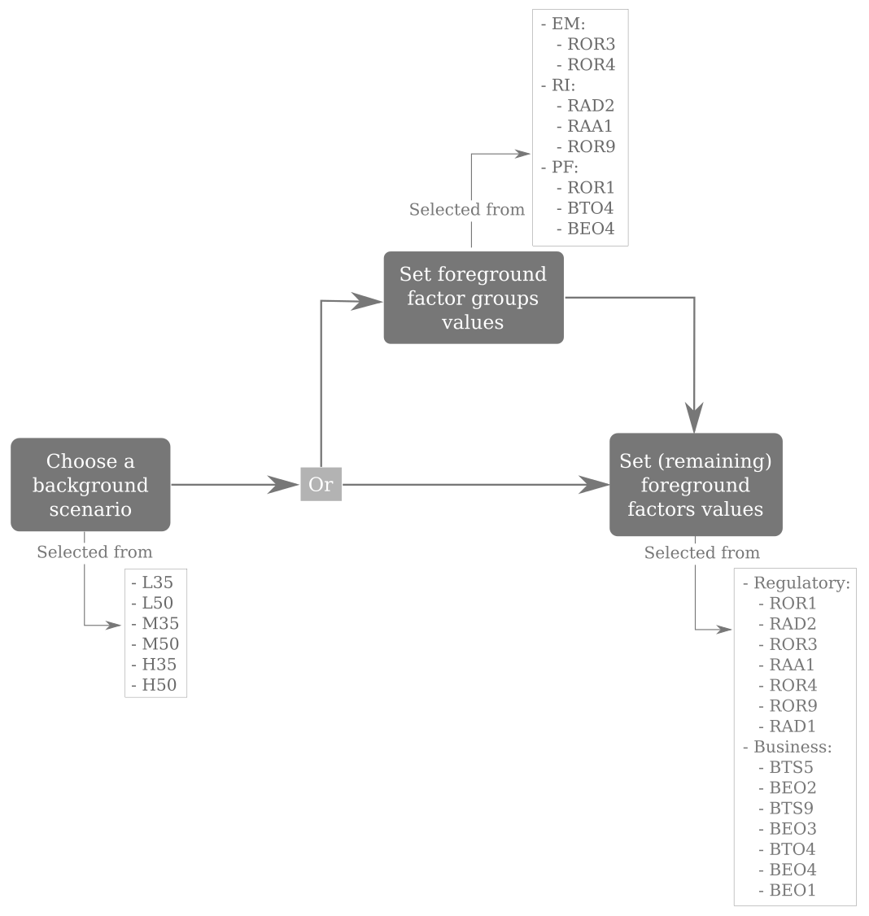

**Figure 5. Process to define a scenario for the Vista model**

Due to the large number of foreground factors the number of scenarios to be exhaustively tested would be very large. For this reason, based on the preliminary results to be obtained with the model, the scenarios tested would be adjusted. Business and regulatory factors along with the scenarios will be subject to a consultation with stakeholders (reported in D6.2). This consultation will allow us to identify which of the combinations of foreground factors and background scenarios are more suitable to be initially tested. After the first results are obtained (reported in D5.1) a second consultation with stakeholders will be carried out (reported in D6.3). From that consultation the model will be fine-tuned and the selection of scenarios finalised, which would yield a higher insight into the model.

# Effect of factors on the model

The objective of this section is to indicate which phases and exogenous variables of the model are affected by the foreground factors and the background scenarios. Different factors will have different types of impact on the system. Some factors are quite high-level and will serve as qualitative indications on how to build scenarios. Other factors are much more specific and will directly change some parameters in the model. Others, which are equally specific, can be directly integrated in the model as a new mechanism for airlines, airports or passengers to use.

Once the model is built, the exact effect of each factor will be defined. In this section we only make a first assessment of the part of the model which will likely be impacted by each factor. This will help us to determine which factor(s) require less focus of attention in each of the sublayers of the model, as well as focusing on building the model around the most important factors – the foreground ones.

Note that we are interested in the **primary** effects of the factors in each sublayer or its components, i.e. the factor has to be related to the **exogenous** variables used to run the sublayers. Obviously, many factors have many indirect effects too, in the sense that each sublayer is linked to each other and thus its modification impacts the other sublayers downstream.

## Effect of SESAR-related factors

A first step is to determine the effect of the factors related to SESAR technological advancements. Since they have very specific targets, which give an indication of their potential effect, they are the easiest to assess.

### Primary effect of KPIs on the model

A first step is to map some of the functional relationships between KPIs and other metrics within the model. This helps to unify the effect of all SESAR-related factors in the model by considering only their effects in terms of the KPIs, except when a specific mechanism is implemented in the model.Table 7 presents the qualitative relationships expected. Note that some KPIs are not explicitly included in this manner. This does not mean that the corresponding KPIs are not modified by a factor. For instance, ‘resilience’ is thought to be too much of an emergent property to modify directly some parameters within the model. However, resilience could in principle be defined and measured within the model and thus be modified by different factors.

**Table 7** **Effect of KPIs**

| KPI | Effect |
| --- | --- |
| Airport Capacity | Sets the relationship between mean delay and traffic volume at airport |
| Airspace Capacity | Sets the relationship between mean delay and traffic volume in airspace |
| Civil-Military Coordination Centre | Not explicitly included |
| Cost Effectiveness (ATCO) | Sets the cost of an ATCO with respect to the volume controlled |
| Cost Effectiveness (TECH) | Sets the cost per flight (with fuel and ANSPs’ charges) |
| Environment / Fuel Efficiency | Sets ratio of best trajectory length/actual trajectory |
| Predictability / Flight Duration Variability | Sets variance of flight duration distribution |
| Punctuality | Sets mean of flight duration distribution |
| Resilience | Not explicitly included |
| Safety | Not explicitly included |

### Sublayers affected by KPIs

Based on the previous table, **Table 8** shows the sublayers of the model (which were defined in D4.1) and the corresponding KPI relationships. A “✓” indicates the presence of a relationship.

**Table 8** **Model components affected by SESAR KPIs**

| KPI | Sublayer & components | | | | | | | | |
| --- | --- | --- | --- | --- | --- | --- | --- | --- | --- |
| Strategic layer | | | |  | Pre-tactical layer | | | Tactical layer |
| Economic model | | | Schedule mapping | Passenger assignment | | Flight plan generation | ATFM reg. generation | Mercury |
| Airport | ANSP | Airline |
| Airport Capacity | ✓ |  |  |  |  | |  | ✓ |  |
| Airspace Capacity |  | ✓ |  |  |  | |  | ✓ |  |
| Cost Effectiveness (ATCO) |  | ✓ |  |  |  | |  |  |  |
| Cost Effectiveness (TECH) |  |  | ✓ |  |  | |  |  |  |
| Environment / Fuel Efficiency |  |  | ✓ |  |  | | ✓ |  |  |
| Predictability / Flight Duration Variability |  |  |  |  |  | |  |  | ✓ |
| Punctuality |  |  |  |  |  | |  |  | ✓ |

## Effect of business and regulatory factors on the components of the model

This section presents the assessment of the sublayers which could be affected by any of the business or regulatory factors considered. This assessment is based on the previous table for the SESAR related business factors (“BTS” nomenclature). For other factors, the assessment is based on the factor description. The assessment is based on the description of the factor itself. Some justifications can be found in Section 5.3 for each individual sublayer of the model.

**Table 9** shows the components in the model that are impacted by the different business and regulatory areas defined in D2.1. A “✓” indicates the presence of a relationship.

**Table 9** **Model components affected by business and regulatory areas**

| Business / Regulatory area | Sublayer & components | | | | | | | | |
| --- | --- | --- | --- | --- | --- | --- | --- | --- | --- |
| Strategic layer | | | |  | Pre-tactical layer | | | Tactical layer |
| Economic model | | | Schedule mapping | Passenger assignment | | Flight plan generation | ATFM reg. generation | Mercury |
| Airport | ANSP | Airline |
| BTS | ✓ | ✓ | ✓ | ✓ |  | | ✓ | ✓ | ✓ |
| BTO | ✓ | ✓ | ✓ | ✓ | ✓ | | ✓ | ✓ | ✓ |
| BAA | ✓ |  |  | ✓ |  | |  |  | ✓ |
| BAP | ✓ |  |  |  |  | |  |  | ✓ |
| BED | ✓ | ✓ | ✓ | ✓ | ✓ | |  | ✓ | ✓ |
| BEO | ✓ | ✓ | ✓ | ✓ | ✓ | | ✓ |  | ✓ |
| ROR | ✓ |  | ✓ | ✓ |  | |  | ✓ | ✓ |
| RAD | ✓ |  | ✓ | ✓ | ✓ | |  |  |  |
| RAA | ✓ |  | ✓ | ✓ | ✓ | |  |  |  |

**Table 10** compiles the potential effects of each individual business and regulatory factor on the different sublayers.

**Table 10** **Model components affected by business and regulatory factors**

| Factors * | Sublayer & components | | | | | | | | |
| --- | --- | --- | --- | --- | --- | --- | --- | --- | --- |
| Strategic layer | | | |  | Pre-tactical layer | | | Tactical layer |
| Economic model | | | Schedule mapping | Passenger assignment | | Flight plan generation | ATFM reg. generation | Mercury |
| Airport | ANSP | Airline |
| BTS1 |  |  |  |  |  | |  | ✓ | ✓ |
| BTS2** |  |  |  |  |  | |  |  |  |
| BTS3 | ✓ | ✓ |  | ✓ |  | | ✓ | ✓ | ✓ |
| BTS4 | ✓ | ✓ | ✓ | ✓ |  | | ✓ | ✓ | ✓ |
| BTS5 | ✓ | ✓ | ✓ |  |  | | ✓ | ✓ | ✓ |
| BTS6 | ✓ | ✓ | ✓ |  |  | | ✓ | ✓ | ✓ |
| BTS7 |  | ✓ | ✓ |  |  | | ✓ | ✓ | ✓ |
| BTS8** |  |  |  |  |  | |  |  |  |
| BTS9 | ✓ | ✓ | ✓ |  |  | |  | ✓ | ✓ |
| BTS10 | ✓ |  | ✓ |  |  | |  |  | ✓ |
| BTS11 |  | ✓ | ✓ |  |  | | ✓ | ✓ | ✓ |
| BTS12 |  | ✓ | ✓ |  |  | | ✓ | ✓ | ✓ |
| BTS13 |  | ✓ | ✓ |  |  | |  | ✓ |  |
| BTS14 |  | ✓ |  |  |  | |  |  |  |
| BTS15 |  |  | ✓ |  |  | |  |  | ✓ |
| BTO1 |  | ✓ |  |  |  | |  | ✓ |  |
| BTO2 |  | ✓ | ✓ |  |  | | ✓ | ✓ | ✓ |
| BTO3 |  | ✓ |  |  |  | |  | ✓ |  |
| BTO4 |  |  | ✓ | ✓ | ✓ | |  |  | ✓ |
| BTO5 | ✓ | ✓ | ✓ |  |  | |  |  |  |
| BTO6 |  |  | ✓ | ✓ |  | |  |  | ✓ |
| BTO7 | ✓ |  | ✓ | ✓ |  | | ✓ |  | ✓ |
| BTO8** |  |  |  |  |  | |  |  |  |
| BTO9 |  |  | ✓ | ✓ |  | | ✓ |  | ✓ |
| BAA1 | ✓ |  |  | ✓ |  | |  |  | ✓ |
| BAP1 |  |  |  |  |  | |  |  | ✓ |
| BAP2 |  |  |  |  |  | |  |  | ✓ |
| BED1 | ✓ |  | ✓ | ✓ |  | |  |  |  |
| BED2 | ✓ |  | ✓ |  | ✓ | |  |  | ✓ |
| BED3 |  |  | ✓ | ✓ | ✓ | |  |  | ✓ |
| BED4 | ✓ |  | ✓ | ✓ | ✓ | |  |  |  |
| BED5 |  | ✓ |  |  |  | |  | ✓ | ✓ |
| BED6 |  | ✓ | ✓ |  |  | |  |  |  |
| BEO1 |  |  | ✓ |  |  | | ✓ |  | ✓ |
| BEO2 |  | ✓ | ✓ | ✓ |  | | ✓ |  |  |
| BEO3 |  |  | ✓ | ✓ | ✓ | | ✓ |  | ✓ |
| BEO4 |  |  | ✓ |  | ✓ | |  |  | ✓ |
| ROR1 |  |  | ✓ | ✓ | ✓ | |  |  | ✓ |
| ROR3 |  |  | ✓ |  |  | |  |  | ✓ |
| ROR4 | ✓ |  |  | ✓ |  | |  | ✓ | ✓ |
| ROR9 |  |  | ✓ | ✓ |  | |  |  |  |
| RAD1 | ✓ |  | ✓ | ✓ |  | |  |  |  |
| RAD2 | ✓ |  | ✓ | ✓ | ✓ | |  |  |  |
| RAA1 | ✓ |  | ✓ | ✓ |  | |  |  |  |
| * For regulatory factors, only those considered not merely as enablers are shown.  ** Safety/security is out of scope of the Vista project and hence these parameters do not have a direct impact on the model. | | | | | | | | | |

## Description of the preliminary expected effect of the factor in the model

The previous table only states if a given factor will have any direct effect on a given sublayer. It does not state the magnitude, direction, or even the qualitative nature of the effect. As a consequence, we present additional tables which give a rough estimation of the type of effect of each factor. For each component/sublayer in the model, a brief description of the preliminary expected effect of the different factors are presented in the following tables. The specific effect will only be fixed when the model starts to be implemented and its specific exogenous variables more precisely defined.

### Economic model

**Table 11. Effect of factors on economic model**

| Factor | Effect | Model/Variables affected |
| --- | --- | --- |
| BTS3 | Optimised procedures for arrival and departure management | * Airport: Increased capacity * ANSP: increased capacity (TMA) |
| BTS4 | Optimised airspace management | * Airport: Increased capacity * ANSP: increased capacity (TMA and en-route), increased cost efficiency * Airline: decreased en-route cost |
| BTS5 | Optimised trajectories for aircraft | * Airport: Increased capacity * ANSP: increased capacity (TMA and en-route), increased cost efficiency * Airline: decreased en-route cost |
| BTS6 | Potential increased density of aircraft in a given region with a constant safety level | * Airport: Increased capacity * ANSP: increased capacity (TMA), increased cost efficiency * Airline: decreased en-route cost |
| BTS7 | Better separation management, better controller team organisation | * ANSP: increased capacity (TMA and en-route), increased cost efficiency * Airline: decreased en-route cost |
| BTS9 | Better and extended AMAN and DMAN procedures | * Airport: Increased capacity * ANSP: increased capacity (TMA and en-route), increased cost efficiency * Airline: decreased en-route cost |
| BTS10 | Better surface management tools. | * Airport: Increased capacity * Airline: decreased en-route cost |
| BTS11 | Enhanced cooperation between airports, NOP, etc. | * ANSP: increased capacity (TMA), increased cost efficiency * Airline: decreased en-route cost |
| BTS12 | Better management of the airspace through increased collaboration, more flexible airspaces, better prioritisation rules etc. | * ANSP: increased capacity (TMA and en-route), increased cost efficiency * Airline: decreased en-route cost |
| BTS13 | Factorisation of the efforts for ANSPs through the use of remote towers possibly controlling vast pieces of airspaces. | * ANSP: increased cost efficiency * Airline: decreased en-route cost (ATCO) |
| BTS14 | More communication, navigation and surveillance tools, enabling some of the other factors. | * ANSP: decreased cost efficiency |
| BTS15 | Common pool of updated information for all stakeholders, leading better informed strategic and tactical decisions. | * Airline: decreased en-route cost |
| BTO1 | Drones take resources from the ANSPs that they cannot allocate to the passengers-oriented side | * ANSP: decreased effective airspace capacity |
| BTO2 | Development of Performance-based navigations with the management of trajectory planning and execution | * ANSP: increased airspace capacity (TMA and en-route), increased cost efficiency * Airline: increased cost efficiency |
| BTO3 | Virtual control centres will allow the ANSPs to factorise the effort have increased flexibility | * ANSP: increased cost efficiency |
| BTO4 | Passenger reaccommodation tools lead to a better assessment of the needs of passengers in case of disruption | * Airline: decreased cost of delay. |
| BTO5 | Machine learning and deep learning will allow in particular a better prediction of the changes of demand | * Airline, ANSP, airport: increased cost efficiency |
| BTO6 | Higher reactivity to disruptions and enhanced disruption management. | * Airline: increased cost efficiency |
| BTO7 | Enhanced A-CDM, resources allocation and reduction of passengers’ disruptions due to missed connections. | * Airline: increased cost efficiency, better delay management procedures within the model. |
| BTO9 | Alternative to fossil fuels, leading to a reduction of emission per kilometre flown | * Airline: decreased emissions per kilometre flown |
| BAA1 | Increased intermodality | * Airport: increased catchment area, decreased demand for short route. |
| BED1 | The economic development of Europe affects the distribution of income and wealth of its inhabitants, triggering changes in demand | * Airline: modification of the passenger profiles shares, modification of the demand volume, modification of the geographical localisation of demand |
| BED2 | Development of high-speed trains has a dual effect, because it potentially brings more passengers to the airports connected but is also a direct competitor for the given routes. | * Airport: increased catchment area * Airline: less demand for short routes. |
| BED3 | The society’s changes are reflected in changes of demand with regard to the type of travel desirable | * Airline: changes in the passenger profile shares. |
| BED4 | Virtual reality devices are likely to decrease at least some types of travel, like small business meetings. | * Airline: decrease for business and leisure passenger demand. |
| BED5 | Traffic predictability allows us to better allocate resources and thus operate closer to the capacity | * ANSP: increased capacity |
| BED6 | More competition could lead to higher cost efficiency locally, more cooperation to a better integration of the system and a higher cost efficiency overall | * ANSP: establishment of super-monopolies and/or higher cost efficiency. |
| BEO1 | The fuel price influences the cost of the gate-to-gate part | * Airline: increased gate-to-gate cost |
| BEO2 | The type of pricing scheme directly impacts the revenues of the ANSPs and the costs of the airlines | * ANSP, airline: different pricing mechanisms implemented within the model, with different level of spatial heterogeneity |
| BEO3 | The airline business drives the price and the type of service they offer, thus impacting the passenger profile share too.  Note: could be an endogenous variable of the model | * Airline: change share of airline business models. |
| BEO4 | Smart integrated tickets allow passengers and airlines to reduce their buffers. | * Airline: smaller turnaround time, increased cost-efficiency. |
| ROR1 | Different rights for the passengers translate into different types of costs for the airlines | * Airline: changes the cost of delay |
| ROR3 | The emission charges add up to the cost of the fuel for the airlines | * Airline: changes the cost per kilometre flown |
| ROR4 | Noise limitation regulations will force the airport to cap its capacity or reduce the number of people affected by the noise, and/or putting some extra charge on some problematic airports. | * Airport: capped capacity for some airport, additional operating costs. |
| ROR9 | Affect the range of prices that the airline can offer to passengers. | * Airline: cap (or not) the prices |
| RAD1 | Regulations regarding the slot allocation can change how airport are benefiting from the slots and how the airline choose their routes | * Airport: change the revenues * Airlines: allow more strategic changes |
| RAD2 | This regulation allows the countries to subsidies some small airports which face adverse conditions regarding their development | * Airport: increased revenues for some small airports |
| RAA1 | These policies lead to the integration of airport with other means of transport. | * Airport: increased catchment area |

### Schedule mapping

**Table 12. Effect of factors on schedule mapping**

| Factor | Effect | Model/Variables affected |
| --- | --- | --- |
| BTS3 | These factors might impact the airport capacity.  These capacities might be used while adjusting the flight schedules | * Airports capacities |
| BTS4 |
| BTO4 | The introduction of passenger reaccommodation tools might affect the scheduling of flights to provide hub operations, e.g. reducing the connecting time between flights or buffers | * Buffers Connecting times |
| BTO6 | Enhanced OTP monitoring and tracking of disruptions might affect the buffers considered during the scheduling phase | * Buffers |
| BTO7 | Turnaround might affect how flight schedules are generated by impacting the minimum turnaround time | * Minimum turnaround time |
| BTO9 | Carbon-neutral fuel development might affect the willingness to recover delay and hence the buffers during scheduling | * Buffers |
| BAA1 | Passengers’ demand evolution, including changes due to high-speed train, intermodality and passengers’ characteristics, affects the schedules offered by airlines | * Passengers’ demand |
| BED1 |
| BED2 |
| BED3 |
| BED4 |
| BEO2 | Airspace charges affects operating costs and hence scheduling decisions | * Operating costs |
| BEO3 | Airlines models affect the scheduling in the model | * Schedule models |
| ROR1 | Passenger provision schemes might affect decisions at scheduling level, e.g. buffers | * Buffers * Connecting times |
| ROR4 | Noise restrictions in airport capacity might affect scheduling possibilities | * Airports capacities |
| ROR9 | Incentivisation of specific airports will affect the schedules of the flights to-from them | * Airports capacities * Passengers’ demand |
| RAD1 | Airport slots availability affects airport capacity and hence the scheduling | * Airports capacities |
| RAD2 | Development of regional infrastructure will affect airports’ capacities and passengers’ demand | * Airports capacities * Passengers’ demand |

### Passenger assignment

**Table 13. Effect of factors on passenger assignment**

| Factor | Effect | Model/Variables affected |
| --- | --- | --- |
| BTO4 | Passenger reaccommodation tools might affect willingness to select tight connections and might affect the capacity of seats available | * Connection times |
| BED3 | Passengers’ profiles affect passengers’ distribution | * Passengers distribution between the different profiles |
| BED4 | Travel substitutes might affect the type of passenger assigned to flights | * Passengers distribution between the different profiles |
| BEO3 | Airlines models affect type of passenger assigned to flights | * Passengers distribution between the different profiles |
| BEO4 | Smart ticketing might affect buffers between means of transport | * Buffer times |
| ROR1 | Passenger provision schemes might affect willingness to select tight connections and might affect the capacity of seats available | * Connection times |
| RAD2 | Development of regional infrastructure will affect passenger demand | * Passenger demand |
| RAA1 | Intermodality might affect passengers’ demand | * Passenger demand |

### Flight plan generation

**Table 14. Effect of factors on flight plan generation**

| Factor | Effect | Model/Variables affected |
| --- | --- | --- |
| BTS3 | These factors might impact the airport capacity. These capacities might be used while adjusting the flight plans | * Airports capacities |
| BTS4 |
| BTS5 | 4D trajectory management will affect the type of flight plan that is generated, it might affect the constraints considered when generating the flight plan | * Flight plan constraints |
| BTS6 | These factors might affect airport and airspace capacity which might affect the constraints when defining the flight plans | * Airports capacities * Airspace capacities * Flight plan constraints |
| BTS7 |
| BTS11 | This factor might impact the airport capacity. These capacities might be used while adjusting the flight plans | * Airports capacities |
| BTS12 | This factor might impact the airport. These capacities might be used while adjusting the flight plans | * Airports capacities |
| BTO2 | Performance-based operations might impact how flight plans are generated | * Flight plan generation process |
| BTO7 | Turnaround might affect how flight plans are generated | * Minimum turnaround time |
| BTO9 | Cost of fuel and carbon-neutral fuels might play a role on the operating costs and hence on the generation of flight plans. | * Costs considered during flight plan generation |
| BEO1 |
| BEO2 | Airspace charges affect the operating cost of the flight plans. |
| BEO3 | Airlines’ models affect the prioritisation of factors during the generation of the flight plan (e.g. time, fuel, buffers) | * Flight plan generation process |

### ATFM regulation generation

**Table 15. Effect of factors on ATFM regulation generation**

| Factor | Effect | Model/Variables affected |
| --- | --- | --- |
| BTS1 | Weather resilience will affect the probability of having a reduced capacity due to weather and hence the probability of implementing ATFM regulations due to weather. | * Probability of regulation due to weather |
| BTS3 | Airport throughput will affect the airport capacity. | * Airports capacity |
| BTS4 | Routes structures will affect the airspace capacity. | * Airspace capacity |
| BTS5 | 4D trajectory management will affect airport and airspace capacity | * Airports capacity * Airspace capacity |
| BTS6 | Conflict management will affect airport and airspace capacity | * Airports capacity * Airspace capacity |
| BTS7 |
| BTS9 | Traffic synchronisation will impact the airport and airspace capacity | * Airports capacity * Airspace capacity |
| BTS11 | Demand and capacity balancing tools are related to the probability of having regulations and their intensity and duration | * Probability of regulation and characteristics |
| BTS12 |
| BTS13 | Remotely provided ATS for aerodromes will affect capacity of some airports | * Airports capacity |
| BTO1 | The introduction of drones/RPAS will have an impact on the capacity of the airports and airspace | * Airports capacity * Airspace capacity |
| BTO2 | Performance-based operations might affect the capacity or airspace and airports | * Airports capacity * Airspace capacity |
| BTO3 | Virtual control centre might impact airspace capacity | * Airports capacity |
| BED5 | Traffic predictability might impact airspace and airport capacity | * Airports capacity * Airspace capacity |
| ROR4 | Noise pollution restrictions might affect airport capacity available | * Airports capacity |

### Mercury

**Table 16. Effect of factors on Mercury**

| Factor | Effect | Model/Variables affected |
| --- | --- | --- |
| BTS1 | Weather resilience will impact the variability and delay of flights on the presence of weather | * Flights variability * Delay |
| BTS3 | Runway throughput will affect the airport capacity and hence the delay | * Airports capacity |
| BTS4 | Route structures will affect the flight times and tactical flight plan variations | * Flights variability |
| BTS5 | 4D trajectory management might impact capacity and predictability | * Airspace capacity * Airports capacity * Flights variability |
| BTS6 | Conflict management tools might increase airspace capacity and reduce tactical en-route delay. | * Airspace capacity |
| BTS7 |
| BTS9 | Traffic synchronisation will affect the airport capacity and hence the arrival delay | * Airports capacity |
| BTS10 | Integrated surface management tools might affect the ground operations times (taxi times) | * Taxi times |
| BTS11 | Demand and capacity balancing might affect tactically the parameters of some of the ATFM regulations, e.g. their duration | * ATFM regulations |
| BTS12 |
| BTS15 | The use of SWIM might affect flight predictability | * Flights variability |
| BTO2 | Performance-based operations might affect how flight plans are selected and executed. | * Flight plan selection and execution |
| BTO4 | Passenger reaccommodation tools affect passengers transfer times and tactical delay recovery strategies as it impacts cost of delay | * Cost of delay * Passenger connecting times |
| BTO6 | The monitoring of OTP might affect how flight plans are selected and executed particularly in terms of tactical delay management | * Flight plan selection and execution |
| BTO7 | Turnaround operations affect the time required to perform the minimum turnaround time | * Minimum turnaround time * Actual turnaround time |
| BTO9 | The development of carbon-neutral fuels might affect the cost of emissions and hence affect the cost of fuel usage impacting the technology/procedures with are affecting fuel consumption such as dynamic tactical delay recovery | * Cost of fuel |
| BAA1 | Multi-modal connectivity at airports and means of transport selected to access the airport will affect the door-to-gate and gate-to-door time. | * Access/egress times * Passengers buffers for connecting to other means of transport |
| BAA2 |
| BAP1 | Airport processing and resource allocation will affect the time required to process passengers at the airports. | * Passengers airport process times |
| BAP2 |
| BED2 | High-speed train development with intermodality will affect the door-to-gate and gate-to-door time. | * Access/egress times |
| BED3 | Passengers’ profiles will affect how passengers are modelled during the tactical phase in terms of access/egress times to the airport, processes within the airport and transfer, particularly in case of missed connections. | * Access/egress times * Passengers airport process times * Passengers buffers |
| BED5 | Traffic predictability might affect how flights evolve tactically in the model | * Flights variability |
| BEO1 | Fuel prices has an impact on the technology/procedures that affect fuel consumption such as tactical delay management | * Cost of fuel |
| BEO3 | Airlines models will affect tactical reaction to disruption | * Delay management |
| BEO4 | Smart integrated ticketing will affect passengers’ buffers times and door-to-gate and gate-to-door times | * Access/egress times * Passengers buffers for connecting to other means of transport |
| ROR1 | Passenger provision schemes would affect cost of delay on some operations and hence processes affecting delay management such as the flight plan selection process or tactical delay recovery by modification of speed. | * Cost of delay |
| ROR3 | Emission allowances scheme might affect the cost of fuel usage and hence technology/procedures with are affecting fuel consumption such as dynamic tactical delay recovery | * Cost of fuel |
| ROR4 | Noise restriction might affect airport capacity and delays on arrival. | * Airports capacity |

# Next steps and look ahead

This deliverable has presented how the Vista scenarios will be built based on possible values of the business and regulatory factors defined in D2.1. The scenarios are built in two stages, using underlying, background factors first and then adding the factors on top, on which we will focus the analyses, to discriminate their effects. This deliverable also assessed the likely parts of the model to be impacted by the different factors in a qualitative way.

The next step will be to write down a specific first version of each block of the model. After the first version, it will be much easier to specify the effect of each factor, and to decide on those which are not needed. The developments of each building block will be largely independent of each other. It is thus important to align the capabilities of each block. To this end, the project will keep track of the required input for each block, to which each upstream block should comply for its output. The alignment between blocks will be tracked by using different tools, including a GitHub repository (or equivalent) and the inGrid repository hosted by Innaxis.

The model will be developed iteratively, with a close interaction with the industrial partners. It is foreseen that at least three major versions of the model will be developed, each having probably different input and output formats. Typical results from the model will be presented to the partners, to assess the general consistency of the model and avoid any major omissions.

Deliverable 5.1 (OCT17) will present some results obtained, probably with the second version of the model, and an assessment of the modifications needed to reach the objectives set by Vista.

The final assessment in Deliverable 5.2 (APR18) will present the results obtained with the final model, likely the third or even fourth version. This iterative process ensures that no crucial block is left to be developed at the very last moment, allows us to avoid ‘over-development’ where a feature of the model is developed even though it does not answer a need for reaching an objective, and also allows us to include the industrial partners efficiently in the model development right from the beginning.

The regulatory and business factors, and the scenarios defined in this deliverable, will be subject to a consultation with stakeholders. This consultation, which will be reported in D6.2 (APR17), will help us to, firstly, ensure that all the regulatory and business factors have been captured in Vista and secondly, which of the combinations of foreground factors and background scenarios are more suitable to be initially tested. A second consultation, reported in D6.3 (DEC17), will present to stakeholders the preliminary results obtained with the model and reported in D5.1, and fine-tune the model and the scenarios that will be analysed in the final iteration of the model development.

|  |
| --- |
| -END OF DOCUMENT- |

1. See SESAR JU (2016). Vista – D4.1 Initial Framework Definition