Evaluation of the Westminster REFRAME Workshop for Guy’s and St Thomas’ Hospital Staff and Junior Doctors: 2018/19

Prepared by:
Ilham Sebah (Research Fellow)
Philippa Shaw (Doctoral Student)
Anna Cheshire (Research Fellow)
April 2020

Contact
Dr Anna Cheshire
University of Westminster
115 New Cavendish Street
London
W1W6 UW
Email: a.cheshire@westminster.ac.uk

Contents

Executive summary 2
Introduction 2
Methods 2
Key findings 2
Participant quotes 3
Conclusions 3
Acknowledgements 3
Background 4
Evaluation methods 7
Participants 7
Data collection 7
Evaluation procedure 8
Data analysis 9
Findings 9
Participants 9
References 19

Executive summary

Introduction
The role of the doctor, although challenging, is one in which many practitioners thrive. However, in the changing landscape of the NHS the prevalence of occupational illness, including burnout, is high. With widespread doctor distress and the negative associated consequences for both the doctor and their patients, there is a now a consensus that organisational change is essential, to ensure the sustainability of the NHS workforce. Resilience training, which provides doctors with a space for reflection and learning self-regulation skills has potential for mitigating some of the impact of occupational stress. This report presents an evaluation of the Westminster REFRAME workshop, a half day, intensive resilience-training programme that has been provided for doctors and other medical staff over the academic year 2018/19.

Methods
Westminster REFRAME workshops were provided for staff at Guy’s and St Thomas’ Hospital across three groups: doctors in their foundation years (FYs), those in the junior doctors’ leadership group (JDLG) and mixed groups (various healthcare professionals working at the hospital who voluntarily signed up to attend the workshop). All attendees were invited to take part in the evaluation. Questionnaires were used to collect quantitative and qualitative data from participants at three time points: immediately prior to the workshop (baseline), immediately after the workshop (post workshop), and two months after the workshop (follow-up). Outcome measures collected included perceived stress and positive well-being. Additionally, participants were asked to rate six statements about the workshop (e.g. ‘the workshop was useful to me’; ‘the ideas and concepts were communicated clearly’). Open-ended questions collected written data regarding participants’ experiences and perceptions of the workshop.

Key findings
- One hundred and twenty junior doctors and other healthcare professionals from Guys and St Thomas’ hospital attended REFRAME workshops in this time period. Eighty-eight participants completed questionnaires immediately pre and post workshop. However, only 13 2-month follow-up questionnaires were completed.
- Participants reported elevated stress levels before the workshop (follow-up data was unavailable).
- All three groups of participants (FY doctors, the JDLG and ‘mixed groups’) had similar stress and well-being scores. However, the mixed groups had the poorest scores for both stress and well-being, suggesting that those who self-refer are most in need of support.
- Seventy-seven percent of all participants agreed that the workshop was useful. Eighty-one percent said that the topics covered would be useful for work, and 72% said that they intended to use some of the techniques they had learnt, including breathing techniques and mindfulness.
- The needs of the FY group may not be as well met compared with the JDLG and mixed groups: FYs tended to score the workshops a little more poorly than the JDLD and mixed groups.
- Participants reported that they found the interactive elements of the session engaging, in particular the practical aspects were found to be highly useful and enjoyable. It was noted that the friendly and welcoming manner created an open atmosphere that helped to facilitate sharing among the attendees.
- Participants had various ideas for improvement, with a key theme being the inclusion of further evidence-based techniques for improving resilience.

Participant quotes
“Gentle - calm, evidence-based data presented, pragmatic”
“Friendly and relaxed”
“Interactive. Using different modalities. Very engaging”
“A chance to stop and engage with this important topic”
“I've become more aware of the shortcomings and the ways to improve them. I've also learned about awareness of breathing techniques and how to put this into practise”
“Opportunity to evaluate areas of strength and weakness and consider practical steps going forward”
“Reminded me to do things I've been meaning to”
“Fact that it exists suggests that being a junior doctor is stressful and that recognition makes me feel better about being stressed at times”

Conclusions
Westminster REFRAME has continued to be valued by Guy’s and St Thomas’ Hospital staff and trainee doctors. Overall, the healthcare professionals who participated in the Westminster REFRAME workshop reported finding their session appropriate and acceptable, indicating that they intended to use the tools and techniques taught and practiced. Results from this evaluation demonstrate the potential for the REFRAME workshop to help healthcare professionals cope better with the impact of occupational strains and improve their resilience. Further evaluation and follow-up with larger samples will aim to provide evidence for the effectiveness of this workshop at individual and organisational levels.

Acknowledgements

We would like to thank:
- The Westminster REFRAME workshop facilitators: Professor David Peters and Doctors Julie Chinn, Henry Lewith, Duncan Platt, Dr Sarah Stewart-Brown and Catherine Zollman
- Dr Daghni Rajasingham Deputy Director for Postgraduate Medical Education, Guy’s and St Thomas’ Hospital
- Guy’s and St Thomas' NHS Foundation Trust and all staff in the department who supported the delivery of the evaluation
- All the doctors and other staff who participated in the workshop and completed the evaluation assessments
- Kathryn Hewson for her help with data entry
- With particular thanks to the late and much missed Prof George Lewith who co-initiated this training, for his untiring enthusiasm for the project.

Background

Medicine is both a highly demanding and rewarding profession (McKinley et al., 2020). Some doctors thrive within their challenging role, finding fulfilment in seeing patients, providing care and celebrating the small wins (Stevenson, Phillips, & Anderson, 2011). Yet the landscape of the NHS continues to change with an accumulation of negative factors making the work of being a healthcare provider more difficult. Consequently, many doctors have said that they are not thriving. This has become particularly apparent in sectors such as primary care, with general practice reported as under “historically unprecedented pressures” (Cheshire et al., 2017b), and the NHS workforce characterised as being ‘in crisis’ (Dale et al., 2015). The current turbulence in the NHS is resulting in doctors resigning, reducing their hours or retiring early. This in turn puts greater pressure on the NHS (Doran, Fox, Rodham, Taylor, & Harris, 2016; Fletcher et al., 2017).

Working within the healthcare system is now more commonly associated with organisational pressure, a poor occupational culture and doctor distress (Carrieri et al., 2020). Increasing pressures are often linked to the changes in workload – such as increasing volume and change in the type of work (Croxson, Ashdown & Hobbs, 2017; Fisher, Croxson, Ashdown, & Hobbs, 2017); increasing work complexity (Cheshire et al., 2017b); and challenges with workload distribution (Branson & Armstrong, 2004). All these factors can have an adverse effect on adverse effect on physical and mental wellbeing (Garbarino, Lanteri, Durando, Magnavita, & Sannita et al., 2016). Doctors are batting these changes in workload whilst working in challenging environments linked with poor communication (Matheson, Robertson, Elliott, Iversen & Murchie, 2016) and a culture of bullying, isolation and fear (Riley et al., 2018). The increasing pressures paired with organisational issues is leading to a lack of job satisfaction (Dale et al., 2015) and increased vulnerability to mental health issues for healthcare professionals (Feeney et al., 2016). This is echoed by Vijendren, Yung, and Sanchez (2015), who found through their literature review that greater job constraints, managerial issues, difficulty with clinical cases and lack of job satisfaction were associated with a diminished mental wellbeing in British doctors. Additionally, compared to the general population, doctors and medical students are subject to elevated levels of alcohol and substance misuse, suicide, stress, depression and burnout (Brooks, Chalder, & Gerada, 2011; Firth-Cozens, 2006; Imo, 2017; Newbury-Birch, Walshaw, & Kamali, 2001; Rotenstein et al., 2016).

Particularly prominent within the current literature is the high prevalence of burnout among healthcare professionals (Imo, 2017). Leiter, Maslach and Frame (2014) define burnout as emotional depletion and a loss of motivation as a consequence of prolonged exposure to chronic interpersonal and emotional stressors at work. They view burnout as a syndrome with three dimensions - emotional exhaustion, depersonalisation and lack of personal accomplishment (Maslach, Jackson, Leiter, Schaufeli, & Schwab, 1986). A recent survey of 1651 UK doctors found that around one third were suffering from burnout and secondary traumatic stress (McKinley et al., 2020). A review of the literature exploring burnout among UK doctors found levels were often reported as high, with prevalence of emotional exhaustion ranging from 31 to 54.3% (Imo, 2017). Burnout prevalence has been reported to be particularly high in medical students (Cecil, McHale, Hart, & Laidlaw, 2014).Such high prevalence is concerning, yet some researchers from the United States argue that burnout in doctors is still under recognised and under diagnosed (Lacy & Chan, 2018).

Burnout is associated with an increased risk of psychiatric morbidity, but can also impact on quality of patient care and patient safety (such as reduced ability to listen, feel and show empathy), reduced cognitive functioning and increased inappropriate referrals (Hall et al., 2017). Due to such associations with burnout there has been an increase in research interest exploring the impact of doctor burnout on patient care (Hall, Johnson, Watt, Tsipa, & O’Connor, 2016), with findings showing an association between poor doctor wellbeing and worse patient safety outcomes, such as medical errors and poorer quality of patient care (Panagioti et al., 2018). Although important, this is contributing to the dominant narratives created through publicised research and the media suggesting that the health of the doctors is of concern predominantly because of the potential negative impact for patients (Spiers et al., 2016).

Consequently, there have been calls for action (George & Gerada, 2019; Patterson, 2016) for all doctors to be valued, supported and cared for and to improve the sustainability of healthcare roles (Baird, Charles, Honeyman, Maguire, & Das, 2016). This drive for change is not confined to the UK, for example in the USA there are calls to extend their framework for delivering high value care from the Triple Aim to the Quadruple Aim (Bodenheimer & Sinsky, 2014). The Triple Aim refers to a three-pronged approach to improving healthcare by targeting improvements in patient’s experience of care, improving the population’s health, and reducing the healthcare costs (Berwick, Nolan & Whittington, 2008).The Quadruple Aim would also include improving the experience of providing care (Sikka, Morath, & Leape, 2015). There is a consensus being reached that there is great need for healthcare organisations to take responsibility and implement organisation changes, in order to make real progress (Lemaire & Wallace, 2017; Wright & Katz, 2018). However, it is recognised that these changes will take time and there is still a need for both reactive and preventative interventions designed for healthcare professionals (Brooks, Gerada, & Chalder, 2011). So far UK doctors’ access to new NHS initiatives to support their health and well-being via occupational health services have been found to be inconsistent and sometimes non-existent (Sauerteig, Wijesuriya, Tuck & Barham-Brown, 2019).

It is consistently reported that doctors are not good at help-seeking (Úallacháin, 2007), with many explanations provided - perceptions that doctors are impervious to illness (Spiers et al., 2016), doctors normalising or trivialising their experience of stress (Thompson, Corbett, & Welfare, 2013), and doctors have difficulty accessing appropriate support (Kay et al 2008). Dobbin (2014), argues that with the major systemic problems with the NHS, the need for doctors “to be resilient, to foster better coping and creative solutions, has never been more pressing” (p. 497). The current report is an evaluation of a preventative intervention which aims to do just that, build resilience in the NHS workforce.

Psychological resilience encompasses both the ability to manage and adapt to adversity (Lown, Lewith, Simon, & Peters, 2015), as well as the growth of an individual after encountering stressful experiences (Dobbin, 2014). Peters, Lynch, Manning, Lewith, and Pommerening (2016) promote that doctors need to have considerable personal resilience due to their intensely stressful and challenging occupation. Building resilience is often seen as most beneficial, and is most often used, as a preventative strategy against burnout amongst doctors (Johnson, Panagioti, Bass, Ramsey, & Harrison, 2017; Tregoning, Remington, & Agius, 2014), in order to reduce the impact of stress and promoting effective coping and healthy behaviours (Kumar, 2016).

It has been reported that doctors perceive resilience training as a potentially worthwhile strategy to improve wellbeing (Hall et al, 2017), yet are concerned that those most likely to benefit are least likely to participate (Cheshire et al., 2017a). Furthermore, resilience training deployed in isolation has been argued to have potentially limited impact if the workplace environment and organisational culture which causes low morale, burnout and intentions to leave, are not also targeted (Kumar, 2016). Nevertheless, improved quality of care provided for the patients and reduced medication errors have been associated with doctors who are more resilient (Epstein, 2014; Lown et al., 2015). Furthermore aspects of resilience training such as the educational component informing doctors about stress and coping techniques have been suggested to be helpful, for example de Visser (2009) argues that the biopsychosocial model of distress and the understanding of neurobiology of emotions are poorly covered in medical school. Dobbin (2014) suggests such education leads to practitioners, who have little idea of the origins or ramifications of distress, to not only help their patients but to also help themselves.

Westminster REFRAME workshop
The Westminster REFRAME workshop is a half day, intensive resilience-training programme for doctors and frontline health professionals. It was designed by Professor David Peters and Professor George Lewith at the Westminster Centre for Resilience. The workshop is highly interactive and focuses on self-regulation and self-care, as well as exploring work-habits, lifestyle, mind-set, strategies for controlling workload, setting goals, planning, prioritizing, and saying no to unreasonable requests. The event is designed for groups of up to 20. It aims to engage participants both in sharing experiences and solutions and, with the help of facilitators, to try out self-regulating techniques (e.g. mindfulness, slow breathing). Attendees are encouraged to set themselves SMART goals, for experimenting with small positive changes that could boost their resilience.

The workshop sets out to reduce the negative impact on doctors and frontline health professionals from their work, and to promote more effective recovery from the adversity and set-backs that they are likely to experience. Improved resilience should enhance well-being, improve job satisfaction, support retention within the UK profession, and support staff to cope and perform safely and competently.

Westminster REFRAME workshops were initially designed for Foundation Year (FY) doctors, and have been delivered to FY1 doctors at Guy’s and St Thomas’ Hospital since 2014. Initial evaluation data showed that participants valued the workshops and found them useful (Lynch, Peters, & Lewith, 2016). Similar workshops designed and delivered for GPs, have also reported positive findings (Lynch et al., 2016). In order to widen participation further, REFRAME workshops have now been developed for a range of hospital staff, with studies showing equally positive results (Cheshire, 2017; Shaw & Cheshire, 2018). During 2018/19, Westminster REFRAME workshops were delivered to staff at Guy’s and St Thomas’ Hospital, London. This report presents the evaluation findings for these workshops.

Evaluation methods

Participants
Over the academic year 2018/19 a series of Westminster REFRAME workshops were delivered at Guy’s and St Thomas’ Hospital. The audience for the workshop were healthcare staff working at the hospital which included the Junior Doctors Leadership Group (JDLG) and FY doctors. For the FYs and those in the JDLG, this workshop was a required part of their year’s training, for other hospital staff it was optional.

Data collection
Those who participated in the workshop were asked to complete questionnaires at three time points: immediately before the workshop (baseline), immediately after the workshop (post workshop), and two months after the workshop (follow-up). The questionnaires allowed for the collection of both quantitative and qualitative data. A more detailed account of the data collected is presented below.

Baseline questionnaire (immediately prior to the workshop)
The questionnaire asked participants to provide demographic data including their sex, age and ethnicity. Following this, two validated scales were used to measure baseline stress and well-being of the participants.

Perceived stress was measured using the Perceived Stress Scale (PSS) (Cohen, Kamarck & Mermelstein, 1983). The PSS was designed to measure the degree to which participants appraise situations in their lives as stressful. Thus, the authors designed it to be a direct measure of the stress experienced by the respondent, not a measure of psychological symptomology. The 10 PSS items explore feelings and thoughts during the last month and respondents are asked how often they felt a certain way. Each item is scored on a scale of 0 to 4, which are summed to give a total score of between 0 and 40. Higher scores indicate increased stress. A score of around 13 is considered average, and scores of 20 or higher are considered to reflect high stress. The PSS has established validity and reliability (Cohen et al., 1983).

Positive well-being was measured using the Warwick-Edinburgh Mental Well-being Scale (WEMWBS) (Tennant et al., 2007). The WEMWBS is a measure of positive mental well-being encompassing items which assess both the hedonic (pleasure) and eudemonic (virtue, using one’s potential and skills) perspectives of happiness. We used the shorter 7-item version of the scale which not only is quicker to complete but may also be more robust than the 14-item version (Stewart-Brown, Tennant, Tennant, Platt, Parkinson & Weich, 2009). Items have five response categories (none of the time, rarely, some of the time, often, all of the time). Responses are scored from 1 to 5, providing a total score ranging from 7 to 35. The scaling properites of the seven items are superior to the 14 items, therefore, the raw scores were transformed into metric scores. The cut points for 7-item WEMWBS are 17 or less for probable depression, 18-20 for possible depression, 21-27 for average mental wellbeing and 28-35 high mental wellbeing (Warwick Medical School, 2021). The scale has established validity and reliability (Tennant et al., 2007).

Post-workshop questionnaire (immediately after the workshop)
Open-ended questions were used to collect participants’ perceptions of the workshop, encouraging qualitative feedback. Questions asked are as follows:
- Please tell us what made you attend this course?
- What did you like about the course?
- What could be improved about the course?
- Do you intend to try to do anything differently after attending this course?
- Any other comments?

The Westminster Quantitative Feedback Questionnaire, a 6-item measure, was used to ascertain participants’ ratings of satisfaction with the workshop. Participants were asked to rate the below statements on a 5-point Likert scale (a score of 1 indicated strongly disagree, 2 disagree, 3 neither agree nor disagree, 4 agree and 5 strongly agree):
- The workshop was useful to me
- The ideas and concepts were communicated clearly
- The pace of the day was just right
- The balance between theory and experiential learning was just right
- The content and topics covered were useful for me for work
- I will use some of the techniques learnt

Follow-up questionnaire (two-months after the workshop)
Participants were asked to specify any changes they had made as result of attending the REFRAME workshop, through a series of open-ended questions. Participants were also asked:
- What they had put into practice from the workshop and how this helped them;
- About any barriers or facilitators to putting learning into practice;
- If they had used the REFRAME website and if they had found it useful
- If they felt that their patients had benefited from them receiving the resilience training
Participants were also asked to complete the PSS and WEMWBS scales again so any changes in perceived stress and mental well-being when compared to the scores at baseline and post workshop could be explored.

Evaluation procedure
A researcher explained the evaluation to all attendees at the beginning of each Westminster REFRAME resilience workshop via a video. This video explained the evaluation to participants and invited them to participate, the facilitator was on hand to answer any questions. Evaluation packs were provided to those who wished to participate, which included a participant information sheet, consent form, the baseline questionnaire and post-workshop questionnaire. Participants were given time to read the information sheet, ask questions, sign the consent form and to complete their baseline questionnaire.
At the end of the workshop participants were asked to complete their post-workshop questionnaire. Participants then placed both their completed questionnaires and consent form into an envelope and returned them to the workshop facilitator, who then returned all envelopes to the researcher. Two months after the workshop, participants were emailed a link to complete their follow-up questionnaire online.

Data analysis
To analyse the quantitative data the researcher used SPSS version 25, to calculate means, frequencies and other summary statistics. The researcher analysed the qualitative findings from the open-ended questions using the thematic analysis framework, as outlined by Braun and Clarke (2006). However, it must be noted that the depth of data received on the feedback forms did not allow for a full thematic analysis. The researcher first read all the text, familiarising herself with the content of the feedback, highlighting key sections of text and words. Following this, the researcher then re-read the text line by line, focusing on one section at a time (one section was defined as all the answers to one question), noting key elements and codes from the feedback. From these codes reoccurring aspects of the feedback were isolated and collated into themes. Quotes typical of the themes are used to illustrate the findings of this analysis within this report.

Findings

Participants
One-hundred and twenty doctors and other healthcare professionals attended the Westminster REFRAME workshop during the 2018/19 academic year. Eighty-eight agreed to participate and completed baseline and post-workshop questionnaires. Owing to issues with follow-up data collection only 13 2-month follow-up questionnaires were completed; therefore it was not possible to examine changes over time for this cohort. See Table 1 for a breakdown of participants within groups.

Table 1: Health professionals attending the Westminster REFRAME workshop and participating in the evaluation

 | Workshop attendance  n (%) | Completed baseline questionnaire  n (%) | Completed follow up questionnaire  n (%)
FYs | 52 (59.1) | 52 (95) | -
JDLG | 27 (30.7) | 27 (100) | -
Mixed Group* | 9 (10.2) | 9 (100) | -
Total | 88 | 88 (97) | 13 (15%)
*various healthcare professionals including those working at the hospital who voluntarily signed up to attend the workshop

Demographics and baseline scores
Participants who completed a baseline questionnaire (n=88) had a mean age of 28 years (range 21-50). More than three quarters of the participants were female (72%); there were a range of ethnicities, but the largest groups were White-British (38%) and South Asian (28%), see Table 2.

Participants reported high stress levels pre workshop, overall, they had a mean PSS score of 22.0, scores were similar between groups (ranging from 21.5 to 23.4). Existing cut-off figures suggest that a score of 20 or above is indicative of high stress (Cohen et al., 1983). With regards to pre-workshop positive well-being, the overall average WEMWBS score was 24.3. Although scores between groups were similar, FY doctors and the JDLG showed a higher mean score (24.9 and 24.3 respectively) compared to the mixed group (20.9), indicating lower mental well-being among those who self-referred to the workshop. All mean group scores fell into the ‘average’ mental health range (Warwick Medical School, 2021),Table 3.

Table 2: Participant demographics

 | Total | FYs | JDLG | Mixed Group
Age: Mean (range) | 28 (21-50) | 26 (21-46) | 29 (21-48) | 40 (31-50)
Sex: Number (%)
Male | 29 (27) | 20 (38) | 6 (22) | 2 (25)
Female | 77 (72) | 32 (62) | 21 (78) | 6 (75)
Ethnicity: Number (%)
White – British | 33 (38) | 18 (35) | 12 (44) | 3 (33)
Asian (South Asian) | 25 (28) | 17 (34) | 5 (18) | 3 (33)
White – European | 7 (8) | 6 (12) | 1 (4) | -
Mixed ethnicity | 4 (5) | 2 (4) | 1 (4) | 1 (11)
White - other | 3 (3) | 1 (2) | 2 (7) | -
Chinese | 1 (1) | - | 1 (4) | -
Arabic | 1 (1) | 1 (2) | - | -
Black/AfroCarribean/  African | 6 (7) | 2 (4) | 3 (11) | 1 (11)
Other | 4 (5) | 3 (6) | 1 (4) | -
Missing | 4 (5) | 2 (4) | 1 (4) | 1 (11)

Table 3: Participant stress and well-being scores immediately before the workshop

 | Total | FYs | JDLG | Mixed  Group
Number | 88 | 52 | 27 | 9
Pre-workshop PSS  mean (range)  scores range 0-40,  ↑ = worse | 22.0 (0-32) | 21.5 (0-28) | 22.5 (15-32) | 23.4 (18-28)
Pre-workshop WEMWBS mean (range)  scores range 7-35,  ↑ = better | 24.3 (9-35) | 24.9 (18-35) | 24.3 (17-35) | 20.9 (9-27)

Experiences of the Westminster REFRAME workshop

Westminster evaluation scales
The Westminster Evaluation Scales overall presented a positive picture of participants’ experiences of the workshop: the majority of responses rated different aspects of the workshop with the maximum scores of 4 and 5 (agree or strongly agree). However, some scores were in the lower score range (1-3 depicting strongly disagree, disagree and neither agree nor disagree, respectively). See Figures 1 to 6. Seventy-seven percent of participants agreed or strongly agreed that the workshop had been useful, with 10% unsure how useful the workshop had been and 12% not finding it useful. Overall, 81% said the topics covered would be useful for work, 85% said concepts and ideas were communicated clearly and 72% intended to use some of the techniques learned. The lowest scores were for pace of the day and balance between theory and practice – 60% of participants were satisfied with the pace of the day and 66% were happy with the balance between theory and practice during the workshop. While ratings between groups for the workshops were similar, FYs tended to score the workshops a little more poorly than the JDLD and mixed groups, see Figure 7 as an example.

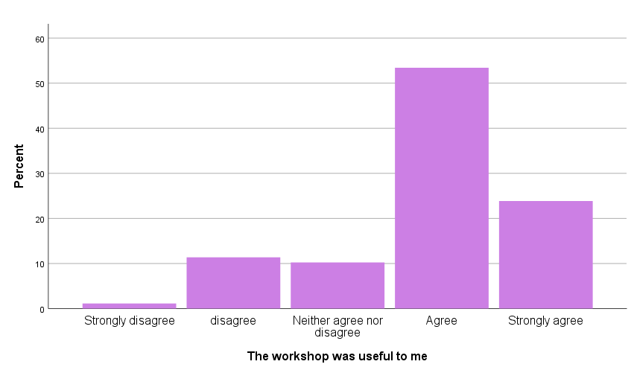
Figure 1: The workshop was useful to me

Figure 2: The ideas and concepts were communicated clearly

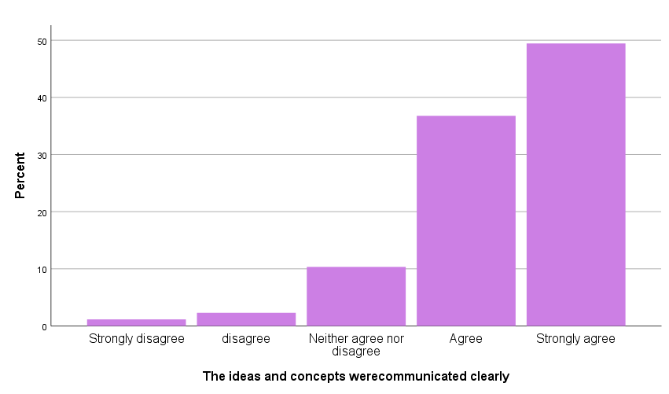

Figure 3: The pace of the day was just right
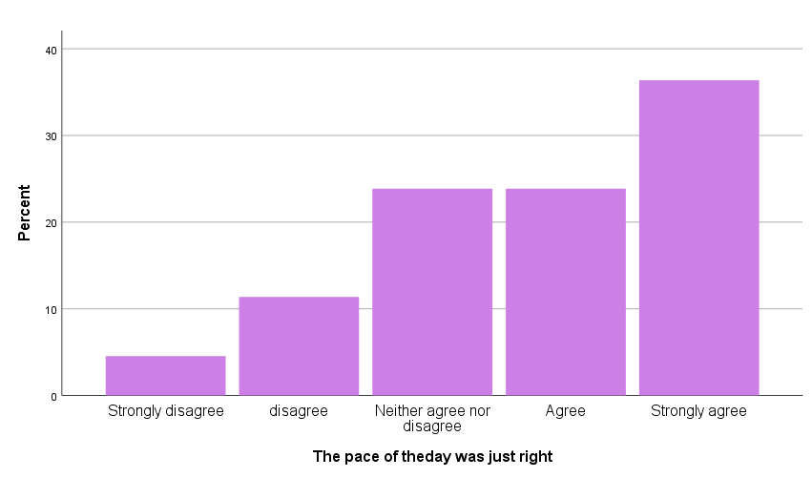
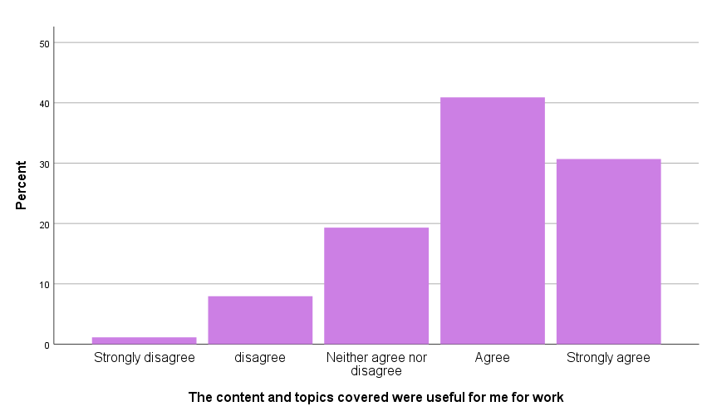

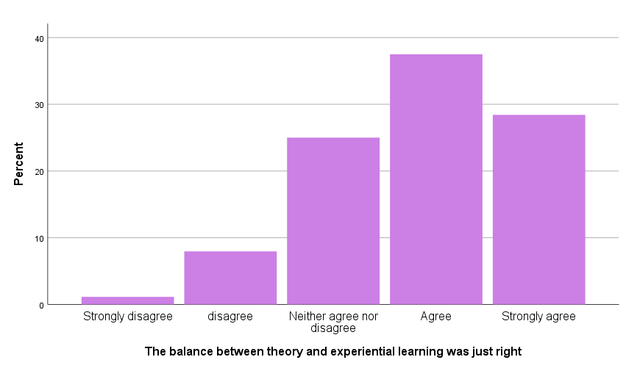
Figure 4: The balance between theory and experiential learning was just right

Figure 5: The content and topics covered were useful for my work

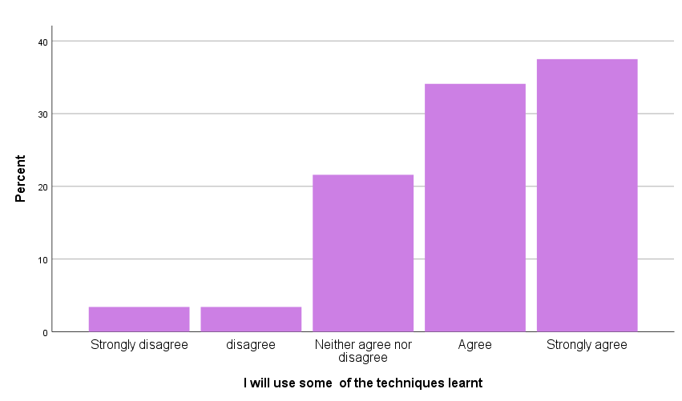
Figure 6: I will use some of the techniques learnt

Figure 7: The idea and concepts were clearly communicated, by group

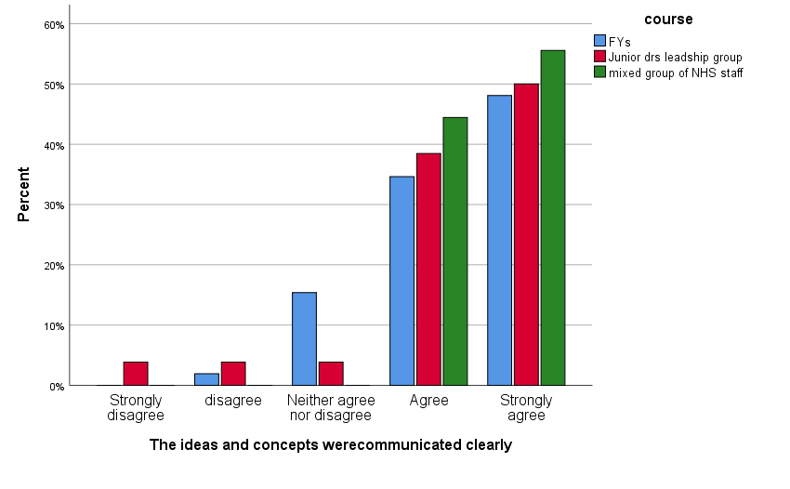
Qualitative Feedback on Westminster REFRAME workshop (post-workshop)

Attendance
Whilst attendance at the workshop was mandatory for FYs and the JDLG, some of the attendees stated their wish to learn new ways to deal with stressors and burnout at work. A few of the participants mentioned that the course had been recommended by a colleague. Others stated that they had an interest in developing their resilience as well as a desire for self-development.

“Compulsory part of leadership course, but would be keen anyway - feel I need more resilience.”

Relating to stressors and burnout at work, a few participants acknowledged the challenging nature of their work and mentioned their concern about being at risk of burnout.

“Stress at work. Risk of burnout.”
“Learn more about myself and coping mechanisms for difficult things in life and work.”
“Feeling fatigued and disillusioned.”
“Interested to reduce work stressors and improve work life balance.”

Some of the attendees expressed their desire to improve their level of resilience, acknowledging their low levels of perceived resilience as a motivation to learn more. More specifically, ongoing stress and lack of control were commonly cited as reasons for needing to improve ability to cope.

“A feeling of being overwhelmed by my workload, loss of control over it.”
“I was interested in the resilience that I currently show in myself and then how I can overcome these things.”

Responses to the session
Overall, the feedback indicated that participants found the session interesting and useful. Participants commented on the supportive, friendly and relaxed nature of the workshop and described the session as being well structured and presented. Many of the participants stated that they enjoyed the interactive activities and modes of delivery, with many citing a good balance and pace achieved in the session.

“Friendly and relaxed.”
“Gentle - calm, evidence based - data presented, pragmatic.”
“Interactive, visual methods. Good speaker.”
“Good pace, safe & supportive feeling. Good balance between interaction and teaching.”

Several of the participants reflected on the knowledge and understanding gained from the workshop. Of particular note was the learning of mindfulness meditation, breathing techniques and the neurophysiology of stress, with a few participants stating their intention to practice mindfulness in their everyday lives.

“Breathing. Scientific underpinnings/ mechanisms for our cognitive fallacies/ responses.”
“Breathing exercise. Intentional activity vs passive activity.”
“Scientific explanations of proven usefulness of mindfulness. Meditation techniques.”

Participants also highlighted the use of the resilience matrix and SMART goals as valuable tools and commented on the engaging and practical nature of the workshop. Many felt that the various resources offered them the opportunity to self-reflect on their strengths and weaknesses and set personal goals for improvement.

“Learning about the neurobiology. The resilience matrix - learning about my own strengths and weaknesses.”
“Discussion on SMART goals for addressing areas of weakness in your resilience matrix.”
“Neurobiology, resilience matrix, lots of resources, the 2 films with different soundtracks.”
“Address weak areas identified in my resilience matrix, using SMART goals.”

Several of the participants enjoyed the group discussion or social elements within the session. Many noted the enjoyable nature of being able to talk to colleagues in the field and learn from others, and reported on the conducive nature of these discussions. Some mentioned that this allowed for more sensitive subject matters to be explored and commented on the therapeutic nature of the discussions.

“I enjoyed the way we could talk to other peers about the challenges that we had encountered and how we overcame them.”
“Talking with others. Learning from others.”
“Interactivity. Listening to other people experience.”

Participants reported that they felt there was a good balance between group communications and providing a space for personal independent reflection. Relating to this, some found they had an increased understanding of the importance of self-awareness and reflection in both their work and personal lives, they commented on how these skills could facilitate a positive change in their mind-set and behaviours.

“Having time to reflect and self-analyse I think is a useful exercise and not done often enough in medicine.”
“'Good to reflect on areas I need to work on e.g. switching off, exercise.”
“Being specific in self-reflection for more proactive change.”

Despite the overall positive experiences reported, some of the participants provided some feedback on how the session could be improved. For example, some commented on the structure of the session with regards to the timetable, while one participant focused on the use of the tools.

“'Less structured tools - they're too objective for subjective things.”
“More clear structure. More on coping mechanisms and building resilience.”

Some commented on the duration of the session with a variety of preferences – either to make the session longer or shorter.

“Shorter course, more meditation.”
“It was a useful session and a bit longer to look at the theory may have been interesting.”
“A bit too long, could be more focused.”
“Longer course.”

Several of the participants suggested incorporating more tips and tools for managing stress. A few of the participants mentioned the need for more practical suggestions that they could apply to everyday life, with the suggestion of including role play. These suggestions mirror the reasons cited for attending the workshop – many participants would like to learn practical skills to help cope with the challenges of work.

“More practical tips (resources, services).”
“'Less time on experimental theory and more time on actual tips.”
“More tools on managing stress and improving resilience.”
“Role play practical/ real situations to see how we react.”

Whilst the majority of the participants enjoyed learning about the neurophysiology of stress and the resilience matrix, a few of the participants felt that too much time was spent on this and did not find this aspect relevant. One participant suggested a reduction of time spent covering the neurophysiology of stress to allow for time on learning about practical approaches.

“Less on the science and more on practical approaches/ changes to our everyday practice.”
“A bit too much time spent on neurology of responses etc.”
“The neurobiology was interesting but possibly unnecessary and superficial.”

Intentions
The majority of the participants specified what they intended to do differently after attending the course, with many reporting how they intended to apply specific tools from the session into their everyday lives. For example, a large number of the participants stated their intention to incorporate the breathing exercises and mindfulness meditation into their practice.

“Take time out to meditate.”
“'Use breathing techniques to reduce stress.”
“Mindfulness/ breathing techniques - make time for this. Also exercise.”

A few specified their intention to take more time out for themselves and to self-reflect and mentioned how this may impact how they respond to stressors at work, with a few mentioning a change in attitude at work.

“Need to focus change of attitude at work. Feel very despondent like nothing's ever going to change but am not usually a quitter… starting with myself and re-instating self-care practices”
“Take time to myself. Switch off after work”

Others sought to make lifestyle changes such as their diet and exercise regime e.g. incorporate more exercise.

“Be kinder to myself, breathing exercises, lifestyle changes – exercise.”
“Use breathing exercise, sleep more, exercise, make time for me!”

Some of the participants specified making changes based on their assessed strengths and weaknesses, derived from the resilience matrix, and mentioned their intention to act on their goals set with the SMART tool.

“SMART GOALS - To prioritise and then do one at a time.”
““I have a SMART goal. Commissioning more around resilience and mindfulness.”
“Using resilience matrix - SMARTER. Intend to practise mindfulness techniques as demonstrated”

References

Baird, B., Charles, A., Honeyman, M., Maguire, D., & Das, P. (2016). Understanding pressures in general practice. London: King's Fund.
Berwick, D. M., Nolan, T. W., & Whittington, J. (2008). The triple aim: care, health, and cost. Health Affairs, 27(3), 759-769.
Bodenheimer, T., & Sinsky, C. (2014). From triple to quadruple aim: care of the patient requires care of the provider. The Annals of Family Medicine, 12(6), 573-576.
Branson, R., & Armstrong, D. (2004). General practitioners' perceptions of sharing workload in group practices: qualitative study. BMJ, 329(7462), 381.
Brooks, S. K., Chalder, T., & Gerada, C. (2011). Doctors vulnerable to psychological distress and addictions: treatment from the Practitioner Health Programme. Journal of Mental Health, 20(2), 157-164.
Brooks, S. K., Gerada, C., & Chalder, T. (2011). Review of literature on the mental health of doctors: are specialist services needed?. Journal of Mental Health, 20(2), 146-156.
Carrieri, D., Mattick, K., Pearson, M., Papoutsi, C., Briscoe, S., Wong, G., & Jackson, M.
(2020). Optimising strategies to address mental ill-health in doctors and medical students: ‘Care Under Pressure’ realist review and implementation guidance. BMC Medicine, 18(1).
Cecil, J., McHale, C., Hart, J., & Laidlaw, A. (2014). Behaviour and burnout in medical students. Medical education online, 19(1), 25209.
Cheshire, A. (2017). Westminster REFRAME workshops for foundation year doctors 2016-2017: Evaluation report.
Cheshire, A., Hughes, J., Lewith, G., Panagioti, M., Peters, D., Simon, C., & Ridge, D. (2017). GPs’ perceptions of resilience training: a qualitative study. British Journal of General Practice, bjgp17X692561.
Cheshire, A., Ridge, D., Hughes, J., Peters, D., Panagioti, M., Simon, C., & Lewith, G. (2017). Influences on GP coping and resilience: a qualitative study in primary care. British Journal of General Practice, bjgp17X690893.
Cohen, S., Kamarck, T., & Mermelstein, R. (1983). A global measure of perceived stress. Journal of Health and Social Behavior, 385-396.
Croxson, C. H., Ashdown, H. F., & Hobbs, F. R. (2017). GPs’ perceptions of workload in England: a qualitative interview study. British Journal of General Practice, bjgpfeb-2017.
Dale, J., Potter, R., Owen, K., Parsons, N., Realpe, A., & Leach, J. (2015). Retaining the general practitioner workforce in England: what matters to GPs? A cross-sectional study. BMC Family Practice, 16(1), 140.
de Visser, R. (2009). Psychology in medical curricula:" need to know" or" nice to know"?. European Health Psychologist, 11(2), 20-23.
Dobbin, A. (2014). Burnt out or fired up? Helping recovery in distressed patients can increase our own resilience. British Journal of General Practice, 497-498.
Doran, N., Fox, F., Rodham, K., Taylor, G., & Harris, M. (2016). Lost to the NHS: a mixed methods study of why GPs leave practice early in England. British Journal of General Practice, bjgpfeb-2016.
Epstein, R. M. (2014). Realizing Engel's biopsychosocial vision: resilience, compassion, and quality of care. The International Journal of Psychiatry in Medicine, 47(4), 275-287.
Feeney, S., O’brien, K., O’keeffe, N., Iomaire, A. N. C., Kelly, M. E., McCormack, J., ... & Evans, D. S. (2016). Practise what you preach: health behaviours and stress among non-consultant hospital doctors. Clinical Medicine, 16(1), 12-18.
Firth-Cozens, J. (2006). A perspective on stress and depression. In J. Cox, J. King, A. Hutchinson, P. McAvoy (Eds), Understanding doctors’ performance (pp22-25). Radcliffe Publishing.
Fisher, R. F., Croxson, C. H., Ashdown, H. F., & Hobbs, F. R. (2017). GP views on strategies to cope with increasing workload: a qualitative interview study. British Journal of General Practice, 67(655): e148-e156.
Fletcher, E., Abel, G. A., Anderson, R., Richards, S. H., Salisbury, C., Dean, S. G., ... & Campbell, J. L. (2017). Quitting patient care and career break intentions among general practitioners in South West England: findings of a census survey of general practitioners. BMJ Open, 7(4), e015853.
Garbarino, S., Lanteri, P., Durando, P., Magnavita, N., & Sannita, W. (2016). Co-Morbidity,
Mortality, Quality of Life and the Healthcare/Welfare/Social Costs of Disordered Sleep: A Rapid Review. International Journal of Environmental Research And Public Health, 13(8), 831.
Hall, L. H., Johnson, J., Heyhoe, J., Watt, I., Anderson, K., & O’connor, D. B. (2017). Strategies to improve general practitioner well-being: findings from a focus group study. Family Practice, 35(4), 511-516.
Hall, L. H., Johnson, J., Watt, I., Tsipa, A., & O’Connor, D. B. (2016). Healthcare staff wellbeing, burnout, and patient safety: a systematic review. PloS one, 11(7), e0159015.
Imo, U. O. (2017). Burnout and psychiatric morbidity among doctors in the UK: a systematic literature review of prevalence and associated factors. BJPsych Bulletin, 41(4), 197-204.
Johnson, J., Panagioti, M., Bass, J., Ramsey, L., & Harrison, R. (2017). Resilience to emotional distress in response to failure, error or mistakes: a systematic review. Clinical Psychology Review, 52, 19-42.
Kay, M., Mitchell, G., Clavarino, A., & Doust, J. (2008). Doctors as patients: a systematic review of doctors' health access and the barriers they experience. British Journal of General Practice, 58(552), 501-508.
Kumar, S. (2016). Burnout and doctors: prevalence, prevention and intervention. In Healthcare (Vol. 4, No. 3, p. 37). Multidisciplinary Digital Publishing Institute.
Lacy, B. E., & Chan, J. L. (2018). Physician burnout: the hidden health care crisis. Clinical Gastroenterology and Hepatology, 16(3), 311-317.
Leiter, M. P., Maslach, C., & Frame, K. (2014). Burnout. The Encyclopaedia of Clinical Psychology, 1-7.
Lemaire, J. B., & Wallace, J. E. (2017). Burnout among doctors. BMJ: British Medical Journal (Online), 358.
Lown, M., Lewith, G., Simon, C., & Peters, D. (2015). Resilience: what is it, why do we need it, and can it help us?. British Journal of General Practice, 65(639), e708-e710.
Lynch, S., Peters, D., & Lewith, G. (2016). FY1 REFRAME evaluation report 2015/16.
Matheson, C., Robertson, H. D., Elliott, A. M., Iversen, L., & Murchie, P. (2016). Resilience of primary healthcare professionals working in challenging environments: a focus group study. British Journal of General Practice, 66(648), e507-e515.
McKinley, N., McCain, R., Convie, L., Clarke, M., Dempster, M., Campbell, W., & Kirk, S.
(2020). Resilience, burnout and coping mechanisms in UK doctors: a cross-sectional study. BMJ Open, 10(1), e031765.
Newbury-Birch, D., Walshaw, D., & Kamali, F. (2001). Drink and drugs: from medical students to doctors. Drug and Alcohol Dependence, 64(3), 265-270.
Panagioti, M., Geraghty, K., Johnson, J., Zhou, A., Panagopoulou, E., Chew-Graham, C., ... & Esmail, A. (2018). Association between physician burnout and patient safety, professionalism, and patient satisfaction: a systematic review and meta-analysis. JAMA internal medicine, 178(10), 1317-1330.
Patterson, D. (2016). Damaged doctors: it’s time for a binding covenant of care between the NHS and its doctors. British Journal of General Practice, 66 (645): 174-175.
Peters, D., Lynch, S., Manning, C., Lewith, G., & Pommerening, D. (2016). The Day After Tomorrows Doctors: UK Undergraduate Medical Student Resilience, Reports on the Symposium 2016
Riley, R., Spiers, J., Buszewicz, M., Taylor, A. K., Thornton, G., & Chew-Graham, C. A. (2018). What are the sources of stress and distress for general practitioners working in England? A qualitative study. BMJ Open, 8(1), e017361.
Rotenstein, L. S., Ramos, M. A., Torre, M., Segal, J. B., Peluso, M. J., Guille, C., ... & Mata, D. A. (2016). Prevalence of depression, depressive symptoms, and suicidal ideation among medical students: a systematic review and meta-analysis. JAMA, 316(21), 2214-2236.
Sauerteig, S., Wijesuriya, J., Tuck, M. & Barham-Brown, H., 2019. Doctors’ health and wellbeing: at the heart of the NHS’s mission or still a secondary consideration?. International Review of Psychiatry, 31(7-8), 548-554.
Shaw, P., & Cheshire, A. (2018). Westminster REFRAME workshops for Guy’s and St
Thomas’ Hospital staff 2017-2018: Evaluation report.
Sikka, R., Morath, J. M., & Leape, L. (2015). The Quadruple Aim: care, health, cost and meaning in work. BMJ Quality & Safety, 24:608-610.
Spiers, J., Buszewicz, M., Chew-Graham, C., Gerada, C., Kessler, D., Leggett, N., ... & Riley, R. (2016). Who cares for the clinicians? The mental health crisis in the GP workforce. British Journal of General Practice, 66(648), 344-345.
Stevenson, A. D., Phillips, C. B., & Anderson, K. J. (2011). Resilience among doctors who work in challenging areas: a qualitative study. British Journal of General Practice, 61(588), e404-e410.
Tennant, R., Hiller, L., Fishwick, R., Platt, S., Joseph, S., Weich, S., ... & Stewart-Brown, S. (2007). The Warwick-Edinburgh mental well-being scale (WEMWBS): development and UK validation. Health and Quality of life Outcomes, 5(1), 63
Thompson, N., Corbett, S., & Welfare, M. (2013). A qualitative study of how doctors use impression management when they talk about stress in the UK. International Journal of Medical Education, 4, 236-246.
Tregoning, C., Remington, S., & Agius, S. (2014). Facing change: developing resilience for staff, associate specialist, and specialty doctors. BMJ: British Medical Journal, 348, g251.
Úallacháin, G. N. (2007). Attitudes towards self-health care: a survey of GP trainees. Irish Medical Journal, 100(6), 489-491.
Vijendren, A., Yung, M., & Sanchez, J. (2015). Occupational health issues amongst UK doctors: a literature review. Occupational Medicine, 65(7), 519-528.
Warwick Medical School (2021). Collect, score, analyse and interpret the WEMWBS. https://warwick.ac.uk/fac/sci/med/research/platform/wemwbs/using/howto/ Accessed 7.1.21.
Wright, A. A., & Katz, I. T. (2018). Beyond burnout—redesigning care to restore meaning and sanity for physicians. New England Journal of Medicine, 378(4), 309-311.

