Sandra Gaudenzi_ 28.01.19_ final draft (4428 words)

Moving from linear to digital interactive stories : a shifting world that demands several mind shifts

Most of us agree that stories have the fundamental role of helping us making sense of our world (Bruner, 1986). During our lifetime, we need to learn several of the world’s patterns to be able to navigate it, and in this context stories are a handy way to remember, and explain, patterns through the logic of our parents and cultural environment. Stories clarify our being and make us belong. Some psychologists even go as far as to say that we even use stories to understand ourselves, our inner world, and to find some coherence within our multiple personalities (Mc Adams, 1993). The reason is that “linear stories have the advantage of making complex things simple” (Thalhofer, 2018:106). Since linear storytelling is based on a causal logic - this happened, then this other thing happened - it favorises our understanding of a deterministic world, where things are processable and predictable, since they always come to a single end. The issue is that “most frequently, things don’t cause each other, they influence each other” (Thalhofer, ibidem)... so could linear storytelling be responsible for misleading us in a simplified explanation of the world?

There is a further complication: the world is becoming increasingly unpredictable. Twenty years of digital technology have changed the world so much that we are now asked to be constantly “innovative” and “fluid” in our approach, meaning that the past learnings are not considerate that useful anymore. Two centuries ago, when most kids were the work apprentices of their parents, that was not the case. So what happens to storytelling in this century’s speedingly evolving digital landscape?

Media history shows us that storytelling always adapts to allow us to keep up with the times. It happened with books, cinema, television, and now again with the Web. Storytelling helps us to explain, but also to shape, the world we live in. Media, technology and society are connected in mutual influential ways. It is no surprise then that an associative medium such as the Web is opening today new storytelling options, stretching the causal logic of film and books. The Open Work (Eco, 1962) and the cinema avant-gardes of the 20th century - that wanted to break free from the single author and the aristotelian narrative form - have finally found a medium that sets them free: the open World Wide Web. Digital media reflect our times. In a less certain world, our modern stories need to help us deal with our uncertainties. As a result, we feel the need to create open stories that can fluctuate, adapt, be shared, be co-authored and, sometimes, have more than a single end.

I am not saying here that films are dead, but just that digital interactive media is offering us a platform to explore our complex, rapidly changing and multi-vocal world. In the words of screen media theorist Patricia Zimmerman “polyphonic new media strategies reject the singular author, the unique voice, the final interpretation. Instead, these works operate as technologies, systems, and practices to bring together many voices that open up space for complex ideas and participatory exchanges to develop in unexpected ways through convenings” (2018:10).

My message to media producers is the following: using the Web as a world distribution platform for your videos is a good start, but it is a little like using a car to go at the speed of a horse. Digital media allow you to do much more, why not embracing it? Mobile technology allows to connect subjects and give them a direct voice, how can you use this as a creative force in your projects? Will you build communities, or adopt co-creation strategies and accept less authorship of your own stories? Interactive media allow you to involve your audiences by giving them the power to choose, browse, change, comment or add to your stories. This power is the agency you give to your users. How will you use it? Which boundaries of action are you going to create for them? What will they learn from it? Different digital platforms will cater for different types and levels of interactivities. Which level of interaction, and platform, is suitable for your story?

These choices are both the opportunities and the dilemmas of our new digital world: we have more freedom and choices than ever before, but where are the limits of such choices, what can we do with them, and how do they shape the relationship author/subject/audience? Stepping into digital storytelling is about moving into a new form of narrative all together that questions our shared world. We can make use of constantly evolving types of digital platforms (mobile phone, tablet, computer, VR, AR, holograms etc..) and extend our definition of storytelling well beyond the aristotelian beginning/middle/end structure. Ultimately, it is about standing for a position in our open digital world. Choosing an interactive form, rather than a linear one, is a statement on itself. It is about embracing the mind shifts that will allow you to detach yourselves from the illusion of a prectictable and causal world and move into a more fluid, sometimes unpredictable, space of action.

When I came to the realization that storytellers were struggling to embrace interactivity for reasons that were more complex than lack of technological skills, I decided to create a workshop that would question and remix authorial beliefs, audiovisual media practices and digital ideation techniques. The idea behind what then became !F Lab (Interactive Factual Lab) was to create a space for storytellers to see interactive media as a space of freedom, to embrace fluidity as a strategy of co-creation, and ultimately conceive projects that reflect our shared world, fears and hopes.

!F Lab and the he WHAT !F IT process

!F Lab (Interactive Factual Lab) is a EU funded training workshop produced by social innovation agency iDrops, that I co-initiated in 2015. !F Lab’s aim was to enable talented creatives to tell impactful stories using digital technology and to push the industry forward. The context in which it acted was the early adoption of interactive narratives from the “big players” (broadcasters such as Arte, BBC, SBS and newspapers such as the New York Times and the Guardian) that had started around the year 2008. The problem was that little was shared about their production practices, and small audiovisual companies had difficulty entering the field. Aware of the difficulties faced by creative producers when embarking in unknown territories, our aim at !F Lab was simple: 1. to help the development of innovative forms of digital storytelling by mentoring new projects, and 2. research best production practices from the industry by testing them. Between 2015 and 2018 !F Lab has guided 72 participants coming from 25 countries and invited top digital creative experts from all over the world to share their knowledge with us.

The structure of !F Lab changed over the years, but the essential logic was to incubate projects through a series of hands-on group workshops, having periods of two months rest in between them for teams to actualise the decisions taken during the workshops. In the last iteration of !F Lab the first five days long workshop, Story Booster, would get all the participants together and the !F Lab team would lead them to transition from an initial concept to a fully fledged paper prototype of their interactive idea. Participants would then go back to their respective countries and had to do research on their audiences, test their ideas, iterate their concept and come prepared to the following workshop, Prototype Booster. This second five days workshop was conceived to support teams while they transformed their paper prototype into a fully working digital prototype. In order to do so, a three days Prototype Jam was organised, where external coders and designers were joining the teams and helped them build a first digital version of their project. This hackathon atmosphere pushed participants to share their ideas with newcomers and to accept influences coming from totally different fields and expertises. This was not always easy, but in most cases, it has been an eye opener on the fundamentally pluri-disciplinary nature of interactive production.

What I have observed during my experience as Head of Studies of !F Lab, is that embarking in the creation of an interactive project is both exciting and frightening, and therefore the challenge is to create the right atmosphere for people to feel inspired, challenged, supported and yet still totally free. At !F lab, we did so by mixing presentations, hands-on work on projects and caring one-to-one mentoring. To make sure that all projects would go through the same development process, we created two types of learning tools: cards and canvases. Cards were mini-lectures delivered by our coaches, while canvases were conceived as practical exercises to help each team take decisions related to their own projects and move on to the next step. Going from a mini-lecture to its actualisation through a hands-on exercise provided the right balance of guidance and freedom that we were looking for.
We called such process the WHAT !F IT process, as it starts from a question (WHAT is my concept?) then asks you to Interact with your audience (hence the “I”), then to Formulate your challenge and impact (“F”), to Ideate through prototyping (hence the “I”) and finally to Test (“T”) before starting again.

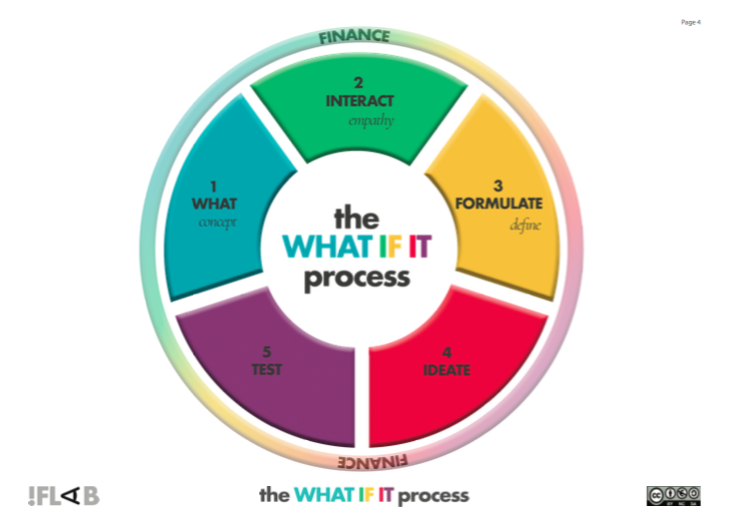
Image 1. The 5 phases of the WHAT !F IT process (http://www.iflab.net/)

The WHAT !F IT process is a methodology that can be used by any person starting an interactive production as it does not need any technical knowledge. It is based on a few fundamental principles, which I believe are good guidelines to produce innovative interactive narratives: start from the user, have a clear purpose (or impact) for your project, work with a multi-disciplinary team from day one and embrace an iterative user centered production process. To give you an idea, here is the overview of all the supporting material we used during the workshops, followed by one example of canvas that we used to help participants pinning down the exact “concept” of their project.
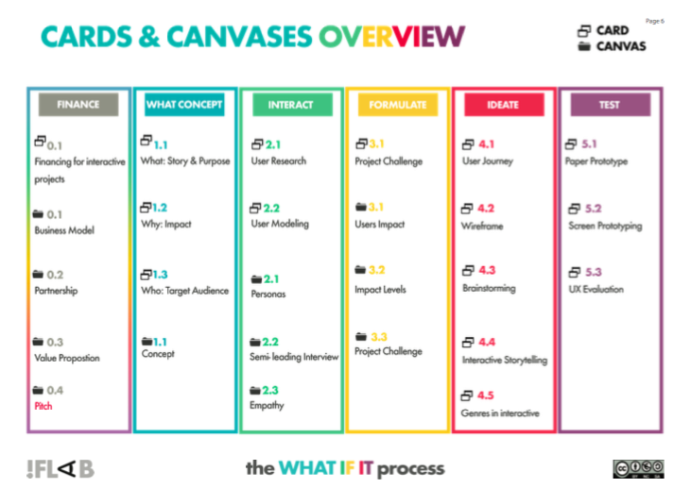

Image 2. Cards and Canvases of the WHAT !F IT process (http://www.iflab.net/)

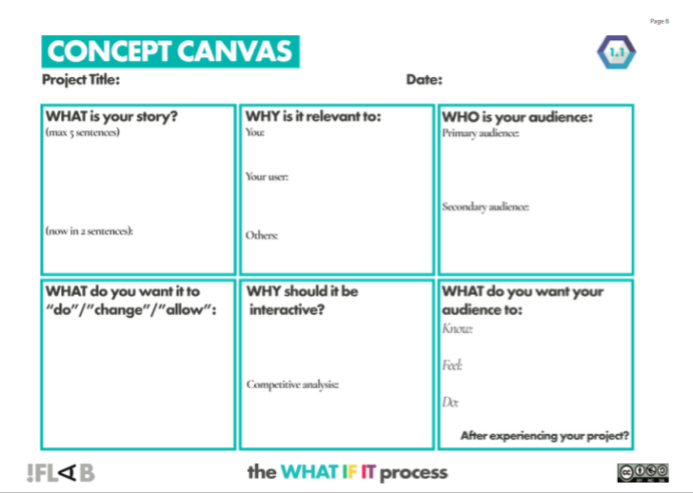
Image 3. Example of Canvas: The Concept Canvas (http://www.iflab.net/)

While I clearly encourage you to download The !F Lab Field Guide to Interactive Storytelling Ideation (http://www.iflab.net/wp-content/uploads/2019/01/The-F-Lab-Field-Guide.pdf) and try it for yourself, I also want to remind you that no methodology is set in stone and that it is conceived to help you, not to limit you. Please experiment with it, and change it accordingly to your needs and professional environment. I have done so myself.

I was contacted by Professor Andre Paz, from the Federal University of Rio de Janeiro, in 2017 to see if we could adapt the WHAT !F IT process to the Brazilian context. Thanks to the support of the British Academy Newton Mobility Grant, and of the BUG Exhibition, we embarked on a one year research project aimed at iterating our process into what we called the IF BUG LAB: a four days interactive ideation process designed for Brazilian audiovisual producers. Taking on board the relative novelty of the interactive narrative field in Brazil, and the consequent lack of financial resources, IF BUG LAB puts a strong emphasis on production resources while keeping the fundamental iterative nature of the WHAT !F IT process. Through this experiment, we were effectively testing the flexibility and malleability of ideation processes. Our finding, is that although processes have to adapt to their cultural and economic contexts, their back bone can be stable and relatively unchanged.
In the case of the WHAT !F IT process this meant keeping the main phases and iterative nature of the process, while changing the emphasis given to them. In other words, what never changed is the view that interactive ideation is not linear and it requires a series of mind shifts, a series of clicks that make you see the world, your work, and your role in it, in a new way. In what follows, I have tried to go back to the essence of each phase of the WHAT !F IT process, added what I learned in Brazil, and ended up with a list of guidelines that I hope will be of use to you.

Guidelines, or mind shifts, for the production of innovative Interactive Narratives

When you start an interactive narrative, you are confronted with an array of questions: which platform should I choose? How will I organise my story? Which part should be interactive? Which technical skills do I need? How much will it cost? Clearly there is no single magic answer, and the options are so many that it can be overwhelming.

Our learning from !F Lab, and IF BUG Lab, is that instead of wanting to take all the decisions alone on day one, it is more beneficial to trust that the answers will impose themselves, and emerge as an evidence, if one follows a creative development process. My proposition is therefore to engage with a series of mental shifts that open you up to new digital challenges and then observe what comes out from engaging with such process. You will notice these mental shifts go hand in hand with the WHAT !F IT process, although we use here a slightly different terminology:

1. Put the user at the center of your creative process

In interactive narratives, you ask your audience to intervene in your story by acting on the interactive points you have designed (click on a link, write a comment, send a video, move in a space, build something etc…). But if the options you have designed are not satisfactory to your users, you lose them. Game specialist Janet Murray defines agency as “the satisfying power to take meaningful action and see the results of our decisions and choices”
(Murray, 1997:126). If the users are not curious to explore the options your have designed for them, you have failed to engage them. While we have all watched a TV programme that did not interest us by pure laziness and inertia, in interactive media the story does not move further if we do not interact with it, so… end of our story. For this specific reason, you should enter in a frame of mind where you design with your audience, and not for your audience. This is the fundamental ethos of User Centered Design (UCD), a branch of Design Thinking, that starts the design of any product, service or experience by studying and engaging with its final user. For Donald Norman, first designer to have used such term, “user centered design emphasizes that the purpose of the system is to serve the user, not to use a specific technology, not to be an elegant piece of programming’ (Norman, 1998:61).

If you look carefully at the WHAT !F IT process (image 1), you will see that we have accommodate the five phases of UCD to the needs of interactive storyters. Phase two is Interact with your user, meaning: test your concept by interviewing your target audience, learn which platforms they use and what they know about your topic before even starting your ideation process. Only after having done so, you can start working on an initial paper prototype of your concept that you will test, again, with your target audience. This is the beginning of an two ways iterative process between you and your audience.

As strange as this might seem, this single mind shift has been the most difficult, and probably most precious, learning for the !F Lab participants that were coming from audio-visual production. They were used to start from their own idea and then roll into production once they had the approval of their commissioning editor. Convincing them that empathising with their audience from start is not only the best way to challenge their own preconceptions, but also a fundamental step to keep their audience engaged, and ultimately to generate clever out of the box ideas, has needed a try-it-yourself attitude.

2. Do your research

A lot of people want to do an interactive narrative because they think it will allow them to bypass closed distribution networks and reach a larger audience. This is a false expectation. Your project might be online, but if no one knows about it, you effectively have no audience. The mindshift needed here is the following: don’t expect audiences to come to you, it is your job to attract them.
Ensuring you will have an audience often boils down to have a promotion budget to spend, but it also means that you need to have a launch strategy and some solid partners. While we encourage you to look for your partners from day one, we also know that if you have nothing to show them it is difficult to involve them. You are in a chicken-and-egg situation where you need a prototype to explain your idea, but you also need help to create your first prototype. Our suggestion is to move in incremental shifts where story development and research of partners move hand in hand. The more you progress with your idea the more you can show it to different people and ask for their help.

For you to be credible in this delicate balance act you need to be prepared and be on top of your game. Never underestimate the importance of having checked who else has treated your topic using linear and interactive narratives:

- have a series of comparative points between what you want to do and what others have done ready.
- why is interactivity essential to engage your selected audience?
- be aware of existing trends in interactive narratives. When the “next technology” starts to be passe’, you need to justify it why you are using it.
- you also should be able to place your project within the different styles of interactive narratives that exist already. After all, you are the specialist… are you not?

This book is a first resource to help you do your comparative analysis, but keep also in mind other existing online resources such as MIT Docubase (http://docubase.mit.edu/), IDFA DocLab (http://www.doclab.org/category/projects/) and i-Docs (http://i-docs.org/).

3. Embrace multi-disciplinary teams and iterative production

It is challenging to be a one man band in digital productions. The skill sets that you need to have between content production, design and coding are still too different for one person to do it all well. So accept the following mindshift: you need help, and you need help from people that come from different industries, hence they will be used to a completely different process and language when working in groups.

We cannot stress enough the importance to have a multi-disciplinary team from day one. It might be difficult at the beginning but it will pay off when you will realise that they come up with ideas and solutions you could not even imagine yourself. To solve the problem of having different approaches to work, we suggest you choose a series of steps that will lead you to the production of a first prototype (also known as a Minimum Viable Product) and to commit to it as a team. This first prototype, once tested with your audience will be your best ally to ask for further funding and to seek for new partners.

4. Consider co-creation with your subjects

If your story involves specific communities then consider co-creating your narrative with them. Documentary makers and artists have experimented during most of last century with participatory practices, but moving to digital media gives you one extra arrow in your bow: social media is by definition communitarian and the Web is first of all a network. The mindshift that interactive narrative offers you here is: why using your single voice to represent others? If you have already embraced a certain level of co-authorship with your users and with your multi-disciplinary team, why not extending it to your subjects?

The recently created MIT Co-Creation Studio emphasises that “co-creation offers alternatives to a single authored vision. It’s a constellation of media methods and frameworks. Projects emerge out of process, and evolve from within communities and with people, rather than being made for or about them” (https://cocreationstudio.mit.edu/). Visiting their website will give you ideas and resources to help you elaborate projects where impact is co-designed with the communities it targets.

5. Have a clear impact strategy

Think of impact as the shift you want your user to have throughout the experience of your project. See it as a before and after list. If there are specific changes you want to happen (gaining awareness by learning about your topic, feeling a specific emotion, doing something like signing a petition or more) you have to design towards it. Your user journey needs to bring the audience where you want it to go (see the User’s Impact Canvas in the WHAT !F IT process).

Now zoom out from your user and see the bigger picture: impact is like an onion, it has different layers. At the core you have the individual (users). But your users can have an impact within their community and have a social impact, and social pressure can scale up and have an impact at a political level. Impact is therefore multi-layered and non-linear (systemic). This brings us to our fifth mindshift: think of impact as a non-linear process with several points of entry. Your job is to strategically define how far you want your project to be influential, and to design action points both in your story and your promotion campaign to set an impact movement in motion. You also need to keep in mind that this is not a set science, networked media are ruled by relational and non-causal logics, so you can only play by ear, constantly adjusting while listening to the reactions that you are generating.

6. Make sure your project is coherent

Finally, as part of the iterative process of creation, go back to your project’s fundamentals: your chosen platform, audiences, impacts, partners and resources. If you want to augment your chances to move from demo stage, or prototype, to full production you need to make sure that these five points are aligned, because this is what will constitute your proposal, or project treatment.

We have noticed throughout the years of !F Lab that often participants had clear answers for each of the five pillars of their projects, but they were not necessarily relating them. For example, we had stories aimed at an audience of teenagers using a platform they do not engage with. Ideas for technically complex transmedia projects that necessitated big financial resources lead by people that had no contacts in the industry. Or even projects on topics that had no proven appeal to the selected target audiences but that the author wanted to continue because of his own interest in it. We all fall in love with our stories, but that is just not enough if we want them to be heard. In a networked and non-linear space such as the digital one, coherence in our intent is still necessary to move a project forward. This brings us with our last, and probably most counter-intuitive mind-shifts of all: to be coherent is not to have predicted all the causes that will have an effect, but to have a systemic vision where different forces can expand towards your wished direction. Think of your digital narrative as a living form that acts on the world through several forces. Your job is to give it a direction, not to pretend to control it.

In conclusion, embarking in the creation of innovative interactive narratives goes far beyond learning new technical skills. It is a political and ideological statement within the digital world, where you take a position by framing and forging what the digital discourse is, or will be. Interactive narratives are not just a way to have free distribution on the Web and making your stories global, they are a way of thinking about the world and about the relationships we want to build within it. They create more than tell. They are tools. They are a statement of action. This is why asking yourself “why should this story be interactive?” from day one is essential. Interactivity is an authorial choice.
Once you find your own answer to this essential question, you then have to decide if you want to follow your creative instinct or prefer the guidance of an ideation methodology like the WHAT !F IT process. This is totally up to you. Whatever you decide, you will probably notice that you cannot avoid addressing some of the mind shifts that are listed in this article. These mind shifts are more or less ineluctable because they are part of the journey that leads us to evaluate, and sometimes discover, what we want out of the digital sphere, and which role we want our stories to have in forging it. Welcome to the digital mind shift.

Dr Sandra Gaudenzi is the Head of Studies of !F Lab (Interactive Factual Lab). She has been consulting, mentoring, researching, lecturing, writing, speaking and blogging about interactive factual narratives for the last twenty years. She is Senior Lecturer at the University of Westminster’s Digital and Interactive Storytelling LAB; visiting Fellow at the Digital Cultures Research Centre (UWE, UK); co-director of the i-Docs conference and website, and co-editor of the book “i-docs: the Evolving Practices of Interactive Documentary”.

REFERENCES

Bruner, Jerome (1986) Actual Minds, Possible Worlds. Cambridge: Harvard University Press.

Eco, Umberto (1962) Opera Aperta, Milano: Bompiani Editore.

Gaudenzi, Sandra (2019) The !F Lab Field Guide to Interactive Storytelling Ideation. http://www.iflab.net/wp-content/uploads/2019/01/The-F-Lab-Field-Guide.pdf

Mc Adams, Dan P. (1993) The Stories we Live by. London: The Guilford Press.

Murray, Janet (1997) Hamlet on the Holodeck. The Free Press.

Norman, Donald (1998) User Centered System Design. New Jersey: CRC Press.

Thalhofer, Florian, Judith Aston, and Stefano Odorico (2018) “A Few Questions for Florian Thalhofer.” Alphaville: Journal of Film and Screen Media, no. 15, Summer 2018, pp. 106– 112. www.alphavillejournal.com/Issue15/InterviewThalhofer.pdf

Zimmermann, Patricia (2018) “Thirty Speculations Toward a Polyphonic Model for New Media Documentary.” Alphaville: Journal of Film and Screen Media, no. 15, Summer 2018, pp. 9–15. www.alphavillejournal.com/Issue15/ArticleZimmerman.pdf

