CERAMICS RESEARCH CENTRE-UK

Pass It On!

The work of the Ceramics Research Centre-UK (CRC-UK), at the University of Westminster, London, has long been recognised for its work in prompting a re-evaluation of the position of ceramics in contemporary art and museum culture. Since it was established in the late 1990s, the CRC’s practice-based and theoretical investigations of ceramic installation, museum intervention, curatorial practice and audience engagement have had an impact on gallery and museum policy, generating new ways of thinking and creating new forms of artistic expression that have had influence beyond academic circles. In recent years much of the CRC’s focus has been on increasing public engagement with contemporary ceramics.¹

At the time of writing, Pass It On! an open access 3-day workshop event, staged as part of the Look Who’s Talking project, has yet to take place; scheduled for October 4th to 6th, 2022, it will be led by artists Clare Twomey and Phoebe Cummings in the foyer of the University’s Regent Street campus – a space within a busy central London location and open to the university community and wider public. The event is informed by the recent work of CRC members in that it is conceived as a situation of encounter and exchange that prioritises the agency of its participants.

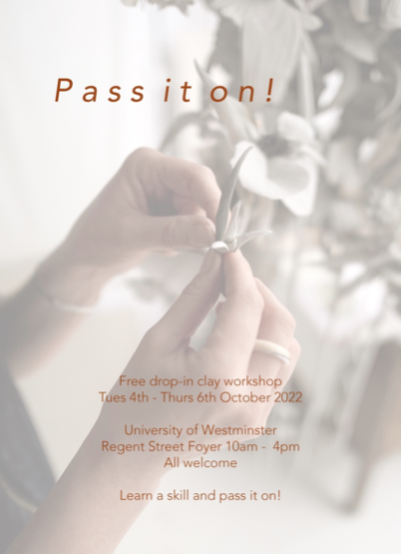

Phoebe Cummings is known for her intricate time-based installations created using raw clay. Her works are inspired by the natural world, reflecting its fragility and transience. At the end of their designated period of exhibition, the clay from which the elaborate forms are constructed is reclaimed, destined to become part of a new sculpture. As such her work subverts notions of the permanence of art, instead encouraging the viewer to appreciate moments of encounter and witness. For example, when the artist created a recent installation, titled This Was Now (2020), its evolution could be observed by visitors to Wolverhampton Art Gallery. During its six-month occupation of the space, visitors were invited to participate in the process of recording the changing work through drawings and writings that also grew and accumulated across the gallery wall; these contributions were later edited and bound for the gallery’s permanent collection.² The preservation of the perceptions and responses of visitors serves as a trace of the work and how it was personally experienced by individuals at a particular time and place in their lives.

Whereas a traditional artwork exists as a physical entity that can be owned by an individual or institution, a work such as This Was Now subverts these ideas. It sought an active rather than passive audience; visitors were not only able to observe the artist at work, gaining an understanding of her creative processes, but were also made aware that the time and thought they gave to the resulting installation would be of lasting value.

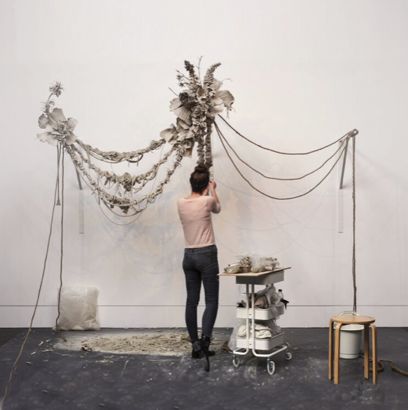
Phoebe Cummings, This Was Now, 2020. Wolverhampton Art Gallery

Similarly, the Pass It On! event aims to foreground interpersonal relations and demonstrate their agency within an artistic encounter. In addition, it draws on the artistic strategy of ‘the gift’: Initially it promises a transfer of skills from experienced maker to novice; the participant will then be gifted a bag of clay to take away, in exchange for their time and labour in passing on their newly acquired skills to two more people. Ecological concerns are also central—the self—hardening clay (that does not require kiln-firing) is recycled, having already been used by upwards of 500 people.

The artistic strategy of ‘the gift’ is informed by the 1925 essay of the same name by French sociologist and anthropologist Marcel Mauss. In this he explores the operation of the gift as a catalyst for the enhancement of solidarity, to establish social contract and obligation, as opposed to being a purely altruistic gesture.³ Roger Sansi, has discussed the influence of Mauss’s insights on contemporary art practices, tracing developments of his ideas within the thinking of Bataille and the surrealists, Debord and Situationist International, to more recent examples of relational and activist art.⁴ Clare Twomey acknowledges that her interest in such ideas of social contract and exchange were first inspired by the critical practice of Canadian collective General Idea, in particular their work Putti (1993) where thousands of baby seal-shaped soaps could be taken by visitors from the museum installation; however, in doing so, they would be aware of the suggestion that they could leave a $10 donation for a local AIDS charity. Similarly, the ‘Stacks’ of printed paper and piles of sweets presented by the late Felix Gonzales-Torres can be depleted by gallery visitors, although, as Nicolas Bourriaud points out, the visitors are aware of their responsibility in that the work would simply disappear if everyone chose to take away a sheet of paper or a sweet.⁵

Twomey also adopts strategies to cause people to reflect on their actions and their effects: To mark the dismantling of her work Monument at the Zuiderzee Museum in 2019 (where it had been installed for the previous ten years), she offered visitors the opportunity to select a historic tile from the sculpture. Whereas the tiles had once been part of the museum’s collections, they were then registered in the name of their new owner and provided with a golden wax seal and authentication by the museum, this symbolic act of transfer reminding recipients that they had taken on the obligation of stewardship.⁶

A further example of Twomey’s strategy of inviting exchange as a form of social contract and collaborative action was her installation FACTORY: The seen and the unseen, which she created when Lead Artist for Tate Exchange (TEX) in 2017. Having installed a factory production line within the TEX space at London’s Tate Modern, for the first week she invited visitors to become part of the workforce, choosing either preparatory tasks, such as weighing clay, or production tasks such as slip casting items of tableware or hand-modelling decorative porcelain flowers under the guidance of expert makers. In return for their labour, participants were able to select a fired pot or flower, made by another unknown worker, to take home. The project also invited personal reflections on labour as, in the second week, work on the bustling production line halted and instead visitors were invited to offer written responses to a short list of probing questions relating to ‘knowledge,’ ‘transformation,’ ‘material’ and ‘value’ in the context of production. They too were allowed to take away a clay item on condition that they replaced it with their handwritten thoughts for other visitors to read.⁷

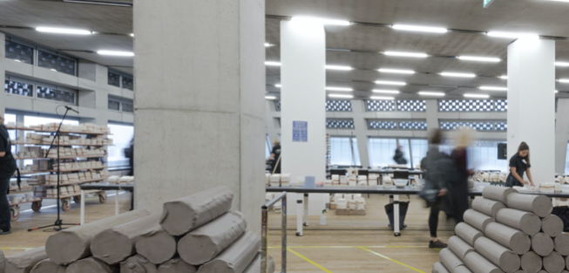
Clare Twomey, FACTORY: The seen and the unseen. 2017. Tate Exchange.
Photo: Matt Greenwood

Rooted in Clare Twomey and Phoebe Cummings’ different artistic practices, Pass It On! seeks to set up a situation of social encounter that creates the conditions for further situations of exchange. When participants pledge to teach two other people clay skills as a continuation of the event, the idea is to introduce the potential of ceramic materials to more people, in the hope that they too may have the opportunity to discover personal value and agency through making.

Tessa Peters

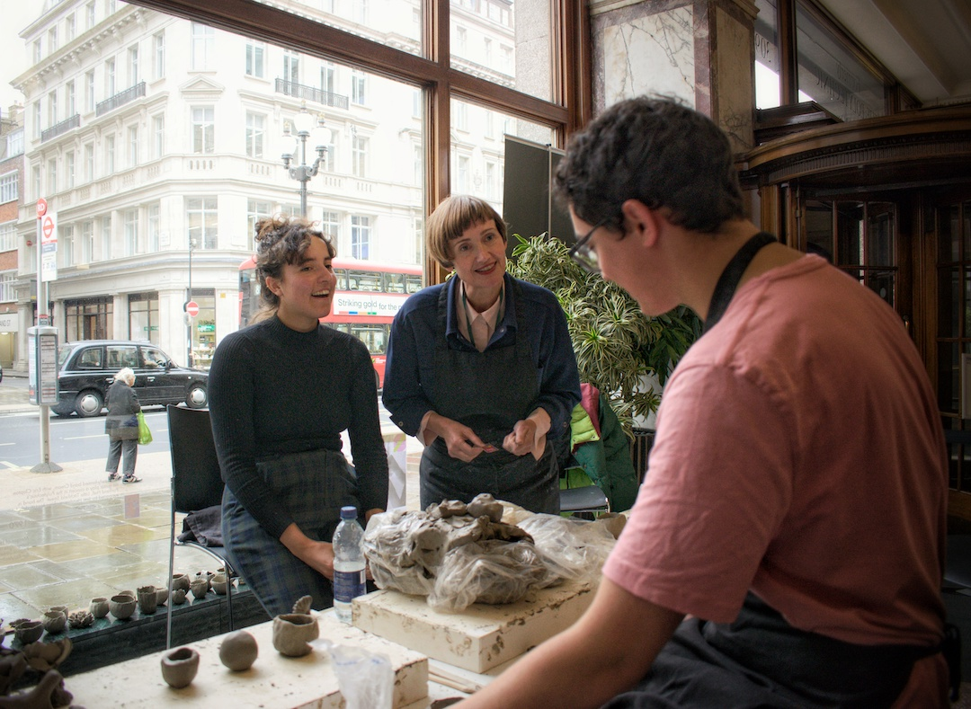

Pass It On! workshop led by Clare Twomey and Phoebe Cummings at the University of Westminster, Regent Street, London W1 on 4-6 October 2022. Workshop photos & videos: Rishika Sahgal.

https://cream.ac.uk/ceramics-research-centre-uk/
@ceramicsresearchcentre_uk

1. See: University of Westminster (2022) ‘Breaking Boundaries in Ceramic Art.’ Available at: https://www.westminster.ac.uk/research/impact/breaking-through-boundaries-in-ceramic-art

2. See: ‘Phoebe Cummings: This Was Now at Wolverhampton Art Gallery’. Available at:
https://www.youtube.com/watch?v=6ropNc5HEVI

3. Marcel Mauss, The Gift: The form and reason for exchange in archaic societies, London: Routledge, 2002.

4. Roger Sansi, ‘The pleasure of expense: Mauss and The Gift in contemporary art,’ Journal of Classical Sociology, 2014, Vol. 14 (1), pp 91–99.

5. Nicolas Bourriaud, Relational Aesthetics, trans. Simon Pleasance & Fronza Woods, Les presses du reel, 2002, p. 39.

6. ‘Monument: From Controversy to Care’. Available at: https://cream.ac.uk/ceramics-research-centre-uk/conversations/conversations-clay-culture-society/monument-from-controversy-to-care/

7. ‘Clare Twomey, FACTORY: the seen and the unseen’. Available at: https://cream.ac.uk/exhibitions/clare-twomey-factory-the-seen-and-the-unseen/

