E.02.35-ComplexityCosts-D3.2-Investment trade-offs
Document information
Project Title | ComplexityCosts
Project Number | E.02.35
Project Manager | University of Westminster
Deliverable Name | Investment trade-offs
Deliverable ID | D3.2
Edition | 01.01.00
Template Version | 03.00.00
Task contributors
University of Westminster
Fundación Instituto de Investigación Innaxis (Innaxis)
Deutsches Zentrum für Luft-und Raumfahrt e.V. (DLR)
Abstract
The characteristics of the mechanisms and disturbances that will be implemented in ComplexityCosts are finalised, with key details of the corresponding technical models and statistical distributions provided. Model scenarios and trade-off analyses are described, along with the final model implementation and simulation planning. Legal aspects of passenger compensation (regarding Regulation 261) are reported. Fuel consumption models and passenger itinerary allocations are summarised.
Authoring & Approval
Prepared By - Authors of the document.
Name & Company | Position & Title | Date
Luis Delgado / University of Westminster | Consortium Member | 29JUL16
Samuel Cristóbal / Innaxis | Consortium Member | 29JUL16
Andrew Cook / University of Westminster | Project Leader | 29JUL16
Graham Tanner / University of Westminster | Consortium Member | 29JUL16
Michael Schultz / DLR | Consortium Member | 29JUL16

Reviewed By - Reviewers internal to the project.
Name & Company | Position & Title | Date
Graham Tanner / University of Westminster | Consortium Member | 30JUL16

Reviewed By - Other SESAR projects, Airspace Users, staff association, military, Industrial Support, other organisations.
Name & Company | Position & Title | Date
N/A

Approved for submission to the SJU By - Representatives of the company involved in the project.
Name & Company | Position & Title | Date
Andrew Cook / University of Westminster | Project Leader | 31JUL16

Rejected By - Representatives of the company involved in the project.
Name & Company | Position & Title | Date
N/A

Rational for rejection
None
Document History
Edition | Date | Status | Author | Justification
01.00.00 | 31JUL16 | Release | Andrew Cook | New document for review by EUROCONTROL
01.01.00 | 28AUG16 | Review | Andrew Cook | Incorporating EUROCONTROL comments
Intellectual Property Rights (foreground)
This deliverable consists of Foreground owned by one or several Members or their Affiliates.
Table of Contents
Executive summary 5
1 Introduction 6
1.1 Purpose of the document 6
1.2 Intended readership 6
1.3 Inputs from other projects 6
1.4 Glossary of terms 6
1.5 Acronyms and Terminology 6
1.6 Acknowledgement 7
2 Scenarios and metrics 8
2.1 Model scenarios 8
2.2 Performance metrics 9
3 Trade-off analyses 13
3.1 Discovering trade-offs in a stochastic context 13
3.2 Comparing trade-offs in a stochastic context 14
3.3 Mechanism trade-offs 15
3.3.1 Intra-mechanism trade-offs 15
3.3.2 Inter-mechanism trade-offs 15
4 Model design and parameterisation 16
4.1 Mechanisms 17
4.1.1 Improving sector capacity with ATCO hours 17
4.1.2 Dynamic cost indexing 18
4.1.3 A-CDM 19
4.1.4 Improved passenger reaccommodation 20
4.2 Disturbances 21
4.2.1 Generic processes 21
4.2.2 Disturbances applied 23
4.3 Fuel, passenger itinerary and delay cost models 29
4.3.1 Fuel consumption model 29
4.3.2 Passenger itinerary allocations 30
4.3.3 Delay cost models 31
5 Implementation and simulations 33
5.1 Implementation methodology 33
5.2 Software management, deployment and execution 34
6 Next steps and look ahead 35
Appendix A 36

List of tables
Table 1. Planning in D3.1 8
Table 2. Planning in D3.2 9
Table 3. Flight-centric metrics 10
Table 4. Passenger-centric metrics 11
Table 5. Cost-centric metrics 12
Table 6. Intra-mechanism trade-offs 15
Table 7. Inter-mechanism trade-offs 15
Table 8. Mechanism 1 – cost and implementation summary 17
Table 9. Mechanism 1 – stakeholder uptake summary 17
Table 10. Mechanism 2 – cost and implementation summary 18
Table 11. Mechanism 2 – stakeholder uptake summary 18
Table 12. Mechanism 3 – cost and implementation summary 19
Table 13. Mechanism 3 – stakeholder uptake summary 19
Table 14. Mechanism 4 – cost and implementation summary 20
Table 15. Mechanism 4 – stakeholder uptake summary 20
Table 16. Industrial action disturbance – implementation summary 23
Table 17. Weather-related disturbances – implementation summary 26
Table 18. Treatment of disrupted flights 30
Table 19. Scenario and modelling phases 33
Table 20. Phases description and dependencies 33
Table 21. Scenario execution phases 34
Table 22. Execution phases overview 34
Table 23. Average number of controllers used, maximum and difference per airspace and ANSP 36

List of figures
Figure 1. Two independent variables, with no evidence of a trade-off 13
Figure 2. Two independent variables, with clear evidence of a trade-off 14
Figure 3. Comparing two trade-off examples 14
Figure 4. Estimated strategic cost per ANSP for improving sector capacity 17
Figure 5. Delay generation concept 21
Figure 6. Example of possible re-routings around industrial action 22
Figure 7. Average daily cancellations 2014 24
Figure 8. Monthly share of operational cancellations 2014 24
Figure 9. Industrial action regulations for the basis dates 25
Figure 10. Number of weather regulations and ANSPs – local case selection 27
Figure 11. Number of weather regulations and ANSPs – disperse case selection 28
Figure 12. Weather-related regulations for the basis dates 28
Figure 13. Cruise weight estimation for different FLs (A320) 29
Figure 14. Cruise fuel estimated for flights in model at nominal cruise speed 29
Figure 15. 2014 itineraries generation 31

Executive summary

The main objective of ComplexityCosts is to gain deeper insights into ATM performance trade-offs for different stakeholders’ investment mechanisms within the context of uncertainty. The full traffic and passenger itinerary day modelled is 12SEP14.

Despite uncertainty being one of the main factors generating reduced performance, behaviours are often driven by complex interactions and feedback loops that render it difficult to assess second-order impacts at a network level. The ComplexityCosts simulation model takes into account different stakeholders, according to corresponding tactical and strategic cost structures, and their interactions. Feedback loops in the model could thus potentially generate new emergent macroscopic behaviour.

This report describes the implementation of the mechanisms and their cost assignments, at the tactical and strategic levels. Stakeholders’ mechanism adoption is modelled according to three uptake levels: baseline (current situation), early adopters (mid-term) and followers (long-term).

Uncertainty (and network performance detriment) is modelled by disturbances introduced into the model: the statistical models for industrial actions and weather are explained. Background ATFM disturbance is also modelled as part of the baseline. The statistical parameters for these disturbances are derived from empirical data, as are the spatial and temporal duration of the disturbances.
The effect of the disturbances will be variously mitigated by the mechanisms. Different mechanisms might deliver different performance as a function of the spatial distribution of the disturbances. In some cases, a mechanism might be better suited for localised disturbances in the network, but provide a lower benefit when disturbances affect the network in a wider manner. For this reason, each disturbance will be modelled with two different spatial scopes: local and disperse.
The combination of a disturbance, mechanism and stakeholder uptake level, is referred to as a scenario. These combinations are summarised in the table below, each with two, non-baseline stakeholder uptake levels applied to the mechanisms.

 |  |  |  | Disturbance type
Mechanism | Focus  area | Primary investment | AO delay driver | Industrial action |  | Weather
 |  |  |  | Local | Disperse | Local | Disperse
1. Improving sector capacity with ATCO hours | en-route | ANSP | magnitude
2. DCI | en-route | AO | cost
3. A-CDM | airport | airport | magnitude
4. Improved pax reaccommodation | airport | AO | cost

This report also describes the metrics (flight-centric, passenger-centric and cost-centric) used to evaluate the scenarios, and the trade-off analysis methodology.

An update is provided on the fuel consumption model and the passenger itinerary allocations, in addition to details regarding the legal practicalities of modelling passenger compensation costs.

Introduction

Purpose of the document
The primary objective of ComplexityCosts is to better understand ATM network performance trade-offs for different stakeholder investments in the context of uncertainty. A variety of investment mechanisms and disturbance types will be considered. This report is intended for internal use, as an update to the Project Officer on the final methodology, prior to Deliverable 4.5 (Final Technical Report). Key material will be re-presented in Deliverable 4.5, in conjunction with the final results.

Intended readership
This report is intended for internal readership, as an update to the Project Officer.

Inputs from other projects
Not applicable.

Glossary of terms
Not applicable.

Acronyms and Terminology
Term | Definition
A-CDM | Airport Collaborative Decision Making
ACE | ATM Cost-Effectiveness
ACI | Airports Council International
AIRAC | Aeronautical Information Regulation and Control
ANSP | Air Navigation Service Provider
AO | Aircraft Operator
ATC | Air Traffic Control
ATCO | Air Traffic Controller
ATFM | Air Traffic Flow Management
ATM | Air Traffic Management
ATMAP | ATM Airport Performance Framework
BADA | Base of Aircraft Data (EUROCONTROL)
CODA | Central Office for Delays Analysis (EUROCONTROL)
DCI | Dynamic cost indexing
DDR/DDR2 | Demand Data Repository
DPI | Departure Planning Information
ECAC | European Civil Aviation Conference
EFB | Electronic Flight Bag
FP | Flight plan
FTFM | Filed Tactical Flight Model  (last-filed flight plan (M1) from Enhanced Tactical Flow Management System from DDR)
GDS | Global Distribution System  (system that distributes inventory on behalf of airlines)
IAF | Initial approach fix
MCT | Minimum connecting time
METAR | Meteorological Aerodrome Report
MUAC | Maastricht Upper Area Control Centre
NDA | Non-disclosure agreement
NMOC | Network Manager Operations Centre
SESAR | Single European Sky ATM Research
SIDs | SESAR Innovation Days
SJU | SESAR Joint Undertaking

Acknowledgement
We are very grateful to PACE Aerospace Engineering and Information Technology GmbH (Berlin, Germany) and Sabre Airline Solutions (Sabre Corporation, Delaware, US), and other industry contacts, for assistance in the assessment of the mechanism costs. We are very grateful to Bott & Co Solicitors (Wilmslow, UK) for advice regarding passenger compensation claims.

Scenarios and metrics
The ComplexityCosts simulation model takes into account different stakeholders, according to their corresponding tactical and strategic cost structures, and their interactions. The aim is to gain deeper insights into ATM performance trade-offs for different stakeholders’ investment mechanisms within the context of uncertainty. Uncertainty is modelled by disturbances introduced into the model. Background ATFM disturbance is also modelled as part of the baseline. The effect of the disturbances will be variously mitigated by the mechanisms.

Different mechanisms might deliver different performance as a function of the spatial distribution of the disturbances, and the level of uptake by the stakeholders. In some cases, a mechanism might be better suited for localised disturbances in the network, but provide a lower benefit when disturbances affect the network in a wider manner. For this reason, each disturbance will be modelled with two different spatial scopes: localised and disperse. The combination of a disturbance, mechanism and stakeholder uptake level, is referred to as a scenario.

This section describes the model scenarios and the metrics used to evaluate them.

Model scenarios
Table 1. Planning in D3.1
 | Disturbance type
Mechanism | Staff shortage |  | Industrial action |  | Weather
 | Local | Disperse | Local | Disperse | Local | Disperse
1. Increasing ATCO hours in staff-shortage sectors
2. DCI
3. A-CDM
4. Improved pax reaccommodation

Table 1 shows the planning for the scenarios as presented in Deliverable 3.1 (Scenario definition; 04MAR16). The crosses indicated out-of-scope combinations of disturbance types and mechanisms. Mechanism 1, increasing ATCO hours in selected sectors, was targeted specifically at sectors with staff shortages, and was thus not appropriate to resolve industrial action disturbances (it would not reverse a strike) or weather-related disturbances (as there is a low expectation that a sector with a staff shortage would be close enough to the weather event). This produces 20 combinations to consider, each with two levels of stakeholder uptake, i.e. 40 scenarios in total (each one against an appropriate baseline).
Mechanism 1 was well-received by ANSP stakeholders in particular, and resulted in a dedicated SIDs paper in 2015. However, during subsequent project planning, it became apparent that changing mechanism 1 to a more generic mechanism (applicable to a wider range of sectors, not only those reporting staff shortages), would be more beneficial to the ComplexityCosts project, primarily in that such a mechanism could then be applied across the industrial action and weather-related disturbances, thus restoring the symmetry of the table and the number of cross-mechanism comparisons that could be made (see Section 3). There would then be less of an imperative to include staff shortages as a disturbance type, such that it is proposed to drop this disturbance and invest the effort in the following activities:
- rendering mechanism 1 more generic;
- extending the weather disturbance to en-route (originally planned as airport only);
- extending the DCI mechanism to cover an extra fuel scenario (one to match the other scenarios, plus a new one with a higher fuel price assumption, since the current baseline price is, historically, low).
Table 2 summarises the final status proposed. It also comprises 40 scenarios. Some extra columns have been added relative to Table 1, to summarise the focus area (en-route or airport) and from where the primary strategic investment in the mechanism comes. Although AO delay magnitudes and delay costs are intimately related, the mechanisms focus more specifically on either the delay magnitude, or delay cost. The latter applies when AO delay costs are (in theory at least) available at the decision-making point during tactical implementation of the mechanism (i.e. airlines applying DCI or controlling pax reaccommodation tools).
The primary benefits are thus an increased comparative analysis across the mechanisms and inclusion of a high-cost fuel scenario added to the DCI mechanism. The net effect is an overall increase in modelling work (including further modelling on re-routings being required; see Section 4.2.1.3). In addition, the issue of which types of disturbance trigger passenger compensation costs, particularly regarding associated reactionary delays, is complicated (see Section 0).

Table 2. Planning in D3.2
 |  |  |  | Disturbance type
Mechanism | Focus  area | Primary investment | AO delay driver | Industrial action |  | Weather
 |  |  |  | Local | Disperse | Local | Disperse
1. Improving sector capacity with ATCO hours | en-route | ANSP | magnitude
2. DCI (+ higher fuel cost scenario†) | en-route | AO | cost
3. A-CDM | airport | airport | magnitude
4. Improved pax reaccommodation | airport | AO | cost

† This qualifier will be dropped in subsequent tables. It is shown here to contrast with Table 1.

Performance metrics

The following tables show the metrics to be deployed in the analyses of the model outputs. They are categorised as:

- flight-centric;
- passenger-centric;
- cost-centric.

The numbering of the metrics is for consistency with previous deliverables. These will be renumbered (sequentially) for greater ease of use in the Final Technical Report. In addition to the values cited, in most cases distributions thereof will also be assessed (such as variance, percentiles and skewness).

As shown for Table 5, strategic and tactical costs metrics have been added to the tables. These costs will be computed individually by stakeholder according to the respective uptake level (baseline, early adopters and followers). The use of the metrics in the analyses is discussed further in Section 3.3.

Table 3. Flight-centric metrics
Code | Name | Subcategory | Units | Description | Comments
A.01 | Flight departure delay | delay | minutes | actual - scheduled | at-gate
A.02 | Flight arrival delay | delay | minutes | actual - scheduled | on-gate
A.03 | Number of departure-delayed flights | delay | flights | count if delay > 5 min | threshold may be varied
A.04 | Departure delay of departure-delayed flights | delay | minutes | uses A.03
A.05 | Number of arrival-delayed flights | delay | flights | count if delay > 5 min
A.06 | Arrival delay of arrival-delayed flights | delay | minutes | uses A.05
A.08 | Reactionary delay | delay | minutes | actual – scheduled (departure delay) | delay caused by late arrival of (other) aircraft or pax**
A.11 | Wait at-gate | delay | minutes | waiting time at gate
A.12 | ATFM delay | delay | minutes | delay due to regulation | imposed at-gate
A.13* | Departure queue | queue | flights | number of aircraft waiting to depart at runway
A.14* | Taxi-out | delay | minutes | from off-block until take-off | deviation from the standard taxi time
A.15* | En-route delay (up to IAF) | delay | minutes | from take-off until IAF point is reached | includes recovery (if any)
A.16* | Arrival holding | delay | minutes | from IAF reached until landed | extra time before landing
A.17* | Taxi-in | delay | minutes | from landing to in-block time | deviation from the standard taxi time
A.41 | Airport reactionary/primary delay ratio | resilience | n/a | reactionary / non-reactionary departure delay
A.42 | Flight-km | disutility | km | leg length,  summed over all flights | classified as “disutility” for comparison with analogue B.16; actually multi-functional
A.15* | CO₂ – at-gate | environment | tonnes | CO₂ emitted at-gate | based on MTOW-extrapolated APU data
A.16* | CO₂ – cruise | environment | tonnes | CO₂ emitted in cruise only | based on fuel burn data in Section 4.3.1.

* Simple estimation only.
** May be split by aircraft and passengers (TBD).

Table 4. Passenger-centric metrics
Code | Name | Subcategory | Units | Description | Comments
B.01 | Passenger departure delay | delay | minutes | actual - scheduled | at-gate
B.02 | Passenger arrival delay | delay | minutes | actual - scheduled | on-gate
B.04 | Number of departure-delayed passengers | delay | pax | passengers affected by departure delay on their first leg only | for delays > 5 minutes; threshold may be varied
B.05 | Departure delay of departure-delayed passengers | delay | minutes | uses B.04
B.06 | Number of arrival-delayed passengers | delay | pax | at final destination
B.07 | Arrival delay of arrival-delayed passengers | delay | minutes | uses B.06
B.11 | Passenger extra time before boarding | wait | minutes | from scheduled to actual boarding time
B.12 | Passenger arrival extra time / journey time | disutility | ratio | delay on arrival divided by journey length | disturbance perception is related to journey length
B.13 | Passenger extra time on aircraft | disutility | minutes | extra time on aircraft, summed over all flights
B.14 | Passenger extra time at airport (or hotel) | wait | minutes | from scheduled to (estimated) actual boarding time
B.15 | Average load factor | resilience | percent | load factors averaged over all flights
B.16 | Passenger-kilometres | disutility | pax-km | pax X leg length,  summed over all flights | analogue of A.42
B.21 | Passenger missed connections | disutility | pax | disrupted itinerary | due to any reason (including cancellations); only first connection missed is counted
B.22 | Passenger re-accommodations | disutility | pax | successfully re-accommodated passengers
B.23 | Number of overnights | disutility | pax | pax not transported on intended day of travel
B.24 | Number of aborted journeys | disutility | journeys | passengers decide to return to (or stay at) departure airport | if departure delay  > 5 hours
B.25 | Number of extra flights taken | disutility | flights | passengers re-accommodated
B.26 | Accumulated passenger departure delay | delay | minutes | sum of departure delay in each leg
B.27 | Accumulated passenger arrival delay | delay | minutes | sum of arrival delay in each leg

Table 5. Cost-centric metrics
Code | Name | Subcategory | Description | Comments
Cost of delay
C.01 | Passenger soft costs | Indirect | e.g. loss of market share due to unpunctuality
C.21 | Passenger hard costs | Direct | e.g. pax reaccommodation costs
C.11 | Crew and maintenance costs | Direct | crew and maintenance costs due to delays
C.12 | Fuel cost | Direct | fuel cost due to delays
C.31 | Total cost of delay | Direct | C01 + C21 + C11 + C12
C.32 | Average total cost of delay |  | C31 / A01 (per flight)
C.02 | Passenger value of time | Indirect | disutility value of delay for passengers
Mechanism-related costs
C.33 | Strategic costs | Direct | as described in Section 4 | each mechanism has its own strategic costs, desegregated by each stakeholder uptake (baseline, early adopters and followers)
C.34 | Tactical costs | Direct | as described in Section 4 | each mechanism has its own strategic costs, desegregated by each stakeholder uptake (baseline, early adopters and followers)
C.35 | Cost resilience | Ratio | measures the effect of the investment mechanism with respect to the cost of the disturbance without the mechanism | full method and formulation published by the authors within the scope of the ComplexityCosts project

All values are costs in 2014-Euros, except C.32 (2014-Euros/flight) and C.35 (cost ratio).

Trade-off analyses
A trade-off is usually understood as a compromise between two opposing preferences, actions or goods. Mathematically, both preferences need to be quantified to determine whether a trade-off could be achieved. In the context of ComplexityCosts, trade-offs are ubiquitous. For example, reducing all AO delay could be a desirable objective. However, recovering all delay would most likely increase costs prohibitively. Two opposing variables may correspond to two different actors, and although they may not actually be inversely proportional, their perception by the two actors needs to be, in order to obtain a trade-off. An example is supply and demand models for price. It is also possible to compare two or more trade-offs and determine which one gives a better compromise for both parties or variables. In this section we describe the methodology and application to ComplexityCosts.

Discovering trade-offs in a stochastic context
In the simplest framework, a trade-off exists when there is an inverse relationship between two variables. When one variable increases the other decreases. In a stochastic context, the two magnitudes need to be considered as a pair of random variables. Considering two random variables as a pair means that both variables are realised simultaneously in each experiment. Figure 1 and Figure 2 show relationships between two normally distributed samples, without and with evidence of trade-offs, respectively, monotonically decreasing as y = 1/x in the latter case. An inverse relationship between two random variables means that most of the time (usually within a 95% confidence interval), when one variable has a large value, the other has a small value. In other words, both variables are not independent and there exists a strong correlation.

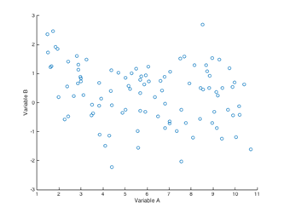
Figure 1. Two independent variables, with no evidence of a trade-off

The easiest case is a linear correlation: the two random variables follow a statistically significant linear relationship (typically monotonically and within a 95% confidence interval). Since testing correlations with any possible increasing or decreasing function is not practical, when linear regression fails, a much more general approach is used to find a statistically significant function between the two variables and then stablish whether that stochastic function is statistically significant and changing monotonically: a generalised additive model (GAM) or a generalised linear model (GLM).

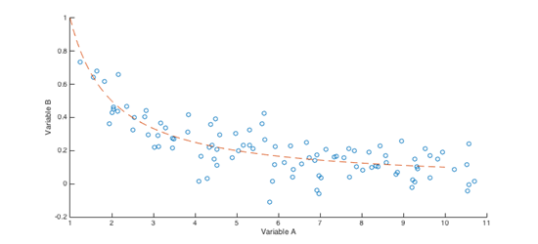

Figure 2. Two independent variables, with clear evidence of a trade-off

Comparing trade-offs in a stochastic context
Comparing trade-offs is possible by examining the underling correlation functions. For instance, in the case of linear negative correlation, the larger the absolute value of the slope the better the trade-off would be for one of the two variables (see Figure 3 – the blue trade-off is the more desirable). In general, since any trade-off correlation function is monotonically decreasing by definition, it is possible to compare the trade-offs using the asymptotic behaviour of the relationship function.
The family of Bachmann-Landau notations defines and classifies different asymptotic behaviours, the most commonly used in computer science is the ‘big O’ notation for problem complexity. This classifies algorithms and functions by how they respond to changes in inputs. Different functions having the same growth rate are usually represented using the same O notation. This will be elaborated upon further in D4.5 (Final Technical Report).
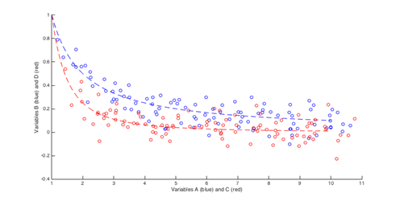

Figure 3. Comparing two trade-off examples

Mechanism trade-offs
In order to explore all possible trade-offs, the methods outlined above will be applied in two phases:

- intra-mechanism trade-offs;
- inter-mechanism trade-offs.

The former explores the trade-offs between different metrics within the same mechanism but under different disturbances, whilst the latter explores trade-offs between different mechanisms under the same disturbances. There are four mechanisms considered (with DCI split into a further cost scenario) and four disturbance levels. Therefore, eight primary trade-off analyses will be carried out, with further consideration across the stakeholder uptake levels (e.g. how uptake affects the benefits returned) and DCI fuel costings. Each analysis consists of two phases, discovery and comparison, as explained in the previous section.

Intra-mechanism trade-offs
The focus of the intra-mechanism trade-offs is to evaluate the performance of each mechanism across the different disturbance types, and their corresponding scales (local and disperse). This will also assess the trade-off between the strategic and tactical costs of the mechanisms (where appropriate, as described in Section 4) and the impacts as described through the performance metrics of Section 2.2 (some of which may be unexpected/unintentional impacts, with respect to the mechanism applied). Best-case outcomes will be contrasted with worst-case, with corresponding analysis of the underlying causes thereof.

Table 6. Intra-mechanism trade-offs
 | Disturbance type
Mechanism | Industrial action |  | Weather
 | Local | Disperse |  | Local | Disperse
1. Improving sector capacity with ATCO hours | Intra-mechanism trade-offs 1
2. DCI (+ higher fuel cost scenario) | Intra-mechanism trade-offs 2
3. A-CDM | Intra-mechanism trade-offs 3
4. Improved pax reaccommodation | Intra-mechanism trade-offs 4

Inter-mechanism trade-offs
Table 7 shows the corresponding sets of analyses to be carried out across the mechanisms, and within the disturbance types. The same principles will be applied as for the intra-mechanism trade-offs described above. Here, however, we may ask such questions as: for a given disturbance type and scale, which mechanism is most cost-effective?

Table 7. Inter-mechanism trade-offs
 | Disturbance type
Mechanism | Industrial action |  | Weather
 | Local | Disperse | Local | Disperse
1. Improving sector capacity with ATCO hours | Inter-mechanism trade-offs A | Inter-mechanism trade-offs B | Inter-mechanism trade-offs C | Inter-mechanism trade-offs D
2. DCI (+ higher fuel cost scenario)
3. A-CDM
4. Improved pax reaccommodation

Model design and parameterisation

The main objective of ComplexityCosts is to gain deeper insights into ATM performance trade-offs for different stakeholders’ investment mechanisms within the context of uncertainty. The full traffic and passenger itinerary day modelled is 12SEP14 (as previously described).

Despite uncertainty being one of the main factors generating reduced performance, behaviours are often driven by complex interactions and feedback loops that make it difficult to assess second-order impacts at a network level. The ComplexityCosts simulation model takes into account different stakeholders, according to corresponding tactical and strategic cost structures, and their interactions. Feedback loops in the model could potentially generate new emergent macroscopic behaviour, often driven by equilibria in trade-offs.

This section describes the implementation of the mechanisms and their cost assignments, at the tactical and strategic levels. Stakeholders’ mechanism adoption is modelled according to three uptake levels: baseline (current situation), early adopters (mid-term) and followers (long-term). These are detailed explicitly in this section. Uncertainty (and network performance detriment) is modelled by disturbances introduced into the model: the statistical models for industrial actions and weather are explained. Background ATFM disturbance is also modelled as part of the baseline. The statistical parameters for these disturbances are derived from empirical data, as are the spatial and temporal duration of the disturbances.

As introduced in Section 2, the effect of the disturbances will be variously mitigated by the mechanisms. Different mechanisms might deliver different performance as a function of the spatial distribution of the disturbances, and the level of uptake by the stakeholders. In some cases, a mechanism might be better suited for localised disturbances in the network, but provide a lower return when disturbances affect the network in a wider manner. For this reason, each disturbance will be modelled with two different spatial scopes: localised and disperse.

Also in this section, an update is provided on the fuel consumption model and the passenger itinerary allocations, in addition to details regarding the legal practicalities of modelling passenger compensation costs.

Note on confidential costs
Costs indicated as “[C1]”, “[C2]”, etc …, have been disclosed (in strict confidence) to the EUROCONTROL Project Officer to demonstrate their sourcing and veracity, but may not be reported here due to NDA / confidentiality restrictions.

Mechanisms

Improving sector capacity with ATCO hours
Table 8. Mechanism 1 – cost and implementation summary
Uptake | Costs |  | Implementation
 | Strategic | Tactical
Baseline | Not applicable |  | No mitigation  Delays not mitigated by adding additional ATCO resources.
Early adopters | Not applicable | Full, seven-hour ATCO shifts (i.e. not marginal shifts) are used for mitigating regulations. For each ANSP, the average extra ATCO capacity for its airspace is estimated as the difference between the average number of maximum controllers available for each of the airspaces of the ANSP that have more than one configuration, and the average number of controllers used in these airspaces during the period AIRAC 1313 to AIRAC 1413. (See Table 23 for data.) The ATCO hourly costs are sourced from EUROCONTROL⁵. | Extra ATCO hours added  Regulations are (partially) averted by implementing the mechanism. In some cases, flights will get ATFM delay assigned due to re-routing as the capacity of re-routed airspaces might also be compromised. This mechanism may also mitigate the latter.
Followers | EUR 1-3M, based on the maximum number of controllers in operations at the ANSP during 2014. Interpolated using Figure 4, using data sourced from EUROCONTROL (ibid.)
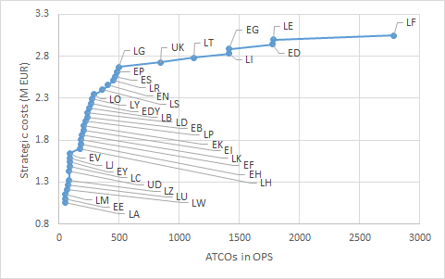
Figure 4. Estimated strategic cost per ANSP for improving sector capacity
Table 9. Mechanism 1 – stakeholder uptake summary
Baseline | None
Early adopters | MUAC, Poland (EP)
Followers | Germany (ED), Greece (LG), Portugal (LP), Cyprus (LC)

Dynamic cost indexing
Table 10. Mechanism 2 – cost and implementation summary
Uptake | Costs |  | Implementation
 | Strategic | Tactical
Baseline | Not applicable |  | Basic ‘rule of thumb’  10% of flights implement basic 'rules of thumb' to recover as much delay as possible when delay exceeds 15 minutes. This recovery will be bounded by a maximum extra fuel burn, to avoid excessive consumption. This basic rule applies anywhere in the network and for all airlines, except for flights of less than 60 minutes, that don't have the time to recover any significant delay.
Early adopters | Cost of crew training regarding new procedures for DCI: cost proportional to the number of pilots per aircraft x aircraft in the fleet that will perform DCI x hours of training required (2 hours) per pilot x cost of crew per hour.  It is considered that Class 2 EFBs are required to operate DCI. It is very difficult to estimate market data, but based on expert industry consultation, an even distribution of current EFB uptake by AOs is considered, with 50% of aircraft currently equipped with Class 1 EFBs, 40% with Class 2 and 10% with Class 3. Therefore, for 50% of aircraft that implement DCI, the cost of upgrading to Class 2 EFBs is considered [C2]. | [C1]%  of the  total net saving accrued to the airline. | Full DCI  For all aircraft implementing the enhanced DCI mechanism:  - When a flight is delayed, the cost of recovering the delay, totally or partially, by speeding up during cruise, is assessed at the top of climb.  - The delay will be considered to be recovered in discrete blocks of minutes; the exact granularity of this recovery will be fully reported in Deliverable 4.5.  - Fuel and cost of time (delay) costs will be considered; costs of delay will be considered from historical look-up tables (i.e. will not be tactically updated).  - Different costs of delay will be considered for inbound and outbound flights from the airlines' hubs.  - As reported by SESAR, when the selected Cost Index is modified, not only the cruise speed changes but the whole trajectory might be modified. In particular, the length of the cruise tends to increase. For this reason, the flights implementing DCI will increase their cruise following a normal distribution (μ=7.60 NM and σ=2.15 NM) bounded in the range [2, 18] NM. The descent duration and fuel will be reduced accordingly ensuring that a minimum descent distance is maintained.
Followers | As for early adopters, the flights considered to operate DCI will require operational training costs and system upgrade costs.

Table 11. Mechanism 2 – stakeholder uptake summary
Baseline | All flights greater than 60 minutes eligible to apply basic rules of thumb, as specified above.
Early adopters | Operations by hub carriers at top three ECAC airports (by passengers in 2014): British Airways at LHR, Lufthansa at FRA, Air France at CDG.
Followers | Early adopters will expand DCI operations to their whole network.  Other hub operators will consider DCI for flights at their major airports. Aircraft operators at seven of the Group 1 ECAC airports, as defined by ACI Europe (>25m pax/year) in which the aircraft operator operated over 33% of the arrivals and departures on 12SEP14, i.e.: Turkish Airlines at IST, KLM at AMS, Lufthansa at MUC, Alitalia at FCO, Air France at ORY, SAS at CPH, SWISS at ZRH.  In addition, a judgemental selection of other carriers: easyJet at LGW, Vueling at BCN, Iberia at MAD.

A-CDM
Table 12. Mechanism 3 – cost and implementation summary
Uptake | Costs |  | Implementation
 | Strategic | Tactical
Baseline | Not applicable | For the airport, agents and ANSP, the annual running cost varies (by airport size) from €50k to €450k.  For the airline, the on-going training costs and flow-management role is assigned as an additional cost (compared with no A-CDM) of €50k for the major/'home' carrier (but quasi-nil for small airports: assigned as airports with less than the lower quartile of movements on the day of study, i.e. airports with fewer than 453 movements), and quasi-nil for the other carriers.  The tactical cost computed is yearly, therefore a factor of 0.34% of the cost will be considered as the cost of the day under study. This will allow the comparison of the tactical cost of the day with the other mechanisms. (0.34% is the proportion of traffic of the day under study (12SEP14) over the total yearly traffic.) | 3% average delay saving  Airports implementing A-CDM will have a reduction in the delay propagated, following a distribution centred on a 3% reduction.
Early adopters | Majority of cost invested by airport, agents and ANSP. These implementation costs vary (by airport size) from €550k to €4800k. Airline costs are fixed at €150k for the major / 'home' carrier, and €50k in total for the other carriers. |  | 4% average delay saving  For airports that form part of the baseline scenario, a delay distribution will be centred on a 4% reduction. For airports newly implementing A-CDM, a 3% centred reduction will be modelled.
Followers |  |  | For airports that form part of the early adopter’s scenario, a delay distribution will be centred on a 4% reduction. For airports newly implementing A-CDM, a 3% centred reduction will be modelled.

Table 13. Mechanism 3 – stakeholder uptake summary
Baseline | Airports with A-CDM implemented in 2014 (DPI operational at NMOC): EDDM, EBBR, LFPG, EDDF, EFHK, EDDL, EGLL, LSZH, ENGM, LIRF, EDDB, LEMD, EDDS, LIMC, EGKK.
Early adopters | Airports with A-CDM implemented by July 2016 (DPI operational at NMOC): LIPZ, LKPR, LEBL, LSGG, LIML.
Followers | Airports at some level of implementation of A-CDM by July 2016: ESSA, LFPO, EKCH, EHAM, LOWW, LTBA, EDDH, LEPA, LFLL, LIRN, ENBR, ENZV, ENVA, EIDW, LPPT, LFMN.

The uptake of the mechanism is based on: airports that were fully A-CDM by 2014 (baseline); those that were fully A-CDM by 2016 (early adopters); those that were at some stage of A-CDM development by 2016 (followers).

Improved passenger reaccommodation

Table 14. Mechanism 4 – cost and implementation summary
Uptake | Costs |  | Implementation
 | Strategic | Tactical
Baseline | Not applicable |  | Local, airport-by-airport solutions only  Passengers with disrupted itineraries (missed connections) will be reaccommodated on subsequent flights.  The final destination of the passenger is considered during the accommodation process, a different itinerary might be used.  The process minimises the cost of reaccommodating the passenger, looking for solutions within the airline and airline alliance, before re-accommodating on competing carriers for high-yield passengers only.  The passenger compensation cost (Regulation 261) is considered during this reaccommodation process.
Early adopters | Not applicable | Fixed cost charged to the airlines per passenger boarded, i.e. [C3]. | Network-wide solutions  For each outbound flight, an assessment is made to analyse how many passengers would miss their connection if the departure is made on-time.  Total network costs (including reactionary delays in the network) are calculated for 15-minute increments of wait times (taking into account prevailing ATFM slot conditions).  An optimised wait/no-wait rule is implemented, based on the net cost best wait time (which could be zero wait).
Followers | Cost of implementation proportional to the volume of passengers boarded, i.e. [C4].

Table 15. Mechanism 4 – stakeholder uptake summary
Baseline | Same airlines as early adopters
Early adopters | Same as in DCI mechanism
Followers | Same as in DCI mechanism

Disturbances

Generic processes

Background ATFM delays
ATFM delay from the day under study will be used as the baseline for the background delay. Figure 5 presents the mechanism to assign ATFM delay to the flights. A pool of potential delays is generated with all the individual ATFM delays reported on 12SEP14. This delay is assigned to flights that operate through the regulated traffic volumes on that day. In this manner, the distribution of delay is similar to that of the baseline.
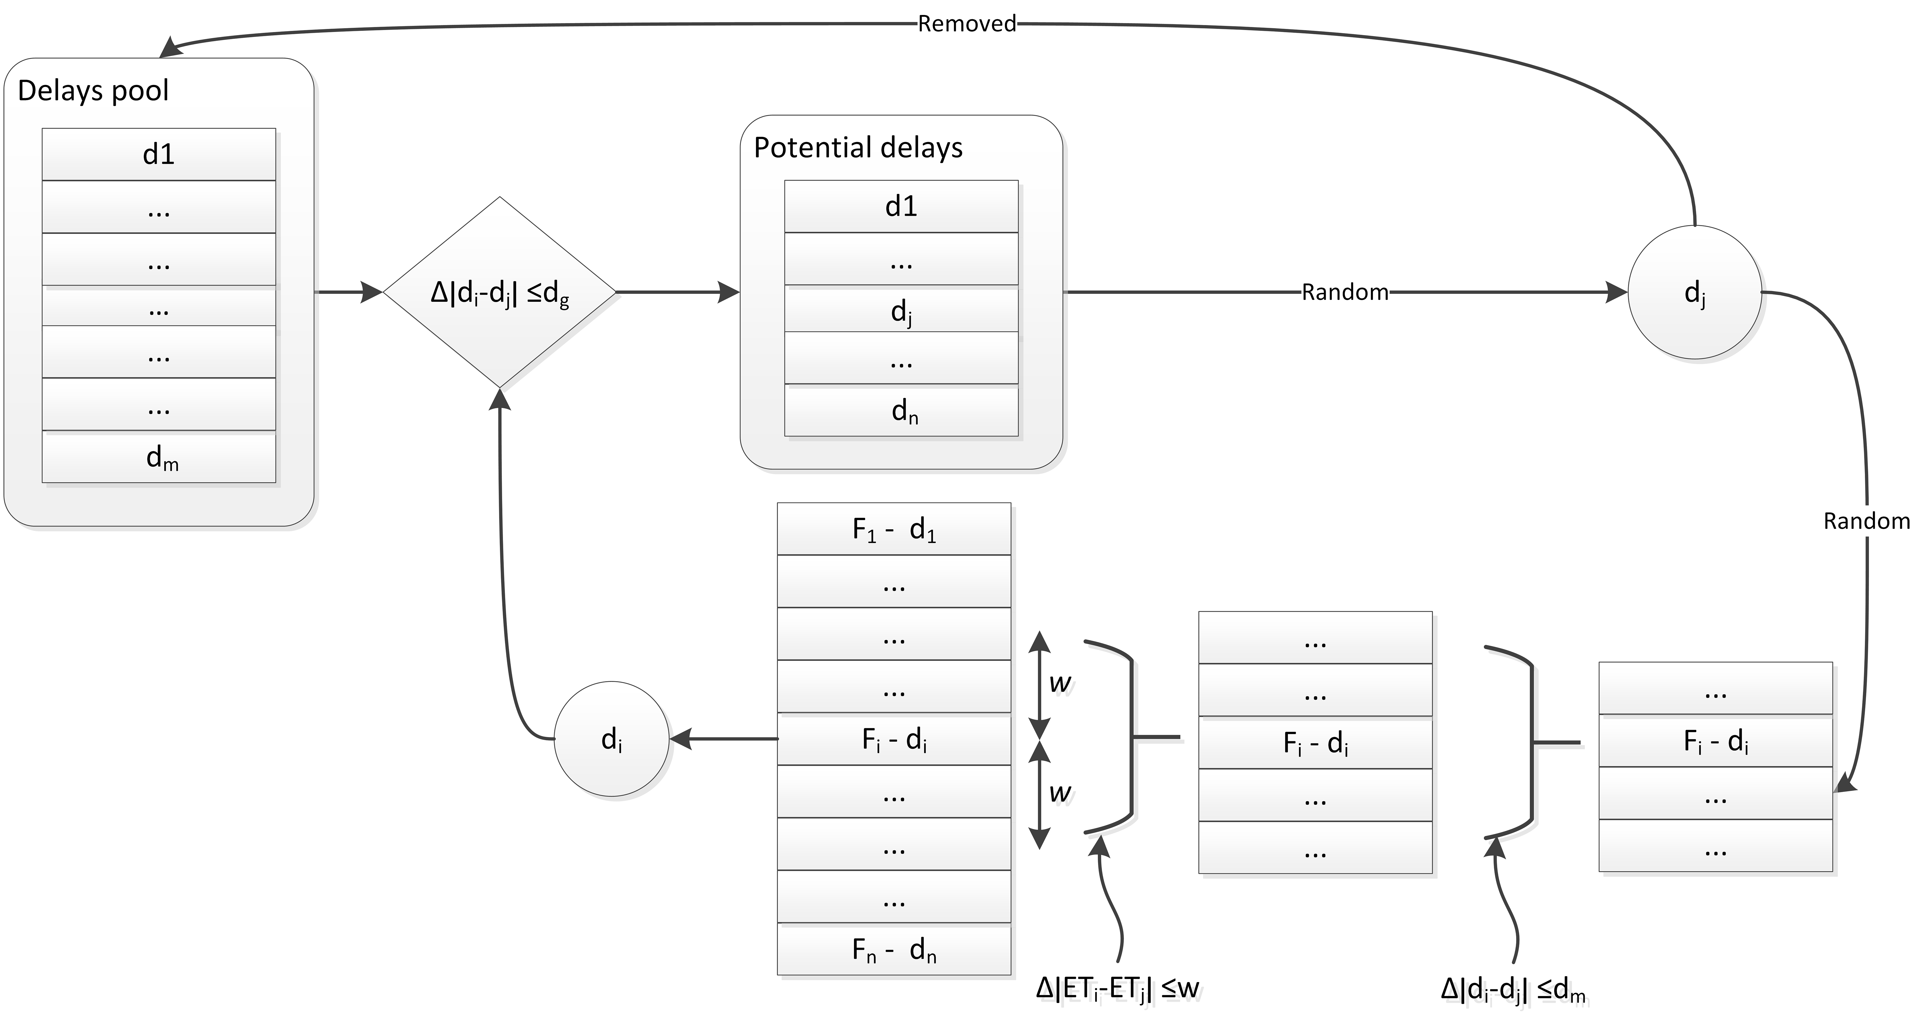
Figure 5. Delay generation concept

1. Delay generation
A delay is selected for each flight which had ATFM delay assigned in the original data. The delays that are within a given delay window (d_{g}) from the flight original delay (d_{i}) will be selected from the pool of delays. A delay will be randomly selected (d_{j}) and withdrawn from the pool of delays. The delay which triggers the selection and the delay selected will be randomly chosen. The range used to select the flights (d_{g}) will control the uncertainty level in terms of where the delay is generated.
2. Delay assignment
The next step is to assign the selected delay to an individual flight. The set of flights that enter the traffic volume around the same time as the flight which generated the delay are selected (i.e. flights with an entry time in the traffic volume within a given number of minutes (w)). Only flights which originally had a delay with a difference smaller than a given threshold (d_{m}) with respect to the flight which generated the delay will be kept as potential flights to be allocated the assigned delay. These thresholds will also be used to control the desired degree of variability with respect to the initial data.
For the assignment of ATFM background delay, the parameters that need to be calibrated in the system are:
- d_{g}: delay window around delay to be assigned;
- w: time window for entry time in regulated traffic volume around the flight that generated the delay;
- d_{m}: maximum delay difference between original delay in selected flight and generated delay.
As one of the disturbances considered is the effect of weather at airports, also modelling delay due to weather where the meteorological disturbance is not explicitly considered, will produce results that are well suited for cross comparisons.

Flights potentially affected by ATFM regulations
ATFM regulations are applied, for a period of time, to traffic volumes that can be defined as airspaces (e.g. a sector or group of sectors), as waypoints, airports or a set of airports. For each modelled ATFM regulation, the list of potential flights affected is computed. This estimation of potential flights affected is computed based on the submitted flight plan (FTFM) that has been shifted in time to meet the schedules of the flight.
Note that even if a flight crosses a regulated traffic volume it might not be affected by the regulation if the entry and exit time for that traffic volume are outside the regulated period. A flight might be affected by a regulation, entering the traffic volume within the temporal scope of the regulation, due to a temporal shift of its trajectory inflicted by a delay (e.g. due to reactionary delay). For this reason, all the flights that enter the traffic volume during or before the regulation are considered to be potentially affected.
In some cases, a delayed flight might avoid a regulation by entering the traffic volume after the regulation ending time. Thus, for each potentially affected flight, there are two times associated: delay entering the regulation and delay avoiding the regulation. The first is the minutes of delay that a flight has to experience to enter the regulated traffic volume while the regulation is active: this value could be zero for flights that would be regulated if operated according to schedule. The latter is the delay that a flight experiences for any reason apart from the regulation itself (avoiding the original regulation, after the regulation period).
Regulated traffic volumes are considered without the rules of traffic exclusion-inclusion and the duration of the regulations are as declared in the DDR data, i.e., the possibility of extending or cancelling a regulation are not considered.

Re-routing

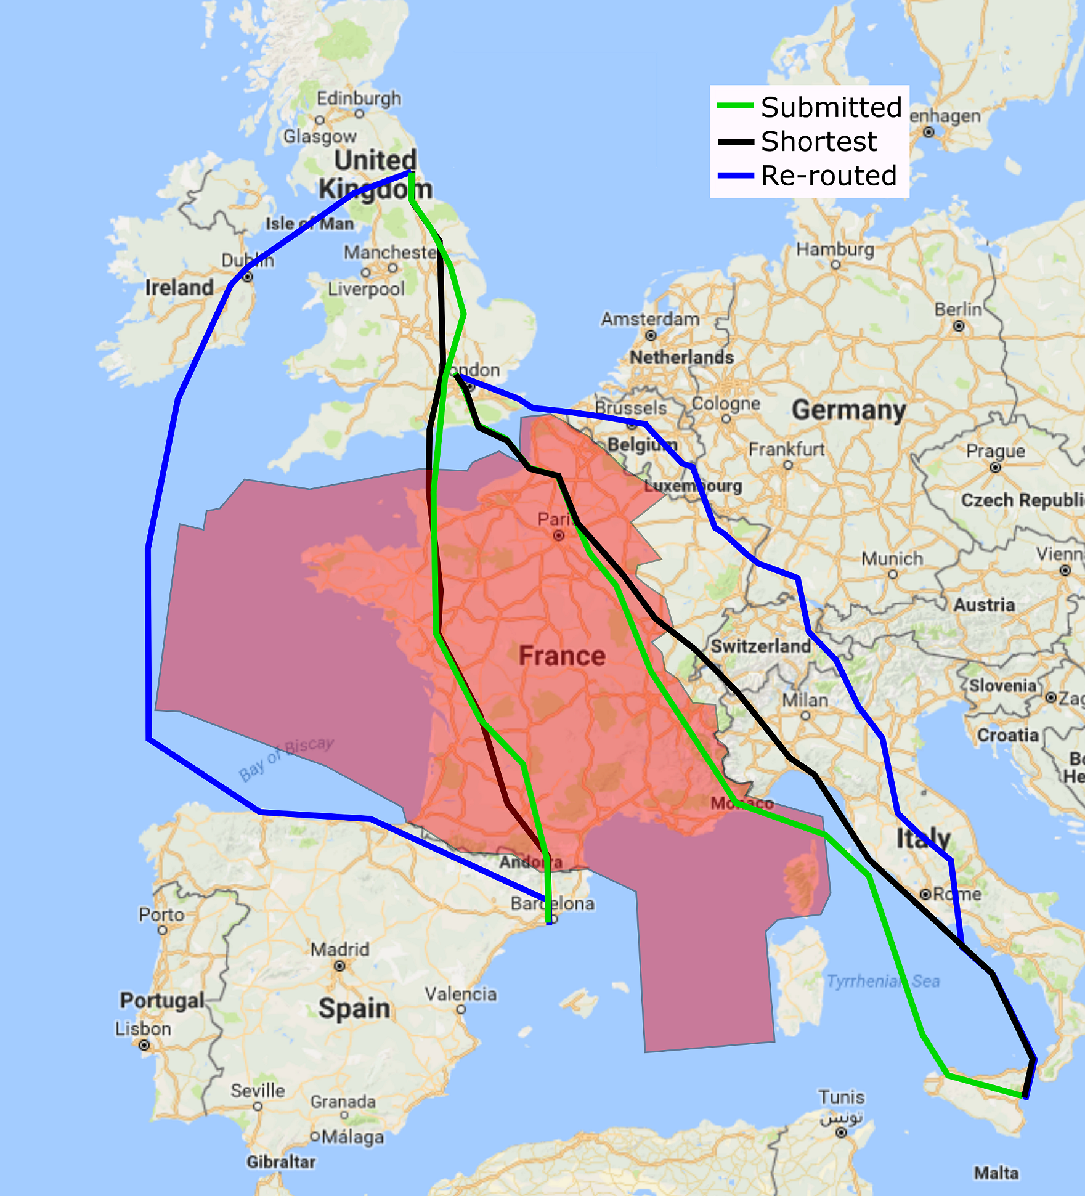

Figure 6. Example of possible re-routings around industrial action

When modelling ATFM regulations due to industrial actions and weather, there is the possibility for the aircraft operator to re-route the flight around the regulated airspace instead of accepting the assigned ATFM delay. A graph of all the possible routes based on the flight plans submitted on the day of study is created. The waypoints used in the flight plans generate the nodes, and the directional edges are added to the graph if a flight plan links two such waypoints. This routes graph consists of over 370 000 nodes and around 600 000 edges. With an A* search algorithm, the shortest route between two points in the graph can be computed. To avoid the regulations, the points that are within the boundaries of the ATFM regulations are withdrawn from the graph before computing the trajectory. Figure 14 presents two examples of possible re-routings around an industrial action. For the possibly re-routed route, the total new flight plan length is estimated and the distance flown within each ANSP region is computed. This allows us to additionally detect ANSPs that might implement ATFM regulations to manage the extra flow derived from re-routings. This is consistent with a posteriori analysis of industrial action days, whereby delays increase at ANSPs surrounding those implementing such regulations.

Disturbances applied

Industrial action

Table 16. Industrial action disturbance – implementation summary
Feature | Parameters
Probability of delay assigned  if enter regulation | 25%
ATFM delay distribution for flights with delay assigned | Burr distribution parameters:  α = 141.474  c = 1.282  k= 4.531
Cancellation and re-routing probabilities | Cancellation probability: 2% - 5%  (including 1.5% background probability)  Re-routing probability: 6% - 8%  (considering extra flight plan distance for re-routing)
Spatial location and extent | Local  One ANSP | Disperse  Five ANSPs
 | Basis date: 24JUN14  ANSP(s): LF  Regulations: 124 | Basis date: 30JAN14  ANSP(s): LF, LZ, LO, LP, LH  Regulations: 137

For each ATFM regulation, there is a given probability of having an ATFM delay assigned, but for industrial actions re-routings and cancellations represent an important factor to be modelled. The possible re-routing routes are computed as explained in Section 4.2.1.3. To model the probability of an airline cancelling its flights, or re-routing, due to industrial actions, different days with industrial actions were analysed. According to CODA, during 2014, operational cancellations remained stable at 1.5%, with peaks of around 8% on days with industrial actions (as shown in Figure 7, those days correspond to AO strikes). Figure 8 presents the average percentage of cancellations for each month in 2014. The peaks observed in April (1.9%) and October (1.8%) are due to strikes at different AOs. In December, there were multiple ATC industrial actions combined with a technical problem at Heathrow, which increased the cancellation rate to 2.4% (ibid.).

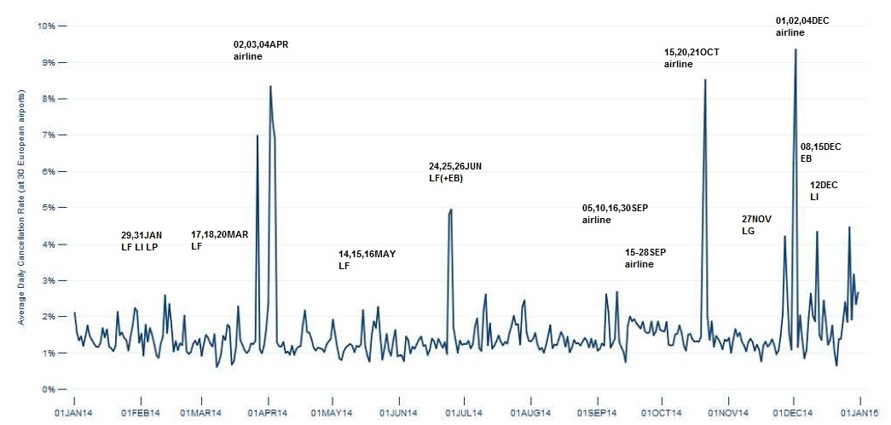

Figure 7. Average daily cancellations 2014
Source: CODA DIGEST, All-Causes Delay and Cancellations to Air Transport in Europe – 2014 (see footnote).

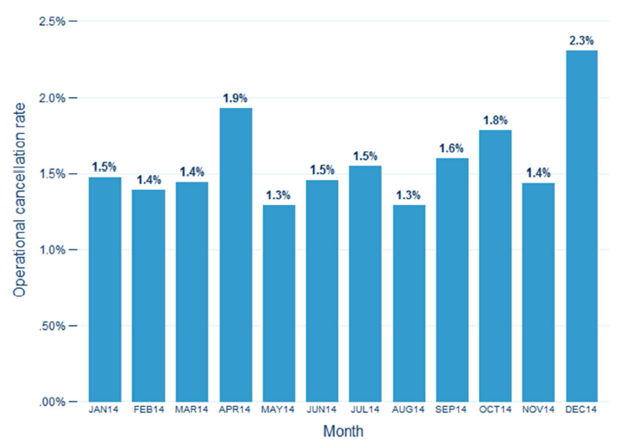

Figure 8. Monthly share of operational cancellations 2014
Source: CODA DIGEST, All-Causes Delay and Cancellations to Air Transport in Europe – 2014 (see footnote).

Figure 7 shows the cancellation rate experienced on a daily basis, industrial actions are marked at some peaks. According to EUROCONTROL, in May 2014, French ATC industrial action generated peaks at 2% of cancellations and the industrial actions of 24-26 June increased the cancellation rate up to 5%. Traffic data on days where industrial actions were implemented (30JAN14, 15MAY14, 24JUN14, 19MAY16, 26MAY16) has been analysed in detail. A comparison between the total number of flights that operated in the ECAC area with respect to the preceding and following weeks, shows that there is a reduction in the total ECAC traffic ranging between 0.4% and 3.9%. Mindful of all of these considerations, a rate of between 2% and 5% of cancellations is considered for flights affected by ANSP industrial actions (note that there is a minimum, baseline level of 1.5% cancellations on a nominal day, for all the flights operating in the ECAC area).

The number of flights that submit a flight plan crossing the regulated airspace on days when industrial actions were active were compared with the traffic expected in the same area for the surrounding weeks, showing that during the regulation there was a reduction of between 7% and 20% of traffic. The percentage of flights that do not use the airspace is higher than the percentage of cancellations, as there are flights that decide to re-route around the regulated areas. The post-operational report by the network manager of regulations implemented on 19MAY16 and 26MAY16 show that there was a reduction of around 8–10% of traffic in the regulated regions (LF). This is consistent with the previous finding. During one of the regulations, the NMOC managed around 2% of the traffic submitting re-route proposals. Considering the reduction of traffic in the areas affected by industrial action, and the level of cancellations, the probability of re-routing is established at between 6% and 8% of the traffic going through such a regulation. This probability can be increased as a function of the extra flight plan distance required to re-route around the regulated region.

For the local scope, the airspace regulations due to industrial actions on basis date 24JUN14 are considered. A total of 124 regulations were implemented in the French airspace. For the disperse modelling day, the regulations of 30JAN14 are modelled, whereby 137 ATFM regulations due to industrial action were implemented in five ANSPs across Europe.

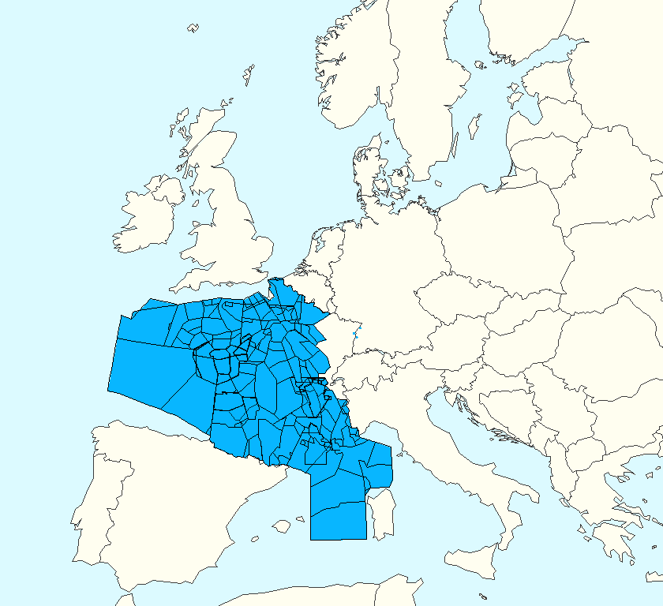  24JUN14 | 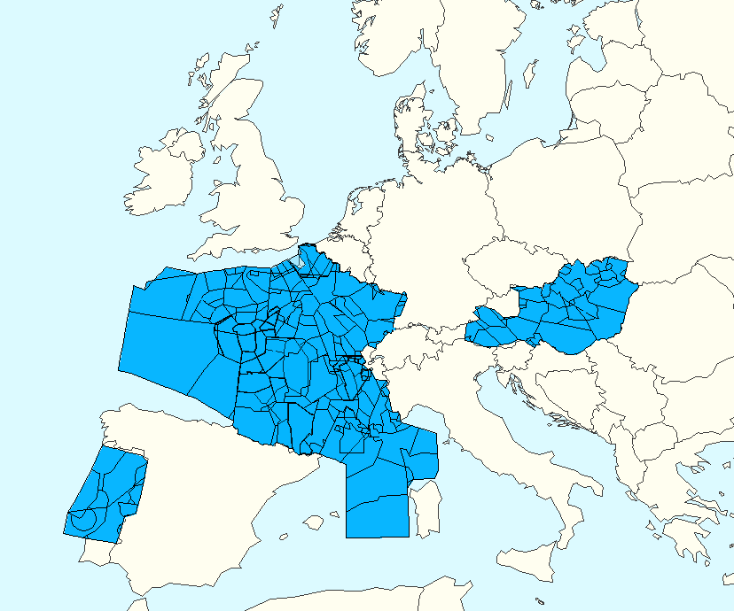  30JAN14

Figure 9. Industrial action regulations for the basis dates

Weather
Table 17. Weather-related disturbances – implementation summary
Feature | Parameters
Probability of delay assigned if enter regulation | Regulations defined at airports: 51%  Regulations defined en route: 32%
ATFM delay distribution for flights with delay assigned | Burr distribution parameters (ATFM airports):  α = 28.809  c = 1.847  k= 1.793  Burr distribution parameters (ATFM en-route):  α = 27.309  c = 1.900  k= 1.847
Delay unrelated to ATFM | Arrival and departure delay modelled at 84 airports grouped into three categories by number of IFR annual movements:  ≤50 000  >50 000  >100 000  Burr distributions: 40 Burr distributions based on airport category  and ATMAP score (between 0 and 6)
Spatial location and extent | Local  Mostly airports affected | Disperse  Mostly en-route affected
 | Basis date: 18OCT14  ATFM regulations  Airports affected  1 airport (1 regulation) in LS  4 airports (6 regulations) in ED  Airspaces affected  1 regulation in EG | Basis date: 25JUL14  ATFM regulations  Airports affected  6 airports (9 regulations) in ED, EG, EP, LP and LS  Airspaces affected  36 regulations in  ED, EDY, EG, EP, LE and LF

For weather-related disturbances there are two types of delay that are considered: ATFM regulations (local and disperse, explicitly modelled – see Table 17) and increased ‘background’ delay due to weather. ATFM regulations are considered at airports and in en-route airspace. These regulations are based on the selected sample days shown (‘basis date’). The basis dates were selected such that airports were predominantly affected for the local disturbances modelled, with mostly en-route airspaces affected for the disperse disturbance day. ATFM regulations of the period AIRAC 1313 to AIRAC 1413 have been analysed. As in the case of industrial actions, for en-route regulations, AOs may opt to re-route.

Delay at airports is often mainly driven by meteorological events. Apart from ATFM delay, weather may also impact system performance (e.g. through lower airport capacities) leading to ‘background’ delay (i.e. delay that is not translated into ATFM delay per se). For this reason, the total delay experienced, for departures and arrivals, at the 84 airports indicated in the table is modelled. To quantify weather effects at airports, the ATMAP weather algorithm provides a weather score by classifying METAR information into five categories (visibility, wind, precipitation, freezing conditions and dangerous phenomena). The delay probabilities used are airport-type and ATMAP-score dependent. The ATMAP score is computed based on the METAR data at the airports, grouped by 30-minute intervals. This allows us to model the evolution of the delay variability as weather evolves during the day and may be deployed to avoid double-counting in our distributions of total delay experienced by flights.

For the local scope case, Figure 10 shows the number of ANSPs that declared regulations on each day with respect to the number of regulations declared on that day due to weather at airports. The number of ANSPs gives us an indication of the spatial distribution of the disturbances (i.e. generally, more ANSPs declaring regulations implies a wider dispersion of the disturbance through Europe on that day). We use the distribution of ATFM regulations to get an approximation of the distribution of weather-related disturbances at airports. After analysing twelve candidate days, it was found that on 18OCT14, there were numerous regulations due to weather at airports in Germany and Switzerland. This thus suggested itself as a good basis date for localised meteorological disturbance that affected the centre of Europe. The other days were either too localised, or too disperse.

For the disperse scope case, the regulations (also AIRAC 1313 to AIRAC 1413) are based on those implemented on 25JUL14, with 45 regulations due to weather (36 in en-route airspace, 9 at airports; across 8 ANSPs). Similarly to the previous figure, Figure 11 shows the day selected is one with a relatively high number of ANSPs affected by weather regulations (the average delay per delayed flight on that day, due to such regulations, was 9 minutes).

Figure 12 shows the locations of the regulations for the local and disperse case basis days. 18OCT14 (left-hand panel) was selected due to the weather at airports in Germany and Switzerland (shown by blue dots), but there was also, as it happens, a regulation in the UK on that day.

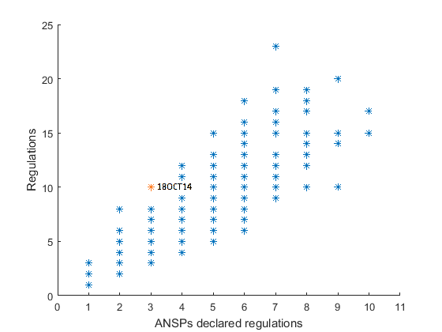

Figure 10. Number of weather regulations and ANSPs – local case selection
Orange marker is local case basis day (18OCT14).

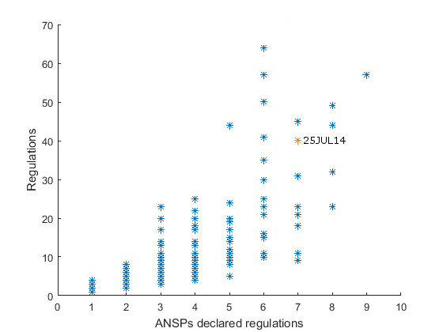

Figure 11. Number of weather regulations and ANSPs – disperse case selection
Orange marker is disperse case basis day (25JUL14).

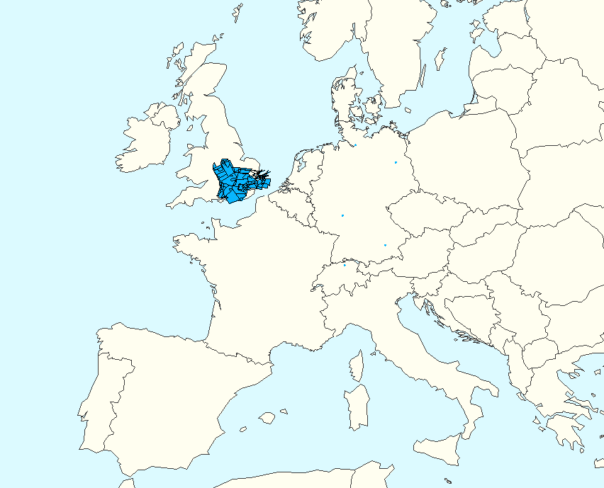  18OCT14 | 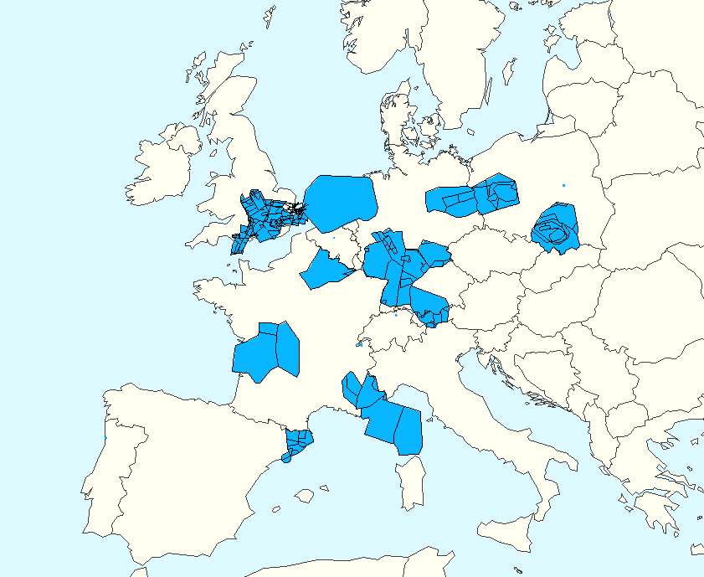  25JUL14

Figure 12. Weather-related regulations for the basis dates

Fuel, passenger itinerary and delay cost models

Fuel consumption model
On the day modelled (12SEP14), 27 237 flights in the DDR2 data are passenger-carrying, commercial flights, and thus fully in scope (with 33 711 flights in total). Fuel consumption is estimated by considering BADA 4 and BADA 3 performance models (81% of flights are modelled with BADA 4, 17.7% with BADA3 and for 1.3% the aircraft type is not in the BADA dataset but has been approximated to BADA 3 aircraft models). These fuel models are individualised per flight. For each flight, the climb and descent phases are analysed from the FTFM DDR2 data, extracting the time and distance, and estimating the fuel based on nominal BADA 4/3 performances. For the cruise, the average flight level used for each flight is computed; for BADA 4 models, the average aircraft weight during the cruise is estimated considering the specific range values at the nominal cruise speed (see Figure 13): this average weight will be considered except for flights where the optimal flight level cannot be reached due to short-distance flights (48% of BADA 4 flights use these estimated weights). For each flight, the average cruise wind is estimated considering that flights are cruising at their nominal cruise air speed according to BADA. The minimum and maximum cruise speed are computed for each flight and it is ensured that the cruise speed is within the aerodynamic domain of the performances. This cruise model allows us to estimate the fuel consumption under nominal conditions, and also to estimate the cruise time and consumption if the cruising speed is modified (e.g. when using DCI). Figure 14 presents, as an example of the model usage, the cruise fuel estimated for all the flights as a function of their flight plan distance. For each aircraft type, the holding fuel is estimated from BADA as the fuel consumption at FL100 with low reference weight.
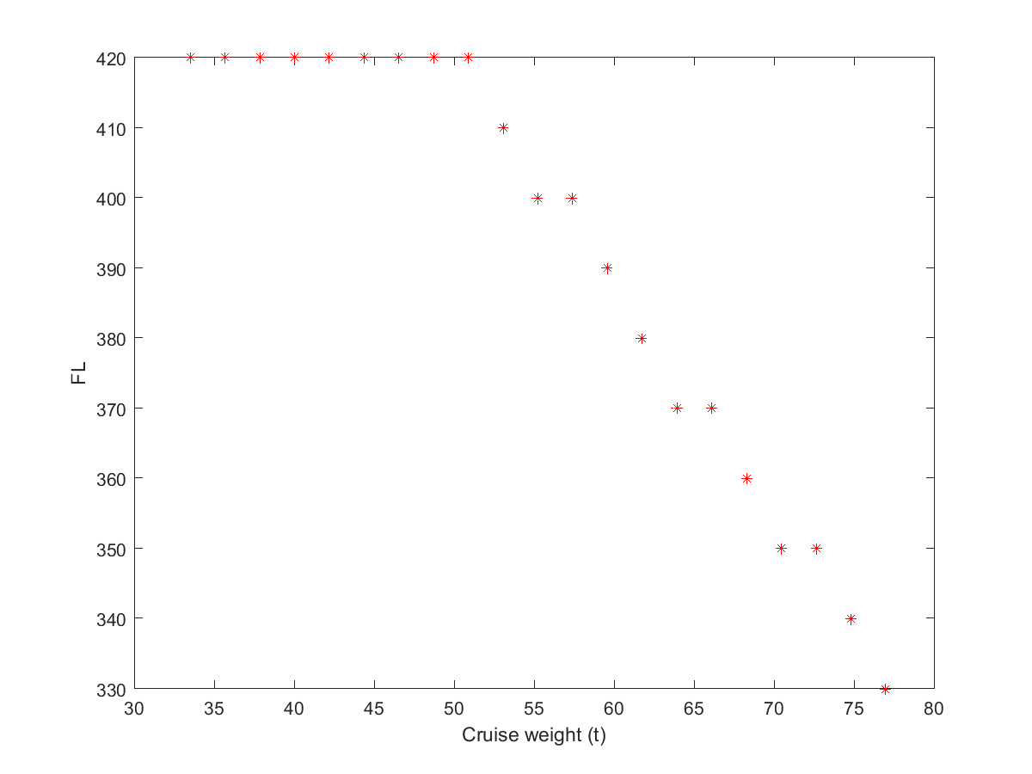
Figure 13. Cruise weight estimation for different FLs (A320)
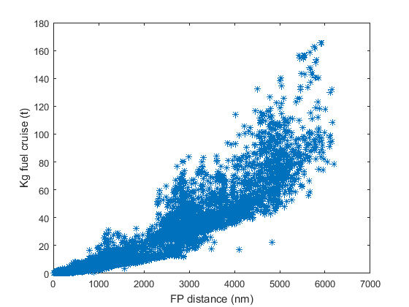

Figure 14. Cruise fuel estimated for flights in model at nominal cruise speed

Passenger itinerary allocations
Flights that submitted flight plans for 12SEP14 to/from 200 ECAC and 50 non-ECAC airports, selected based on the highest ACI EUROPE passenger totals, are considered in ComplexityCosts. Such flights may be disrupted with respect to their published schedules, i.e., delayed, cancelled or diverted. Table 18 shows the treatment of such flights when allocating passengers to them and when modelling them in the system at a tactical level. As shown, flights that were delayed, cancelled or diverted are restored to their original schedule for the passenger allocation process. For the tactical model, for delayed flights, the trajectory of the flight plan is shifted in time restoring them to their original schedule; these flights might then be affected by ATFM delay or disturbances, as explained in Section 4.2. For cancelled and diverted flights, the same cancellation or diversion is maintained in the model (the tactical flight plan either does not exist, or demonstrates the diversion).

Table 18. Treatment of disrupted flights
Disruption to flight | Treatment in allocation of passenger itineraries | Treatment in tactical model
Delayed | Restored to original schedule | Restored to original schedule
Cancelled |  | Cancelled
Diverted |  | Diverted

Individual passenger itineraries are generated from previous modelling for September 2010. This generation of itineraries is an iterative process fed with data from various sources to ensure that they are as representative as possible of 12SEP14. These data sources include passenger total values from ACI EUROPE, GDS sample itineraries to identify passenger connections and fare adjustments, and Eurostat passenger flows. Overall passenger growth during the period was around 13% (according to Eurostat data).
Figure 15 shows the main processes for the generation of the new itineraries. Firstly, the itineraries of 2010 are reallocated to 2014 flights. In this process, the possible flights that could be used by the 2010 passengers are computed. Some of those itineraries might still be possible with 2014 flights (flights still linking the 2010 origin and destinations, and with schedules that allow such connections), while others are no longer feasible, as some routes are no longer served.
88.5% of the 2010 itineraries are potentially possible with 2014 flights; 10.7% are not possible due to certain routes no longer being operated; 0.8% of the itineraries cannot be allocated to 2014 flights as the MCT would not allow the connections at the airports.
The model also introduces new routes, introduced since 2010, that require new itineraries to be generated. For itineraries that can be made with 2014 flights, an assignment is made based on weighted-preference rules designed to maintain airline preference and, for multiple-leg itineraries, to maintain airline alliances / partnership compatibilities. Target load factors per airline type (i.e. full-service, low-cost carrier, charter, regional) are defined based on ACI statistics and other supporting sources. Whilst the first parse is executed without load-factor constraints, the algorithm subsequently removes itineraries that are otherwise viable but generate excessive load factors. These unserved itineraries are reassigned to alternative routings, where possible.
For the generation of all new itineraries, total passenger numbers at the airports (ACI statistics), GDS data, and Eurostat passenger flow data are considered along with the new routes from 2014 (from schedule data). Such itineraries are generated reflecting remaining, unfulfilled demand from 2010, and a fare adjustment process is performed as the final step. Calibration summaries will be produced in the final reporting, to show alignment with the external data sources.
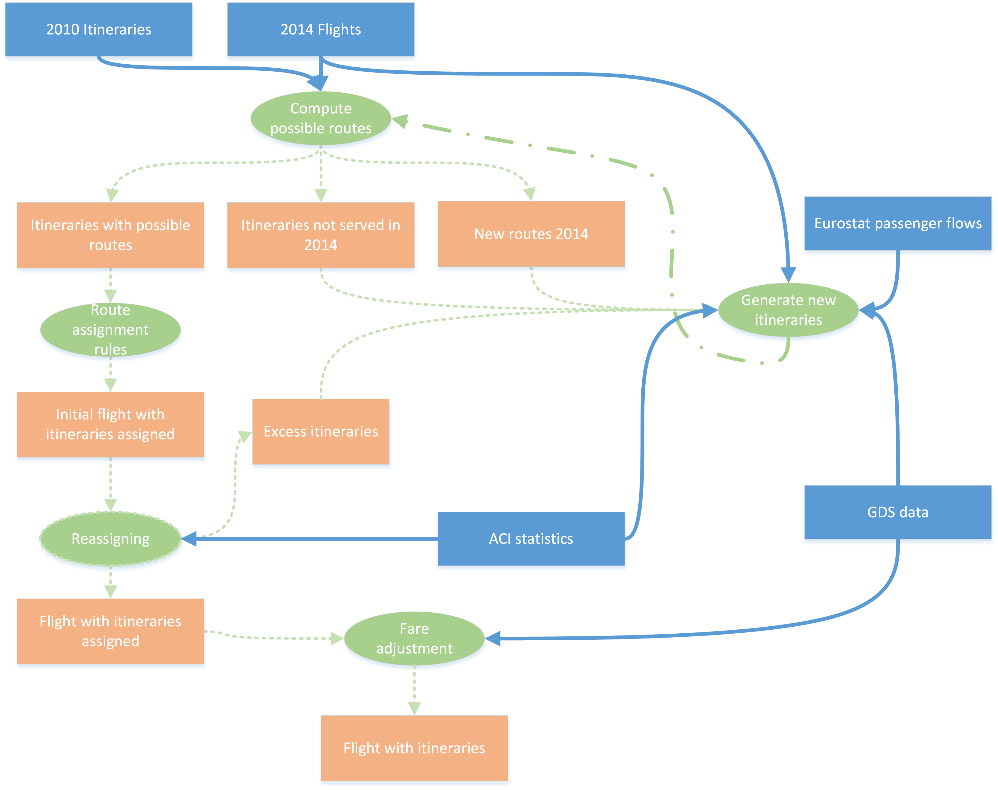

Figure 15. 2014 itineraries generation

Delay cost models
In order to be able to assess the scenarios using the cost-centric metrics of Table 5, it is necessary to model the corresponding tactical costs. These are primarily modelled as costs of delay to the airline, across a range of delay durations, according to ‘low’, ‘base’ and ‘high’ cost scenarios, for the year 2014, by various phases of flight.
The main costs of delay to the airline are comprised of passenger, fuel, maintenance, crew and (strategically) fleet costs. These values replace previous costs of delay published by the University of Westminster for the reference year 2010, extended to fifteen aircraft types, produced partly within the remit of ComplexityCosts, and based on an airline consultation regarding the cost of passenger delay to the AOs.
These costs draw on various sources of evidence, with a particular focus on the impact of Regulation (EC) No 261/2004, which establishes the rules for compensation and assistance to airline passengers in the event of denied boarding, cancellation or delay.

Importantly, Annex 1 of the Regulation sets out a non-exhaustive list of circumstances considered as ‘extraordinary circumstances’ (which are currently being reviewed by the Commission), whereby passenger compensation payments are exempted:
i. natural disasters rendering impossible the safe operation of the flight;

ii. technical problems which are not inherent in the normal operation of the aircraft, such as the identification of a defect during the flight operation concerned and which prevents the normal continuation of the operation; or a hidden manufacturing defect revealed by the manufacturer or a competent authority and which impinges on flight safety;

iii. security risks, acts of sabotage or terrorism rendering impossible the safe operation of the flight;

iv. life-threatening health risks or medical emergencies necessitating the interruption or deviation of the flight concerned;

v. air traffic management restrictions or closure of airspace or an airport;

vi. meteorological conditions incompatible with flight safety; and

vii. labour disputes at the operating air carrier or at essential service providers such as airports and Air Navigation Service Providers.

2. The following circumstances shall not be considered as extraordinary:

i. technical problems inherent in the normal operation of the aircraft, such as a problem identified during the routine maintenance or during the pre-flight check of the aircraft or which arises due to failure to correctly carry out such maintenance or pre-flight check; and

ii. unavailability of flight crew or cabin crew (unless caused by labour disputes).
We note that passenger assistance (e.g. refreshments and hotel accommodation) is due even if the disruption is caused by extraordinary circumstances, since these only exempt operators from paying compensation,. Airlines may decide to make payments outside the requirements and scope of Regulation 261, for customer retention purposes.
This raises specific questions regarding compensation payments, particularly with respect to reactionary delays, as a consequence of extraordinary circumstances. Responses were very kindly provided by Bott & Co Solicitors (Wilmslow, UK) who specialise in airline compensation claims and Regulation 261:
Q: When may airlines claim that weather is an 'extraordinary circumstance'? How is reactionary delay treated?
A: It is generally accepted by the courts that not all bad weather is extraordinary. The burden is still on the air carrier to prove that the conditions were ‘freakish’ or ‘wholly exceptional’ (e.g. snow in the Middle East). It is also generally accepted that any bad weather on a previous flight is not an extraordinary circumstance. The courts adopt a strict interpretation that the meteorological condition has to actually affect the flight concerned, and reactionary delays (even for the same aircraft) would not be exempted.
-------------
Q: Consider, for example, a strike in France. If an aircraft was due to fly LHR-MAD-FRA-LHR, but the first leg was severely delayed (or cancelled) due to the strike, could the airline apportion disruption on the MAD-FRA and FRA-LHR legs to the French strike also, as an indirect effect, thus avoiding paying compensation?

A: This may indeed be used as a defence. The courts take the view that reactionary effects are still extraordinary – the only exception to this is where it concerns bad weather.
Although the weather modelled in ComplexityCosts is not ‘freakish’ or ‘wholly exceptional’ (which would thus entitle the passenger to compensation, e.g. due to aircraft unavailability) these effects are modelled as consequent ATFM delay and will thus be assigned as not entitling the passenger to compensation. This renders consistency and comparability across all the disturbance types (ATFM baseline, weather-related (ATFM) and industrial action), thus avoiding the situation whereby one type is associated with compensation payments and another is not.

Implementation and simulations

Implementation methodology

The ComplexityCosts model is implemented using an agile software methodology called ‘Scrum’. Scrum is an incrementally iterative software development process, although it can be applied to model design in general. Instead of defining a final list of requirements and functionalities, the software is built iteratively, focusing on having short development cycles and sequentially increasing functionalities, as needed. Each development cycle needs to be verified and validated, so it is necessary not only to define the next cycle functionalities but also to define a collection of input/output tests for each component, as well as a collection of test (/use) cases for the integrated software. Table 19 shows the four phases required to perform the final simulations.

Table 19. Scenario and modelling phases
 | No disturbance | Disturbance type
Mechanism | Baseline | Industrial action |  | Weather
 |  | Local | Disperse | Local | Disperse
0. No mechanism, baseline | P0 | P1 | P1 | P1 | P1
1. Improving sector capacity with ATCO hours | P2 | P4 | P4 | P4 | P4
2. DCI | P2 | P4 | P4 | P4 | P4
3. A-CDM | P2 | P3 | P3 | P3 | P3
4. Improved pax reaccommodation | P2 | P3 | P3 | P3 | P3

In Scrum, each phase is completed when the outputs are mature and appropriately validated. Table 20 shows the different Scrum phases for ComplexityCosts.

Table 20. Phases description and dependencies
Phase | Description | Feeds | Effort (appx.)
P0 | Validation of all input except those related to mechanisms and disturbances | P1 – P4 | 40%
P1 | Validation of disturbances (local & disperse) with no mechanisms in place | P3 and P4 | 20%
P2 | Validation of mechanisms and costs, with no disturbances | P3 and P4 | 20%
P3 | Final results, set one | N/A | 10%
P4 | Final results, set two | N/A | 10%

Each cycle has a typical duration of one week. In each cycle, the simulation platform is refined and expanded with new functionalities. More importantly, each cycle also defines a series of tests to be run on the new elements individually. These tests are run on simplified cases; a collection of input/outputs sufficient enough to be confident regarding the correct implementation of the model. The new model, once the new elements are integrated, is tested using a series of test cases. A test case is a reduced and controlled input artificially created using a collection of sample outputs (not necessarily final outputs), used for debugging and verification purposes.

The Scrum iterative process repeats itself in each phase until the elements are mature. The Scrum methodology requires a validation of the functional specifications at the beginning of each development cycle, so that validation of the functional requirements will be addressed iteratively. An absolute zero bug state in software programming is a delusion, as errors will always appear and unexpected behaviour is always possible. However, it is the task of verification to ensure that the number of errors is reduced to a minimum and that unexpected behaviours have the least possible impact on the overall performance.

Software management, deployment and execution

A key element of the Scrum methodology is version control. A version control records changes in given software, and more sophisticated tools allow change requests, comments, validation of new changes, and even the creation of new software branches that develop independently. The ComplexityCosts model is implemented using GitHub, a fully featured version control repository, which stores all data source files online (but in a private repository) and therefore it can be accessed by multiple collaborators so changes in code can be easily tracked, reviewed and commented.

Testing and development is carried out locally, using in-house computing infrastructures. However, for the final cycles of the development process, the platform will be migrated to a cloud-based environment in which multiple scenarios can be executed simultaneously using parallel computing, reducing drastically the total time required to execute the simulations when compared to non-parallel execution.

Table 21. Scenario execution phases
 | No disturbance | Disturbance type
Mechanism | Baseline | Industrial action |  | Weather
 |  | Local | Disperse | Local | Disperse
0. No mechanism, baseline | E0 | E1 | E1 | E1 | E1
1. Improving sector capacity with ATCO hours | E1 | E2 | E2 | E2 | E2
2. DCI | E1 | E2 | E2 | E2 | E2
3. A-CDM | E1 | E2 | E2 | E2 | E2
4. Improved pax reaccommodation | E1 | E2 | E2 | E2 | E2

The execution of the scenarios will be as per Table 21. The first execution (E0) is made as soon as phase P0 is completed, as it serves as a reference for validating other scenarios. The second execution set is performed over the baseline for both mechanisms and disturbances. By comparing E0 with the expected outputs of E1 the model can be considered validated and the final simulations can start. Note that the eight simulations corresponding to E1 will be carried out in parallel, as the model will be already deployed in the cloud. The last set of simulations (E2) will also be run in parallel, but since some scenarios could take longer than others, it will be prioritised so that the analysis can start while still in the execution phase.

Table 22. Execution phases overview
Execution phase | Deployment | Simultaneously performed | Comments
E0 | Locally | Single execution,  non-parallel processing | Serves as base to validate E1
E1 | Cloud | Two groups in parallel  (disturbances and mechanisms) | Contrasting E0 and E1 leads to full validation
E2 | Cloud | All scenarios run in parallel | Prioritised according to modelling and reporting requirements

Next steps and look ahead

The next steps comprise the completion of the modelling work and analysis of the results, for final reporting in Deliverable D4.5 (Final Technical Report), due in August 2016.
This report will be prepared in parallel with a SIDs paper, which has a submission deadline of 12SEP16.

Note
It is possible that further updated data on A-CDM costs and impacts of recent French industrial actions may be acquired in time for incorporation into the model, although these are not critical, as other data are already available in both cases.

Table 23. Average number of controllers used, maximum and difference per airspace and ANSP

ANSP | USE | MAX | DIFF | ANSP | USE | MAX | DIFF | ANSP | USE | MAX | DIFF
EB | 7.5 | 12.0 | 4.5 | EV | 6.6 | 8.0 | 1.4 | LJ | 4.3 | 10.0 | 5.7
ED | 6.3 | 11.8 | 5.5 | EY | 4.7 | 6.0 | 1.3 | LK | 6.7 | 12.0 | 5.3
EDY | 5.7 | 12.7 | 7.0 | GC | 9.8 | 16.0 | 6.2 | LM | 2.0 | 4.0 | 2.0
EE | 2.6 | 4.0 | 1.4 | LA | 4.8 | 8.0 | 3.2 | LO | 12.0 | 24.0 | 12.0
EF | 5.6 | 10.0 | 4.4 | LB | 3.2 | 9.0 | 5.8 | LP | 13.5 | 20.0 | 6.5
EG | 7.3 | 10.0 | 2.7 | LC | 5.5 | 10.0 | 4.5 | LQ | 2.0 | 4.0 | 2.0
EH | 8.8 | 12.0 | 3.2 | LD | 7.1 | 19.0 | 11.9 | LS | 4.6 | 9.0 | 4.4
EI | 7.7 | 12.0 | 4.3 | LE | 9.9 | 15.9 | 6.0 | LT | 8.5 | 10.5 | 2.0
EK | 9.4 | 12.0 | 2.6 | LF | 10.8 | 20.4 | 9.6 | LW | 2.7 | 6.0 | 3.3
EN | 6.2 | 10.1 | 3.8 | LG | 6.0 | 14.0 | 8.0 | LY | 6.5 | 17.5 | 11.0
EP | 10.3 | 18.0 | 7.7 | LH | 5.5 | 9.4 | 3.9 | LZ | 4.6 | 10.0 | 5.4
ES | 3.6 | 6.0 | 2.4 | LI | 7.2 | 14.3 | 7.1 | UK | 6.0 | 8.5 | 2.6
KEY
USE: average number of controllers used in airspace, according to airspace configuration opening schemes.
MAX: maximum number of controllers, on average, available per airspace
DIFF: difference in (maximum) number of controllers available (in principle) and number used

Source: Internal analysis of DDR data for AIRAC 1313 to1413.
-END OF DOCUMENT-

‘Early adopter’ and ‘follower’, i.e. excluding the baseline. See Section 4.
L. Delgado, A. Cook, S. Cristóbal and H. Plets, 2015. Controller time and delay costs - a trade-off analysis. Schaefer, D. (Ed.) Proceedings of the fifth SESAR Innovation Days, Bologna.
A. Cook, L. Delgado, G. Tanner, S. Cristobal. Measuring the cost of resilience, Journal of Air Transport Management, 2016 (in print).
‘O’ is used since the growth rate of a function is typically referred to as its ‘order’.
A disturbance is defined as an event that may potentially cause (or aggravate) a disruption. A disruption is an event where normal operations are significantly degraded.
EUROCONTROL, ATM Cost-Effectiveness (ACE) 2014 Benchmarking Report with 2015-2019 outlook, prepared by the Performance Review Unit (PRU) with the ACE Working Group, 2016.
SESAR, E.02.14 – DCI-4HD2D – D3.2 Final technical report, 2016.
EUROCONTROL: 2008 (Airport CDM Cost Benefit Analysis. Ed. 1.4) & 2016 (A-CDM Impact Assessment, Final Report).
http://www.eurocontrol.int/articles/cdm-airports (accessed July 2016).
An algorithm widely used in pathfinding between multiple nodes.
E.g.: Monthly Network Operations Report Analysis – May 2016. EUROCONTROL, 2016.
CODA DIGEST, All-Causes Delay and Cancellations to Air Transport in Europe – 2014 - Edition CDA_2014_005. EUROCONTROL, 2015.
CODA DIGEST, All-Causes Delay and Cancellations to Air Transport in Europe – Quarter 4, 2014. EUROCONTROL, 2015.
Monthly Network Operations Report Analysis – May 2016. EUROCONTROL, 2016.
Technical Note: Algorithm to describe weather conditions at European airports. ATMAP weather algorithm, (Version 2.3). EUROCONTROL, 2011.
According to the derived weather score, weather conditions are defined as significant if the score is higher than 1.5 (default European score for bad weather).
Cook, A., Tanner, G. European airline delay cost reference values, updated and extended values, Version 4.1. 24 December 2015. https://www.eurocontrol.int/publications/european-airline-delay-cost-reference-values
University of Westminster. The cost of passenger delay to airlines in Europe, consultation document. 17 August 2015.
European Commission, 2004. Regulation (EC) No 261/2004 of the European Parliament and of the Council of 11 February 2004 establishing common rules on compensation and assistance to passengers in the event of denied boarding and of cancellation or long delay of flights, and repealing Regulation (EEC) No 295/91, 17 February 2004, 1-7.
Rouissi, N., Correia, V. Airline passenger protection regulations: does the patchwork work? A legal perspective. 18th Air Transport Research Society (ATRS) World Conference, Bordeaux, 2014.
European Commission, Commission staff working document – impact assessment, Brussels, 13 March 2013.

