The changes of intergovernmental collaboration dynamic in post-disaster destination management: Network analysis

Abstract
Employing network analysis, this study explores the changing dynamics of intergovernmental collaboration throughout the whole process of post-disaster destination management. Jiuzhaigou National Park after the Jiuzhaigou earthquake forms the subject of the case study. Our empirical analysis indicates the following findings: first, intergovernmental collaboration is developed both hierarchically and horizontally at the emergency, intermediate and long-term recovery stages of post-disaster destination management, but it is largely dominated by hierarchical interactions; second, local government increasingly acts as a lubricant role in facilitating the functioning of intergovernmental collaboration during the whole process of post-disaster destination management. These findings contribute to greater insights into the changes of intergovernmental collaboration dynamic in comprehensive post-disaster destination management. This study also provides implications for governments and tourism destinations to improve intergovernmental collaboration for more effective destination management in the context of post-disaster.
Keywords
Intergovernmental collaboration; Post-disaster; Destination management; Network analysis; Jiuzhaigou National Park

1 Introduction
Destination management has been widely discussed in tourism research (Beritelli et al., 2007; Gelter et al., 2020; Granville et al., 2016). In light of the rapid increase in the number of disasters that have occurred over the past 30 years (Schulz & Blecken, 2010), it is particularly significant to achieve post-disaster destination management effectively. Destination management is defined as a “proactive, visitor-centred approach to the economic and cultural development of a destination” (Wang, 2011:2). Destination management in the post-disaster context focuses much on developing strategies and actions to return the destination to a normal (pre-event) state or an improved state (Mair et al., 2016), which often incorporates a range of stakeholders to collaborate in response to post-disaster challenges (Jiang & Ritchie, 2017). Among those stakeholder collaboration, intergovernmental collaboration has recently received growing attention in post-disaster destination management, as it offers a way of mobilising substantial resources that are needed for post-disaster destination management (Amore & Hall, 2016). Intergovernmental collaboration occurs between the national, state and local governments to achieve common goals (Cameron, 2001; Kapucu et al., 2010). On the basis of their respective advantages, multi-level government sectors can collaborate with one other to engage in post-disaster destination management, including from saving lives and protecting properties, to addressing short-term needs of victims, and to developing and implementing post-disaster destination recovery projects (Becken & Hughey, 2013; Faulkner & Vikulov, 2001). As intergovernmental collaboration plays an important role in promoting post-disaster recovery, destination management can increase the extent of intergovernmental collaboration to respond to post-disaster challenges.
Past research has further explored post-disaster destination management from the lifecycle perspective (Chan et al., 2019) and linked it to the varying focus of intergovernmental collaboration. Faulkner (2001) suggests a six-phase disaster process of destination management, and post-disaster phase focuses primarily on emergency, intermediate and long-term recovery. Ritchie (2004: 672) gives anatomy of the three sages: emergency (the crisis has just hit and the effects of the disaster have been felt); intermediate (the short-term needs of the people must be dealt with--restoring utilities and essential services); and long-term recovery (continuation of the previous phase, but aspects that could not be addressed quickly are attended to at this point). The focus of intergovernmental collaboration at the three post disaster stages is often different according to the changing of time pressure, control intensity and post-disaster management goals (Cioccio & Michael, 2007; Maldonado et al., 2009; Paraskevas & Arendell, 2007): at the emergency stage, the main aim of intergovernmental collaboration is to rescue people and property (Kusumasari et al., 2010); at the intermediate stage, collaborative government efforts address restoring tourism-related services and help affected communities rebound to normal (He & Zhuang, 2016); at the long-term recovery stage, intergovernmental collaboration seeks to rebuild tourism-related infrastructure and stimulate destination marketing (Faulkner & Vikulov, 2001; Ritchie, 2004). The varying focus of intergovernmental collaboration at the emergency, intermediate and long-term recovery stages may lead to different ways in which multi-level government sectors interplay, configure and collaborate (Amore & Hall, 2016). Nevertheless, prior research has given little attention to the changing dynamics of intergovernmental collaboration throughout the whole process of post-disaster destination management. The engagement of government sectors and the interplay they have at different stages could affect the foci, directions, and the effectiveness of collaboration, which thus plays a significant role in undermining or facilitating the success of post-disaster destination management (Deen, 2015; Espia & Fernandez, 2015).
Methodologically, most post-disaster destination management studies have adopted a qualitative approach to describe intergovernmental collaboration (Cioccio & Michael, 2007; Hystad & Keller, 2008). A few studies have employed extensive case-study methodologies to conduct a detailed analysis of government roles and interventions in post-disaster contexts (Amore & Hall, 2016; Calgaro, 2010). The existing research on post-disaster destination management, rooted in qualitative methods, provides a descriptive analysis of interactions between multiple government sectors. However, several important aspects of intergovernmental collaboration remain unclear, including which government departments are interconnected, how they are interconnected, and what kind of relationship they maintain. Such facets can reveal the functioning of intergovernmental collaboration in promoting post-disaster destination management (Kapucu & Demiroz, 2011). Network analysis is one of the major methods to systematically assess intergovernmental collaboration in other disciplines (Caruson & Macmanus, 2012; Jung & Song, 2014). Network analysis can provide more methodological insights into the interface of which government sectors form a collaborative structure, and collaborative interactions among those government sectors in post-disaster destination management. Therefore, this study, drawing on the case of Jiuzhiagou National Park, uses network analysis to explore the changing dynamics of intergovernmental collaboration at the emergency, intermediate and long-term recovery stages of post-disaster destination management.
Jiuzhaigou National Park is one of the most famous national parks in China. It is managed by the local government, but higher level of governments are also involved in its tourism destination management mainly in the form of supervision. The 2017 Jiuzhaigou earthquake seriously destroyed local natural landscape, which led to the collapse of local tourism industry. It was subsequently announced that Jiuzhaigou National Park would have to close for post-disaster recovery. Government sectors at national, provincial, and local levels collaborated to reconstructed natural landscape and tourism-related facilities, and restored local tourism industry. The successful post-disaster destination management, dominated by intergovernmental collaboration, enables Jiuzhaigou National Park to recover swiftly and reopen to the public after two years that the earthquake occurred. Since Jiuzhaigou National Park has developed an intergovernmental collaboration framework in post-disaster destination management, this case can provide more insights for other tourism destinations.
The contributions of this study are two-fold. In theory, to the best of our knowledge, quantitative research on intergovernmental collaboration is scarce in post-disaster destination management (Amore & Hall, 2016; Calgaro, 2010; Cioccio & Michael, 2007; Hystad & Keller, 2008). This research could be the first detailed analysis to systematically explore the structure of intergovernmental collaboration in post-disaster destination management. Based on this, the study, building on the complexity of destination management in the post-disaster context, can contribute to greater understanding of the changing dynamics of intergovernmental collaboration that occur throughout the whole process of post-disaster tourism destination. In practice, attention to the changes of intergovernmental collaboration dynamic can help multi-level governments and tourism destinations to improve collaborative strategies at different stages of post-disaster destination management.
2 Literature review
2.1 Post-disaster destination management and intergovernmental collaboration
With a growing interest in minimising negative disaster impacts on tourist destinations, scholars have given critical standpoints concerning destination management in the post-disaster context (Gurtner, 2016; Seraphin, 2019). Post-disaster destination management consists of overcoming adverse effects of a disaster, as well as keeping destinations competitive and attractive as before (Amujo & Otubanjo, 2012; Lee & Hyun, 2016). That is, successful post-disaster destination management should involve swift emergency rescue, well-organised intermediate strategies, and implementing long-term recovery projects (Faulkner, 2001). As such, post-disaster destination management often requires a substantial input of resources, capital and technology. Many studies increasingly highlight the necessity of considering government support as an effective strategy for post-disaster destination management (Kato, 2018; Seraphin et al., 2020).
Previous studies have paid considerable attention to the significant role of multi-level government sectors in post-disaster destination management (Beaumont & Dredge, 2010; Dredge, 2006; Pavlovich, 2001). Many scholars have shown how national and provincial governments often provide disaster response assistance through emergency management training, providing information about potential post-disaster events, and giving local governments funding to facilitate long-term recovery, such as compensation loans and tax exemptions (Zurita et al., 2015). Higher level governments are not only responsible for providing extensive resources to help local governments restore affected areas, but also take steps to work out the next stage of post-disaster recovery (Ghaderi et al., 2015). Local governments are geographically situated at the lowest level and closest to affected communities (Baker & Refsgaard, 2007). Responsibilities of local governments concerning post-disaster destination management can be divided into three categories: 1) taking the initiative in protecting their citizens and tourists (Col, 2007); 2) mobilising local initiatives to engage in the decision-making process; and 3) ensuring greater administrative discretion and flexibility to implement post-disaster planning (Cretney, 2016). Different types of government sectors with distinct roles and functions and their participation underline the significance of these bodies in implementing post-disaster destination management.
Due to the complexity of post-disaster destination management, the engagement of government sectors, often taking the form of intergovernmental collaboration, can bridge the capacities of multi-level government sectors for management (Ladkin et al., 2008). Many studies in other disciplines, such as political science, have explored the establishment and development of intergovernmental collaboration. There are two main types of intergovernmental collaboration: hierarchical collaboration and horizontal collaboration (Hovil & Stokke, 2007; Pierre & Peters, 2000). Hierarchical collaboration emphasises that multi-level government sectors collaborate to achieve common goals in the centralised way (Moore, 2009). Horizontal collaboration is characterised by local autonomy, devolved power and decentralised problem-solving (Caruson & MacManus, 2012). The two types can be summarised as top-down or bottom-up collaboration (Kapucu & Garayev, 2014). Based on that, scholars have subsequently re-contextualised the two modes discussed above. Instead of separating hierarchical collaboration from horizontal collaboration, Scharpf (1994: 40) focuses on their interdependencies, as hierarchical power can be realised by local political practices and negotiations, and hierarchical structures can also enhance coordination capacity of local political networks. He emphasises the need for interdependence between hierarchical intervention and local political practices. This interdependence can be understood as “the tangled hierarchies or shadow of hierarchical authority” (Amore & Hall, 2016: 116). The combination of hierarchical intervention with horizontal coordination not only includes the hierarchical administrative mode, but adds the engagement of government sectors at the same level (Jessop, 2011).
Different types of intergovernmental collaboration reflect different modes of interaction that can be shaped by political-administrative contexts (Hall, 1999, 2009; Pierre & Peters, 2005). In many western countries, hierarchical collaboration, horizontal collaboration and the combination of the two are widely welcomed in post-disaster tourism destination management (Amore & Hall, 2016). Unlike many Western countries, the centralised Chinese administrative system has been particularly significant in dominating post-disaster destination management (Yang et al., 2011). This essentially means that the central government has the ultimate decision-making power: that is, the central government has absolute authority, while the local government is subordinate to the superior and the central government (Zhong & Lu, 2018). Although local governments start to strengthen horizontal collaboration with other government at the same level, central and local governments in the Chinese centralised political-administrative structure still follow the traditional hierarchical collaboration mode (Shi, 2012).
The above discussion of intergovernmental collaboration has consistently emphasised how different level government sectors interconnect to form collaborative structure, and further reflected different modes of interaction within a specific context. Intergovernmental collaboration can provide a means to address organisational and operational issues that emerge from post-disaster destination management (Amore & Hall, 2016). Post-disaster policy announcements, decisions, and measures for destination management are drawn up and implemented through a wide range of intergovernmental interactions (Ritchie, 2004). This collaborative process involves the sharing of resources between multi-level government sectors in order to address the post-disaster destination management challenges that a single government sector cannot resolve alone. However, little effort has been made to conceptualise the structure of intergovernmental collaboration. It remains unclear how collaboration among government sectors operates across functional, hierarchical and geographical boundaries in post-disaster destination management.
2.2 Network analysis as an approach to understand intergovernmental collaboration in post-disaster destination management
Behind intergovernmental collaboration lie extensive interactions between multi-level government sectors. As the prevailing discussion on intergovernmental collaboration, collaborative activities are likely to interconnect different level government sectors to form the structure. Network analysis is an innovative approach to reveal intergovernmental collaboration (Caruson & Macmanus, 2012; Jung & Song, 2014; Mandell & Keast, 2007). A range of network analysis indicators, including network density, centrality, clique, structural hole, etc., can be used to examine the degree of government sectors engagement, the collaborative links that they form, and their interactions within the structure of intergovernmental collaboration (Burgos & Mertens, 2017). While network analysis approach has been increasingly used to explore tourism destination management, rarely has it been applied to understand intergovernmental collaboration in post-disaster destination management. The foci of network analysis is generally the engagement of actors and their interactions between actors (Mandell & Keast, 2007). Yet related issues of both network foci have been performed to explore intergovernmental collaboration in post-disaster destination management.
With regard to the first foci of network analysis, intergovernmental collaboration often involves multiple government sectors with distinct roles and functions throughout the whole process of post-disaster destination management (Liu-Lastres et al., 2020). Destination management often requires the engagement of higher level of government sectors, which provides substantial budgetary and necessary resources to help local government respond to disasters (Brooks et al., 2013). Examples of the engagement of local governments in the post-disaster destination are common, such as the case of Tahoku-Oki earthquake (Iuchi et al., 2013), or local government contracting policies and practices to help tourism businesses recover in the Palm Beach of Florida (Atkinson & Sapat, 2013). The second foci relates to interactions existing between different government sectors in post-disaster destination management. Existing literature on this theme mainly emphasises hierarchical collaboration between multi-level government sectors for post-disaster destination management. Horizontal interaction also exists within the collaboration, when local governments seek to collaborate with inter-local government sectors for implementing post-disaster projects easily (Kusumasari et al., 2012). Relying on higher level governments and hierarchical interaction that they generate can provide significant formal support for post-disaster destination management. This support cannot be obtained through horizontal collaboration (Bankoff, 2003). But when national or provincial governments exert their power over local governments at the expense of local interests, this can lead to increased fragmentation of the whole intergovernmental collaboration. Horizontal interaction has become increasingly prominent to mobilise local resources and knowledge in response to disasters (Kapucu et al., 2010). However, substantial post-disaster destination management requires a high level of resource input. Resources embedded into horizontal networks are often limited (Kapucu & Garayev, 2014).
As discussed above, the existing studies on post-disaster destination management of intergovernmental collaboration briefly introduce the two foci of network analysis. However, past literature seems to ignore several important factors of collaboration, including the positioning, forwarding and receiving modes of government sectors, and the extent to which a government sector exercises power over other sectors in the collaborative structure. Attention to such elements can reveal how government sectors collaborate with others to function the whole collaborative system for post-disaster destination management (Maldonado et al., 2009). Therefore, employing networks analysis, the study explores the engagement of government sectors and their interactions within the collaborative structure throughout the whole process of post-disaster destination management. Based on the foregoing, the changing dynamics of intergovernmental collaboration in post-disaster destination management are discussed in depth.
3 Methodology
3.1 Case study
Jiuzhaigou National Park, one of the most popular national parks in China, is chosen as the case for this study. It is located in Aba Tibetan and Qiang Autonomous Prefecture of Sichuan Province (See Fig. 1). Jiuzhaigou National Park was declared as a United Nations Educational, Scientific and Cultural Organisation (UNESCO) world heritage site in 1992. Jiuzhaigou National Park received approximately 5,000,000 visitors in 2016. It contributed about 30% of the total tourism income of Aba Prefecture.
On the evening of 8th August of 2017, an earthquake with a magnitude of seven degrees hit Jiuzhaigou. It was reported that that 25 people died, 525 people were injured, and 73,671 houses were damaged. In addition to the loss of life, natural environment, tourism-related infrastructure and asset supporting tourism industry within Jiuzhaigou National Park were destroyed. The tourist complex in Jiuzhaigou National Park, including natural beauty areas (waterfalls and lakes), hotels and inns, restaurants, shops and transport, was partially destroyed. Direct economic loss caused by the earthquake amounted to about 8 billion yuan, equivalent to one-third of Jiuzhaigou County’s GDP county in 2017. After the earthquake, it was announced that Jiuzhaigou National Park would shut down for three years for post-disaster recovery. National, provincial and municipal government sectors collaborated with the administration bureau of Jiuzhaigou for post-disaster destination management.
The post-disaster destination management of Jiuzhaigou National Park basically follows the lifecycle of post-disaster destination management (Calgaro, 2010; Faulkner & Vikulov, 2001; Miller & Ritchie, 2003; Ritchie, 2004). The emergency stage lasted from 8th August to 14th August, 2017, as rescue and damage limitation was the main objective at this stage and rescue activities fundamentally completed within seven days (Shaw, 2006). During this period, the administration bureau of Jiuzhaigou National Park, with the help of Jiuzhaigou county government and Aba Autonomous Prefecture government, took swift actions to rescue local residents, tourists and properties. Tens of thousands of police officers, fire-fighters, and emergency operations officials were recruited to participate in this rescue effort. Certain basic needs, such as water, food and shelter, were provided during the emergency phase.
The intermediate stage took place from 15th August to 7th November, 2017. At this stage, post-disaster destination management tasks carried out by the administration bureau mainly entailed restoring affected communities to normal as quickly as possible. Working in conjunction with other government sectors at different levels, the administration bureau took extensive intermediate actions to fulfil short-term needs of victims, and restore utilities and essential services. Beyond that, destination management efforts also related to prepare for long-term management (Faulkner & Vikulov, 2001; Ritchie, 2004). The Sichuan provincial government began networking with other government sectors at municipal and district levels to draw up the General Plan for the whole post-disaster recovery process.
The announcement of the General Planning for Post-disaster Reconstruction of Jiuzhaigou on 8th November, 2017 signalled the end of the intermediate stage and the beginning of the long-term recovery stage. At this point, the main focus of the post-disaster destination management switched to implement the General Plan for long-term recovery and rehabilitation (Miller & Ritchie, 2003). The General Planning for Post-disaster Reconstruction of Jiuzhaigou consisted of five anchor projects: 1) the restoration and protection of the ecological environment project; 2) the prevention and control of geological disasters project; 3) the restoration and improvement of the tourism destination and industry; 4) the reconstruction of public services; 5) the restoration and reconstruction of urban and rural housing. The General Planning for Post-disaster Reconstruction played a significant role in determining the scale and the development direction of post-disaster reconstruction, and achieving the economic and social development goals of the disaster-stricken areas. The five anchor projects provided a basis for planning, and design for the next level of construction projects. These projects need to complete to a basic level within two years.
Due to the various elements involved in rehabilitation, a coordinated approach was required to effectively implement these projects. Following the General Planning guidelines, the administration bureau of Jiuzhaigou National Park was designated as the main government sector with full responsibility for implementing the five anchor projects. National, provincial and municipal government sectors played a supportive and supervisory role in this process. Within the following two years, the administration bureau of Jiuzhaigou National Park made arrangements with multi-level authorities to expedite measures for the restoration and reconstruction of natural environment, wildlife, infrastructure, tourist facilities, collapsed buildings, and livelihoods. Following the General Planning requirement, the five anchor projects need to fundamentally complete in two years. On 8th August 2019, the administration bureau of Jiuzhaigou announced that this target was basically achieved. The fulfilment of these projects marked the end of the long-term recovery stage, and paved the way for Jiuzhaigou National Park to reopen to the public step-by-step.
3.2 Data collection and analysis
In this study, network analysis is employed to assess the structure of intergovernmental collaboration in post-disaster management of Jiuzhaigou National Park by using UCINET 6 software. Government sectors are represented as nodes. The data was derived from a content analysis of news reports from the websites of Jiuzhaigou Administration Bureau, Jiuzhaigou County Government, Aba Autonomous Prefecture, Sichuan Province Government, and the Chinese central Government. 989 reports relating to the post-disaster management of Jiuzhaigou National Park from 8th August 2017 to 8th August 2019 were collected. After eliminating those reports that did not relate to interactions between government sectors for post-disaster destination management, or were duplicate reports, or only contained photos, 68 reports were selected for this study: 8 reports related to the emergency stage (from 8th to 14th August 2017); 12 reports associated with the intermediate stage (from 15th August to 7th November 2017); 48 reports related to the long-term recovery stage (from 8th November 2017 to 8th August 2019). Table 1 illustrates the three stages of post-disaster destination management and the data collected.
The data analysis can be divided into two phases. In the first phase, to evaluate the intergovernmental response to the earthquake, we carefully reviewed the reports to identify interactions between different government sectors, and each interaction was recorded. The purpose of content analysis here was to understand interactions between different government sectors involved in post-disaster management of Jiuzhaigou National Park. 49 government sectors actively participated in the intergovernmental collaboration throughout the whole process of post-disaster destination management (see Table 2): 11 government sectors engaged in the emergency stage; 21 government sectors were involved in the intermediate stage and; 33 government sectors in the long-term recovery stage. We then constructed four adjacency matrixes in the form of government sector × government matrix (49×49 adjacency matrix for the whole network of post-disaster destination management, 11×11 adjacency matrix for the emergency stage, 21×21 adjacency matrix for the intermediate stage, and 33×33 adjacency matrix for the long-term recovery stage). Interaction between government sectors was valued at either 0 or 1. 0 indicates no interaction between two government actors; 1 means that interaction existing between two actors. The structured data obtained from the content analysis was used as an input for network analysis.
In the second phase, network analysis is employed to identify the structure of intergovernmental collaboration in the post-disaster management of Jiuzhaigou National Park. Four principal foci of network analysis are listed by Haythornthwaite (1996: 330), namely cohesion, structural equivalence, prominence, and range. This study aims to examine actors and interactions between government sectors in post-disaster management of Jiuzhaigou National Park. Accordingly, the measurements of density, average distance, centrality, clique and structural holes are used to examine the structure of intergovernmental collaboration.
4 Results
4.1 Government sector profiles and visualisation
Table 3 shows descriptive statistics relating to government sectors that participated in post-disaster management of Jiuzhaigou National Park. Regarding their types, we found that almost half of the engaged government sectors were at the municipal or district level; over one third operated at the provincial level; less than one fifth operated at the national level. The descriptive statistics indicate that a wide range of government sectors, ranging from national to provincial and municipal to district levels, engaged in post-disaster management of Jiuzhaigou National Park. The active participation of higher level government sectors represents a point of difference with the Western model of intergovernmental collaboration that depends heavily on local government bodies to facilitate post-disaster destination management (Becken & Hughey, 2013). This can be explained by the fact that hierarchical intervention is vital to ensure the effective functioning of intergovernmental collaboration in the Chinese centralised political-administrative structure (Ge et al., 2010).
Employing a graphical approach, we produced four visual network diagrams of intergovernmental collaboration in post-disaster destination management of Jiuzhaigou National Park. Network visualisation can identify the different components of the network, discover network patterns and features, and gain insights into the underlying dynamics of the network (Trias et al., 2019).
Figure 2 illustrates the entire network of intergovernmental collaboration in post-disaster management of Jiuzhaigou National Park. Figure 2 shows that government sectors at national, provincial and local levels collaborate for post-disaster destination management. Intergovernmental collaboration is structured hierarchically and horizontally to facilitate destination management.
Figure 3 shows the network of intergovernmental collaboration at the emergency stage. ABJ is the central government sector at this stage. Government sectors at the national, provincial and municipal levels are coordinated, and intergovernmental collaboration mainly developed hierarchically to promote the response activities. Most government sectors, such as ABJ, GA, GS and SCC, play important roles at this stage. This can be explained by the fact that these principal sectors are mainly responsible for the whole emergency management, including rescue activities, provision of shelters and producing disaster impact reports.
Figure 4 shows the network of intergovernmental collaboration at the intermediate stage. ABJ plays a leading role in facilitating relief activities, and government sectors at the national level are strongly interconnected with each other at this stage. Compared with intergovernmental collaboration at the emergency stage, horizontal connections between government sectors become more significant at this stage. However, intergovernmental collaboration primarily operates in a hierarchical way. Figure 4 demonstrates that the number of functional government sectors increases rapidly during this stage. Functional sectors, such as TPBA, GEBS, NTD and NFB, are mainly grouped for drawing up the rebuilding planning of tourism-related infrastructure and ecological environment.
Figure 5 displays the network of intergovernmental collaboration at the long-term recovery stage. ABJ remains the central sector and has the most connections with other sectors. GJ, DRCA and GA act as the secondary central locations within the network. The long-term recovery activities rely heavily on hierarchical collaboration, but horizontal collaboration becomes much more significant in functioning the whole collaboration. Figure 5 illustrates that the long-term recovery is heavily dependent on government sectors at municipal and district levels. The focus of this stage is to implement the General Plan and the five anchored projects. Thus, many functional government sectors at the municipal and district levels, such as EMOA, CEITA, TPBA, and ICBA, are delegated to implement the anchored projects at this stage.
4.2 Network density and average distance
Density measurement is carried out to gauge connectivity level of within a network (Hanneman & Riddle, 2005). Table 4 displays descriptive statistics for network density and average distance of intergovernmental collaboration at the emergency, intermediate and long-term recovery stages. Network density refers to the portion of potential ties in a network that are actual ties. A potential tie is the tie that could potentially exist between two actors, while an actual tie is one that actually exists. Network density is not only determined by the sum of ties between actors, but by the sum of actors in the network (Lian et al., 2012; Wise, 2014). The equation 1 shows the calculation of the network density $D$ as following (Alsamadani et al., 2013):
$$D=\frac{T}{n(n-1)} (1)$$
Where $T$ is the actual number of ties, $n$ is the number of government sectors in the network. In Table 4, the intermediate stage has the highest density value with 21 actors and 184 ties; the emergency stage ranks the second, and has 11 actors and 37 ties; the long-term recovery stage has the lowest density value, with 33 actors and 147 ties. Although there are 147 ties at the long-term stage, the number of actors engaged at this point is considerably higher than that of the emergency stage. Thus, network density at the long-term stage is the lowest. The above results demonstrate that the most frequent interactions between government sectors occurred at the intermediate stage. One explanation may be that measures for post-disaster destination management at the intermediate stage often relate to the continuing rescue efforts, the provision of facilities or mental health support to affected locals (Faulkner & Vikulov, 2001). Post-disaster destination management at this stage involves a combination of ongoing emergency protection and pre- long-term recovery. The combination requires a broad range of specific government sectors to engage in this complex management process.
Average distance $AD$ is to measure network cohesion. The equation 2 of average distance $AD$ is shown below (Fujihara et al., 2009):
$$AD=\frac{\sum_{j}^{n}{d_{ij}}}{2n};i ≠j (2)$$
Where $d_{ij}$ denotes as the length of the shortest path between government sector $i$ and $j.$ $n$ is the number of government sectors. The bigger average distance is, the less network cohesion is. The average distance of collaborative network is the smallest, suggesting its network cohesion is the biggest at the emergency stage; the average distance increases at the intermediate stage; the average distance becomes the greatest at the long-term recovery stage with the smallest network cohesion. All of average distance at the three stages are greater than one, indicating that each government sector at the three stages can connect with other government sectors within the collaboration structure by virtue of a sector.
4.3 Centrality
Centrality is a significant quantitative characteristic in network analysis, and refers to the power that an actor gains within the structure, rather than power obtained by individual attributes. Centrality has been widely used to examine the power of actors within the network structure (Wasserman & Faust, 1994). Degree, closeness and betweenness are three main centrality measurements which are used to analyse the position and power of government sectors in intergovernmental collaboration. The rationale for measuring degree centrality is that actors with more ties are less dependent on other sectors, and thus they are more powerful within the network (Hanneman & Riddle, 2005). The equation 3 of degree centrality $C_{D}\left(i\right)$ is shown below (Freeman, 1978):
$${ C}_{D}\left(i\right)=\sum_{j}^{n}{I_{ij}}; i ≠j (3)$$
Where $I_{ij}$is the value of the tie from government sector $i$ to government sector $j$ (the value is either 0 or 1: $I_{ij}=1$ means a tie existing between government sector $i$ and government sector$j$, $I_{ij}=0$ means no tie between them). $n$ is the number of government sectors.
Closeness centrality indicates the shortest path between an actor and one other actor, and is used to analyse the communication process between actors (Comfort & Haase, 2006). The equation 4 of closeness centrality $C_{c}\left(i\right)$ is shown below (Freeman, 1978):
$${ C}_{c}\left(i\right)=\frac{1}{\sum_{j}^{n}{d_{ij}}}; i ≠j (4)$$
Where $d_{ij}$ denotes as the length of the shortest path between government $i$ and $j$, and $n$ is the number of government sectors.
Betweenness centrality of a government sector discloses the extent to which this sector is in an advantageous position and could make significant links with other sectors (Comfort and Haase, 2006). The equation 5 of betweenness centrality $C_{B}\left(i\right)$ is shown below (Freeman, 1978):
$${ C}_{B}\left(i\right)=\sum_{j}^{n}{\sum_{k}^{n}{\frac{g_{jk}\left(i\right)}{g_{jk}} ;j≠}}k≠i (5)$$
Where $g_{jk}$ is the number of the shortest path for government actor j to reach actor k; $g_{jk}\left(i\right)$ is the number of shortcuts from government actor $j$ and government actor $k$, which also crosses point $i$; $n$ is the number of government sectors.
Table 5 displays the results of centrality measures of intergovernmental collaboration during the emergency stage. ABJ ranks the highest in degree centrality, followed by GA. Being the most connected actor in the network is not always an advantageous position, but dependent on the context. In this study, the assumption is that government sectors with more links are in relatively advantageous positions, as they have access to alternative ways to satisfy their needs. Thus, at the emergency stage of post-disaster destination management, ABJ and GA are the most connected, and both therefore have more resources to tap into other government sectors. ABJ and GA also have the most closeness centrality, indicating that they have more frequent interactions with other government sectors at this post-disaster destination management stage. One explanation may be that local government sectors play an important role in actively protecting local residents and tourists (Col, 2007). In terms of betweenness centrality, ABJ, GA and DFS have the maximum amounts. This indicates that these three government sectors play the most critical role in functioning intergovernmental collaboration, and their power is highly concentrated. ABJ tops the list and this is perhaps linked to its role in controlling resource allocation, deciding where to direct efforts, and establishing and facilitating coordination between government sectors at the emergency stage.
Table 6 shows the results of the centrality measures of intergovernmental collaboration at the intermediate stage. ABJ and DRCS have the highest degree and closeness centrality. These results indicate that ABJ and DRCS are more closely connected than others, and have the most frequent interactions in the collaboration. One possible explanation for the highest ranking of ABJ in degree and closeness centrality is that ABJ may make greater efforts than other sectors to maintain ties with other government sectors, as it is closest to the affected region (Baker & Refsgaard, 2007). The foci of the intermediate stage is to restore utilities and essential services that are essential for the long-term recovery of tourism destination, which requires much financial support (Ritchie, 2004). It is not surprising that DRCS ranks highly and plays an influential role at this stage. ABJ is the highest in terms of betweenness centrality during the intermediate stage, indicating that it heavily involves in implementing intermediate activities for destination management. This could be because the principal government sectors often play a bridging role in implementing destination management through collaborating with other functional government sectors.
Table 7 shows the results of network centrality of intergovernmental collaboration at the long-term recovery stage. ABJ and GA rank the highest in degree, closeness and betweenness centrality. These results suggest that ABJ and GA have the most extensive web of links, making it relatively easy to influence the other. Both also have the most structural advantages in bargaining for and exchanging resources required for long-term recovery activities. This is because long-term recovery work focuses on reconstructing tourism-related infrastructure, rehabilitating environmentally-damaged areas, restoring tourist business, and boosting tourism-market confidence (Faulkner & Vikulov, 2001). The implementation of long-term recovery projects often relies heavily on local government due to its geographical and institutional proximity to the region (Çakar, 2018).
4.4 Clique analysis
Clique analysis is used to identify the sub-networks of government sectors within the network (Hanneman & Riddle, 2011). In this study, clique analysis was undertaken to show the preferred types of cliques and subgroups operating in intergovernmental collaboration.
Table 8 shows the clique analysis results of intergovernmental collaboration at the emergency, intermediate and long-term recovery stages. At the emergency stage, four cliques are identified in the network: the cliques 1, 3 and 4 develop hierarchically, and involve government sectors at national, provincial and municipal levels; the clique 2 develops horizontally, and all the government sectors in this clique are at the municipal level. All the cliques have links with ABJ. At the intermediate stage, six cliques are identified in the intergovernmental collaboration network: the cliques 1, 2, 3 and 5 develop in a hierarchical way, while the clique 4 and 6 develop horizontally. Hierarchical collaboration involves government sectors at the national, provincial and municipal levels in the clique 1 and 5, while the clique 2 and 3 only involve government sectors at the provincial and municipal levels. Horizontal collaboration within the clique 4 relates to provincial government sectors, while the clique 6 involves government sectors at the municipal level. At the long-term recovery stage, there are fourteen cliques identified within the collaboration structure. Eleven hierarchical cliques involve national, provincial and local government sectors, while three local cliques are involved in the horizontal collaboration.
In Table 8, intergovernmental collaboration developed hierarchically throughout post-disaster destination management process, but horizontal collaboration between provincial or local government sectors also plays an increasingly important role. Even if hierarchical influence remains apparent within intergovernmental collaboration under the Chinses centralised system (Xu & Lu, 2013), horizontal collaboration becomes progressively more significant in post-disaster destination management. This phenomenon has also been observed in many western countries, such as New Zealand (Amore & Hall, 2016). The interdependencies between hierarchical intervention and horizontal coordination within the post-disaster destination management could be explained by the fact that “the hierarchical power is realised in or through local political practices or negotiations, so too is the effective collaboration of local political networks or clans enhanced by virtue of their embeddedness within hierarchical structures” (Scharph, 1994: 40).
  - Structural holes
Structural holes represent the non-redundancy ties between two actors and indicate whether an actor is in an advantageous position to control the flow of information and resources within the network as a whole (Scott, 2013). Burt (1992) identifies three indicators of structural holes, namely: effective size, efficiency and constraint. We use these measures to test structural holes of intergovernmental collaboration in this study.
Effective network size is to measure the redundancy of certain ties of nodes (Burt, 1992). The equation 6 of network effective size ${ES}_{i}$is shown below (Burt, 1992):
$${ ES}_{i}=n-\frac{1}{n}\sum_{j}^{n}{\sum_{q}^{n}{m_{jq}}};q≠i, j (6)$$
Where $m_{jq}$ equals the strength of direct ties from government sector $j$ to government $q$, and $n$ is the number of government sectors.
Efficiency is the ratio of the effective scale of the network nodes to the actual scale (Burt, 1992). The equation 7 of network efficiency ${EC}_{i}$is shown below (Burt, 1992):
$${ EC}_{i}=\frac{{ES}_{i}}{l} (7)$$
Where ${ES}_{i}$ is the network effective size, and $l$ is the number of actors that connect to government sector $i.$
Constraint measures the extent to which node is directly and indirectly dependent on other nodes, via crisscrossing connections and the absence of structural holes (Burt, 1992). The equation 8 of network constraint $C_{ij}$is shown below (Burt, 1992):
$C_{ij}= {{(p}_{ij}+\sum_{q}^{n}{p_{iq }p_{jq})}}^{2};q≠i, j$ (8)
Where $p_{ij}$ equals the strength of direct ties from government sector $i$ to government $j$; $p_{iq }p_{jq}$ is the sum of the indirect tie strength from $i$ to $j$ via $q$; $n$ is the number of government sectors.
Table 9 shows the measurement results of structural holes at the emergency stage of post-disaster destination management. ABJ and GA have the largest effective size but the fewest constraints, revealing that they are the most non-substitutable government sectors and are situated in a bridging position. This may be linked to the significant role they play at the emergency stage: both ABJ and GA are situated at the local level, and they thus are responsible for rescue and relief activities to protect affected locals and tourists (Cretney, 2016). LRBS and TBA rank the highest in efficiency, demonstrating that they are in the most advantageous positions in exchanging information and resources. This could be due to their positions within the collaborative structure as a whole, in that both government sectors are only connected with ABJ.
Table 10 shows the results of structural holes of intergovernmental collaboration at the intermediate stage of post-disaster destination management. ABJ and DRCS are the top two in effective size ranking as well as having the lowest constraint values, which suggests that both ABJ and DRCS play the non-substitutable roles at this stage. It is also the easiest for them to link with other sectors. DRCS is an emerging sector within the collaborative structure at this stage. Its prominent role is partly in accordance with the focus on tourism planning during this stage of the post-disaster destination development. GEBS and SMBS have the highest efficiency scores, meaning that they can mostly impact other government sectors at this destination management stage. One of the main tasks at the intermediate stage is to assess and monitor the damaged environment (Ritchie, 2004). Thus, these two government sectors that are responsible for environmental protection and monitoring are the most influential within the collaboration.
Table 11 shows the structural holes results of intergovernmental collaboration at the long-term recovery stage. ABJ and GA are the two highest in effective size ranking, denoting that both have more non-redundancy ties, enabling them to span across other government sectors. ABJ and DRCA have the lowest constraint values, and hence are in the most advantageous position in information flow from multiple channels. Most resources required for the long-term recovery have to pass through these government sectors. NCD, EMOA, DFA, OLRS, BGMRS, and ABS have the highest efficiency values, showing that these government sectors have the most ties with other government sectors. However, they are also the most constrained sectors within the collaboration structure and so are likely to face hierarchical obstacles. These results indicate that government sectors cross functional, geographical and hierarchical boundaries are inclusively situated within the collaboration through political agreement, concessions and compromise. The results also show that the collaboration develops hierarchically at this stage, as government sectors at the provincial and local levels are driven by hierarchical power to operate long-term recovery activities for destination management.
5 Discussions and conclusion
The study, taking Jiuzhaigou National Park as the case, employed network analysis to explore the changing dynamics of intergovernmental collaboration that occur throughout the whole process of post-disaster destination management. Intergovernmental collaboration is a joint response that extends across the national, provincial and local government levels in post-disaster management of Jiuzhaigou National Park. At the emergency stage of post-disaster destination management, intergovernmental collaboration relies heavily on hierarchical collaboration. Higher level government sectors, featured with stronger supportive capabilities, provide diversified resources for local government to implement rescue activities and protect locals and tourists. At the intermediate and long-term recovery stages of post-disaster destination management, intergovernmental collaboration is dominated by hierarchical collaboration. However, horizontal interactions play a significant role in mobilising resources and coordinating post-disaster destination management activities at the intermediate and long-term recovery stages.
Throughout the whole process of post-disaster destination management, intergovernmental collaboration develops both hierarchically and horizontally to promote the post-disaster management of Jiuzhaigou National Park, but it is largely dominated by hierarchical collaboration. As mentioned in the network visualisation and clique analysis sections, higher level governments use their central position to facilitate connectivity across the collaboration and dominate the collaborative mode at all the three stages. Our results also suggest that intergovernmental collaboration is primarily based on intergovernmental hierarchies established and maintained in post-disaster destination management. This is in line with the argument advanced by Tang et al. (2017) which claims that, in the context of Chinese centralised political-administrative structure, hierarchical collaboration is the traditional approach employed in response to post-disaster destination management challenges. During the emergency, intermediate and long-term recovery stages, the participation of local government bodies is required, but working together with higher level government sectors in the intergovernmental collaboration. Such hierarchical intervention can prevent the fragmentation of local authorities and facilitate wider collaboration that goes beyond functional and institutional boundaries in post-disaster destination management (Liu-Lastres et al., 2020).
As the post-disaster destination management develops, especially during the intermediate and long-term recovery stages, local government sectors progressively play a lubricating role in the intergovernmental collaboration, and horizontal collaboration becomes increasingly significant. Our findings obtained from the analysis of centrality and structural holes reveal that municipal and district government sectors are the dominant actors in facilitating the functioning of intergovernmental collaboration. The principal government sectors at the local level, such as ABJ, GJ and GA, establish collaborative relationships with other government sectors at the same level to integrate their resources and capabilities for more effective destination management after disasters. The central position of local government sectors affects the flow of information/resources, the direction and speed, and the functioning of intergovernmental collaboration in achieving post-disaster management goals. In particular, intergovernmental collaboration mainly functions through the interconnections between the administration bureau of Jiuzhaigou National Park and other actors. ABJ is situated in the most advantageous position in controlling resource allocation, deciding where to direct efforts, and facilitating coordination between government sectors. In addition, as discussed in the clique section, horizontal collaboration becomes more dominant as post-disaster destination management develops. Building on the existing literature that emphasises the functions of higher-level government sectors in the Chinese context in post-disaster destination management (Ge et al., 2010; Guo, 2012; Xu & Lu, 2013), our findings provide a greater understanding of the bridging role played by local government sectors and the significance of horizontal collaboration to destination management activities in response to post-disaster challenges.
These findings provide more insights into intergovernmental collaboration in comprehensive post-disaster destination management. Building on the lifecycle model of post-disaster destination management (Chan et al., 2019; Faulkner, 2001; Ritchie, 2004), this study expands the understanding of the changing dynamics of intergovernmental collaboration in response to disaster challenges. Findings showed in the case of Jiuzhaigou National Park contribute to post-disaster destination management knowledge. This can be regarded as a reference for other tourist destination management. Results derived from this study highlight the changing dynamics intergovernmental collaboration throughout the whole process of post-disaster destination management. In the whole process of post-disaster tourism destination management, due to the focus change of tourism destination management at different stages, government sectors at all levels interact with each other in different ways. These findings add more insights into past studies that only concentrate on static characteristics of intergovernmental collaboration in all stages of post-disaster destination management (Amore & Hall, 2016; Hall, 2009; Jiang & Ritchie, 2017). Besides that, intergovernmental collaboration in post-disaster management of Jiuzhaigou National Park is hybrid in the Chinese centralised political-administrative structure, with an interdependence between hierarchical collaboration and horizontal interactions. This hybrid is not mutually exclusive, but complementary throughout the whole process of post-disaster destination management. This outcome contributes to the existing studies on hierarchical or horizontal collaboration in post-disaster destination management (Larsen et al., 2011; Whitehead, 2003). In the case of Jiuzhaigou National Park, due to the different time pressure, control degree and event intensity in different management stages, post-disaster destination management has a strong complexity. This complexity leads to more demanding strategic management responses of post-disaster destination management, which thus requires the combination of both types of intergovernmental collaboration. Understanding post-disaster destination management, their lifecycle and potential impacts and actions can help us to develop collaborative strategies by multi-level government sectors, as well as coping with destination management incidents after disasters.
6 Limitation and implications
This study has some limitations. Firstly, the study only discusses the intergovernmental collaboration between government sectors. As other participating actors such as NGOs, local entrepreneurs, etc., have the potential to engage in post-disaster destination management (Ireni, 2014), future research could focus on the collaboration among these stakeholders and Secondly, given that horizontal collaboration is inevitable in the Chinese context, future research could examine the benefits and drawbacks of the horizontal governmental approach to post-disaster destination management in China. Despite the establishment of a hierarchical order, more discussion regarding unconventional and non-horizontal approaches can be conducted. Thirdly, this study only presents the network landscape of intergovernmental collaboration in the post-disaster management based on the text data collected from official government websites. To a certain extent, there is a lack of detailed analysis of internal data at multi-level government sectors in post-disaster destination management. Thus, future research can adopt a mixed-methods approach, such as integrating the data generated by interviewing with different level governments into network analysis, to have more insights into the internal working structure of intergovernmental collaboration.
Despite the limitations outlined above, intergovernmental collaboration was extremely important throughout the process of the post-disaster management of Jiuzhaigou National Park, and hence it can clearly be seen to play a fundamental role in post-disaster destination management. Thus, intergovernmental collaboration should be established and developed to promote post-disaster destination management, and could take one of two forms. In the first, higher-level government sectors can be incorporated into intergovernmental collaboration in order to resolve post-disaster destination management issues. More specifically, higher level government sectors can engage in post-disaster destination management by providing more supportive resources for local government bodies. In the second, as local governments play an increasingly important role in coordinating post disaster response activities, national and provincial governments can decentralise power and give more power to local governments, especially in the context of Chinese centralised political and administrative structure. Thus, local governments with extensive local knowledge are in a favourable position in terms of intergovernmental cooperation, and hence could enable post-disaster destination management to operate more effectively.
References
Alsamadani, R., Hallowell, M., & Javernick-Will, A. N. (2013). Measuring and modelling safety communication in small work crews in the US using social network analysis. Construction Management and Economics, 31(6), 568-579.
Amore, A., & Hall, C. M. (2016). From governance to meta-governance in tourism? Re-incorporating politics, interests and values in the analysis of tourism governance. Tourism Recreation Research, 41(2), 109-122.
Amujo, O. C., & Otubanjo, O. (2012). Leveraging rebranding of ‘unattractive’ nation brands to stimulate post-disaster tourism. Tourist Studies, 12(1), 87-105.
Atkinson, C. L., & Sapat, A. K. (2013). Hurricane Wilma and long-term business recovery in disasters: the role of local government procurement and economic development. Journal of Homeland Security and Emergency Management, 11(1), 169-192.
Baker, D., & Refsgaard, K. (2007). Institutional development and scale matching in disaster response management. Ecological Economics, 63(2-3), 331-343.
Bankoff, G. (2003) Vulnerability as a measure of change in society. International Journal of Mass Emergencies and Disasters, 21(2), 5-30.
Beaumont, N., & Dredge, D. (2010). Local tourism governance: A comparison of three network approaches. Journal of Sustainable Tourism, 18, 7-28.
Becken, S., & Hughey, K. F. D. (2013). Linking tourism into emergency management structures to enhance disaster risk reduction. Tourism Management, 36, 77-85.
Beritelli, P., Bieger, T., & Laesser, C. (2007). Destination governance: Using corporate governance theories as a foundation for effective destination management. Journal of Travel Research, 46(1), 96-107.
Brooks, J. M., Bodeau, D., & Fedorowicz, J. (2013). Network management in emergency response: Articulation practices of state-level managers - interweaving up, down, and sideways. Administration and Society, 45(8), 911-948.
Burgos, A., & Mertens, F. (2017). Participatory management of community-based tourism: A network perspective. Community Development, 48(4), 546-565.
Burt, R. S. (1992). Structural holes. Harvard University.
Çakar, K. (2018). Critical success factors for tourist destination governance in times of crisis: a case study of Antalya, Turkey. Journal of Travel & Tourism Marketing, 35(6), 786-802.
Calgaro, E. (2010). Building resilient tourism destination futures in a world of uncertainty: Assessing destination vulnerability in Khao Lak, Patong and Phi Phi Don, Thailand to the 2004 Tsunami (Doctoral thesis). Macquarie University, Sydney. Retrieved from http://hdl. handle.net/1959.14/164721. Access February 16, 2021
Cameron, D. (2001). The structures of intergovernmental relations. International Social Science Journal, 53(167), 121-127.
Caruson, K., & Macmanus, S. A. (2012). Interlocal emergency management collaboration: Vertical and horizontal roadblocks. The Journal of Federalism, 42(1), 162-187.
Chan, C.-S., Nozu, K., & Cheung, T. O. L. (2019). Tourism and natural disaster management process: perception of tourism stakeholders in the case of Kumamoto earthquake in Japan. Current Issues in Tourism, 23(15), 1864-1885
Cioccio, L., & Michael, E. J. (2007). Hazard or disaster: Tourism management for the inevitable in Northeast Victoria. Tourism Management, 28(1), 1-11.
Col, J. M. (2007). Managing disasters: The role of local government. Public Administration Review, 67, 114-124.
Comfort, L.K., & Haase, T.W. (2006). Communication, coherence, and collective action: The impact of Hurricane Katrina on communications infrastructure. Public Works Management and Policy, 10(3), 328-343.
Cretney, R. (2016). Local responses to disaster: the value of community led post disaster response action in a resilience framework. Disaster Prevention and Management, 25(1), 27-40.
Deen, S. (2015). Pakistan 2010 floods. Policy gaps in disaster preparedness and response. International Journal of Disaster Risk Reduction, 12, 341-349.
Dredge, D. (2006). Networks, conflict and collaborative communities. Journal of Sustainable Tourism, 14(6), 562-581.
Espia, J. C. P., & Fernandez Jr, P. (2015). Insiders and outsiders: Local government and NGO engagement in disaster response in Guimaras, Philippines. Disasters, 39(1), 51-68.
Faulkner, B. (2001). Towards a framework for tourism disaster management. Tourism Management, 22(2), 135-147.
Faulkner, B., & Vikulov, S. (2001). Katherine, washed out one day, back on track the next: a post-mortem of a tourism disaster. Tourism Management, 22(4), 331-344.
Fujihara, A., Ide, Y., Konno, N., Masuda, N., Miwa, H., & Uchida, M. (2009). Limit Theorems for the Average Distance and the Degree Distribution of the Threshold Network Model. Interdisciplinary Information Sciences, 15(3), 361-366.
Ge, Y., Gu, Y., & Deng, W. (2010). Evaluating China’s national post-disaster plans: The 2008 Wenchuan earthquake’s recovery and reconstruction planning. International Journal of Disaster Risk Science, 1(2), 17-27.
Gelter, J., Lexhagen, M., & Fuchs, M. (2020). A meta-narrative analysis of smart tourism destinations: implications for tourism destination management. Current Issues in Tourism, 1-15.
Ghaderi, Z., Mat Som, A. P., & Henderson, J. C. (2015). When disaster strikes: The Thai floods of 2011 and tourism industry response and resilience. Asia Pacific Journal of Tourism Research, 20(4), 399-415.
Granville, F., Mehta, A., & Pike, S. (2016). Destinations, disasters and public relations: Stakeholder engagement in multi-phase disaster management. Journal of Hospitality and Tourism Management, 28, 73-79.
Guo, Y. (2012). Urban resilience in post-disaster reconstruction: Towards a resilient development in Sichuan, China. International Journal of Disaster Risk Science, 3(1), 45-55.
Gurtner, Y. (2016). Returning to paradise: Investigating issues of tourism crisis and disaster recovery on the island of Bali. Journal of Hospitality and Tourism Management, 28, 11-19.
Hall, C. M. (1999). Rethinking collaboration and partnership: A public policy perspective. Journal of Sustainable Tourism, 7, 274-289.
Hall, C. M. (2009). A typology of governance and its implications for tourism policy analysis. Journal of Sustainable Tourism, 19(4-5), 437-457.
Hanneman, R.A., & Riddle, M. (2005). Introduction to social network methods. University of California.
Hanneman, R. A., & Riddle, M. (2011). Concepts and Measures for Basic Network Analysis. In J. Scott, & P. J. Carrington (Eds.), The sage handbook of social network analysis (pp. 340-369).
Haythornthwaite, C. (1996). Social network analysis: An approach and technique for the study of information exchange. Library and Information Science Research, 18:323-342.
He, F., & Zhuang, J. (2016). Balancing pre-disaster preparedness and post-disaster relief. European Journal of Operational Research, 252(1), 246-256.
Hovil, S., & Stokke, K.B. (2007). Network governance and policy integration – The case of regional coastal zone planning in Norway. European Planning Studies, 15, 927-944.
Hystad, P. W., & Keller, P. C. (2008). Towards a destination tourism disaster management framework: Long-term lessons from a forest fire disaster. Tourism Management, 29(1), 151-162.
Ireni, S. L. (2014). Entrepreneurial brokers in disaster response network in typhoon haiyan in the philippines. Public Management Review, 17(10), 1-22.
Iuchi, K., Johnson, L. A., & Olshansky, R. B. (2013). Securing Tohoku's future: Planning forrebuilding in the first year following the Tohoku-oki earthquake and tsunami. Earthquake Spectra, 29(1), 479-499.
Jessop, B. (2011). Metagovernance. In M. Bevir (Eds.), The sage handbook of governance (pp. 106-123).
Jiang, Y., & Ritchie, B. W. (2017). Disaster collaboration in tourism: Motives, impediments and success factors. Journal of Hospitality and Tourism Management, 31, 70-82.
Jung, K., & Song, M. (2014). Linking emergency management networks to disaster resilience: bonding and bridging strategy in hierarchical or horizontal collaboration networks. Quality & Quantity, 49(4), 1465-1483.
Kapucu, N., Arslan, T., & Collins, M. L. (2010). Examining intergovernmental and interorganisational response to catastrophic disasters. Administration and Society, 42(2), 222-247.
Kapucu, N., & Demiroz, F. (2011). Measuring performance for collaborative public management using network analysis methods and tools. Public Performance and Management Review, 34(4), 549-579.
Kapucu, N., & Garayev, V. (2014). Structure and network performance: horizontal and vertical networks in emergency management. Administration and Society, 48(8), 931-961.
Kato, K. (2018). Debating sustainability in tourism development: Resilience, traditional knowledge and community: A post-disaster perspective. Tourism Planning and Development, 15(1), 55-67.
Kusumasari, B., Alam, Q., & Siddiqui, K. (2010). Resource capability for local government in managing disaster. Disaster Prevention and Management: An International Journal, 19(4), 438-451.
Ladkin, A., Fyall, A., Fletcher, J., & Shipway, R. (2008). London tourism: A ‘post-disaster’ marketing response. Journal of Travel & Tourism Marketing, 23(2-4), 95-111.
Larsen, R. K., Calgaro, E., & Thomalla, F. (2011). Governing resilience building in Thailands tourism-dependent coastal communities: Conceptualising stakeholder agency in social–ecological systems. Global Environmental Change, 21(2), 481-491.
Lee, K. H., & Hyun, S. S. (2016). The effects of perceived destination ability and destination brand love on tourists’ loyalty to post-disaster tourism destinations: The case of Korean tourists to Japan. Journal of Travel & Tourism Marketing, 33(5), 613-627.
Lian, T., Yu, C., & Zong, Q. (2012). A study on net-work structure of China's tourism website: Based on a social network analysis. Tourism Science, 6, 80-88.
Liu-Lastres, B., Mariska, D., Tan, X., & Ying, T. (2020). Can post-disaster tourism development improve destination livelihoods? A case study of Aceh, Indonesia. Journal of Destination Marketing & Management, 18, 100510.
Mair, J., Ritchie, B. W., & Walters, G. (2016). Towards a research agenda for post-disaster and post-crisis recovery strategies for tourist destinations: A narrative review. Current Issues in Tourism, 19(1), 1-26.
Maldonado, E. A., Maitland, C. F., & Tapia, A. H. (2009). Collaborative systems development in disaster relief: The impact of multi-level governance. Information Systems Frontiers, 12(1), 9-27.
Mandell, M.P., & Keast, R. (2007). Evaluating network arrangements. Public Performance and Management Review, 30(4), 574-597.
Miller, G. A., & Ritchie, B. W. (2003). A farming crisis or a tourism disaster? An analysis of the foot and mouth disease in the UK. Current Issues in Tourism, 6(2), 150-171.
Moore, M. H. (2009). Networked government: Survey of rationales, forms, and techniques. In S. Goldsmith, & F. K. Donald (Eds.). Unlocking the power of networks: keys to high-performance government (pp. 190-228).
Paraskevas, A., & Arendell, B. (2007). A strategic framework for terrorism prevention and mitigation in tourism destinations. Tourism Management, 28(6), 1560-1573.
Pavlovich, K. (2001). The twin landscapes of Waitomo: Tourism network and sustainability through the Landcare Group. Journal of Sustainable Tourism, 9, 491-504.
Pierre, J., & Peters, B.G. (2000). Governance, politics and the state. St. Martin’s Press.
Pierre, J., & Peters, B.G. (2005). Governing complex societies: Trajectories and scenarios. Palgrave Macmillan.
Ritchie, B. W. (2004). Chaos, crises and disasters: a strategic approach to crisis management in the tourism industry. Tourism Management, 25(6), 669-683.
Scharpf, F. W. (1994). Games real actors could play: Positive and negative coordination in embedded negotiations. Journal of Theoretical Politics, 6(1), 27-53.
Schulz, S. F., & Blecken, A. (2010). Horizontal cooperation in disaster relief logistics: benefits and impediments. International Journal of Physical Distribution and Logistics Management, 40(8/9), 636-656.
Scott, J. (2013). Social network analysis (3rd ed.). Sage.
Seraphin, H. (2019). Natural disaster and destination management: The case of the Caribbean and hurricane Irma. Current Issues in Tourism, 22(1), 21-28.
Seraphin, H., Korstanje, M., & Gowreesunkar, V. (2020). Diaspora and ambidextrous management of tourism in post-colonial, post-conflict and post-disaster destinations. Journal of Tourism and Cultural Change, 18(2), 113-132.
Shaw, R. (2006). Indian Ocean tsunami and aftermath: Need for environment-disaster synergy in the reconstruction process. Disaster Prevention and Management, 15(1), 5-20.
Shi, P. (2012). On the role of government in integrated disaster risk governance—Based on practices in China. International Journal of Disaster Risk Science, 3(3), 139-146.
Tang, P., Deng, C., Shao, S., & Shen, G. Q. (2017). Leveraging intergovernmental and cross-sectoral networks to manage nuclear power plant accidents: A case study from China. Journal of Cleaner Production, 162, 1551-1566.
Trias, A. P. L., Lassa, J., & Surjan, A. (2019). Connecting the actors, discovering the ties: Exploring disaster risk governance network in Asia and the Pacific. International Journal of Disaster Risk Reduction, 33, 217-228.
Wang, Y. (2011). Destination marketing and management: Scope, definition and structures. In Y. Wang, & A. Pizam (Eds.). Destination marketing and management: theories and applications (pp. 1-20).
Wasserman, S., & Faust, K. (1994). Social network analysis: methods and applications. Cambridge University Press.
Whitehead, M. (2003). ‘In the shadow of hierarchy’: Meta-governance, policy reform and urban regeneration in the West Midlands. Area, 35(1), 6-14.
Wise, S. (2014). Can a team have too much cohesion? The dark side to network density. European Management Journal, 32(5), 703-711.
Xu, J., & Lu, Y. (2013). A comparative study on the national counterpart aid model for post-disaster recovery and reconstruction. Disaster Prevention and Management, 22(1),75-93.
Yang, W., Wang, D., & Chen, G. (2011). Reconstruction strategies after the Wenchuan earthquake in Sichuan, China. Tourism Management, 32(4), 949-956.
Zhong, K., & Lu, X. (2018). Exploring the administrative mechanism of China's Paired Assistance to Disaster Affected Areas programme. Disasters, 42(3), 590-612.
Zurita, M., Cook, B., Harms, L., & March, A. (2015). Towards new disaster governance: subsidiarity as a critical tool. Environmental Policy & Governance, 25(6), 386-339.

Table 1. Post-disaster destination management stages and the data collected
Phase | Duration | Total number of secondary reports collected
Emergency stage | From 08/08/2017 to 14/08/2017 | 8
Intermediate stage | From 15/08/2017 to 07/11/2017 | 12
Long-term recovery stage | From 08/11/2017 to 08/08/2019 | 48
Data sources:
Jiuzhaigou Administration Bureau website (https://www.jiuzhai.com/)
Jiuzhaigou County Government website (http://www.jzg.gov.cn/)
Aba Autonomous Prefecture website (http://www.abazhou.gov.cn/)
Sichuan Province Government website (https://www.sc.gov.cn/)
Chinese Government website (http://www.gov.cn/)

Table 2. 49 government sectors that participated in the post-disaster destination management of Jiuzhaigou National Park
No. | Government sector | Full title
1 | ABJ | Administration Bureau of Jiuzhaigou National Park
2 | GJ | Jiuzhaigou County government
3 | DCJ | Department of Construction of Jiuzhaigou County
4 | DFJ | Department of Finance of Jiuzhaigou
5 | DRCJ | Development and Reform Commission of Jiuzhaigou county
6 | FGBJ | Forestry and Grass Bureau of Jiuzhaigou County
7 | SFJ | South Forestry Bureau of Jiuzhaigou County
8 | TBA | Tourism Bureau of Aba Autonomous Prefecture
9 | DCA | Department of Construction of Aba Autonomous Prefecture
10 | GA | Aba Autonomous Prefecture government
11 | DRCA | Development and Reform Commission of Aba Autonomous Prefecture
12 | EMOA | Emergency Management Office of Aba Autonomous Prefecture
13 | DFA | Department of Finance of Aba Autonomous Prefecture
14 | CSOA | Comprehensive Supervision Office of Aba Autonomous Prefecture
15 | CEITA | Committee of Economic and Information Technology of Aba Autonomous Prefecture
16 | EPCURA | Environmental Protection Committee for Urban and Rural Construction of Aba Autonomous Prefecture
17 | ROA | Reconstruction Office of Aba Autonomous Prefecture
18 | FGBA | Forestry and Grass Bureau of Aba Autonomous Prefecture
19 | WBA | Water Bureau of Aba Autonomous Prefecture
20 | TPBA | Transport Bureau of Aba Autonomous Prefecture
21 | FBA | Finance Bureau of Aba Autonomous Prefecture
22 | ICBA | Industrial and Commercial Bureau of Aba Autonomous Prefecture
23 | MG | Mianyang City government
24 | EPCURS | Environmental Protection Committee for Urban and Rural Construction of Sichuan Province
25 | GEBS | Earth and Environment Bureau of Sichuan Province
26 | DRS | Department of Construction of Sichuan Province
27 | DRCS | Development and Reform Commission of Sichuan province
28 | GS | Government of Sichuan Province
29 | DCS | Department of Construction of Sichuan Province
30 | DFS | Department of Finance of Sichuan Province
31 | LRBS | Land and Resource Bureau of Sichuan Province
32 | TBS | Tourism Bureau of Sichuan Province
33 | OLRS | Land and Resources Office of Sichuan Province
34 | GAQSS | General Administration of Quality Supervision of Sichuan province
35 | BGMRS | Bureau of Geology and Mineral Resources of Sichuan province
36 | EBS | Energy Bureau of Sichuan Province
37 | ABS | Auditing Bureau of Sichuan Province
38 | FGBS | Forestry and Grass Bureau of Sichuan Province
39 | SMBS | Surveying and Mapping Bureau of Sichuan Province
40 | PCSS | Protection Central Station of Sichuan Province
41 | NCD | National Construction Department
42 | NCAD | National Civil Affairs Department
43 | NDRC | National Development and Reform Commission
44 | NEB | National Earthquake Bureau
45 | NFB | National Finance Bureau
46 | NFD | National Finance Department
47 | NTB | National Tourism Bureau
48 | NTD | National Transport Department
49 | SCC | State Council of China

Table 3 Descriptive statistics of government sectors involved in the post-disaster management of Jiuzhaigou National Park
Types | Number | Percentage
National | 9 | 18.3%
Provincial | 17 | 34.6%
Municipal/district | 23 | 46.9%

Table 4. Network density and cohesion of intergovernmental collaboration networks at the emergency, intermediate and long-term recovery stages
Indexes | Emergency stage | Intermediate stage | Long-term recovery  stage
Density | 0.3364 | 0.4381 | 0.1392
Ties | 37 | 184 | 147
Actors | 11 | 21 | 33
Average distance | 1.664 | 1.733 | 1.861

Table 5 Centrality measures of the intergovernmental collaboration network at the emergency stage
Government sectors | Degree | Closeness | Betweenness
SCC | 40.000 | 62.500 | 0.000
GS | 40.000 | 62.500 | 0.000
GA | 50.000 | 66.667 | 3.333
GJ | 40.000 | 62.500 | 0.000
ABJ | 100.000 | 100.000 | 75.556
NDRC | 20.000 | 55.556 | 0.000
DFS | 30.000 | 58.824 | 1.111
DFJ | 20.000 | 55.556 | 0.000
WBA | 20.000 | 55.556 | 0.000
LRBS | 10.000 | 52.632 | 0.000
TBA | 10.000 | 52.632 | 0.000

Table 6. Centrality measures of the intergovernmental collaboration network at the intermediate stage
Government sectors | Degree | Closeness | Betweenness
ABJ | 70.000 | 76.923 | 41.404
GJ | 65.000 | 66.667 | 2.480
GEBS | 10.000 | 42.553 | 0.000
SMBS | 10.000 | 42.553 | 0.000
GS | 65.000 | 66.667 | 2.480
GA | 55.000 | 54.054 | 0.000
NDRC | 60.000 | 64.516 | 0.287
NCAD | 60.000 | 64.516 | 0.287
NFD | 60.000 | 64.516 | 0.287
NCD | 60.000 | 64.516 | 0.287
NTD | 60.000 | 64.516 | 0.287
NFB | 60.000 | 64.516 | 0.287
NTB | 60.000 | 64.516 | 0.287
NEB | 60.000 | 64.516 | 0.287
DRCS | 70.000 | 68.966 | 19.234
DRS | 15.000 | 47.619 | 0.000
TBA | 25.000 | 52.632 | 26.842
TPBA | 15.000 | 36.364 | 0.000
FBA | 15.000 | 36.364 | 0.000
ICBA | 15.000 | 36.364 | 0.000
TBS | 10.000 | 48.780 | 0.000

Table 7. Centrality measures of the intergovernmental collaboration network at the long-term recovery stage
Government sectors | Degree | Closeness | Betweenness
ABJ | 100.000 | 100.000 | 86.492
DRCS | 12.500 | 53.333 | 0.067
GS | 15.625 | 54.237 | 0.202
DCS | 9.375 | 52.459 | 0.000
NCD | 3.125 | 50.794 | 0.000
DFS | 6.250 | 51.613 | 0.000
TBS | 15.625 | 54.237 | 0.134
TBA | 15.625 | 54.237 | 0.134
DCA | 15.625 | 54.237 | 0.403
GJ | 21.875 | 56.140 | 1.310
GA | 25.000 | 57.143 | 1.579
DRCA | 21.875 | 56.140 | 1.210
EMOA | 3.125 | 50.794 | 0.000
DFA | 3.125 | 50.794 | 0.000
CSOA | 6.250 | 51.613 | 0.000
NFD | 9.375 | 52.459 | 0.000
DCJ | 9.375 | 52.459 | 0.000
CEITA | 9.375 | 52.459 | 0.000
EPCURS | 12.500 | 53.333 | 0.000
EPCURA | 12.500 | 53.333 | 0.000
OLRS | 3.125 | 50.794 | 0.000
ROA | 9.375 | 52.459 | 0.000
GAQSS | 9.375 | 52.459 | 0.000
BGMRS | 3.125 | 50.794 | 0.000
MG | 9.375 | 52.459 | 0.000
DRCJ | 9.375 | 52.459 | 0.000
EBS | 9.375 | 52.459 | 0.000
ABS | 3.125 | 50.794 | 0.000
FGBS | 15.625 | 54.237 | 0.000
PCSS | 15.625 | 54.237 | 0.000
FGBA | 15.625 | 54.237 | 0.000
FGBJ | 15.625 | 54.237 | 0.000
SFJ | 15.625 | 54.237 | 0.000

Table 8. Clique analysis results for the intergovernmental collaboration network at the emergency, intermediate and long-term recovery stages
Stage | Clique | Government sector | Size
Emergency stage | 1 | SCC GS GA GJ ABJ | 5
 | 2 | GA ABJ WBA | 3
 | 3 | ABJ NDRC DFS | 3
 | 4 | ABJ DFS DFJ | 3
Intermediate stage | 1 | ABJ GJ GS NDRC NCAD NFD NCD NTD NFB NTB NEB DRCS | 12
 | 2 | ABJ GJ GS DRS | 4
 | 3 | ABJ TBA TBS | 3
 | 4 | GEBS SMBS DRCS | 3
 | 5 | GJ GS GA NDRC NCAD NFD NCD NTD NFB NTB NEB DRCS | 12
 | 6 | TBA TPBA FBA ICBA | 4
Long-term recovery stage | 1 | ABJ, DRCS, GS, GA | 4
 | 2 | ABJ, GS, GA, ROA | 4
 | 3 | ABJ, GS, GA, MG | 4
 | 4 | ABJ, DFS, GA | 3
 | 5 | ABJ, GJ,GA | 3
 | 6 | ABJ, DRCS, GA, DRCA | 4
 | 7 | ABJ, DCS, DCA, ROA | 4
 | 8 | ABJ, TBS, TBA, EPCURS, EPCURA | 5
 | 9 | ABJ, TBS, TBA, GJ | 4
 | 10 | ABJ, DCA,DRCA,CEITA | 4
 | 11 | ABJ, GJ,CSOA | 3
 | 12 | ABJ, GJ, NFD,DCJ | 4
 | 13 | ABJ, DRCA, DRCJ, EBS | 4
 | 14 | ABJ, FGBS, PCSS, FGBA, FGBJ, SFJ | 6

Table 9. Results for structural holes in the intergovernmental collaboration network at the emergency stage
Government sectors | EffSize | Efficie | Constra
SCC | 1.000 | 0.250 | 0.766
GS | 1.000 | 0.250 | 0.766
GA | 2.000 | 0.400 | 0.667
GJ | 1.000 | 0.250 | 0.766
ABJ | 8.300 | 0.830 | 0.240
NDRC | 1.000 | 0.500 | 1.125
DFS | 1.667 | 0.556 | 0.840
DFJ | 1.000 | 0.500 | 1.125
WBA | 1.000 | 0.500 | 1.235
LRBS | 1.000 | 1.000 | 1.000
TBA | 1.000 | 1.000 | 1.000

Table 10. Results for structural holes within the intergovernmental collaboration network at the intermediate stage
Government sectors | EffSize | Efficie | Constra
GJ | 2.692 | 0.207 | 0.281
GEBS | 1.000 | 1.000 | 1.125
SMBS | 1.000 | 1.000 | 1.125
GS | 2.692 | 0.207 | 0.281
GA | 1.000 | 0.091 | 0.331
NDRC | 1.167 | 0.097 | 0.306
NCAD | 1.167 | 0.097 | 0.306
NFD | 1.167 | 0.097 | 0.306
NCD | 1.167 | 0.097 | 0.306
NTD | 1.167 | 0.097 | 0.306
NFB | 1.167 | 0.097 | 0.306
NTB | 1.167 | 0.097 | 0.306
NEB | 1.167 | 0.097 | 0.306
DRCS | 4.571 | 0.327 | 0.248
DRS | 1.000 | 0.333 | 0.926
TBA | 3.400 | 0.680 | 0.513
TPBA | 1.000 | 0.333 | 0.926
FBA | 1.000 | 0.333 | 0.926
ICBA | 1.000 | 0.333 | 0.926
TBS | 1.000 | 0.500 | 1.125

Table 11. Results for structural holes within the intergovernmental collaboration network at the long-term recovery stage
Government sector | EffSize | Efficie | Constra
ABJ | 29.406 | 0.919 | 0.087
DRCS | 1.500 | 0.375 | 0.424
GS | 2.200 | 0.440 | 0.483
DCS | 1.000 | 0.333 | 0.637
NCD | 1.000 | 1.000 | 1.000
DFS | 1.000 | 0.500 | 0.587
TBS | 1.800 | 0.360 | 0.487
TBA | 1.800 | 0.360 | 0.487
DCA | 2.600 | 0.520 | 0.462
GJ | 4.615 | 0.659 | 0.356
GA | 5.133 | 0.642 | 0.351
DRCA | 4.429 | 0.633 | 0.342
EMOA | 1.000 | 1.000 | 1.000
DFA | 1.000 | 1.000 | 1.000
CSOA | 1.000 | 0.500 | 0.599
NFD | 1.000 | 0.333 | 0.609
DCJ | 1.000 | 0.333 | 0.609
CEITA | 1.000 | 0.333 | 0.522
EPCURS | 1.000 | 0.250 | 0.572
EPCURA | 1.000 | 0.250 | 0.572
OLRS | 1.000 | 1.000 | 1.000
ROA | 1.000 | 0.333 | 0.517
GAQSS | 1.000 | 0.333 | 0.637
BGMRS | 1.000 | 1.000 | 1.000
MG | 1.000 | 0.333 | 0.517
DRCJ | 1.000 | 0.333 | 0.602
EBS | 1.000 | 0.333 | 0.602
ABS | 1.000 | 1.000 | 1.000
FGBS | 1.000 | 0.200 | 0.555
PCSS | 1.000 | 0.200 | 0.555
FGBA | 1.000 | 0.200 | 0.555
FGBJ | 1.000 | 0.200 | 0.555
SFJ | 1.000 | 0.200 | 0.555

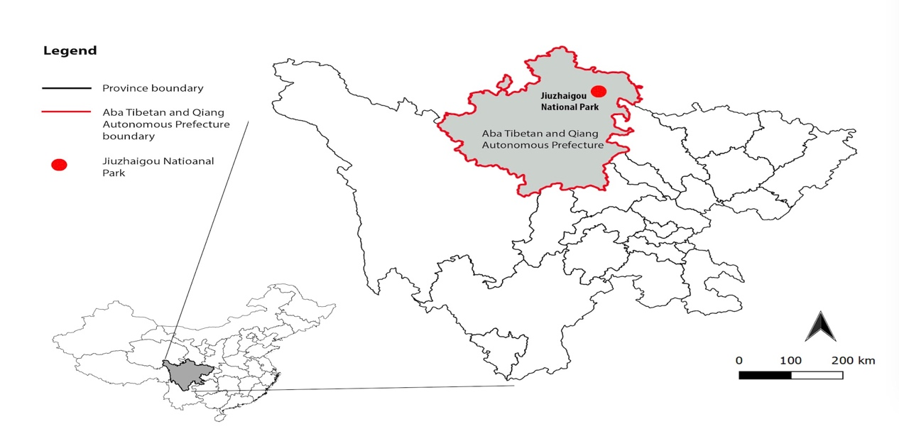
Figure 1. The location of Jiuzhaigou National Park (Source: authors)

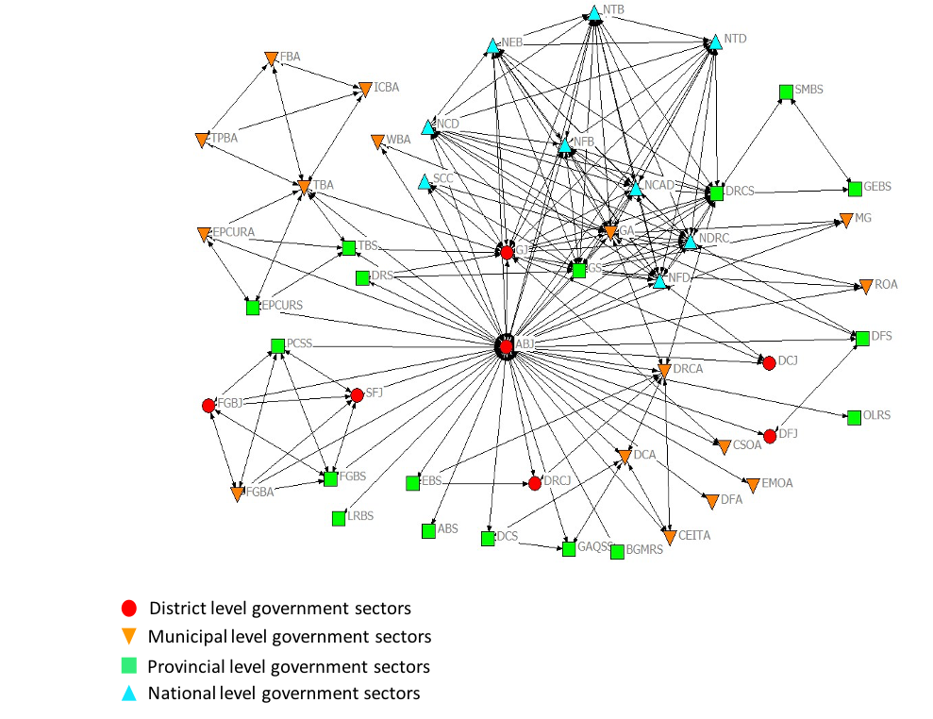
Figure 2. The entire network of intergovernmental collaboration for the post-disaster destination management of Jiuzhaigou National Park

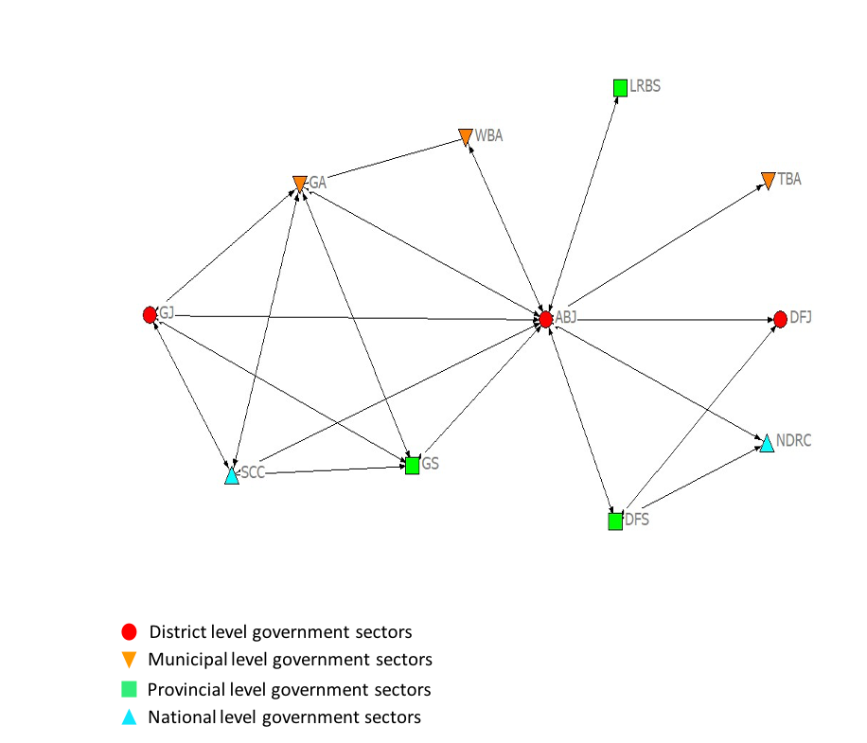
Figure 3. The intergovernmental collaboration network at the emergency stage

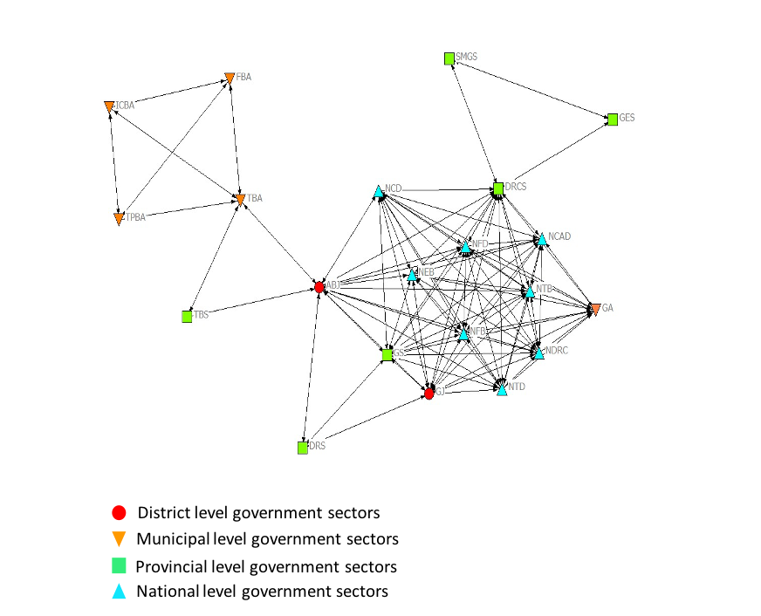
Figure 4. The intergovernmental collaboration network at the intermediate stage

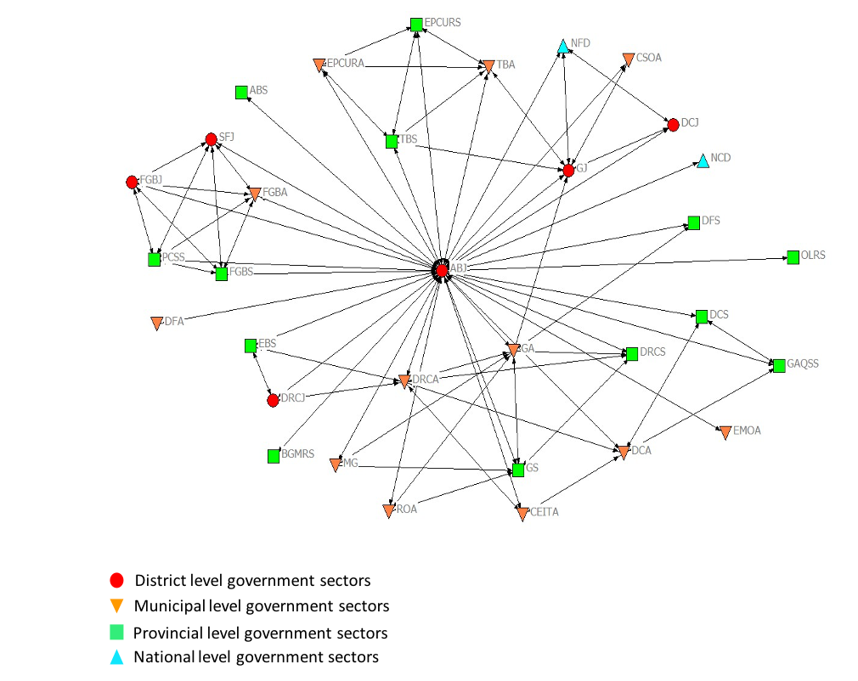
Figure 5. The intergovernmental collaboration network at the long-term recovery stage

