CLAYGROUND COLLECTIVE
Animate your City and River Thames foreshore walks (Roman and Delftware history)

Clayground Collective succinctly characterises its mission as encouraging the development of clay studies and hand skills while ‘inviting the public to engage in activities which are enjoyable, absorbing and meaningful and from which they can learn.’ The ways in which they do this are diverse and far-reaching, involving a vast network of partners, collaborators, communities and individuals from different social backgrounds, cultures and generations. The activities they devise have ‘strong visual impact, an element of performance and collective making, contributing to shared cultural memory.’¹ In producing public events and installations they have worked, for example, with schoolchildren, youth, community and specialist interest groups, homelessness charities, mental health groups and visually impaired young people, often finding ways to bring participants together to share experiences as they work on a specific project.

Clayground Collective was formally established in 2007, although the proto-organisation dates from projects carried out as early as 2001. Its principal personnel and directors are Duncan Hooson, Julia Rowntree and Claire West, who work with a team of associates. Duncan is a ceramic artist, specialising in participatory public artworks and an educator, teaching on the Ceramics BA course at Central Saint Martins; Julia is an experienced producer and researcher who came to Clayground following a career as Development Director of the London International Festival of Theatre (LIFT); Claire is a freelance consultant working on curatorial and development projects, having formerly held senior managerial positions at organisations such as the Crafts Council, London’s South Bank Centre and Horniman Museum.

The projects Clayground are presenting in the Look Who’s Talking online exhibition took place between May and September 2022; they are representative of the organisation’s approach in that, on the one hand, they are informal and celebratory clay events designed to be creative, experiential and inclusive and, on the other, use clay processes and ceramic objects to inspire people’s curiosity about ceramic culture as a window on human history.

One of the projects, Animate Your City, was part of the London Festival of Architecture. Its first event was a tactile workshop, in which blind and visually impaired children and their carers were invited to imagine and build an ambitious, large-scale collaborative sculpture of their city. It was followed by a further experiential, sensory clay workshop, this time open to all.² The aim of the second workshop was to get the participants to connect with clay through their sense of touch. Sighted participants worked alongside blind and visually impaired people, gaining an understanding of other ways to connect with the material world. It offered the opportunity to practice visual memory and rely on other senses to represent ideas about the city. Not only were these events joyful and creative experiences but, as research bears out, when children and young people in particular are offered the chance to learn new skills, it can ‘expand their horizons and develop a sense of self, well-being and belonging.’³ Such activities can also give young people the chance the express themselves verbally and artistically on the same level as adults, and build confidence in their ability to turn an idea into a reality.⁴

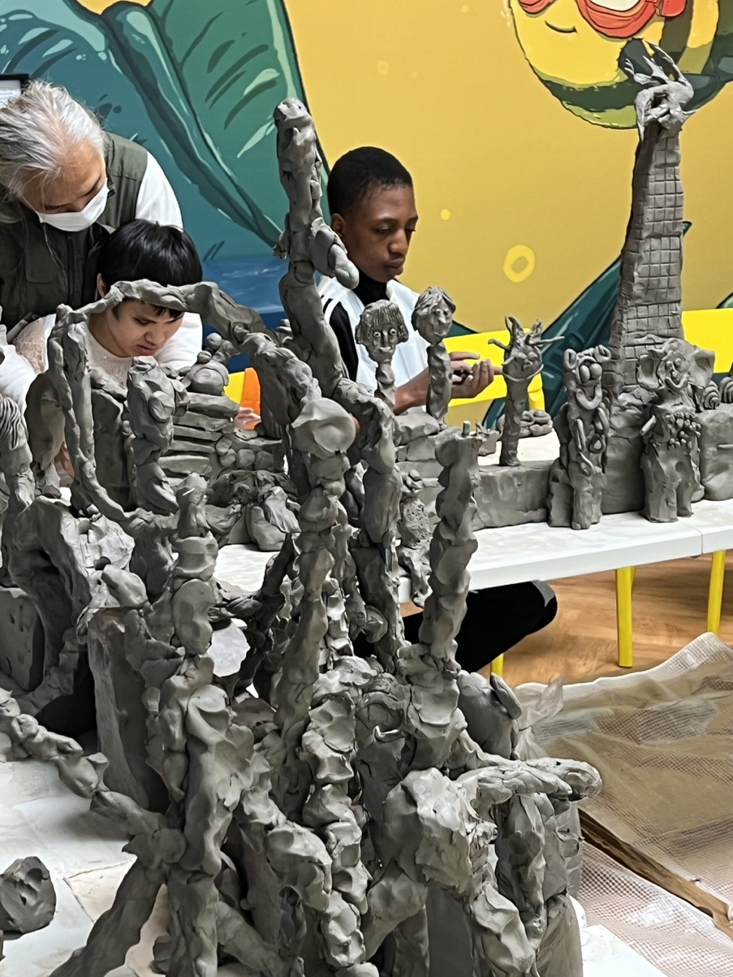
Clayground Collective, Animate Your City, May – June 2022

Clay is a relatively inexpensive and accessible material that appeals to all age groups and, as the clay used to make the sculptures is unfired, it can be recycled and used again, which makes the projects eco-friendly. Clayground Collective have expertise in adapting this kind of ambitious making event to very different needs and ends. At the Summer of Stories festival at London’s Regents Park Estate in August 2022, Clayground’s making activity centred on an ancient tree that stands in the gardens and which is thought to be around 300 years old. Participants from the local community were asked to imagine, if this tree could talk, what stories might it tell of things it has seen over the years?⁵ From the individual responses a new temporary collaborative monument took shape.

The series of River Thames foreshore walks that ran between May and September provided a focus on Roman London and English Delftware potters. Led by Clayground Associate and Thames archaeologist, Mike Webber, these walks started with a consideration of the wider historical context of the cityscape before participants went down to the foreshore of the River Thames at low tide to look for ceramic fragments.⁶ As the Clayground blog post explains, ‘Each fragment, its clay, the use and type of glaze, opens a window onto the social, technological and trading history of London.’⁷ Whereas sherds of Roman domestic pots are distinguishable from their greyish clay and lack of glaze, fragments of English Delftware of the 16th to 18th centuries can be spotted by their distinctive blue and white, hand-painted decoration. However, these are not the only possible finds, and those who joined the walks could also discover evidence of medieval pottery, examples of 17th century German saltglaze pots and Victorian wares, among others — all traces of the life of London’s past.

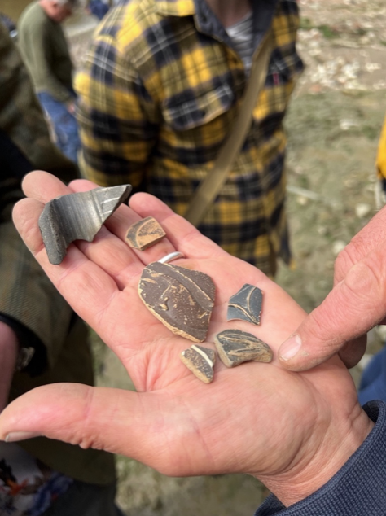
Ceramic sherds found on the Thames foreshore during a
walk led by archaeologist Mike Webber

This strand of activity, which casts light on important Roman sites adjacent to the Thames, revealing ceramic traces of Roman life on its foreshore, also connects to Clayground’s close involvement with the Friends of the Highgate Roman Kiln Project. Following the Roman invasion of Britain in AD 43, a pottery was established on a site that now lies within the boundary of Highgate Wood, North London. During the 1960s archaeologists found evidence of ten kilns on the site and many items of pottery that indicated the operation of a pottery there for a period of more than a hundred years. One of the kilns was successfully excavated at the time and removed for conservation, but has since resided in museum storage. The aim now is to restore the kiln to the site and create a related education centre and ceramics studio.⁸

Clayground Collective’s work with the Roman Kiln Project seeks to engage in discussions with the local communities who stand to benefit from the initiative, covering topics ranging from what they would like to see, to the ceramic industry and issues of sustainable resources. In a recent workshop Duncan Hooson and team demonstrated how clay dug in the locality could be processed for use, and participants made poppy-head beaker pots, replicating those that would have been made by the Roman potters.

The Activate Your City project, the River Thames foreshore walks and Roman kiln-related activities underline the value of social engagement and the power of clay in developing creativity, while bringing direct experience of what can be achieved by working co-operatively. All help people to learn more about their environment, connecting them to their history and sense of place in the world.

Tessa Peters

@claygroundcollective

1. See Clayground Collective: http://www.claygroundcollective.org/what-we-do/public/

2. Animate Your City was organised with EPR Architects @eprarchitects at the Royal Society for Blind Children (RSPB) Life Without Limits Centre @rsbccharity . The workshops were held on 21 May and 18 June, 2022 and led by Duncan Hooson and Claire West with Ewelina Bartkowska, Nicky O’Donnell and Laura West.

3. J. Weitz (1996) quoted by Seana S. Lowe, ‘Creating Community: Art for Community Development’, Journal of Contemporary Ethnography, Vol. 29, No. 3, June 2000, p. 359.

4. Seana S. Lowe, ‘Creating Community: Art for Community Development’, pp. 375–376.

5. The Summer of Stories festival was produced by Fitzrovia Youth in Action and Old Diorama Arts Centre in collaboration with Camden Council Youth Service, Detached Project, Regents Park Estate Guardians Project, and the University of the Arts London Crime Research Centre. It was supported by T-Factor and other partners.

6. The walks were open to the public who could book a place online. They were aimed at participants of 18+ years, with two discounted places per walk for children/young people between the age of 8 and18. The walks are led by Mike Webber with Duncan Hooson, Claire West and Julia Rowntree in association with the Port of London Authority.

7. Clayground Collective, ‘Thames foreshore fragments and visual references,’ Dec 2012. Available at: http://www.claygroundcollective.org/thames-foreshore-fragments-and-visual-references/

8. See: The Highgate Roman Kiln Project: https://www.highgateromankiln.org.uk/

