CLIMATE URBANISM IN THE POST-PANDEMIC WORLD: MAPPING VULNERABILITIES AND EXPLORING COMMUNITY ACTIVISM IN EAST LONDON.

Giulio Verdini¹ & Corinna Dean²
1 Corresponding Author, University of Westminster, em: g.verdini@westminster.ac.uk
2 University of Westminster, em: c.dean@westminster.ac.uk

Abstract

This chapter proposes an approach to understand and map city social and environmental vulnerabilities, alongside bottom-up and emerging community experiences in response to the pandemic, with the aim to provide a critical understanding on whether the goal of designing climate resilient and socially inclusive post pandemic neighbourhoods can be achievable. This is in response to the UN-HABITAT call to enhance the ‘resiliency against all hazards’, in times of pandemic, and tackle together economic shocks, public health crisis, and climate challenges.

A framework of city resiliency based on the principles of climate urbanism is applied to the Lower Lea Valley in East London, in the context of studio pedagogy. This helps envision how to design post-pandemic sustainable climate actions, while critically taking into account the role of communities and other local actors. However, it also shows that such scenarios might reproduce inequality at the local level, with limited capacity to address inclusion if multi-level and multi-scalar approaches are not employed.

Keywords
Climate Urbanism; pandemic; urban design; vulnerability; communities; inequality; green gentrification.

Cite as: Verdini, G., Dean, C. (2022). Climate Urbanism in the Post-pandemic World: Mapping Vulnerabilities and Exploring Community Activism in East London. In: Giorgi, E., Cattaneo, T., Flores Herrera, A.M., Aceves Tarango, V.d.S. (eds) Design for Vulnerable Communities. The Urban Book Series. Springer, Cham. https://doi.org/10.1007/978-3-030-96866-3_13

Introduction

Major urban areas have been hit by the COVID pandemic in an unprecedented way, revealing old and emerging socio-economic and environmental vulnerabilities. London is no exception, especially due to long-lasting problems of housing affordability, deprivation, and the persistency of environmental management challenges typical of post-industrial global cities. On the other hand, the pandemic has also stimulated new bottom-up demands of quality public and green space, and urban facilities that will likely to last beyond this period.

The spreading of the global pandemic of COVID since early 2020 exposed cities and nation states to unprecedented challenges, determining a rapid reshaping of the global agenda of sustainability. While the UN Sustainable Development Goals and the new ‘Urban Agenda’ have already placed emphasis on tackling together social disparities and environmental challenges, COVID has demonstrated the need of more holistic approaches to take into account a more complex horizon of resiliency. This is the key message of the UN-HABITAT Report ‘Cities and Pandemics: Towards a more just, green and healthy future (2021). According to the report, the current global public health crisis has determined raising inequalities; has revealed structural problems of neighbourhoods, cities and regions both in terms of their form, functions and effective governance; and it requires now to envision a green recovery which cannot underestimate climate change, the next great new challenge the world will need to face in the years to come.

It is too early to understand whether efforts towards a more resilient urban future will generate a genuine green recovery, as advocated from various sectors of the civil society and governments, but there are already controversial aspects that populate the debate towards the implementation of effective and inclusive low-carbon cities (The Guardian, 2020). Nevertheless, from the point of view of academic scholars which train architects and planners to design future low-carbon interventions in cities, it is essential to strengthen their analytical ability to understand such complexity, looking at how urban spaces materialize these contradictions and how it is possible to design places, envisioning context-specific and fine-grained opportunities for an effective transition towards sustainability.

This chapter, therefore, explores the development and application of a new integrated framework to understand and map city vulnerabilities, tested during an urban and landscape design studio (called ‘Climate Urbanism Studio’) targeting the study of the Lower Lea Valley in East London. This tool attempts to address together economic shocks, pandemics and climate challenges, revealing the narrow margin in the real world to effectively take on board such challenges in a meaningful way. The underlying assumption of this exercise is that measures to counter the exacerbated vulnerabilities in cities, might not produce any relevant and transformative change addressing issues of climate justice, as advocated by the new set of theories of ‘Climate Urbanism’ (Castán Broto et al, 2020), but rather another version of the business as usual. The proposed framework supports this argument with evidence from the fieldwork implemented. On the other hand, there are promising bottom-up experiences showing the resilience of local community and their demand for more sustainable and inclusive neighbourhoods. In this respect the studio is taken as an opportunity to reflect on practices of sustainability and their potential scalability in a complex area like London. The ultimate goal is to reinforce the effectiveness of a new incipient climate pedagogy, which often risks to be narrowly confined to addressing pure sectoral environmental problems.

The Climate Urbanism Studio ran from January to April 2021. It is a semester-long studio for year 2 students of the undergraduate course BA Designing Cities: Planning and Architecture at the University of Westminster. The brief states explicitly that ‘The studio investigates how to build up climate resilient post-pandemic cities and neighbourhoods, capitalizing on existing learning from the COVID-19 outbreak’ . The case study selected is the lower Lea Valley in East London, stretching north to south from the Elisabeth Park in Stratford, to the Leamouth and the river Thames. The river coincides with the administrative border between the neighbourhoods of Tower Hamlets and Newham and, for this reason, it has remained relatively untouched by large property-led developments of the London Docks. It is an important ecological resource for this part of the city, with the potential to reinforce its role of social and environmental infrastructure for the surrounding residential areas. The area hosts a very diverse population, including: some of the most deprived areas of the UK, for example Aberfeldy Village in Poplar; new gentrified developments, such as Limmo Peninsula; and relatively underdeveloped areas hosting creative industries and art communities, such as Trinity Buoy Wharf, both in the Lea Mouth of Tower Hamlet (Fig 1).

Figure 1. East London with the area of the Lower Lea Valley object of study. Source: Authors, pictures: Giulio Verdini, based on UK digimap base (https://digimap.edina.ac.uk, Public Domain).

In the next section a series of theories and concepts from the emerging field of climate urbanism will be introduced, relating environmental and climate challenges to wider issues of social inequality and economic deprivation. This will be followed by another section that explores the feature of the mentioned case study of East London, looking at its social and environmental history until recent, and not fully implemented, attempts to develop the Lea River Park since its conception in the late 2000s, as part of the Olympic Games works (Nicholls, 2014).

The second part will instead introduce the overall methodology adopted to map the area, including the framework of sustainability to assess resiliency against all hazards and design climate actions. This will be followed by a series of real case studies from the Lower River Lea, utilized to inspire the studio explorations, and a discussion session that highlights the critical aspects to take into account when moving from theory to practice.

Theory
Emerging vulnerabilities in times of pandemic and how they could (or should) inform a critical climate urbanism

In introducing ‘Unsustainable Inequalities’ Chancel argues that ‘reducing inequality is inseparable from the attempt to fundamentally alter our relationship to the environment’ (2020, p.1). While warning of potential social and institutional resistance to change, he argues that disadvantaged groups might benefit the most from environmental protection and the fight to climate change, in the long run. However, the battle to achieve that should be played both in the national, or supra level, policy arena, and at the local level. This would avoid selfish local behaviors that, despite promising attempts to initiate transition towards sustainability, would replicate locally broader inequalities. It is the case, for instance, of the increasingly debated topic of green gentrification that, in absence of equity-oriented public policies, would accelerate the displacement of low-income communities in the face of urban greening improvements (Gould & Lewis, 2016).

The aspect of the quantitative improvement of the provision of urban green, which is important in the emerging field of climate urbanism, is even more problematic in light of the recent COVID pandemic. Urban green and, in general, quality public space, has been advocated as an essential component to heal the wounds of this health crisis, particularly from the point of view of communities wellbeing as a series of recent publications from very different contexts are showing (Berdejo-Espinola et al., 2021; Mayen Huerta & Utomo, 2021). In this respect, it is legitimate to believe that the risk for any climate-resilient post-recovery strategies would be to exacerbate existing social inequalities, if the equity dimension is not taken seriously into account in the first place.

Overall, climate urbanism is associated with the new emerging trend of cities to promote themselves as ‘viable and appropriate sites of climate mitigation and adaptations’ and to protect them ‘from the hazards associated with climate change’ (Long & Rice, 2019, 993). However, such discourse has essentially gained ground as a way to protect urban economies, but has failed so far to provide enough elements to appreciate the social justice impact of climate change. It is in this spirit that a recent book on climate urbanism has been published, in the attempt to put forward a more critical research agenda (Broto, et al. 2021).

Climate urbanism should therefore favor the implementation of both urban mitigation and adaptation strategies to climate change, while having the ambition to be truly transformative, ethical and democratic (Long et al., 2020). For this purpose a series of potential pathways of climate urbanism are highlighted: reactive, entrepreneurial and transformative. Reactive climate urbanism refers to actions to reduce ex post noticeable impacts of climate change; entrepreneurial refers instead to actions that assume the fight to climate change as a way to boost city competitiveness; and, finally, transformative, refers to actions that are capable to alter the status quo by mobilizing multiple stakeholders in a more inclusive way, addressing the unequal distributions of climate costs, especially among vulnerable communities (Broto, Robin and While, 2020). While intuitively cities will need to embrace a meaningful combination of each pathway, it is from its power to generate collective projects around climate change, engaging local communities and the diversity of civil society, that climate urbanism can unveil its transformative and inclusive potential.

In this respect, ensuring wider and meaningful engagement of a different variety of stakeholders in climate urbanism projects is surely a conditio sine qua non for building up more inclusive approaches, tackling more effectively emerging vulnerabilities. It would not, however, necessarily ensure equity, as initially mentioned, especially if such practices are disjointed by genuine inclusive public policies and practices, with the risk of participation being a vehicle to give only voice to the powerful ones or to misrepresent the marginal ones (Beebeejaun, 2006). In other words, the risk of the local trap that assumes the local scale as inherently democratic should be avoided, and a careful assessment of the local conditions should be made (Purcell, 2006).

The COVID pandemic has exacerbated even further inequalities in cities. The pandemic has in fact only relatively impacted white collars jobs, that could be replaced by safer home working, but it has disproportionally impacted low-income jobs crucial to carry on some essential works. In other words ‘the impact of the virus has diverged according to geography and social class, with the least privileged people and places normally seeing the worst effects’ (Florida, Rodríguez-Pose and Storper, 2021, p.4). The potential legacy of the new structure of work together with the new needs of households, assuming a part will remain as it is now, may further increase the quest for suburban and greener locations. However, this digital-led centripetal force might have an impact only at the microgeography scale of cities, but not necessarily questioning agglomeration forces as a whole (Florida, Rodríguez-Pose and Storper, 2021). Therefore, while knowledge workers and creative will still gravitate around cities, delivering their work in hybrid forms, the rest, on the contrary, will be even more precarious or made redundant by the accelerated digitization imposed by new economy. This is something that very likely is going to stay in place for long, and it has already transformed cities, as the case study of East London will show later on.

Climate urbanism will be increasingly implemented in every city, given the emphasis on city climate actions that is made in international and national agendas especially in light of the UN Climate Change Conference (Cop26) in Glasgow. However the way in which will be interpreted and adapted at the local level will make a huge different, from the point of view of prioritizing actions, generating more or less holistic frameworks, and eventually tackling effectively inequality.

The capability of reducing inequalities will be, in the long run, the only way to make any climate policy really politically and socially viable, therefore missing the opportunity of being socially inclusive, would prevent or at least affect its overall efficacy (Chancel, 2020). However, while there is a great deal of advocacy for setting up effective climate resilient post-pandemic strategies (UN-HABITAT, 2021) this might be in risk to remain an optimistic rhetoric. The idea so largely acclaimed that green recovery should be a way to emerge from the crisis better equipped, could hide the risk of not being able to tackle effectively inequality in the long run. Additionally, the current pandemic has not only exacerbated social inequality in a generic way, but it has raised even further people’s exclusion by class and ethnic connotation (Florida, Rodríguez-Pose and Storper, 2021). This seems to be the biggest challenge.

The framework proposed in the second part of this chapter is an assessment tool to help design and hopefully build climate-resilient post pandemic strategies, potentially applicable both in pedagogy and practice. It attempts to analyse together the various dimensions of climate urbanism (Broto, Robin and While, 2020) together with emerging vulnerabilities. However, the result of this exercise cannot be discussed in abstract terms. This is imperative in any attempt to put forward new and genuinely locally-informed climate pedagogies and practices, where place based understanding of problems is crucial to determine concrete ways forward (Verdini et al, 2019). It is for this reason that a case study approach is utilized here. In the next chapter the context of East London will be introduced and methodologically the framework will be applied to such context.

The case of East London: a socio-economic and environmental history of vulnerabilities

This section will introduce the relevance of East London to a debate on climate urbanism with a focus on the Lee Valley, which is undergoing major acceleration of urban development resulting in contested urban trajectories. A consideration of this can be positioned in relation to Doreen Massey’s argument which calls for a reinvigoration of the spatiality of our cities, as discussed in For Space (2005). With a focus on London she argues that political and social issues are battled out within, ‘a confrontation between imaginations of the city’ (Massey, 2005, p.157). So despite London being a successful city in terms of finance as exemplified in the physical manifestation of The City and its economy, it is because of this, not despite, that we still have great areas of poverty and exclusion. If we are to respond to Massey’s proposition to reimagine the city, in response to the River Lee, there is a cacophony of social identities and rich typologies expressed within its diversity of spatial conditions, informal occupancies, (a lot recently cleared to make way for the Olympics) occupying the spatial margins of the city, and houseboat dwellers, all of which could drive an enlightened way of reimagining how space is shaped. The architect Mann writes in ‘Bastard Countryside’ (2003) about mixed landscapes, describing the history of the industrial hinterland, celebrating the non-pedigree typography of the site. Our approach to the site therefore introduces to current thinking about how to engage with the non-human. Clark quotes, ‘What seems to underpin the new cosmopolitan environmentalism … is the premise that left to itself, nature is docile; it maintains its given forms and positions. Culture on the other hand, is seen to be inherently dynamic,’ (Clark, 2002, p. 107).

In our current climate this is no longer the case and as we highlight in the case studies, nature and its assemblages, contribute to a balanced system of ecology between water, land and interstitial spaces, a natural habitat of reed beds are used to filter out nitrates and other nature based solutions are being reintroduced. By considering non-human agency of active agents it is possible to engage with new forms of knowledge making. Bennet, the political theorist, argues for a more dynamic involvement with the environment and the need to recognize the active participation of non-human forces in events (Bennet, 2010).

Rivers have always played an important part in the development of urban conglomerations encompassing a variety of functions and uses, related to agriculture, industrial locations, and forms of transportations, and witnessing, in its evolution, a balance between natural ecologies, history and culture. The history of the River Lea is primarily one of industrialisation. It performed the role as London’s back goods yard, providing connections for developing industry, supporting agricultural areas for growing foodstuffs as well mills, and most recently light industry. This has left a negative ecological legacy of ground and water pollution, and altered and engineered river ways, which has had a detrimental effect on the natural flood plains. The River Lea is the most engineered river in England (Environmental Agency, 1947). In 1424 an Act was issued to improve the navigability of the river. The Act constituted a commission drawn from local landowners who were responsible for implementing improvement works funded by tolls. In 1571 a second Act was passed with the intention of increasing the supply of grain into the City, by improving navigation on the Lower Lea. These works included the construction of water cuts and tow paths. In the seventeenth century disputes recorded between the mill operators and Commissioner of Sewers, accused them of penning back the water and causing flooding and the silting up of the river channels (London Borough of Newham, 2006). The mouth of the River Lee, is marked by the remnants of the East India Dock Basin, which stood at the head of the colonial shipping trade, to east, the exoticism of the trades stuffs marred by the slave exploitation and associated insidious practices. This dock area remains an abandoned relic of the past. The entire East London, especially along the prime locations of the Thames, has been for long object of massive urban regeneration processes, reverting, in some cases, the entire image of this area, from a former and deprived post-industrial wasteland, to a global hub of finance and services, especially in the area of Canary Wharf, on the West side of the River Lea, with concerted attempts to bring property-development to the East, in the area of Royal Docks (FT, 2021a).

Most recently there has been a focus on the area of Stratford, as a site for regeneration with the staging of the London 2012 Olympics and the legacy of the event (Nicholls, 2014). The creation of this new urban quarter with swathes of landscaping was intended to usher in new job creation, and increased mixed tenure housing to readdress the high levels of over populated spaces. The reality is that the opportunities has been limited, economic deprivation is still high and public health discrepancies rife. In terms of the physical landscape, the ecological planting around the Olympic park is compromised by the existing inadequacies of the Thames Water sewerage system, evidenced after heavy rainfall with visible raw sewerage and debris being pumped into the wildlife ponds (Thames Waterkeeper). The system Combined Sewerage Overflow permits raw sewerage to be pumped directly into rivers, combined with the nitrate, heavy rainwater run off from adjacent road surfaces.
During the pandemic the areas immediately east of the River Lea, with their persisting high level of social deprivation, were reported in the Financial Times describing the three boroughs— Barking and Dagenham, Redbridge and Newham, as the ‘Covid Triangle’. According to the article: ‘The restricted residential tenures expressed in the highest number of multiple occupancy per capita in London and zero hours contracts have been exasperated by Covid, and this is under the shadow of the Olympic Legacy which was up held as an intervention which would have a long term ameliorative effect across classes to improve health, employment and housing’ (FT, 2021b). The article drew focus to the discrepancy between white collar workers able to work from home though digital platforms in contrast to the zero hour employees whose place of work is in hospitality/catering, cleaning, taxi drivers and other insecure employment. Overall the River Lea crosses some of the most deprived areas of London as fig. 2 shows. Therefore to understand the context of our approach to Climate Urbanism it is important to realise the existing levels of deprivation, before testing tools and creating layers of understanding and responses.

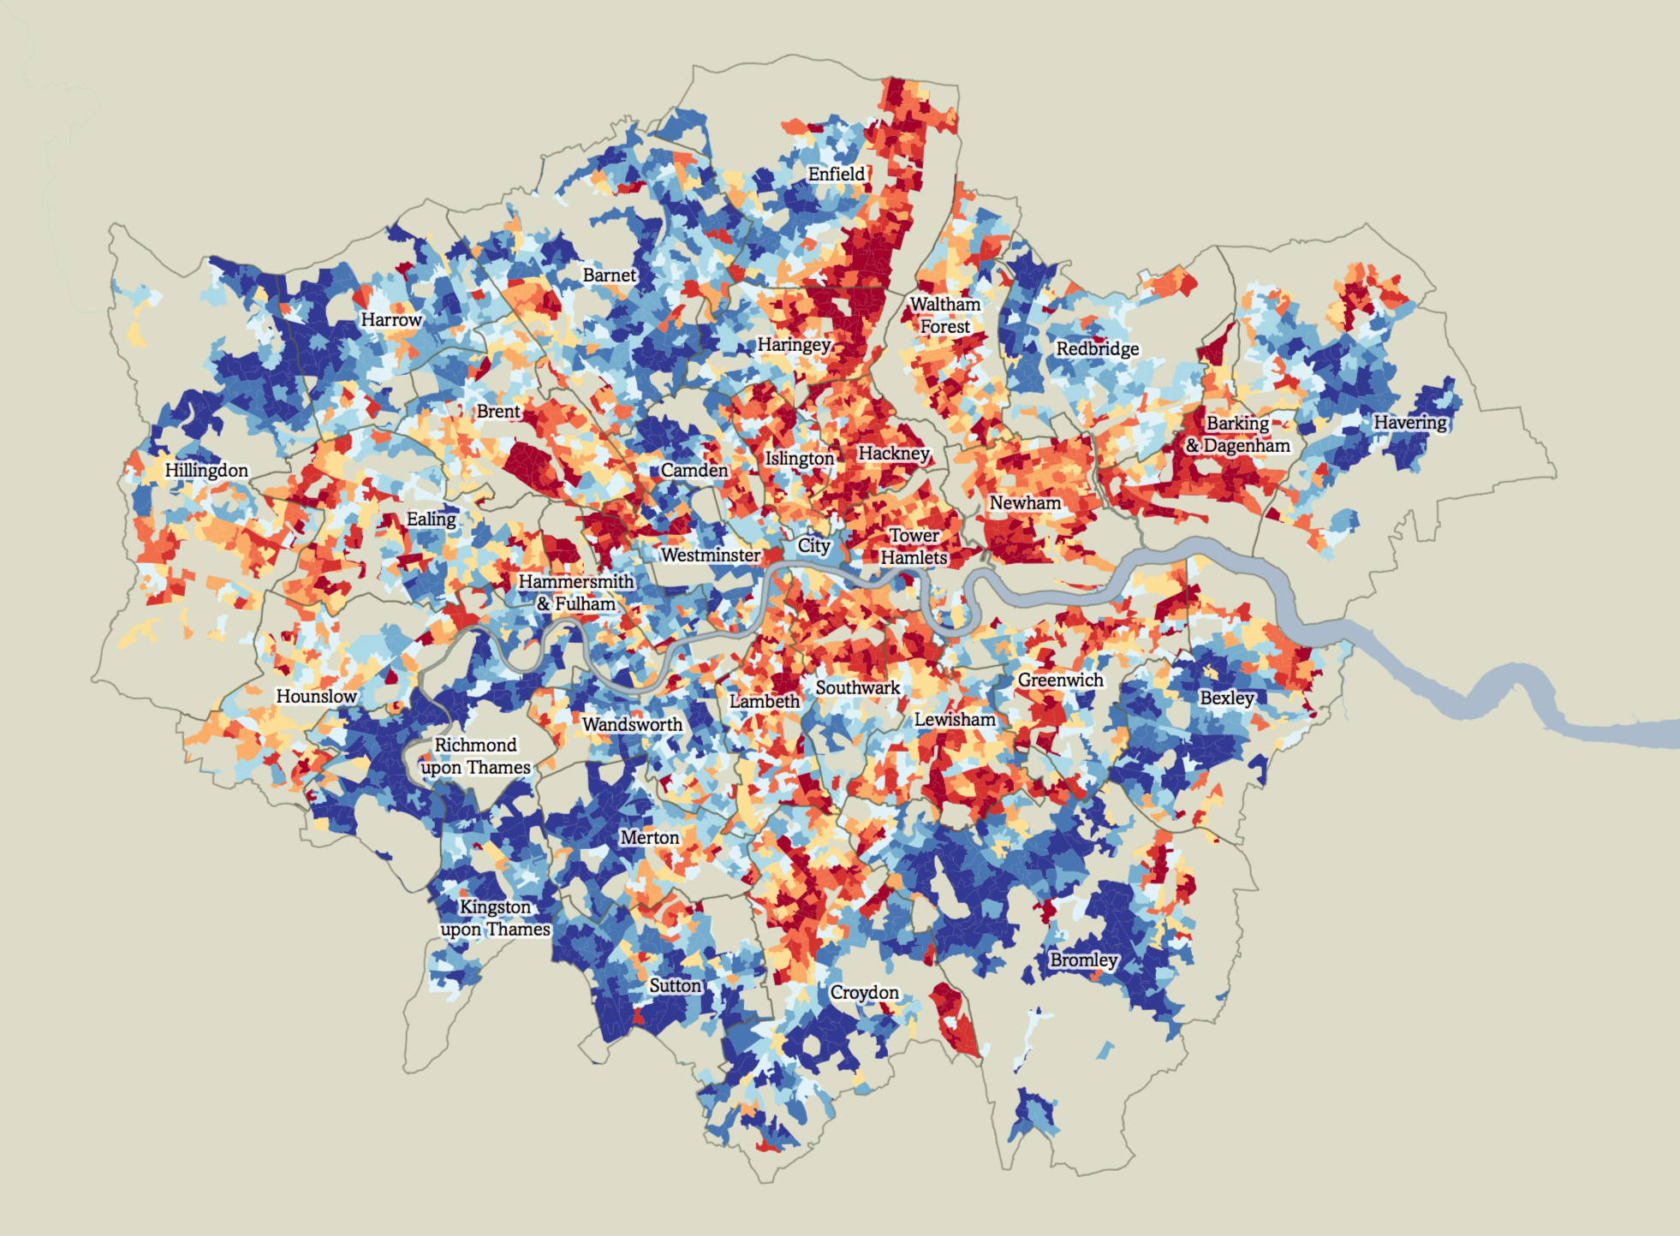
Figure 2: Map showing the English Index of multiple deprivation (rebased for London), 2019. In dark red the most deprived decile and in dark blue the least deprived. The index takes into consideration income, employment, crime, living environment, education, health and barriers to housing and services. Source: Trust For London, from UK Open Government Licence (Public Domain). Available at: https://www.trustforlondon.org.uk/data/index-multiple-deprivation-2019-rebased-london/

To reveal the interrelations between the urban actors involved in shaping future identities and visions for the sites, a number of different sources were used: empirical data collection, grey literature and local reports, and engagement with key local actors. A major source of information is the publication Cinderella River Report to respond to the Lee Valley Hydrocitizenship project, a combined academic and community participation research project to challenge societal assumptions that the river is merely a utility (Read, 2017). Key actors consulted included the non-statutory bodies operating in the area, such as the Canal & Rivers Trust, which has been mandated by government to maintain England’s river and canals as well as engage the public with the heritage and ecology of waterside sites.

One of the key interventions into the area was the intention to extend the existing Lee Valley Regional Park southwards from the Olympic Park at Stratford to the River Thames at East India Dock Basin. This was in response to a historical proposal by Patrick Abercrombie in the 1944 London Plan, to connect the Green Belt to the Thames. The project client, the London Thames Gateway Development Corporation stated their commitment to create a new urban park of regional importance, named Lea River Park. This was stated in a document delivering the principles of the design. Due to successive changes in local government, the phased development suffered numerous funding delays. The patch work state of the land around the Lea existed as dead-ends, fractured routes and off-limits industrial edges.
Holbrook from 5th Studio, main consultant of the Lea Valley Park project, describes the practice’s approach to project, then titled ‘the Fatwalk’, as installing ‘vanguard top-down infrastructure moves that will enable further, bottom-up projects’ (Wainwright, 2010, p.13). Here he refers to the introduction of a foot bridge crossing over the A 13 a major east/west artery and two other crossings. The Lower Lea runs from Stratford High Street, which neighbours the Olympic District and the head of the river which runs into the Thames.

On winning the competition for the Design Framework in 2006, 5th Studio’s preliminary work created a description of the remarkable existing landscape, in order to value and distinguish it from the Olympic Park design which took a tabula rasa site after a series of clearing the site of allotments and east London activities of small scale business. The design direction was to work with what was there and what is latent in the peripheral and marginal zones. Carefully mapping the existing characteristics, the object was to create links between and to the river’s bank. Connections running east west are poorly serviced leaving residents who live nearby with blockages both physical and imagined to reach the bank. There is little access to open space ‘statistically speaking, each inhabitant of the adjacent residential areas has only a third of the open space recommend for London’ says Holbrook (Meyer and Frederick, 2012).

Methodology
A framework to assess resiliency against all hazards and urban climate actions in design studios

Working during the Pandemic, the site was initially analysed remotely. Therefore initial research was desk based which involved researching into local community groups, social media accounts, official websites. Moreover, remote interviews with local organisations were organised as well as meeting members actively engaged with the site such as Celia Coram from Save Lea Marshes activist group, and Tom Holbrook from 5th Studio.

Students have also been asked to reflect on potential strategies used by urban planners and urban designers to facilitate integrated mitigation and adaptation in cities and to relate them to the building of climate resilient post-pandemic actions (Fig. 3)

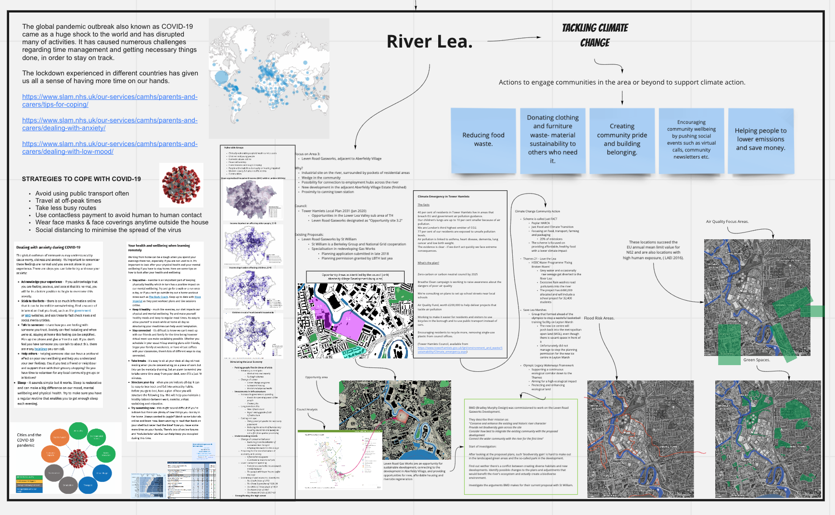
Figure 3: Strategies to tackle climate change. Analysis from the Studio Miro Board. Source: Students of BADC Year 2.

Strategies taken in consideration, according to the Second Assessment Report of the Urban Climate Change Research Network (Raven et al., 2018), are the following:
(1) Reducing waste heat and greenhouse gas emissions through energy efficiency, transit access, and walkability;
(2) Modifying form and layout of buildings and urban districts;
(3) Use of heat-resistant construction materials and reflective surface coatings; and (4) increasing vegetative cover
(5) SUDs (sustainable urban drainage systems)

In our studio students have primarily reflected on point 1 (transit access/walkability); and 4) vegetative cover, touching also point 2 and 5, especially in their group analysis.

Consequently, an analytical framework was proposed and suggested to guide the collection of data, cases, practices, precedents (Fig. 4). The framework enabled students to design climate resilient post-pandemic interventions, by understanding challenges as highlighted by recent international organizations’ guidelines and mapping social, environmental and economic vulnerability (UN-HABITAT, 2021). It proposes to envision opportunities by considering and critically selecting one or more actor in their investigation (local communities, local government, private sector), active in their study area of the Lower Lea River. This is aligned with the three suggested pathways of climate actions (Broto et al. 2020).

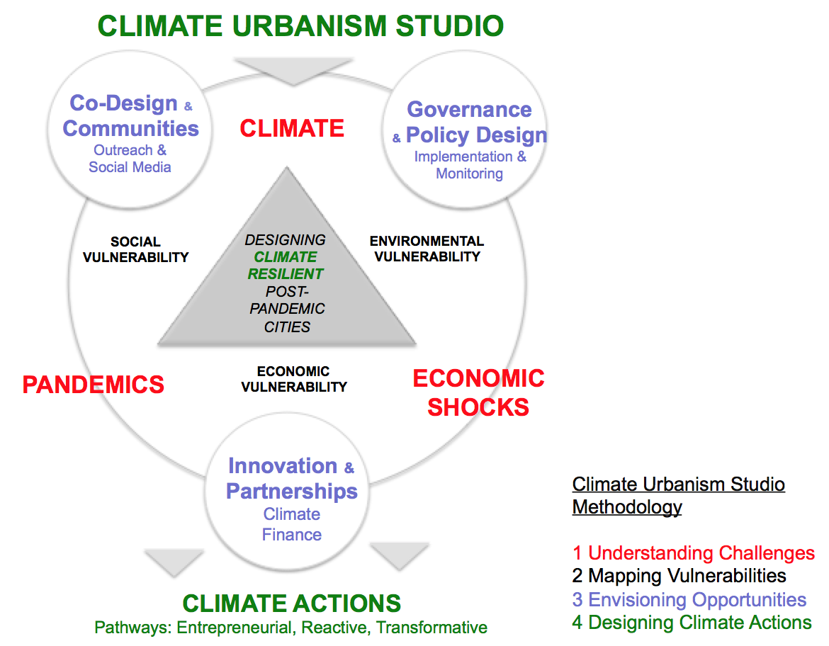
Figure 4: The climate urbanism studio framework. Source: Authors.

Case Study & Findings
The Lower Lea Valley in East London: Studio explorations

The following section selects examples of the chosen students’ real case studies, used to suggest tentative design strategies, and addressing key general and more specific questions debated in the studio. In particular: What are the social and cultural barriers in terms of accessing and appropriating green and blue public spaces across the River Lea? Are existing forms of community engagement truly inclusive, taking into account a wider range of vulnerable people? And more specifically, are there synergies between new bottom-up demand of quality space induced by the pandemic and incipient forms of transformative and just climate urbanism? Are there instead any associated risks in terms of inclusion?

To address the above a series of interviews were set up with key members of three local communities during the studio period and beyond in preparation of a video about the Lea Valley: Cody Dock, Trinity Buoy Wharf and the Levan Road Gasworks (Fig. 5).

Figure 5. The three areas selected in the left side Google map are: 1. Cody Dock; 2. the Levan Road Gasworks; and 3: Trinity Buoy Wharf. Number A is the Channelsea Island that was also discussed in the studio. On the right side there is the River Lea Framework 2007, as designed by 5th Studio
(Full map available at: https://www.5thstudio.co.uk/projects/lea-river-park-the-leaway/ ). Source: Authors composition, pictures: Giulio Verdini.

Cody Dock is a community-based organisation, named after the original dock, built in the eighteenth century. The site is leased to a community organisation, founded and directed by Simon Myers, and sits in the Lower Lea Valley amongst a number of serviced buildings of London, such as large storage warehouses. This area was claimed by the local community during the post 2008 economic crisis, when real estate pressure was relatively lower allowing for a series of initiatives to take off (Kamvasinou, 2017). Cody Dock is a collection of community arts infrastructure buildings in appropriated shipping containers, and provides workshop spaces and outdoor classrooms. The prime objectives of Cody Dock are to raise the profile of the river by connecting local communities and schools (citizen science projects), to restore the docks, and to allow residential moorings, which have been overall reduced along the river due to development pressure. Due to the lack of master planning in the surrounding areas, to reach Cody Dock one is taken though a convoluted path of inactive streets, with car parking foregrounding large storage buildings.

The other access route brings walkers and cyclists from the Thames Path, which has been one of the major objectives of 5th Studio’s project to create a continuous path along the River Lea. Cody Dock relies today on over 1000 volunteers. When establishing the organisation, two mill ponds were cleared with the intention to create a centre for the study of ecology. The widening of the programme to house an ecology centre is an instrumental action in shifting perceptions of this area, to foreground ecology as a valued element embedded in the area. A report by the architects Witherford Watson Mann of the Upper Lea Landscape Strategy (2008) commissioned by a wealth of Stakeholders from London Development Agency to Thames Water, states that the diversity of landscape identities/mixed characters is celebrated alongside the acknowledgement of the piecemeal nature of disconnected developments and ad hoc industrial sites, ‘this simply leads to a form of mutual degradation, where one neglected or defensive edge becomes the cause of another’ (WWMA and JCLA, 2008, p. 18). According to the interviews realised, Cody Dock has been object of rediscovery from the local inhabitants, especially during the partial lockdown. Due to limited possibility to travel and commute to central London locations, the River Lea has been an important resource for local people, which in some cases have became aware of Cody Dock and its initiatives for the first time. However, while the community initiatives promoted at Cody Dock have been set up in a an inclusive and open way, the area, although located in Newham, is secluded from the rest of borough, being surrounded from industrial areas, and resulting to be more accessible towards Tower Hamlets. While this is not a clear indication of the social diversity of users, given the lack of data, it is intuitive the industrial area creates a barrier towards the more multicultural and deprived core of Newham.

The second case study is the arts organisation Trinity Buoy Warf (TBW), which is located adjacent to the East India Dock Basin, in an environmentally fragile area of London. The director, Simon Cowan, talks about the challenge of managing a former brownfield site surrounded by industry wastelands against the recent proposal of construction of 55,000 housing units. He discusses the role of the organisation as a pivotal player in placing local community at the core of on-going more sustainable forms of regeneration. TBW has a unique model where it is let on a 124 years lease and 25% of its annual rent is distributed by the leaseholder to support local arts. The project upholds a long-term involvement with the area, where development is carried out incrementally establishing a commitment in supporting the local arts community over a long period of time. The complexity of the area, which is markedly divided between the characteristic of the Upper Lea Valley and the Lower Lea Valley demonstrates the local divisions along the River Lea, as a result of different development patterns. Similar to Cody Dock, although profoundly different in their broad social and cultural aim, this area represents a form of resistance to mainstream development, as stated in the mentioned ‘Cinderella Report’: ‘Trinity Buoy Wharf is unashamedly, if alternatively, marketed. This is a project driven by a proactive community group, who, although they have no money, are high on ideas and idealism. However, they operate in the context of inexorable development and realise that the key to the promotion of their plans lies in their ability to harness institutional support and partnership, which they manage with tremendous ingenuity and determination’ (Read, 2017, p. 17). During the pandemic, however, this area has suffered a real desertification, given the impact of COVID on art activities and cultural industries, as in many other similar contexts (UNESCO, 2021). Therefore, this is today questioning the future development of the site as an inclusive cluster of arts and culture, in a relatively marginal and more affordable area of London. The risk for TBW is to gradually fall into unavoidable residential-led pressure, like the neighbouring scheme of Limmo Peninsula, given the environmental attraction of the Lea Mouth.

The third case here considered is the regeneration area of Leven Road Gasworks, a former industrial infrastructure of the decommissioned Gas Works in Tower Hamlet, on the West side of the River Lea, which had been earmarked for residential development by the London Based developer St William. The rhetoric broadcast by the developer is to act as an opportunity for sustainable development, connecting to a deprived area of Aberfeldy Village and provide opportunities for new affordable housing and riverside regeneration. This is set against the council’s objective Climate Emergency in Tower Hamlets in which 40% of residents in Tower Hamlets live in areas which breach EU and government air pollution guidance, linked to asthma, heart disease, dementia. Optimistically, the council has set a target to be Zero carbon neutral by 2025.
The developer rhetoric states their aim to connect the wider community with the river for the first time and to conserve and enhance the existing and historic river characteristic, although these statements are difficult to quantify. A closer look to the plan highlights the segregated vision for the site from the neighbouring buildings, and minimal landscape intervention along the river for the pure sake of beautification of the site. The master plan appeared not to engage with the wider master planning issues and the 5th Studio Design Code, as this area was originally designated as a park, due to the lack of green space provision in the lower Lea Valley. Due to constant changes in funding bodies and lack of overall strategic vision the, Design Code is not consulted. The largest obstacle to the work carried out by 5th Studio is in Holbrook’s words the lack of ‘constituency’ to carry the project through so that it has long term supporters and is kept visible. This seems to be a constant issue in terms of operating on the larger scale level, as sites cross council boundaries, and with it stakeholder boundaries and interests. The intricacies and cross-referenced stakeholders’ values and objectives reveal the complexity in shaping the urban landscape, and the risk that, in absence of coordinated development, it is difficult to pursue the common good for the area.

An additional key observations important to add is that the pace of on-going urban transformation, potentially accelerated by COVID, might impact on the existing lack diversity of spaces’ use. This arose from the three year study of communities around the River Lee, discussed in the Cinderella River Report, that focused on the problems of diversity and engagement with public and semi-public green spaces within the River Lea, stating that ‘the current programme of management is paternalistic: volunteers accept and embrace a particular culturally indexed view of landscape, access, what is parkland, biodiversity etc. This may not be shared across all ethnic groups, classes and age ranges’ (Read, 2017, p.158). In order to engage more thoroughly with levels of access to green/blue spaces it was not fully possible to respond to this issue, due to limited data available. Moreover, data collection from the council’s website of QGIS mapping tended to be too generic and denoted ethnicity relating only to residential areas. In order to engage fully with this topic, qualitative interviews and observations would need to take place. This is an aspect that will need to take into account to monitoring trends of inclusions (or decreased diversity in accessing public and green space) across East London.

The final consideration, touched during the studio, was about climate urbanism and whether, and under which conditions, this can really help re imagine urbanism as a site of meaningful negotiation between the environment, public space and lived experience. In responding to the above question, it is worth noting that the River Lea remains a green/blue infrastructure with a certain level of accessibility, and a series of very diverse community-led initiatives that have preserved its environmental value. However, piecemeal developments are threatening the residual flexibility of the space, imposing a more rigid and privatised use. There are, nevertheless, areas still relatively untouched, such as the case of the ecological intervention of Channelsea Island in the River Lee. This intervention, promoted by the charity Canal & River Trust (CRT), solely ensures remote access, therefore allowing the natural conditions of the site, an island within the canal system, linked only to the riverside by a disused railway bridge, to flourish. The ecology of the river has been abused and still remains heavily polluted. Through looking at nature based solutions, values are placed on the ability of the existing reed beds alongside extensive work carried out by the ecology department of CRT to replant the verges along the River which have been artificially constructed causing the loss of natural habitats and root systems crucial to stabilising the River banks. It is an intervention that aims to reinstate the so-called third landscape, the space left over by man for nature to evolve (Clément, 2004). Spaces like this are rare in the area, and their conservation beyond speculative appetites could help introduce different and more inclusive narratives to the River Lea.

Discussion and conclusion

East London, and particularly the area along the River Lea is an area of persisting inequality. The impact of the pandemic has strongly hit this part of the city and it will be very likely to increase such trends in the near future.

From an environmental history point of view, the River Lea is an extremely fragmented and highly engineered natural space, showing an unsustainable pressure on the area of years of piecemeal developments, pollution, illegal and unregulated waste discharge into the river. Those developments have also favoured processes of gentrification in the area. It is only in recent years that advocacy has been made to revert this image, especially with the proposal of realising the Lea River Park, on the side of the large scale investments for the Olympic Games in 2012. Currently, the area is suspended between the difficulties of implementing the park, further eroded by new developments, and new emerging bottom-up forces that are claiming for a new life of the river nurturing its ecology, alongside a greater provision of the green space and paths. This has been amplified during the pandemic when most Londoners have rediscovered the River as a space for their wellbeing, especially during the lockdown. It is promising as advocacy for improving access to green space has been probably one of the most recurring consequences of the pandemic.

The pandemic therefore seems to have accelerated a gradual process of community re-appropriation of the area, which has set up an incipient bottom-up environmental agenda of care of the river. It is indeed a positive aspect that however needs to be carefully contextualised. From the point of view of climate urbanism, which seeks to decarbonise urban transformation and regeneration processes in cities, it is crucial to understand who can benefit from these actions and their overall impact. The climate urbanism studio presented in this chapter helped map and correlate vulnerabilities and insurgent practices of environmental activism. The three cases presented show interesting experiences. Cody Dock is an area where bottom-up grass roots organisations are setting up social enterprises, advocating for more sustainable and inclusive practices. They also witnessed a huge increase of use of the river walk and their facilities as a result of the pandemic and the rediscovery of local communities. Trinity Buoy Wharf is an art and cultural cluster that needs to redefine its identity in the post-COVID period. It is located in an environmentally fragile area, in risk of being object of residential speculation. The area of Leven Road Gasworks is a heritage area ‘waiting to be transformed’, that could easily fall into the development trap of other regeneration projects in London. Lastly, the additional case of Channel sea island is an area without human access, that could be utilized as wildlife area and nature reserve.

Overall these existing interventions challenge the pro-development housing model so far perpetuated demonstrating a variety of enforced environmental improvements that have the ambition to conserve the residual natural environment. However, one might legitimately ask to what extent this can be conducive of more inclusive urban transformation in the post-pandemic period, reinforcing instead existing social divide in the area, and consequently whether climate urbanism can further generate urban (green) gentrification. The last question posed in the studio on whether, despite all, climate urbanism can help to re imagine urbanism as a site of negotiation between the environment, public space and lived experience is a problematic one. It is evident that the River Lea is a space of increasing activism, but it is still too early to assess whether it can be truly transformative. The risk, in fact, is that the new green demand in the post-pandemic period will come mostly from those who can afford it, accelerating the development pressure, and resulting in small scale green aesthetic adjustments, rather than in substantial improvement of green space provision that a serious climate agenda would require and deprived areas would need.

References

- Beebeejaun, Y. (2006), The participation trap: The limitations of participation for ethnic and racial groups, International Planning Studies, 11 (1), 3-18.
- Bennett, J. (2010), Vibrant Matter: A Political Ecology of Things. Durham: Duke University Press.
- Berdejo-Espinola, V., Suarez-Castro, A., Amano, T., Fielding, K., Rui Ying, R., Fuller, R. (2021), People and Nature, 3, 597-609.
- Castán Broto, V., Robin, E., While, A. (2020), Climate Urbanism. Towards a Critical Research Agenda, London: Palgrave Macmillan.
- Chancel, L. (2020), Unsustainable inequalities. Social justice and the environment, Cambridge, MA: The Belknap Press of Harvard University.
- Clark, N. (2002), The Demon-Seed: Bioinvasion as the Unsettling of Environmental Cosmopolitanism. Theory, Culture and Society, 19(1-2), 101–125.
- Clément, G. (2004), Manifeste du Tiers Paysage, Artlibre. Available at: https://www.caue-nord.com/SPASSDATA/attachments/2006_10/06/5f7f3d9a6fac7-d43183.pdf
- Environment Agency (1947), River Lee Floods 50 Years On, Bristol: Environmental Agency.
- Financial Times (2021a), 40 Years on: My Docklands, 13 June 2021.
- Financial Times (2021b), Inside the ‘Covid Triangle’: a catastrophe years in the making, 4 March 2021.
Available at: https://www.ft.com/content/0e63541a-8b6d-4bec-8b59-b391bf44a492
- Florida, R., Rodríguez-Pose, A. and Storper, M. (2021), Cities in a post-covid world, Urban Studies, Ahead of Print.
- Gould, K., and Lewis, T. (2016), Green gentrification. Urban sustainability and the struggle for environmental justice, London: Routledge.
- Huerta Mayen C. and Utomo, A. (2021), Evaluating the association between urban green spaces and subjective well-being in Mexico city during the COVID-19 pandemic, Health & Place, 70, ahead of press.
- Kamvasinou, K. (2017), Temporary intervention and long-term legacy: lessons from London case studies, Journal of Urban Design, 22:2, 187-207.
- London Borough of Newham (2006), Three Mills Conservation Area. Character Appraisal and Management Proposals, London: London Borough of Newham.
- Long, J., Rice, J. (2019), From sustainable urbanism to climate urbanism, Urban Studies, 56 (5), 992 – 1008.
- Long, J., Rice, J., and Levenda, A. (2020), Climate urbanism and the implications for climate apartheid, in Castán Broto et al., ibidem, 31-49.
- Mann, W. (2003), Bastard Countryside, Scroope 15, Cambridge Architecture Journal, Cambridge University School of Architecture.
- Massey, D. B. (2005). For space. London, UK: Sage Publications.
- Meyer, F. and Schlaich, C. (2012), Saving the landscape. London 2012, Bauwelt, 24. Available at: https://www.bauwelt.de/themen/bauten/Saving-the-landscape-2154874.html
- Nicholls, A. (2014), London 2012 legacy: Olympic Park waterways, Civil Engineering Special Issue, 167, Issue CE6, Nov. 2014
- Purcell, M. (2006), Urban Democracy and the Local Trap, 43 (11), 1921-1941.
- Raven, J., Stone, B., Mills, G., Towers, J., Katzschner, L., Leone, M., Gaborit, P., Georgescu, M., and Hariri, M. (2018), Urban planning and design. In: Rosenzweig, C., W. Solecki, P. Romero-Lankao, S. Mehrotra, S. Dhakal, and S. Ali Ibrahim (eds.), Climate Change and Cities: Second Assessment Report of the Urban Climate Change Research Network, New York: Cambridge University Press, 139–172.
- Read, S. (2017), Cinderella River, Commissioned by Hydrocitizenship, London: CDS. Available at: https://www.leevalley.org/uploads/2/6/4/2/26426437/cinderella_river_lr_simon_read.pdf
- The Guardian (2020), What could a good green recovery plan actually look like?, 7th November. Available at:
https://www.theguardian.com/environment/2020/nov/17/what-could-a-good-green-recovery-plan-actually-look-like Accessed 22 June 2021.
- Wainwright, O. (2010), First look: Connectivity underpins 5th Studio’s Lea Valley vision, Building Design, 26th November, p.13.
- WWMA & JCLA (Witherford Watson Mann Architects and John Cock Landscape Architects), (2008) From Edge to Common Ground – Upper Lee Valley Landscape Strategy, WWM Report.
- UNESCO (2021), Cultural and Creative Industries in the Face of COVID-19: An Economic Impact Outlook, Paris: UNESCO. Available at: https://en.unesco.org/creativity/publications/cultural-creative-industries-face-covid-19
- UN-HABITAT (2021), Cities and Pandemics: Towards a more just, green and healthy future, Nairobi: UN-HABITAT.
- Verdini, G., Alkhani, R., Beech, N., Cascone, P., Lamb, T., Woltjer (2019), Globally-Informed City Climate Pedagogy & Practice: a position paper. Available at: http://blog.westminster.ac.uk/ccpp/ccpp-a-position-paper/

The BA Designing Cities course page: https://www.westminster.ac.uk/architecture-interiors-and-urban-design-courses/2021-22/september/full-time/designing-cities-planning-and-architecture-ba-honours and its related blog: http://blog.westminster.ac.uk/designingcities/
Quoted from the Studio brief distributed to students at the beginning of the semester in early 2021.
For more information about the River Lea Park: https://www.queenelizabetholympicpark.co.uk/the-park/venues/parklands-and-playgrounds/waterways-and-rivers/lea-river-park
For more information about COP26 : https://ukcop26.org
For more information about Save the Lea Marches : https://www.saveleamarshes.org.uk
For more information about the architectural and urbanism practice 5th Studio https://www.5thstudio.co.uk
The video was prepared by 5 students over the summer 2021 to be presented at the Youth 4 Climate ILAUD event in Milan on the 28th September 2021.
For more information about Cody Dock : https://codydock.org.uk
For more information about Trinity Buoy Wharf: https://www.trinitybuoywharf.com
For more information about the residential-led scheme of Limmo Peninsula: https://limmopeninsula.co.uk
For more information about Leven Road Gaswork regeneration project: http://www.levenroadgasworks.co.uk
See: https://www.towerhamlets.gov.uk/lgnl/environment_and_waste/Sustainability/Climate_emergency.aspx
For more information about Channelsea Island: https://canoelondon.com/exploring-londons-channelsea-river/
For more information about the Canal and River Trust : https://canalrivertrust.org.uk/about-us

