**THE EVOLUTION OF SCHEDULED AIR ROUTES BETWEEN THE UK & EUROPE AND THE CHANGING ROLE OF LOW-COST AND NETWORK CARRIERS**

Dr Nigel Dennis

Senior Research Fellow

University of Westminster

35 Marylebone Road

London NW1 5LS

United Kingdom

Tel: +44 (0)20 350 66559

Email: dennisn@westminster.ac.uk

**1. BACKGROUND**

The UK is the major European market which has had the longest experience of low-cost airlines going back to the mid-1990s. At that time, Ryanair carried only a few million passengers per year, mostly between the UK and Ireland while easyJet only started operations at the end of 1995. The period for this study is from 1997 (just before the rapid LCC expansion took off) to 2023, with a particular focus on the trends between 2017 and 2023 which cover the impacts of the pandemic and Brexit. Figure 1 shows the rapid growth in traffic from 1997-2007. There was then a slump that may have been related to the credit crunch, high fuel prices, greater security restrictions (the liquids ban) and increased taxes on UK flights. From 2015-17 strong growth resumed but this was already tapering off in 2018-19 before the pandemic hit and demand in 2023 is still 8% down overall on 2019 levels (Harper, 2022). As this paper will show, the impact has been very variable by market, however (Dunn, 2022a).

**Figure 1: Terminal passengers at UK airports 1997-2023**

Source: CAA

**2. ROUTE DEVELOPMENT FROM LONDON**

Tables 1-3 consider the development of low-cost carriers (LCCs) over the period 1997-2023 on routes from London (taking all airports together – Heathrow, Gatwick, Stansted, Luton, London City and Southend) to various European destinations (similarly all airports are included as per the IATA categorisations). 1997 was before the main low- cost revolution took place and 2017 is representative of the high point before Brexit and the pandemic. Some routes had already started to decline by 2019 although others showed further modest growth. 2023 is the latest available full year when restrictions on travel have eased following the pandemic. Figures in red indicate a decline from the previous time point. The CAA data is only available by airport and in a few cases (primarily Gatwick) both LCCs and Network carriers operated from the same airport in which case the traffic allocation has been estimated on the basis of seat capacity and average load factors.

Table 1 examines the routes from London to other major hubs such as Amsterdam, Frankfurt. Zurich and Copenhagen. This shows that most of these markets have only enjoyed modest growth over the last 26 years. They were well served in 1997 and fares were often already competitive providing less potential stimulus to demand. Lisbon and Madrid were clearly immature markets in 1997 and have seen more dramatic growth. Other more mature or business focused markets like Frankfurt and Amsterdam have hardly grown at all. Paris has declined due to the acceleration of Eurostar services with the opening of HS1 on the UK side of the channel in 2007. Most of these routes have failed to regain their 2017 traffic levels in 2023.

The market share of low-cost airlines on routes from London to major hub airports is generally in the 30-40% range (in Table 1 they are ranked by LCC market share in 2023). These are still dominated by British Airways and the foreign hub carrier. The low-cost share of local traffic (excluding hub connections) will be rather higher however. A number of routes saw LCC market share decline between 2007 and 2012 when fuel prices were high but most grew again by 2017. Since then however, LCC penetration has flattened out with their average market share unchanged at 36% since 2017. Rome is an unusual case due to the withdrawal of Alitalia who sold their slots at Heathrow. ITA, as their successor, now operates just 2 flights per day to London City. On most of the other routes the LCC share is declining, which is partly due to the withdrawal of Vueling on Amsterdam and Eurowings on Munich. The network carriers are in a relatively stronger position when operating from their hub airport as they have the feeder traffic to draw upon which means they can compete more aggressively on frequency and price in the local market too.

**Table 1: Traffic growth and low-cost market share - routes from London to major hub cities**

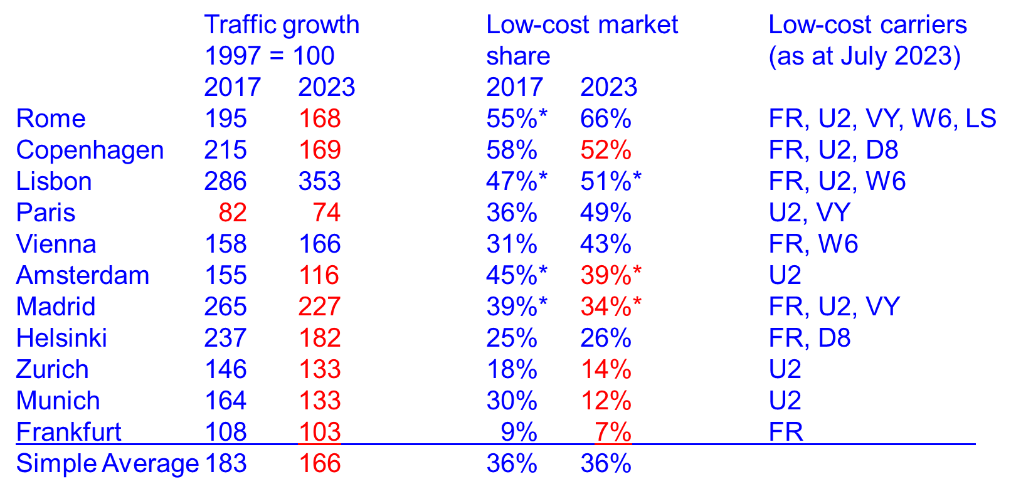

* Estimated Figures include secondary airports

FR-Ryanair, U2-easyJet, D8-Norwegian, VY-Vueling, W6-Wizz, EW-Eurowings,

LS-Jet2 (includes subsidiaries) Source: Compiled from CAA Statistics and OAG

Table 2 shows the routes to other major airports from London where traffic exceeds 1 million passengers per year – they are not major hubs for the network carriers however. These have shown more dynamic growth with the exception of Dublin and Dusseldorf (Brussels is Eurostar impacted to an even greater extent than Paris). The very high growth rates of Alicante and Malaga are distorted by switching from charter flights to scheduled. The low-cost airlines perform rather more strongly on these type of routes, often taking 40-60% of the market. In many cases the leading low-cost operator has pushed one of the traditional flag carriers out of the top two places on the route. To Nice and Geneva, for example, easyJet and BA dominate, while to Dublin it is Ryanair and Aer Lingus. A low-cost airline has become the largest operator in some of these markets, with one of the traditional airlines withdrawing completely, or utilising a low-cost offshoot. The low-cost market share seems to have peaked in 2017 however with most settling back to around 50%. As with Rome, Milan is impacted by the weakness of ITA. The traditional leisure markets such as Alicante, Malaga and Barcelona are strongly LCC dominated but in the mixed markets an equilibrium seems to have been found.

Mixed business/leisure destinations such as Berlin, Barcelona and Milan appear able to support a substantial growth in demand but ones without much tourist appeal are more dependent on inbound traffic to London (e.g. Oslo, Dusseldorf).

**Table 2: Traffic growth and low-cost market share - routes from London to other primary destinations (> 1 million annual passengers)**

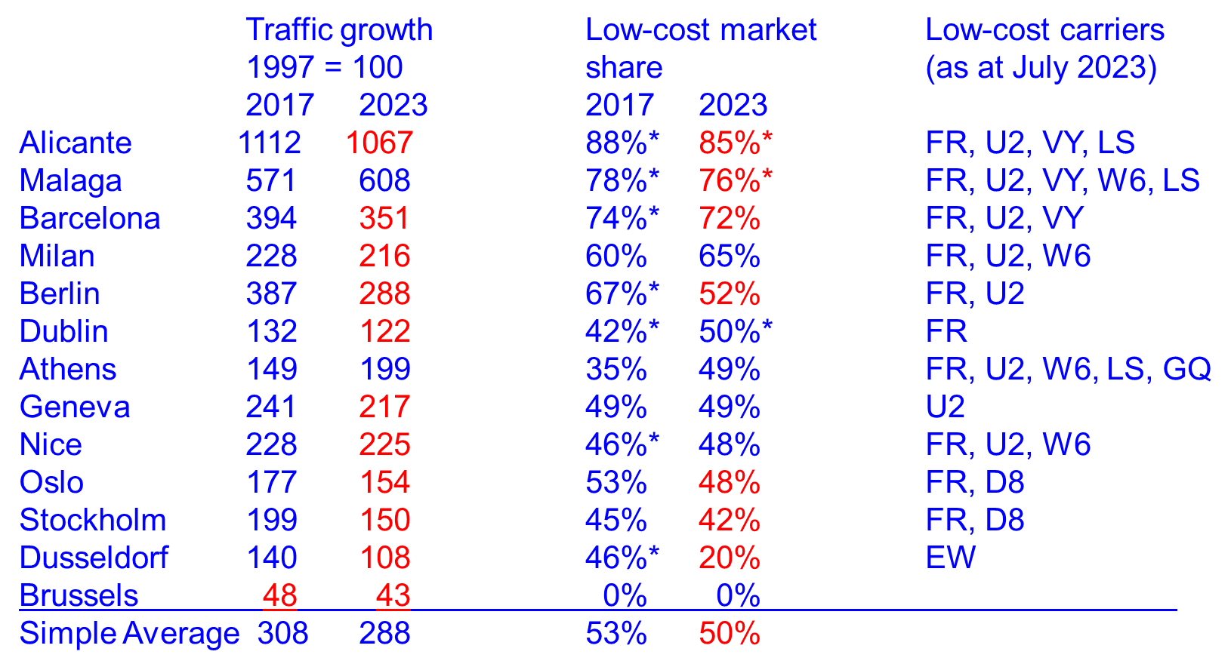

* Estimated Figures include secondary airports GQ-Sky Express

FR-Ryanair, U2-easyJet, D8-Norwegian, VY-Vueling, W6-Wizz, EW- Eurowings

LS-Jet2 (includes subsidiaries) Source: Compiled from CAA Statistics and OAG

The secondary routes (under 1 million passengers per annum – Table 3) have seen some of the highest growth rates. These were often places that were very expensive and hard to get to in the old days. For example, Venice was somewhere that many British people would like to visit but when BA and AZ controlled the market, fares were well over £200 return (which would be about £350 at current prices). There was therefore a large stimulus to demand when competition increased and prices fell. The performance of the LCCs falls into two main categories. Firstly, leisure destinations where the low-cost airline dominates with a market share of 60%+ and the traditional carriers may well cut back or pull out altogether. Secondly, the more business oriented routes where low-cost market share is lower (under 60%). These are likely to remain important as feeder routes for British Airways to its Heathrow hub but the prospects for other carriers are less certain. Where traffic is mainly foreign originating (e.g. Luxembourg), the bias in Frequent Flier Programme membership has enabled the foreign airline to hang on.

The main differentiation in recovery from the pandemic is that routes to sunny places south of a line through Switzerland have typically bounced back to above their previous levels while routes to more business focused destinations in northern Europe are languishing well below their 2017 traffic. Mixed business/leisure destinations such as Lyon or Vienna are generally doing better than those that have little attraction for British tourists such as Dusseldorf or Gothenburg.

**Table 3: Traffic growth and low-cost market share – selected secondary routes from London (< 1 million annual passengers)**

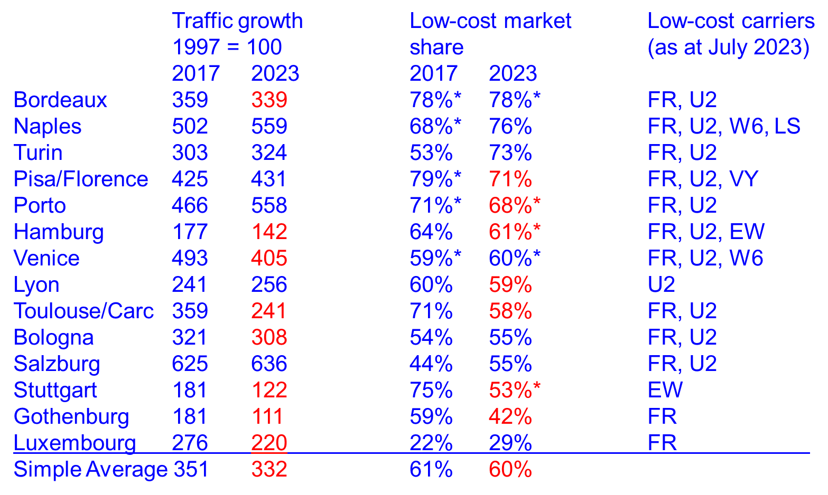

* Estimated Figures include secondary airports MT-Thomas Cook, 0B-Blue Air

FR-Ryanair, U2-easyJet, D8-Norwegian, VY Vueling, ZB-Monarch, EW-Eurowings

(includes subsidiaries) Source: Compiled from CAA Statistics and OAG

**3. SERVICES FROM REGIONAL AIRPORTS**

The next group of tables consider the dramatic growth of scheduled services that has taken place at the regional airports since the LCCs entered the market.

Table 4 shows the number of destinations with non-stop scheduled air service in the month of July for the three years under study. It can be seen that there was a huge expansion in points served between 1997 and 2017. Edinburgh, for example, has gone from 30 routes in 1997 to 136 in 2023; Bristol from 14 to 99; Liverpool from 4 to 57. The smaller regional airports have often found the going tougher however and Cardiff Wales actually has fewer routes now than 26 years ago. Most airports have also seen a slight decline from 2017-23, particularly marked at Birmingham and Glasgow. The loss of flybe has hit Southampton and Cardiff particularly hard. Belfast City has offset this by attracting more other airlines.

**Table 4: Network coverage (1997-2017-2023) UK regional airports**

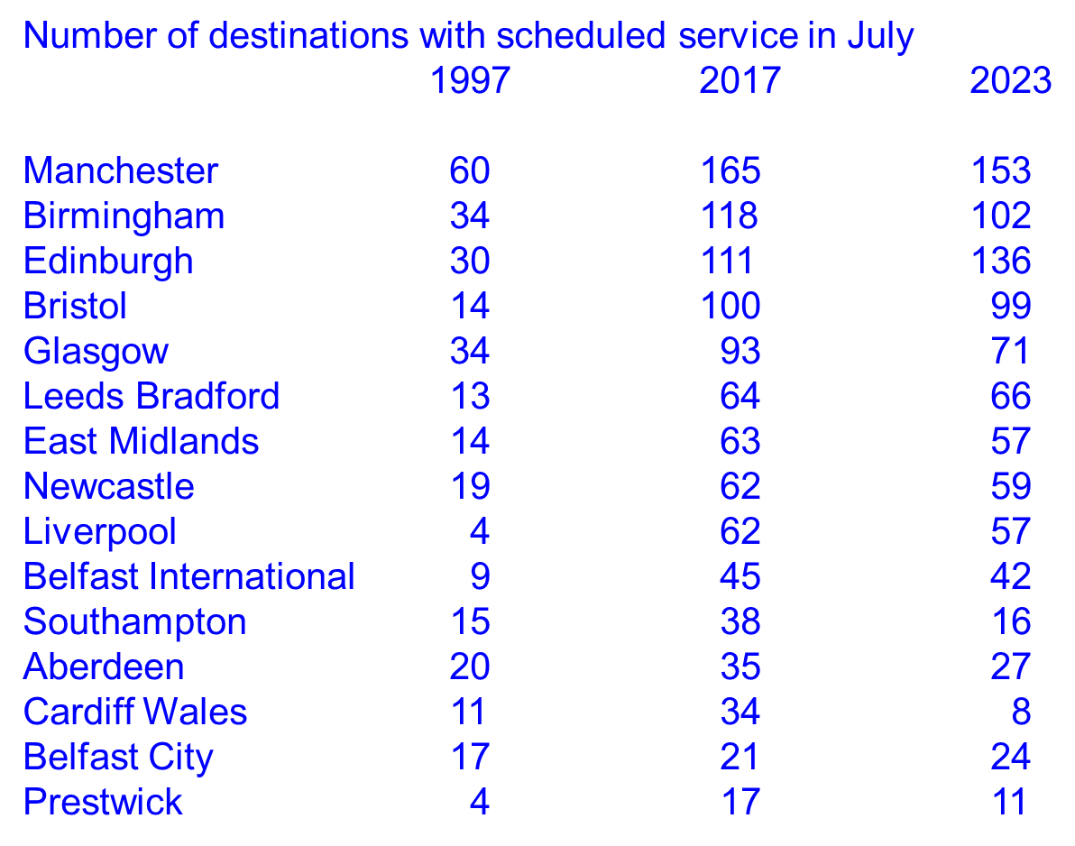

Source: Compiled from OAG

Table 5 considers the change in frequencies that has occurred over this time period. It is immediately apparent that this is less than the change in network coverage. Some airports are actually handling fewer commercial flights in 2023 than in 1997 (Glasgow, Southampton, Aberdeen, Cardiff, Belfast City, Prestwick) while Birmingham, Leeds Bradford and Newcastle are almost unchanged. Almost all the airports have dropped from 2017 to 2023.

**Table 5: Flight frequencies (1997-2017-2023) UK regional airports**

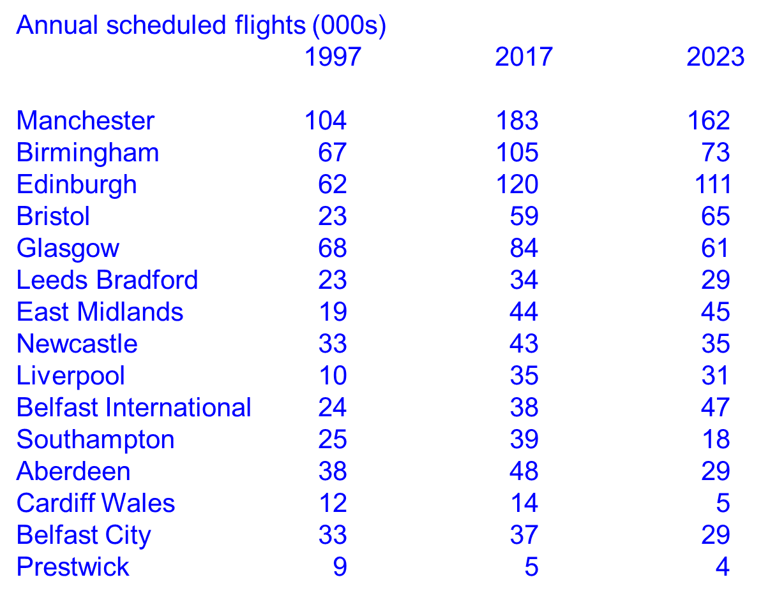

Source: Compiled from CAA Statistics

The explanation for this divergence is provided by Table 6 which presents the number of passengers per flight (average passenger load). This has risen consistently in every case from 1997 to 2017 although a few airports (Liverpool, Belfast International and Southampton) slipped back after 2017.

It can therefore be concluded that the low-cost airlines have supported a vast increase in the number of direct routes available from the smaller airports (Mason, 2023) but they typically fly much larger aircraft at much lower frequencies than was the case previously. Some of the increase in passengers per flight has also been achieved through higher load factors. Whereas the typical regional service in 1997 was a small Embraer jet with 50 seats resulting in high unit costs and high fares to match but good frequencies (e.g. twice per day), in 2023 this has become a 737-800 with 189 seats giving low unit costs and low fares but low frequencies (e.g. three per week). This is a reflection of the decline in importance of the business market and the role of hub connections for short-haul travel whereas leisure passengers value more direct flights and are willing to fit around low frequencies. These issues will be examined further below.

**Table 6: Passengers per flight (1997-2017-2023) UK regional airports**

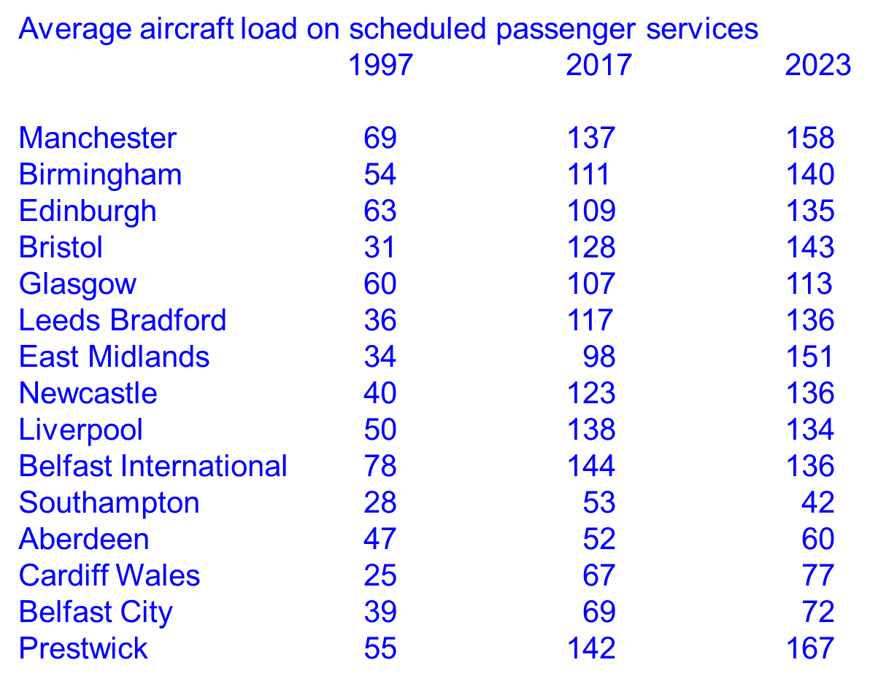

Source: Compiled from CAA Statistics

**4. CHANGE IN TYPE AND DISTRIBUTION OF TRAFFIC**

Low-cost airlines are fluid as to the airports they serve and in many cases several different airports can cater for the same demand (Jimenez et al, 2017). This can be seen in the UK where Prestwick has lost out to Edinburgh and Glasgow, Cardiff to Bristol while Manchester has regained the initiative from Liverpool and Leeds Bradford. Another example is from the market between the UK and North-West Italy. Six different airports at the Italian end have enjoyed service here but for Brescia and Genoa the best days are in the past. Bergamo and Turin have held their ground but there has been a clear shift to Milan Malpensa which reflects the underlying strength of major airports in major markets.

**Table 7: Low-cost carrier traffic between London and North-West Italy (thousand passengers)**

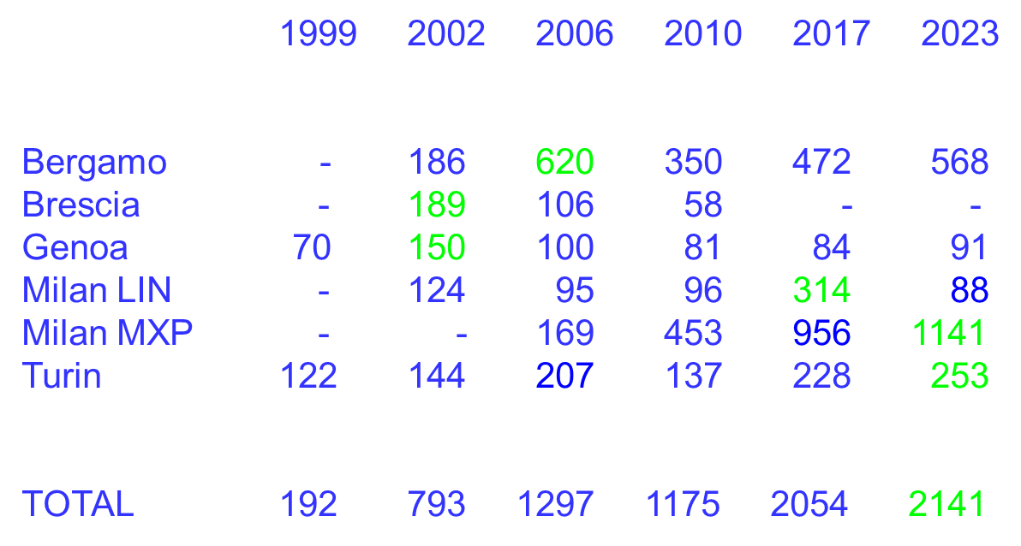

Peak year shown in green for each airport

There was no low-cost service in 1997

Source: Compiled from CAA Statistics

Although the low-cost airlines have benefited passengers wishing to make simple point to point journeys, they have reduced connectivity from smaller airports to the wider global network through the main hubs. The airline operating the route is critical if it is to be used as a feeder to the hub. KLM, Air France and Lufthansa have more than 50% of traffic on routes they fly from UK regional airports connecting at their hubs e.g. Cardiff-Amsterdam-Singapore. This is because it is priced and promoted effectively, luggage is checked through, schedules are co-ordinated and the airline is obliged to complete the journey if connections are missed. Other airlines with IATA interline facilities such as flybe (in the past) or Loganair typically manage around 10% transfers at the European hubs but for the LCCs – based on CAA survey data – it is only 1% of their traffic on routes like Liverpool-Amsterdam, Bristol-Amsterdam or Leeds/Bradford-Paris that connects at the European end. Thus, an easyJet service brings the benefit of lower fares to people who just wanted to go to Amsterdam from the UK but is of little use to passengers heading for Bangkok, Athens or New York.

One of the most striking changes arising from the pandemic is the decline in importance of business travel. The combination of working from home, ‘Zoom’ meetings, Brexit and environmental concerns have combined to greatly reduce the amount of business travel. Table 8 shows that business travel by UK residents to the EU is down by 33% and other business travel markets are down by at least 20%. In contrast, holiday travel is little changed on EU routes while the strong dollar in 2023 and pent-up demand (Dunn, 2022b) helped boost the number of Americans in the UK. Visiting friends and relatives (VFR) shows a slight decline in EU markets and an increase in non-EU which would be consistent with the changed migratory patterns following Brexit where workers from Asia and Africa have replaced those from Europe in the UK. Japan, Russia and China have been excluded from the rest of the world figures as these markets all had challenges in 2023.

It may have been expected that this would hit the legacy carriers worst - but they have been able to adapt by filling their business class with wealthy leisure passengers. Some of these have suddenly become sensitive to not being packed into a crowded aircraft with 200 other passengers, along with a need for connections to business class on long-haul flights. In some ways it has been an epiphany for the network carriers – they have had to accept they won’t get many business passengers paying 4x as much as economy for flexible business class in future (this market was declining anyway) but there are plenty of leisure passengers who are willing to pay 2x as much for a restricted ticket in business class which helps compensate.

**Table 8: Change in demand by journey purpose (UK international air passengers) 2019-2023**

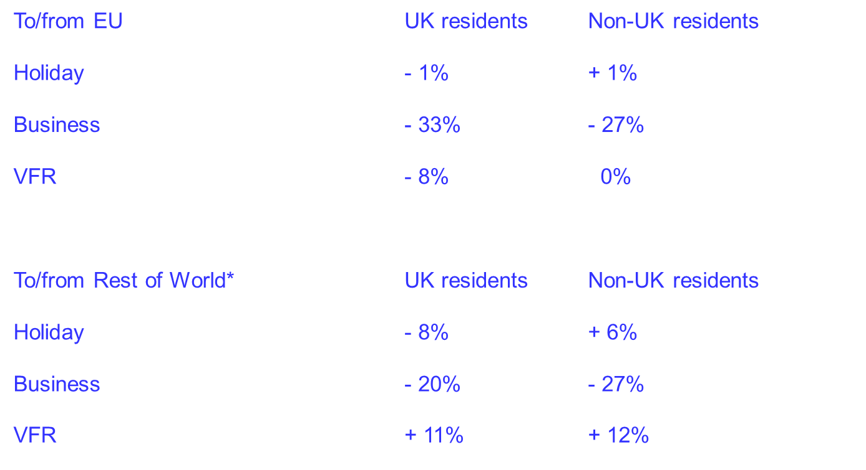

* Excluding Russia, Japan, China

Source: Compiled from ONS Travel Trends

**5. CONCLUSIONS AND FUTURE PROSPECTS**

Low-cost airlines serve more destinations with direct flights but operate larger aircraft and lower frequencies than traditional airlines. The network airlines have been driven back to their ‘fortress hubs’ but will remain the major players at these airports and the market may now be turning again in their direction (at the very least they appear to have ‘stopped the rot’ in terms of attrition by LCCs). Low-cost airlines dominate the non-hub markets and the strong ones are likely to drive out the weaker new entrants. There has been a shift back to larger airports which offer a more robust market especially during challenging times such as the ‘Credit Crunch’ and the covid pandemic. Business traffic has collapsed since the pandemic and the pent-up leisure demand appears to be now largely satisfied. Environmental concerns may be squeezing some European air travel.

The LCCs may however be reaching the limits of what is possible with their business model in a mature market. For traditional network airlines, every route they add strengthens the network (as long as it is from a hub) because it will provide feed to the existing routes in addition to new local passengers. For the low-cost airlines operating simple point-to-point flights, every new route they add weakens the network – assuming the routes have been chosen in the correct order – as it will have less demand than the existing ones. To date, they have been able to overcome this by several means – stimulating demand with low fares, attracting market share from existing airlines and taking advantage of the underlying growth in the market which means another swathe of potential routes becomes viable each year. Unfortunately, these factors all appear to be coming to an end. Fares are unlikely to fall any further and are rising in real terms due to increases in fuel and labour costs. The LCCs are likely to plateau at about 60% market share because there is typically 20% of the market willing to pay more for the convenience (e.g. frequencies, primary airports) or extra product features (e.g. business class, Frequent Flier Programmes) of traditional carriers and another 20% of the European market is connections to long-haul flights which the LCCs simply don’t do. Around 90% of Ryanair and Wizz’s capacity is on flights within Europe (Klophaus and Yu, 2023). If the short-haul market is mature and not growing this leaves the growth opportunities in the long-haul arena, persuading passengers to upgrade to premium products or from small airports with little LCC service that can be only viably served through a hub. This will replicate what is already happening in the United States where the network carriers are now doing much better than their LCC rivals such as Southwest, Spirit and JetBlue. Analyst Bill Swelbar considers Southwest’s network strategy ‘busted’ and asks ‘At what point did the airline actually outgrow its point-to-point architecture?’ (Swelbar, 2024). Southwest is also suffering from ‘lack of a true on-board premium product’ according to Thomas Fitzgerald, analyst at TD Cowen (Boynton, 2024).

Ryanair and Wizz have many new planes on order however and are determined to continue their previous high growth rates which may lead to the following scenarios: With the network carriers mostly secure in their current market position (although aircraft such as the A321XLR potentially allow LCC expansion into long-haul), the focus will shift to competition between LCCs. Ryanair may be expected to win this due to having the lowest unit costs. It also has more opportunity to add ‘no-frills’ services from major airports to its traditional focus on secondary airports (Dobruszkes et al, 2017). In contrast, easyJet is in a slightly protected position at the major airports where slots are scarce and may have to move to emulating the full-service carriers with additional product features such as interline facilities (through ticketing and checked baggage) and a business class – this appears to be the direction in which Southwest is moving in the US (Aviation Strategy, 2024). Additional airport capacity at congested locations such as Gatwick and Heathrow may offer new opportunities for LCC growth.

It is possible that some of the weaker LCCs will fail leaving opportunities for the survivors to fill the gap. The other possible way forward would be through mergers (Massy-Beresford and Flottau, 2024). Lufthansa has a rather unsuccessful LCC in Eurowings and so may be interested in easyJet or Wizz to gain economies of scale and replace this brand. It is difficult to see much benefit for AF-KL or IAG in buying another LCC. The other possible tie up was tried during the pandemic with an opportunistic bid for easyJet by Wizz that was rebuffed. easyJet is now in the stronger position but (like JetBlue v Spirit in the US) Wizz has a very different business model that looks more vulnerable in the changing circumstances and raising it to easyJet cost levels looks a poor recipe. Ryanair will run into monopoly issues with any of the other airlines except the very small ones and its record with Lauda, Buzz and Malta Air has been mixed. They would perhaps be best advised to hold tight and let others fail. Regional airlines are likely to be reduced to pure business markets plus some hub feeder routes for their major airline partners, particularly where LCCs have severely eaten into the local traffic (Harper, 2023).

**BIBLIOGRAPHY**

Aviation Strategy, Southwest and Elliott: Brutal activism, May/Jun, pp5-10, 2024.

Boynton, C., Change is in the air at Southwest, Aviation Week and Space Technology, Jul 29-Aug 11, p50, 2024.

Dobruszkes, F., Givoni, M. and Vowles, T. Hello major airports, goodbye regional airports? Recent changes in European and US low-cost airline airport choice, Journal of Air Transport Management, Volume 59, Mar, pp50-62, 2017.

Dunn, G., Turning tide on demand, Airline Business, Sep-Oct, pp36-37, 2022a.

Dunn, G., Peaking too soon? Airline Business, Nov-Dec, pp40-41, 2022b.

Harper, L., Demand hopes and cost concerns, Airline Business, Mar-Apr 2022, pp14-15, 2022.

Harper, L., Carriers plot US-style future, Airline Business, Dec, p22, 2023.

Klophaus, R. and Yu, C., Short-haul airline services in Europe and North America - A cross-business model and cross-continental analysis, Journal of Air Transport Management, 109, 102400, 2023.

Jimenez E., Claro, J., Pinho de Sousa, J. and DeNeufville, R., Dynamic evolution of European airport systems in the context of Low-Cost Carriers growth, Journal of Air Transport Management, [Volume 64, Part A](https://www.sciencedirect.com/journal/journal-of-air-transport-management/vol/64/part/PA), Sep, pp68-76, 2017.

Mason, K., Europe’s air travel revolution, Air Transport World, Jun, pp48-50, 2023.

Massy-Beresford, H. and Flottau, J., European consolidation is finally taking shape, Aviation Week and Space Technology, Jul 1-14, pp51-52, 2024.

Swelbar, W., William "Bill" Swelbar’s Post, Chief Industry Analyst at The Swelbar - Zhong Consultancy - A Commercial Aviation Economic Analysis. Linkedin, Aug, 2024 available at <https://www.linkedin.com/posts/swelbar_a-feeble-attempt-describing-a-young-southwest-activity-7229492185098846208-7F2f>