PRESS RELEASE

JANE AUSTEN’S HOUSE UNVEILS NEW ART INSTALLATION INSPIRED BYAUSTEN’S LETTERS, , CREATED BY ACCLAIMED ARTIST CLARE TWOMEY

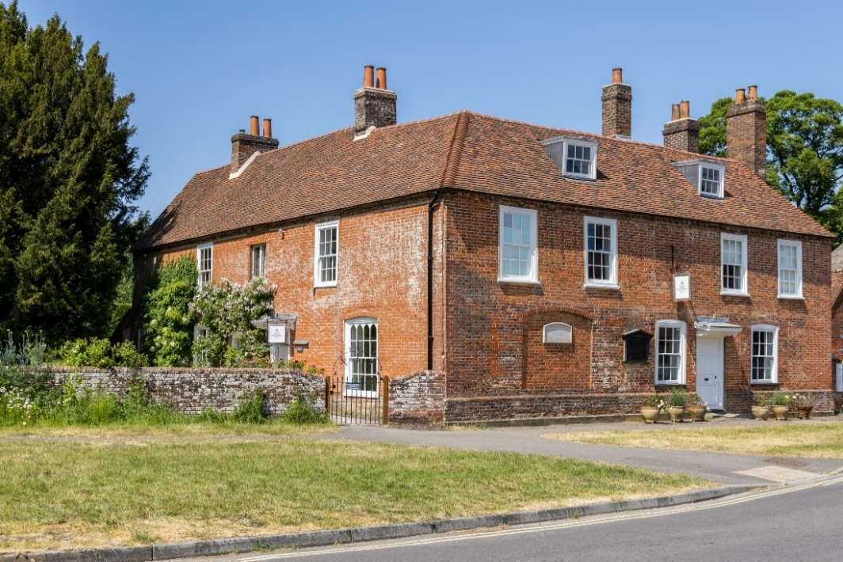
[Jane Austen’s House. Credit: Luke Shears, Jane Austen’s House.
Available to download from the Notes to Editors section]

29 April 2026

Jane Austen’s House in Chawton, Hampshire — Jane Austen’s home for the last eight years of her life and where she lived, wrote, and published her novels — has today unveiled a new art installation inspired by Jane Austen’s letters, created by acclaimed British artist Clare Twomey.

Opening today, 29 April, ‘Till this moment I never knew myself’ is a site-specific art installation created by Twomey in response to Jane Austen’s House – the house in which Jane Austen lived and wrote her globally-beloved novels. Inspired by a quote from Pride and Prejudice, the installation plays with ideas of self-reflection, understanding and knowledge; ways in which readers look to Jane Austen’s novels to ‘see’ themselves; and the ways in which Jane Austen’s House itself has become a place of pilgrimage for Jane Austen fans.

The artwork consists of 60 mirrors, which are displayed throughout Jane Austen’s House. As visitors explore the museum they will encounter the mirrors, which create reflections of the House itself, museum objects, the viewer and other visitors. Each mirror is engraved with the quote ‘Till this moment I never knew myself’, which occurs in chapter 36 of Pride and Prejudice. The line is spoken by the novel’s heroine Elizabeth Bennet, after reading Mr Darcy’s letter and learning the truth about Mr Wickham’s character; it is a crucial realisation for Elizabeth, marking the turning point in her regard for Mr Darcy, and a pivotal moment in the novel.

The quote is engraved in Jane Austen’s own handwriting. Since there is no surviving manuscript of Pride and Prejudice in existence, Twomey drew on photographs of Jane Austen’s holograph letters held in the Jane Austen’s House collection to recreate the quote word-by-word, giving the artwork both a level of authorial authenticity and creating a sliver of the lost manuscript that many viewers will find extraordinarily moving. Three of the letters used by Twomey will be displayed alongside the artwork.

Clare Twomey says: “To be invited into Jane Austen's words is more than you can explain, to put your hand on hers and feel the depth of those words. Till this moment I never knew myself, this new work brings a sense of clarity to me as an artist, when so many years of accumulated knowledge becomes a work. Museums are company and reflection to the worlds we build and believe in; they are quiet friends that walk with us. These mirrors and Jane Austen’s words bring all that together. I am so grateful to Jane Austen and the curators and readers that carry her words forward.”

Lizzie Dunford, Jane Austen’s House Director says: “It has been fascinating to watch an artist of Clare’s calibre and experience be inspired by the letters written by Jane Austen that are such a central part of the collection here at Jane Austen’s House. The work that she has created is multi-faceted, nuanced and elegant.”

‘Till this moment I never knew myself’ runs from 29 April to 1 November 2026 and is free with House admission.

ENDS

NOTES TO EDITORS

For Images
Press Images available to download.
Please use listed credits or the credit: Jane Austen’s House.

Contact:
Amelia Harvell, Head of Marketing and Communications
Amelia.Harvell@janeaustens.house
01420 83262

About Jane Austen’s House
Jane Austen’s House in the picturesque Hampshire village of Chawton is one of the most important literary sites in the world. It was in this inspiring cottage that Jane Austen’s genius flourished and where she wrote, revised, and had published all six of her globally beloved novels: Sense and Sensibility, Pride and Prejudice, Mansfield Park, Emma, Northanger Abbey and Persuasion.

Today, Jane Austen’s House is a cherished museum with an unparalleled collection of Austen treasures, including items of furniture, paintings, and household objects. Visitors can discover Jane’s personal letters and first editions of her novels, items of jewellery that she cherished, portraits of her friends and family, and the tiny table where she wrote. Visitors can explore the rooms where Jane lived and wrote, from the sunny Drawing Room where she practiced the piano every morning, and where she read Pride and Prejudice aloud to a neighbour on the very day she received her first copy, to the vibrant green Dining Room where she wrote, and the cosy bedroom upstairs that we believe she shared with her beloved sister Cassandra.

Jane lived at what is now Jane Austen’s House for the last eight years of her life. She moved here in 1809 with her mother, sister Cassandra, and friend Martha Lloyd after a period spent living in lodgings. The house was owned by Jane’s brother Edward, who had been adopted by the wealthy Knight family and had since inherited the Chawton Estate. The house – a 17th century building – was offered to the women rent-free for life.

In May 1817, after a period of ill health, Jane Austen left the village to seek medical treatment in Winchester. She died two months later, on 18 July 1817. Jane’s mother and sister continued to live at the house for the rest of their lives. In 1845 the house was split into three dwellings to provide homes for staff on the Chawton estate, and the building remained in this state until it was put up for sale in 1947. After an appeal by the Jane Austen Society, the house was bought by Mr T.E. Carpenter who turned it into a museum dedicated to the life and works of Jane Austen, opening to the public in 1949.

About Clare Twomey
Clare Twomey is a British artist, researcher, and curator living and working in London. Twomey is among the most groundbreaking and influential ceramic artists of her generation. Her practice encompasses site-specific installation and performance; she frequently collaborates with institutions, and embraces audience participation and temporality. This artist led exploration is located in the area of art, clay, ceramics and craft practices in museum and contemporary art institutions, making original and significant contributions to knowledge in the field.

Clare Twomey’s installations have the social and historical context in which the installation is created as their point of departure. Often they only exist within these frameworks. A number of her installations disappear or perish in the course of the exhibition period as part of the work. Often the onlooker’s mode of behaviour is conceptually included in Twomey’s works.

Clare Twomey is actively involved in critical research in the area of the clay practices and the arts, including writing, curating and making. She has developed work, which expands the fields’ knowledge of larger scale installation works.

Twomey was awarded an MBE in the Queen’s New Years Honours for services to art in 2022. Awarded a PhD in 2018. Twomey is a Professor at the University of Westminster who works with clay in large-scale installations, Sculpture and site-specific works. Over the past 20 years she has exhibited at the Museum of Modern Art Paris, Victoria and Albert Museum, Tate, Crafts Council, Museum of Modern Art Kyoto Japan, the Eden Project and the Royal Academy of Arts.

