Supplementary material - Model diagnostics

Table 1 below shows the correlation coefficients of each explanatory variable used in the statistical models as part of the checks performed to see if there is multicollinearity present.
Table 1. Correlation coefficients of explanatory variables used in the statistical models
 |  | School-level variables |  |  |  | LSOA-level variables |  |  | Local environment variables
 | Variable | FSM | Mixed or multiple | Asian / Asian British | Black / Black British | Black / Black British | IMD score | Population density | Ratio: main road to minor road | NOx level
School-level variables | FSM | NA | 0.138 | 0.003 | 0.543 | 0.469 | 0.575 | 0.424 | 0.143 | 0.065
 | Mixed or multiple | 0.138 | NA | -0.456 | 0.124 | 0.073 | -0.039 | 0.05 | 0.041 | 0.034
 | Asian / Asian British | 0.003 | -0.456 | NA | -0.28 | -0.131 | 0.063 | 0.133 | 0.057 | -0.032
 | Black / Black British | 0.543 | 0.124 | -0.28 | NA | 0.737 | 0.52 | 0.273 | 0.08 | 0.07
LSOA-level variables | Black / Black British | 0.469 | 0.073 | -0.131 | 0.737 | NA | 0.694 | 0.29 | 0.007 | 0.008
 | IMD score | 0.575 | -0.039 | 0.063 | 0.52 | 0.694 | NA | 0.342 | 0.122 | 0.013
 | Population density | 0.424 | 0.05 | 0.133 | 0.273 | 0.29 | 0.342 | NA | 0.093 | 0.052
Local environment variables | Ratio: main road to minor road | 0.143 | 0.041 | 0.057 | 0.08 | 0.007 | 0.122 | 0.093 | NA | 0.147
 | NOx level | 0.065 | 0.034 | -0.032 | 0.07 | 0.008 | 0.013 | 0.052 | 0.147 | NA

The table below presents the Variance Inflation Factor (VIF) scores for the explanatory variables used in Model 2 and Model 3.
Table 2. VIF scores for the explanatory variables used in Model 2 and Model 3
 | Variable | VIF score
School-level variables | FSM | 1.851
 | Asian/Asian British | 1.387
 | Black/Black British | 2.205
 | Mixed or multiple ethnicity | 1.322
LSOA-level variables | Black/Black British | 2.599
 | IMD score | 2.279
 | Ratio: main road to minor road | 1.028
Local environment variables | NOx level | 1.013
 | Population density | 1.098

To test whether independent variables are linearly related to the logit of the dependent variable, we have initially performed a graphical check (see Figure 1) of linearity by plotting the values of each independent variable against the logit of the outcome. This is summarised with a best fit “loess” line that should be monotonic if the assumption of linearity is not broken. There is clear evidence of a non-linear relationship between NOx levels and the log odds and some suggestion of non-linearity in the graphs of the ratio of main road to minor roads and the Asian/Asian British LSOA ethnicity.

Figure 1. Values of the explanatory variables plotted against the logit of the outcome - School Streets for Model 2
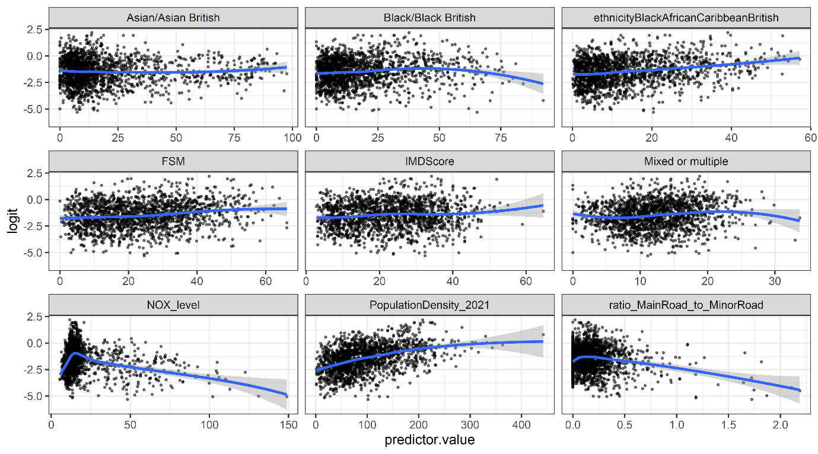
As a further test whether the assumption of linearity has been violated, we have executed a logistic regression model but, alongside the predictors that were already included in Model 2, we have included, for each variable, the interaction between each predictor and the log of itself (Hosmer & Lemeshow, 1989).

In the model output, if an interaction is significant it indicates that the relationship between the variable itself and the logit of the outcome has violated the assumption of linearity (Field.. x). It is clear from the outcome below that there are two variables that violate the assumptions: the ratio of main to minor roads and the population density. None of the other log variables were statistically significant.

Table 3. Regression summary of model including interactions with log of each explanatory variable
 | Dependent variable:
 | School Street or not
 | Model including interactions with log of variables
Free school meals (% eligible) | -0.072 (0.064)
Ethnicity: Asian/Asian British (%) | -0.040 (0.041)
Ethnicity: Black/Black British (%) | -0.013 (0.055)
Ethnicity: Mixed/Multiple (%) | 0.235 (0.141)
LSOA ethnicity: Asian/Asian British | 0.064 (0.053)
LSOA ethnicity: Black/Black British | 0.051 (0.074)
Index of Multiple Deprivation score | -0.049 (0.097)
Ratio of main to minor roads | -0.845 (0.484)
NOx level from motor vehicles | -0.034 (0.067)
Population density | 0.055*** (0.016)
LogInteraction of free school meals | 0.018 (0.015)
LogInteraction of ethnicity: Asian/Asian British (%) | 0.010 (0.009)
LogInteraction of ethnicity: Black/Black British (%) | -0.0004 (0.012)
LogInteraction of ethnicity: Mixed/Multiple (%) | -0.061 (0.040)
LogInteraction of LSOA ethnicity: Asian/Asian British | -0.017 (0.012)
LogInteraction of LSOA ethnicity: Black/Black British | -0.005 (0.018)
LogInteraction of Index of Multiple Deprivation score | 0.007 (0.023)
LogInteraction of ratio of main to minor roads | -1.687** (0.621)
LogInteraction of NOx level from motor vehicles | 0.003 (0.014)
LogInteraction of population density | -0.008** (0.003)
Intercept | -2.917*** (0.766)
Observations | 1,728
Log Likelihood | -890.465
Akaike Inf. Crit. | 1,822.929
Note: | *p<0.05**p<0.01***p<0.001

References
Hosmer, D.W. & Lemeshow, S. (1989) Applied logistic regression. Wiley: New York

