How street greenery facilitates active travel for university students

Abstract
Introduction: Active travel is currently gaining popularity worldwide as a sustainable form of travel. However, very few studies have examined how the built environment affects active travel behaviour on university campuses, particularly in China. It is a key feature of Chinese university campuses that they are generally gated communities, which are spatially organised in a very different way from campuses in other countries, and they often also provide for students’ daily needs, meaning that students tend to travel off-campus less frequently.
Aims: This research aims to explore the link between street greenery and the active travel behaviour of students on closed university campuses in China.
Methods: The study combined sensor data from Guangzhou Higher Education Mega Centre (HEMC), China, with individual cross-sectional survey data from university students and applied a multilevel logistic regression model to conduct the analysis. Street-view images were analysed using a deep learning approach, which represents an emerging method for assessing urban green space.
Results: The results demonstrated that street greenery on campuses is positively associated with active travel among university students. Modes of travel also influenced active travel, with university students who owned bicycles tending to participate in active travel more; however, those who travelled by electric bikes were less likely to participate in active travel.
Conclusions: This study suggests that policymakers and transport planners should focus more on greening urban areas and improving walking and cycling environments to achieve green transport goals through urban planning.

Keywords
Active travel; Health; Equity; Behavioural change; Street greenery; Urban planning

Highlights
- Street-view images and deep learning are combined to assess urban green space.
- Street greenery has a positive impact on active travel on gated university campuses.
- Ownership of transport tools influences the tendency to use active travel.
- Green space assessed by remote sensing is not associated with active travel.
- Using street-view images has great potential for transport studies.

1. Introduction
Active travel (AT) can prevent health risks by increasing physical activity (Passi-Solar et al., 2020; Wang et al., 2022a), and the relationship between the built environment and AT has received growing attention in recent years (An et al., 2019; Ding and Gebel, 2012; Yang et al., 2021a). Improving the built environment is an effective way to promote AT and, consequently, good health, as built environments that promote AT can effectively improve physical activity (Norwood et al., 2014). Furthermore, built environments that promote AT can also improve the attractiveness of streets for pedestrians (Chen et al., 2022; Van Loon et al., 2013) and encourage more frequent physical activity which helps to maintain health (Boakye et al., 2021; Laddu et al., 2021; Pereira et al., 2020; Wang et al., 2021b).
Among the environmental factors influencing AT, urban green spaces play a significant role, via features such as shading and good landscaping, and are important components of providing a good cycling environment and landscape for walking (Lu et al., 2019b; Krenn et al., 2015). Many cities in different countries have attracted investment to maintain and develop urban green space in order to improve the quality of life, such as Barcelona (Pérez del Pulgar et al., 2020) and Shanghai (Xiao et al., 2017). Street-view greenery is a crucial part of urban green systems and plays an important role in the aesthetic quality of the urban landscape (Du et al., 2016).
In China, university campuses are constructed as separate communities that have specific transport patterns within them, which generally differ from university campuses in western countries. This is because most university campuses in China are gated and are usually planned on the basis of the closed development model (Sun et al., 2018). Within these gated campuses, dormitories are provided to reduce the cost of living for students (typically containing 2 to 4 beds in a room), and most costs are subsidised by the government (Sun et al., 2018). Public transport, such as the underground and buses are generally not allowed to operate their services inside campuses, meaning that most university students in China have to either walk or cycle. Consequently, most daily activities associated with student life take place on campus, and the on-campus accommodation may also decrease the amount of off-campus travel, which means that the frequency of travel within university campuses is high, but, correspondingly, it tends to be low outside of campuses. Therefore, the travel patterns of university students in China are quite different from those of their counterparts in other countries, such as in Europe and the USA. For example, the average frequency of off-campus trips per week for Chinese university students was found to be about two trips per week (Zhan et al., 2016), whereas the corresponding figure for both Thai and American students was more than four trips per week (Chen, 2012; Limanond et al., 2011). These significant differences in off-campus travel patterns may be due to the particular built environment of Chinese university campuses, as facilities needed for daily life such as shops, canteens, banks and dormitories are located within the campus, meaning that students do not need to travel much off-campus (Liu, 2017). Consequently, studying the factors that influence the AT behaviours of Chinese university students can provide a theoretical basis for green travel-related planning and design in a special local context. However, few previous studies have focused on the AT behaviours of Chinese students who live in gated university campuses. Therefore, this study explores the association between urban greenery and the AT behaviour of students on gated university campuses in China using data from street-view images and questionnaires, which is analysed using a multilevel logistic regression model.
The rest of the paper is organised as follows. The literature related to this study is reviewed in the next section. Section 3 describes the case study, research data sources, variable settings, and methods of analysis used. Section 4 explains the results in terms of the relationship between street greenery and AT. Section 5 discusses the findings, the policy implications, and the strengths and limitations of this study. The final section summarises the key findings and provides conclusions.

2. Literature review

2.1. Urban greenery and active travel
Urban greenery is generally regarded as one of the most important factors in building liveable and pleasant city streets for walking and cycling (Hoedl et al., 2010; Lu et al., 2019b; Krenn et al., 2015). There is a growing recognition that urban greenery is vital to well-being (Helbich, 2018; Nieuwenhuijsen et al., 2017), and exposure to the natural environment appears to have a range of benefits for mental health (Hartig et al., 2014; Silva et al., 2018).
However, the association between urban green spaces and active travel (AT) remains unclear. While it has been generally proven by scholars that urban greenery has a positive impact on AT (Nawrath et al., 2019; Vich et al., 2019), some studies have demonstrated either that these effects are weak (Hogendorf et al., 2020), insignificant (Sallis et al., 2020), or even negative (Mäki-Opas et al., 2016; Mertens et al., 2017). For example, a study conducted in the Netherlands found a negative association between residential green space and AT in leisure time (Maas et al., 2008). Sugiyama et al. (2013) conducted a ten-year longitudinal study in Adelaide, Australia, and found no clear association between urban greenery and AT. Some studies have also demonstrated an association between the two, although this association is influenced by how it is measured. Using case studies conducted in Milwaukee and Green Bay from the US, Tsai et al. (2019) concluded that the herbaceous coverage of the living environment is negatively associated with AT. Other researchers have also suggested that the built environment may not be the only factor influencing travel behaviours. Factors such as socio-economic characteristics (Hasnine et al., 2018), the purpose of travel (essential or leisure) (Moura et al., 2017), and culturally specific practices (Moudon et al., 2016) may also affect AT.

2.2. Travel behaviour of university students
Increasing transport demand has led scholars to pay more attention to sustainable transport patterns within the university environment in order to tackle traffic congestion problems (Shannon et al., 2006). Regarding the influence of the campus environment on college students’ travel behaviours, via a study of students and faculty staff of the University of North Carolina, USA, Rodríguez & Joo (2004) found that built environments, such as pavement layouts and topography, were strongly associated with the tendency to use AT. Wang et al. (2012) used a web-based survey to demonstrate that students who live on or near campus were more likely to choose AT in preference to motorised travel. Similarly, scholars have pointed out differences in travel characteristics between students who attend urban campuses and those who study at suburban campuses (Khattak et al., 2011). By taking Canadian university students as an example, Cole (2003) found that travel costs and street environment factors impacted on students’ travel mode choices.
In China, university campuses are relatively 'independent' communities, and are often cut off from the external transport network by boundary walls (Sun et al., 2011), regardless of whether the university is built in an urban or rural area. Historically, Chinese universities were constructed and governed by a centralised government-run system, which originated in the mid-1950s, and typically were spatially separated from the surrounding urban living space by walls and gates (Liu, 2017). The Chinese central or provincial governments that fund these universities play a crucial role in their operations and governance, with accommodation and other resources on campus mostly provided to university students in the form of welfare (Liu, 2017). This model of governance implies that Chinese universities are spatially independent from other organisations. Therefore, the travel patterns inside gated university campuses are dramatically different from those of open campuses, making local transport planning and management difficult.
Cycling, as a form of AT and an alternative to using motor vehicles, is one of the most sustainable modes of transportation. It is considered the most favourable alternative mode of travel in university campus contexts due to the small range of travel distances involved (Tolley, 1996). Yang et al. (2019) found that cycling facilities are positively associated with cycling behaviours. Factors that encourage people to cycle include physical condition, sustainability, and the cost of travel (Cavill & Watkins, 2007). However, studies that have researched the association between urban greenery and cycling travel behaviour have demonstrated varying results. Some studies have found a positive association between urban greenery and cycling (Fraser & Lock, 2011; Krenn et al., 2014; Porter et al., 2020), while others have found no clear association between them (Christiansen et al., 2016; Sun et al., 2017).
The travel behaviour of university student populations differs significantly from that of other social groups (Khattak et al., 2011). For example, there is an association between the built environment and children’s active travel behaviour (Lu et al., 2019b; Moran et al., 2016; Wang et al., 2022b), and an association has been found between built environment factors such as cycling infrastructure and adolescents’ cycling activities (Mäki-Opas et al., 2014; Verhoeven et al., 2017). Similarly, some studies have provided evidence of an association between the built environment and the active travel behaviours of older adults. For instance, it has been found that the built environment has an influence on their mental health which may, in turn, affect older adults’ active travel behaviour (Van Cauwenberg et al., 2012; Wang et al., 2019b). Many studies have focused on the association between the built environment and active travel among university students (Cole, 2003; Khattak et al., 2011; Wang et al., 2012). Previous studies have found that university students are more likely to participate in AT than other population groups (Bonham & Koth, 2010; Shannon et al., 2006). However, to date, very few studies have examined the travel characteristics of Chinese university students (Sun et al., 2018; Zhan et al., 2016), and most of those have only explored travel characteristics in general, rather than examining the relationship between the built environment and the specific travel modes of Chinese university students. In addition, it is also worth mentioning that our study enables the residential self-selection bias to be mitigated, because students are randomly assigned to a university in China. Hence, the self-selection bias is likely to be less of an issue for Chinese students, compared to students in some western countries, for instance (Yang et al., 2021). Therefore, this study investigates the relationship between the AT behaviour of university students and street greenery within Chinese closed university campuses.

3. Case study, data and method

3.1. Study area
Guangzhou Higher Education Mega Centre (HEMC) is situated in Guangzhou city, the capital city of Guangdong province, China. Guangzhou HEMC is a national advanced university settlement that offers integrated learning, research, strong links with industry, senior talent training, scientific research, and good communications. Guangzhou HEMC has a large population, with over 250,000 students and lecturers studying and living there (Hu et al., 2012). It consists of a conglomeration of ten universities: Sun Yat-sen University (A), South China Normal University (B), South China University of Technology (C), Guangzhou University (D), Guangdong University of Technology (E), Guangdong University of Foreign Studies (F), Guangzhou University of Chinese Medicine (G), Guangzhou Academy of Fine Arts (H), Xinghai Conservatory of Music (I), and Guangdong Pharmaceutical University (J). Guangzhou HEMC covers an area of 43.3 km², and it is located on an island surrounded by the Pearl River (Figure 1). Guangzhou HEMC is located in the Panyu district, the urban area of Guangzhou City, which has good public transport coverage, including the metro and buses, making it possible to get to the centre of Guangzhou within half an hour. Instead of the scattered pattern of distribution of universities in other cities such as Shanghai and Beijing, Guangzhou HEMC is comprised of a dense distribution of university campuses and it has developed almost exclusively as a hub for higher education. Due to this unique demographic background and development trajectory, it can be regarded as a representative study area for investigating the AT behaviour of Chinese university students living on closed campuses. Additionally, one of the benefits of collecting data on gated university campuses is that self-selection bias is eliminated (Yang et al., 2021b).

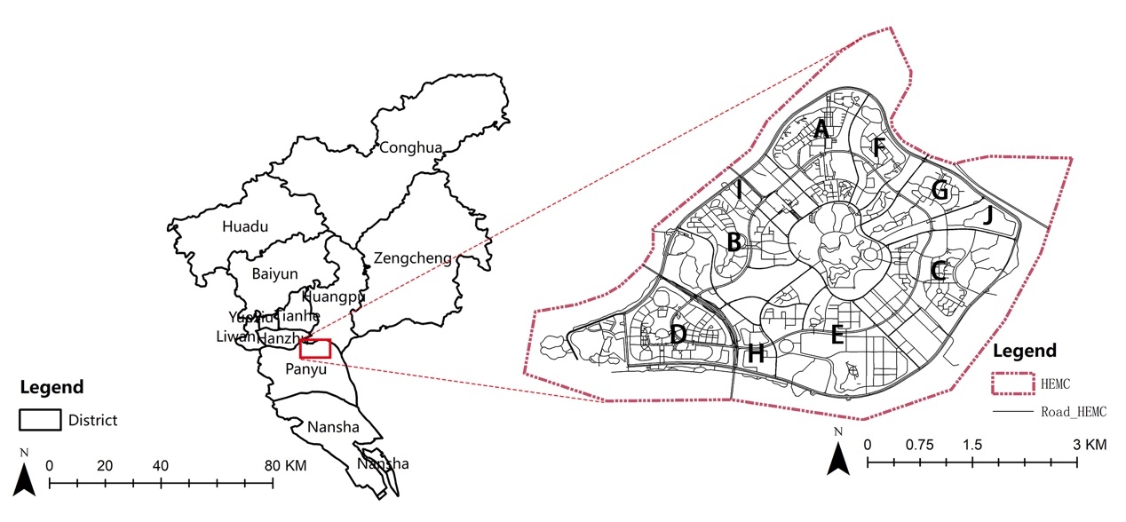
Fig. 1. Location of HEMC in Guangzhou

3.2. Data

3.2.1. Individual-level survey data
Due to the impact of the COVID-19 pandemic, we conducted an online questionnaire in May and June 2021 via Wenjuanxing (wjx.cn), the largest survey collection platform in China. This online platform has been adopted by more than 30,000 companies and over 90 per cent of Chinese universities (Sun et al., 2020). It provides a rich source of respondents and supports various functions. These advantages made it an ideal choice for collecting our data.
The online questionnaire used for this study followed the guidelines set out by Regmi et al. (2017) for conducting a valid and effective online questionnaire. To assess Chinese university students’ travel behaviour, we designed the questionnaire to encompass both demographic data, including gender, age, educational attainment, and income; and travel characteristics such as travel mode preference (both on-campus travel and off-campus travel), transport ownership and travel satisfaction. After eliminating 154 invalid samples using trap questions and manual screening, a total of 811 valid samples were eventually collected from ten universities in Guangzhou HEMC, with a response rate of 83.5%, of which 44.5% were male, and only 3.33% of respondents were over 30 years old.

3.2.2. Street-view images
Lu et al. (2019b) suggested that there is a stronger relationship between street greening and AT (i.e., walking and cycling) than other greening measures. Therefore, street-view images can be a good indicator of how the environment is perceived by pedestrians travelling along the street. We used Baidu Maps to obtain street view images (BSV), which is a viable data source that has recorded street-view images of 372 cities in China (Zhou et al., 2019b). Baidu Maps’ panoramic images have 360° horizontal and 180° vertical coverage and can be accessed online. As Google Maps is not accessible in China, Baidu Maps can be regarded as a relatively high-quality alternative data source.
The image extraction process worked as follows (Helbich et al., 2019). First, all the street vector elements of the study area were extracted and imported using ArcGIS software. Second, sample points for which images needed to be collected were created within the street network, and their latitude and longitude coordinates were recorded automatically using ArcGIS. The sample points in this study took into account the scale of the study area, and were obtained by dividing each street element equally, which made them closer to the 50m sampling distance used in previous studies (Helbich et al., 2019; Liu et al., 2020; Lu et al., 2019b) (Figure 2). We chose to create sample points along streets, because these images are collected by cars, and as pedestrians are typically active on the street, this provides a better measure of how pedestrians perceive their travel environment. 1,316 sample points obtained from the street view images were retained after removing 127 images that did not meet the requirements of the study, for example (1) images that did not match the location; and (2) sample images where the main field of view was obscured by other objects such as large vehicles.
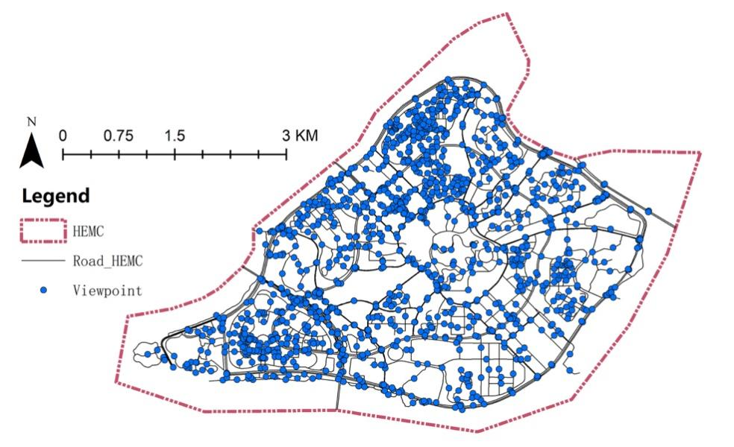
Fig. 2. Sample points for street view images

3.2.3. Remote sensing data
Derived from the analysis of remotely sensed images, the normalised difference vegetation index (NDVI) (Tucker, 1979) is also used as a parameter for evaluating green exposure. The NDVI is calculated from the reflectance values in the near-infrared band (NIR) and the visible region obtained from satellite images (Wu et al., 2021). The value is between -1 and 1, and a higher value indicates a larger amount of vegetation. The formula used to calculate the NDVI is as follows:
$NDVI=\frac{NIR-R}{NIR+R}$ (1)
where $NIR$ represents the near-infrared band, and$R$ represents the infrared band.
We calculated the NDVI values using Landsat 8 satellite image data with a spatial resolution of 30m provided by the Geospatial Data Cloud (http://www.gscloud.cn/sources/accessdata/411?pid=1), and the image was taken on 29 November 2013 by satellite. The NDVI values of each university campus were calculated using ArcGIS and included in the data tables. Figure 3 illustrates the distribution of the NDVI values for Guangzhou HEMC.
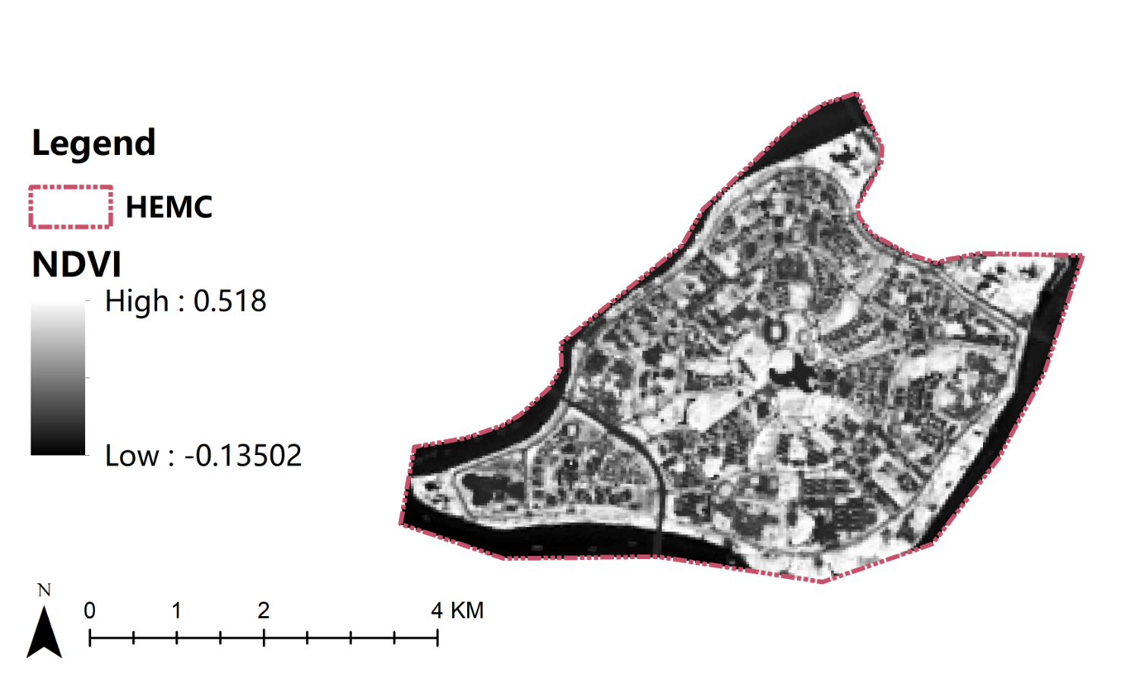
Fig. 3. The distribution of NDVI values for Guangzhou HEMC

3.3. Methods

3.3.1. Deep learning approach
Semantic segmentation methods have been widely used to extract the streetscape green spaces from satellite images (Helbich et al., 2019; Long et al., 2015). In order to do this, the relevant methods can be divided into two types: conventional methods and deep learning methods. Conventional methods include image processing and machine learning, and can manually extract the relevant feature by the use of appropriate feature extractors. For instance, Li et al. (2015) proposed an image processing method using colour channel segmentation for inferring environmental attributes (e.g., green view index). Chacra and Zelek (2016) developed a machine learning based method using the Scale Invariant Feature Transform (SIFT) algorithm and the Support Vector Machine (SVM) algorithm, to represent features of the urban physical environment (e.g., roads). In the case of simple scenarios, such as uniform illumination, and the absence of noise from the outdoor environment, conventional methods offer a simple and accurate means of extracting appropriate features (Kang et al., 2020). However, the segmentation of green space is regarded as a more complex scenario, for example if it involves objects of different scales and irregular distribution of illumination. For this reason, conventional methods require relevant features to be manually defined and this process is very time consuming and challenging. Therefore, a deep learning approach, which is data driven, can be used to circumvent the limitations of conventional methods. The primary advantage of this approach is that feature extraction can be automated by replacing the standard feature extractor with a Convolutional Neural Network (CNN) (Xiong et al., 2020). There are a variety of semantic segmentation methods based on deep learning approaches, such as fully convolutional network-8s (FCN-8s) and U-Net. In a study similar to ours, Yao et al. (2019) proposed a semantic segmentation method using FCN-8s that could be used for urban perception from street-view images, which demonstrated a good level of accuracy for their task. Therefore, we used a fully CNN (i.e., FCN-8s) to calculate the percentage of street-level greenery for each street view image. FCN-8s can identify common objects at ground level (e.g., trees, vehicles) from street view images and predict the semantic properties of each pixel in the image (Badrinarayanan et al., 2017; Long et al., 2015). This method has been demonstrated to be able to accurately identify 150 categories of objects (Yao et al., 2019). Figure 4 illustrates the processing structure of the FCN.
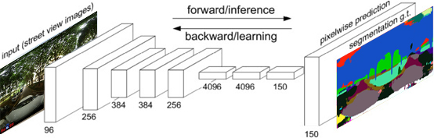
Fig. 4. FCN processing structure

We used an image semantic segmentation application and source code provided by Yao et al. (2019) (see https://github.com/whuyao/human-machine-adversarial) and trained our FCN network using the ADE20K dataset developed by MIT (Zhou et al., 2019a). The ADE20K dataset consists of nearly 150 annotated object categories, such as vehicles and trees (Helbich et al., 2019). By feeding street view panorama images into the trained FCN network, the proportion of green space (e.g., grass, meadows and trees) can be determined. The pixel contrast accuracy of this network was 0.814426 on the training dataset and 0.66839 on the test dataset (Yao et al., 2019). Figure 5 illustrates samples of the results obtained from the segmentation procedure using FCN-8.
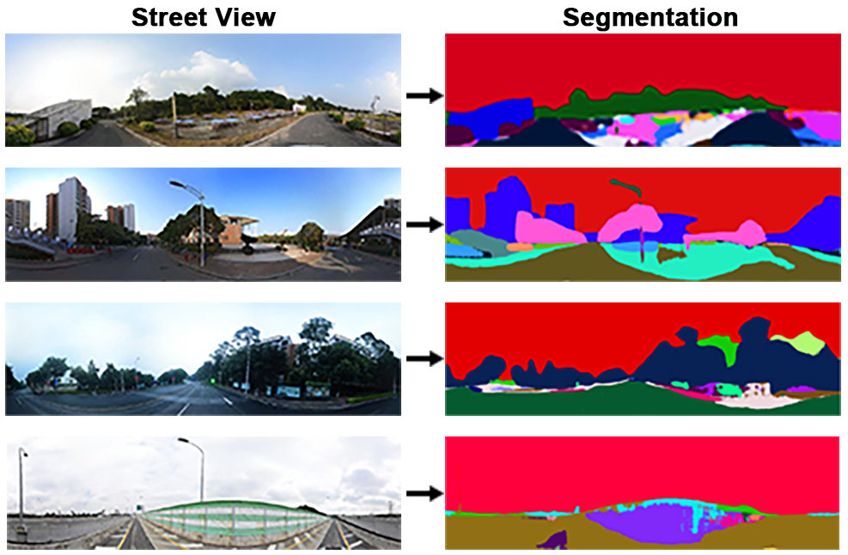
Fig. 5. Samples of the results of the image segmentation obtained using FCN-8

Following the image segmentation generated by the FCN method, the proportion of green space (e.g., trees, grass, and shrubs) was determined. The Green Vegetation Index (GVI) for each sample point was calculated from the ratio of green space pixels per image to the total number of pixels per image. Finally, the average GVI scores were computed for each university campus using ArcGIS (Li & Ghosh, 2018) and divided into three classes (low, moderate and high) in relation to 10 university campuses to enable each level of street greenery to be compared. Figure 6 illustrates the distribution of GVI values at Guangzhou HEMC.
Fig. 6. The distribution of GVI values at Guangzhou HEMC

3.3.2. Variables
Following previous studies (Hoedl et al., 2010; Lu et al., 2019b), the tendency to use AT (AT mode tendency) was chosen as a dependent variable in this study. As part of the questionnaire, the respondents were asked to answer the question: ‘Do you prefer to carry out active travel (walking or cycling) daily?’ To avoid sparse data bias (Greenland et al., 2016), we recorded this variable as a binary variable rather than a scale variable, for which a response of ‘Yes’ was recorded as 1 and ‘No’ was recorded as 0.
All the descriptive analyses and definitions of the variables are illustrated in Table 1. We followed previous studies and controlled for some demographic variables, such as gender, age, educational attainment, income, travel tools ownership, and hukou status (a system of household registration used in China) (Cao, 2019; Helbich et al., 2019; Li et al., 2015; Liu et al., 2020; Wang et al., 2021a; Yin & Wang, 2016). In order to investigate the travel status of Chinese university students, we also controlled for travel satisfaction, which was recorded for different travel modes: car, bus, metro, bike/e-bike, and walking. Three options were available: low, moderate, and high. We also included the question: ‘Which university campus do you live on?’ to establish whether our data were hierarchical in structure. The GVI and NDVI values are also shown in the table.

Table 1
Descriptive statistics.
 | Variables | Categories | Proportion (numbers)/mean (SD)
Dependent variables | Active travel tendency | Yes | 69 (558)
 |  | No | 31 (253)
Independent variables | GVI (%) | Low (0-0.155) | 27 (223)
 |  | Moderate (0.156-0.180) | 36 (285)
 |  | High (0.181-0.206) | 37 (303)
 | NDVI |  | 0.17 (0.10)
Demographic variables | Gender | Male | 39 (320)
 |  | Female | 61 (491)
 | Age (years) |  | 22 (5.20)
 | Educational attainment level | Undergraduate and below | 83 (674)
 |  | Postgraduate and above | 17 (137)
 | Driving licence | Yes | 52 (422)
 |  | No | 48 (389)
 | Income | <3000 RMB per month | 48 (389)
 |  | ≥3000 RMB per month | 52 (422)
 | Hukou status | Local hukou | 37 (298)
 |  | Non-local hukou | 63 (513)
 | Partner relationship status | Partner relationship | 35 (286)
 |  | No partner relationship | 65 (525)
Transport tool ownership | Bike ownership | Yes | 40 (327)
 |  | No | 60 (484)
 | E-bike ownership | Yes | 22 (176)
 |  | No | 78 (635)
 | Car ownership | Yes | 6 (51)
 |  | No | 94 (760)
Travel satisfaction | Car travel satisfaction | Low | 11 (89)
 |  | Moderate | 38 (309)
 |  | High | 51 (413)
 | Bus travel satisfaction | Low | 14 (110)
 |  | Moderate | 30 (241)
 |  | High | 56 (460)
 | Metro travel satisfaction | Low | 7 (59)
 |  | Moderate | 18 (144)
 |  | High | 75 (608)
 | Bike/e-bike travel satisfaction | Low | 9 (73)
 |  | Moderate | 21 (171)
 |  | High | 70 (567)
 | Walking satisfaction | Low | 13 (103)
 |  | Moderate | 29 (235)
 |  | High | 58 (473)
SD = standard deviation.

3.3.3. Statistical analysis
Following previous studies (Helbich et al., 2019; Wu et al., 2021; Yang et al., 2020), because of the hierarchical nature of our data, we used a multilevel logistic regression model to investigate the relationship between the natural environment and the tendency to use AT. The equations used for the analysis are as follows (Goldstein, 2011):

$\text{logit} \left(p_{ij}\right)=\text{l}\text{og}\left(\frac{p_{ij}}{1-p_{ij}}\right)=β_{0j}+\sum_{k=1}^{q}{β_{k}x_{kij}}$ (2)

where $β_{0j}=γ_{00}+μ_{0j}$ (3)

Which can be combined into:
$\text{logit} \left(p_{ij}\right)=\text{l}\text{og}\left(\frac{p_{ij}}{1-p_{ij}}\right)=γ_{00}+\sum_{k=1}^{q}{β_{k}x_{kij}}+μ_{0j}$ (4)

where $p_{ij}$ is the probability of active travel (AT) for the i-th individual of the j-th university; $β_{0j}$represents the random intercept; $x_{kij}$ represents the covariate and $β_{k}$ denotes its corresponding coefficient; $γ_{00}$is the fixed component in the random intercept; $μ_{0j}$ is the level 2 (university-level) residual.

Individuals at level 1 were nested within the university campuses at level 2 in the models. The intraclass correlation coefficient (ICC) is a parameter used to describe how strongly units in the same group resemble each other:
$ICC=\frac{σ_{u0}^{2}}{σ_{u0}^{2}+π^{2}/3}$ (5)

Where $σ_{u0}^{2}$ represents the between-group variance and $ε_{ij}$ has a standard logistic distribution (with mean 0 and variance $π^{2}/3$≈3.29).
In this study, we adopted a stepped approach to test the impact of the natural environment on university students’ AT behaviour. First, we fitted a baseline model that contained only socio-economic, demographic variables (Model 1). Second, we regressed the association between respondents’ tendency to use AT and street greenery (Model 2). Third, as former studies have claimed that there is an association between travel satisfaction and AT behaviour (Mouratidis, 2019), Model 3 was further controlled for individual travel satisfaction covariates: car travel satisfaction, bus travel satisfaction, metro travel satisfaction, bike/e-bike travel satisfaction, and walking satisfaction.

3.3.4. Sensitivity and robustness tests
Next, two additional sensitivity tests were conducted for the best-fit model to ensure the robustness of the relationship between the natural environment and AT behaviour (Models 2a–3b). As vehicle ownership may influence the tendency to use AT among university students (Etminani-Ghasrodashti et al., 2018), we excluded individuals who owned cars from the sample and re-ran the adjusted model (Models 2a–3a). We then repeated our analyses with a binary classified variable (the most commonly used travel mode in the last two weeks) replacing the active tendency variable (Models 2b–3b). Respondents who chose cycling and walking as their most commonly used travel mode were considered to have an AT tendency, while those who did not were considered to have no AT tendency. Last, the NDVI was calculated using remote sensing images from overhead perspectives. Thus, the results are different from those obtained using street view greenery and can be regarded as a comparable measurement of green space (Wang et al., 2019a). As the impact of green exposure may also be influenced by the methods that are used to measure greenery (Wang et al., 2019a), we changed the independent variables to the NDVI values (Models 2–5), in order to investigate the measurement difference between the GVI and the NDVI.

4. Results

4.1. Characteristics of the study population
Table 1 summarises the characteristics of the study population: 68.8% of the respondents had a low willingness to participate in AT, while 31.2% had a strong tendency to participate in AT; 27.5% of the university students who responded lived on campuses with a low GVI, and 37.4% lived on university campuses with a high GVI. Overall, the average age of the respondents was 22 years old, 83.1% had a bachelor’s degree or lower, and more than half had a driving licence. Approximately 48% of the respondents had a monthly income of less than RMB 3,000, more than half were female, and about one-third had a local hukou, while 35.3% of the respondents had a partner. Regarding transportation, 40.3%, 21.7%, and 6.29% of the respondents owned a bicycle, an e-bike, and/or a car, respectively. More than half of the respondents had a high level of satisfaction with car travel (50.9%), bus travel (56.7%), and walking (58.2%). About two-thirds of the respondents were very satisfied with metro travel and cycling, with ratings of 75.0% and 69.1%, respectively.

4.2. Baseline results
The multilevel logistics regression model results are illustrated in Table 2, linking the AT activities of university students to street greening. Model 1 illustrates the relationship between the covariates and the respondents’ tendency to use AT. The results indicate that, holding all the other variables constant, within the university student population, those with a bachelor’s degree or lower are more likely to be willing to use AT compared to those with a master’s degree or higher (OR = 0.628, 95% CI: 0.400–0.985). Other individual-level socio-demographic variables such as age, gender, and monthly income had no statistically significant effect on AT behaviours.
In Model 2, transport tool ownership was added to Model 1. Meanwhile, Model 3 added travel satisfaction variables to Model 2, namely walking satisfaction, cycling satisfaction, bus travel satisfaction, metro travel satisfaction, and satisfaction with private car travel. Street greenery was positively associated with the likelihood of respondents being willing to participate in AT according to both Model 2 and Model 3. Participants who were exposed to moderate street greening were four times more likely to be involved in AT than those exposed to a small amount of street greenery (Model 2: OR = 4.093, 95% CI: 1.213–13.794; Model 3: OR = 3.674, 95% CI: 1.162–11.616). Similarly, respondents with high exposure to street greening were also more likely to have a stronger intention to participate in AT than those with low exposure to street greening (Model 2: OR = 5.047, 95% CI: 1.803–14.126; Model 3: OR = 3.863, 95% CI: 1.443–10.340).
In terms of how ownership of a mode of transport may affect AT behaviours, respondents who owned a bicycle were twice as likely to have the intention to travel actively than those who did not, holding all the other variables constant (Model 2: OR = 2.030, 95% CI: 1.422–2.890; Model 3: OR = 2.053, 95% CI: 1.392–3.028); however, participants who owned an e-bike were less likely to participate in AT than respondents who did not own an e-bike (Model 2: OR = 0.590, 95% CI: 0.397–0.876; Model 3: OR = 0.632, 95% CI: 0.413–0.968). Respondents who owned a private car were not significantly more likely to be active travellers than those who did not own a private car. In terms of travel satisfaction, respondents with a high level of walking satisfaction were more likely to participate in AT than those with a low level of walking satisfaction (OR = 5.687, 95% CI: 3.152–10.262), and respondents with a moderate level of walking satisfaction were similarly more likely to participate in AT than those with a low level of walking satisfaction (OR = 2.349, 95% CI: 1.304–4.232). Satisfaction with other travel modes, such as private car, bike, and e-bike, did not significantly influence respondents’ intentions to participate in AT.

Table 2
Baseline model predicting active travel tendencies.
 | Model 1  OR. (95% CI) | Model 2  OR. (95% CI) | Model 3  OR. (95% CI)
Fixed part
Independent variables
GVI (ref: Low)
Moderate |  | 4.093*(1.213-13.794) | 3.674*(1.162-11.616)
High |  | 5.047*(1.803-14.126) | 3.863**(1.443-10.340)
Covariates
Demographic variables
Female (ref: male) | 0.872(0.617-1.231) | 0.883(0.621-1.256) | 0.880(0.603-1.283)
Age | 1.005(0.970-1.041) | 1.001(0.966-1.037) | 0.995(0.958-1.033)
Postgraduate and above (ref: undergraduate and below) | 0.628*(0.400-0.985) | 0.655(0.415-1.034) | 0.671(0.409-1.101)
Driving licence (ref: no driving licence) | 0.964(0.682-1.363) | 1.036(0.726-1.479) | 0.973(0.665-1.424)
Income level (ref: <3000 RMB per month)
≥3000 RMB per month | 0.684(0.453-1.032) | 0.715(0.468-1.094) | 0.580**(0.366-0.919)
Local hukou (ref: non-local hukou) | 1.204(0.847-1.713) | 1.207(0.843-1.729) | 1.186(0.805-1.746)
Partner relationship (ref: no partner relationship) | 0.990(0.691-1.421) | 1.068(0.736-1.550) | 1.097(0.735-1.636)
Transport tool ownership
Bike ownership (ref: no bike ownership) |  | 2.030***(1.422-2.890) | 2.053***(1.392-3.028)
E-bike ownership (ref: no e-bike ownership) |  | 0.590**(0.397-0.876) | 0.632*(0.413-0.968)
Car ownership (ref: no car ownership) |  | 0.705(0.358-1.390) | 1.013(0.475-2.157)
Travel satisfaction
Car travel satisfaction (ref: Low)
Moderate |  |  | 1.597(0.847-3.011)
High |  |  | 1.252(0.658-2.390)
Bus travel satisfaction (ref: Low)
Moderate |  |  | 1.038(0.559-1.928)
High |  |  | 1.252(0.656-2.390)
Metro travel satisfaction (ref: Low)
Moderate |  |  | 1.038(0.559-1.928)
High |  |  | 1.609(0.862-3.001)
Bike/E-bike satisfaction (ref: Low)
Moderate |  |  | 1.176(0.480-2.882)
High |  |  | 0.540(0.240-1.216)
Walking satisfaction (ref: Low)
Moderate |  |  | 2.349**(1.304-4.232)
High |  |  | 5.687***(3.152-10.262)
Constant | 2.211(0.789-6.197) | 0.772(0.257-2.322) | 0.201**(0.495-0.819)
Random part
Var (Universities) | 1.000** | 0.445** | 0.376**
Number of individuals | 811 | 811 | 811
Number of schools | 10 | 10 | 10
Log likelihood | -454.969 | -439.117 | -395.968
AIC | 927.937 | 906.235 | 839.937
OR = odds ratio; CI = confidence interval; AIC = Akaike information criterion. *p< 0.05, **p< 0.01, ***p< 0.001.

4.3. Robustness of the effects
Table 3 summarises the results of the robustness tests for the GVI and respondent AT correlations. Despite a few differences in the odds ratio coefficients, the association between street GVI and AT tendency remains statistically significant, and its coefficient remains constant across all models used in the robustness tests.

Table 3
Robustness tests.
 | Model 2a  OR. (95% CI)  No car ownership | Model 3a  OR. (95% CI)  No car ownership | Model 2b  OR. (95% CI)  Change the dependent variable | Model 3b  OR. (95% CI)  Change the dependent variable
GVI (ref: low)
Medium | 4.552**(1.435-14.441) | 3.976*(1.333-11.862) | 2.298***(1.387-3.810) | 2.046**(1.277-3.280)
High | 5.462***(2.046-14.579) | 4.121**(1.610-10.546) | 2.110***(1.340-3.322) | 1.847**(1.197-2.850)
Log likelihood | -406.093 | -367.767 | -502.512 | -509.362
AIC | 838.185 | 781.5342 | 1031.024 | 1066.724
OR = odds ratio; CI = confidence interval; AIC = Akaike information criterion. *p< 0.05, **p< 0.01, ***p< 0.001.

We also re-analysed the association between AT and green space by replacing the GVI with the NDVI. Table 4 illustrates the relationship between AT intentions and the NDVI, in contrast with the models using the GVI. Both Model 4 and Model 5 demonstrated that the relationship between the NDVI and AT is not significant, indicating a difference between street greenery measured using street-view images and greenery analysed vertically via remote sensing.

Table 4
GVI vs. NDVI.
 | Model 2  OR. (95% CI)  GVI | Model 3  OR. (95% CI)  GVI | Model 4  OR. (95% CI)  NDVI | Model 5  OR. (95% CI)  NDVI
GVI (ref: low)
Medium | 4.093*(1.213-13.794) | 3.674*(1.162-11.616) | 2.394(0.629-9.119) | 2.418(0.724-8.077)
High | 5.047*(1.803-14.126) | 3.863**(1.443-10.340) | 3.570(0.933-13.652) | 2.896(0.864-9.704)
Log likelihood | -439.117 | -395.968 | -441.338 | -397.762
AIC | 906.235 | 839.937 | 910.676 | 843.524
OR = odds ratio; CI = confidence interval; AIC = Akaike information criterion. *p< 0.05, **p< 0.01, ***p< 0.001.

5. Discussion

5.1. Urban greenery and travel mode
Urban green spaces fulfil important sensory functions that have visual effects and reflect the aesthetic landscape (Yang et al., 2009). However, only greenery that can be seen from the pedestrian’s viewpoint can actually influence or reflect the pedestrian’s real experience of green exposure (Li et al., 2015). In this study, green spaces were analysed from street-view images, demonstrating that exposure to green street space was statistically significantly and positively associated with university students’ willingness to participate in AT after controlling for individual socio-demographic and transport characteristics. These findings confirm those of previous studies (Astell-Burt et al., 2014; Lu et al., 2018, 2019b).
Compared with the travel behaviour of university students in other countries (Chen, 2012; Limanond et al., 2011), Chinese university students do not have much need to travel, which is most likely due to the functionality of how Chinese university campuses are designed. Therefore, green street space on campus is one of the most significant ways in which students are exposed to green space and it can potentially promote AT. Our findings suggest that bicycle ownership among university students positively influences participation in AT, while e-bike ownership diminishes the tendency to use AT. This might be because bicycle use on Chinese university campuses is already sufficient to meet mobility needs due to the relatively short travel distances involved. A previous study demonstrated that 86.6% of Chinese university students choose to walk when travelling less than 1 km, and 41.6% chose to cycle within 1–4 km (Zhan et al., 2016), which would cover a large area of a university campus.
E-bikes are now more accessible, so most students who choose to travel by e-bike would be able to travel a longer distance. Lee et al. (2017) reported that the GVI increases with longer travel distances. Long-distance travel can reduce the probability of using AT; therefore, e-bike ownership may negatively affect the intention to participate in AT. The non-significant effect of private cars on university students’ decision to participate in AT may be caused by fewer students owning private vehicles. Our study also found that walking satisfaction among Guangzhou university students had a positive effect on AT. At the same time, other modes of travel were less associated with AT, which may also be because the main mode of travel used on university campuses is walking. Our findings provide evidence to support Lu et al.'s (2019b) view that streetscape greening is crucial in promoting AT. Therefore, to promote AT among university students, it is necessary to increase exposure to campus greenery.

5.2. Differences between university students and other social groups
Previous studies have suggested that the effect of green space on AT may vary by gender, age, educational attainment, and income status (Astell-Burt et al., 2014; Lu et al., 2019b). However, our study found no statistically significant association between AT and individual demographic factors, such as the gender, age, hukou status, and income of Guangzhou university students. This might be due to the small differences in demographic characteristics among the university student population. The study also found that university students with a postgraduate degree had a lower tendency to participate in AT than those with a bachelor’s degree or below after excluding transport characteristics. This result may be because graduate students’ travel is not confined to the university campus, due to family life and work commitments, resulting in longer travel distances.
We also found that the green spaces on campuses, as measured by the NDVI, were less associated with AT. This is in line with the findings of Lu et al.’s (2019a) study. It may be that previous studies that failed to confirm the association between green space and AT used inappropriate measurement approaches (Lu et al., 2019b). For example, Vich et al. (2019) and Mäki-Opas et al. (2016) found that green space is significantly negatively associated with walking time. However, these studies used remote sensing data as the measurement methods and, consequently, they may not provide an accurate picture of the green space, nor do they assess the quality of the green environment. However, the green spaces on closed university campuses are scattered, and most of them take the form of street greenery. This may also have an impact on the green space assessed using remote sensing.

5.3. Implications for urban design and planning
As a study that explores gated university campuses in China, several conclusions can be drawn about urban planning based on the findings. First, green space on streets within Chinese university campuses can have a positive impact on AT. In order to build environmentally friendly and sustainable cities, urban planners and designers need to focus on the use of accessible green spaces in cities. Therefore, it is necessary to increase the quality and quantity of green spaces that citizens are exposed to (Ta et al., 2021), rather than simply increasing the number of parks, which has been the case in the past. This argument is also in line with Zhou et al.’s (2022) findings shown that simply increasing urban built environment areas is not effective in improving travel times. This could be done by combining greenery with the travel routes that people commonly use, for instance, linking workplaces and residences by ecological corridors. However, further research is still needed to explore what measures would be most effective at increasing people's exposure to greenery. Second, this study demonstrates that the tendency to use AT is influenced by bicycle ownership. The lack of a good cycle path system in urban areas may restrict cycling trips due to concerns about traffic safety (Lu et al., 2019b). Therefore, in addition to increasing the amount of accessible green exposure, urban planners should also improve conditions for cycling trips, including cycle routes, cycle lanes, and shortcuts. It is also possible to increase bicycle use effectively by linking street greenery, large green spaces, and other cycling infrastructure to create integrated bicycle networks.

5.4. Strengths and limitations
This study is one of the first to examine the relationship between natural outdoor green environments and active travel behaviour among university students on gated campuses in China. It has three strengths. Firstly, we measured exposure to the natural environment based on street-view images from the human-eye perspective. Secondly, we explored the association between street-level exposure to greenery and active travel on Chinese university campuses and the influence of university students' travel characteristics on active travel behaviour. Thirdly, this study provided policymakers and urban planners with recommendations for creating an urban environment that encourages green travel.
Our study also has several limitations. Firstly, it is set in a unique built environment context in China, where university campuses are generally gated, whereas most universities in western countries are open. Therefore, if similar studies were conducted in western universities, the findings may differ, so a further comparative study would be useful. Secondly, the precise residential locations of respondents were geocoded through self-reported university campuses. These locations may not be as accurate as locations tracked using Global Positioning System (GPS) data, and it was also not possible to identify specific green space exposure routes and exposure times. To some extent, this may prevent us from identifying a direct, reliable link between street greenery and active travel on university campuses. Third, although online surveys have the advantage of high response rates and saving time, their drawbacks include limited relevance and duplicate responses. Finally, this research was conducted during the Covid-19 pandemic, and therefore results might differ from those that would be obtained in normal times.

6. Conclusions
Chinese university campuses have different travel mode patterns to those of wider society. This study is the first to explore the association between exposure to visible street greenery on closed university campuses and the AT behaviours of university students. It used street-view images, questionnaire data, and multilevel logistic regression modelling to explore these relationships. We found that campus street greenery and transport ownership were statistically significantly associated with the intention to use AT. Street greenery on campus is positively associated with university students’ tendency to participate in AT, and travel modes also affect AT. Bike ownership is positively associated with AT, while owning an e-bike has a negative impact on AT. From a methodological perspective, the data source of street view images may benefit further research on sustainable urban and transport development. To achieve the goal of green transport through urban planning, policymakers need to focus on both greening urban areas and improving the environment for cycling and walking.

References
An, R., Shen, J., Yang, Q., & Yang, Y. (2019). Impact of built environment on physical activity and obesity among children and adolescents in China: A narrative systematic review. Journal of Sport and Health Science 8(2), 153–169. https://doi.org/10.1016/j.jshs.2018.11.003
Astell-Burt, T., Feng, X., & Kolt, G. S. (2014). Green space is associated with walking and moderate-to-vigorous physical activity (MVPA) in middle-to-older-aged adults: Findings from 203 883 Australians in the 45 and Up Study. British Journal of Sports Medicine, 48(5), 404–406. https://doi.org/10.1136/bjsports-2012-092006
Badrinarayanan, V., Kendall, A., & Cipolla, R. (2017). SegNet: A deep convolutional encoder-decoder architecture for image segmentation. IEEE Transactions on Pattern Analysis and Machine Intelligence, 39(12), 2481–2495. https://doi.org/10.1109/tpami.2016.2644615
Boakye, K. A., Amram, O., Schuna, J. M., Duncan, G. E., & Hystad, P. (2021). GPS-based built environment measures associated with adult physical activity. Health and Place, 70, 102602. https://doi.org/10.1016/j.healthplace.2021.102602
Bonham, J., & Koth, B. (2010). Universities and the cycling culture. Transportation Research Part D: Transport and Environment, 15(2), 94–102. https://doi.org/10.1016/j.trd.2009.09.006
Cao, M. (2019). Exploring the relation between transport and social equity: Empirical evidence from London and Beijing. PhD thesis, London, UCL.
Cavill, N., & Watkins, F. (2007). Cycling and health: An exploratory study of views about cycling in an area of North Liverpool, UK. Health Education, 107(5), 404–420. https://doi.org/10.1108/09654280710778556
Chacra, D. A., & Zelek, J. (2016). Road segmentation in street view images using texture information. 13th Conference on Computer and Robot Vision (CRV), 424-431. https://doi:10.1109/CRV.2016.47.
Chen, X. (2012). Statistical and activity-based modeling of university student travel behavior. Transportation Planning and Technology, 35(5), 591–610. https://doi.org/10.1080/03081060.2012.701818
Chen, L., Lu, Y., Ye, Y., Xiao, Y., & Yang, L. (2022). Examining the association between the built environment and pedestrian volume using street view images. Cities, 103734. doi:10.1016/j.cities.2022.103734.
Christiansen, L. B., Cerin, E., Badland, H., Kerr, J., Davey, R., Troelsen, J., van Dyck, D., Mitáš, J., Schofield, G., Sugiyama, T., Salvo, D., Sarmiento, O. L., Reis, R., Adams, M., Frank, L., & Sallis, J. F. (2016). International comparisons of the associations between objective measures of the built environment and transport-related walking and cycling: IPEN adult study. Journal of Transport and Health, 3(4), 467–478. https://doi.org/10.1016/j.jth.2016.02.010
Cole, L. (2003). Assessing Sustainability on Canadian University Campuses: Development of Sustainability Assessment Framework (Doctoral dissertation, Royal Roads University).
Ding, D., & Gebel, K. (2012). Built environment, physical activity, and obesity: What have we learned from reviewing the literature? Health and Place, 18(1), 100–105. https://doi.org/10.1016/j.healthplace.2011.08.021
Du, H., Jiang, H., Song, X., Zhan, D., & Bao, Z. (2016). Assessing the visual aesthetic quality of vegetation landscape in urban green space from a visitor’s perspective. Journal of Urban Planning and Development, 142(3), 04016007. https://doi.org/10.1061/(asce)up.1943-5444.0000329
Etminani-Ghasrodashti, R., Paydar, M., & Hamidi, S. (2018). University-related travel behavior: Young adults’ decision-making in Iran. Sustainable Cities and Society, 43, 495–508. https://doi.org/10.1016/j.scs.2018.09.011
Fraser, S. D. S., & Lock, K. (2011). Cycling for transport and public health: A systematic review of the effect of the environment on cycling. European Journal of Public Health 21(6), 738–743. https://doi.org/10.1093/eurpub/ckq145
Goldstein, H. (2011). Multilevel Statistical Models (4th ed.). Chichester: John Wiley & Sons.
Greenland, S., Mansournia, M. A., & Altman, D. G. (2016). Sparse data bias: A problem hiding in plain sight. BMJ (Online), 352, i1981. https://doi.org/10.1136/bmj.i1981
Hartig, T., Mitchell, R., de Vries, S., & Frumkin, H. (2014). Nature and health. Annual Review of Public Health, 35(1), 207–228. https://doi.org/10.1146/annurev-publhealth-032013-182443
Hasnine, M. S., Lin, T. Y., Weiss, A., & Habib, K. N. (2018). Determinants of travel mode choices of post-secondary students in a large metropolitan area: The case of the city of Toronto. Journal of Transport Geography, 70, 161–171. https://doi.org/10.1016/j.jtrangeo.2018.06.003
Helbich, M. (2018). Toward dynamic urban environmental exposure assessments in mental health research. Environmental Research, 161, 129–135. https://doi.org/10.1016/j.envres.2017.11.006
Helbich, M., Yao, Y., Liu, Y., Zhang, J., Liu, P., & Wang, R. (2019). Using deep learning to examine street view green and blue spaces and their associations with geriatric depression in Beijing, China. Environment International, 126, 107–117. https://doi.org/10.1016/j.envint.2019.02.013
Hoedl, S., Titze, S., & Oja, P. (2010). The bikeability and walkability evaluation table: Reliability and application. American Journal of Preventive Medicine, 39(5), 457–459. https://doi.org/10.1016/j.amepre.2010.07.005
Hogendorf, M., Oude Groeniger, J., Noordzij, J. M., Beenackers, M. A., & van Lenthe, F. J. (2020). Longitudinal effects of urban green space on walking and cycling: A fixed effects analysis. Health and Place, 61, 102264. https://doi.org/10.1016/j.healthplace.2019.102264
Hu, J., Zhong, G., Cheng, Z., & Wang, D. (2012). GIS-based road safety evaluation model for cyclist in campus of Higher Education Mega Center. IEEE Conference on Intelligent Transportation Systems, Proceedings, ITSC, 1127–1131. https://doi.org/10.1109/itsc.2012.6338868
Kang, Y., Zhang, F., Gao, S., Lin, H., & Liu, Y. (2020). A review of urban physical environment sensing using street view imagery in public health studies. Annals of GIS, 26(3), 261–275. https://doi.org/10.1080/19475683.2020.1791954
Khattak, A., Wang, X., Son, S., & Agnello, P. (2011). Travel by university students in Virginia. Transportation Research Record: Journal of the Transportation Research Board, 2255(1), 137–145. https://doi.org/10.3141/2255-15
Krenn, P. J., Oja, P., & Titze, S. (2014). Route choices of transport bicyclists: A comparison of actually used and shortest routes. International Journal of Behavioral Nutrition and Physical Activity, 11(1), 1–7. https://doi.org/10.1186/1479-5868-11-31
Krenn, P. J., Oja, P., & Titze, S. (2015). Development of a bikeability index to assess the bicycle-friendliness of urban environments. Open Journal of Civil Engineering, 5(4), 451–459. https://doi.org/10.4236/ojce.2015.54045
Laddu, D., Paluch, A. E., & LaMonte, M. J. (2021). The role of the built environment in promoting movement and physical activity across the lifespan: Implications for public health. Progress in Cardiovascular Diseases, 64, 33–40. https://doi.org/10.1016/j.pcad.2020.12.009
Lee, J., He, S. Y., & Sohn, D. W. (2017). Potential of converting short car trips to active trips: The role of the built environment in tour-based travel. Journal of Transport and Health, 7, 134–148. https://doi.org/10.1016/j.jth.2017.08.008
Li, X., & Ghosh, D. (2018). Associations between body mass index and urban “Green” streetscape in Cleveland, Ohio, USA. International Journal of Environmental Research and Public Health, 15(10), 2186. https://doi.org/10.3390/ijerph15102186
Li, X., Zhang, C., Li, W., Ricard, R., Meng, Q., & Zhang, W. (2015). Assessing street-level urban greenery using Google Street View and a modified green view index. Urban Forestry and Urban Greening, 14(3), 675–685. https://doi.org/10.1016/j.ufug.2015.06.006
Limanond, T., Butsingkorn, T., & Chermkhunthod, C. (2011). Travel behavior of university students who live on campus: A case study of a rural university in Asia. Transport Policy, 18(1), 163–171. https://doi.org/10.1016/j.tranpol.2010.07.006
Liu, X. (2017). The governance in the development of public universities in China. Journal of Higher Education Policy and Management, 39(3), 266–281. https://doi.org/10.1080/1360080x.2017.1300122
Liu, Y., Wang, R., Lu, Y., Li, Z., Chen, H., Cao, M., Zhang, Y., & Song, Y. (2020). Natural outdoor environment, neighbourhood social cohesion and mental health: Using multilevel structural equation modelling, streetscape and remote-sensing metrics. Urban Forestry and Urban Greening, 48, 126576. https://doi.org/10.1016/j.ufug.2019.126576
Long, J., Shelhamer, E., & Darrell, T. (2015). Fully convolutional networks for semantic segmentation. Proceedings of the IEEE Conference on Computer Vision and Pattern Recognition, 3431-3440. https://doi.org/10.1109/cvpr.2015.7298965
Lu, Y., Sun, G., Gou, Z., Liu, Y., & Zhang, X. (2019). A dose–response effect between built environment characteristics and transport walking for youths. Journal of Transport and Health, 14, 100616.
Lu, Y., Yang, Y., Sun, G., & Gou, Z. (2019). Associations between overhead-view and eye-level urban greenness and cycling behaviors. Cities, 88, 10–18. https://doi.org/10.1016/j.cities.2019.01.003
Maas, J., Verheij, R. A., Spreeuwenberg, P., & Groenewegen, P. P. (2008). Physical activity as a possible mechanism behind the relationship between green space and health: A multilevel analysis. BMC Public Health, 8(1), 1–13. https://doi.org/10.1186/1471-2458-8-206
Mäki-Opas, T. E., Borodulin, K., Valkeinen, H., Stenholm, S., Kunst, A. E., Abel, T., Härkänen, T., Kopperoinen, L., Itkonen, P., Prättälä, R., Karvonen, S., & Koskinen, S. (2016). The contribution of travel-related urban zones, cycling and pedestrian networks and green space to commuting physical activity among adults - A cross-sectional population-based study using geographical information systems. BMC Public Health, 16(1), 760. https://doi.org/10.1186/s12889-016-3264-x
Mäki-Opas, T. E., de Munter, J., Maas, J., Den Hertog, F., & Kunst, A. E. (2014). The association between physical environment and cycling to school among Turkish and Moroccan adolescents in Amsterdam. International Journal of Public Health, 59(4), 629-636.
Mertens, L., Compernolle, S., Deforche, B., Mackenbach, J. D., Lakerveld, J., Brug, J., Roda, C., Feuillet, T., Oppert, J. M., Glonti, K., Rutter, H., Bardos, H., De Bourdeaudhuij, I., & Van Dyck, D. (2017). Built environmental correlates of cycling for transport across Europe. Health and Place, 44, 35–42. https://doi.org/10.1016/j.healthplace.2017.01.007
Moran, M., Plaut, P., & Baron-Epel, O. (2016). Do children walk where they bike? Exploring built environment correlates of children’s walking and bicycling. Journal of Transport and Land Use, 9(2), 43–65.
Moudon, A. V., Lee, C., Cheadle, A. D., Garvin, C., Johnson, D., Schmid, T. L., Weathers, R. D., & Lin, L. (2016). Operational definitions of walkable neighborhood: Theoretical and empirical insights. Journal of Physical Activity and Health, 3(s1), S99–S117. https://doi.org/10.1123/jpah.3.s1.s99
Moura, F., Cambra, P., & Gonçalves, A. B. (2017). Measuring walkability for distinct pedestrian groups with a participatory assessment method: A case study in Lisbon. Landscape and Urban Planning, 157, 282–296. https://doi.org/10.1016/j.landurbplan.2016.07.002
Mouratidis, K. (2019). Built environment and leisure satisfaction: The role of commute time, social interaction, and active travel. Journal of Transport Geography, 80, 102491. https://doi.org/10.1016/j.jtrangeo.2019.102491
Nawrath, M., Kowarik, I., & Fischer, L. K. (2019). The influence of green streets on cycling behavior in European cities. Landscape and Urban Planning, 190, 103598. https://doi.org/10.1016/j.landurbplan.2019.103598
Nieuwenhuijsen, M. J., Khreis, H., Triguero-Mas, M., Gascon, M., & Dadvand, P. (2017). Fifty shades of green. Epidemiology, 28(1), 63–71. https://doi.org/10.1097/ede.0000000000000549
Norwood, P., Eberth, B., Farrar, S., Anable, J., & Ludbrook, A. (2014). Active travel intervention and physical activity behaviour: An evaluation. Social Science and Medicine, 113, 50–58. https://doi.org/10.1016/j.socscimed.2014.05.003
Passi-Solar, Á., Margozzini, P., Cortinez-O’Ryan, A., Muñoz, J. C., & Mindell, J. S. (2020). Nutritional and metabolic benefits associated with active and public transport: Results from the Chilean National Health Survey, ENS 2016–2017. Journal of Transport and Health, 17, 100819. https://doi.org/10.1016/j.jth.2019.100819
Pereira, M. F., Almendra, R., Vale, D. S., & Santana, P. (2020). The relationship between built environment and health in the Lisbon Metropolitan area – can walkability explain diabetes’ hospital admissions? Journal of Transport and Health, 18, 100893. https://doi.org/10.1016/j.jth.2020.100893
Pérez del Pulgar, C., Anguelovski, I., & Connolly, J. (2020). Toward a green and playful city: Understanding the social and political production of children’s relational wellbeing in Barcelona. Cities, 96, 102438. https://doi.org/10.1016/j.cities.2019.102438
Porter, A. K., Kohl, H. W., Pérez, A., Reininger, B., Pettee Gabriel, K., & Salvo, D. (2020). Bikeability: Assessing the objectively measured environment in relation to recreation and transportation bicycling. Environment and Behavior, 52(8), 861–894. https://doi.org/10.1177/0013916518825289
Regmi, P. R., Waithaka, E., Paudyal, A., Simkhada, P., & Van Teijlingen, E. (2017). Guide to the design and application of online questionnaire surveys. Nepal Journal of Epidemiology, 6(4), 640–644. https://doi.org/10.3126/nje.v6i4.17258
Rodríguez, D. A., & Joo, J. (2004). The relationship between non-motorized mode choice and the local physical environment. Transportation Research Part D: Transport and Environment, 9(2), 151–173. https://doi.org/10.1016/j.trd.2003.11.001
Sallis, J. F., Cerin, E., Kerr, J., Adams, M. A., Sugiyama, T., Christiansen, L. B., Schipperijn, J., Davey, R., Salvo, D., Frank, L. D., De Bourdeaudhuij, I., & Owen, N. (2020). Built environment, physical activity, and obesity: Findings from the international physical activity and environment network (IPEN) adult study. Annual Review of Public Health, 41(1), 119–139. https://doi.org/10.1146/annurev-publhealth-040218-043657
Shannon, T., Giles-Corti, B., Pikora, T., Bulsara, M., Shilton, T., & Bull, F. (2006). Active commuting in a university setting: Assessing commuting habits and potential for modal change. Transport Policy, 13(3), 240–253. https://doi.org/10.1016/j.tranpol.2005.11.002
Silva, R. A., Rogers, K., & Buckley, T. J. (2018). Advancing environmental epidemiology to assess the beneficial influence of the natural environment on human health and well-being. Environmental Science and Technology, 52(17), 9545–9555. https://doi.org/10.1021/acs.est.8b01781
Sugiyama, T., Giles-Corti, B., Summers, J., du Toit, L., Leslie, E., & Owen, N. (2013). Initiating and maintaining recreational walking: A longitudinal study on the influence of neighborhood green space. Preventive Medicine, 57(3), 178–182. https://doi.org/10.1016/j.ypmed.2013.05.015
Sun, C., Cheng, J., Lin, A., & Peng, M. (2018). Gated university campus and its implications for socio-spatial inequality: Evidence from students’ accessibility to local public transport. Habitat International, 80, 11–27. https://doi.org/10.1016/j.habitatint.2018.08.008
Sun, Y, Du, Y., Wang, Y., & Zhuang, L. (2017). Examining associations of environmental characteristics with recreational cycling behaviour by street-level strava data. International Journal of Environmental Research and Public Health, 14(6), 644. https://doi.org/10.3390/ijerph14060644
Sun, Y, Guo, Y., & Zhao, Y. (2020). Understanding the determinants of learner engagement in MOOCs: An adaptive structuration perspective. Computers and Education, 157, 103963. https://doi.org/10.1016/j.compedu.2020.103963
Sun, Y, Wang, Z., Zhang, Y., & Sundell, J. (2011). In China, students in crowded dormitories with a low ventilation rate have more common colds: Evidence for airborne transmission. PLoS ONE, 6(11), e27140. https://doi.org/10.1371/journal.pone.0027140
Ta, N., Li, H., Zhu, Q., & Wu, J. (2021). Contributions of the quantity and quality of neighborhood green space to residential satisfaction in suburban Shanghai. Urban Forestry and Urban Greening, 64, 127293. https://doi.org/10.1016/j.ufug.2021.127293
Tolley, R. (1996). Green campuses: Cutting the environmental cost of commuting. Journal of Transport Geography 4(3), 213–217. https://doi.org/10.1016/0966-6923(96)00022-1
Tsai, W. L., Yngve, L., Zhou, Y., Beyer, K. M. M., Bersch, A., Malecki, K. M., & Jackson, L. E. (2019). Street-level neighborhood greenery linked to active transportation: A case study in Milwaukee and Green Bay, WI, USA. Landscape and Urban Planning, 191, 103619. https://doi.org/10.1016/j.landurbplan.2019.103619
Tucker, C. J. (1979). Red and photographic infrared linear combinations for monitoring vegetation. Remote Sensing of Environment, 8(2), 127–150. https://doi.org/10.1016/0034-4257(79)90013-0
Van Cauwenberg, J., Clarys, P., De Bourdeaudhuij, I., Van Holle, V., Verté, D., De Witte, N., De Donder, L., Buffel, T., Dury, S., & Deforche, B. (2012). Physical environmental factors related to walking and cycling in older adults: the Belgian aging studies. BMC Public Health, 12(1), 1-13.
Van Loon, J., Shah, T., Fisher, P., Thompson, M., Minaker, L., Raine, K., & Frank, L. D. (2013). From the environment to health: Built environment impacts on active transportation, physical activity and obesity. Canadian Journal of Diabetes, 37, S275. https://doi.org/10.1016/j.jcjd.2013.03.294
Verhoeven, H., Ghekiere, A., Van Cauwenberg, J., Van Dyck, D., De Bourdeaudhuij, I., Clarys, P., & Deforche, B. (2017). Which physical and social environmental factors are most important for adolescents’ cycling for transport? An experimental study using manipulated photographs. International Journal of Behavioral Nutrition and Physical Activity, 14(1), 1-13. doi:10.1186/s12966-017-056-z.
Vich, G., Marquet, O., & Miralles-Guasch, C. (2019). Green streetscape and walking: Exploring active mobility patterns in dense and compact cities. Journal of Transport and Health, 12, 50–59. https://doi.org/10.1016/j.jth.2018.11.003
Wang, L., Zhou, Y., Wang, F., Ding, L., Love, P. E. D., & Li, S. (2021b). The influence of the built environment on people’s mental health: An empirical classification of causal factors. Sustainable Cities and Society, 74, 103185. https://doi.org/10.1016/j.scs.2021.103185
Wang, R., Feng, Z., Pearce, J., Yao, Y., Li, X., & Liu, Y. (2021a). The distribution of greenspace quantity and quality and their association with neighbourhood socioeconomic conditions in Guangzhou, China: A new approach using deep learning method and street view images. Sustainable Cities and Society, 66, 102664. https://doi.org/10.1016/j.scs.2020.102664
Wang, R., Helbich, M., Yao, Y., Zhang, J., Liu, P., Yuan, Y., & Liu, Y. (2019). Urban greenery and mental wellbeing in adults: Cross-sectional mediation analyses on multiple pathways across different greenery measures. Environmental Research, 176, 108535. https://doi.org/10.1016/j.envres.2019.108535
Wang, R., Lu, Y., Zhang, J., Liu, P., Yao, Y., & Liu, Y. (2019a). The relationship between visual enclosure for neighbourhood street walkability and elders’ mental health in China: using street view images. Journal of Transport and Health, 13, 90-102.
Wang, R., Xu, S., Xiao, X., Yang, L., Lu, Y., Dong, G., & Zhao, X. (2022a) Exposure to eye-level greenspace reduces health inequalities of high blood pressure: A gender difference perspective. Hygiene and Environmental Health Advances, 1, 100001. doi:10.1016/j.heha.2022.100001.
Wang, X., Khattak, A. J., & Son, S. (2012). What can be learned from analyzing university student travel demand? Transportation Research Record: Journal of the Transportation Research Board, 2322(1), 129–137. https://doi.org/10.3141/2322-14
Wang, X., Liu, Y., Zhu, C., Yao, Y., & Helbich, M. (2022b). Associations between the streetscape built environment and walking to school among primary schoolchildren in Beijing, China. Journal of Transport Geography, 99, 103303. doi:10.1016/j.jtrangeo.2022.103303.
Wu, W., Yao, Y., Song, Y., He, D., & Wang, R. (2021). Perceived influence of street-level visible greenness exposure in the work and residential environment on life satisfaction: Evidence from Beijing, China. Urban Forestry and Urban Greening, 62, 127161. https://doi.org/10.1016/j.ufug.2021.127161
Xiao, Y., Wang, Z., Li, Z., & Tang, Z. (2017). An assessment of urban park access in Shanghai – Implications for the social equity in urban China. Landscape and Urban Planning, 157, 383–393. https://doi.org/10.1016/j.landurbplan.2016.08.007
Xiong, C., Li, Q., & Lu, X. (2021). Automated regional seismic damage assessment of buildings using an unmanned aerial vehicle and a convolutional neural network. Automation in Construction, 109, 102994. https://doi.org/10.1016/j.autcon.2019.102994
Yang, H., He, D., Lu, Y., Ren, C., & Huang, X. (2021b). Disentangling residential self-selection from the influence of built environment characteristics on adiposity outcomes among undergraduate students in China. Cities, 113, 103165. https://doi.org/10.1016/j.cities.2021.103165
Yang, H., He, D., Lu, Y., Ren, C., & Huang, X. (2021b). Disentangling residential self-selection from the influence of built environment characteristics on adiposity outcomes among undergraduate students in China. Cities, 113, 103165. doi:10.1016/j.cities.2021.103165.
Yang, J., Zhao, L., Mcbride, J., & Gong, P. (2009). Can you see green? Assessing the visibility of urban forests in cities. Landscape and Urban Planning, 91(2), 97–104. https://doi.org/10.1016/j.landurbplan.2008.12.004
Yang, L., Liu, J., Lu, Y., Ao, Y., Guo, Y., Huang, W., Zhao, R., & Wang, R. (2020). Global and local associations between urban greenery and travel propensity of older adults in Hong Kong. Sustainable Cities and Society, 63, 102442. https://doi.org/10.1016/j.scs.2020.102442
Yang, Y., Wu, X., Zhou, P., Gou, Z., & Lu, Y. (2019). Towards a cycling-friendly city: An updated review of the associations between built environment and cycling behaviors (2007–2017). Journal of Transport and Health, 14, 100613.
Yao, Y., Liang, Z., Yuan, Z., Liu, P., Bie, Y., Zhang, J., Wang, R., Wang, J., & Guan, Q. (2019). A human-machine adversarial scoring framework for urban perception assessment using street-view images. International Journal of Geographical Information Science, 33(12), 2363–2384. https://doi.org/10.1080/13658816.2019.1643024
Yin, L., & Wang, Z. (2016). Measuring visual enclosure for street walkability: Using machine learning algorithms and Google Street View imagery. Applied geography, 76, 147-153.
Zhan, G., Yan, X., Zhu, S., & Wang, Y. (2016). Using hierarchical tree-based regression model to examine university student travel frequency and mode choice patterns in China. Transport Policy, 45, 55–65. https://doi.org/10.1016/j.tranpol.2015.09.006
Zhou, B., Zhao, H., Puig, X., Xiao, T., Fidler, S., Barriuso, A., & Torralba, A. (2019a). Semantic understanding of scenes through the ADE20K dataset. International Journal of Computer Vision, 127(3), 302–321. https://doi.org/10.1007/s11263-018-1140-0
Zhou, H., He, S., Cai, Y., Wang, M., & Su, S. (2019b). Social inequalities in neighborhood visual walkability: Using street view imagery and deep learning technologies to facilitate healthy city planning. Sustainable Cities and Society, 50, 101605. https://doi.org/10.1016/j.scs.2019.101605
Zhou, M., Wang, D., & Guan, X. (2022). Co-evolution of the built environment and travel behaviour in Shenzhen, China. Transportation Research Part D: Transport and Environment, 107, 103291.

