Westminster students’ artwork displayed as part of Sustainable Planet Exhibition in King’s Cross
Following a competition to find ten pieces of student work reflecting on this year’s Earth Day on 22 April, Westminster students’ artworks are now on display as the Sustainable Planet Exhibition in King’s Cross.
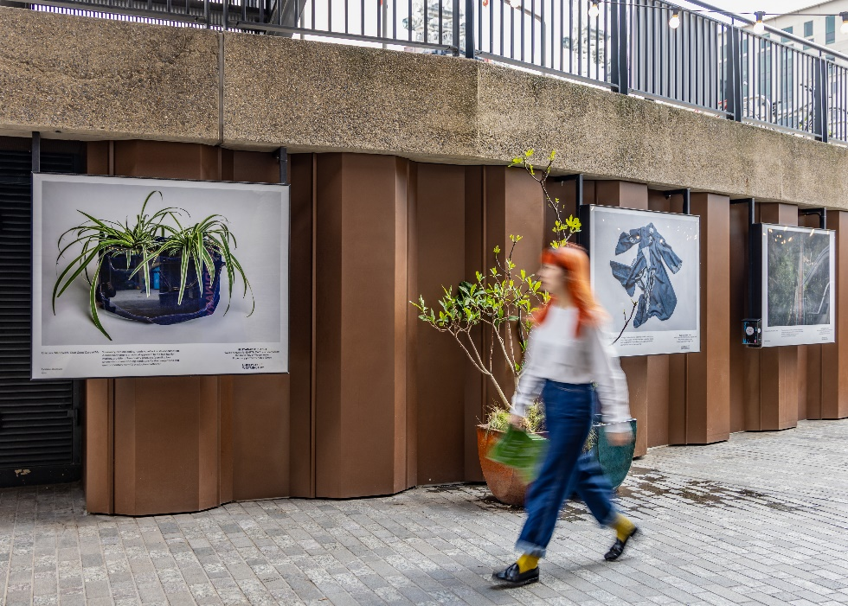
1Credit: John Sturrock
The pieces speak to three of this year’s Earth Day themes: Plant Trees, End Plastics and Sustainable Fashion. They also reflect a range of art forms, including painting, photography, fashion design and poetry.
The competition was the first arts collaboration between the University of Westminster and King’s Cross, and the resulting exhibition consisting of the winning pieces features work in lightboxes along Lower Stable Street at King’s Cross. A launch was held on 17 April and the pieces will be on display until 15 May 2023.
The students whose work was chosen to be featured are Nissam Fassi-Fihri with the piece titled Look Up; Charlotte Chin with the piece titled Life Cycle of Trees; Jasmine Etuate with her piece Precipitating England; Cristiano Mantovani with the piece Take Good Care of Me; Marie Baverstock and her piece titled London Plant Trees; Can Erdogdu with the piece titled Plant Your Damn Trees; Emily Duff with her poem titled Clothes Tell a Story; Ollie Astley with the piece Forget Fast Fashion; Iris Savatovsky with the piece Planting for the Planet; and Nicola Jurkiewicz with the piece titled S*ck of It.
Speaking about the inspiration behind her piece Life Cycle of Trees, Charlotte Chin said: “Composed of the tropical rainforest of Kuala Lumpur, Malaysia, the trees assemble themselves amongst the canopy bridge, emphasising the sustainability and use of trees today. The forest in the city acts as a carbon sink, absorbing and storing carbon dioxide from the surrounding urban area. This artwork portrays the life cycle of trees, from growing, cutting down, creating a built environment benefiting humans, and eventually decaying. Understanding the life cycle of trees, it conveys a message about the importance of trees to humans and the built environment, while also raising awareness about deforestation and the preservation of our natural habitats.”
Speaking about what it means to have her work chosen to be part of the exhibition and the inspiration behind it, Marie Baverstock commented: “I was thrilled when Pippa contacted me saying I would be part of the exhibition as I haven't created physical art in a while, so it was really nice to know that people liked it. I had a great time at Coal Drops Yard in King’s Cross celebrating the other artists and talking about the messages behind our work.
“I was inspired by the rings inside a tree trunk and so drew a cut down tree trunk in the shape of London, with the rings a nod to the city's growth over the years. This serves as a reminder that as London expands and construction continues, it is important to keep green spaces and plant trees for a healthier city and future generations.”
On her piece, Precipitating England, Jasmine Etuate, added: “The Precipitating England coat is inspired by puddles that I have come across when going on walks around London. The lining fabric is dead stock satin, which I purchased from a British fabric supplier. My goal as a fashion designer is to create sustainable clothes which are long lasting and to minimise the fashion carbon footprint.
“Being featured in the exhibition has been amazing. The people I met along the way and seeing my work with such talented people was such a delightful experience.”
Emily Duff, whose poem titled Clothes Can Tell a Story featured as part of the exhibition, said: “It is such a privilege to be the only poet selected to be involved in the Sustainable Planet Exhibition at King's Cross. Monday's event was a great chance to meet the other creatives selected, and to view my poem and their artwork in their final light boxes.
“My poem is written to invoke the memories attached to clothing you own, whether it be a hand-me-down or something you stumbled across in a charity shop. All of the clothes we wear hold memories, tell stories, and I wanted people to remember this and encourage more sustainable choices when it comes to fashion.”
Nissam Fassi-Fihri, who created the piece titled Look Up, commented: “Having my work chosen and winning a competition after only two months of living in London was and is such an incredible feeling, a blessing, and an achievement. [Look Up] is actually one of the first pieces of conceptual work that I have done, as I was used to sketching from images or existent work and reproducing them in my own way, so this just motivates me to create more and maybe participate in other competitions. Drawing and sketching is a hobby I look forward to pursuing, and I thank each jury member for motivating me to do so by choosing my piece!”
Find out more about Art, Design and Visual Culture courses at the University of Westminster.
Find out more about the University of Westminster’s commitment to Sustainable Development.
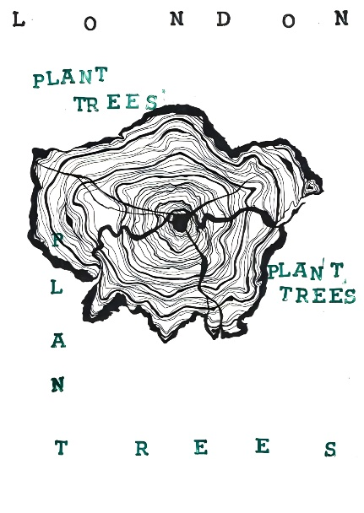
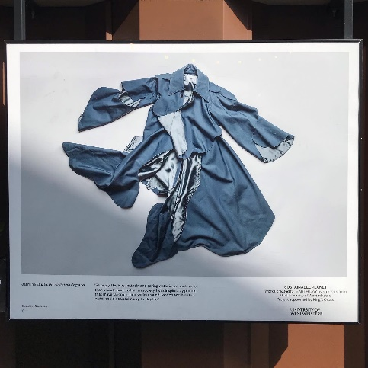
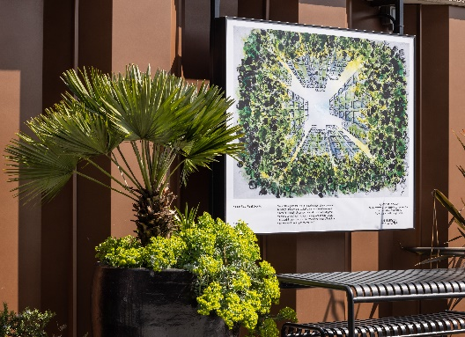
Photos for inclusion in carousel:

