The Brand-Consumer Metaverse Exchange Framework.
A dynamic understanding of the metaverse experience through self-concept, experience and engagement.

List of Figures

Figure 1 - The Brand-Consumer Metaverse Exchange Operationalization

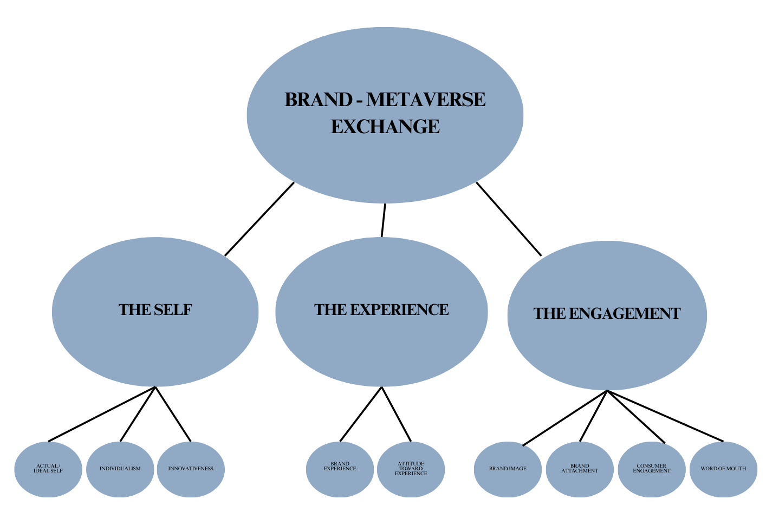
*Source: Own Elaboration

Figure 2 - The Metajuku-Everyrealm district
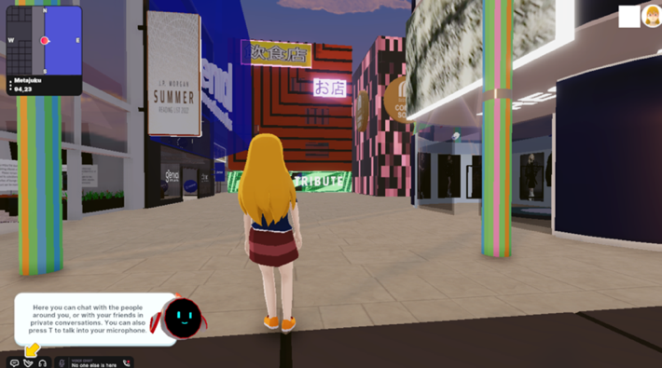
*Source: Decentraland.org

Figure 3 - J.P. Morgan branch

*Source: Decentraland.org

Figure 4 - The Brand-Consumer Metaverse Exchange Framework
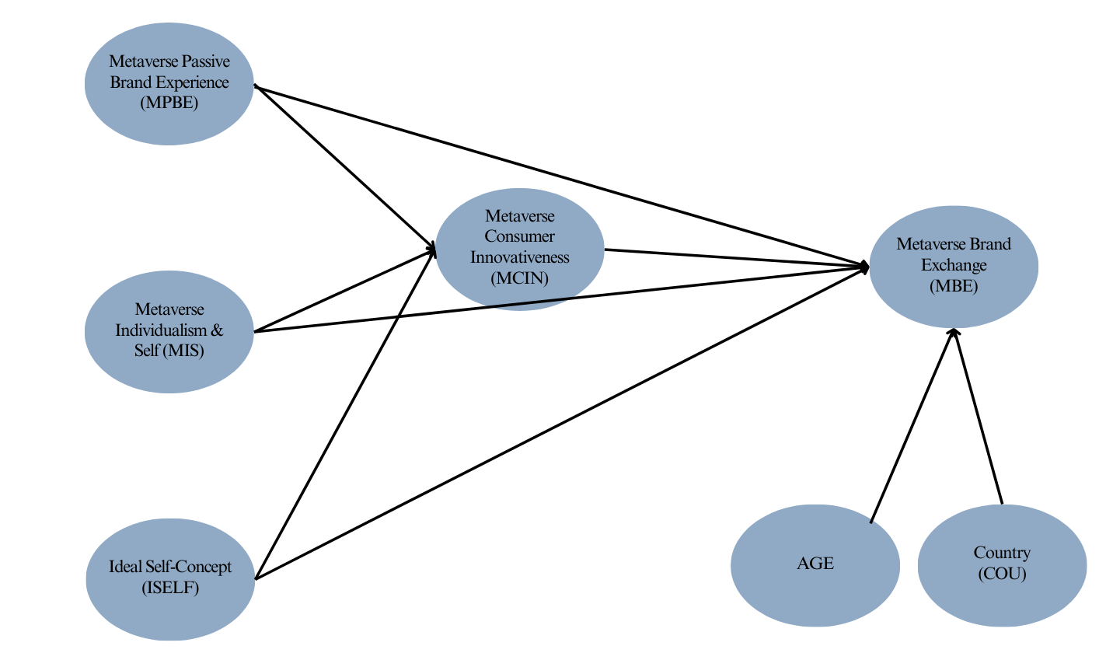

*Source: Own Elaboration

Figure 5. Final CFA model
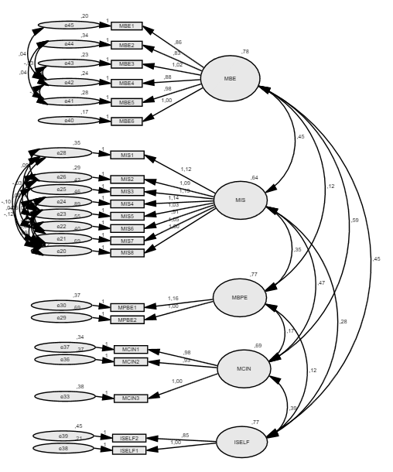
*Source: IBM AMOS, 23

Figure 6. Measurement of the proposed model
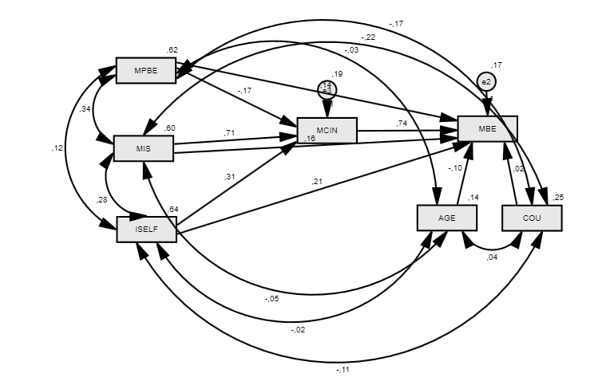
*Source: IBM AMOS, 23

