The Journal of Inclusive Practice in Further and Higher Education 12:1 December 2020

Edition produced by NADP with Paddy Turner as editor

Article 3: 24-hour exams - blessing in disguise for inclusive assessments or a logistical nightmare for higher education?
Authors: Daniela de Silva & Dr Claire Robertson, University of Westminster

Abstract:
In recent years, inclusive assessments have been at the forefront of the course design debate. While some universities had adopted 24-hour exams as alternative assessments for disabled students, most implemented 24- or 48-hour exams for the first time in April/ May 2020 following the unprecedented effects of the COVID-19 pandemic. This required students to take exams online, so they could progress with their studies.
This paper presents and discusses feedback gathered in three surveys designed to capture experiential feedback following use of online assessments/exams during the COVID-19 lockdown. Responses from 23 academic staff (survey 1) and 32 students (survey 2) from the University of Westminster precedes responses gathered from 21 National Association of Disability Practitioner (NADP) colleagues from different UK universities. Results are presented according to themes identified in responses, highlighting aligned discussions focusing on concerns as well as blessings/benefits associated with use of online assessments/exams. Exploration of whether 24-hour online assessments/exams can (and should) become embedded in the course design of university courses in the future follows, facilitating an informed choice of integrating inclusive assessments more routinely from hereon.
The unprecedented COVID-19 circumstances brought an opportunity to bring the wider utility of 24/48 online assessments/exams to the forefront of the higher education ‘inclusive assessments’ agenda. Results presented here suggest that they should be retained: embedding inclusivity within future course designs.
Key words: 24- /48-hour online assessments/ exams; inclusive assessments; inclusive course design.

Introduction
This paper is based on a session presented at the University of Westminster Virtual Learning and Teaching Symposium organised by the Centre for Education and Teaching Innovation (CETI) and held on 30th June 2020.
The rationale behind inclusive assessments is that these types of assessments meet the needs of a variety of diverse learners (disabled, mature, international and students with family commitments, etc.) The QAA (2018) UK Quality Code for Higher Education, Chapter B6 states that:
‘Through inclusive design wherever possible, and through individual reasonable adjustments wherever required, assessment tasks provide every student with an equal opportunity to demonstrate their achievement’ (page 17).
To achieve this, Hockings (2010) notes that inclusive assessment must include design and use of “fair and effective assessment methods and practices that enable all students to demonstrate to their full potential what they know, understand and can do” (page 13).
Various universities offer comprehensive advice on inclusive practices and principles (e.g. University of Plymouth (2020); Reading University (2020); The University of Edinburgh (2020) and many more). The University of Worcester (2018) for example promotes a ‘universal design’ approach which considers the diverse needs of all its students and argues that inclusive practice enhances the experience of all students, noting ‘inclusive practices are, therefore, good practices’. The debate about inclusive assessments and choice of assessments was in progress before the UK declared a lock down due to the COVID-19 pandemic on 23rd March 2020, closing physical access to universities before completion of the usual end of year, May/June exams on campus (The Guardian, March 2020).
Assessments which had until that time been branded as feasible alternatives to traditional two- or three-hour exams, with growing evidence supporting their use (e.g., Collings and Schoenborn, 2016; Jopp and Cohen, 2020), suddenly became extremely pertinent for several reasons. Evaluation of student understanding and attainment remained key, but health and safety concerns necessitated social distancing across all universities. The QAA Covid-19 Thematic Guidance (2020: p.6) stated: “Offering assessments over a 48-hour window to allow for students' local circumstances such as immediate surroundings, connectivity, and time zone differences” prompting immediate engagement with this inclusive assessment method.
The inclusion of 24- or 48-hour online assessments enabled higher education institutions to reach diverse students across the UK and across the globe in different time zones. They ensured accessibility for most students and reduced the need for reasonable adjustments in online exams. Finally, and perhaps most importantly, experiences with online assessments paved the path to transformational assessment practices (JISC, 2020) at various UK universities, thus promoting practices that are equitable by design for most students. This paper shares insight gained from academic staff, students and support staff on the learning opportunities this experience has facilitated for all Higher Education Institutions.

Methodology
The data presented in this paper was collected via three anonymous surveys at the beginning of June 2020 (shortly after the first exam cycle) using Google Forms. The first includes responses from 23 academics and registry services staff from the University of Westminster, including course and module leaders as well as Learning and Teaching Directors from across the University. The turnaround for the survey to be completed was two weeks and the distribution was requested via managers in various departments. Considering that it was sent around at the time of marking and exam boards, the relatively small number of responses was expected.
The second survey included questions pertinent to students and gathered information from 32 respondents.
The third survey was sent to members of NADP (The National Association of Disability Practitioners) to gain insight into the experiences of other universities which implemented 24- or 48-hours online assessments. There were responses from 21 colleagues from universities across the UK. Once the survey answers were completed and received, they were analysed and summarised. Findings including anonymised comments from the participants were presented at the University of Westminster Learning and Teaching Symposium.

Results and Discussion
The aim of the three surveys was to collate colleagues’ and students’ feedback, to evaluate their concerns and capture information on any positive reactions reported on the remote online assessments/ exams. An intention was also to initiate discussions on how the debate re online assessments can be taken forward, making them an integral part of course design in the future.

Survey One - academics from the University of Westminster
In the first survey which included responses from 23 academic colleagues, the distribution of the feedback was not very even; that is, most of the academics were from the College of Liberal Arts and Sciences 16 (66.6%) where the second author is based, with only three (12.5%) responses from the registry offices, four (16.7%) from the Westminster Business School and one (4.2%) from the Student Union.

Concerns/negatives of 24-hour online assessments/exams for academics from the University of Westminster
The main concerns for colleagues can be divided into themes. The first was academic misconduct and the ‘unknowns’ linked to whether the student (or someone else) answered the questions while at home and online. The second linked to the design of online assessments/ exams. The fast rollout to online assessments (decisions were made within several weeks) meant that some worried that module learning objectives might not be appropriately assessed. A group of colleagues said that the online assessments may not provide a fair measure of students’ knowledge. Others commented that they did not assess what exams would normally assess because the format was different.
The third theme which emerged linked to problems with connectivity, that is the quality of the Wi-Fi which had an impact on access to Blackboard (the virtual learning environment used at the University of Westminster). Colleagues commented that Blackboard crashed for some of their students during the 24-hour period and some colleagues had to support some of their students online, including on a Saturday.
The fourth theme linked to the living conditions of students (both those in the UK and elsewhere across the world). Academics commented that some of their students lived in very crammed living conditions with no access to a quiet space to take the exam. Therefore, this factor probably had an adverse effect on the student’s online assessment, and one which could not be fully evaluated.
Finally, some academics found that greater effort was needed to mark the online assessments/exams. They reflected on the lack of previous experience marking these types of assessments, and to sufficient ‘practice’ needed to determine what they could/should reasonably expect from students.

Positives/blessings of online assessments/exams for academics from the University of Westminster
Since students could access the exams from anywhere in the UK and the world, one of the module leaders commented that in her/ his view, the 24-hour open book exams/ assessment worked better than s/he expected. Other academics felt that the answers the students gave were at a much higher level than the students would normally produce, and this showed a real commitment and dedication on the part of the students. Moreover, once the marking scheme was appropriately adjusted, the academics were able to see the differentiation between the submissions.
Another colleague said that this was a very successful exam format for their module and s/he felt that the students could think more in depth about the answer. S/he went further to say that it was relatively easy to spot those students that had not answered the question asked or understood what they wrote. Another noted that the best answers still stood out as they were well constructed, well written and demonstrated very good understanding of the topic. Moreover, the lecturers reflected that they could still see that the weaker students, the ones who in an ordinary exam would not answer anything, now had ‘some kind of an answer.’ They added that it remained obvious that they just copied and pasted from either the lecture materials or their notes. In short, academics could see differentiation between answers, and good answers stood out in the 24-hour online assessments/ exams.
When asked if the 24-hour exams provide a level playing field for the diverse body of students, rating their responses from 1 strongly disagree to 5 strongly agree, most respondents eight (34.8%) were unable to discriminate; five (21.7%) each agreed and strongly agreed, four (17.4%) less strongly agreed and only one respondent (4.3%) strongly disagreed that online assessments/exams provided a level playing field for all students (Figure 1).

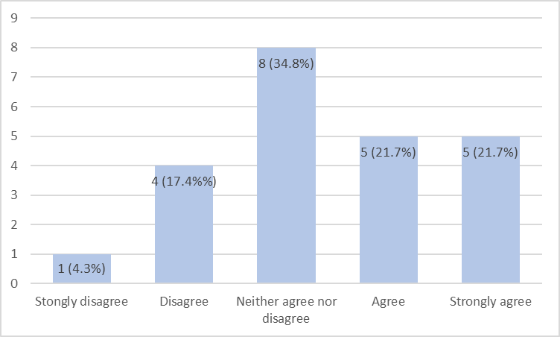

Figure 1. Survey One: Academics from the University of Westminster. Responses to Q2: How strongly do you agree with this statement: 24-hour exams provide a level playing field for all students and remove the need for extra time (1 = strongly disagree; 5 strongly agree)

When colleagues were asked whether they would like to see 24-hour exams continue as a regular type of assessment in the future 11 (47.8%) said ‘maybe’; seven (30.4%) said ‘yes’ and five (21.7%) said ‘no’ (Figure 2).

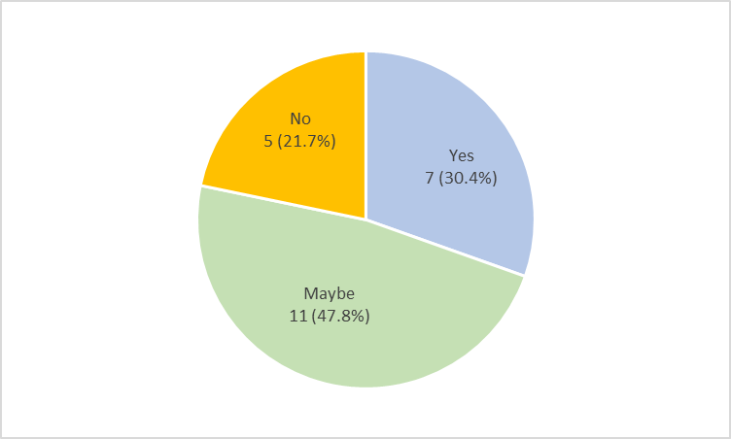

Figure 2. Survey One: Academics from the University of Westminster. Responses to Q3: ‘Would you like to see 24 hour exams included as a regular type of assessment in the future?

This was a relatively small survey with only 23 respondents across the University of Westminster (the university has around 1600 academic colleagues). The aim for any future surveys will require more responses and capacity to assess replies across different schools or even courses to provide a much clearer picture of whether 24-hour exams can be included as a regular type of assessment across different subject areas.

Survey Two - students from the University of Westminster
32 students responded to this survey, 21 (68.5%) of whom were undergraduate, ten (28.6%) postgraduate and only one student (2.9%) from a foundation course. Greater responses were obtained from students in the College of Liberal Arts and Sciences (Figure 3).

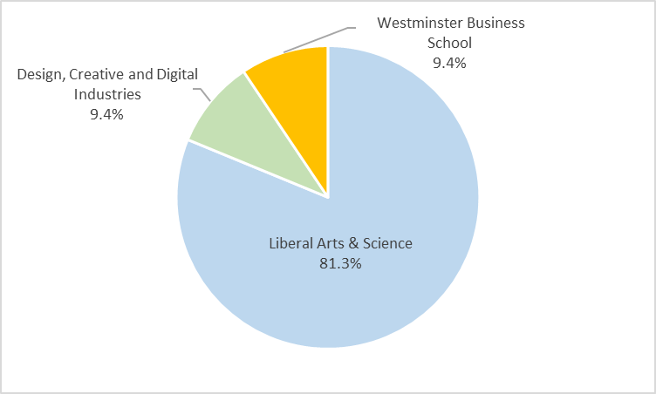
Figure 3. Survey Two: Students from the University of Westminster. Responses to Q1: ‘Please tick which college you are attending’

Concerns/negatives for students from the University of Westminster
Survey 2 demonstrated that the concerns students had with the 24-hour online assessments/ exams could also be divided into themes. The first which stood out was stress and anxiety. Some felt that it was very hard to concentrate on the internet and they reflected on the level of stress associated with not submitting on time. They also felt their anxiety lingered for much longer compared to a traditional two to three-hour exam.
The second theme echoed one shared by academics: difficulties with the internet connection or the Blackboard site. One student reported that s/he could not submit the answers and move on to the next ones. S/he felt that this problem lost her/ him half of the time, and indications were that they felt this had affected her/his mark.
The third theme was the level of difficulty of the online assessments/ exams. Some students felt that the online assessments/ exams were no more or less difficult than normal exams, however the level of support information and the actual structure of the online assessments was not communicated to them very well. Furthermore, students felt there were many variations of the online assessments across the modules which was confusing and added pressure. Some felt that the expectations for academic excellence in the 24-hour online assessments/ exams felt much higher.
The 24-hour online assessments/ exams were rolled out at a time when quick decisions had to be made (e.g., several universities choosing to apply a no detriment policy (UCL, 2020), University of Dundee (2020); or include no exams at all as in the case of Queen’s University, Belfast (2020) to prevent delaying graduation for many students.
The alternative, use of online assessments/ exams, option as implemented at the University of Westminster, required retrospective learning in the unprecedented circumstances of Covid-19. It is apparent that under the circumstances, some academic colleagues did not have enough time to prepare and send off detailed instructions about the online assessments/ exams. This provision is of the essence if online assessments become part of the course design and assessment choice in future.
The fourth theme which emerged from the students’ survey was that students found referencing quite difficult as they were not sure what level was expected (e.g., in text citations) or how many references they needed to include. Again, this brought along a certain degree of stress and anxiety (as noted in theme one).
The fifth theme students commented on was time management. A mature student said that as a parent to a toddler, s/he found it very difficult to manage her/ his time because s/ he needed to look after her/ his child and submit the exam within 24 hours. These exams were taken during the period of time when family visits were not allowed due to the Covid-19 lock down and therefore this student could not rely on family for childcare and could not have her/his child at nursery either as most nurseries were closed. The expectation was that they could select and use the time required within the full 24- or 48-hour period available. However, the capacity of individual students to do this would have inevitably differed based on their circumstances (e.g., size of home, presence of partner, age of child).

Positives/blessings for students from the University of Westminster
Some of the responding students felt that the online exam questions were just as difficult as a traditional exam. However, they felt more at ease doing the exams at home. One particular student felt that the online assessment was ‘a nice challenge’ and that it was a great preparation opportunity for professional life. Others felt that the online assessments were less stressful; they had time to really think about their answers and reflected that it was easier to concentrate compared to a traditional exam.
Students reported that everyone had equal time to prepare. This comment is significant considering the response of one student who described managing a difficult family situation experienced during the exam period. Due to the pressure of dealing with a family member who was taken ill, s/he would not have been able to come to university and sit the exam if there was no option to do a 24-hour online assessment/exam.
Another student thought that 24-hour exams were a great choice and would like to see them retained as a choice because s/he finds actual exams really stressful and the opportunity to complete them at home was much more relaxing. A student with parenting and other responsibilities around their children and home schooling reported that the 24-hour exams enabled them the opportunity to demonstrate the knowledge s/he had. Moreover, this student felt that 24-hour online assessments/ exams comprised a more ‘student-centred’ approach to assessments. It can be assumed that this (although we cannot be certain of their intended meaning) relates to the capacity for students to have the choice of how to organise their time and work needed to complete the exam).

Do 24-hour online assessments/ exams provide a level playing field for students?
Figure 4 highlights the student opinion on whether online assessments provided a level playing field for students, removing the need for reasonable adjustments including extra time to complete assessments. 15 (46.9%) agreed, ten (31.3%) were undecided, and only seven (21.9%) did not agree that this was the case. The University of Westminster (2020) provided clear guidelines saying that the 24-hour online exams “should note that your exam is not expected to take longer to complete than the originally planned time (2 or 3 hours for example). The 24 hours provides a window of time for you to complete the upload as required.” This would suggest however that this was not always read/understood by students.
Although 24-hours were available for completion of assessments, this highlights the importance of clear directions to ensure students remain aware of the expectation on them with regard time required to complete the work/ questions set.

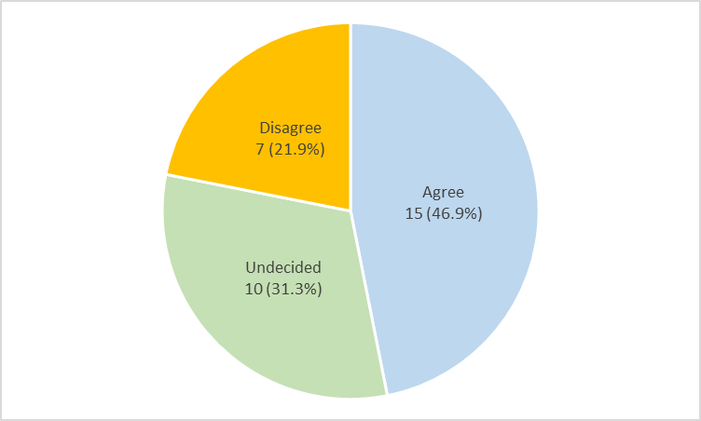
Figure 4: Survey Two: Students from the University of Westminster. Responses to Q4: ‘24-hour exams provide a level playing field for all students and remove the need for extra time’

A large majority 21 (65.6%) of students responded positively to question 5 (Figure 5) highlighting that they would like 24-hour exams to be part of their assessment choices in the future. Only three (9.4%) disagreed and eight (25%) replied maybe. The demographic of these respondents is unknown, however it highlights again the importance of clear instructions for all students, to ensure they do not attempt to spend the full 24-hours on the paper for example.

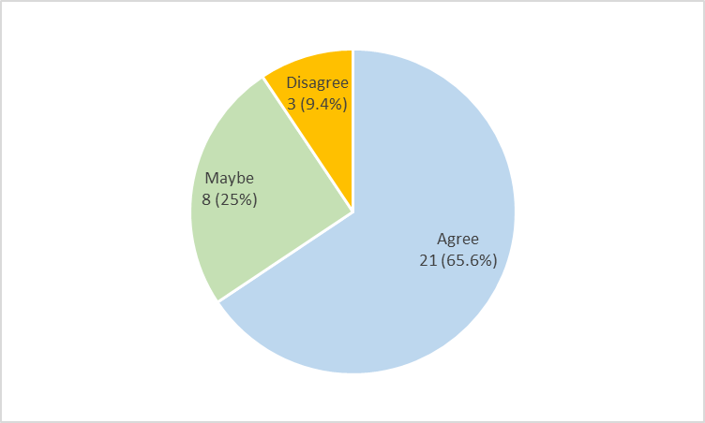
Figure 5: Survey Two: Students from the University of Westminster. Responses to Q5: Would you like 24-hour online exams to be part of your assessment choice in future?

Survey Three – colleagues from other UK universities
Inclusion of insight from colleagues in other higher education institutions was made possible by sending the survey via the group email of the National Association of Disability Practitioners across the UK. These responses are predominantly therefore from individuals in managerial or advisory roles within disability and wellbeing services (see Figure 6).
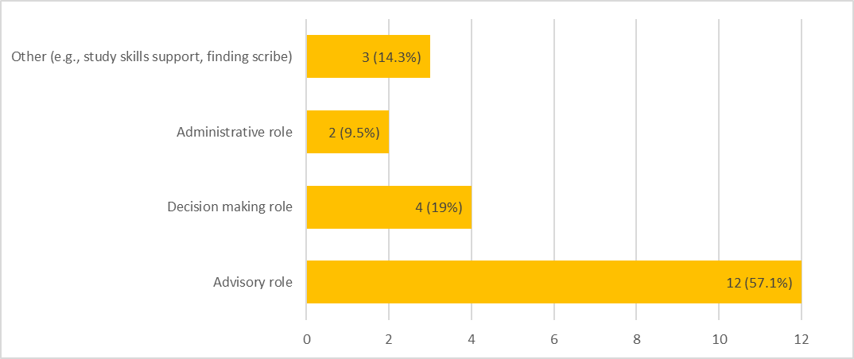
Figure 6: Survey Three: Colleagues from other UK universities. Demographic of respondents by job roles in 24- / 48-hour online assessments/exams.

The majority of respondents (n=12, 57.1%) had an advisory role, four (19%) had a decision-making role, two (9.5%) were administrative and the rest, five (24%) were arranging scribes, providing study skills or wrote papers about their concerns.
Reflecting on operational set up of online exams (with 1 being most difficult and 5 being very easy), ten (47.6%) said it was neither easy nor difficult, while two (9.5%) considered it very difficult and only one (4.8%) thought it was very easy (Figure 7).

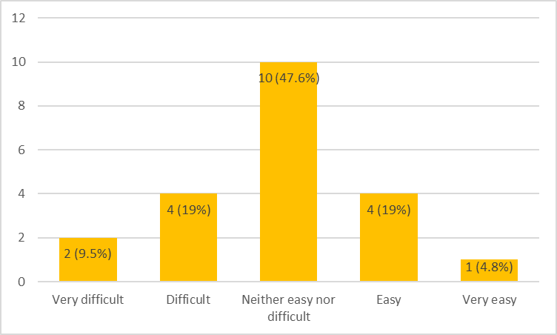
Figure 7: Survey Three: Colleagues from other UK universities. Responses to Q3: ‘How easy or difficult was it to operationally set up 24 or 48-hour exams?’ (1 = very easy to 5 – very difficult).

Concerns/negatives - colleagues from other UK universities
Non-academic respondents predominantly agreed that some students (including but not only those with ‘adjustments’ in place) still required one to one support in order to have a level playing field. Students on the autistic spectrum for example were considered to find 24-hour online assessments/ exams quite stressful and much harder than traditional exams. The main reason offered to explain this linked to amendments to their ‘usual way of working for an exam’ suggesting that in time, this difficulty may reduce. Preparation was considered harder, with students unable to decide how much time they needed to spend on the exam and understanding of the assessment criteria they would be marked against being uncertain. For students on the autistic spectrum, online assessments were a very big change in a very short space of time and therefore are likely to have had a detrimental impact.
Colleagues reported that certain students had the ‘terrible’ incentive to work throughout the night, for the full 24 hours available, and that many therefore had extended feelings of anxiety and stress. One to one support was needed to calm them down and to reassure them that they did not need to work throughout the 24 hours, adding workload on support staff and potential inequity in support for those who sought support/ advice relative to those who did not for example.
There were cases reflected on (from different universities) where some dyslexic students who would have had 25% extra time in an ordinary campus-based exam, informed staff that they felt they needed (or wanted) 25% on top of the 24-hour time given to other students.

Positives/blessings from colleagues – other UK universities
Many colleagues found that offering the remote 24- or 48-hour online assessment/ exams window created a level playing field and reduced the need for extra time for any student. Perceptions noted that this assessment method allowed students to use assistive technology which can be problematic in exams, within their home environment. For instance, students who use speech to text software already had established use of the software at home and were more comfortable using it in those circumstances.
In addition, the extended time periods offered in online assessments/ exams mitigated the need to request time breaks - all students could take breaks whenever they personally thought it was necessary. Some colleagues also felt that students could demonstrate higher education skills in synthesis and analysis without being burdened with the artificial need to memorise knowledge and facts.
These comments led to a general agreement with the question whether 24-hour exams provide a level playing field for students and remove the need for extra time with nine (42.9%) agreeing. Four respondents (19%) were neutral, however five (23.8%) disagreed and two (9.5%) strongly disagreed. Only one respondent (4.8%) strongly agreed that 24-hour exams provide a level playing field and remove the need for extra time (Figure 8).

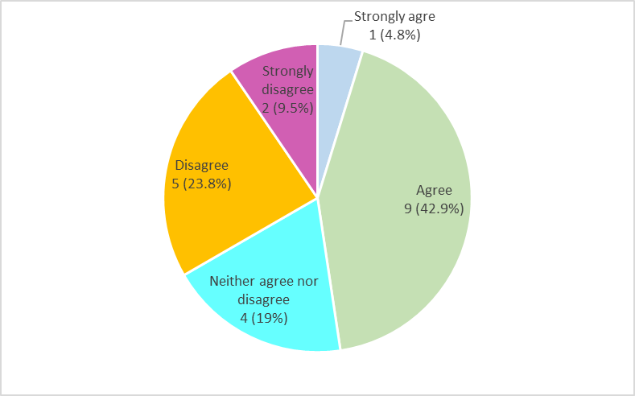
Figure 8: Survey Three: Colleagues from other UK universities. Responses to Q5 ‘How strongly de you agree with this statement: 24-hour exams provide level playing field for all students and remove the need for extra time’

Further thoughts from colleagues at other UK universities
Edinburgh Napier university used week long open book exams as a replacement for the campus-based closed book exams. Students were sent prompts by phone or Skype to help them to keep on task. Colleagues at this institution felt that this benefited students with additional responsibilities such as home schooling/ childcare. Giving full week to complete the exams made it easier to fit the three to four hours needed to complete the task around the other commitments in their lives. This was considered a very student-centred approach towards assessment.
Colleagues from other universities reflected on the need for universities to recognise the need for quiet space, efficient Wi-Fi and clear marking criteria to minimise anxiety amongst students while completing assessments – and to provide this space if it is not feasible at home. Colleagues recognised that various departments need to work closely with the accessibility team at universities to produce clear, step-by-step guidance about taking the online exams as well as the marking criteria if this method is used for exams in the future.

24-hour online assessments /exams: Conclusion and recommendations for the future
The 2019/ 20 academic year will be remembered in the UK for the indecision experienced by high school students awaiting decisions around taking and grading GCSE and A-levels by Ofqual and exam boards. Management of admissions decisions during clearing, when candidates did not receive the grades they were predicted compounded these difficulties (BBC News, 12th September 2020). For those already at university, variability in protocols used across higher education institutions in assessment of students added additional concerns (The Guardian, 21st March 2020). Irrespective of whether scientific advances can prevent situations like the COVID-19 pandemic occurring again, its impact on the spring and summer terms of 2020 cannot be ignored. Huge efforts have been undertaken by thousands of university staff across the UK alone and the lessons learnt from this work must be shared. First-hand experience gained from a sample of individuals involved in the design and marking (survey 1: academics), completion (survey 2: students) and management (survey 3: university management and support staff) of 24- or 48- hour online assessments/ exams has been gathered and presented here. Results are shared to facilitate learning from these experiences. Reactive to the conclusions made by Magne and Miller (2018) our findings have highlighted that ‘assessment design should: be considered at programme level, include variety; assess key learning outcomes; and think not just in terms of the discipline but also the wider skills that employers are looking for’ (page 62). This may require some adaptation of learning outcomes and marking techniques if longer (24- /48- hour) online assessments/ exams are integrated more generally in university assessment options; and for different subject areas we acknowledge this format may have more or less suitability (e.g., when immediate recall of facts may be vital, for example the capacity to link illness symptoms to a diagnosis without the need for 24 hours of consideration). Feedback received following the presentation at the Learning and Teaching Symposium on the 30th June 2020 at the University of Westminster from academic colleagues included comments that improved assessment design must prioritise alignment between learning outcomes, assessment criteria and key graduate skills. The potential benefit of including options for mode of assessment offered now also seems especially pertinent. Pre-COVID, such options were suggested to reduce the need for academics to design assessment modifications as a means of ‘reasonable adjustment’ where needed. Today, they may be considered an alternative but more inclusive method to testing when the planned assessment is not feasible due to restraints imposed by sources outside our control. Most pertinent of all is the realisation across all of higher education today: integration of feedback from students on how to ensure clarity in design and dissemination of instructions for online/ assessments/ exams is vital and can only drive forward the dialogue about diversifying assessments in higher education.

References
BBC News (12th September, 2020). Coronavirus: The story of the big U-turn of the summer. Written by Sean Coughlan. Access from: https://www.bbc.co.uk/news/education-54103612 (27th November, 2020).
Biggs, J. and Tang, C. (2007). Teaching for Quality Learning at University. Maidenhead: Open University Press.
Boud, D. & Falchikov, N. (2006) Aligning assessment with long term learning. Assessment & Evaluation in HE. vol31.no4.p399-413
Collings, J. and Schoenborn, P. (2016) ‘Inclusive Assessment: Why? What? How?’ [PowerPoint Presentation]
Hockings, C. (2010). Inclusive learning and teaching in higher education: a synthesis of research. York: Higher Education Academy. Access from: https://www.advance-he.ac.uk/knowledge-hub/inclusive-learning-and-teaching-higher-education (5th Nov, 2020).
JISC (2020) https://www.jisc.ac.uk/news/how-covid-19-has-changed-student-assessment-for-good-15-jun-2020 (Accessed: 19th Nov, 2020)
Jopp, R. & Cohen, J. (2020) Choose your own assessment – assessment choice for students in online higher education, Teaching in Higher Education.
Leeds Becket University (2018), Inclusive Assessment Design. Available at: https://www.leedsbeckett.ac.uk/staffsite/-/media/files/staff-site/quality-assurance/key-information/validation/inclusive-assessment-guide-final.pdf (Accessed: 10.09.20)
Magne, P. and Miler, W. (2015) ‘Inclusive Assessment Design and delivery in the disciplines’ in PedRIO Paper 7, Available at : https://www.plymouth.ac.uk/uploads/production/document/path/5/5858/PedRIO_Paper_7_.pdf (Accessed: 11.09.20)
QAA: (2018) UK Quality Code for HE. Chapter B6. Assessment of students and recognition of prior learning. Available at: https://www.qaa.ac.uk/docs/qaa/quality-code/chapter-b6_-assessment-of-students-and-the-recognition-of-prior-learning.pdf?sfvrsn=9901f781_8 (Accessed: 10.09.20)
QAA: (2020) https://www.qaa.ac.uk/docs/qaa/guidance/covid-19-thematic-guidance-academic-standards.pdf?sfvrsn=cbcccd81_6 (Accessed: 12.11.20)
Queen’s University Belfast (2020) Cancelled Exams https://www.bbc.co.uk/news/uk-northern-ireland-51979583 (Accessed:12th Nov, 2020)
The Guardian (21st March 2020). Oxbridge to replace summer exams with online assessments due to coronavirus. Written by David Batty. Access from: https://www.theguardian.com/education/2020/mar/21/oxbridge-to-replace-summer-exams-with-online-assessments-due-to-coronavirus
The University of Edinburgh (2016) https://www.ed.ac.uk/institute-academic-development/learning-teaching/staff/inclusive/accessibility/assessment/questions (accessed 12.11.20)

UCL (2020) No Detriment Policy https://www.ucl.ac.uk/teaching-learning/assessment-and-awards-2019-20/exceptional-amendments-academic-regulations-2019-20-assessments (Accessed:12.11.20)
University of Dundee (2020) No Detriment Policy https://www.dundee.ac.uk/announcements/coronavirus-update-students-20-04-2020 (Accessed:12.11.20)
University of Plymouth, Inclusive Assessments https://www.plymouth.ac.uk/about-us/teaching-and-learning/inclusivity/inclusive-assessment (Accessed:12.11.20)
University of Reading; https://www.reading.ac.uk/engageinassessment/different-ways-to-assess/eia-different-assessment-methods.aspx (accessed:12.11.20)
University of Westminster (2020) Exam Guidelines: https://www.westminster.ac.uk/current-students/studies/exams-and-coursework/exam-timetables (accessed on 10.11.12)
University of Worcester (2018) Principles and Practices for Inclusive Learning, Teaching and Assessment. Available at: https://www2.worc.ac.uk/inclusiontoolkit/documents/2._Principles_and_practices_for_inclusive_learning_teaching_and_assessment.pdf (accessed: 09.09.20)
Waterfield, J., & West, B.,(2006) Inclusive Assessment in Higher Education: A Resource for Change. Plymouth University

