LEAP THEN LOOK

Learning to be an Artist

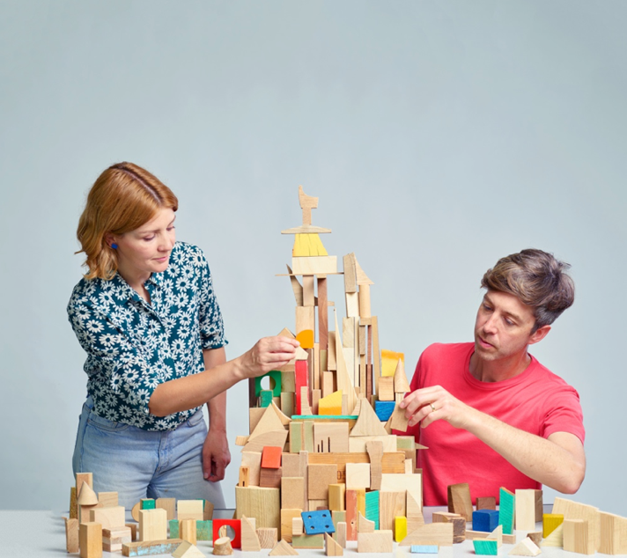
Leap Then Look: Lucy Cran and Bill Leslie.
Photographer: Hugh Fox @mrhughfox

Leap Then Look’s founders, artists Lucy Cran and Bill Leslie, believe that ‘contemporary art practice should and can be made available and accessible to everyone and that we can all benefit from engaging with new ways of looking, making and thinking.’ They devise projects, workshops and events for a broad range of people and social groups, with an emphasis ‘on working together, inspiring playfulness, inquisitiveness and experimentation.’ Their exciting and unconventional approaches enable participants to engage in multiple processes to create their own work, which might include object making, performance, installation, film, and photography.¹

Their workshops are carefully structured environments providing an active space of exploration that can facilitate discovery — discoveries that might be personal or collective, perhaps bringing social, ecological or cultural insights. For example, in 2021, Leap Then Look devised a series of workshops titled Take/Make/Use/Lose as part of the London Schools Climate Kickstart Project, coinciding with the COP 26 UN Climate Change Conference held in Glasgow. These challenged young people from three schools in different areas of London to explore ways of reworking, remaking and reusing existing objects by paying attention to the particular qualities of their materials and components. In June 2022, as part of the London Festival of Architecture, they invited families to create a temporary installation around and across the Wiggle Wonderland pavilion and exhibition space.² This took inspiration from Duchamp’s renowned Mile of String installation, that he conceived to hamper visitor access at the opening of The Papers of Surrealism exhibition in New York in 1942;³ in a comparable spirit, children and their carers made a giant web of string, resulting in playful, unexpected ways to navigate and experience the space.
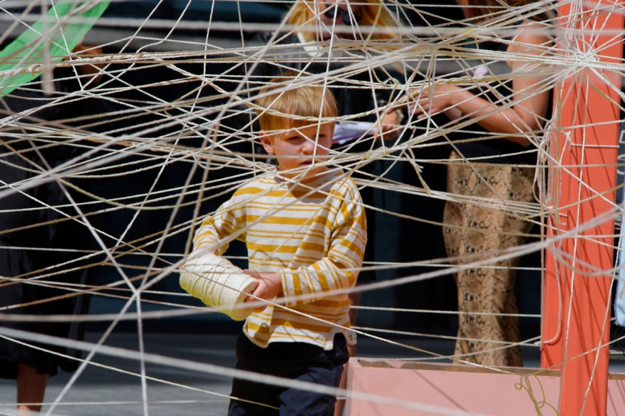
Leap Then Look, 1 Mile of String, at the London Festival of Architecture
within the Wiggle Wonderland structure in St Giles Square.

In creating activities that encourage play, Look Then Leap are influenced, in part, by the work of English paediatrician and psychoanalyst, Donald Winnicott. His concept of a transitional object identifies an item used by an infant to support the developmental necessity of separating from the mother, and in gaining the capacity to distinguish between ‘me’ and ‘not me.’ Bill Leslie points out that, for Winnicott, it is such a shift from ‘object relating’ to object use’ that underpins people’s capacity to play, enabling us ‘to use and manipulate things, and to hold multiple meanings or possibilities for objects within our understanding.’⁴ Winnicott also identified the significance of creating a safe environment where an infant can feel confident to take risks and explore. This is the ‘potential space’ or ‘holding space’ that ideally exists ‘between baby and mother, between child and family, between individual and society,’⁵ which can also be recognised as a space of therapy, pedagogy and creativity. It is this kind of space that Cran and Leslie seek to provide where, having laid the conditions for the encounter, they intervene as little as possible so that participants are given agency to explore and discover for themselves.

The family workshop developed by Leap Then Look for the Royal Academy of Arts, London (August 28) was titled Play, Assemble, Connect and took the theme of ‘learning to be an artist.’ Lucy Cran describes her studio practice as ‘making as a process of learning and discovery,’ and the theme reflects Cran and Leslie’s interest in sharing their artistic approaches with others. The event, which is presented as part of the Look Who’s Talking online exhibition, ran across four rooms, and it showed some strategies that can be used to encourage new ways of looking, making and thinking, without any pre-defined goals or expectations.

Room 1
The short text panels, placed at the entrance to each room, provided a simply worded introduction to a proposed activity and offered families a few suggestions. The text for Room 1 set the scene by encouraging participants to Think like an artist, and read:

Artists need starting points and materials to explore. Sometimes it’s best not to know what you are making before you start.
In this room there are lots of materials and a series of instructions. Think carefully about what they mean and try to make responses that surprise you.

The wealth of materials provided included foam offcuts, pre-cut shapes, sticks, tubes, wire and tape, and a series of open-ended instructions could be found around the space, which participants could interpret in whatever way they chose.

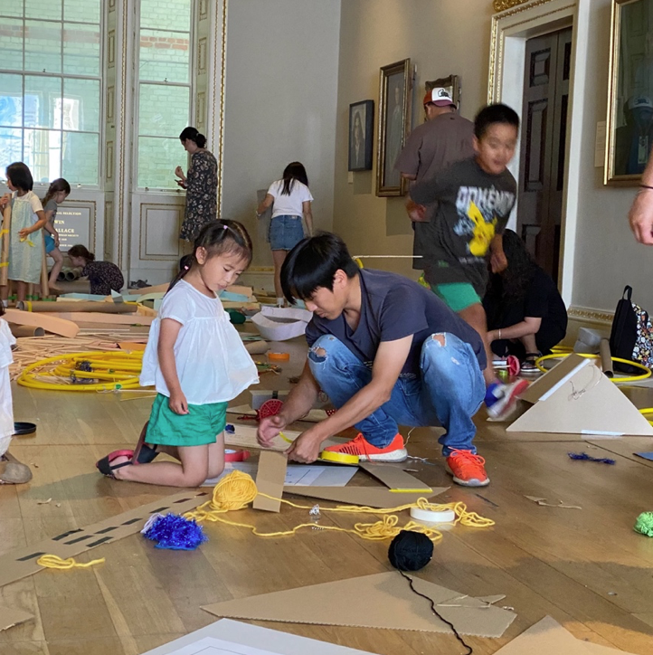
Leap Then Look, Play, Assemble, Connect workshop (Room 1),
Royal Academy of Arts, London.

Room 2
Room 2 was The projection room, where it was suggested:

Art is not just for looking at. It can change the way we act and think.
Get in the way of the projection. Use your body to make shadows and explore the different movements you can make.

Here the visitors encountered a video projection of footage of people responding to the experimental choreographer Yvonne Rainer’s hand dance (1966), which was edited together with footage of experimental mark-making. A range of ‘shadow props’ and coloured acetate shapes were available to use, so that participants could explore shadow making as they interacted with the moving images.
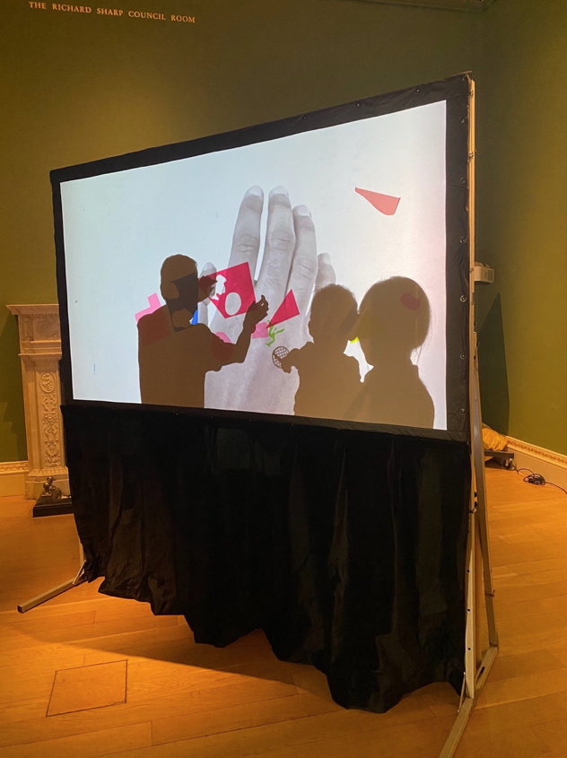
Leap Then Look, Play, Assemble, Connect workshop (projection play in Room 2),
Royal Academy of Arts, London.

Room 3
For Room 3: Working together, the text explained:

Artists don’t always work alone. Making things with other people can be fun and exciting, and can make us do things in different ways.
In this room there are bamboo sticks and fastenings. Can we work together to make the biggest structure possible?

A large quantity of sticks of various lengths could be found, along with connecting materials, such as reusable cable ties, elastic and string.
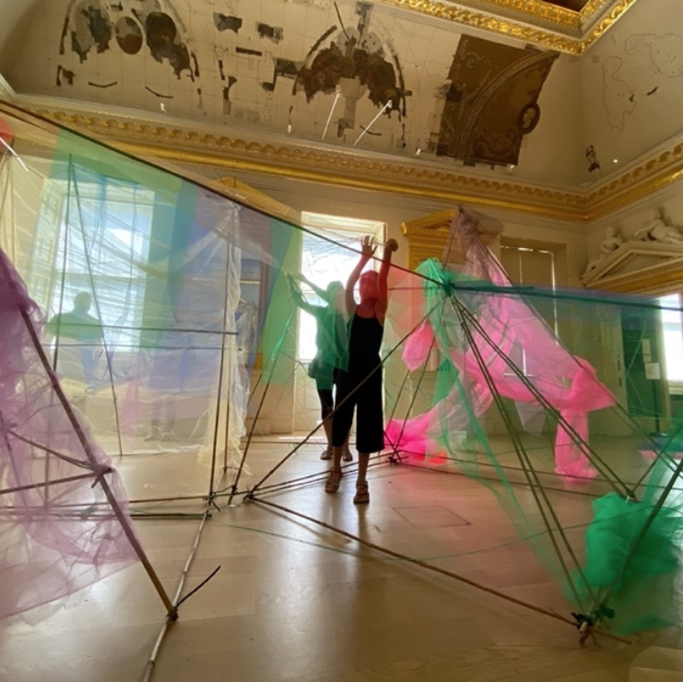
Leap Then Look, Play, Assemble, Connect workshop (building a structure in Room 3),
Royal Academy of Arts, London.

Room 4

The theme of Room 4 was Use your ears and visitors were told:

Artists listen carefully to their surroundings. Listen carefully. What can you hear that you wouldn’t normally notice?
This room has lots of materials to make sounds with. How many different sounds can you make? Can you play them together to make a sound performance?

The collection of materials and objects that were available to experiment with included pots and pans, sticks, bells, an electric guitar and an amplifier. Participants were able to explore the sonic possibilities of these objects, finding different ways to play and move among them.
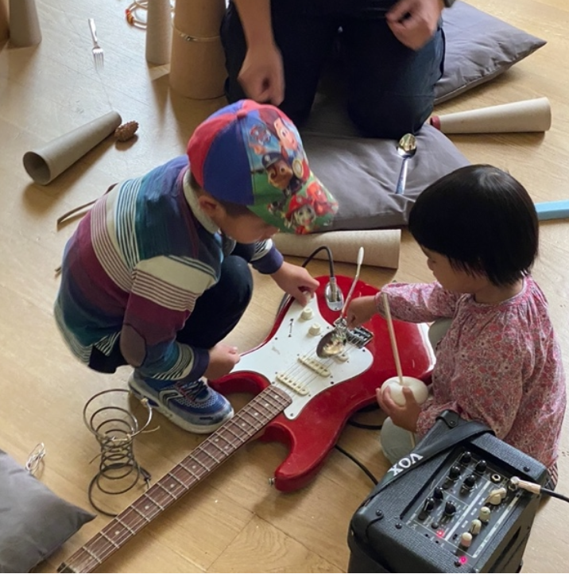
Leap Then Look, Play, Assemble, Connect workshop (experiments in
sound making in Room 4), Royal Academy of Arts, London.

In revered cultural spaces, such as London’s Royal Academy of Arts, many visitors can feel constrained and passive consumers of information, but the Play, Assemble, Connect workshop offered productive alternatives to conventional modes of intellectual contemplation. Participants were given multiple opportunities for free exploration and play, permission to experience art and art processes – socially and collectively – in active and imaginative ways. As ever, for Leap Then Look, the activities aimed to challenge the expectations of participants, and to open up a space where children and adults alike could be genuinely surprised by what they had created.

Tessa Peters

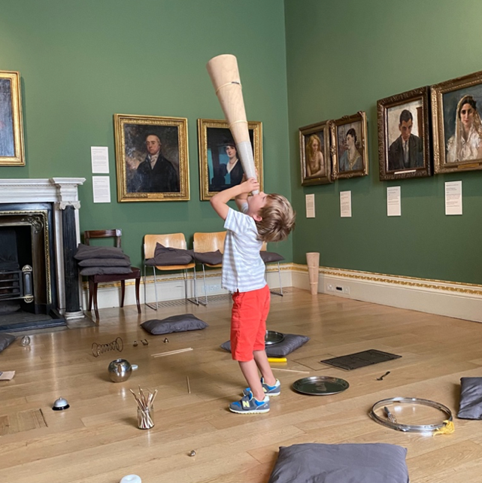

1. See Leap Then Look website: https://www.leapthenlook.org.uk/AboutUs.html

2. Wiggle Wonderland is a touring pavilion and exhibition space activated by artists and communities. The project is a collaboration between architectural designer Beau McCarthy and artist Lucy Grainge. See: https://www.lucygrainge.com/wiggle-wonderland

3. See: David Hopkins, ‘Duchamp, Childhood, Work and Play: The Vernissage for First Papers of Surrealism, New York, 1942.’ Tate Papers, No. 22, Autumn 2914. Available at: https://www.tate.org.uk/research/tate-papers/22/duchamp-childhood-work-and-play-the-vernissage-for-first-papers-of-surrealism-new-york-1942

4. Bill Leslie, ‘Good Enough Sculptures; Good Enough Teaching: Creating opportunities for play and physical exploration in the teaching and making of art.’ In Nicholas Addison & Lesley Burgess (eds) Debates in Art and Design Education, 2nd Edition. London: Routledge, 2020.

5. D. W. Winnicott, ‘The Location of Cultural Experience,’ Playing & Reality, London: Routledge, 2005, p.139

