The material-semiotics of fatherhood: the co-emergence of technology and contemporary fatherhood

Shona M Bettany ^{a ⃰}
Ben Kerrane ^{b}
Margaret K Hogg ^{c}

ª Westminster University Business School, Marylebone, London, UK, W1B 2UW; Tel: +44 (0)20 7911 5000; S.Bettany@westminster.ac.uk
^{b} Manchester Business School, Booth Street West, Manchester, UK, M15 6PB; ben.kerrane@mbs.ac.uk
^{c} Lancaster University Management School, Lancaster, UK, LA1 4YX; m.hogg@lancaster.ac.uk

⃰ Corresponding author

October 2013

Abstract
Using Actor Network Theory (ANT) this paper examines the role of caring technologies in the complex transition to new fatherhood, exploring the ambivalent role these objects play in the family setting to co-enable different forms of fathering and masculinity. The paper explores the processes through which these objects, together with emerging fatherhood enact a material-semiotic struggle over identity, processes and action. In doing, so the paper derives insights of potential value to marketers, technological innovators, and policy makers alike.

Keywords: Actor network theory, fatherhood, transitions, masculinity, caring technologies

The material-semiotics of fatherhood: the co-emergence of technology and contemporary fatherhood

1. Introduction: contextualising new fatherhood
The family is the most important site of consumption (Commuri & Gentry, 2000). Families house complex bundles of identities at the collective and individual level as family members use consumption in pursuit of identity goals (Epp & Price, 2008). Within the family context, the transition to new fatherhood represents a life changing process. Research is required to understand how consumption supports, enables, and is entangled with this period of change in men’s lives. Researchers associate transitional periods with various changes such as stress and role readjustment (Mehta & Belk, 1991; Verplanken & Wood, 2006), the intensification of consumption activity, and increased sensitivity towards marketing messages (Hadjimarcou, 2012; Mergenhagen, 1995). Therefore, studies which examine transitions in more detail have the potential to make a powerful contribution to managerial and academic understanding of consumer activities and practices.
Consumer research offers extensive studies of motherhood including the experiences of empty-nest women (Hogg, Curasi & Maclaran, 2006), maternal empowerment (Carrigan & Szmigin, 2006; Commuri & Gentry, 2005), provision of childcare (Dinnin Huff & Cotte, 2013), and the transition to motherhood (Banister, Hogg & Dixon, 2010; Hogg & Banister, 2011), however issues surrounding fatherhood remain under-researched (VOICE group, 2009). Men facing fatherhood encounter a well-documented male identity crisis (Pleck, 1981) with an unprecedented number of pressures (social, economic, historical and political) as they strive towards meeting “the many conflicting and contradictory demands made of them due to their male sex role” (Gentry & Harrison, 2010, p.77). Commensurately, the relationship between men and fatherhood is less clear than that of women and motherhood, (Miller, 2011a).
Whilst recent research highlights the changing nature of fatherhood (Miller, 2011b), the father-as-breadwinner idea is still powerful (Brannen & Nilsen, 2006; Coskuner-Balli and Thompson, 2013). Many men define themselves as a man by their ability to support their family financially (Henwood & Procter, 2003). Men face pressure to conform to orthodox gender norms about economic fatherhood and being a man (Connell 1987), which potentially inhibits a care-giving and nurturing role in family life (Russell, 1986; Williams, 2008). Despite the increasing challenge to take a more active role in the upbringing of their children, fathers still expect to have less involvement than mothers (Henwood & Procter, 2003). Whilst government policies try to facilitate the increased involvement of fathers, for example, paternity leave and flexible working policies (Miller, 2011a), fathers often do not take advantage of these opportunities (Featherstone, 2009). Fathers face role conflicts between masculinity and fatherhood which create confusion about how to do gender (Gentry & Harrison, 2010), and often feel detached from this woman-centered process (Locock & Alexander, 2006). Consumption can emerge as a way to cope. This paper presents research which examines the contemporary transition to fatherhood, and offers an account of the role that consumption of technological artefacts play in the construction of the father identity. The paper uses actor-network theory to present a dynamic account of the co-emergence of fatherhood and technology during this transition, and in doing so offers insights of value to marketers and policy makers alike.

2. Fatherhood and technology
The home is a site of rapidly increasing technologization (Silva, 2010). Turkle (2012) argues that caring technologies, that is, technologies that assist with the mundane caring tasks of the very young, old or infirm, are one of the fastest growing areas for technological innovation. However, studies of technology and the home focus predominantly on information and communications technologies (ICTs) (Wajcman, 2007), for example, their role in managing work/family life boundaries (Chesley, 2005; Golden, 2013) and on technologies such as smart and green homes (De Silva, Morikawa and Petra, 2012). Studies of more mundane technologies, as in the extensive literature on household technology (Silva, 2010), focus predominantly on the experiences of female consumers (Cockburn, 1985; Gershuny, 2000), for instance the gendered design and use of the microwave oven and the washing machine (Cockburn & Ormerod 1993).
Consumer research examining the relationship between consumers and technology has mainly focused upon the ideologies around technology (Kozinets, 2008; Thompson, 2004) and underlying discourses surrounding technology (Buchanan-Oliver, Cruz & Schroeder, 2010). The broader disciplinary context mirrors this, examining various aspects of consumer use of ICTs, for example, mobile phones (Kalakota & Robinson, 2002; Sullivan Mort & Drennan, 2002), computers (Dickerson & Gentry, 1983) and the internet (Dickson, 2000).
Consumer research calls for studies that examine the consumer/technology relationship through the lens of identity and gendered issues (Kozinets, 2008). This is particularly important in relation to constructions of masculinity, as studies show that masculinity and technology in Western cultures are inextricably linked (Cockburn, 1985; Dempsey, 2009; Holt & Thompson, 2004; Lohan & Faulkner, 2004,). This paper offers a greater understanding of the role of consumption in the important life-transition into fatherhood; and, using actor network theory, also offers a detailed examination of the consumer/technology relation vis-à-vis the role that mundane, caring technological objects play in constructions of masculinity during this period of discontinuous change.

3. Theoretical underpinnings: actor network theory and ambivalence
In employing actor-network theory this paper contributes at both the theoretical and empirical levels to consumer research. Studies of the consumer/technology relation in consumer research highlight the ambivalence consumers feel towards technology (Buchanan-Oliver et al., 2010; Kozinets 2008; Mick & Fournier, 1998; Thompson, 2004), particularly the love-hate relationship often felt towards technology represented by the technophobia/technophilia binary. Research shows that consumers rarely fall neatly on to one side or the other of this binary opposition. Consumers tend to experience tensions between both the love and hatred of the technology in their lives and thus experience an ongoing ambivalent state in their relationships with technological objects. Actor Network Theory (ANT) from the science, technology, and society discipline offers a route to examine the construct of ambivalence in order to offer valuable theoretical insights.
ANT has a long history in sociology beginning with studies of laboratories (Callon, 1986; Latour, 1980) and extending to research that examines socio-technological networks in a wide variety of contexts (Law, 1992, Bajde, 2013). The ontological basis of ANT is that culture is material-semiotic (Haraway, 1991; Law 1999), which implies that all human and non-human participants in an analysis should be treated as equal, active participants. Latour (2000, p. 192) argues that “purposeful action and intentionality may not be properties of objects, but they are also not properties of human either. They are properties of collectives of human and non-humans”. Latour’s argument is that agency is linked to how the meaning and materiality of objects, bodies, and other entities emerge. Agency is not something that human actors have (and apply) to the material world around them. The material object emerges as an effect of the surrounding relations. That is, meaning and materiality, subject and object, co-emerge and are co-constituted. Meaning and materiality are embedded within complex socio-material assemblages of people, things and ideas (Canniford & Shankar, 2013). ANT seeks to understand how these assemblages become stable or fail to achieve stability (Latour, 2005).
Recently, ANT theorists have called for research which will add to theories of identity projects by exploring further “the potential of ANT to make sense of the role of technology in the reassembly of how people construct themselves and their actions” (Lagesen, 2012, p. 442). Sociological research (Miller, 2010; Dant, 1999; Douglas & Isherwood, 1979) reports that objects within the home have an important role to play in identity projects and family relationships because when consumers interact with objects, social relations become embedded and reproduce societal norms, including gender and identity norms. ANT theorists similarly focus on the analysis of objects as a way to unpick complex social milieu. ANT theorists use the idea of material delegation (Akrich and Latour, 1992; Singleton & Mulkay, 1993), that is, roles, tasks, and relationships delegated in social contexts to material objects, and through this, social relationships become fixed and enduring in particular ways.
In consumer research, qualitative analyses tend to privilege human meaning and action (Bajde, 2013; Bettany 2007). However, ANT has emerged within consumer research fairly recently and uses a material-semiotic approach to provide innovative analyses of consumption contexts. Thomas, Price and Schau (2013) use ANT, in their study of long distance runners, to examine how heterogeneous communities align their interests and achieve cohesion through resource-dependence. Bettany and Kerrane (2011) use ANT to examine how mass-produced chicken coops become important actors in the formation and maintenance of a voluntary simplified lifestyle identity, and Giesler (2012) uses classic ANT theory (Callon, 1986) (fig. 1) to theorise the market making processes around doppelganger brand management.

Figure 1 here

Giesler (2012) uses the classic process model of ANT (Figure 1) to offer accounts of how the conflicting meanings of technophobia and technophillia are repeatedly overcome in the market making process for the brand (in this case, Botox®). However, some ANT theorists (Leigh-Star, 1995; Singleton and Mulkay, 1993) criticize utilization of classic ANT, as it offers somewhat simplistic accounts of struggle over meaning leading to the eventual stabilisation of that meaning. Instead the concept of ambivalence, described as “artful inconsistency” (Law & Moser, 1999) is used to theorise a more or less permanent state of struggle. Singleton and Mulkay (1993) argue that ambivalence can act to stabilise or destabilise the network, challenging the assumption of classic ANT that stabilisation of meaning is only achieved after struggle is resolved within the social context.
This is particularly apposite for understanding the role of caring technologies within the context of the transition to new fatherhood. Designers and marketers of caring technologies are troubled by how to design their products and communicate their meaning because, not only do consumers already display ambivalence towards technologies per se, but compounding this, the concepts of technology and care present a classic opposition (Turkle 2012). Garlick (2010), for example, argues that technology is culturally viewed as an escape from the material, and particularly from the constraints of the body and human relations (she conceptualises this as transcendence). However, the act of caring is deeply associated with human connections and the body (she conceptualises this as immanance).

Men during complex role transitions report the need to transcend the body and escape immanence through their use of technology. Consumer research shows, for example, that men use technologies to construct acceptable masculine identities particularly in contexts where masculinity is subject to challenges. For example, Inhorn and Wentzell (2011) show how men engage with new health technologies, rather than softer counselling based therapies, to regain control and reassert masculinity in the face of the aging process. Coskuner-Balli and Thompson (2013) show how technologies (among other strategies) are used by stay at home fathers to gain cultural legitimacy for their unconventional performances of masculinity. Underpinning these consumption activities is a struggle with the ambivalence of transcendence and immanence.
Theorists working within the material-semiotic approach of ANT re-conceptualize human practices and meanings. In ANT the semiotics of human meaning and the materiality of material objects are seen not as fixed, but as contingent processes and achievements (Akrich & Latour, 1992; Hearn & Husu, 2011). The analysis, therefore, goes beyond interpretivist studies that focus on human meaning and action to provide a dynamic account of the technological objects as well. The study firstly asks how fathers achieve and negotiate a successful transition into new fatherhood. Secondly, the study asks how objects achieve an identity as caring technologies. Finally, the study offers a dynamic account of how these two achievements of identity are interlinked and co-constituted. This is not, therefore an account of father’s coping strategies, which suggests a humanist or psychological analysis, but rather of dynamic processes where new fathers re-assemble their identities alongside technological objects which also have contingent identities.

4. Method
This paper presents data from a UK study focusing on the narratives of ten men, participating in parenting classes in North West England, and transitioning into the role of new father. Because of the complexity surrounding role transition, the study draws upon a smaller number of participants to capture the richness of their stories (Thompson, 2005; Tian & Belk, 2005). The male member of the research team interviewed all participants before the birth (last trimester) and after the birth (between two weeks-three months after birth) to capture accounts of anticipating and experiencing fatherhood (Miller, 2011a).
During the first interview, the researcher stimulated the exploration of respondents feelings and expectations associated with becoming a new father, asking for descriptions of preparations for the new baby to stimulate consumption stories. As with Henwood and Procter’s (2003) study, the researcher encouraged the men to discuss what concerned them and how they made sense of their experiences. Most respondents commented on the likely reactions of their female partner to the questions posed but such interpretations emerged from the accounts of the men themselves, and not as a result of researcher discussions directly with the femail partner
In interviews after the birth, the researcher encouraged the participants to describe events and experiences since the first interview; experiences of first-time fatherhood; and to reflect on prior expectations. The researcher also encouraged participants to show items they had purchased and recount their purchase and consumption history around the transitional period and the use of specific products
The study recruited participants aged 22 to 39 years, and all white, employed, heterosexual and living with their partners (figure 2). The researcher recorded all interviews and offered participants confidentiality and written consent contracts. Each interview lasted between one to three hours and mostly took place within participants’ homes.

Figure 2 here

The research team analysed and interpreted the data on two levels (Henwood & Procter, 2003; Miller, 2011a). Each researcher read and coded participants’ transcripts independently, then the research team shared individual codes and reviewed interpretations to establish common themes.

5. Analysis: making sense of fatherhood transitions with caring technologies
The analysis reveals three main stages in the transition to new fatherhood (figure 3). The men narrate this process through discussions of the early stages of their partner’s pregnancy (‘pre-fatherhood’), immediately after the birth of their child (‘inceptive fatherhood’), and their experiences a short time after their child’s birth (‘early fatherhood’).
At each stage of new fatherhood the men also comment on the tension between the two dominant fatherhood discourses (father-as-breadwinner and involved father) and illustrate how technological products (principally the BabyJogger™ pushchair, electronic baby monitors, and the DreamMover™ automated baby rocker) become involved as important actors within this transitional process. The choice of these technologies was identified through engagement with the fathers themselves.

Fig. 3 here

5.1 Pre-fatherhood
Before the baby arrived, the men reflect mainly on the role that their fathers had played when they were children. The men discuss the ‘classic role’ of their fathers, somewhat cut-off from the softer, nurturing side of parenting associated with mothers. Many of the men characterise their father as being disciplinarian at that time, and often absent from the family home due to work commitments. Neil, for example, describes his father as being a “very reticent man”, with the men using the role adopted by their own father to help position themselves, in a qualitatively different way, in relation to the involvement that they envisage having with their own child:

“I wouldn’t say that my father was the perfect role model. But there was always this sort of distance (..) so I want to better that, to be better, a better dad ... My role as a father will be completely different to the role of my father, classic, he wouldn’t be changing nappies, even, he wasn’t at the birth, you know, he was the classic male (.) he’d be down the pub, celebrating, maybe having a cigar. I’m going to do it all” (Neil).

For many of the men having the best of both worlds necessitates demonstrating to others that they are, in a highly masculine and competitive sense, in control as expectant parents. In this phase many participants enrol consumption objects as a way of envisioning control over their impending transition.
Paul is an avid runner, and adamant that his newborn baby won’t inhibit his leisure pursuit. To regain an element of control over his leisure time (which he is reluctant to give up completely) and to balance the demands of caring for his newborn baby, he purchased a BabyJogger™ pushchair, a baby carriage specifically designed to allow users to go jogging with their baby. Paul reports that this will enable him to pursue his love of running through the use of a product which also facilitates spending time with his, as yet unborn, child,

“I’ve always been a runner, I’ve ran for years, and I was certain the baby wouldn’t stop me [running]. The pram is brilliant for that, the BabyJogger (..) twenty inch wheels, rear suspension, it’s a good bit of kit, and you can go out in all weathers with it, spend time with the baby, carry on with your life before” (Paul).

Perhaps unsurprisingly the use of technological products, such as the BabyJogger™ pushchair, was not always viewed in positive terms by informants female partners. Paul’s partner, for example, reportedly questioned the safety of the BabyJogger™ pushchair being pushed around at speed, particularly as Paul was an urban runner; and she also questioned whether spending time with a baby in this manner was appropriate.
Nevertheless, such consumption choices enables men to have a virtual umbilical cord (VOICE group, 2009) which helps them feel connected to their partner’s embodied pregnancy (Locock & Alexander, 2006). Indeed, informants did not feel able to discuss every detail of their partner’s pregnancy with their male friends, which potentially challenges their traditional notion of hegemonic masculinity. The men feel inhibition in discussing certain details of their partner’s pregnancy with their male friends, but feel content at demonstrating their commitment to caring for their (unborn) child through technological consumption choices:

“I didn’t feel that I could talk to my male friends about it, or not about all of it, like episiotomies, stitches (..) that kind of stuff. But the tech, I could talk about the gadgets and the technology with them, that was fine, legitimate talk. I got really in to the monitor, and I could talk to my mates about that ... setting it up, checking the range worked, hooking the camera up” (Andrew).

Men often use technological objects to bond to, and reassert power within, social contexts (Saugeres, 2002). During these discussions technological objects became reified as utopian means of power and control over a context largely out of the direct control of the respondents, and commensurately as a means to stabilise masculine identity in a period of discontinuous change. The object relations recounted here offer a way to ensure business as usual (as a man) while holding the promise of also attaining the role status as involved father (having it all) (Fig ?).

5.2 Inceptive fatherhood
Post-birth, the men feel overwhelmed, characterising this early time as more demanding than initially imagined (“I knew it was going to be difficult, but not this difficult”). Many describe feeling pushed out as other family members direct their attention to their partners and the new baby, at a period which informants characterise as being highly feminised:

“Probably about half way through I felt a bit invisible ... her Mum and sister were always there, just always there, they, they’ve been through, they have kids, but I felt a bit left out. I kept looking for my way in” (David).

For informants, consumption offers opportunities to participate in the provision of care for their child; but the men also recognise and position their partner as the primary care-giver of their baby. Here the men viewed their female partners as the expert (Marsiglio, Amato, Day & Lamb, 2000), as Steve describes:

“My wife’s the expert, she tells me ... I don’t have a clue about bepanthem [nappy rash cream] or what the best milk power is. Things like that get me down, not knowing (..) or not knowing what’s best to do” (Steve).

Sociologists report that deep cultural associations exist between men and the perception of incompetence with caring tasks (Brescoll and Uhlmann, 2005) and faced with this role uncertainty the men, instead, involved themselves with larger consumption choices (e.g. how to decorate the nursery, which baby surveillance equipment to purchase and set up), in order to, as they saw it, appropriately demonstrate competence. At this stage, however, many informants questioned whether they could meet the demands of being an involved father, and the demands of being the main financial provider for the family. The new fathers enrol consumption objects at this point to help alleviate such tension.

Mark reports concerns that upon returning home tired from work he is expected to rock his newborn baby to sleep. Worried that he may not have the time, or the inclination, to do this, Mark purchased a DreamMover™ (an automatic baby rocker) to help make parenting easier by taking work/effort away from him:

“I do my best to try and help her out. I think I do my bit ... someone told me that you would have to rock the baby to get them to sleep. Her friends said they had to endlessly rock their babies to get them off. I couldn’t be doing with that, so I bought this automated rocker. You just sit him in and away it goes ... ” (Mark).

As a way to enable involved fatherhood the baby rocker allowed the father to be the one to get the baby off to sleep, but at the same time, this object allowed the father to also locate himself within the classic breadwinning father role, as Steve, another purchaser of the baby DreamMover™, explained:

“I sit the baby in the rocker and it means I can get onto my mobile and check the last emails of the night…I know, I know…” *wry smile* (Steve).

The wry smile, of course, is because this is not the involved fatherhood Steve envisaged before the baby was born; or was expected within the family network. However, the technological object, through role flexibility, helped the achievement of this productive role ambiguity for the father and through this, the network remains ambivalent, but stable.

5.3 Early fatherhood
At this point, new fathers continue to reflect on whether their expectations of new fatherhood meets with the realities of being a new Dad. Following the men’s return to work after paternity leave, they discuss feeling freedom and being glad to be back to normal. Many of the new fathers recognize an initial naivety in thinking that fatherhood wouldn’t change their lives to the levels now reported. The men describe taking on a different role when they resume paid work, marking a shift from a period of sharing parenting duties in caring for a newborn baby, to quickly falling back into the demands of a working role. Here the men place precedence on their own paid work commitments over the (unpaid) needs of their partner, inherently prioritising their own needs and commitments:

“Now that I’m back at work things have changed somewhat. I don’t do the night feeds, I don’t get up in the night if the baby cries ... sleep is important for me, I need to get more sleep than Sarah [his partner] to make sure I’m fit to work” (Frank).

At this stage, the new fathers rationalize role resumption as economic provider and helper rather than co-carer. In this phase, the technological items that the men used in earlier stages of their transition to fatherhood took on a new significance.

“When I went back to work I thought it would be hard, leaving them alone. But it was less draining at work, and I didn’t feel bad as the monitor was set up, the car seat was in ... I could go to work knowing they were going to be ok, protected, I’d done my bit to help ... I was just so conscious that she wasn’t working and that we’d be screwed if I wasn’t bringing money in, so there was the need to bring home the bacon, and my work took on this new significance” (Steve).

Whereas such products were once used as a way for the men to demonstrate their love and care for their children (disrupting hegemonic gender norms), now such technological products were used by the new fathers to justify their role resumption as financial provider and help them to escape into the world of paid work (perpetuating hegemonic gender norms). Jack, for example, researched and purchased a sophisticated baby monitor system, with under bed alarm, and felt content, and justified, in his need to return to work in the knowledge that he had in place a system that would ensure the safety of his child when he was away:

“I spent ages looking at what was best for the baby, how to protect him. The baby system’s brilliant, it’s got a pressure pad that tells you if he’s not breathing or rolling around, this alarm thing ... I don’t feel bad going to work, one of us needs to bring the money in, and the system’s in place to help make sure he’s ok when I’m not there. The next day I’m up and out, practically run out the door to work” (Jack).

Fathers retreat into gender roles quickly after their paternity leave ends. Here the men rationalize their return to an emphasis on the breadwinner role through necessity and justify this role resumption through involving technological products (e.g. sophisticated baby monitors) as a means of escape. This was not, however, an uncontested shift back into the traditional fatherhood role as family expectations, and in particular spousal expectations, often monitor and check this process. In one example, Jack recounted how his partner had banned the use of mobile phones in the house while their son was sleeping, due to an account she had read on a mums’ internet forum (Mumsnet) that implied that under-mattress safety monitors often didn’t work when interfered with by mobile phone signals. He recounts, quite angrily:

“These busy bodies! I can’t [use my mobile phone] when it’s my night to mind George and get some peace so I have to keep checking him, or not use the phone. She [his partner] rings me to check up that it’s switched off!” (Jack).

In this account the technological object clearly fails to co-construct and maintain conflicting masculine identities, neither offering help with power and control or nurturance. Miller and Slater (2010) argue that the first mode of technology is the promise of satisfying unrealistic desires, and here the consumption object’s prior promise emerges in practice quite differently. However, here the technology is not held accountable, only the female interference. This “masculine irrefutability of technology” (Garlick, 2010, p. 597) means that the baby monitor, emerges as an important actor in both exacerbating gender struggle within the home and fatherhood role conflict.
6. Understanding ambivalence
Figure 4 here
6.1 Techtopia: the BabyJogger™ and Dreams of superdad
In the period before the baby is born, the respondents largely present a classic story of the utopian character of the expectations placed upon technology. Within western cultures, the ascription of technology is a status elevator for objects and their users (Borgmann, 2000) conferring high status especially in terms of those who master technology and thus have enhanced control over their environments (Coskuner-Balli & Thompson, 2013). Furthermore, the status of a technology commands, for example, price premiums for consumer objects (Silva, 2010). Achieving the status of technology/technology competent is therefore important for the consumer object and the consumer subject. The object studied, the baby jogger, fits into the utopian, or techtopian (Kozinets, 2008) ideologies of control, of achieving mastery, and the commensurate vision the fathers have of possible transcendence. However, the ANT view of technology as a contingent achievement rather than an essential state would argue that the status of the baby jogger cannot be secure as the object has not become active within the network of the new family. As mentioned above, that promise often is not realized after the baby is born. During subsequent interviews, informants often reported a distinct lack of jogging activity:

“Oh that? No, not really. I thought it was, ermm, it didn’t really work like that. I prefer to run on my own if I can get out, it’s not really, it’s more of a hindrance” (Paul).

Dempsey (2009) associates technology use with maverick masculinity, the ability to do things differently or better than others, but the Baby Jogger fails at this level. Instead of emerging with the identity of technology co-enabling hegemonic masculinity (previously wrought through discussions of wheels and gears), in practice, the jogger emerges instead as non-technological and feminine, as fashion (“it’s trendy”) and convenient (“it’s light and folds easily”). The network of baby + father + baby jogger materialises the object in a very different way from originally predicted.

6.2 Co-operative ambivalence: technology and caring balanced
After babies are born, ambivalence reigns. The DreamMover™ automated baby rocker in the early fatherhood period emerges as ambivalent, but in a way which is co-operative with the new father’s identity project. However, this does not result in stability of meaning but in a permanent state of cooperative ambivalence for both father and object within the network of the family (figure 4). In terms of managing role incongruity, the father is doing his bit and the rocker is doing its bit, too.
The rocker emerges as enough of a technology to satisfy some of the techtopian promise of transcendence - escape and control for the father - but, at the same time, requires enough caring and nurturing action (for example, the baby cannot be left alone in the rocker) to satisfy enough of the requirements the nurturing father feels is necessary. Through, and not in spite of, this ambivalent state, a degree of the struggle is contingently satisfied. Although this results in an uneasy status for both the new father and the rocker (embedded as they are within the family network) the result is enough network stabilization due to the recognition that this is not in fact ideal, but satisfactory.

6.3 Conflictual ambivalence: high tech low touch
The baby monitor, particularly the under bed alarm, within the early fatherhood period emerges as ambivalent in a way which is conflictual with the father’s attempts at role congruence within the network of the family context. This results in a continual struggle where other networks (Mumsnet) and technologies (the mobile phone) emerge to interfere. In terms of the gendered relations becoming embedded in the object (fig 4), the technology is not rejected as a technology and reconfigured as feminine, as was the case with the BabyJogger™, or emerge as ambivalent in terms of its status as a technological object in a way that cooperates with the father’s own ambivalence, as with the baby rocker. Instead the interfering networks (“these busybodies”) are blamed for the failure of this technology to deliver what was promised. Here ambivalence results not in a failure of the technology as such, but destablizes the network through intensification of the gender struggle between masculinity roles as they emerge from within the family network.
7. Discussion and Conclusion
The analysis offered in this paper demonstrates the complexity of ambivalence, in relation to the micro-context of men’s relationships with individual consumption objects in an important transitional period. In doing so, this study offers a dynamic perspective on both human and technological identity projects, and their inextricably linked character. As shown in figure 4, summarising the analysis above, three types of ambivalence emerge, with different outcomes for the participants. This raises important issues for both marketers and designers of these technological solutions to respite from caring tasks. Advertising tends to overemphasise the enablement factors of new technologies (Buchanan-Oliver, et al 2010). However, communication vis a vis caring technologies needs to incorporate a perception of balance in their inherent ambivalence between transcendence and immanence, and how this translates in the practice of identity projects. Designers often make gendered assumption about the end user (Faulkner 2001) and may emphasise the technological elements in design in order to appeal to a male consumer. The BabyJogger™ and under-mattress alarm as they emerge in their family networks create too much distance (transcendence) from the act of care (immanence), for example, they have morphed from their original solutions quite dramatically. The under-mattress alarm replaces the simple listening device of past baby monitors that required attendance by the parents, even in another room, in the form of careful listening, to a complete reliance on an electronic alarm system. The BabyJogger™ completely reconfigures the original purpose of the pram which was designed as a device to offer safety, comfort, and fresh air to the infant, and in this product becomes a tool to contain the infant while other, disconnected activities (i.e. running) are taking place. In contrast to these examples, the DreamMover™ baby rocker incorporates a degree of attendance and care and is not too qualitatively different from the original product, the canvas baby rocker on a metal spring. The only technological change is that the requirement to tap the rocker with a foot is removed, the need for bodily presence, to offer visual or verbal support as an aid to the rocker, remains. This mode of analysis, thus, offers transferable insights from caring contexts, into contexts where the appropriate technological solution might not be the one offering the maximum promise of transcendence, for example in the design of technologies to address green or ecological needs (as touched upon by Coskuner-Balli and Thompson 2013).

The materiality of technology affords or inhibits the doing of particular gendered relationships (Wacjman 2007). However, in the theorizing of ambivalence through this worked example this paper shows how masculine gender norms are continually in the making, and co-produced with key household objects which act as material-semiotic co-actors. Ambivalent relations and modes of being eventually become embedded in family networks, both challenging and reproducing gender norms. As well as studies of technological relations in consumer research (Kozinets 2008), ANT within consumer research and the broader sociological context largely ignores gender related issues (Lagerson 2012). This paper offers a novel and insightful progression in terms of understanding the complexities of often conflicting and paradoxical gendered consumer identity projects

This paper also adds to the already existing knowledge of consumer perceptions of paradox around the consumption of technology, by illustrating, using an empirical context, that ambivalence is a multi-faceted construct in use. The stabilization or destabilization of a network, in this case, the family, can emerge as a function of the nature of the ambivalent relations (in this case between transcendence and immanence). This demonstrates that the success of caring technologies, embedded within socio-material relations, is more akin to enacting an ambivalent state, and thus develops ANT within consumer research beyond the more commonly produced heroic narratives of successful alignment of interests.

The authors acknowledge the helpful comments of the two anonymous reviewers and the guest editorial team.

8. References

Akrich M, Latour B. A summary of a convenient vocabulary for the semiotics of human and nonhuman assemblies. In: Bijker W, Law J, editors. Shaping technology, building society: studies in sociotechnical change. Cambridge, Mass: MIT Press; 1992. p. 259-264.
Bajde D. Consumer culture theory (re) visits actor-network theory: flattening consumption studies. Mark Theory 2013; 13: 227-242.
Banister E, Hogg M, Dixon M. Becoming a mother: negotiating discourses within the life-framing identity project of motherhood. Advs Consum Res 2010; 37 (in press).
Bettany S. The material-semiotics of consumption, or, where (and what) are the objects in consumer culture theory? In: Belk R, Sherry JF, editors. Research in consumer behavior. Oxford, UK: JAI Press; 2007. p. 41-56.
Bettany SM, Kerrane B. The (post-human) consumer, the (post-avian) chicken and the (post-object) eglu: towards a material-semiotics of anti-consumption. Eur J of Mark 2011; 45: 1746–56.
Borgmann A. The moral complexion of consumption. J Cons Res 2010; 26 (4): 418-422.
Brannen J, Nilsen A. From fatherhood to fathering? Transmission and change among British fathers in four-generation families. Sociol 2006; 40: 335-352.
Brescoll V, Uhlmann E. Attitudes towards traditional and non-traditional parents Psych of Women Quarterly 2005; 29: 436–445.
Buchanan-Oliver M., Cruz A, Schroeder J. Shaping the body and technology: discursive implications for the marketing communications of technological products. Eur J Mark 2010; 44 (5): 635-652.
Callon M. Some elements of a sociology of translation: domestication of the scallops and the fishermen of St Brieuc bay. In: Law J, editor. Power, action and belief: a new sociology of knowledge. London, UK: Routledge and Kegan Paul; 1986. p. 196–23.
Canniford R, Shankar A. Purifying practices: how consumers assemble romantic experiences of nature. J Cons Res 2013; 39 (5): 1051–1069.
Carrigan M, Szmigin I. “Mothers of invention”: maternal empowerment and convenience consumption. Eur J Mark 2006; 40: 1122 – 1142.
Chesley N. Blurring boundaries? Linking technology use, spillover, individual distress, and family satisfaction. J Marriage Fam 2005; 67: 1237-1248.
Cockburn C, Ormrod S. Gender and technology in the making. London: Sage; 1993.
Cockburn C. Machinery of dominance: women, men and technical know-how. London: Pluto; 1985.
Commuri S, Gentry JW. Opportunities for family research in marketing. Acad Mark Sci Rev 2000; 8: 1-34.
Connell RW. Gender and power: society, the person and sexual politics. Stanford, CA: Stanford University Press; 1987.
Coskuner-Balli G, Thompson CJ. The status cost of subordinate cultural capital: at-home fathers’ collective pursuit of cultural legitimacy through capitalizing consumption practices. J Con Res 2013; 40 (1): 19-41.
Dant T. Material culture in the social world: values, activities, lifestyles. Buckingham, UK: Open University Press; 1999.
De Silva LC, Morikawa C, Petra IM. State of the art smart homes. Eng Appl Artif Intel 2012; 25 (7): 1313-1321.
Dempsey S. The increasing technology divide: persistent portrayals of maverick masculinity in US marketing. Fem Media Stud 2012; 9 (1): 37-55.
Dickerson MD, Gentry JW. Characteristics of adopters and non-adopters of home computers. J Cons Res 1983; 10: 225-235.
Dickson PR. Understanding the trade winds: the global evolution of production, consumption, and the internet. J Cons Res 2000; 27: 115-22.
Dinnin Huff A, Cotte J. Complexities of consumption: the case of childcare. J Con Aff 2013; 47 (1): 72-97.
Douglas M, Isherwood B. The world of goods. London: Routledge; 1979.
Epp AM, Price LL. Family identity: a framework of identity interplay in consumption practices. J Consum Res 2008; 35: 50-70.
Featherstone B. Contemporary fathering. Bristol: Policy Press; 2009.
Garlick, S. Taking control of sex? Hegemonic masculinity, technology, and internet pornography. Men Mascul 2010; 12: 597-614.
Gentry J, Harrison R. Is advertising a barrier to male movement toward gender change? Mark Theory 2010; 10: 74-96.
Gershuny J. Changing times: work and leisure in postindustrial society. Oxford, UK: Oxford University Press; 2000.
Giesler M. How doppelganger brand images influence the market creation process: longitudinal insights from the rise of Botox cosmetic. J Mark 2012; 76 (6): 55–68.
Golden A. The structuration of information and communication technologies and work-life interrelationships: shared organizational and family rules and resources and implications for work in a high-technology organization. Commun Mono 2013; 80 (1): 101-123.
Hadjimarcou J. An investigation of informational versus emotional advertising appeals during life transitions. Int J Man Mark Res 2012; 5 (1): 55-65.
Haraway DJ. Simians, cyborgs and women: the reinvention of nature. London, UK: Free Association; 1991.
Hearn J, Husu L. Understanding gender: some implications for science and technology. Interdiscipl Sci Rev 2011; 36 (2): 103-113.
Henwood K, Proctor J. The ‘good father’: reading men’s accounts of paternal involvement during the transition to first-time fatherhood. Brit J Soc Psych 2003; 42: 337-355.
Hogg MK, Banister EN. Getting the body back (or not): exploring new mothers' expectations of their body before and after birth. Proceedings of the 9th Association for Consumer Research Conference on Gender, Marketing and Consumer Behavior conference. Boston; 2011.
Hogg MK, Curasi CF, Maclaran P. The (re)-configuration of production and consumption in empty nest households. Consump Mark Cult 2004; 7 (3): 239-259.
Holt DB, Thompson CJ. Man-of-action heroes: the pursuit of heroic masculinity in everyday consumption. J Consum Res 2004; 31: 425-440.
Inhorn MC, Wentzell E. Embodying emergent masculinities: reproductive and sexual health technologies in the Middle East and Mexico. Am Ethnol 2011; 38 (4): 801-815.
Kalakota R, Robinson M. M-Business: the race to mobility. New York: McGraw-Hill; 2002.
Kozinets RV. Technology/ideology: how ideological fields influence consumers’ technology narratives. J Cons Res 2008; 34: 864-881.
Lagesen VA. Reassembling gender: actor-network theory (ANT) and the making of the technology in gender. Soc Stud Sci 2012; 42 (3): 442-448.
Lamb ME. Introduction: the emergent American father. In: Lamb ME, editor. The father role: a cross-cultural perspective. Hillside, NJ: Lawrence Erlbaum; 1987. p. 1-26.
Lamb ME. The changing roles of fathers. In: Shapiro JL, Diamond, MJ, Greenburg M, editors. Becoming a Father. New York: Springer; 1995. p. 18-35.
Latour, B. Give me a laboratory and I will raise the world. In: Knorr-Cetina KD, Mulkay M, editors. Science observed: perspectives on the social study of science. London: Sage; 1980.
Latour B. Reassembling the social: an introduction to actor–network theory. Oxford, UK: Oxford University Press; 2005.
Latour B. When things strike back: a possible contribution of 'science studies' to the social sciences. British J Sociol 2000; 51: 107-124.
Law J. After method: mess in social science research. London, UK: Routledge; 2004.
Law J, Moser I. Managing, Subjectivities and Desires. Concepts and Transformation 1993; 4 (3): 249-279.
Lee E, Moschis GP, Mathur A. A study of life events and changes in patronage preferences. J Bus Res 2001; 54 (1): 25-38.
Leigh-Star, S. Ecologies of Knowledge: Work and Politics in Science and Technology. New York: SUNY Press; 1995.
Locock L, Alexander J. Just a bystander? Men’s place in the process of foetal screening and diagnosis. Soc Sci Med 2006; 62: 1349-1359.
Lohan M, Faulkner W. Masculinities and technologies: some introductory remarks. Men Mascul 2004; 6: 319–29.
Marsiglio W, Amato P, Day RD, Lamb ME. Scholarship on fatherhood in the 1990s and beyond. J Marriage Fam 2000; 62: 1173-1191.
Mehta R, Belk RW. Artifacts, identity, and transition: favorite possessions of Indians and Indian immigrants to the United States. J Cons Res 1991; 17: 398–411.
Mergenhagen P. Targeting transitions: marketing to consumers during life changes. New York, USA: American Demographics Books; 1995.
Mick DG, Fournier S. Paradoxes of technology: consumer cognizance, emotions, and coping strategies. J Cons Res 1998; 25: 123-143.
Miller T. “It’s a triangle that’s difficult to square”: men’s intentions and practices around caring, work and first-time fatherhood. Fathering 2010; 8 (3): 362-378
Miller T. Falling back into gender? Men’s narratives and practices around first-time fatherhood. Sociol 2011a; 45: 1094-1109.
Miller T. Making sense of fatherhood: gender, caring and work. London: Cambridge University Press; 2011b.
Pleck, JH. American fathering in a historical perspective. In: Kimmel MS, editor. Changing men: new directions in research on Men and masculinity. Newbury Park, CA: Sage; 1987. p. 83-97.
Pleck, JH. The myth of masculinity. London: MIT Press; 1981.
Russell G. Primary caring and role sharing fathers. In: Lamb ME, editor. The father’s role: applied perspectives. New York: John Wiley and Sons; 1986. p. 29-57.
Saugeres L. Of tractors and men: masculinity, technology and power. Sociol Ruralis 2002; 42 (2): 143-159.
Silva EB. Technology, culture, family: influences on the home. London: Palgrave Macmillan; 2010.
Singleton V, Mulkay M. Actor Networks and ambivalence general practitioners in the UK cervical screening programme. Soc Stud Sci 1993; 23: 227–64.
Sullivan Mort G, Drennan J. Mobile digital technology: emerging issues for marketing. J Database Mark 2002; 10 (1): 9-24.
Thomas TC, Price LL, Schau HJ. When differences unite: resource dependence in heterogeneous consumption communities. J Cons Res 2013; 39 (5): 1010-1033.
Thompson CJ. Consumer risk perceptions in a community of reflexive doubt. J Cons Res 2005; 32: 235-248.
Thompson CJ. Marketplace mythology and discourses of power. J Cons Res 2004; 31:162-80.
Tian K, Belk R. Extended self and possessions in the workplace. J Cons Res 2005; 32: 297-310.
Tronto J. Moral boundaries: a political argument for an ethic of care. New York: Routledge; 1993.
Turkle S. Alone together: why we expect more from technology and less from each other. New York: Perseus Books; 2012.
Verplanken B, Wood W. Interventions to break and create consumer habits. J Public Policy Mark 2006; 25 (1): 90-103.
VOICE group. The involved ostrich: Mother’s perceptions of Fathers’ participation in the transition to parenthood. Adv Cons Res 2009; 36: 254-260.
Wajcman J. ICTs and inequality: net gains for women? In: R Mansell, C Avgerou, D Quah, R Silverstone, editors. Oxford handbook of information and communication technologies (581-599). Oxford, UK: Oxford University Press; 2007.
Williams S. What is fatherhood? Searching for the reflexive father. Sociol 2008; 42: 487-502.

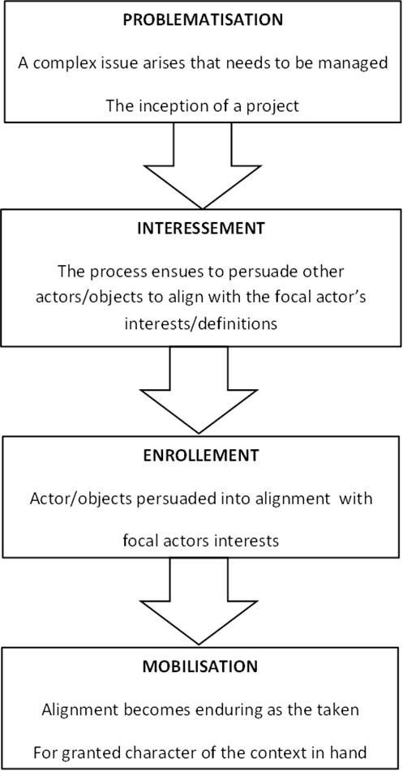

Figure 1: The Classic Actor Network Theory Process Model (Callon 1986)

Name | Age | Occupation | Family situation | Partner’s Occupation | Name of child
Neil | 39 | IT technician | Married to Joyce for 5 years | Librarian | Ben
Mark | 29 | Solicitor | Married to Claire for 3 years | Solicitor | Walter
Paul | 36 | Account Manager | Co-habiting with Chloe for 3 years | Hairdresser | Isabelle
Andrew | 25 | Teacher | Co-habiting with Helen for 2 years | Teacher | Rebecca
David | 22 | Sales Assistant | Co-habiting with Jane for 2 years | Teaching Assistant | Daniel
Steve | 26 | Lecturer | Married to Sharon for 2 years | PR Executive | Jake
Frank | 31 | Sales Manager | Married to Sarah for 3 years | Office Administrator | William
Jack | 38 | Doctor | Married to Bridgette for 5 years | Dentist | George
Thomas | 28 | Electrical engineer | Co-habiting with Eve for 2 years | Teacher | Sophia
John | 30 | Accountant | Married to Natalie for 4 years | Currently unemployed | Tess

Figure 2: Table of Participants

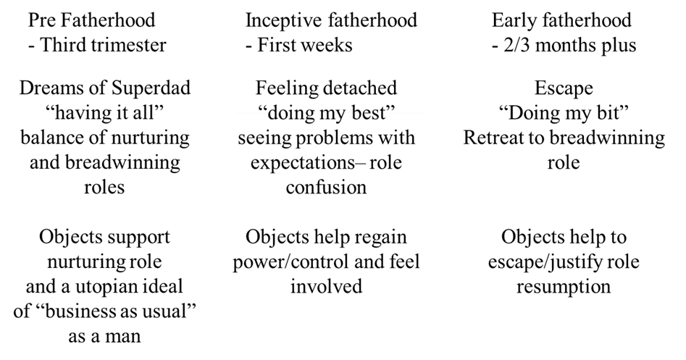
Figure 3: Stages of transition to new fatherhood

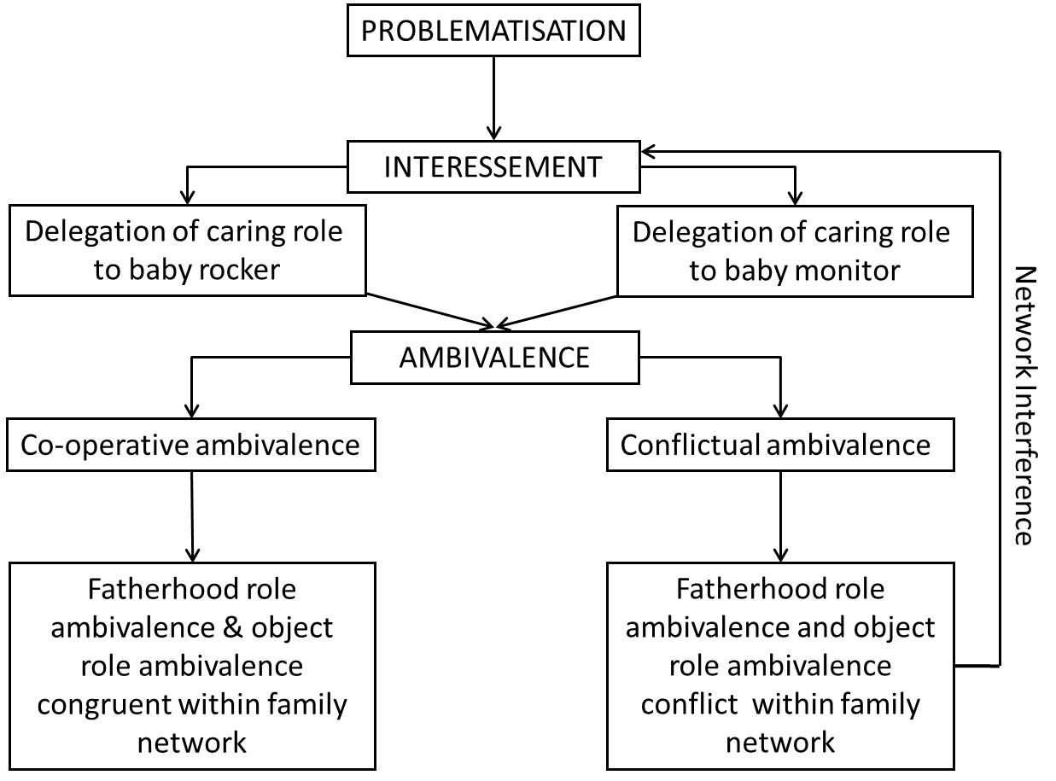
Figure 4: Adapted model of ANT proces

