**Supporting Information**

**Table S1.**

Factor analysis: Orthogonal Rotated Component Matrix.

|  |  |  |
| --- | --- | --- |
|  | Factor | |
|  | 1 | 2 |
| Nausea (item) | 0.64 | 0.43 |
| Headache (item) | 0.30 | 0.69 |
| Dizziness (item) | 0.54 | 0.44 |
| Fatigue (item) |  | 0.73 |
| Eye strain (item) |  | 0.80 |
| Avoidance (item) | 0.37 | 0.59 |
| MSSQ (score) | 0.58 | 0.38 |
| Migraine (score) | 0.56 | 0.32 |
| SWID (score) |  | 0.75 |
| Syncope (score) | 0.69 |  |

Loadings <0.3 not shown for clarity; Varimax Rotation; Variance: Factor 1=40.4%; Factor 2=12.1%.

**Table S2.**

Correlation matrix of all questionnaires used for the pooled data.

|  | |  | | VIMSSQ | | MSSQ | | Migraine | | SWID | | Syncope | | Age | | Sex | |
| --- | --- | --- | --- | --- | --- | --- | --- | --- | --- | --- | --- | --- | --- | --- | --- | --- | --- |
| VIMSSQ_total |  | Pearson's *r* |  | – |  |  |  |  |  |  |  |  |  |  |  |  |  |
|  |  | *p*-value |  | – |  |  |  |  |  |  |  |  |  |  |  |  |  |
| MSSQ |  | Pearson's *r* |  | 0.545*** |  | – |  |  |  |  |  |  |  |  |  |  |  |
|  |  | *p*-value |  | < 0.001 |  | – |  |  |  |  |  |  |  |  |  |  |  |
| Migrn_Total |  | Pearson's *r* |  | 0.478*** |  | 0.348*** |  | – |  |  |  |  |  |  |  |  |  |
|  |  | *p*-value |  | < 0.001 |  | < 0.001 |  | – |  |  |  |  |  |  |  |  |  |
| SWIDtot |  | Pearson's *r* |  | 0.347*** |  | 0.357*** |  | 0.343*** |  | – |  |  |  |  |  |  |  |
|  |  | *p*-value |  | < 0.001 |  | < 0.001 |  | < 0.001 |  | – |  |  |  |  |  |  |  |
| Syncope |  | Pearson's *r* |  | 0.308*** |  | 0.266*** |  | 0.276*** |  | 0.321*** |  | – |  |  |  |  |  |
|  |  | *p*-value |  | < 0.001 |  | < 0.001 |  | < 0.001 |  | < 0.001 |  | – |  |  |  |  |  |
| Age |  | Pearson's *r* |  | −0.124*** |  | −0.035 |  | −0.139*** |  | 0.038 |  | −0.042 |  | – |  |  |  |
|  |  | *p*-value |  | < 0.001 |  | 0.255 |  | < 0.001 |  | 0.220 |  | 0.171 |  | – |  |  |  |
| Sex |  | Pearson's *r* |  | 0.056 |  | 0.055 |  | 0.166*** |  | −0.003 |  | −0.040 |  | −0.074** |  | – |  |
|  |  | *p*-value |  | 0.090 |  | 0.074 |  | < 0.001 |  | 0.912 |  | 0.199 |  | 0.008 |  | – |  |

**Table S3.**

Breakdown of item scores of the VIMSSQ-short (percentages and means [standard deviations, SD], *n* = 920).

|  |  |  |  |  |  |
| --- | --- | --- | --- | --- | --- |
| Item of VIMSSQ | Never (0) | Rarely (1) | Sometimes (2) | Often (3) | Mean (SD) |
| Nausea | 40.8% | 21.4% | 29.3% | 8.5% | 1.06 (1.02) |
| Headache | 22.3% | 28.0% | 36.0% | 13.7% | 1.41 (0.98) |
| Dizziness | 38.2% | 31.7% | 23.6% | 6.5% | 0.98 (0.94) |
| Fatigue | 36.0% | 24.5% | 28.5% | 11.1% | 1.15 (1.03) |
| Eye strain | 20.1% | 22.6% | 37.8% | 19.5% | 1.57 (1.02) |
| Avoidance | 31.6% | 28.5% | 31.7% | 8.2% | 1.16 (0.97) |

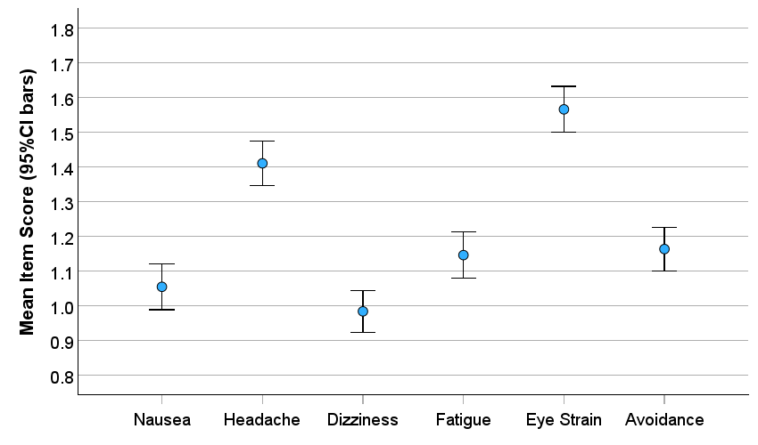

**Figure S1.** Graphical overview of means ± 95% confidence intervals (CIs) for item scores of the VIMSSQ-short (*n*=920).

