Naturally-Occurring Autoantibodies to Human Chorionic Gonadotropin (hCG) and its Subunits in Ovarian cyst Patients
N. Chikadze¹, M. Tevzadze², M. Janelidze³, N. Porakishvili⁴
Division of Immunology and Microbiology Javakhishvili Tbilisi State University, Georgia ¹Tbilisi Medical Academy, Georgia²IQ Clinic, Georgia³
School of Life Sciences, University of Westminster, London, UK⁴

Abstract:
Background: Growing evidence supports the existence of immune-surveillance mechanisms in ovarian tumour patients, including autoantibodies to tumour associated and tumour specific antigens, tumour growth factors. Glycoprotein hormone human chorionic gonadotropin (hCG) and its hormone-specific hCGβ subunit have been associated with epithelial tumours such as bladder, lung, oral/facial, breast, cervical, ovarian, vaginal, prostate, renal and pancreatic carcinomas. It is believed that hCG plays a role of an autocrine growth factor for tumor cells. Here we have demonstrated that sera of patients with ovarian cyst contain naturally-occurring autoantibodies, predominantly of IgG2 isotype, that bind to hCG and its subunits with high affinity.
Materials and Methods: Titration of blood sera from 36 female patients, aged 22-61 after ethical permission and informed consent, diagnosed with ovarian cyst and healthy age-matched controls (n=12) was performed using a classical enzyme-linked immunosorbent assay (ELISA). Binding of the sera to the following antigens was tested: hCGαβ, hCGβ, hCGα, hCGβ C-terminal peptide (hCGβCTP) and hCGβ core fragment (hCGβCF). The same type of ELISA (with necessary modifications) was used for further investigation of subclass usage and assessment of binding affinity of the detected autoantibodies.
Results: Our data indicates that the sera of the majority of patients with ovarian cyst contain significantly higher levels of the natural IgG antibodies binding to hCGαβ, hCGβ, hCGα, hCGβCTP and hCGβCF, than those of the healthy controls. Natural IgG antibodies to hCGαβ heterodimer were detected in 78% of cases, to hCGβ in 61% of cases, to hCGα in 78% of cases, to hCGβCTP in 69% of cases, to hCGβCF in 83% of cases. These autoantibodies predominantly belonged to the IgG2 subclass and were characterized by the high binding affinity. It is plausible that they cross- bind to sugar side chains of hCG and its subunits.
Conclusion: Our data demonstrated that sera of patients with the ovarian cyst contains elevated levels of naturally-occurring IgG antibodies, which bind to hCG and/or its subunits. The overwhelming majority of these autoantibodies belong to the IgG2 isotype thus indicating that they might be directed against carbohydrate antigens within highly glycosylated hCG.

Introduction:
Ovarian cysts are often asymptomatic fluid-filled sacs which can affect women of any age. They are commonly discovered through gynecological imaging and vary widely in etiology, from physiologic, to complex benign, and finally to neoplastic [1,2]. Therefore, it is important to apply accurate laboratory biomarkers for early detection of malignant transformation. Currently, carbohydrate antigen 125 (CA-125) in combination with human epididymis protein 4 (HE4) are used as established biomarkers for the detection of ovarian cancer, which is the fifth most killing cancer in the word. A disadvantage of CA-125 is its low sensitivity to ovarian carcinomas at stage I, where only 50% of patients have an increased level of CA-125. Moreover, increased level of CA125 can also be detected in patients with endometriosis, pregnancy, uterine myomas, acute and chronic salpingitis and pelvic inflammatory disease [3, 4]. Therefore, there is still an obvious need in new biomarkers that would serve as more precise diagnostic and/or prognostic indicators.
Here we hypothesize that naturally-occurring, anti-human chorionic gonadotropin (hCG) antibodies can be used as a prediction biomarker for non-malignant ovarian cysts whilst playing a protective role against their malignisation, and investigate epitope-based specificity of these antibodies.
hCG is a member of the glycoprotein hormone family, together with luteinizing hormone (LH), follicle stimulating hormone (FSH) and thyroid stimulating hormone (TSH). hCG is a heterodimer consisting of a family-shared α-chain non-covalently associated with a hormone-specific β-chain. hCG is produced by the trophectoderm of the pre-implantation embryo within a few days of fertilization, is essential for implantation and for the production of progesterone and estrogen by corpus luteum to ensure its maintenance through the duration of the pregnancy [5,6]. Miniscule expression of hCG whole hormone and/or hCGβ can be found in normal tissues of both men and non-pregnant women, but physiological importance of this phenomenon remains unknown [7].
It has been well demonstrated that hCG is a biomarker for placental, trophoblast-derived and germ-cell derived tumours. The hormone-specific hCGβ has been associated with epithelial tumours such as bladder, lung, oral/facial, breast, cervical, ovarian, vaginal, prostate, renal and pancreatic carcinomas [6,8,9]. The tumor cells not only secret hCG, but it is also expressed on their surface as an α/β dimer or the hCGβ-chain only [10,11]. It is believed that hCG plays a role of an autocrine growth factor for tumor cells [12,13] and may act at different levels to facilitate cancer progression: (a) as a transforming growth factor; (b) as an immunosuppressive agent; (c) as an inducer of metastasis; (d) as an angiogenic factor [10]. Bioneutralisation of hCGβ in carcinomas represents therefore a desirable approach for targeted anti-cancer therapy. Neutralization of soluble hCG with antibody may abrogate hCG-mediated tumor growth, angiogenesis, and immune escape [14-16]. Recently we have demonstrated, that it is possible to develop a potential cancer vaccine, with high immunogenicity, which selectively targets hCG and its β subunit [17].
In the present study we have investigated the binding ability of sera from ovarian cyst patients to hCG and its subunits, the subclass usage of the reveled IgG autoantibodies and assessed their binding affinity.
Materials and Methods
Patients and Controls
Sera from 36 clinically diagnosed ovarian cyst patients aged 22-61 were collected in preservative-free test-tubes at “IQ clinic” of Tbilisi, Georgia. All patients were newly diagnosed and untreated at the time. Healthy control females (n=12), as well as patients were enrolled to the study following the informed consent by the collaborating group of clinicians observing full anonymity and ethical permission granted by the ethics committee of National Center for Disease Control and Public Health of Georgia Separated sera were stored in 0.5 ml aliquots at -20°C for no longer than 2 months.
Antibody titres
For the assessment of the titres of naturally-occurring autoantibodies to hCGαβ, hCGβ, hCGα, hCGβcarboxy-terminal peptide (hCGβCTP) and hCGβ core fragment (hCGβCF) of IgG isotypes a standard enzyme linked immunosorbent assay (ELISA) method was used as previously described by us [18]. Briefly, Nunc MaxisorpC 96-well flat-bottomed microtiter plates were coated with 50µl of hCGαβ, hCGβ, hCGα, hCGβCTP or hCGβCF at the concentration1µg/ml in 0.05M carbonate-bicarbonate buffer (CBB, pH=9.6; Sigma, USA.), in duplicates. The plates were incubated overnight at 4°C. Blocking was performed using Pierce™ Protein-Free Blocking Buffer (Thermo Fisher Scientific, USA). Sera were serially diluted 1:25-1:6400 in PBS-Tween–BSA. For the detection antibody goat anti-human IgG hourse-raddish peroxidase (HRP)-conjugated antibody (Sigma, USA) was used, and the substrate 3,3′,5,5′-Tetramethylbenzidine (TMB) (Sigma, USA). The plates were read at the optical density (OD) 450nm in a spectrophotometer (Selecta, Spain). The 50% and 75% titres were calculated as the dilution of serum corresponding to 50% or 75% of the plateau respectively, and the end-point titer as the highest but one dilution giving an OD above the control. t-test was used to access significance between the mean values.
IgG subclasses
For the identification of IgG-subclasses the plates were coated with the protein as above. Following the application of an optimal serum dilution, defined above as the 50% titre, rabbit HRP conjugated antibody (Sigma, USA) to human IgG subclasses (IgG1, IgG2, IgG3 and IgG4) was added at a concentration 1µg/ml and the rest of the essay was performed as above.
Antibody relative affinity
Sera dilution which corresponds to 75% of the plateau binding as defined above were added to antigen-coated microtiter plates, the plates were incubated for 2 h at 37°C, washed three times in PBS-T and 100 μl of ammonium thiocyanate (ATC, Sigma) in PBS was added for 15 min at RT. The chaotropic agent ATC dissociates antibody–antigen binding in a molarity-dependent manner and was used at 0.0625–4 M. Following washing 3 times with PBS, the secondary HRP- conjugated antibody (Sigma, USA) was added and OD readings performed as above.
Results and Discussions:
Titers of anti-hCGαβ, anti- hCGβ, anti-hCGα, anti-hCGβCTP and anti-hCGβCF were determined in the sera of patients with ovarian cyst and clinically healthy volunteers (Figure 1). For each protein the results were segregated into three groups: sera with normal (within the normal range), intermediate and high titres.
Sera of the majority of patients with ovarian cyst contained significantly higher levels of IgG antibodies binding to the tested antigens, compared to normal controls: natural IgG antibodies to hCGαβ heterodimer were detected in 78% of cases (p,<0.0001, mean OD at 1:50 dilution – 0.34216±0.189899) , to hCGβ in 61% of cases (p=0.0001, mean OD at 1:50 dilution = 0.429182±0.214614), to hCGα in 78% of cases (p<0.0001, mean OD at 1: 50 dilution=0.41725±0.200384), to hCGβCTP in 69% of cases (p<0.0001, mean OD at 1:50 dilution = 0.5126 ±0.350849), to hCGβCF in 83% of cases (p<0.0001, OD at 1:50 dilution = 0.391367±0.097786). Out of these, sera of 18 patients was binding to all tested antigens, sera of 4 patients to four, sera of 5 patients to three and one sera to two tested antigens. There was no serum which binds only one out of five tested antigens (Figure 1).

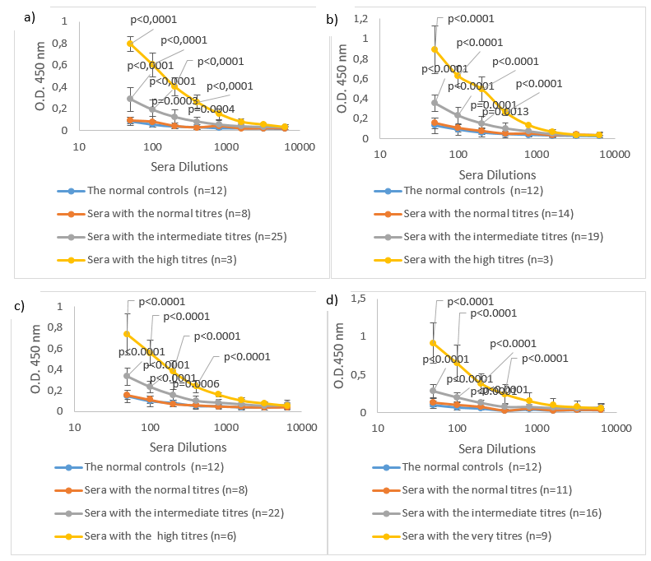
Figure 1: Titration of blood sera from female patients (aged 22-61)diagnosed with ovarian cyst (n=36) and healthy age-matched controls (n=12) was performed using enzyme-linked immunosorbent assay (ELISA). Binding of the sera to the following antigens were tested: a)hCGαβ, b)hCGβ, c)hCGα, d)hCGβ C-terminal peptide (hCGβCTP)and e)hCGβ core fragment (hCGβCF).
e)

In order to assess the distribution of the detected naturally-occurring IgG isotypes, we have chosen 12 sera with respectively high levels of IgG autoantibodies to any of following antigens: hCGαβ, hCGβ, hCGα, hCGβCTP and hCGβCF. The sera was then tested by ELISA as described above (Figure 2).
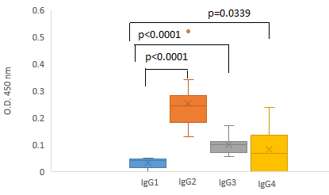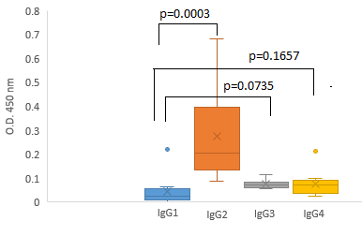
c)
b)
a)
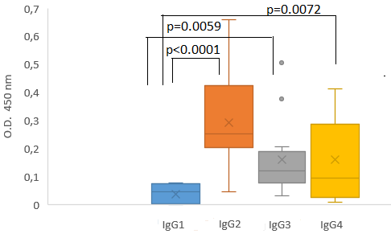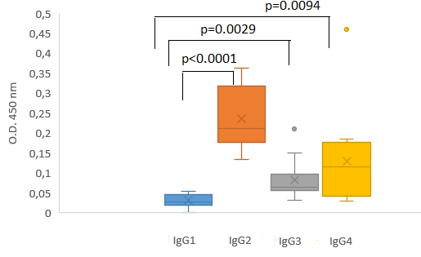
d)
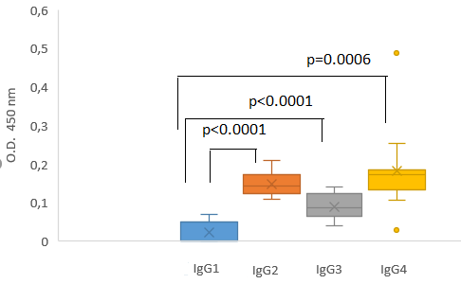
Figure 2: Distribution of naturally-occurring IgG Isotypes to a) hCGαβ, b) hCGβ, c) hCGα, d)hCGβCTP, e) hCGβCF in patients with ovarian cyst (n=12).The groups are shown using box-and-whisker diagrams wherethe middle line of the box represents the median or middle number. The x in the box represents the mean. The median divides the data set into a bottom half and a top half. The bottom line of the box represents the median of the bottom half or 1st quartile. The top line of the box represents the median of the top half or 3rd quartile. The whiskers extend from the ends of the box to the minimum value and maximum value.
e)

According to our results there is the overwhelming prevalence of IgG2 subclass in the pool of autoantibodies to all tested antigens The optical density (OD) of binding of serum IgG2 autoantibodies to hCG was 0.252888±0.099656, to hCGβ 0.293045±0.187829, to hCGα 0.236625±0.079578, to hCGβCTP 0.314708±0.154222, to hCGβCF 0.152583±0.032702.
Low titres of autoantibodies of IgG3 isotype to hCGαβ were detected in 7 out of 12 samples (OD= 0.1256±0.0301, p<0.0001), to hCGβ in 2 samples (OD= 0.11225±0.00375,p=0.1419) to hCGβCTP in 7 samples (OD= 0.235429±0.137386, p<0.0001), to hCGβCF in 4 samples (OD= 0.123125±0.01291, p<0.0001). Anti- hCGα autoantibodies of IgG3 isotype were not detected. Additionally, low titres of autoantibodies of IgG4 isotype were found in some sera, especially those which bind to hCGβCF. No autoantibodies of IgG1 isotype to any of the tested hCG subunits were found in the sera of patients with ovarian cyst.
It is well known, that IgG2 is the second most abundant subclass of IgG, with an average concentration of 3.0 mg/ml in adult serum and it is the predominant IgG subclass that binds to polysaccharide antigens [19, 20]. Since hCG whole hormone and its subunits are glycoproteins, it is plausible that autoantibodies bind to sugar side chains. Both subunits of hCG are heavily glycosylated: hCGα contains two N-glycosylationsites on Asn 52 and Asn 78, hCGβ-contains two N-glycosylation sites (Asn 13 and 30) on its core region and four O-glycosylation sites on its carboxy-terminal peptide (hCGβCTP; Ser 121, 127, 132, and 138). Glycosylation of both subunits is important for the assembly, secretion, metabolic half-life and signal transduction. In normal pregnancy, hCG preparations primarily show mono- and biantennary N-linked oligosaccharides, and tri- and tetrasaccharide O-linked oligosaccharides. In contrast, choriocarcinoma-derived hCG preparations have larger, triantennary O-linked oligosaccharides [21].
The avidity of binding of sera to all tested antigens were determined using a chaotropic agent ammonium thiocyanate (ATC) in ELISA assays as described above. Our data demonstrated that the avidity of binding of naturally-occurring autoantibodies to hCG and its subunits in the sera of patients with the ovarian cyst is quite high. In order to inhibit the binding ability by 50% 0.5M and 1M concentrations of ATC were required (Figure 3). It is interesting that the binding avidity of antibodies to hCGαβ, hCGβ and hCGβCTP is pretty similar.
The fact that the autoantibodies we have detected in ovarian cyst patient bind with a high affinity to the native hCG and its subunits, may serve as a basis for an effective phagocytosis of the created complexes. Indeed, binding affinity is not merely a matter of theoretical interest, as affinity and avidity affect the properties of antibodies. A high-affinity antibody is superior to a low-affinity antibody in the immune elimination of an antigen [22].

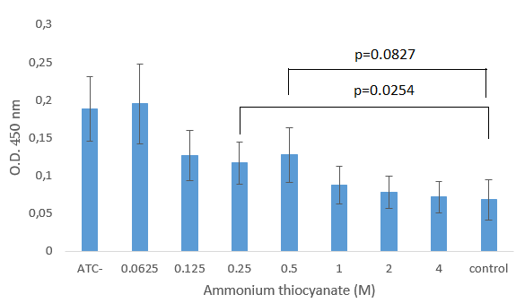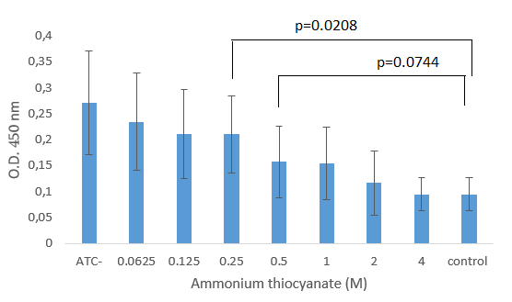
Figure 3: The binding avidity of the sera from patients with the ovarian cyst (n=12) to a) hCGαβ, b) hCGβ, c) hCGβCTP. The binding of an antibody and its corresponding antigen was disrupted by thiocyanate solution of different concentrations (from 0.0625M to 4M). The graphs show the mean absorbance and ± SD indicated as bars through each data point.
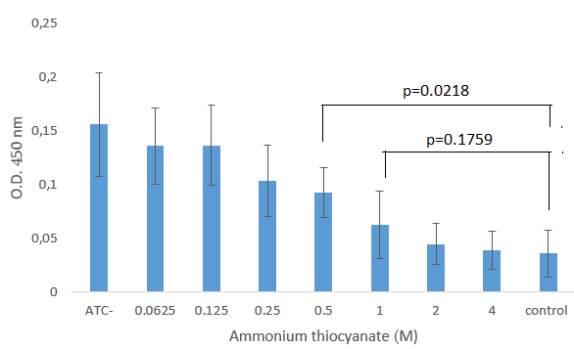
In conclusion, we have detected the naturally-occurring autoantibodies to hCG and its subunits in the blood of the majority of patients with the ovarian cysts. The overwhelming majority of these autoantibodies belong to the IgG2 isotype thus indicating that they might be directed against carbohydrate antigens within highly glycosylated hCG. Further investigation of the protective role of anti-carbohydrate autoantibodies against ovarian cancer may lead to the development of novel tumour prevention, stratification and early detection strategies.
Acknowledgement: This study was supported by a research grant from the Shota Rustaveli National Science Foundation of Georgia -Grant ID: 218024; Project Title: “Assessment of naturalanti-hCG antibodies in patients with gynaecologicaltumours”
References:
1. Sutton JB. Origin of Certain Cysts-Ovarian, Vaginal, Sacral, Lingual, and Tracheal. J Anat Physiol. 1886; 20(3):432-55.
2. Jaroslava D. Cytology of Ovarian cysts. CeskPatol. 2019; 55(2):107-111.
3. Medeiros LR, Rosa DD, da Rosa MI, Bozzetti MC. Accuracy of CA 125 in the diagnosis of ovarian tumors: a quantitative systematic review. Eur J ObstetGynecolReprod Biol. 2009; 142(2): 99–105.
4. Y. Chen, Y.-L. Ren, N. Li, X.-F. Yi, H.-Y. Wang Serum human epididymis protein 4 vs. carbohydrate antigen 125 and their combination for endometrial cancer diagnosis: a meta-analysis, Eur Rev Med PharmacolSci 2016; 20 (10): 1974-1985;
5. Fishel SB, Edwards RG, Evans CJ. Human chorionic gonadotropin secreted by preimplantation embryos cultured in vitro. Science.1984;223:816-8.
6. Talwar GP, Gupta JC, Shankar NV. Immunological approaches against human chorionic gonadotropin for control of fertility and therapy of advanced-stage cancers expressing hCG/subunits. American journal of reproductive immunology.2011;66:26-39.
7. Stenman UH, Alfthan H, Hotakainen K. Human chorionic gonadotropin in cancer. Clinical biochemistry.2004;37:549-61.
8. Iles RK. Ectopic hCG beta expression by epithelial cancer: malignant behaviour, metastasis and inhibition of tumor cell apoptosis. Molecular and cellular endocrinology. 2007;260-262:264-70.
9. Iles RK, Delves PJ, Butler SA. Does hCG or hCG beta play a role in cancer cell biology? Molecular and cellular endocrinology. 2010;329:62-70.
10. Cole LA.BiologicalLA. Biological functions of hCG and hCG-related molecules. ReprodBiolEndocrinol.2010;8:102
11. Acevedo HF, Tong JY, HartsockHart sock RJ. Human chorionic gonadotropin-beta subunit gene expression in cultured human fetal and cancer cells of different types and origins. Cancer.1995;76:1467-1475.
12. Sheaff MT, Martin JE, Badenoch DF, et al.betahCG as a prognostic marker in adenocarcinoma of the prostate. J ClinPathol. 1996;49:3291996; 49:329-32.
13. Acevedo HF, Krichevsky A, Campbell-Acevedo EA, et.al. Expression of membrane-associated human chorionic gonadotropin, its subunits, and fragments by cultured human cancer cells. Cancer.1992;69:1829-42.
14. Geissler M, Wands G, Gesien A, et al.Genetic immunization with the free human chorionic gonadotropin beta subunit elicits cytotoxic T lymphocyte responses and protects against tumor formation in mice. Lab Invest. 1997;76(6):859-871.
15. Triozzi PL, Gochnour D, Martin EW, et.al. Clinical and immunological effects of a synthetic Beta-human chorionic-gonadotropin vaccine. Int J Oncol. 1994;5:14471994; 5:1447-53.
16. Yu N, Xu W, Jlang Z, et al. Inhibition of tumor growth in vitro and in vivo by a monoclonal antibody against human chorionic gonadotropin beta. Immunol Lett. 2007;114:942007; 114:94-102.
17. Kvirkvelia, Nino, Chikadze, Nino, Makinde, Julia, McBride, Jeffrey D., Porakishvili, Nino, Hills, Frank, Martensen, Pia M., Justesen, Just, Delves, Peter J., Lund, Torben and Roitt, Ivan. Investigation of factors influencing the immunogenicity of hCG as a potential cancer vaccine. Clinical & Experimental Immunology. 2018; 193 (1)73-83.
18. Chikadze N. AkhvledianiL.Gachechiladze N, Mitskevichi N, Delves P. J. Porakishvili N. Antibodies against hCG in patients with gynaecologicalgynecological tumors. Proc. 13th World Congress on Controversies in Obstetrics, Gynecology& Infertility (COGI) held jointly with the German Society of Obstetrics & Gynecology, November 4-7, 2010, 325-328.
19. Strohl, W.Strohl, W. R., andStrohl, and Strohl, L. M. Antibody structureAntibody structure–functionrelationshipsfunction relationships. inTherapeuticin Therapeutic Antibody Engineering. Woodhead Publishing Series in Biomedicine. 2012; 3:37–595,
20. Gar Kay Hui, Antoni D. Gardener, Halima Begum, JayeshGor, and Stephen J. Perkins.
The solution structure of the human IgG2 subclass is distinct from those for human IgG1 and IgG4 providing an explanation for their discrete functions.J. Biol. Chem.2019; jbc.RA118.007134.
21. Toll, Hansjörg et al. Glycosylation Patterns of Human Chorionic Gonadotropin Revealed by Liquid Chromatography-Mass Spectrometry and Bioinformatics.ElectrophoresisBioinformatics. Electrophoresis. 2006; 27(13) 2734) 2734–2746.
22. Dimitrov JD, Lacroix-Desmazes S, Kaveri SV. Important parameters for evaluation of antibody avidity by immunosorbent assay. Anal. Biochem. 2011;418:149–151
Резюме
Природные аутоантитела к хорионическому гонадотропину человека (ХГЧ) и его субъединицам у пациенток с кистой яичников
Н. Чикадзе¹, М. Тевзадзе², М. Джанелидзе³, Н. Поракишвили^{1,4}
Тбилисский Государственный Университет им. Джавахишвили, Грузия ¹
Тбилисская Медицинская Академия, Грузия²
Клиника IQ, Грузия³
Вестминстерский Университет, Лондон, Великобритания^{1,4}
Актуальность вопроса: В последнее время возросло количество данных подтверждающих существование механизмов иммунологического надзора у пациенток с опухолями яичников, включая аутоантитела к опухоль-ассоциированным и к опухоль-специфическим антигенам , факторам роста опухоли. Гликопротеиновый гормон хорионический гонадотропин человека (ХГЧ) и его гормон-специфическая субъединица - ХГЧβ, ассоциированы с такими эпителиальными опухолями, как рак мочевого пузыря, легких, полости рта / лица, молочной железы, шейки матки, яичников, влагалища, простаты, почек и поджелудочной железы. Считается, что ХГЧ выполняет роль аутокринного фактора роста опухолевых клеток. Согласно нашим данным, сыворотки пациенток с кистой яичников содержат высокоаффинные природные аутоантитела, преимущественно изотипаIgG2, которые ркагируют с ХГЧ и его субъединицами.
Материалы и методыː Мы провели титрование сывороток крови 36 пациенток в возрасте от 22 до 61 года с диагнозом киста яичников и здоровых добровольцев соответствующего возраста (n = 12), после подписания информированного согласия, с использованием классического иммуноферментного анализа (ИФА). Был проведен анализ связывания сывороток со следующими антигенами: ХГЧαβ, ХГЧβ, ХГЧα, ХГЧβC-терминальный пептид (hCGβCТП) и центральный фрагмент ХГЧ β (ХГЧ βЦФ). ИФА того же типа (с необходимыми модификациями) был использован для дальнейшего исследования распределения обнаруженных IgGаутоантител по подклассам и для оценки их аффинитета.
Результаты: Полученные нами данные указывают на то, что сыворотки большинства пациенток с кистой яичников содержат статистически достоверно высокие уровни естественных антител IgG, способные связываться с ХГЧαβ, ХГЧβ, ХГЧα, ХГЧβCТП и ХГЧβЦФ, по сравнению с сыворотками здоровых добровольцев. Природные IgGаутоантитела к гетеродимеру ХГЧαβ были обнаружены в 78% случаев, к ХГЧβ в 61% случаев, к ХГЧα в 78% случаев, к ХГЧβCТП в 69% случаев, к ХГЧβЦФ в 83% случаев. Эти аутоантитела преимущественно принадлежали к подклассу IgG2 и характеризовались высоким аффинитетом связывания. По нашей гипотезе, они могут перекрестно связываться с боковыми углеводными цепями ХГЧ и его субъединиц.
Заключение: Результаты наших исследований показывают, что сыворотки пациенток с кистой яичников содержат повышенные уровни природных IgG-антител, которые связываются с ХГЧ и / или его субъединицами. Подавляющее большинство этих аутоантител принадлежат к изотипуIgG2, что указывает на то, что они могут быть направлены против углеводных антигенов высоко гликозилированного ХГЧ.
reziume
adamianisqorionuligonadotropinis (aqg) damisisuberTeulebissawinaaRmdegobunebriviantisxeulebisakvercxiskistismqonepacientebSi
n. WikaZe¹, m. TevzaZe², m. janeliZe³, n. foraqiSvili^{1,4}
iv.javaxiSvilissaxelobisTbilisissaxelmwifouniversiteti, saqarTvelo¹
Tbilisissamedicinoakademia, saqarTvelo²
IQ klinika, Tbilisi, saqarTvelo³
vestminsterisuniversiteti, londoni⁴
sakiTxisaqtualuroba:sulufro da ufroizrdebaimmonacemebisraodenoba, romlebicsimsivneebismqonepacientebSiimunurigadarCenismeqanizmebisarsebobasadastureben. maTSorisganixilebasimsivniszrdisfaqtorebis, simsivne-asocirebuli da simsivne-specifiuriantigenebissawinaaRmdegoautoantisxeulebisarseboba. glikoproteinulihormoniadamianisqorionuligonadotropini (aqg) da misihormon-specifiuriaqgβsuberTeuli, asocirebulniarianiseTepiTelursimsivneebTan, rogorebicaa Sardis buStis, filtvis, pirisRrus/saxis, mkerdis, saSvilosnosyelis, sakvercxis, saSos, prostatis, Tirkmlis da pankreasiskarcinomebi. iTvleba, rom simsivneebisTvisaqg-s autokrinulizrdisfaqtorisroliaqvs. CvenikvlevisSedegebisTanaxmad, sakvercxiskistismqonepacientebisumravlesobissisxlisSratSi, warmodgeniliabunebriviautoantisxeulebi, umeteswiladIgG2 izotipis, romlebicromlebicmaRaliafinobiTukavSirdebianaqg-s da missuberTeulebs.
masala da meTodebi:Catarda 22—61 wlisasakis 36 pacientiqalis da Sesabamisiasakis 12 janmrTelimoxalisepiris, sisxlisSratebistitrirebaeTkiskomisiisnebarTvis da informirebulTanxmobazexelimoweriTTanxmobisgancxadebisSemdeg. titrirebisTvisgamoyenebuliiyoklasikuriimunofermentulianalizi (ELISA). SefasdaSratebisSemdegantigenebTandakavSirebisunari: aqgαβ, aqgβ, aqgα, aqgβ –karboqsiterminaluripeptidi (aqgβktp), aqgβ –centralurifragmenti (aqgβcf). aRmoCeniliautoantisxeulebisqveklasebisSesaswavlad da dakavSirebisafinobisSesafaseblad, gamoyenebuliiyoigive tipis ELISA saWiromodifikaciebiT.
Sedegebi: CvensmiermiRebuliSedegebigamoxatavs, rom sakvercxiskistismqonepacientebisumravlesobissisxlisSratSiarisbunebriviIgG iseTiautoantisxeulebismaRali done, romlebicukavSirdebianaqgαβ-s, aqgβ-s, aqgα-s, aqgβktp-s da aqgβcf-s gansxvavebiTjanmrTelikontrolebisagan.bunebriviIgG antisxeulebi, aqgαβ heterodimers ukavSirdebodaSemTxvevaTa 78%-Si, aqgβ-s – SemTxvevaTa 61%-Si, aqgα-s - SemTxvevaTa 78%-Si, aqgβktp-s – SemTxvevaTa 69%-Si da aqgβcf-s – SemTxvevaTa 83%-Si. esautoantisxeulebiZiriTadadIgG2 qveklassmiekuTvnebodnen da xasiaTdebodnendakavSirebismaRaliafinobiT. savaraudoa, rom esantisxeulebiukavSirdebianaqg-sa da misisuberTeulebisgverdiTjaWvebs.
daskvna:CveniSedegebismixedviTsakvercxiskistismqonepacientebisumetesobissisxlisSratiSeicavsbunebriv, IgG autoantisxeulebs, romlebicukavSirdebianaqg-s da/an missuberTeulebs. am autontisxeulebisdidiumravlesobaIgG2 izotipisaa, racimismaniSnebelia, rom SesaZloaisinimimarTuliarianmaRaliglikozilirebismqoneaqg-s naxSirwylovaniantigenebisaken

