Key Words: Pedagogy, Experimental, Feminist, Radical, Process

Abstract: This essay draws together an account of pedagogic experiments in architectural education that happened at the Polytechnic of the South Bank School of Architecture, PGDip (RIBA Part 2) between 1987 and 1991. Revisiting this period of holacratic autonomy and student-led collaborative education, I hope to shed some light on the value of manifesting transformative creative educational models in the contemporary context of design education in the 21st century.

Charting an extraordinary period of student agency, the work considers how the notion of social and individual political resistance, manifested as creative action, can inform a transformative and liberating feminist methodology. Understanding and challenging the relationship between education and politics both in terms of architectural production, the individual and the institution, is central to the notion that architectural education is intrinsically linked to politics and patriarchal hegemony. Thirty years after these events took place, the almost unbroken march of the privatisation and commodification of architectural education and the increasing homogenisation of a skills based, profession-led curriculum, contextualised by political uncertainty, may be a moment to reconsider the potential embedded in an alternative, rebellious, feminist design studio and practice.

…a Few People, a Brief Moment in Time: Architectural Education Experiments 1987- 91

The value of information does not survive the moment in which it was new. It lives only at that moment; it has to surrender to it completely and explain itself to it without losing any time. A story is different. It does not expend itself. It preserves and concentrates its strength and is capable of releasing it even after a long time.

Walter Benjamin Illuminations: Essays and Reflections, 1968

This work attempts to evaluate a brief period of rebellion and student agency in polytechnic education. This moment in time is manifested in an experimental methodology that embedded individual and communal values that appear to have been lost in the contemporary context of architectural education, but could be reclaimed.

The essay revisits the educational space formulated and made manifest by Kevin Rowbotham in the department of architecture at the Polytechnic of the South Bank between 1987 and 1991. This period of radical pedagogic experimentation, the events that occurred and Rowbotham’s writing continues to be central to my practice as an architectural educator who continues to search for a feminist pedagogy. The period is one when the School underwent a significant change in leadership and academic staffing and coincides with the end of a political and social era in the UK. This was architectural education at the end of Margaret Thatcher’s eight-year term as Conservative Prime Minister and here it marks a teleology of rapid neo-liberalisation, increasing globalisation, concurrent with the changing capacities of information technology (technology of drawing), financial de-regulation and the withdrawal of state commitment to universal higher education.

The AAE’s call for papers for this journal described a search for an architectural education that is

‘…more than transactional … a narrative of personal and social transformation’.
AAE ‘Call for Expressions of Interest’, Charette 6(1)

The possibility of challenging the accepted hierarchical relationship between tutor and student, assuming the role of the former is to impart knowledge and critically, social and cultural values, to the latter is considered. This construct, still so embedded in architectural education, assumes the student’s knowledge, experience and culture must be subsumed by the profession’s accepted value system and means of production.

Understanding the limitations of contemporary studio practices through readings of radical methodologies may represent an opportunity to consider our understanding of what architectural education might be - a process that can inspire, embody and respond to individual and collective experience. Challenging the increasing influence of the profession and persistent hegemony of patriarchy throughout architectural education and the spectre of the BME ‘Attainment Gap’, I hope to reveal the potential manifest in this particular brief moment of transformative alternative creative situations.

The analysis is structured as a series of stories and critical architectural enquiry interspersed with theoretical, historical and visual references that can be understood as a form of knowledge creation in the model of Claude Levi-Strauss (1966/1962), constructed through subjective accretion of contemporary historical fragments. It aims to offer a model for locating possible resistance in contemporary architectural education in an increasingly chaotic, uncertain and globalised cultural context.

The methodology is constructed around photography, drawings, oral and other historical analysis and creative writing and through non-linear, multiple anecdote, constructing a form of hierarchic inversion, a feminist construction as in Mikahail Bakhtin’s dialogic encounter and imagining, deliberately challenging the conventional structure of the academic paper and the assumptions implicit in (patriarchal) modernist design processes embedded in notions of form follows function. The accounts, extracts and visual work represents and archives a historical moment in the creation of architectural knowledge. Here, a radical moment is revisited in an attempt to contextualise and make sense of my continued attempts to reconstruct a teaching methodology from the ruins of the process of systematic dismantling that began in the 1970s and is now almost fully complete. The moment is one populated by a wealth and diversity of architectural and other artistic, visual and cultural intellect from Kevin Rhowbotham (architect, artist, educator), Hannah Vowels (Artist, Deputy Head of Architecture Birmingham City University), Glyn Banks (Artist), Emma Birkett (Artist) and Benjamin Zephaniah (Poet) to Katherine Shonfield (Writer, Artist, Educator), Tony Harrison (Poet), Arthur and Marilouise Kroker (Artists), Rose Nãg (Artist).

This essay is my story; a working class girl from a one parent family living on a notorious ‘sink’ estate in North London, I was educated in a radical feminist socialist school and somehow managed not to drop out of architectural education, despite the sense of alienation and misogyny experienced throughout my degree and later in the profession. Deliberately anecdotal and frayed, it should be read as a collage of moments rather than a document that might be understood as chronological. The texts are a woven feminist fragment to be read as Chetcheglov’s New Urban Formulary might be, by luxuriating in its pleasures.

Part 1: privatisation: a political context
The university is a key site for reproducing the knowledge, culture and power in our society. But universities are complex places, not just reproducing, but also contesting and creating knowledges, culture and power. They are a priority for feminist work for several reasons: first, because their status and history are being used to authorize and reproduce patriarchal, corporate, and state power; second, because universities are being dismantled as sites for accessible education, critical thought and political challenge; third, because universities hold a responsibility to all the people of our society and world for whom they act as a repository of knowledge and a source of education; and fourth, because we need them. They can keep alive our hope and become our meeting place for a collective praxis.
Keith Louise Fulton Strategies Feministes 1999.
…art can create disturbance and protest, and protest can create art.

Martin Argles 2012

As a child I remember walking past the art school demonstrations in Crouch End, seeing the students shouting from open windows and being intrigued by the banner hung over the locked gates, wondering what the words ‘Student Control of College’ might mean. Jane Tankard A Fairy Story, 2017.

The demise and silencing of the British art school as a politically critical avant-garde institution, it might be argued, began in 1968 with the so-called Hornsey College of Art Uprising, during which students occupied the Crouch End Hill site. The college, which was founded in 1880, survived until 1973 when, under Edward Heath’s Conservative government, it was merged with Enfield Technical, eventually becoming a department at Middlesex University.

The privatisation of education and corporate suffocation of the independent art school through amalgamation into the so-called New Universities began in the early 1970s and ended in 1992 when UK polytechnics were given ‘university status’, marking the end of radical arts programmes in the UK. The strait-jacketing of these sites of potential resistance and experimentation has been embedded strategically over a period of forty years into a contemporary undergraduate system that is driven by league tables with employability and ‘dove tailing’ with industry, particularly with the recent introduction of ‘apprenticeships’, at its core. This context is now even more alarming with the UK Foreign Affairs Select Committee identifying apparent evidence of ‘Chinese interference’ on UK campuses with the aim of restricting academic freedom.

The Polytechnics, whose focus was on STEM (science, technology and mathematics) subjects, were valued as providers of education relevant for industry, making them a powerful force in architecture, planning and engineering. Contemporary League Tables locate the ‘new’ in direct competition with ‘old’ universities; judging both against the same criteria, the polytechnic architectural degree has become undervalued, whilst helping to camouflage the often staid complacency of provincial red brick university architectural education.

Key also to this essay’s context is the almost unbroken continuum, since the late 19th century, of a European architectural education system dominated by Beaux Arts principles that institutionalised architectural education and established the architect as an elite specialist who must be apprenticed within the studio culture and ranked against their contemporaries in order to value and evaluate potential output. In the 1980s, the Beaux Arts system of paternalist hierarchy, competition and individualism was very much the dominant force in architectural design education, as it is today.

At 10 years old having walked home from school, I enter the council estate where I live and see a guy, recently let out of prison, leaning against the wall playing with a small, real gun, clicking the trigger (no bullets or was there one?). I am at one end of the open courtyard and have to get to the far end and he has a clear sight line the whole way. I understand that the architecture of the flats cannot protect me in anyway until I get to my stair well. In the pouring rain I shut my eyes and run full pelt straight into one of the metal poles installed in the 1940s when the estate was built for hanging out washing (long redundant as people stole or dirtied the washing). I come round, flat on my back, soaking wet with Keir Hardie (the block, not the politician of course) looming over me with its long, exposed access balconies and I hate where I live so much I know I have to get out.

Jane Tankard A Fairy Story 2017

The view that education is a commodity that must be a servant to Capital, was first muted in Parliament in 1985 by Sir Keith Joseph, one year after the Battle of Orgreave and the same year that Jocelyn Stevens, a committed Thatcherite, became the Rector of the RCA. “I was sent there and found a letter on the desk from the appropriate minister (Keith Joseph) saying, “We are very concerned about the RCA and look forward to seeing some new plans from you, failing which we will close it.” Jocelyn Stevens. Stevens immediately sacked eleven design tutors who were known anecdotally as politically and creatively radical.

In the early 1980s, Thatcher was encouraged by her policy unit to pursue a war of attrition with the miners, but in essence she was waging war on anyone who adopted socialist values.

(Privatisation) was one of the central means of reversing the corrosive and corrupting effects of socialism...Just as nationalisation was at the heart of the collectivist programme by which Labour governments sought to remodel British society, so privatisation is at the centre of any programme of reclaiming territory for freedom.

Margaret Thatcher Margaret Thatcher: The Downing Street Years, 1993

In Form to Programme, Kevin Rowbotham describes how the posture of apolitical professionalism obviates any commitment on the part of the architect to political resistance, by constraining the architectural debate to issues of instrumentality and contingency” This tendency, coupled with the assertion that architectural education is a training for the profession, is exemplified in the notion that (e)ssentially the profession assumes that architecture is coincident with teaching, and is identical with it, creating a space in which architectural education is determined by the need of the profession to serve Capital. …. Practitioners position themselves before theorists, whom they marginalise as visionaries and idealists, thereby condemning their criticisms to the grey zones of supposition and speculation.

The role of the profession in suppressing the politicisation of architectural education, is self-serving; the status quo must be maintained if it is to operate successfully within the capitalist system, a system which in the 1980s was booming.

The business of architecture is the circumnavigation of the topography of form in all its appearances….form is the primary means of political intervention at the level of cultural critique ……professional (architectural) practice is too willing to pay lip service to the highest cultural values and the most optimistic civic ambitions, whilst at the same time accepting the demands of the money markets as natural, normal and unassailable.

Kevin Rhowbotham Form to Programme 1995

It is 1976 and London appears to be in chaos. The streets are filthy and full of rubbish, empty buildings are boarded up and squatted by hippies and revolutionaries. I walk with my Mum to the Archway Road to visit the ‘Commie Shop’ as people on the estate called it, the first Vegan food shop and cafe in North London. I can’t remember what we buy but this definitely isn’t the world of Findus frozen dinners I am used to. The people here represent political danger, but I understand the real threat is the Cold War and the Nuclear Bomb. A couple of years later I join a youth theatre in the church on Jackson’s Lane, saved by the protesting hippies who also run the vegan café. We write a play about a post nuclear living hell ‘Spit at the Wind’. CND (Campaign for Nuclear Disarmament) says we can go on tour with them, but Mum says I can’t skip school for that. Instead I go to anti-Thatcher rallies and watch Ari Up (the lead singer of the girl punk band the Slits) who has managed to leave home at 14, the same age as me, and is actually doing something.

Jane Tankard A Fairy Story 2017

“Where was he to get his tuition, if not there (Ecole de Beaux Arts Paris)? Besides his tuition would not prevent him from having ideas of his own, later on. He recalled the fifteen months of apprenticeship he had spent with his master, a former grand-prize man, now architect… However, but for his fellow pupils, the young man would not have learnt much at the studio in the Rue du Four, for the master only paid a running visit to the place some three times a week. A set of ferocious brutes, were those comrades of his….. (who) had taught him how to prepare a surface, outline and wash in plan. And the sheets of paper he had laboriously smudged, and the hours he had spent in poring over books before he had dared to present himself at the School! And he had narrowly escaped being plucked in spite of his assiduous endeavours… There’s no time for pleasure if a fellow wishes to pass his examinations and secure the necessary honourable mentions, especially if, besides all that, he has to find time to earn his bread. As for myself, it’s almost killing me”.

Emile Zola The Masterpiece 1886/2008

The miners took pride in working class values and the Art School was a site of radical creativity and political resistance, both positions were completely contrary to the culture of competitive individualism of the Beaux Arts system and Thatcherism. The privatisation of education through the introduction of student loans is a similar mechanism to Thatcher’s selling off of social housing and the credit boom. Its aim was to suffocate education as a space for revolutionary ideology through the chaining of students to lifelong debt.

"The fees are so high that thinking independently is now a risk," says one final-year student at UCL's Bartlett School of Architecture… there is no time to sleep or go for a jog, let alone to think whether the project is truly meaningful.

Guardian newspaper 27.02.2013

I study Russian at school and visit the USSR in 1979, just before the Moscow Olympics. It is -40F and I believe communism is essential to manifest change. Everything is intense and focused, especially soviet realist architecture. Despite my rejection of the architecture of my estate just a short time ago, I am hooked because despite being committed to being an artist, I believe that if I want to change the world, then architecture holds the key.

Jane Tankard 2017 A Fairy Story

The financial burden of a course necessitating five years of study and the perceived employment crisis fuelled by political instability, has led architectural education further and further towards a skills based, industry-fodder approach with students viewing themselves as individuals in competition with one another for those elusive well-paid jobs, not only to live, but to pay off the debt.

“The accepted assumption that persists today that an experienced or celebrated architect is equipped to teach, derives from the assumption that the school is fundamentally a site of skill acquisition and apprenticeship. The necessary separation between practice and education was almost totally ignored during my undergraduate education, theory being an academic speculation that was useful as a means of ‘testing’ and then rejecting political resistance, rather than an opportunity “…to develop a process of thinking, an articulacy of speculation and reflection.”

Kevin Rhowbotham Form to Programme 1995

1983: I am 19 years old, a self-confessed party animal who, seduced by Sartre and the intellectuals of the Left Bank, aestheticise philosophy and radical ideas. Ian Curtis has been dead for 3 years. I arrive in Manchester and despite having my purse stolen seconds after I step off of the night bus, fall madly, passionately in love with this beautiful wasteland of derelict industrial buildings and filthy junk filled canals. I see absolute beauty everywhere...I also begin my architectural journey in the studio by establishing pretty bloody quickly that the study of architecture is not what I had imagined. Self-congratulatory, retrospective and overtly racist and sexist, I am in total shock at the reticence and ambivalence of my all-male, white tutors.

I live very happily in a flat in a deck access block in Hulme, a large social housing estate built in the 1970s. If I was on my own in the flat at the weekend, a local family would invite me to Sunday dinner. Kids and dogs and arguing, the mother saw me as a key to helping her children get out of Hulme. I loved their busy, crazy off the wall family.

The School of Architecture was located right on the edge of this deprived neighbourhood (now demolished and much of it replaced by privatised and student housing), yet we never once discussed it formally on the course. The majority (95%?) of the students were white, middle class and from families who had strong connections with the profession. My peer group appeared to have no political views of their own. During a studio conversation, I mentioned the poor quality of our neighbouring housing (cockroaches, cold bridges, noise, broken lifts), a student responded, “My Dad (an architect) says you could put some people in a palace and they’d turn it into a shithole”. Disgusted I go to the library and read as much as I can about the social history of the city. I am going to have to educate myself.
Jane Tankard A Fairy Story 2017

Part 2: 1988 A narrative
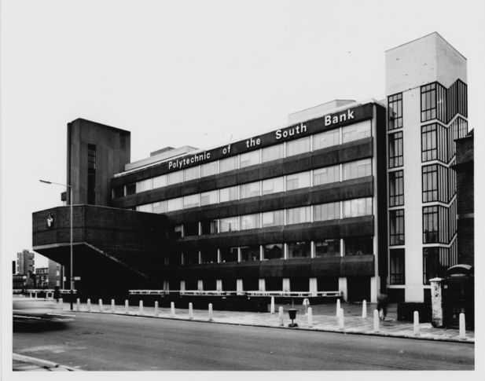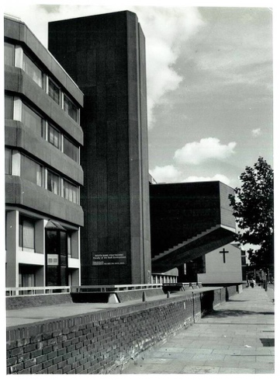

(Figure 1 + 2: Polytechnic of the South Bank, Wandsworth Road. London (1970s) (with permission of the LSBU University Archives)

…who is society? There is no such thing! There are individual men and women and there are families and no government can do anything except through people and people look to themselves first. It is our duty to look after ourselves and then also to help look after our neighbour and life is a reciprocal business and people have got the entitlements too much in mind without the obligations, because there is no such thing as an entitlement unless someone has first met an obligation…

Margaret Thatcher Woman’s Own Magazine 1987

A vaguely Post-Modernist approach to architectural design formed the limited strands of theory that underpinned my undergraduate education, the content of which was reliant on historicism and completely counter to the radical utopianism of the 1960s, the revolutionary Soviet architecture of the early 20th Century or the stunning drawings of the De-Constructivists. I remember being disproportionately excited during a lecture on syntax and semantics because it represented, finally, ideas that were contemporary and theoretical.

Having been educated to BA(Hons) Part 1 at an ‘old’ University, weighed down by the unquestioning acceptance of the profession with its embedded myths, conventions, misogyny, racism and homophobia, like many of my new PG Dip cohort, I had been ready to leave the profession and explore alternative career routes. In May 1988 an invitation to a PGDip crit by a student friend already studying at South Bank, transformed my view completely. The day was exhilarating and I came away feeling inspired, challenged and desperate to start studying again. Feeling as if my three years of Undergraduate study had been a complete waste of my time, I enrolled on the PGDip, enthused by the course leadership and the cultural values fundamental to a polytechnic education

Architecture at South Bank had a very different philosophy underpinning it. I began my studies with about twenty home students and ten German students who intended to study for the first year only. The Course Leader, Kevin Rhowbotham, had a collective approach to architectural education and forensic expectations for research and critique, which generated an atmosphere of creative multidisciplinary actions, be they with a Rotring pen or a chainsaw. He represented the role of the architect as servant to the political elite and posited the potential for the profession to effect social change. The two years were viewed as a complete journey – year one would be spent defining a thesis and year two refining and representing it.

…the posture of apolitical professionalism obviates any commitment on the part of the architect to political resistance, by constraining the architectural debate to issues of instrumentality and contingency. Hence questions concerning issues such as the nature, source and margin of client profit, the appropriateness of building to context, the client’s motive for building, or even the pertinence of the client’s brief to user requirements, are considered to be questions outside the concerns of the architectural profession.

Kevin Rowbotham Form to Programme 1985

(Rowbotham’s) working tactics are an attempt to cut though the complacency that infests the studio institutions, to provide a genuine platform from which the student can speculate on the subject.

David Greene Form to Programme 1985
Rowbotham’s critical analysis of the profession and our developing understanding of the political context to practice contextualised our production as political action and the studios on Wandsworth Road in which we worked were robust, dirty spaces where we argued, constructed and drew. This was very much our territory and regarded as our social space too.

Through a series of workshops run with the year above us, we were introduced to Mapping, Coding, Printing, Collage and Superimposition, Scratch models and Auto-dynamism. This process allowed us to be super-productive – no longer looking for the perfect conceptual idea or paralysed by the blank sheet of paper, we engaged in a process of making that enabled us to explore design processes intuitively. Everything was photographed and actions repeated many times. The walls of the studio were covered in layered collages that, through analysis and interrogation, became composition. These constructed works were then examined at different scales. One representation could be read multiple times at 1:1, 1:500 or 1:10,000, at the scale of the hand or the scale of the city.

Collectively we read and analysed Walter Benjamin’s essay Art in the Age of Mechanical Reproduction, embracing his assertion that once notions of creativity and authenticity cease to be applicable to artistic production, the function of art is based on another practice – politics. The means of representation and the process of production of the drawing, we now recognised as political, collective and pivotal in evolving architectural design concepts.

The act of collaborative drawing production was central to studio at this time– an attack on the notions of authorship and individual ‘genius’ nurtured by the academic institution and embedded by the profession. The sketch was despised and ignored as a vague, non-committal irrelevance, a means of representation that fostered an ideology of the (male) genius at work. The pressure and competitiveness students have to struggle with was not part of our experience and there were many other spaces of discourse and pleasure beyond the studio that fuelled and inspired our work.

Drawings were made as constructions without the convention of line on tracing paper, they were ‘grown’ using soil and seeds, cast, stolen, re-appropriated. Representations were overlaid with superimposed material fragments, other people’s drawings, photographs. The image, projected onto dyeline paper and printed to make ‘blueprints’ challenged the myth of the nature, codes and readings of the conventions of architectural drawing.

Authorship was redundant. Collaboration was central and essential to a collective creative means of making. For weeks our cohort worked tirelessly on the communal drawing (singular, continuous, constructed on a never-ending roll of tracing paper) that would be a competition entry and academic submission for the students in the year above. The drawing, no longer a representation of the status quo or a nostalgic artifice to promote and legitimise the Government’s anti-societal ambitions, was understood as polemical rather than representational – an agency through which active, politicised methodologies could evolve.

Studying in an environment that rejected all accepted conventions and the complacency that was the mainstay of provincial UK architectural education was radical and liberating. The inevitable fears about the collective versus individual competition were raised (how will we be marked?!) and quickly quashed. We would all get A’s if we worked hard. We worked night and day.
The Slaughterhouse exhibition was our first collaborative action that interacted with the public. An exhibition of work of the year above us, we helped install beautiful constructions made of fragments of cast and constructed elements and found pieces.

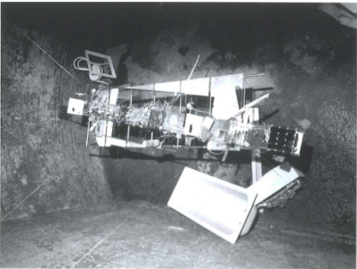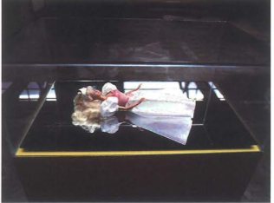

(Figure 3: Kevin Rowbotham and students Canary Wharf model Slaughterhouse Gallery, London 1987)

(Figure 4: Kevin Rowbotham and students Barbie-tecture exhibition, Rivington Street Warehouse 1992)
Contemporary poetry, text imaginings and ruthless forensic readings of key texts (Rowe, Venturi, Foucault, J. G. Ballard, Tafuri, John Berger) and revolutionary artistic action/making from the early 20th century inspired our position and process. We attend the Krokers’ lecture at the ICA, read ‘Panic Encyclopaedia’, and discover a lot of people who really interested us, notably Hannah Vowles and Glyn Banks.

The environment of that year enabled me to investigate design as a patriarchal construct and have that position valued and supported. The notion that architecture could be created through a feminist methodology, that a new language and typologies could be evolved, had manifest itself through my research and response to collective studio activity. In this radical moment I rejected all aspects of the patriarchal system as I understood it.

Part 3 1989 Panic Crash, the Collective
Come to the edge.
We might fall.
Come to the edge.
It's too high!
COME TO THE EDGE!
And they came,
and he pushed,
And they flew.
Christopher Logue New Numbers 1969

There was a good deal of tension in the department at this time and Rowbotham, whose methodology was apparently deeply threatening to the hierarchy of the department, was clearly disliked by other members of staff. This seemingly idyllic, if challenging, period appeared to have abruptly halted when Rhowbotham was removed from his postgraduate duties to teach undergraduate first year. With no computers or mobile phones it took time for word to get round, but soon enough it was established that Kevin was no longer our tutor. The symbolism of his ‘demotion’, was not lost on us and we held several meetings, wrote statements and manifestos. This process manifested in our rejecting the staff reintroduced to teach us and the whole cohort joined undergraduate first year, attending lectures and collaborating on their installation projects. Rowbotham’s philosophy lectures were extraordinary; possibly some of the best I have ever experienced and pure theory, not applied, a thread of education that would be difficult to manifest or retain in architectural education today. And a very different context to 2010 when Middlesex University closed its Philosophy Department.
These felt like extraordinary times – we were, to an extent free and still being educated by Rowbotham. No one questioned the fact that we were in a year of students who had just started; we worked on the same projects, evolving them collectively. I distinctly remember approaching the building on Wandsworth Road one morning to see a crane hoisting crushed cars onto the roof. When I got up there, I found Kevin and some students getting organised to cut up the cars with chainsaws.
The difficult atmosphere amongst the staff was palpable and no doubt exacerbated by the student body who became more and more intent on taking control of our education, rejecting much of the rest of the curriculum delivered by other tutors. The studio became a safe space and a place where, although Rowbotham was setting the agenda via his teaching in 1st year, suggesting what we should read and what competitions we might work on, we were to a greater or lesser extent autonomous. The German students really helped us take a resolute stand on our collective positioning against the department. Naively we assumed that the rest of the staff who were, by default in our view, defending the educational values we had rejected, would tolerate our stand to exclude them from the studios.

For a few weeks we worked together on a competition entry. Inspired by The Atrocity Exhibition by J. G. Ballard, this was a period when little drawing happened as we were constantly casting and modelling. Engaging in ‘Auto-dynamism’, the process concluded with the construction of a huge plaster cast model of an intervention around the site of the Birmingham Motorway system known as Spaghetti Junction, made from casts of our bodies and fragments of the cars still on the department roof. Our proposition of constructions and landscape threaded through the discarded, left over spaces from the civil engineering road scheme, is lost but, as our concerns at this point were with process, it seems fitting that some of the images of that process alone survive.

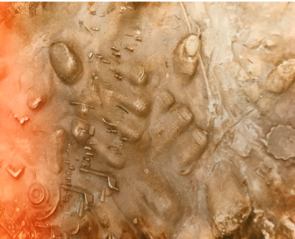
(Figure 5: ‘Crash’ cast model (fragment) plaster and found materials)

It was the day we locked the door to the studio (actually to create a safe space for the women students to make casts of their bodies) that caused everything to change more drastically. The locked room, it seems, so angered the Acting Head that he destroyed our model, smashed to pieces and left shattered across the studio. We were devastated and to add to our distress, a couple of days later we discovered that Kevin was gone. The staff we had rejected in favour of our mentor, were now imposed on us once more. We felt like wild animals, set free for a brief spell in the wild only to be unceremoniously chained and re-caged. For a short period we attended the ‘set’ lectures but soon started walking out in protest; we could no longer tolerate the sexist terminology or white colonial positioning so embedded in their content. Furious, we gave the newly appointed Head of School notice we were leaving the course – en masse. To our amazement his response was to offer us, quite incredibly, the budget to run our course ourselves, even getting permission to negotiate which, if any, tutors from the department we would utilise for core teaching and what they could or could not teach us.

I remember the first meeting we held; 100% commitment from every student was required if we were to make this work. Everyone was complicit and keen to get organised. We took control of everything and immediately decided to only have departmental guidance for our dissertations. All other tutors would be employed by us from outside of the institution as collaborators and consultants. This group included artists, poets and performance artists and building product manufacturers, but interestingly no architects.

Part 4: Feminist action, class, empowerment, opportunity

Our studio is constructed as a form of resistance to the violence committed against the Collective in contemporary architectural education. Notions of hierarchy, patriarchy and control in Britain are constantly manipulated in order to maintain the status quo; this is fundamental to the education system which is no longer a site of experimentation and social action. We have been brain washed into accepting the repetitive production mind-set that ensures the regurgitation and endless revision of what has gone before. Already a slow, lumbering beast unable to respond effectively or creatively to social or cultural change, architectural theory is literally shuddering to a halt. Led by fetishised engineering and technology, it is simply another manifestation of patriarchy. No ideas are possible in this context, only a self-reflexive notion of a kind of poetic masturbation; an architecture of ‘parts’ put together to form a Meccano kit to signify technological progress. And the antidote to a culture of neurosis and alienation is another kind of architecture: a Disney version of infantile fantasy based on ‘historic’ nostalgia, a tranquiliser dissipating the nation’s potential for political action when not physically exhausted by labour. Contemporary architectural theory has failed; it’s focus on the individual is self-indulgent maintaining a 19th century obsession with morality. Society and the commune must be valued; by celebrating the chaos and panic inherent in contemporary society, architectural education can be the vehicle to expose the potential for different methodologies, programme and form. We are challenging the comfortable, rational, contextual. The notion of context is completely redundant/irrelevant as the contemporary urban context is merely mimicking and responding to the hierarchies and power structures embodied in an architecture of the past.”
Jane Tankard (notes from my studio sketchbook, 1989).

Addressing the extreme right-wing political backdrop of the period, we were determined to establish and achieve a Marxist feminist space in which revolutionary architectural ideas could be produced and we consciously engaged in a design process that was located politically in complete opposition to the systems integral to our experience of the time.

We arranged for Kevin to teach us at night; we let him in via the fire escape and he helped us to get things structured. He suggested we employ design tutors as a matter of urgency to teach us the following year and we invited a team that included Hannah Vowles, Glyn Banks, Emma Birkett and Rose Nãg. They agreed to work with us and the school administrator organised contracts and arranged payments. Like Kevin they were extremely challenging tutors but the relationship between tutor and student had effectively completely transformed. They were more like critical friends, helping us to evolve our individual polemic into major projects.

The thesis and the political position that this period framed became the mechanism for a methodology that was ruthlessly adhered to. For technology we built fragments of our building propositions in the studio. When we felt there was a gap in our knowledge, we filled it as a group, inviting the first years, to attend workshops and readings. I remember running a structures workshop with professional dancers where we built human structures and drew them in order to fully understand structural principles. We learned that explaining what you know to others is a brilliant way of understanding better yourself.
In May we said goodbye to our German partners who were returning home to continue their studies and we went off to spend the summer researching for our dissertations.

Bakhtinian notions of intercultural communication and the potential to identify multi-disciplinary creative space within those intersections were adopted intuitively. Our cohort was made up of individuals from a diverse demographic who used their individual cultural experiences to create intersectional methodologies that were informed by rigorous investigations into the spaces between our knowledge and understanding. No longer working to pre-determined programmes or briefs but instead responding to knowledge, analysis and shared principles, we evolved critical collective and individual programmes that challenged our understanding of typology, framing our work with theoretical rigour and specificity.

November 9th 1989 was a Thursday. In the studios, reports filter through that the Berlin Wall is about to fall. Some of us phone our friends in Germany. There is a sense that things are changing but we also know that unlike our cousins not so far away, the UK remains a political space supported and reinforced by the media.
There were many moments during this period when despite holding the budget and governing ourselves, we were confronted, often extremely aggressively, by the institution. This was particularly prevalent towards the middle of the year when interim crits were approaching. There were a number of stand offs and the dramatic, destructive response to our locked studio doors the year before had not been forgotten.

When the department tutors took it upon themselves to enter into and disrupt our allocated studio spaces, we attempted to negotiate and debate. On one occasion a very angry tutor stated that my project, a refuge for abused women and children in Hackney, had no technological understanding whatsoever and would fail. My proposal was using the simplest of domestic construction techniques - a straightforward strategy that would not have challenged any contractor, but manipulated to create spaces without programme that were designed around experience and materiality. I wasted a valuable opportunity for creative feedback by inviting this tutor to my crit where I had nothing on the wall; I simply drew the ‘technology’ as he deemed to call it as he asked me to, on a flip chart. These were terrifying moments; we were literally being forced to confront the hierarchies we had chosen to reject and ‘defend’ our work in the crudest of ways.

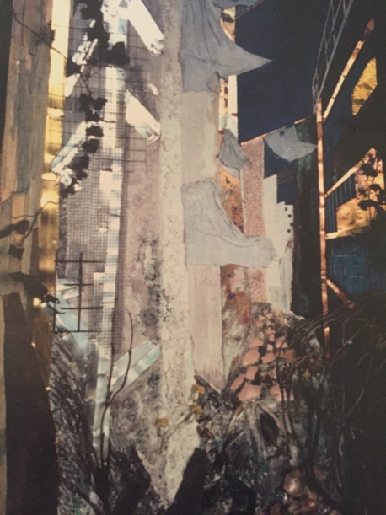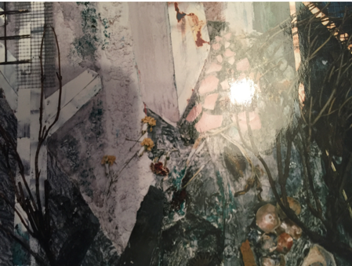

(Figure 6: PGDip mixed media drawing (2 metres x 2.4 metres, women’s refuge Jane Tankard 1988 South Bank Polytechnic)

(Figure 7: Women’s refuge, drawing detail Jane Tankard 1989 South Bank Polytechnic)

Stan Sherrington became Head of School in 1990, close to the end of our final weeks in the department and at last we had an advocate who shared some of our principles. He managed to keep one foot in both camps; he kept the institution away from us as much as possible and supported us when we needed it. The confrontations stopped and we worked harder than ever, constructing our final installations in the studio.
Despite our visiting tutors, mostly we educated each other, challenged, argued and set the highest of standards for us all. The assumption that we would all pass was absolute (we all did). That year South Bank Polytechnic won the RIBA Silver Medal and a number of us visited other schools to talk about our work. This example of student agency was valued both by the institution (the polytechnic, RIBA) and the profession (external examiners).

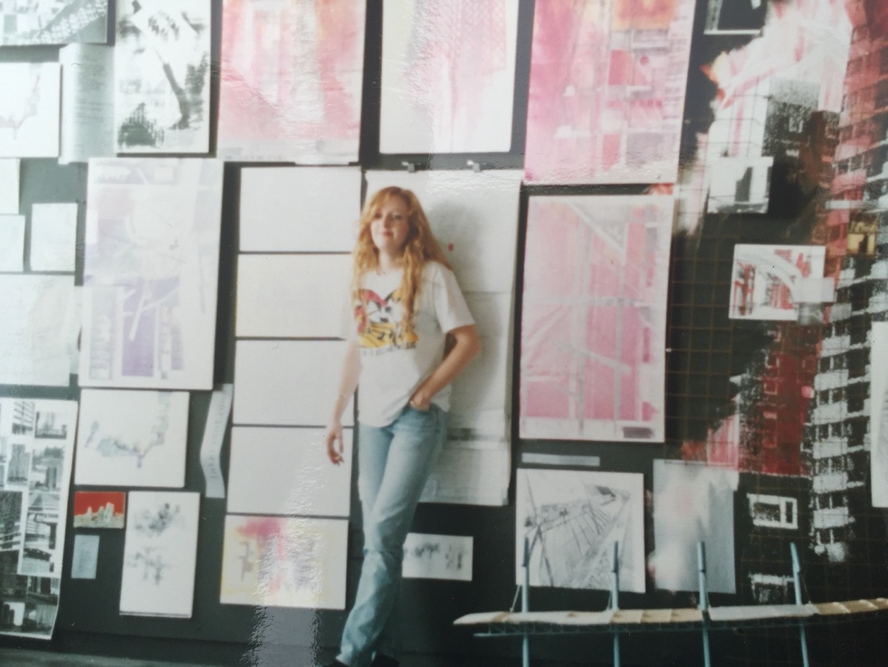

(Figure 8: Dr Tonia Carless RIBA Silver Medal Prize Winner 1990 South Bank Polytechnic)

On 13th June 1990, just a couple of days before our end of year exhibition, police in Bucharest attacked the School of Architecture where a sit-in of students and hunger strikers were protesting about the self-styled new government that had come to power after the revolution. The building was attacked by miners and industrialists, brought in by the government in an attempt to quash the rebellion. The School of Architecture was destroyed and many students badly beaten. A few weeks later we welcomed those same students to London. Invited by UK members of Europan - Europe, we met our contemporaries: half starved to death by Ceacescu and nearly beaten to death by their countrymen. Like the Paris Uprising of 1968 and Rome in the same year art and architecture schools were the site of political confrontation.

Post script 2015-16

Take off your shoes and walk along the beach

Through the ocean’s last thin sheet of water

Gliding landwards and seawards. You feel

reconciled in a way you would not feel if there

were a forced dialogue between you and either

one or other of these great phenomena. For

here, in between land and ocean – in this

in-between realm, something happens to you that

is quite different from the seaman’s alternating

nostalgia. No landward yearning from the sea, no

seaward yearning from the land. No yearning for

the alternative – no escape from one into the

other.

Aldo Van Eyck

As the unity of the modern world becomes increasingly a technological rather than a social affair, the techniques of the arts provide the most valuable means of insight into the real direction of our own collective purposes.

Marshall McLuhan The Medium is the Message: an inventory of effects 1967

Before completing my studies, Sherrington asked me if I would like to teach in the department. I seized the opportunity to go on learning through collaboration continuing very much in the spirit of this transformative period of my life.

I have now been teaching for 30 years, the past 20 in 3rd year undergraduate. Over this period I have become increasingly frustrated by the growing influence of the profession on architectural education and the insistent veering towards political conservatism and instruction-based learning, a condition exacerbated by increasing student numbers and decreasing funding and resources against a backdrop of a political shift to the right. Radical feminist practice, regardless of discipline or context is as marginalised as it ever was, its threatening presence in the second half of the 20th century appears simply to have been rendered powerless through a process of commodification and co-opting by patriarchy.

In response, I have returned to the education and experience described in this essay for inspiration and methodology. The futility of ‘training’ architects rather than teaching them to learn through experimentation, analysis, collective interaction and theoretical discourse and to engage in the unknown and unpredictable has become central to my teaching, manifesting in an interrogation and creative resurrection of what, how and in what context, I had learnt. The value of understanding the contemporary political context, the role of the architect in maintaining the status quo, the notion of form to programme and the techniques of representation and investigation described earlier are central to my studio practice.

Every year is different and processes depend to a large extent on the students who have chosen to be in the studio. We begin by identifying artists, makers, journalists and film makers who have exposed, through edited views, cracks and fragments of potential radical space which students overlay with their own experience, knowledge and detailed research. The orthographic drawing becomes a tool of forensic analysis rather than mute representation, resulting in carefully constructed ‘choreographic’ drawings, often at very large scales, that describe the architectural ephemera often omitted from the drawing: time, movement, narrative, ‘props’, contexts. These drawings describe a space somewhere between the real and the imagined, over which can be overlaid both the individual student’s cultural history and narrative and a social commentary defined and refined through debate and conversation that celebrates difference and personal experience. The politics of action and language are discussed on a daily basis and interrogations of formal and informal architectural devices are critical to the process. These are the architects of tomorrow and so we tend to choose a near future scenario to contextualise our urban proposals.

In 2015, the studio spent the year examining ideas about Political Space in the context of social governance. Architectural notions of demarcation, devolution and democracy were investigated using global historical precedents. Through a collaborative and communal approach to the output of the studio, we identified and took inspiration from the work of artists such as Jeremy Deller and Sheila Donagh to understand how we might edit our view and construct relevant representations. We addressed issues of race, sexuality and gender and identified a studio practice that was knowing and tolerant of one another.

The potential for radical or subtle transformation through architectural proposition is central to studio investigations into the nature of democratic space and its erosion in rapidly changing global and local contexts. Each student was asked to construct a manifesto in order to clarify intention, but also to define the parameters within which the project would evolve.

Focusing on the South Bank, we considered the social, political and economic contexts of the South Bank Place development adjacent to the Shell Tower. This luxury housing project was read against the backdrop of the post war socialist and civic ambitions of the Festival of Britain and the South Bank Centre. We visited New York, considered the impact of the 24-hour city and the lives of immigrant families first settled at the end of the 19th century whose relatives still live and work in the metropolis. The studio went on to study the Houses of Parliament, using alternative artistic and architectural action and activity from the 1960s as templates to present and inform the work which evolved initially as an intervention, creating public space from private, eventually developing into more permanent propositions that would serve, provoke or enable social engagement with politics. Intended to contextualise and interrogate architectural production, education and space the work was intentionally polemical and provocative, challenging the expectations of a 3rd year architectural ‘scheme’ and its conventions.
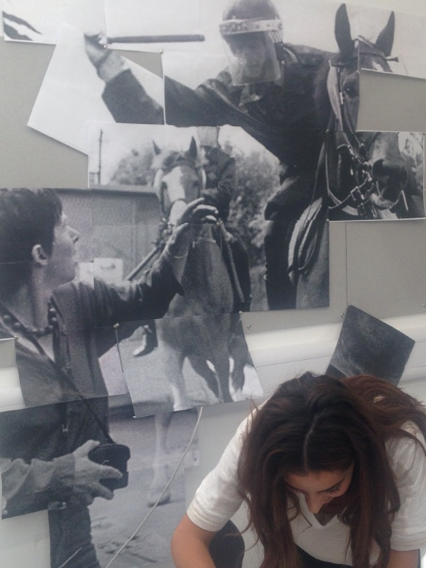

(Figure 09: Battle of Orgreave Vanessa Assaf 2015)

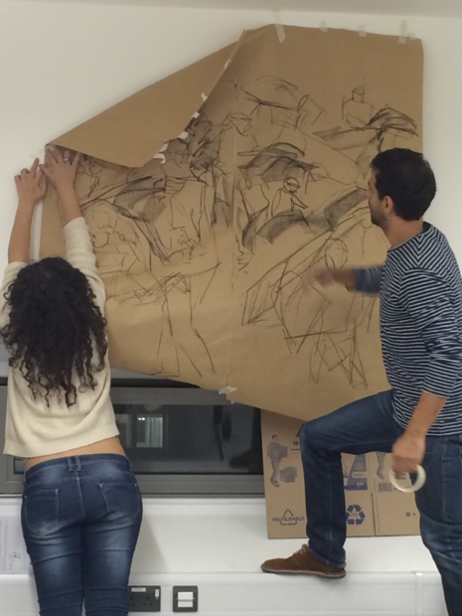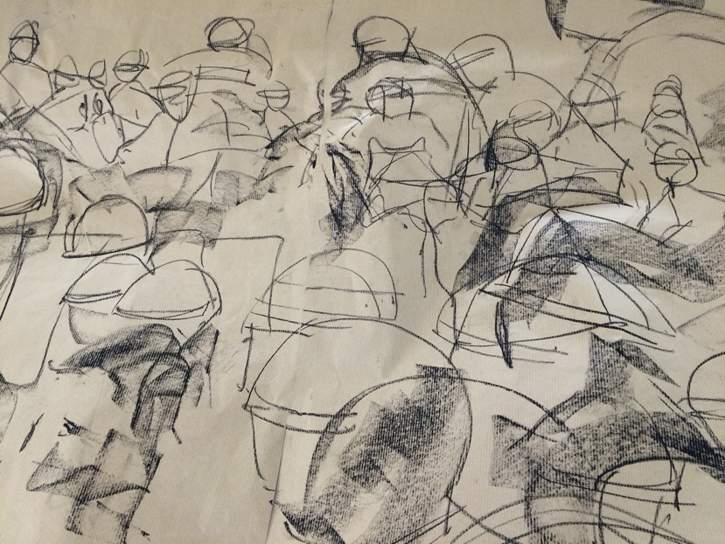

(Figure 10 + 11: Poll Tax Riots Farid Abdulla 2015 )

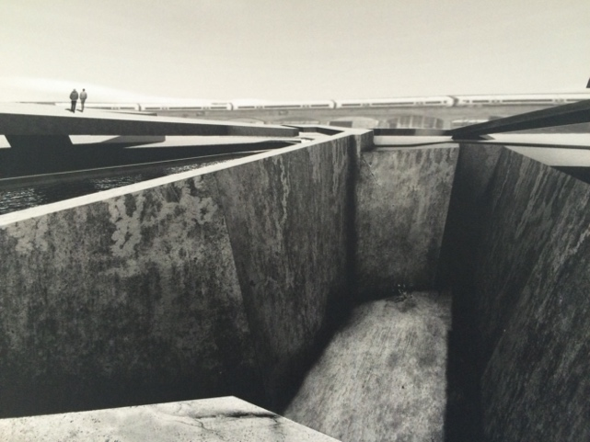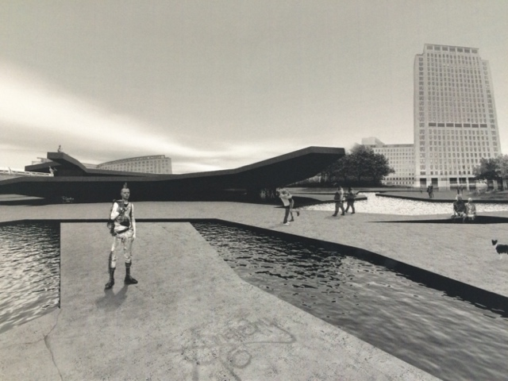

(Figure 12 + 13: Michelle Barratt 2016 ‘Parly’)

(Figure 14: Eira Mooney 2016 Citizen Choreography)

The process is not linear; like this essay, the work evolves out of an assemblage of fragments, researched, found, contextualised, analysed. Students are given each other’s projects to work on and present. There is no ‘end’ in the conventional sense of the word, production simply stops when time runs out. Dangerous as this may seem, the students produce work to match Learning Outcomes and Assessment Criteria, but the drawings and models arise at specific points in the process. In this particular year, our exhibition – led entirely by the students – challenged the notion of the individual in favour of the collective.

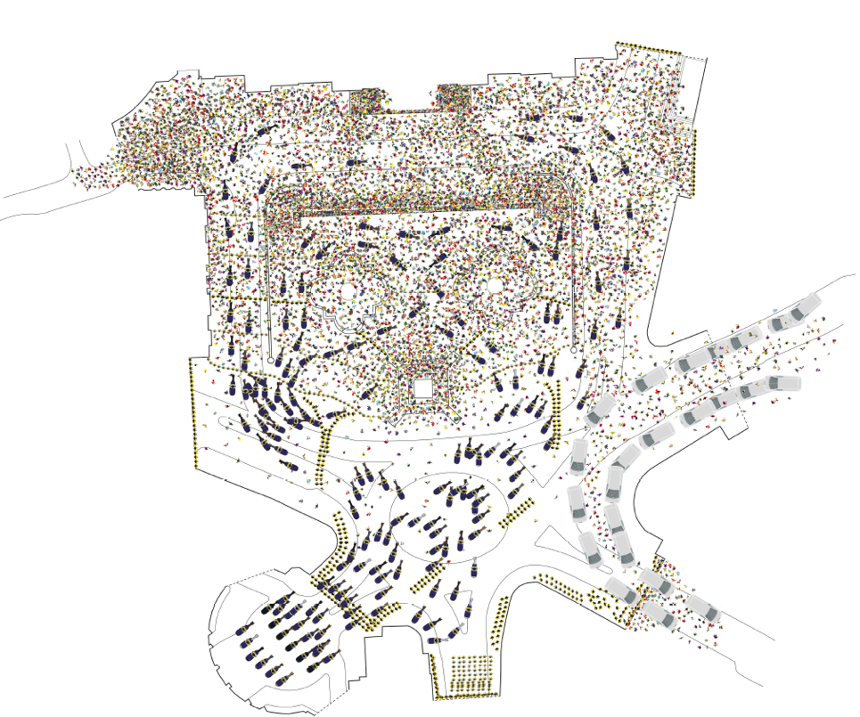

(Figure 15: Javier Garcia Navarro 2016 Poll Tax Riots Choreography)

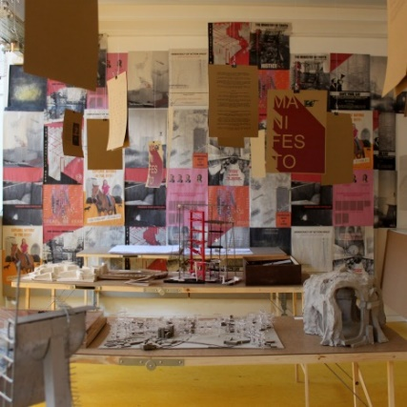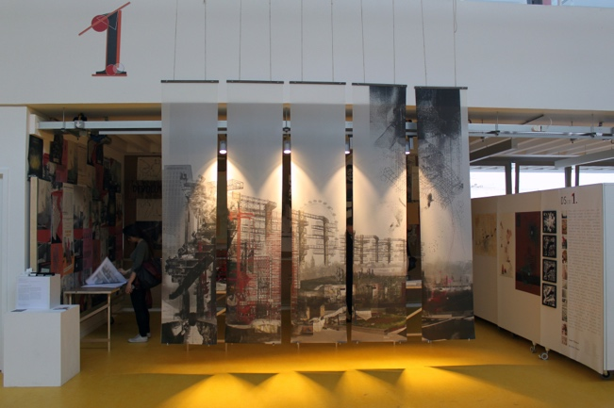

(Figure 16 + 17 End of year exhibition, Design Studio 1 University of Westminster 2016)

2019: reconstructing the collective

“There followed on the birth of mechanisation and modern industry… a violent encroachment like that of an avalanche in its intensity and its extent. All bounds of morals and nature, of age and sex, of day and night, were broken down. Capital celebrated its orgies.”

Karl Marx Capital 1887

Almost 50 years since the political moments that mark the beginning of this essay, and just over 150 years since the publication of Das Kapital, it could be argued that Marx’s tenet, all that is solid melts into air, has come to pass. Marx’s commentary on the industrial transformation of society through mechanisation precedes the electronic and now digital revolution that is completely transforming contemporary global society. Artificial Intelligence and the potential that humans will no longer need to think, make decisions or control our environment is the future context that goes hand in hand with a ‘Bladerunner 2049’ apocalyptic vision of a natural world that is completely destroyed by the worst of our consumerist excesses. Architecture can be transformative, catalytic, alchemical, yet against this super-fast changing context, the profession appears to be more like a slow, reactionary beast.

“…professional practice is too willing to pay lip service to the highest cultural values and the most optimistic civic ambitions, whilst at the same time accepting the demands of the money markets as natural, normal and unassailable.”

Kevin Rowbotham Form to Programme 1995

The potential for a radical utopian architectural education seems to be all but lost, its final death throes manifesting in funding strategies that include models such as the Apprenticeship scheme, where the school of architecture is not just beholden to and policed by the government but by the employer and the profession. As we stand on the precipice of global catastrophe, the overdue search for alternative solutions to our social and political contexts begins. The opportunity for architectural educators to challenge the course laid out for us may be a brief moment in time, initiated by a few people in search of radical change but revisiting the experiments of the past may make useful models for the future.

“We have to be all those difficult things,
like cheerful and kind and curious and patient,
and we’ve got to study and think and work hard,
all of us, in all our different Worlds,
And then we’ll build…”

Somewhere in the garden a nightingale was singing,
and a little breeze touched her hair and stirred
the leaves overhead. And somewhere else,
in each and one of the parallel worlds,
a nightingale would sing, and a little breeze
would be stirring the leaves in the Botanic garden.

“And then what, build what?”

“The Republic of Heaven,” said Lyra.

Philip Pullman His Dark Materials 1995

Walter Benjamin, ‘The Storyteller’ from ‘Illuminations: Essays and Reflections’, HMH (1968)
Lévi-Strauss, C. (1962) La Pensée Sauvage, University of Chicago Press
Bakhtin, M. M. (1982) The Dialogic Imagination University of Texas Press. (Bakhtin’s) emphasis on a boundless context that constantly interacts with and modifies the text helps us avoid formalist insistence on the autonomous art object. His emphasis on the situated utterance and the interpersonal generation of meaning avoids the static ahistoricism of an apolitical value-free semiotics. Min, Eungjun. (2001). Bakhtinian Perspectives for the Study of Intercultural Communication. Journal of Intercultural Studies. 22. 5-18. 10.1080/07256860120037382.
Sullivan, L. The Tall Office Building Artistically Considered 1896 Lippincott’s Magazine
Chtcheglov, I. New Urban Formulary 1953 www.bopsecrets.org. Retrieved September 2017
https://www.theguardian.com/education/2019/nov/05/alarming-chinese-meddling-at-uk-universities-exposed-in-report
Edwards, R. ‘Margaret Thatcher, Thatcherism and Education’ McGill Journal of Education (1989)
Farndale, N. A Hard Man to Like The Telegraph 24.10.1998
Thatcher, M. Margaret Thatcher: The Downing Street Years, New York: HarperCollins (1993)
Rowbotham, K. Form to Programme, Black Dog Press (1995)
ibid
Zola, E. The Masterpiece Oxford University Press (1886/2008)
Oliver Wainwright ‘Pressure builds for change in Britain’s schools of architecture’ Guardian (27.06.2013) https://www.theguardian.com/artanddesign/2013/jun/27/pressure-builds-change-schools-architecture
Margaret Thatcher, Woman’s Own Magazine interview (September 23rd 1987)
Scratch uses waste and discarded materials as an operating medium through the juxtaposition of unfamiliar forms and surfaces
A pre-conscious/unconscious production in which formal structuring processes are allowed free play, unfettered by logical editing
Arthur and Marilouise’s lecture titled ‘Panic’ was delivered at the ICA autumn 1988
Logue,C. New Numbers’, Cape (1969)
J. G. Ballard, The Atrocity Exhibition Flamingo (1993)
Van Eyck, A. Architectural Design Journal December 1962
McLuhan, M. The Medium is the Message: an inventory of effects Penguin Books (1967)
Marx, K. Capital: A Critique of Political Economy Volume 1’ Progress Publishers, Moscow USSR (1887)
Pullman, P. His Dark Materials, Scholastic books (1995)

