|  |  |  |
| --- | --- | --- |
|  |  | |
|  | D4.1 Initial Framework Definition | |
|  | Deliverable 4.1 | |
|  | Vista | |
|  | Grant: | 699390 |
|  | Call: | H2020-SESAR-2015-1 |
|  | Topic: | Sesar-05-2015 Economics and Legal Change in ATM |
|  | Consortium coordinator: | University of Westminster |
|  | Edition date: | 22 December 2016 |
|  | Edition: | 01.00.00 |

|  |
| --- |
| EXPLORATORY RESEARCH |



|  |  |  |
| --- | --- | --- |
| Authoring & Approval | | |
| Authors of the document | | |
| Name/Beneficiary | Position/Title | Date |
| Luis Delgado / University of Westminster | Consortium Member | 21 December 2016 |
| Gérald Gurtner / University of Westminster | Consortium Member | 21 December 2016 |
| Andrew Cook / University of Westminster | Project Leader | 21 December 2016 |
| Samuel Cristóbal / Innaxis | Consortium Member | 21 December 2016 |
| Jorge Martin / Innaxis | Consortium Member | 21 December 2016 |

|  |  |  |
| --- | --- | --- |
| Reviewers internal to the project | | |
| Name/Beneficiary | Position/Title | Date |
| Graham Tanner / University of Westminster | Consortium Member | 22 December 2016 |
|  |  |  |

|  |  |  |
| --- | --- | --- |
| Approved for submission to the SJU By — Representatives of beneficiaries involved in the project | | |
| Name/Beneficiary | Position/Title | Date |
| Andrew Cook / University of Westminster | Project Leader | 22 December 2016 |

|  |  |  |  |
| --- | --- | --- | --- |
| Rejected By - Representatives of beneficiaries involved in the project | | | |
| Name/Beneficiary | | Position/Title | Date |
| N/A |  | |  |

|  |  |  |  |  |
| --- | --- | --- | --- | --- |
| Document History | | | | |
| Edition | Date | Status | Author | Justification |
| 01.00.00 | 22 December 2016 | Release | Vista Consortium | New document for review by the SJU |
|  |  |  |  |  |
|  |  |  |  |  |
|  |  |  |  |  |
|  |  |  |  |  |

Vista

Market forces trade-offs impacting European ATM performance

This deliverable is part of a project that has received funding from the SESAR Joint Undertaking under grant agreement No 699390 under European Union’s Horizon 2020 research and innovation programme.



Abstract

The initial evaluation framework definition of the Vista project is presented. The framework is software code of an extended air traffic management model. The primary objective of Vista is to quantify the current and future (2035, 2050) relationships between a currently non-reconciled set of performance targets in Europe. Specifically, it examines the trade-offs between, and impacts of, regulatory and business factors and whether future alignment between these may be expected to improve or deteriorate. A preliminary selection of the business and regulatory factors, and metrics, to be modelled is presented. Various modelling approaches are considered and an appropriate method selected.

Table of Contents

Abstract 3

Executive summary 5

1 Introduction 6

1.1 Objectives of Vista 6

1.2 Overview of this deliverable 7

1.3 Acknowledgement 7

2 High-level model definition 8

2.1 Stakeholder identification 8

2.1.1 Passengers 8

2.1.2 Airlines 9

2.1.3 ANSPs 11

2.1.4 Airports 12

2.1.5 Environment 13

2.2 Scope 14

2.2.1 Temporal and spatial scope 14

2.2.2 Scenario definitions 14

2.3 Metrics and trade-offs to be analysed 25

2.3.1 Metrics 25

2.3.2 Trade-off analysis 27

2.4 Modelling approach 29

2.4.1 Framework and approach 29

2.4.2 Modelling technique selected for Vista 35

3 Platform description 37

3.1 Project infrastructure 37

3.2 Project software architecture 38

3.2.1 Preliminary requirements 38

3.2.2 Platform architecture 40

4 Next steps and look ahead 48

Executive summary

The purpose of this document is to describe the initial evaluation framework definition of the H2020 SESAR Research and Innovation action, the ‘Vista’ project. The goal is to introduce the framework in several terms: from the background used for the model to more technical information regarding the definition of the model and its implementation: actors, languages, stakeholders, timeframes, factors, processes to be modelled and metrics that will be used, among other high-level specifications.

The primary objective of Vista is to quantify the current and future (2035, 2050) relationships between a currently non-reconciled set of performance targets in Europe, specifically, the trade-offs between, and impacts of, regulatory and business factors and whether their alignment may be expected to improve or deteriorate in future. Vista will statistically quantify associated potentially undesirable interactions and trade-offs between KPAs for passengers, airlines, ANSPs, airports, and the environment.

The evaluation framework is software code of an extended air traffic management model. This model, and its software implementation, will be developed to support the Vista goals. The development will leverage on work carried out in recent years by the University of Westminster and Innaxis, deploying a key component of the framework: the ‘Mercury’ model.

The model and a description of the platform that will be implemented are presented. This includes: fuller identification of stakeholders to be modelled; a description of the geographical and temporal scope of the project; and, an overview of how the scenarios that are considered in Vista will be generated, along with a preliminary selection of the business and regulatory factors to be included.

Regulatory factors are regulations that define the operational framework modelled and that might well affect how a process or operation in the system functions. Also included in this definition are (policy) instruments, i.e. policy objectives that are not binding (non-regulatory) but may also contain operational targets that influence behaviour. Business factors are such factors other than regulatory that are considered within the model. These are non-regulatory (‘market’) factors that affect (business) operations and are set by the stakeholders or in the wider economic environment. These factors include tools, technologies and processes.

A preliminary selection of metric groups to be included in the analysis and a discussion of their context and the corresponding trade-off analyses is also presented, with a discussion of the different modelling approaches considered and selection of the most appropriate model.

This is then developed further to describe the platform to be implemented from a systems architecture perspective. Two aspects are presented regarding the platform description: the project infrastructure (identifying the resources that will be used to support the development and validation of the model) and the project software architecture (identifying the modelling tools that will be used and describing the model architecture).

Finally, key next steps and associated deliverables are summarised.

# Introduction

## Objectives of Vista

The primary objective of Vista is to quantify the current and future (2035, 2050) relationships between a currently non-reconciled set of performance targets in Europe, specifically:

* the trade-off between, and impacts of, ‘regulatory’ and ‘business’ factors (which we define in Section 2.2);
* the horizontal metric trade-offs *within* any given period;
* the vertical trade-offs *between* periods, particularly as many targets are not currently mapped from year to year, are discontinuous with other targets, or even entirely missing for given periods (such as, vitally, passenger performance targets);
* whether alignment may be expected to improve or deteriorate as we move closer to Flightpath 2050’s timeframe, for example.

Vista will also identify and quantify potentially undesirable interactions such as, but not limited to: (i) over-provision of ANSP service (driven by SES performance targets, but reducing delays below users’ needs thus resulting in sub-optimal cost-efficiencies); (ii) flight cancellations instigated by airlines as a cost-saving measure relative to long delays (driven by changes to Regulation 261); (iii) increased emissions as a result of airlines recovering delay through accelerated fuel burn (driven by business and regulatory pressures).

A dedicated workpackage explores the trade-offs between these metrics. Vista will study such trade-offs using statistical tools, due to the stochastic behaviour of the model (see Section 2.3). The analyses will include correlation coefficient computations within a given scenario, and comparisons of such coefficients between scenarios, using null models and other statistical tools to identify statistically significant results.

## Overview of this deliverable

In Workpackage 4, the evaluation framework to assess the impact of the modelled factors is presented and developed. In this deliverable the model and a description of the platform that will be implemented are presented. This includes:

* an identification of stakeholders to be modelled;
* a description of the geographical and temporal scope of the project;
* an overview of how the scenarios that are considered in Vista will be generated, along with a preliminary selection of the business and regulatory factors to be modelled;
* a preliminary selection of metric groups to include in the analysis and a discussion of their context and the corresponding trade-off analyses;
* a discussion of different modelling approaches with a selection of the most appropriate model;
* a description of the platform to be implemented from a systems architecture perspective.

## Acknowledgement

The DATASET2050 project (‘Data-driven approach for seamless efficient travel in 2050’; EU Research and Innovation programme, Horizon 2020) is examining door-to-door travel in Europe in the current, 2035 and 2050 timeframes. The partners are: Innaxis (Coordinator); the University of Westminster; Bauhaus Luftfahrt; and, EUROCONTROL. For consistency of future modelling scenarios, the Vista partners have aligned the passenger profiles of Section 2.1.1 with those of DATASET2050, and checked the definition of the background scenarios of Section 2.2.2(c) for mutual consistency and coverage. These contributions were led by Bauhaus Luftfahrt in DATASET2050, and this (partial) alignment of the two models is by mutual consent.

The opinions expressed herein reflect the authors’ view only. Under no circumstances shall the SESAR Joint Undertaking be responsible for any use that may be made of the information contained herein.

# High-level model definition

## Stakeholder identification

In this section we identify key characteristics of the stakeholders to be modelled, and how these relate to the modelling process.

### Passengers

Several types of passenger are currently being considered for inclusion in Vista, such as: ‘cultural seekers’, ‘family and holiday travellers’, ‘single travellers’, ‘best agers’, ‘environmental travellers’ and ‘digital native business travellers’. The detailed characteristics of these passengers will be reported in later deliverables, and their allocation across various routes and regions will be determined in subsequent modelling. This work is being carried out in coordination with the DATASET2050 project (please see Acknowledgement in Section 1.3). Not only their behaviour during operations but also demand itself might be affected by the types of passengers modelled. For example, if the proportion of ‘environmental travellers’ increases in Europe, one would expect a slower increase of air travellers as a whole. These categories would then affect the processes that generate the demand for Vista at the strategic level.

Another important consideration is that not all the phases of the door-to-door journey will be equally affected by the distinction between passenger types. The characteristics of the passengers will, in general, play a more major role in the door-to-gate (e.g. regarding airport access mode), and, to a lesser extent the gate-to-door phases (e.g. regarding uptake of new technologies for ticketing and security clearance) than in the gate-to-gate phase. However, in the gate-to-gate phase, passengers may be differentially prioritised, subject to future business and regulatory processes, according to such factors as their uptake of new technologies (e.g. use of in-trip recovery tools) and journey travel-time priorities (e.g. some passengers being more prepared to accept late arrival times during disruption, just as certain travellers currently volunteer for compensation and a later flight in cases of flight overbooking). The total number of passenger categories considered within the model might vary as a function of the travel phase, whereby some of the six potential categories cited above might be collapsed into fewer categories if some are ultimately deemed to be equivalent as far as responses to model processes are concerned (e.g. rebooking during disruption). In the current scenario, this is likely to be collapsed into two categories: a simple ‘premium’ and ‘standard’ (‘premium’ passengers are highest-yield passengers associated with high-end fares, receiving priority for rebooking during disruption).

Finally, it is worth noting that in order for Vista to represent in a holistic manner the effect of the different factors on the system, not only flight metrics need to be generated, but passengers-centric metrics are also required. Therefore, full origin-destination itineraries, i.e. including flight connections and connection times, must be considered. Multi-leg itineraries account for discrepancies between some flight- and passenger-centric metrics and drive some airline behaviour when dealing with delay (e.g. reaccommodation of passengers or cost index variation for the tactical recovery of delay).

### Airlines

Airlines can be differentiated by their:

* Business model[1]: full-service, low-cost, regional, charter; cargo;
* Fleet stratification;
* Passenger volume and ticket pricing and categories;
* Geographical coverage;
* Physical and human resources;
* Alliance(s) and subsidiary airlines.

In Vista, airlines archetypes will be defined based on the four business models above (excluding cargo). The particular characteristics of each of the airlines will be considered at different phases in the modelling. They will play a role, for example, in the strategic decisions to respond to the different modelled factors that might differ for different airline types, in the creation of flight plans and their selection at the pre-tactical and tactical level, or even when considering technology uptake. The characteristics of these four airline types to be modelled in Vista are outlined below. These are typical characterising features to be used in the Vista model, although the actual demarcation between a number of these operator types is becoming rather less pronounced in many cases.

**(a) Full-service airlines**

Full-service airlines, also called ‘network’ or ‘legacy’ carriers (inheritors of the former national airlines of many countries before privatisation). Their main features are:

* Hub-and-spoke strategy: allows them to offer a diversified network of routes, concentrated in one or more hub airports (distribution centre) and to base their traffic on a high number of connecting passengers;
* Operate different models of aircraft, with different capacities and ranges as result of their variety of routes;
* Multi-product strategy, with several classes in cabin (first class, business class and economy class), corresponding to different levels of service to the passenger;
* Wide variety of ticket prices;
* Passenger loyalty programmes (frequent flyer programmes, FFPs);
* Participation in strategic (airline) alliances;
* High volume of sales through travel agencies.

Full-service airlines will behave differently depending on whether they are operating at or away from their hub airport(s). Any operation at the hub will have more schedule flexibility, and will rarely consider alternative destinations. Away from the hub, the airline will be less flexible regarding schedule.

**(b) Low-cost carriers**

A low-cost carrier (LCC), ‘low-fare’ or ‘budget’ airline is determined by its target market. Aiming at a certain market segment determines a wide set of differentiating characteristics with respect to full-service or regional carriers. The LCC primary target market is passengers sensitive to price, offering the basic product, transportation, at the lowest possible fare. To compensate for the loss of revenue by tight ticket pricing, LCCs may charge for extras like food, priority boarding and seat selection, luggage, etc. These are the main LCC characteristics:

* Low fares, fewer traditional passenger services;
* Low yield, high volume;
* Low overhead cost (outsourcing);
* Bypass global distribution systems (e.g. Amadeus, Sabre, etc.) through internet distribution;
* Simplified ticket categories;
* Bundled and unbundled services;
* Short average flight lengths, high frequency;
* Congested hub airports avoided, preferring less congested airports.

Low-cost carriers compete on prices and frequencies on short- and medium-range routes, with point-to-point traffic, offering very few different ticket prices, sold mainly by telephone or internet, giving a minimal service for a low price. The reduction of the unit cost is obtained not only by offering fewer services to the passenger, but also through a better utilisation of their productive means, minimising the diversity of aircraft they use (generally all their aircraft belong to the same model) and achieving greater flying hours per day (by reducing greatly the turnaround times).

**(c) Regional Airlines**

These companies specialise in passenger transport in, generally, short-range routes, and for this reason, very often on domestic or intra-EU flights. They operate fleets of aircraft of the so-called ‘regional’ models, with planes of fewer than 100 seats. Some of them operate in an independent way, but the majority operate as franchisees or with some type of agreement with a full-service airline.

**(d) Charter**

Charter companies, originally from Europe, arise due to the restrictive regulations in Europe that existed before 1993. They address a single segment of the market, tourism trips (vacations), and base their strategy on the sale of sets of seats to tour operators and travel agencies, which are those who sell the tickets to the passengers, generally together with a wider vacation package (hotel, activities, etc.). Unlike the rest of the airlines that transport passengers with pre-established and regular frequencies and schedules, the charter companies offer their flights on demand. Their load factors are usually very high, and the part of the package price attributed to the flight is at a rate considerably lower than that of regular flights (until the appearance of the low-cost carriers). Given the on-demand characteristic of charter airlines, they show some flexibility in schedule, however, they are very restricted regarding the economic aspect.

### ANSPs

In the Vista context, ANSPs are air traffic management units (meteorological services, search and rescue services and aeronautical information services are not considered).

Different characteristics can be considered when defining the ANSPs, such as:

* Ownership
  + Government owned:
    - Government department;
    - Autonomous entities;
    - Autonomous civil aviation authority.
  + Private ownership:
    - Privatisation;
    - Private participation and private involvement.
* Functional units
  + Aerodrome (aerodrome ATS)
  + Approach (TMA)
  + Area (ACC)
* Exogenous factors
  + Size of airspace
  + Cost of living in the ANSP’s state
  + Density of traffic
  + Structural complexity of traffic
  + Traffic variability

In Vista, these characteristics might have an impact on the services and capacities offered by the different ANSPs affecting the strategic modelling and the probability of regulations modelled at a pre-tactical level. Some ANSP parameters, such as CRCO charges, might play a role in the flight plan generation and demand for different airspace regions.

### Airports

The classification of airports is considered in Vista to model their characteristics and possible evolution. Airports can be classified in different ways. ICAO differentiates them based on ownership. However, other classifications are possible based on their characteristics such as internal organisation, number of movements, number of runways, traffic mix, or services provided.

* Ownership
  + Government owned
  + Private ownership and participation/involvement
  + Airport network
* Internal organisation: Functions vary according to size, mix of traffic, areas of responsibility and business model
  + Revenues:
    - Air revenues (e.g., landing charges, parking and hangar charges);
    - Ground-handling;
    - Non-aeronautical activities (e.g., fuel and oil concessions, restaurants, duty-free shops);
    - Bank and cash management revenues;
    - Grants and subsidies.
* Movements. Following the ATM Master Plan, airports may be classified into the following capacity groups:
  + Very High Capacity needs (VHCn):
    - for airports and TMAs > 100 movements per busy hour;
    - for en-route ACCs > 300 movements per busy hour;
  + High Capacity needs (HCn):
    - for airports and TMAs between 60 and 100 movements per busy hour;
    - for en-route ACCs between 200 and 300 movements per busy hour.
  + Medium Capacity needs (MCn):
    - for airports and TMAs between 30 and 60 movements per busy hour;
    - for en-route ACCs between 50 and 200 movements per busy hour.
  + Low Capacity needs (LCn):
    - for airports and TMAs < 30 movements per busy hour;
    - for en-route ACCs < 50 movements per busy hour.
* Other factors:
  + Number of runways;
  + Military traffic: Many airports have military bases using the same runways, which could affect traffic flows due to the different performance characteristics, or have different on-board equipment requirements than civil aircraft;
  + Traffic mix: Airports which have general aviation traffic, increased helicopter traffic, search and rescue bases, aviation academies and commercial aviation;
  + Airspace type: Airspace type will classify airports by their services provided, this is quite important to know if VFR traffic (normally general aviation traffic) is accepted at the airport;
  + Seasonality: Some airports, such as Ibiza, have very different behaviour from winter season to summer season. This may be a factor to be also considered when classifying airports.

In Vista, the airports characteristics will play a role when determining the probabilities of ATFM regulations and on the technology uptake, for example implementation of E-AMAN or A-CDM.

### Environment

The environmental characteristics of the system can be analysed from estimates of emissions. In this context, CO2 and NOx will be considered in Vista. Commitments endorsed across aviation industry associations involve a stepped improvement in CO2 fuel efficiency through to 2050. The evaluation of new policy solutions in Europe is still incomplete. NOx is also the most significant pollutant from an air quality standpoint around airports due to emissions below 1000 ft. Although there is no specific EU legislation in relation to aviation emissions for NOx, the general EU legislation which limits values for the pollutants, and in particular for NOx, applies around airports and NOx pollution already has an impact on aviation operations as it might limit the possibilities of future airport expansion and may, in future, be costed or have permit allocations, as does CO2. Various non-regulatory instruments (such as Flightpath 2050 and the SESAR Master Plan) have also defined environmental goals.

## Scope

### Temporal and spatial scope

Geographically, Vista focuses on the traffic within the EU-28 and EFTA countries, including the major flows to and from this region. Three temporal frames are considered: current, 2035 and 2050. In each timeframe, processes from the strategic to the tactical phases are modelled. In the strategic phase, demand and capacity will be identified; the pre-tactical phase will consider flight plan definition, delay assignment and other operational constraints. Finally, the tactical phase will model the flights’ executions and passengers’ itineraries, with the tactical management of delay and uncertainty.

### Scenario definitions

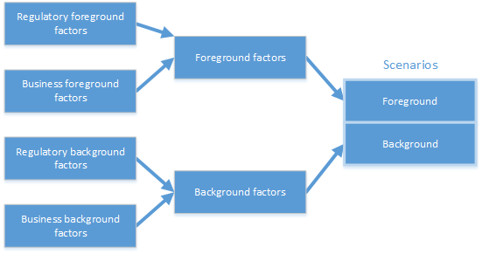

**Figure 1. Scenario definitions**

**Table 1. Definition of regulatory and business factors**

| Factor | Definition | Examples |
| --- | --- | --- |
| Regulatory | Regulations that define the operational framework modelled and that might well affect how a process or operation in the system functions. Also included in this definition are (policy) **instruments**, i.e. policy objectives that are not binding (non-regulatory) but may also contain operational targets that influence behaviour. | * Regulation 261/2004, passenger compensation and assistance scheme * Directive 2008/101 to include aviation on the European Emission Trading System (ETS) * Regulation 549/2004 laying down the framework for the creation of the Single European Sky * Flightpath 2050* (example of an instrument) |
| Business | Factors other than regulatory that are considered within the model. These are non-regulatory (‘market’) factors that affect (business) operations and are set by the stakeholders or in the wider economic environment. These factors include **tools**, **technologies** and **processes**. | * Cost of fuel * Uptake of passenger reaccommodation (rebooking) tool * Uptake of A-CDM * General economic development affecting demand |
| * European Commission (2011). Flightpath 2050. Europe’s Vision for Aviation Report of the High-Level Group on Aviation Research. | | |

As in any real-world scenario, a scenario in Vista is generated by combining regulatory and business factors (as defined in Table 1) in a given timeframe (current, 2035 or 2050). They are shown in Figure 1. These factors will have an impact on the metrics in the system and the pro- and re-activity of the stakeholders. Such factors are further divided between ‘foreground’ (for which the model will explicitly analyse the impact) and ‘background’ (over which the stakeholders have limited control or for which we do not want to have a specific study of their impact). The background factors are combined as fixed, pre-defined values that model the background scenarios to which the foreground factors are applied. The factors defined in a scenario set include all the exogenous variables in the simulation (including the presence and uptake of tools, technologies and procedures, potential demand, fuel prices, etc.).

The set of factors considered in Vista are to be presented in D2.1 (Supporting Data from Business and Regulatory Scenarios Report). Their division into foreground and background factors, and the grouping of the background factors to generate the background scenarios, are to be presented in detail in D3.1 (Business and Regulatory Scenario Report). In D3.1, the expected effect of the factors on the processes modelled in Vista will also be included.

Below, a **preliminary**, **example** overview of these factors and of the background scenarios, is presented. This preliminary selection gives an overview of the type of factors and scenarios to be considered in Vista. Once the first consultation with stakeholders is finished, this list of possible factors will be *refined and extended* and the possible model values analysed per factor fully defined.

**(a) Preliminary foreground regulatory and business factors considered**

Table 2 and Table 3 present some exampleregulatory and business foreground factors, respectively. These factors will be assessed to understand their impact on the metrics for the various background scenarios defined in the project.

**Table 2. Preliminary regulatory foreground factors considered**

| Factor | Possible values | Primary stakeholder affected | Possible impact | Factor Id |
| --- | --- | --- | --- | --- |
| Regulation 261 - passengers’ compensation | * Current Regulation 261 implementation * Inclusion of provision of spare capacity on flights for passengers missing connection * Enhanced allocation of delay causes | Airlines | Direct impact on metrics assessed in Vista  Might also affect the behaviour of the stakeholders when dealing with delay, e.g. tactical recovery of delay or strategic assignment of buffers in schedules | R1 |
| Emission trading scheme - Directive 2008/101 and ICAO resolution A39-3 | * Medium carbon offset price * High carbon offset price | Airlines | Emission charges represent an increase in cost leading to impacts on some strategies to deal with delay, e.g. dynamic cost indexing | R2 |

**Table 3. Preliminary business foreground factors considered**

| Factor | | Possible values | Primary stakeholder affected | Possible impact | Factor Id |
| --- | --- | --- | --- | --- | --- |
| Area | Tool/technology/procedure/etc. |
| Fuel | Fuel price | * Low * High | Airlines | Direct impact on metrics assessed in Vista  Impact on some behaviour of stakeholders, e.g., flight plan definition or tactical delay recovery trade-offs | B1 |

**(b) Preliminary background regulatory and business factors considered**

Table 4 and Table 5 present a list of example regulatory and business background factors considered in Vista, to be refined and extended in subsequent work.

**Table 4. Preliminary regulatory background factors considered**

| Factor | Possible values | Primary stakeholder affected | Possible impact | Factor Id |
| --- | --- | --- | --- | --- |
| Regulation 549/2004 - Single European Sky Framework Regulation | * Low   + No FAB   + free-routing inside FIR * Medium   + FABs   + free-routing inside FABs * High   + Complete integration – Single European Sky   + O-D free-routing | ANSPs  Airlines | Higher integration allows the operation of the European air traffic management network to act as a single entity  Shorter routes can be selected with impact on some Vista metrics  Expected cost reduction and increased cooperation between ANSPs leading to a reduction in ATFM regulations | R3 |

**Table 5. Preliminary business background factors considered**

| Factor | | | Possible values | Primary stakeholder affected | Possible impact | Factor Id | |
| --- | --- | --- | --- | --- | --- | --- | --- |
| Area | | Tool/technology/procedure/etc. |
| Technology uptake | | DCI uptake | | * Hub airlines in operations to-from the hub * Hub airlines in their whole network and selection of other carriers and flights * All airlines | Airlines | Reduction of operational costs and delay | B2 |
| Time-based operations uptake | | * Medium * High | Airlines  Airports | Increase capacity at airports  Reduction of ATFM and tactical delay | B3 |
| Passenger reaccommodation tools uptake | | * Hub airline operations at hubs * Hub airlines operations in whole network and selection of other flights | Airlines | Reduction of operational costs | B4 |
| A-CDM implementation | | * Following established A-CDM implementation plan and timeframe | Airlines  Airports | Reduction of delay propagation at airports | B5 |
| E-AMAN implementation | | * Medium * High - including prioritisation | ANSPs  Airports  Airlines | Reduction arrival delay and prioritisation arrivals | B6 |
| Remote towers | | * No * Small airports * Small and medium airports |  | Expected cost reduction and loss of local anchoring of ANSPs | B7 |
| Virtual centres | | * No * Yes | ANSPs | Expected cost reduction and possible transition towards centre consolidation | B8 |
| Drones / RPAS | | * Medium demand * High demand | ANSPs  Airlines | Potential disruption with new entrants in the ANSP market leading to lower system capacity | B9 |
| Machine learning and deep learning | | * Medium * High | Airlines | Optimisation of operations under disruption | B10 |
| Fuel | | Development of carbon-neutral fuels | * Yes * No | Airlines  Environ-ment | Possible reduction of penalties from ecological regulations  **(cont’d …)** | B11 | |
| Demand evolution | | Economic development of EU – EFTA | * Low development   + Stagnation of middle class development   + Status quo of supply chain costs   + Regionalisation   + Status quo for energy demand   + Status quo of air transport demand * Medium development   + Increasing of middle class development   + Increase of supply chain costs   + Globalisation   + Status quo for energy demand   + Status quo of air transport demand * High development   + Increasing of middle class development   + Increase of supply chain costs   + Globalisation   + Increase energy demand   + Increase air transport demand | Airlines | Modification of demographic and macro-economic environment of the EU  Modification of passenger and flight demand | B12 | |
| Development of high-speed trains | * Low * High | Airlines | High-speed trains have a dual effect:  - direct competition with airlines for some routes (decreased local demand);  - increased catchment areas for some airports | B13 | |
| Rise of ecological travel demand | * Yes (very high share) * No (current share) | Airlines  Airports | Possible reduction of passenger demand | B14 | |
| Development of virtual reality meetings and tourism | * No * Yes | Airlines | Decrease on demand for business (VR meetings) and leisure (VR tourism) travel. I.e. reduction of passenger demand. | B15 | |
| Traffic volatility and unpredictability | * Current * High | ANSPs  Airlines | Financial instability for ANSPs | B16 | |
| Environmental awareness | * Low * Medium * High | Airlines | Higher environmental awareness might lead to reduced demand for air transport | B17 | |
| System charges | | CRCO charges heterogeneity | * Low * High | ANSPs  Airlines | Possible trade-offs on route selection considering direct operating costs | B18 | |

**(c) Definition of background scenarios**

Background factors are grouped to create the background scenarios to which apply the regulatory and business foreground factors. Table 6 presents a preliminary list of possible background scenarios to be considered in Vista by selecting the values for the background factors presented in the previous section. This work is being carried out in coordination with the DATASET2050 project (please see Acknowledgement in Section 1.3). Once the consultation with the Vista stakeholders is concluded, the factors defining the background scenarios and their definitive values will be established.

**Table 6. Preliminary background scenarios**

| Period | Name | Background factors |
| --- | --- | --- |
| Current | Current | All factors to default |
| 2035 | Low economic development (L35) | * R3 - Single European Sky integration: Low * B2 - DCI uptake: Hub airlines at hub * B3 - Time-based operations uptake: Medium * B4 - Passengers reaccommodation tools uptake: Hub airlines at hub * B6 - E-AMAN implementation: Medium * B7 - Remote towers: No * B8 - Virtual centres: No * B9 - Drones/RPAS: Medium * B10 - Machine learning and deep learning: Medium * B11 - Development of carbon-neutral fuels: No * B12 - Economic development of EU - EFTA: Low * B13 - Development of high-speed trains: Low * B14 - Rise of ecological travel demand: No * B15 - Development of virtual reality meetings: No * B16 - Traffic volatility and unpredictability: Current * B17 - Environmental awareness: Low * B18 - CRCO charges heterogeneity: High |
| Medium economic development (M35) | * R3 - Single European Sky integration: Medium * B2 - DCI uptake: Hub airlines at hub * B3 - Time-based operations uptake: Medium * B4 - Passengers reaccommodation tools uptake: Hub airlines at hub * B6 - E-AMAN implementation: Medium * B7 - Remote towers: No * B8 - Virtual centres: No * B9 - Drones/RPAS: Medium * B10 - Machine learning and deep learning: Medium * B11 - Development of carbon-neutral fuels: No * B12 - Economic development of EU - EFTA: Medium * B13 - Development of high-speed trains: High * B14 - Rise of ecological travel demand: No * B15 - Development of virtual reality meetings: No * B16 - Traffic volatility and unpredictability: High * B17 - Environmental awareness: Medium * B18 - CRCO charges heterogeneity: High |
| High economic development (H35) | * R3 - Single European Sky integration: High * B2 - DCI uptake: Hub airlines whole network * B3 - Time-based operations uptake: Medium * B4 - Passengers reaccommodation tools uptake: Hub airlines whole network * B6 - E-AMAN implementation: Medium * B7 - Remote towers: Small airports * B8 - Virtual centres: No * B9 - Drones/RPAS: Medium * B10 - Machine learning and deep learning: High * B11 - Development of carbon-neutral fuels: Yes * B12 - Economic development of EU - EFTA: High * B13 - Development of high-speed trains: High * B14 - Rise of ecological travel demand: No * B15 - Development of virtual reality meetings: No * B16 - Traffic volatility and unpredictability: Current * B17 - Environmental awareness: High * B18 - CRCO charges heterogeneity: Low |
| 2050 | Low economic development (L50) | As per above except:   * B2 - DCI uptake: Hub airlines whole network * B6 - E-AMAN implementation: High including prioritisation * B7 - Remote towers: Small airports * B9 - Drones/RPAS: High |
| Medium economic development (M50) | As per above except:   * B2 - DCI uptake: All airlines * B3 - Time-based operations uptake: High * B6 - E-AMAN implementation: High including prioritisation * B7 - Remote towers: Small airports * B9 - Drones/RPAS: High * B10 - Machine learning and deep learning: High |
| High economic development (H50) | As per above except:   * B2 - DCI uptake: All airlines * B3 - Time-based operations uptake: High * B6 - E-AMAN implementation: High including prioritisation * B7 - Remote towers: Small and medium airports * B8 - Virtual centres: Yes * B9 - Drones/RPAS: High * B10 - Machine learning and deep learning: High |
| ‘Blue-sky’ (highly optimistic) | * R3 - Single European Sky integration: High * B2 - DCI uptake: All airlines * B3 - Time-based operations uptake: High * B4 - Passengers reaccommodation tools uptake: Hub airlines whole network and selection other flights * B6 - E-AMAN implementation: High including prioritisation * B7 - Remote towers: Small and medium airports * B8 - Virtual centres: Yes * B9 - Drones/RPAS: High * B10 - Machine learning and deep learning: High * B11 - Development of carbon-neutral fuels: Yes * B12 - Economic development of EU - EFTA: High * B13 - Development of high-speed trains: High * B14 - Rise of ecological travel demand: Yes * B15 - Development of virtual reality meetings: Yes * B16 - Traffic volatility and unpredictability: Current * B17 - Environmental awareness: High * B18 - CRCO charges heterogeneity: Low |

## Metrics and trade-offs to be analysed

### Metrics

The use of appropriate metrics in Vista is a core component of the project. Metrics need to be intelligible (preferably fairly simple), sensitive (accurately reflecting the aspect of performance being measured) and consistent (they cannot be continually refined without losing comparability).

In applied practice, these desirable qualities present a challenge: designing metrics that suitably take exogenous variables and baseline factors into account not only often renders them less simple to explain, but often further drives the requirement to continually review them to maintain appropriate sensitivity.

It is particularly important that metrics are (operationally) meaningful to the corresponding stakeholders and relate to their needs, to the maximum extent possible. For example, a metric should preferably not be so abstract such that an airline cannot measure it, or impose a 4-hour door-to-door goal for passengers that do not want it. We return to both of these points below.

In the Vista model, both full cost and quasi-cost metrics will be evaluated. The former includes delay costs to the airlines, the latter includes changes in arrival delay predictability (primarily for passengers) and NOx emissions (at least in the current scenarios, where NOx emissions do not have an associated direct cost – see Section 2.1). Whilst trade-offs even between costed metrics have hitherto received insufficient attention, assessing trade-offs between metrics that cannot be fully monetised (quasi-cost metrics) is particularly challenging in many industries, air transport being no exception.

In addition to the *a priori* metrics shown in Table 7 (shown by metric groups and stakeholder groups), Vista will also utilise *a posteriori* and derived metrics, including those drawing on complexity science (such as community detection methods for describing the way delay propagation may be locked into sub-communities of an airport network). As flagged above, however, an effort should be made to avoid metrics that are too abstract, except in cases where they add particular interpretative value that cannot be obtained through the use of simpler, or proxy metrics.

When using one metric as a proxy for another, it is vital that this reflects an evidence-based approach regarding the suitability of such a relationship, as these relationships may be deceptive. For example, flight delay is generally not a good proxy for passenger delay. Previous research in the US and Europe has demonstrated the non-equivalence of the average delays of (delayed) flights and passengers.

Reflecting a particular issue raised in Section 1.1, trade-offs between passenger-centric and flight-centric metrics need to be better understood, as they are observed to move in opposite directions under certain types of flight prioritisation. It has also been demonstrated that under some flight prioritisation strategies, significant reductions in the average cost of flight delay are observed, whilst significant reductions in flight delay *per se* are not.

Regarding the metric groups in the table, it is also important to note that measures of dispersion (such as variance, skew, kurtosis, (inter-decile etc.) ranges) will also be made for many of these metrics. This is pertinent for two main reasons.

Firstly, significant differences between scenario outcomes may be hidden in averages (and other measures of central tendency) over the whole network, but reflected in the tails of distributions, etc.

Secondly, it may be the case that for some metrics, measures of dispersion are equally, or more, important to the stakeholder than the average. Consider the example of door-to-door journey times. It may be that certain passengers would prefer a cheaper (or more environmentally friendly) 6-hour door-to-door journey time with higher predictability, than a more expensive (or less environmentally friendly) 4-hour door-to-door journey time with a lower predictability (higher travel time variance).

These trade-offs are difficult to assess, and relate to issues such as passenger value of time and utility, a detailed analysis of which would remain outside the scope of Vista, but progress towards a better understanding of these trade-offs for further study will be made through the capture and analysis of predictability (delay variance) and other measures of dispersion, in addition to basic value of time estimates.

This brings us again to the issue of proxy measures. Can complex metrics such as passenger utility, and indeed ostensibly simpler measures of door-to-door journey times, be captured through proxy metrics (such as arrival times at destination, numbers of missed connections) without requiring recourse to passenger surveys?

Such metrics in particular may need to be adaptable in future, as passenger requirements change. Whilst SES Performance Scheme metrics tend to be monotonic (e.g. with a continuing downward pressure on ANSP charges, and on delay targets, etc.), desirable targets for passengers may vary both as a function of passenger type (see Section 2.1.1) and of timeframe (as socio-economic norms change, e.g. by 2035 and 2050), but not necessarily monotonically.

Similar trade-offs arise for airlines between average delay and delay predictability, in that a higher average delay with a better predictability might be preferred to a lower average delay with poorer predictability (which, for example, has strategic phase cost implications through schedule buffer requirements).

We will also include resilience-focused metrics in the evaluation framework of Vista, quantifying recovery from disrupted states, as this is a currently under-exploited area of performance assessment that the research team has been actively engaged in in recent work. The metrics deployed in Vista will next be formally discussed in D5.1 (Initial Assessment Report).

**Table 7.** **Initial metric groupings by stakeholder type**

| Stakeholder | Metrics |
| --- | --- |
| Passengers | * Number / volume * Delay (departure, arrival; reactionary) * Missed connections * Gate-to-gate time * Door-to-door time * Hard / soft costs * Value of time (utility) |
| Airlines | * Number / volume (flights, pax) * Delay (departure, arrival; reactionary) * Gate-to-gate time (OTP) * Missed connections * Gate-to-gate time * Revenue and costs (incl. delay) |
| ANSPs | * Number / volume (flights) * Flight-km controlled * Delay (generated, mitigated) * Revenue and costs (incl. delay) |
| Airports | * Number / volume (flights, pax) * Delay (departure, arrival; reactionary) * Missed connections * Revenue and costs (incl. delay) |
| Environment | * Emissions (including costs to stakeholders, where applicable)   + CO2   + NOx |

### Trade-off analysis

In order to analyse the trade-offs between the metrics, various plots will be made such as the examples presented in Figure 2, Figure 3 and Figure 4. These plots will be combined with statistical analyses of the results to obtain information about the variable trade-offs for the different scenarios analysed.

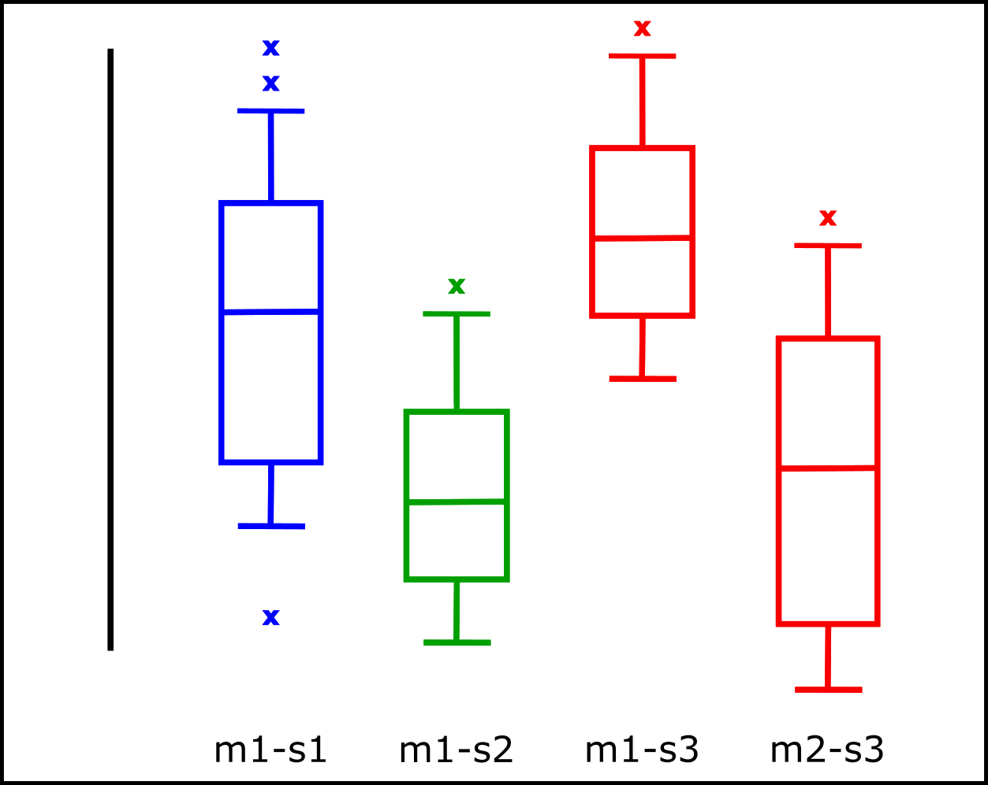

**Figure 2. Example of boxplot for different metrics and different scenarios**

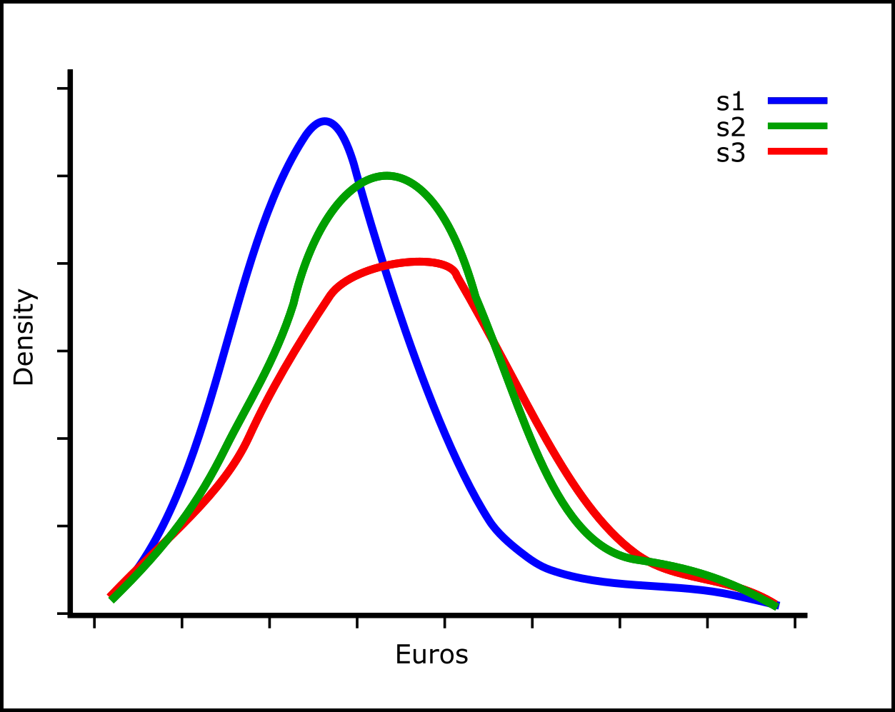

**Figure 3. Example of distribution of a metric for different scenarios**

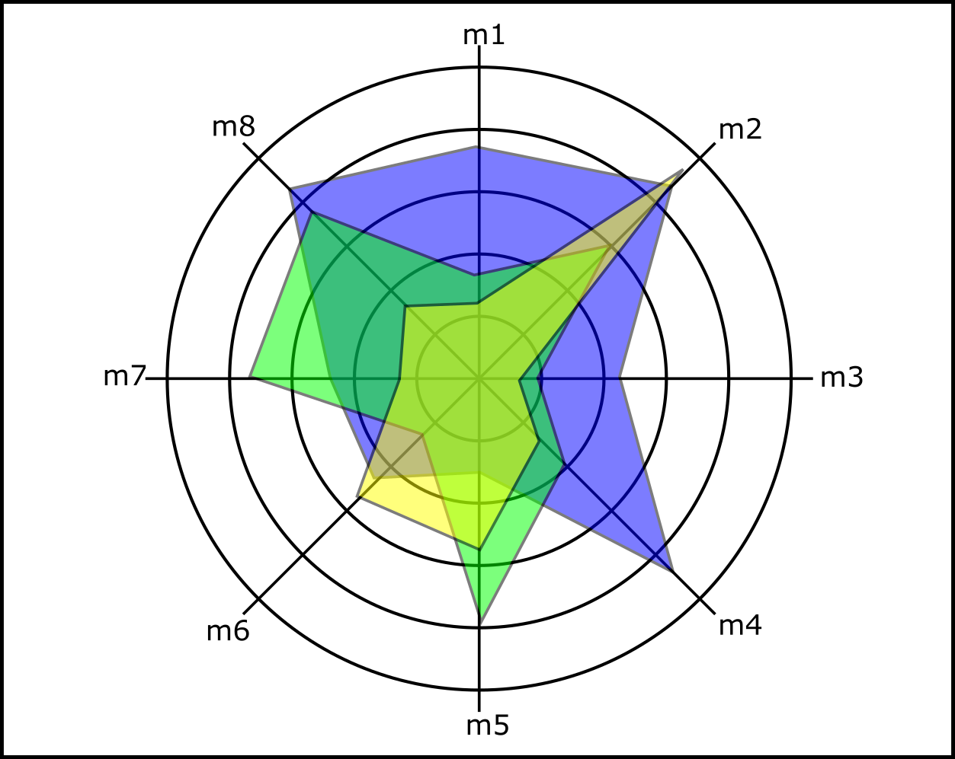

**Figure 4. Example of radial plot for eight metrics and three scenarios**

Vista will study quantitatively the presence of trade-offs between different metrics. ‘Trade-offs’ specifically refer to opposing forces, e.g. situations where a change in the system provides some kind of advantage in one area (for one KPA) but at the same time a disadvantage in another. In terms of metrics in a stochastic environment (such as Vista), a trade-off between two metrics occurs when there is a negative correlation relationship between the two random variables representing the output metrics.

As a consequence of the stochastic model runs, *each* run of the model will produce a given set of metrics and a statistical analysis is thus required to determine significant trends. Computing the linear correlation values is a first step, but additional analyses will be performed. In particular, it is important to use null hypothesis tests in order to verify if the values obtained in the analysis are statistically significant, or are likely to have occurred by chance, i.e. with an almost zero probability. These procedures naturally yield confidence intervals on the correlation coefficient values. Non-linear correlation effects will also be tested in some cases if certain statistics are particularly complex.

Different trade-offs can be obtained in different situations. Within one scenario (with fixed input parameters), it is very likely that different runs will provide a first level of trade-off. Simply put, some runs will display a high value for ‘metric A’ and a small value for ‘metric B’, whereas others will be *vice versa*. Vista aims to study the impact of business and regulatory factors. To do this, it will perform comparative statistical analyses between scenarios. It will compare the correlation values obtained in each scenario between two metrics to determine whether they are significantly different, using, for instance, bootstrap methods. This kind of analysis will complement the simpler ones, when one compares simply averages of different metrics, and determine how values change across different scenarios.

## Modelling approach

### Framework and approach

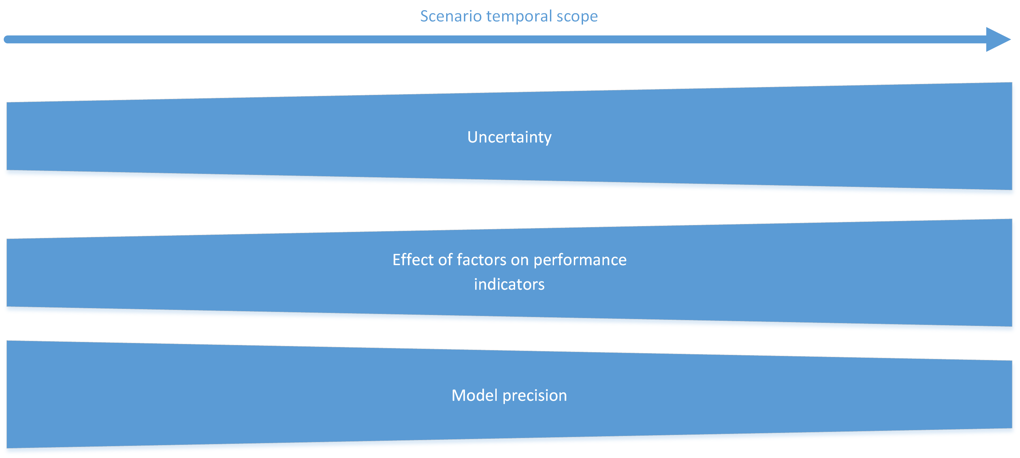

**Figure 5. Effect of temporal scope**

The temporal scope and evolution of the system is an important factor in Vista but, as described in Figure 5, as the temporal frame is further out in time, the uncertainty associated with some parameters increases, and hence the model precision decreases. Moreover, the effect of some of the business or regulatory factors increases as the environment, in which operations are carried out, changes. These effects should be considered when selecting a modelling approach (see Section 2.4.2). Table 8 summarises different modelling options considered in Vista, along with their benefits and drawbacks. Each model addresses all phases of execution: strategic, pre-tactical and tactical. These three options go from a more micro-detailed model to a more high-level model. We then discuss each possibility in more detail.

**Table 8.** **Modelling options considered in Vista**

| Modelling option | Stages | Description | Benefits | Drawbacks |
| --- | --- | --- | --- | --- |
| **(a) Agent-based micro-model** | Single stage | Covers all the phases in one event-driven (agent-based) model. Different agents make decisions at different timescales. | Self-consistent model with high level of detail. Heterogen-eity of agents is naturally taken into account. | The computational load is heavy and calibration is difficult due to the high number of agents. |
| **(b) Macro-economic with meso-model** | Three-stage | This is a three stage model covering the three execution phases and adapting the detail required for each.  A macro-economic model is used to define demand and capacity. Individual flight schedules and passenger itineraries are then generated. Finally, a mobility model is used to represent the pre-tactical and tactical execution of these itineraries.  The effect of different factors and tools / technologies / procedures are explicitly modelled at a European level for each phase. | Quanti-tative results are directly obtained from the model.  The level of detail of the model is adapted for the different execution stages. | The mobility model requires individual flight schedules and passenger itineraries that can be difficult to generate and validate for future timeframes (2035, 2050) due to the high level of uncertainty.  Due to these uncertainties, the model might require a high number of executions to obtain results that are consolidated. |
| **(c) Current meso-model with future influence diagram** | Two-stage | The analysis of the factors and their temporal evolution is done in two stages:   1. A detailed meso-model represents current operations (supply and demand) of the system. The effects of the factors are modelled here, generating an analysis of their impacts on the metrics. 2. From the output of the model, a parameters’ relationship model is produced. This is done by modelling the relationship of the outputs of the model, or as a direct description of the output of previous simulations. On this model, the effect of the factors is projected to the future timeframes (2035, 2050) based on a higher-level influence diagram model[2]. | The more precise meso-model is only used for current operations since it is easier to model the effect of the factors for that timeframe  The calibration of the model is easier as it can be done based on historical data. | It might be difficult to project the results from the current scenarios to the future frameworks. This is particularly important when there are changes in supply and demand. Results might become more qualitative as the forecast used becomes less accurate.  Some of the factors that affect operations might be easier to model in the current timeframe but factors that affect supply and demand will still need to be modelled in the meso-model to adapt the flows of the flights and passengers in order to understand the impact of their evolution on the metrics.  There might be a high number of assumptions in terms of the influence diagram model. It might be difficult to establish the impact of more than one factor at the same time in the model.  The validation of the influence diagram model might be complex. |

**(a) Agent-based micro-model**

In this possibility, a fully microscopic model is developed. In this solution, each individual stakeholder instantiation is an agent (each airline, each airport, etc.), and makes decisions within a single event-driven simulation. Each agent updates its belief periodically based on the state of the overall simulation, including the expected state of other agents.

Based on this belief, each agent takes decisions periodically, some concerning their near future (tactical decisions such as rerouting flights), others impacting their long-term future (strategic decisions such as operating a given route). The agents would, in principle, be able to learn in real time from their past decisions and adjust them to meet their objectives.

This solution gives probably the highest degree of realism, since it is able to fully take into account the heterogeneity in terms of business models, geographical locations and timeframes. This kind of simulation is able to catch emergent behaviours and highly non-linear relationships between metrics. It is also able to catch out-of-equilibrium economic phenomena (like technology adoption) and is usually not bound by some rationality assumption of the agents.

Moreover, such a detailed simulation allows us to finely control the model and backtrack the causes of macroscopic behaviours, if needed. Having set up the factors in the model, the agents will evolve in their behaviour until an equilibrium is reached.

However, this level of detail comes at a price. Firstly, it is less easy to understand the model itself. Many processes operate in parallel with lots of data produced. Some details of the model might not be useful overall for the understanding of the phenomena in which one is interested, but the modeller loses sometimes the capacity to assess this point. Secondly, these models require huge computational power, due to the amount of information exchanged by the agents. This means that the model runs in extended periods of time, making it more difficult to handle from a technical and management point of view. Thirdly, the calibration of so many different agents is sometimes problematic and sometimes relies heavily on common heuristics. Even if the unique feedback we get from airlines in this project might help us in this regard, it is doubtful whether we could manage to create a realistic heterogeneity among agents in the timeframe of the project.

Finally, the model has to be highly integrated, c.f. other solutions where some degree of modularity is present. From a development point of view, this requires a large effort of coordination within the project, with often extensive runs using ‘dummy’ agents to test the different parts independently. Bug tracking is also more complicated due to interdependent processes.

**(b) Macro-economic with meso-model**

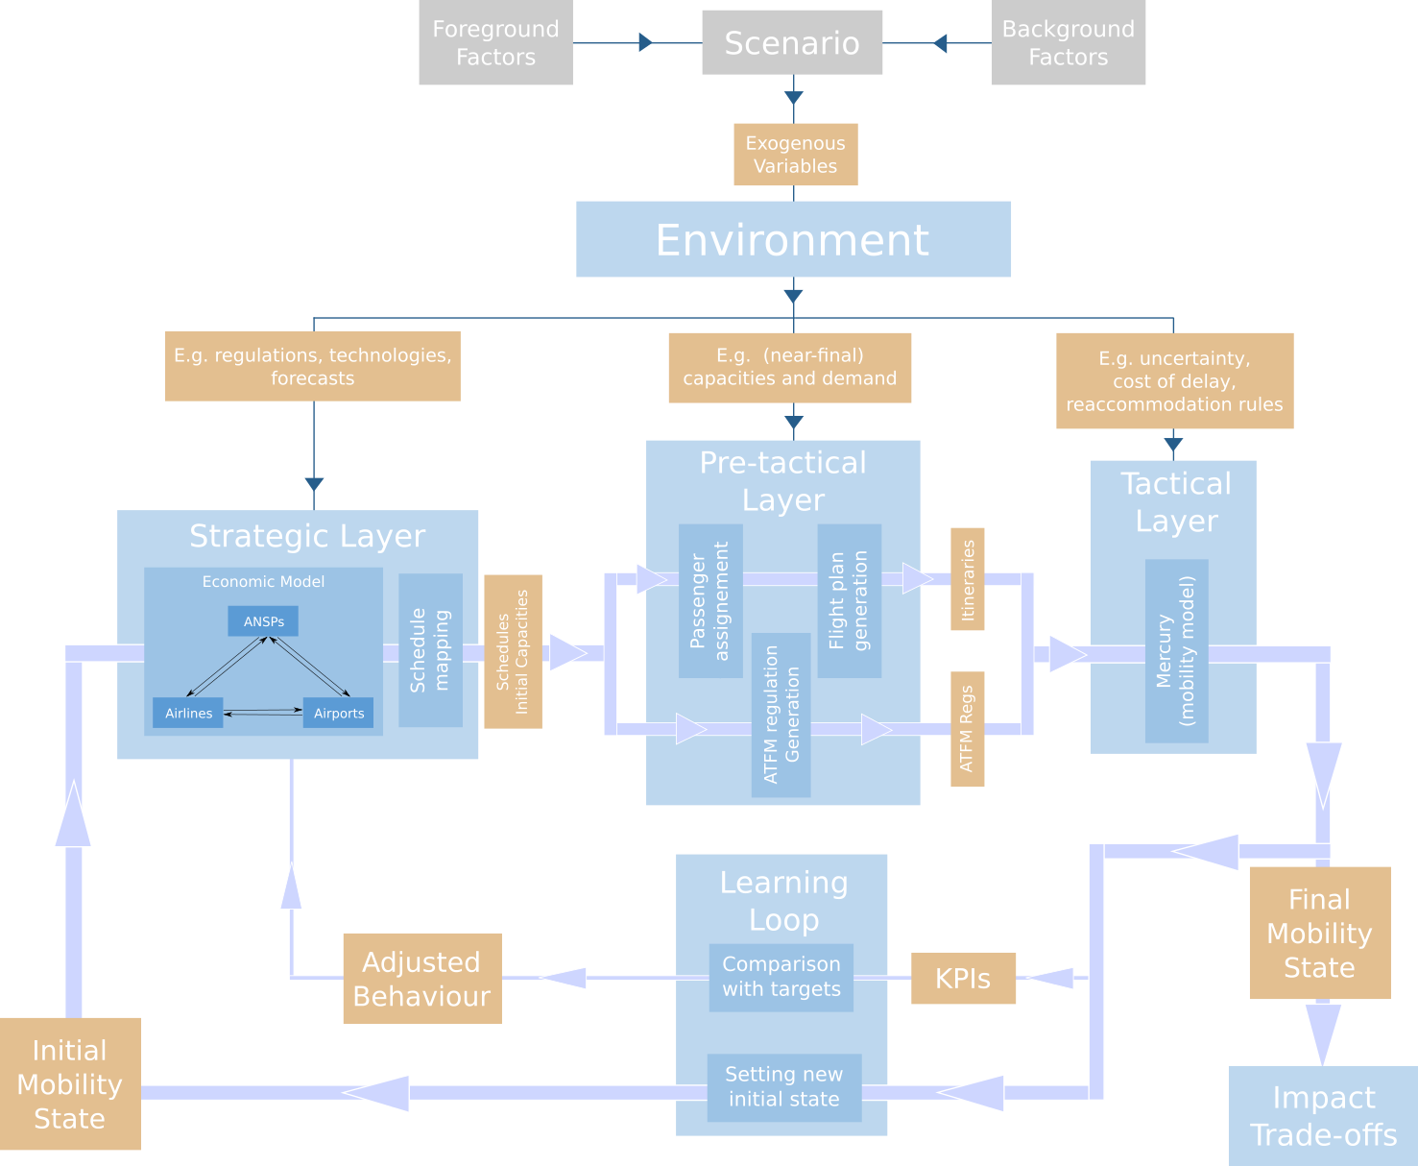

**Figure 6. Detailed flow diagram**

Figure 6 presents the high-level blocks of this three-stage mobility model. This model computes the metrics of the system for a given environment. In this context, the environment is defined by all the information needed as input for the model, i.e. the set of static data which is not modified by the model – hereafter called ‘exogenous’ data. Hence, the factors considered in a given scenario are part of the environment and directly set these exogenous variables. The exact composition of the environment depends on the level of detail of the different model components, i.e. defining which variables are endogenous or exogenous. Examples of exogenous variables included in the environment are the cost of fuel or passenger compensation policies. (Other variables, such as the presence of Functional Airspace Blocks or widespread free-route implementation might, or might not, be integrated into the environment, depending on whether they are part of the ANSPs decision-making within the model or input factors. This is subject to subsequent planning decisions within the project.)

The model is organised according to the three ATM phases, which are affected by factors (business factors - including tools and technologies; regulatory factors, including instruments) considered in the environment, plus a learning loop:

* **Strategic phase:** The main objective of this phase is to provide the flight schedules, passenger demand and profiling, and ATM capacity and restrictions. This phase uses a macro-economic model based on numerical equations to define the flow drivers, i.e. high-level traffic flow models, and to instantiate some of the system parameters, e.g. capacity provided by selected airports. Based on the output from the macro-economic model, and considering historical data and previous system executions, flight schedules are adjusted and passenger flows defined. Note that some factors, such as fares or minimum connecting times at airports, are considered and adjusted when defining the output of this strategic phase. Some of these parameters are the output of the economic model, while others are defined in the environment.
* **Pre-tactical phase:** This second stage of the model defines individual passenger itineraries, based on historical data, the output of the strategic phase and other exogenous factors. These passenger itineraries are allocated to flights with a partially stochastic model. For each flight, a set of possible flight plans is generated (including possible re-routings that could be used by the tactical mobility model). Finally, considering, among other factors, the strategic demand (schedules) and the capacity provided by the ATM system, ATFM regulations and restrictions are generated.
* **Tactical phase:** In this third and final phase, the passenger itineraries and flight plans are modelled and simulated, with an even-driven simulation model, including a degree of uncertainty. The output of one or several runs of this mobility model generates the metrics that are subsequently consolidated.
* **Learning loop:** Some of the values selected by the economic model have an impact on the flight schedules and the capacity and restrictions modelled. These parameters are set as the result of a consideration of a previous state of the system (either from historical data or from previous executions) and of their expected impact on the system’s metrics. Based on some objective functions, airlines, airports and ANSPs reach an economic equilibrium which set these strategic high-level parameters. This equilibrium is reached within the macro-economic model by solving the demand and supply equations that capture the expected gains for the stakeholders.

However, the final impact of these settings on the metrics can only be assessed once the tactical mobility model has been executed. In some cases, unexpected results might well be obtained. For this reason, it is possible to envision a learning process so that the outcome of the economic model can be adjusted based on previous model executions. This will be achieved by comparing the results obtained with the originally expected ones estimated by the macro-economic model and adjusting the high-level strategic parameters accordingly. This loop would ensure that those scenarios most modified from the current situation (e.g. a less conservative 2050 scenario with a group of significantly different new regulations) are computed reasonably well, since the output of the strategic phase is based on a prior state of the system, including schedules. This loop could be computationally heavy, but would ensure self-consistency within the model and could capture additional effects, such as the inertia of new technology adoption. Moreover, this learning process would avoid some calibration issues, since some parameters could be adjusted during the loop for consistency. Finally, the ‘training’ could be carried out on background scenarios alone, by defining default values for the foreground factors, ensuring a trained and calibrated model that could be used on the specific scenarios, i.e. with different foreground factors.

**(c) Current meso-model with future influence diagram**

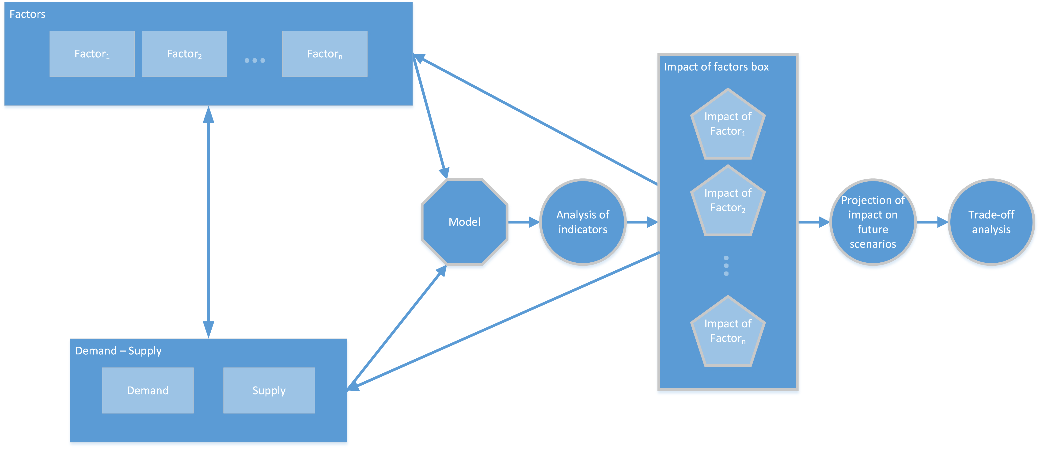

**Figure 7. Phases of the analysis of the factors**

As depicted in Figure 7, supply and demand provide the strategic and pre-tactical inputs for the model, similar to those described in the meso-model approach. However, in this case, the effect of the factors is analysed only for the current scenario. The analysis of the indicators will provide an understanding of the impact of the factors that could be fed into the factors definition and into the supply-demand model. These effects will be projected into the 2035 and 2050 scenarios. This projection could be complex, as an understanding of the impact of the environment forces on the metrics is required which leads to a modelling of the impact of forces on the supply and demand similar to the description in the meso-model approach.

### Modelling technique selected for Vista

After detailed internal discussion, the team has decided to pursue the direction of option (b) for the model. Indeed, this option allows us to have a good balance between a detailed, microscopic description, and feasible implementation in terms of coding and computational effort.

Option (a) would require a complete rewrite of the baseline engine platform by including strategic and pre-tactical decisions into the main event simulator. It would require a high level of effort just for the coding and at least as much effort for the calibration. The runs themselves would be very heavy to compute, and, as a consequence the post-processing analysis could turn out to be weak.

Option (c) would be computationally light but requires us to make strong assumptions about the extrapolation of the effects of different factors onto the future scenarios. These assumptions could jeopardise the interpretation and the forecasting power of the model. Moreover, the project would not be leveraging properly on previous efforts and on the capabilities of modelling flights and passenger itineraries.

As a consequence, the team has decided to build a model similar to that described in option (b). The three-stage process makes it easier to implement each module independently with independent input/output generation and independent testing procedures. Moreover, if one of the modules appears to be more complicated than expected, it is then much easier to simplify it without impacting the others, c.f. a fully integrated simulation as per option (a).

Further considerations need to be made for this option, refining the model concept. Among them, the degree of detail of the strategic layer and the weight of historical data will be chosen at a later stage during the actual model construction. The learning loop will also be added as the last component, after having assessed its functionality in the model.

# Platform description

In this section two aspects are presented regarding the platform description:

* **Project infrastructure**: identifying the resources that will be used to support the development and validation of the model.
* **Project software architecture**: identifying the modelling tools that will be used and describing the model architecture.

## Project infrastructure

The University of Westminster and Innaxis have defined a set of preliminary development requirements based on their experience of managing previous projects. These requirements are self-imposed to ensure smooth project development and to keep sensitive data secure:

1. **Provide development environment:** Collaborators will work with their own computers during the development phase.
   1. **Manage source code versions:** Each collaborator could have different versions of the same code. The system we will use will be able to keep track of changes that are produced and to work in a distributed environment.
   2. **Manage documentation versions:** Collaborators are responsible for keeping the documentation updated. Each collaborator could be developing and also documenting at the same time. The system we will use will be able to keep track of changes in the documentation and to work in a distributed environment.
2. **Provide data management environment:** Collaborators will work with their own computers during the data management phase.
   1. **Manage data versions:** Each collaborator could have different versions of the data. The system will be able to keep track of changes in data that are produced and to work in a distributed environment.
   2. **Store large data:** The resource will be able to handle large data files.
   3. **Keep data secure:** Access to sensitive data will be restricted.
3. **Provide batch simulation deployment:** There is a central processing resource to perform simulations, instead of relying on collaborators’ machines.
   1. **Process large data:** The resource will be able to process large data optimally.
4. **Provide validation analysis environment:** Collaborators will work with their own computers in the validation analysis phase.
   1. **Manage results storage:** The central processing resource will store the results in a resource accessible to all collaborators.
   2. **Store large results:** The resource will be able to handle large results.
   3. **Keep results secure:** Access to results will be restricted to specific collaborators.

Regarding computer facilities:

* Each collaborator will use their own computer to carry out all the phases of the project, except the batch simulation phases. This will require a reliable internet connection to synchronise work.
* There is a single Git repository accessible for all collaborators to share latest versions of the code and maintain a history of versions, to track changes.
* There is a single wiki service accessible for all collaborators to share latest versions of the documentation.
* There is a single computer cluster to manage data and results storage and also to provide batch simulation. The cluster will have several instances for each purpose. Data and processing are grouped in the same cluster to improve performance and availability. Several folders will be shared and certain files will be restricted for access.

Synchronisation protocols are required to allow us to develop the platform in a distributed way. For this reason:

* SSH (secure shell) will be enabled in centralised solutions when available;
* web management consoles will be enabled in other centralised cases;
* S3 file transfer protocol will be enabled;
* each facility will have its own access management system;
* SSH access will use public/private key certificates to maintain a secure connection.

## Project software architecture

### Preliminary requirements

Based on the high-level model selected in the previous section (see Section 2.4.2 and Figure 6), some preliminary functional and non-functional requirements have been defined. The objective of these requirements is to drive the platform architecture development while providing some characteristics that are considered desirable for the platform.

**(a) Functional**

1. Vista requires historical data to model the behaviour of the system.
2. The simulator is fed with validated data. The simulator assumes the data are well shaped to be used.
3. The simulator will reproduce scenarios described by the foreground and background factors. The combination of foreground and background factors will define the set of scenarios to be simulated.
4. The simulator generates metrics to quantify the performance of the scenario. Raw output data requires post-processing to be meaningful for analysis.
5. Scenario metrics must be analysed to understand the trade-offs.
6. Scenario parameters are used in all the model layers. The behaviour of each layer depends on the scenario parameters.
7. Validated historical data are also used in all the model layers. The behaviour of each layer also depends on historical data.
8. The strategic layer reproduces the strategical features of the ATM scenario to be fed to the pre-tactical layer. Some decisions taken in the strategic layer will be refined in lower layers.
9. The pre-tactical layer reproduces the pre-tactical features of the ATM scenario to be fed to the tactical layer. Some decisions taken in the pre-tactical layer will be refined in the tactical layer.
10. The tactical layer reproduces the tactical features of the ATM scenario.
11. Scenario metrics are collected from the metrics generated in all the layers. Some metrics are grouped into high-level metrics to reduce complexity when performing the analysis.
12. The values of the tactical metrics are estimated in the strategic layer.
13. The scenario metrics will be compared with the expectations to quantify the impact of strategic decisions in lower layers.
14. Strategic decisions can be relaxed in a simulation run if their impact is too high.

**(b) Non-functional**

1. Data are validated outside the simulator. Data are validated only when data changes, to reduce simulation time.
2. Scenario results are analysed outside the simulator.
3. Produce maintainable and scalable code.
4. The simulator is designed in a layered architecture that can be independently debugged.
5. The model has good horizontal scalability. Scenario executions are independent.
6. There are no external dependencies for the simulator.

### Platform architecture

As shown in Figure 8, the Vista platform is formed of three main blocks: a data validator, a simulator and a scenario analyser.

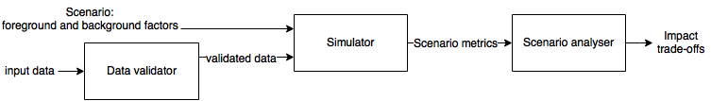

**Figure 8. Very high-level architecture**

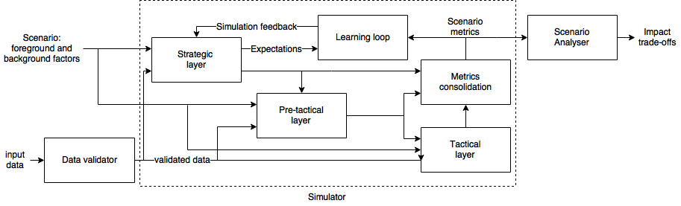

**Figure 9. High-level platform description**

Figure 9 describes the main blocks of each of the different systems presented in Figure 8. These are the main characteristics of each sub-system and its relationship with the model description shown in Figure 6.

* The **data validator** is used each time the input data changes and checks if the data are valid to be used at simulation. It takes the data collected in the data management process. The data validator will produce validated data to be fed into the simulator. It confines the processes that describes the environment in Figure 6.
* The **simulator** models the strategic, pre-tactical and tactical-phase for a given scenario and includes the learning loop. It uses the validated data and the scenario parameters as input and provides the metrics for the scenario as output.
* The **scenario analyser** combines the results to infer the trade-offs analysis. It generates the trade-off analyses.

#### Data validator

This sub-system validates the data before using it in the simulation. This sub-system will develop the following set of tasks:

1. **Check data completeness**: Any missing field contained in the dataset could lead to an unexpected model behaviour. Thus, the dataset will be scanned for missing fields and valid data formats.
2. **Data availability**: This process will ensure that all the required data are collected. In some cases, this process can be automated based on the missing fields, identified in the data completeness analysis, but in other cases manual data acquisition might be required.
3. **Check data consistency**: The data between different datasets need to be linked. From this process, link failures might emerge leading to the need for data acquisition from other sources, or to the relaxation of the model specification so that those links are no longer required.
4. **Data formatting**: Restructuring of the data for performance. High data processing can be a high-demand task. For this reason, in order to expedite the simulation processes, some pre-computation and data acquisition techniques will be implemented, such as the addition of caching mechanisms to speed up filtering and data acquisition by the simulation platform or changing the data format for storage efficiency. When the data are validated, they might be restructured to fulfil model requirements.

The tasks described above will be executed sequentially, the output of one task being the input of the following.

Depending on data size, processing the whole input data sequentially may not be optimal. Therefore, the data completeness process may partition the data and process the data into several threads at the same time to improve performance.

#### Simulator

This section develops the text of Section 2.4. The tool reproduces a scenario (described as a set of foreground factors) and quantifies its performance by calculating the associated metrics. In the following, the internal details of the sub-systems are covered. As shown in Figure 9, the simulator is based on:

* A three-stage simulator, which covers the strategic, pre-tactical and tactical features of the system;
* A learning loop that quantifies the impact of strategic decisions in lower layers and modifies the strategic decisions, if necessary;
* A metric consolidation process that analyses the data from all the model layers to generate the scenario metrics.

**(a) Strategic layer**

The macro-economic model has the task of setting high-level decisions for the different stakeholders. It will likely be based on a static, deterministic equilibrium between a small number of representative agent-like entities. The ‘agents’ will represent changes in passenger demand and different business models for the stakeholders: airlines, airports and ANSPs. The latter might instead be considered as part of the environment, i.e. input parameters for the model, instead of part of the strategic layer, as a function of exactly which economic effects Vista is capturing. This will be decided at a later stage after the first consultation with the stakeholders is completed.

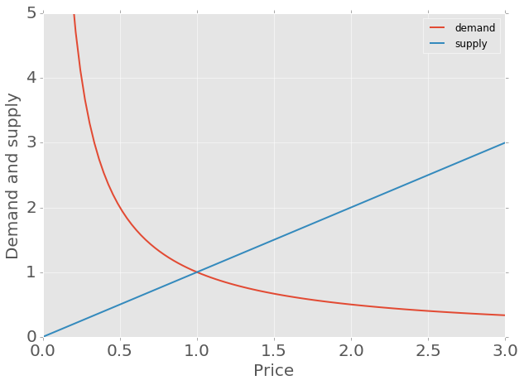

**Figure 10. Illustration of a demand and a supply curve**

The fundamental effect that the strategic layer captures is the variation of supply and demand based on the different factors. To do this, the project plans to use a description in terms of demand and supply curves, as illustrated in Figure 10, in which a consumer is willing to consume less of the product (or service) if the price is higher (demand side) and the supplier is willing to sell more of the product if the price is higher (supply side). The intersection of the demand and the supply curves represents the economic equilibrium for this environment and sets the price for the corresponding resource. Further technology advancements or regulatory environments may modify such curves, especially the supply, which in turn drives the equilibrium price up or down.

The basic assumptions will be that:

* passenger demand is exogenous to the system and modelled by the factors in the environment;
* airlines have a decreasing demand function potentially modified by the factors;
* airports and ANSPs have an increasing supply function potentially modified by the factors;
* different business models of airlines (at least) and maybe airports and ANSPs are competing for the same resources.

As a consequence, the macro-economic model will not take into account the full heterogeneity of the airlines, airports, etc., but will rely on archetypes. In particular, the model is likely to be blind to geographical locations *per se*, even if these locations can have an indirect impact regarding business models (for instance, there are more airport hubs in western European countries).

The output of the macro-economic model will be high-level changes in drivers, for example: ‘an increment of 20% of the share of flights at hubs for LCCs’. These high-level changes will then be reflected in changes of schedules *via* the schedule mapper of Figure 6. The role of the schedule mapper is to take as input a historical set of schedules, plus the changes in drivers, and then adapt the schedules in such a way that it reflects these high-level changes. Ideally, the changes should be non-paradigmatic to be able to produce consistent schedules and not radically new sets of schedules, which are unlikely to be self-consistent. Note that this schedule mapper is not a schedule generator, which computes all the schedules for all the airlines from scratch, but a model to adjust the schedules to the economic factors captured by the macro-economic model.

The output of the schedule mapper is the schedules themselves. At the same time, the economic equilibrium will set the capacity levels for airports and ANSPs. All of these outputs are then injected into the pre-tactical layer.

**(b) Pre-tactical layer**

The pre-tactical layer of the Vista model will translate the schedules into passenger itineraries, generate the flight plans and produce realistic ATFM regulations. The input of the layer is the set of schedules from the strategic layer (or from elsewhere) and the projected capacities for the ANSPs and airports. Additionally, the layer needs from the environment the information concerning passenger demand, such as its magnitude, composition, geographical location, etc.

The layer has two independent threads (see Figure 6). The first takes care of the passenger itineraries generation, making sure that the passenger choices are consistent with their profiles (types), as introduced in Section 2.1.1.

The passenger itineraries will be assigned using a combination of sample generation based on conditional probabilities, taking into account these passenger profiles, and historical passenger itineraries combined with different data sources, e.g. GDS data and IATA ticket (PaxIS) data. For each origin-destination itinerary, the possible flight options available are considered and an itinerary-to-flight assignment process is carried out, ensuring that targeted load factors are achieved.

Once the passenger itineraries are known, the thread will generate a set of possible flight plans for each flight. The direct operation cost of each flight plan is estimated along with other potentially useful parameters such as the probability of direct routing or tactical delay recovery. This set of flight plans will, therefore, comprise the most economical flight plan, which is the one more likely to be used, as well as several alternatives. This variability allows the tactical layer to consider uncertainty, re-routing to avoid ATFM regulations, and a more realistic flight plan selection at the execution phase to account for airline operational variability. The output of this process is thus a set of passenger itineraries (including connections) with the corresponding flight plans.

The second thread of the pre-tactical layer aims at producing realistic ATFM regulations to be used during the tactical run. We differentiate between two types of regulations:

* Regulations that are a direct consequence of the flight plans, i.e. related to capacity limits;
* Regulations that are more stochastic in nature, e.g. due to weather, military exercises.

The first types of regulations can be directly generated using simple rules based on the traffic expected, based on the schedules. The second type will be generated randomly based on similar events observed in historical data. The probability of some regulations occurring might be affected by the characteristics of the scenario modelled, for instance, the frequency of military exercises might decrease for future scenarios where increased military/civil cooperation is planned.

The ATFM regulations generated by this thread will comprise the pre-tactical definition of the regulations and are then passed on to the tactical layer, which will use them to disturb the system and compute how the flights and passenger itineraries are affected.

By the nature of the processes modelled in this layer, there will be some degree of randomness, therefore, for a given input from the strategic layer. This pre-tactical layer may be run multiple times.

**(c) Tactical layer**

The tactical layer comprises the mobility model based on the legacy software simulator, ‘Mercury’. Mercury was successfully used in previous SESAR projects, e.g. POEM and ComplexityCosts, to reproduce different ATM scenarios from a tactical point of view. The characteristics of the current platform (lack of external dependencies, different levels of event modelling, inclusion of uncertainty, being a modular platform, and including an integrated post-processing set of simulations for a given scenario) make it ideal for its use and extension in Vista.

The Mercury platform can be represented as a set of components that run simultaneously to simulate the tactical phase. A given input in the model is executed following Monte Carlo simulations several times to generate high-level indicators. There are four main functional blocks within the tactical layer:

* The **state initialiser**, which changes the initial simulation state from the baseline, taken from the initial data, to a different state. It creates the simulation objects from input data before the simulation starts to define the initial simulation state.
* The **model base component**, which creates and stores the simulation objects that expose the interface to allow the events to change the simulation state. The simulation state will be separated between different entities (‘agents’) that interact.
* The **event base components** that define how and when to interact to changes in the state during the simulation. Each event is defined by its name, the procedure that needs to be executed, an identification of the simulation object that will change the state, the time when it should be processed and the event stack to which it belongs. The identification of the event stack allows the model to be extended.

Table 9 describes the dependencies between the current eight implemented methods and the ‘agents’ in the model. If, in Vista, an existing method or any ‘agents’ are modified, the corresponding events would be revised and tested accordingly.

**Table 9. Dependencies between implemented methods**

| Name | Triggered by | Airports | Airlines | Flights | Passengers |
| --- | --- | --- | --- | --- | --- |
| Leg flight start | [Initialisation] |  |  | ✓ | ✓ |
| Ask for departure slot | Flight | ✓ | ✓ | ✓ |  |
| Manage runway | Airport | ✓ |  |  |  |
| Take off | Flight | ✓ |  | ✓ |  |
| Arrive at PTI* | Flight |  |  | ✓ |  |
| Ask for arrival slot | Flight | ✓ |  | ✓ |  |
| Pax gate arrival | Passenger | ✓ |  |  | ✓ |
| Flight leg end | Flight |  |  | ✓ |  |

* PTI: passing time over Initial Approach Fix (IAF)

* The **simulation scheduler** that manages the execution of the simulation. These methods also capture the outputs of the tactical model which can be useful when verifying and debugging the software. This component provides the user with the ability to start, stop, and resume a simulation. Before starting a simulation, all of the ‘agents’ are reset to their initial status.

**(d) Learning loop**

The high-level parameters selected by the strategic layer, based on the macro-economic model, have a direct impact on the scheduling, the demand, and the itineraries generated and simulated. In some cases, those high-level decisions might lead to unexpected results that are only identified once the tactical model has been executed. A learning process, such that the consolidated output of a given environment with a set of decisions by the strategic layer can be compared against the expectations defined by the macro-economic model, is therefore planned. Considering the discrepancies between the expected results and the actual, observed metrics, the strategic high-level parameters can be re-adjusted and the system re-run. Different learning techniques, such as reinforcement learning, will be considered, and as introduced in Section 2.4.1, this loop will ensure that those scenarios most modified from the current situation (e.g. a less conservative 2050 scenario with a group of significantly different new regulations) are computed reasonably well, since the output of the strategic phase is based on a prior state of the system, including schedules, and it will be ensured that a stable solution is modelled for the new scenario.

This learning process could avoid some calibration issues, since some parameters could be adjusted during the loop for consistency. As this loop can be computationally heavy, i.e. the simulation needs to be run to obtain metrics on each learning iteration, the training phase could be carried out for a limited number of scenarios only. The scenarios used for this calibration could be limited to the background scenarios, with default foreground factors, so that the model is calibrated for the future timeframes defined by the scenarios (e.g. ‘low 2035’), then applying the foreground factors to them, thus reducing the demands on the learning loop.

Note that not only the parameters for the strategic model decisions are changed, but that the following runs of the system could be based on the data generated by the previous executions. For example, the schedule mapper might base the schedules on already-modified, previous runs. Historical schedules, or the itineraries generated in the pre-tactical layer, might be based on previous itineraries. This can be useful when evolving from the current scenario to future ones, such as 2050, by underpinning them with the modelling of compatible scenarios for 2035.

**(e) Metrics consolidation**

The outputs of the different layers of the model have different levels of detail and generate large amounts of data. It would be difficult to estimate the performance of a scenario simply by analysing raw output data from the model.

Consequently, the metrics consolidation component will perform a descriptive statistical analysis for all collected data to measure the variability of data in different iterations of the same scenario. It will reuse software libraries used in other projects, to deal with the statistical functions and probability distribution models that will be used.

Therefore, to store the results from the different layers and consolidate those results is the function of this component. Note that in some cases this process may be complex, as the tactical layer bases its execution on Monte Carlo simulations and therefore the input into the layer is executed several times. The metric consolidation module will store the results from those runs and consolidate the metrics. As the output of the pre-tactical layer is also the result of a process with some degree of randomness, one could think of a Monte Carlo simulation of the processes downstream, including several executions of the pre-tactical layer, each followed by a set of executions of the tactical module. This methodology will be further assessed once the platform is implemented.

This module will also quantify the value of the metrics defined for evaluating the model. This module will define the exposed interface of output data, as the purpose of output data is to be analysed. This will require a deep scan of data, so data partition algorithms and parallelisation strategies might be used to speed up the process.

#### Scenario analyser

The scenario analyser comprises a set of tools furthering the understanding of the results of the simulations. By its nature, this is likely to change during the development of the model, since more tools will be added as needed.

The analysis will be based on several steps:

* Analysis of individual runs;
* Consolidation of runs from the same (given) scenarios;
* Comparisons of different scenarios.

The analyses will be centred around the metrics introduced in Section 2.3 and their trade-offs. The first step is required in order to have intra-run statistics, e.g. to compute the average and variance of metrics. Consolidating different runs comprises comparing them and extracting some statistical regularities, as highlighted in Section 2.3. This will involve computations of correlation coefficients, and maybe non-linear effects. Comparing different scenarios implies the comparison of different distributions obtained during the previous step. This is achieved through statistical tests to check for differences between averages, the distributions themselves (and thus variances etc.) or even the correlations between metrics.

All of these procedures will be highly automated, considering a large number of metrics at the same time. After the first analyses, some further analyses will be performed, more in depth, for a more restricted set of metrics. Indeed, some metrics are expected to behave in a certain way, or to have certain inter-relationships, as for instance discussed with the stakeholders. These hypotheses will be tested through dedicated analyses, as needed. Findings that are counterintuitive and/or unexpected are particularly useful for identifying unintended consequences.

In order to perform these analyses, Vista will use a centralised database where the results of the individual runs will be stored. Standard libraries will be used to perform the statistical analyses, directly querying the database. This will ensure the reproducibility of the results within the project and enable independent checking procedures on the output of the model.

Scripts will be written in order to produce the various graphs necessary to promote the comprehension and elucidation of the results, as highlighted in Section 2.3.2. These graphs will be mostly exploited internally, whilst the best and most relevant ones will be included in the deliverables reporting on the results. They will also be used to test the expectations of the stakeholders.

# Next steps and look ahead

Following this deliverable, the next steps in Vista are focusing on the identification of regulatory and business factors, which will be reported in D2.1 (Supporting Data for Business and Regulatory Scenarios), on their division between foreground and background factors, their anticipated impact on the model – and on the generation of scenarios, which will be reported in D3.1 (Business and Regulatory Scenarios). These deliverables are expected to be ready in January 2017.

The factors identification will be based on a literature review and the expertise of the consortium members. These factors will be classified between foreground and background factors and, for each of them, the corresponding possible values (parameterisations) along with their potential impacts on the model. In D3.1, the background factors will be grouped to define the background scenarios and a first assessment of the total number of scenarios to be modelled in Vista will be presented.

These two deliverables will be used during the consultation with stakeholders activities that will take place to ensure that the factors selected, and modelled, are relevant. The stakeholders represented as members of the Vista consortium are already contributing to this factor identification process, e.g. questionnaires have been created and distributed to help define the factors and their impact.

Complementing the stakeholder consultation, once the next two deliverables have been submitted, the consortium will focus on the development and implementation of the model presented in this deliverable. During these activities, the different model layers will be specified and implemented. During the early stages of the detailed definition of the models, stakeholder (consortium member) meetings will be arranged to ensure that the impact of the factors is being properly captured, identifying key important features pertinent to operational practice.

|  |
| --- |
| -END OF DOCUMENT- |

1. All included in the Vista model, except cargo-only carriers and aircraft.
2. An influence diagram is a concise, directed graph of a decision situation; it is similar to a flow diagram or decision tree.