E.02.14 - DCI-4HD2D Dataset Management and case study design
Document information
Project Title | DCI-4HD2D (CASIOPEIA Extension)
Project Number | E.02.14
Project Manager | The Innaxis Foundation and Research Institute
Deliverable Name | Dataset Management and case study design
Deliverable ID | D1.1
Edition | 00.00.02
Template Version | 03.00.00
Task contributors
The Innaxis Foundation and Research Institute.
University of Westminster
Abstract
This document is the first technical deliverable of the CASSIOPEIA extension DCI-4HD2D. It shows the dataset management proposed and the case study design, meaning the algorithms that will be implemented in the CASSIOPEIA platform. Additionally, it provides insights into the complexity of the problem.
Authoring & Approval
Prepared By - Authors of the document.
Name & Company | Position & Title | Date
Alberto Blanch / The Innaxis Foundation and Research Institute | Consortium Member | 15/01/2015
Luis Delgado / University of Westminster | Consortium Member | 15/01/2015

Reviewed By - Reviewers internal to the project.
Name & Company | Position & Title | Date
Alberto Blanch / The Innaxis Foundation and Research Institute | Consortium Member | 15/01/2015

Reviewed By - Other SESAR projects, Airspace Users, staff association, military, Industrial Support, other organisations.
Name & Company | Position & Title | Date

Approved for submission to the SJU By - Representatives of the company involved in the project.
Name & Company | Position & Title | Date
David Pérez / The Innaxis Foundation and Research Institute | Consortium Member | 15/01/2015

Rejected By - Representatives of the company involved in the project.
Name & Company | Position & Title | Date

Rational for rejection
Document History
Edition | Date | Status | Author | Justification
00.00.01 | 27/11/2014 |  | INNAXIS | New Document
00.00.02 | 02/02/2015 |  | INNAXIS | Implementation of ECTL comments
Intellectual Property Rights (foreground)
This deliverable consists of SJU foreground.

Table of Contents
1 INTRODUCTION 6
1.1 Purpose of the document 6
1.2 Intended readership 6
1.3 Inputs from other projects 6
1.4 Glossary of terms 6
1.5 Structure of the Document 9
2 SESAR operational improvements research 10
2.1 Operational improvements 10
2.1.1 SESAR improvements 10
2.1.2 Ground processes improvements 10
3 Dataset Management 14
3.1 Calculation of SESAR trajectory improvements 14
3.1.1 Methodology for implementation 14
3.1.2 Sample case 15
3.2 Implementation of ground improvement processes 17
3.2.1 Methodology for implementation 17
3.2.2 Sample case 17
3.2.3 Ground improvement issues 18
3.3 Aircraft weight, flight level and fuel model 19
4 Case Study design 22
4.1 Problem description 22
4.1.1 Complexity of the problem 22
4.1.2 Hub airport connections analysis 25
4.1.3 Maximum delay potentially recovered and realised 32
4.1.4 Problem description summary 36
4.2 Logical architecture 38
4.2.1 Overall processes 38
4.2.2 Aircraft processes 40
4.2.3 AOC Processes 41
4.2.4 AMAN-DMAN Processes 51
5 References 53

List of tables
Table 1 – Minimum turnaround time by aircraft type, AO type and airport size (SESAR, 2013) 12
Table 2 - Flight sample. 15
Table 3 - Flight sample climb segments. 15
Table 4 - Flight sample descent segments. 16
Table 5 - Sample case distance and speed. 16
Table 6 - Sample case segment distances and times. 16
Table 7 - Pax connecting matrix. 17
Table 8 - Pax connecting matrix extract from sample case. 18
Table 9 – Single inbound – outbound case: options available 23
Table 10 – Several inbound flights with one connecting outbound flight. 24
Table 11 - Types of tickets. 47
Table 12 - Cost applied per ticket type. 48
Table 13 - Provisions costs. 48
Table 14 - Soft costs variables 51

List of figures
Figure 1- Turnaround times - medium aircraft, regional airlines (SESAR, 2013) 13
Figure 2- Mean average altitude as a function of flight plan distance grouped by 100 NM and altitude fitting for A320 aircraft types 19
Figure 3- Mean Average altitude as a function of flight plan distance and altitude fitting A320 20
Figure 4- Flight level-weight relationship for twin-engine aircraft 21
Figure 5 – DCI-4HD2D connection scheme 22
Figure 6 – Diagram relating one inbound feeding c connecting outbound flights 23
Figure 7 – Diagram relating i inbound feeding a connecting outbound flight 24
Figure 8 - Connections for passengers and flights as a function of time after inbound flight arrival. 25
Figure 9 - Connections for passengers and flights as a function of time after inbound flight arrival (probability function). 25
Figure 10 - Difference between passengers and flight connections as a function of time after inbound flight arrival. 26
Figure 11 - Connections for passengers and flights as a function of buffer time after inbound flight arrival. 27
Figure 12 - Difference between passengers and flight connections as a function of buffer time after inbound flight arrival. 27
Figure 13 - Difference between passengers and flight connections as a function of buffer time after inbound flight arrival. 28
Figure 14 - Flights with given number of connecting outbound flights and passengers using the connection. 28
Figure 15 - Probability function of flights having a given number of connections and passengers using a given connection. 29
Figure 16 - Location of connecting outbound flights when inbound flight is scheduled to arrive. 29
Figure 17 - Location of connecting flights as a function of connection number. 30
Figure 18 - Percentage of location of connecting flights as a function of connection number. 30
Figure 19 - Location of connecting flights as a function of time after inbound flight arrival time. 31
Figure 20 - Percentage of location of connecting flights as a function of time after inbound flight arrival time. 31
Figure 21 - Accumulative percentage of connecting flights by category as a function of time after inbound flight arrival time. 32
Figure 22 - Twin jet engine aircraft trip times. 33
Figure 23 - Maximum delay recovered by increasing speed. 33
Figure 24 - Maximum delay realisable by reducing speed. 34
Figure 25 - Maximum potential delay recovered by aircraft family. 34
Figure 26 - Maximum potential delay realisable by aircraft family. 35
Figure 27 - Frequency of maximum potential delay recovered by flights from-to hub. 35
Figure 28 - Probability function of maximum potential delay recovered as a function of the potential delay recovered. 36
Figure 29 - Probability function of total potential delay recovered as a function of the flight distance. 36
Figure 30 - Differences in algorithms between DCI-4HD2D and CASSIOPEIA CS3 38
Figure 31 - Processes and triggers of the model. 39
Figure 32 - Interaction among agents. 39
Figure 33 – Inbound flight process. 40
Figure 34 - Outbound flight process. 41
Figure 35 - Estimated In Block Times (EIBTS) that need to be considered for rescheduling. 42
Figure 36 - Affected aircraft by single delay. 42
Figure 37 - Estimated Off Block Times (EOBTs) that need to be considered when rescheduling. 44
Figure 38 - Outbound recovery process. 44
Figure 39 - Types of delay. 47
Figure 40 - Inbound delay costs. 47
Figure 41 - Hard costs calculation process. 48
Figure 42 - Reallocation process. 49
Figure 43 - Soft costs calculation process. 50
Figure 44 - Soft cost assignments by airline type. 50
Figure 46 - AMAN-DMAN Process. 52

INTRODUCTION

Purpose of the document
This document explains the design of the algorithms of the DCI-4HD2D project, which will be implemented in the CASSIOPEIA platform. This project, as an extension of the first CASSIOPEIA project, improves the previously designed Case Study 3 "Dynamic Cost Index". While some parts of the design remain the same as before, most of them have been improved and revised for errors. Additionally, several new concepts have been designed and will be implemented later in the project.
As explained in the proposal, Work Package 1 deals with three main sections: research of SESAR operational improvements, dataset management, and case study design. These areas will be tackled in the next sections.

Intended readership
This report is written for the professional reader and assumes an understanding of air transport and ATM. Without detriment to appropriate referencing and delineation, the text is not cluttered with explanations of common acronyms or principles.

Inputs from other projects
This project is the extension of project E.02.14 CASSIOPEIA, and as such, many components will be related. However, for readability purposes, this document is self-contained.

Glossary of terms
Term | Definition
4D | Four-dimension (3 spatial dimension plus time)
4HD2D | Four Hour Door to Door
AC | Aircraft
AIBT | Actual In-Block Time
AMAN | Approach manager
ANSP | Air Navigation Service Provider
AO | Aircraft Operator
AOBT | Actual Off-Block Time
AOC | Aircraft Operator Centre
ARCT | Actual Reaching Cruise Time
ATFM | Air Traffic Flow Management
ATM | Air Traffic Management
ATMS | Air Traffic Management System
ATRS | Air Transport Research Society
BADA | Base of Aircraft DAta aircraft performance model (EUROCONTROL)
BDI | Beliefs, desires and intentions
CAD | Communication and Dissemination
CASS | CASSIOPEIA
CASSIOPEIA | Complex Adaptive Systems for the Optimisation of ATM
CDM | Collaborative Decision Making
CHT | Charter carrier
CI | Cost Index
CIT | Transport Engineering Conference (Spain)
CMC | Connection Missed Costs
CO | Carbon monoxide
CS | Case Study
CTO | Controlled Time Over
DA-CDM | Deferred Acceptance Collaborative Decision Making
DCI | Dynamic Cost Indexing
DMAN | Departure manager
EATM | European Air Traffic Management
EIBT | Estimated In-Block Time
EOBT | Estimated Off-Block Time
EPTI | Estimated Passing Time over IAF (Initial Approach Fix)
ETSIA | Escuela Técnica Superior de Ingeniería Aeronáutica (School of Aeronautical Engineering)
EU-OPS | European Union - Operations
FL | Flight level
FPL | Flight PLan
FRA | Free Route Airspace
FSC | Full Service Carrier
IADIS | International Association for the Development of the Information Society
IAF | Initial Approach Fix
IAI | Indirectly Affected Inbound (flight)
IATA | International Air Transport Association
ICAO | International Civil Aviation Organisation
if | Inbound flight
IWSOS | International Workshop on Self-Organizing Systems
JATM | Journal of Air Transport Management
Lat | Lattitude
LCC | Low Cost Carrier
Lon | Longitude
MCT | Minimum Connecting Time
MTOW | Maximum Take-Off Weight
MTT | Minimum Turnaround Time
NC | Non connecting (pax)
NM | Nautical Miles
of | Outbound flight
PAAMS | Conference on Practical Applications of Agents and Multiagent Systems
Pax | Passenger(s)
PDA | Portable electronic tablets
PRB | Performance Review Board
PRISME | Pan-European Repository of Information Supporting the Management of EATM
PRR | Progress Review Report
PRU | Performance Review Unit
PTI | Passing Time over IAF (Initial approach fix)
RBS | Ration by schedule
REG | Regional carrier
RTD | Reserved Time of Departure
SAS | Scandinavian Airlines
SID | SESAR Innovation Days
SESAR | Single European Sky ATM Research Programme
SWIM | System Wide Information Management
SJU | SESAR Joint Undertaking
TOC | Top Of Climb
TOT | Take-Off Time
TRIP | Transport Research and Innovation portal
UDPP | User-Driven-Prioritisation Process
UPM | Universidad Politécnica de Madrid
URL | Uniform Resource Locator
US | United States
WCTR | World Conference on Transport Research
WTC | Wake Turbulence Category
WP | Work Package

Structure of the Document
The document is structured in the following manner:
- Section 2 describes the SESAR operational improvements research, including SESAR improvements and ground operations improvements.
- Section 3 describes the dataset management; including the methodologies for the calculation of SESAR trajectory improvements, and for the implementation of ground improvements.
- Section 4 details the case study design, providing insight of the problem and detailing the logical architecture of the agents’ processes.
- Section 5 provides the list of references used to generate this document.

SESAR operational improvements research

Operational improvements
This section explores the main SESAR and airline operations improvements expected to change the duration of the different operations taking place, either on ground or in the air, which will reduce the total gate to gate time.

SESAR improvements
The main SESAR improvement, which will affect the flight list of the sample provided, is free routing and its impact on horizontal efficiency. According to PRR 2013, at European level, the observed level of inefficiency in 2013 in the filed flight plans was 4.86% with the actual trajectory being 1.7% better than the filed plans (3.14%).
The implementation of “Free route airspace (FRA) initiatives” aims at enhancing en-route flight efficiency with subsequent benefits for airspace users in terms of time and fuel and a reduction of CO2 emissions for the environment.
The optimum trajectory cannot be completed due to the fact that runways have fixed orientations, and departure and arrival procedures in Airports' TMAs include fixed segments allowing for obstacle clearance, as well as for rather smooth intersections of airways to allow for easier vectoring and sequencing instructions by controllers. Full implementation of SESAR improvements will allow the introduction of direct free routing by which airlines will be able to implement 4D trajectories. These improvements are expected to reduce the inefficiencies of the trajectories as much as possible.
With this SESAR improvement the optimum trajectory, without conflicting traffic, will be close to the orthodromic route from origin to destination. The winds aloft may modify the optimum trajectory; however, for DCI-4HD2D, we will consider the orthodromic line as the baseline for the optimum trajectory.
Another relevant improvement expected from SESAR that is relevant for DCI-4HD2D is the introduction of extended-AMAN systems. There is no benefit in optimising the cost index to recover some minutes of delay if the aircraft is then delayed at holding stacks due to runway congestion. Therefore, a promptly negotiation of arrival slots will represent a significant improvement for cost efficient delay recovery strategies. DCI-4HD2D will incorporate this concept with a slot negotiation with the AMAN at 250 NM before the EPTI.

Ground processes improvements
When considering D2D timing, passengers' connections at hub airports can represent a significant amount of total travel time. In order to optimise the connecting time at the airport, first the Minimum Connecting Time (MCT) should be optimised and secondly the airline should have an aircraft ready which might require an optimised turnaround process.
The reduction of the MCT is the result of a conjoint effort by airlines and airports. This reduction can be achieved by improving accurate and timely information delivered to the passengers and by the use of technology to smooth the connection process.
One of the key competition factors between hub airports is this connecting time required. MCT in Europe varies considerably depending on the complexity of particularly large hub airports (MEHR, 2013). Increase their competitive advantage is important for airports, therefore, they are willing to make investments and cooperate with their airlines for example by reducing the minimum connecting times (SESAR, 2012).
Some examples of MCT, some of them that have been reduced in the last years, are:
- Vienna airport leads Europe with respect to a short MCT with only 25 minutes for Star Alliance flights (Vienna International Airport, 2014).
- At Munich airport (Munich Airport, 2014), the relationship between the airport and Lufthansa is paramount in the operations of T2 terminal. The MCT in Terminal T2 is only 30 minutes and in T1 is 35 minutes. Munich airport achieves this by:
  - Improved passenger orientation with measures such as screens at every arrival gate that display onward connections relevant to the de-boarding passengers, or the seven Lufthansa Service Centres which provide one-stop service for booking, rebooking, ticketing and check-in. There is a special shuttle bus for passengers needing to travel between terminals, which links them in less than 45 minutes avoiding security controls, as the bus only commutes between the non-public areas.
  - High-speed baggage system will expedite the transfer of the checked luggage.
  - The hub control centre is managed between Munich Airport, Lufthansa and Terminal 2's "command centre" for maximizing connectivity. The hub control centre has a team of experts in charge of ensuring that passengers and their baggage reach their connecting flights. They maintain constant contact with air traffic control, can request priority landing clearance and reassign gate positions to minimize the distance that connecting passengers have to cover. When incoming flights are delayed, leaving less than the required 30 min to make connections, the hub control centre dispatches the special "ramp direct service" to pick up passengers and their luggage at the gate and drive them directly to their connecting flight. If customs and passport control are required, passengers pass a special ramp-side checkpoint.
- Copenhagen Airport has developed a strategic partnership with SAS focusing on the six airports from which SAS carries the largest number of passengers via Copenhagen. The minimum connecting time has been reduced from 40 to 30 minutes for passengers flying via Copenhagen to or from Stockholm, Gothenburg, Oslo, Bergen, Stavanger and Helsinki (Copenhagen, 2011).
- Madrid Barajas has reduced the MCT at the T4 terminal where Iberia operates. To reduce connection times at T4, Iberia has speeded up the processing of passengers and luggage. The MCT was reduced by 10 minutes across its flight network. In December 2013, 55 minutes were needed for connections within the main T4 building, and 65 minutes for connections between T4 and T4S. It was expected that by January 2014 these times would be reduced to 45 and 55 minutes, respectively, for all flights operated by Iberia, Iberia Express, and Iberia Regional/Air Nostrum beginning or ending in T4 (Tourism insider, 2013).
- In 2012 Iberia launched the Ágora project to streamline the transit of passengers. Ágora introduced innovation at the T4 in Barajas such as the use of PDAs for Iberia crew showing passengers information (e.g. their connections) or the use of virtual assistant to encourage the use of automatic check-in. The plane to plane service for passengers at risk of missing a connection at T4 was also introduced (Iberia, 2012).
- Amsterdam Schiphol has a MCT of 40 minutes (MEHR, 2013).
- Heathrow T5 requires 60 minutes between two international flights (Heathrow, 2014).
As discussed in (SESAR, 2012b), in general passenger connections tend to be longer than the MCT. On that study, less than 1% of connections were found to be shorter than 40 minutes (which was the declared MCT for the airport under study). As stated in (SESAR, 2012b), "Although shorter MCTs may be available as exceptions, the affected connecting flights may still be scheduled with more generous transfer times, i.e. MCTs are only the minimum connecting times".
The turnaround is a generic term used to describe the aircraft ground processes. As stated in (Schultz M. K., 2012), the turnaround time is defined as the aircraft parking time, between on-block and off-block. Different processes occur during this time: (un)loading, catering, cleaning, refuelling, and (de)boarding. Due to logic and safety regulations requirements (e.g., cleaning must start after de-boarding or EU-OPS regulation limits how to refuel when passengers are on-board the aircraft (European Commission, 2008)), some of these activities must be executed sequentially. The critical path is defined as the connection of specific parallel and sequential turnaround processes that limit the shortest turnaround time due to these dependencies (Oreschko, 2010) (Boeing, 2008). Besides bridges and (de)boarding, fuelling, catering and cleaning are the processes that appear the most on the critical path with an occurrence of 57%, 35% and 8% respectively (Fricke, 2009). Only reducing the time of the processes in the critical path the total turnaround time can be shortened.
Turnaround performances can vary significantly between airports and operations, for example, for an A320 family aircraft the minimum gate times ranges from 30 minutes up to 55 minutes and for a B747 from 50 minutes up to 2 hours and 30 minutes (Fricke, 2009). It is worth noticing that buffers are usually allocated between the different processes and that airlines can recover part of the inbound delay (potentially to 33% of the inbound delay on average) by reducing tactically the total turnaround time (Fricke, 2009). Research has also been conducted to optimise the total time required on the boarding phase as this process is always part of the critical path (e.g. the boarding time could be reduced between 20-25% if an additional door is used, between 10-15% by changing the boarding strategy and around 3% of reduction by optimising the seat layouts) (Schultz M. K., 2013). An improvement on the turnaround time required can lead to a higher utilisation of the aircraft; according to (Boeing, 2008b), with a reduction of 10 minutes (from 40 to 30 minutes) on the turnaround time the number of trips in a year can be increased on 8.1 percent.
In (SESAR, 2013), analyses were undertaken on EUROCONTROL's PRISME traffic data to determine the overall minimum turnaround times observed. The MTT was approximated as the 2nd percentile of one month of historical turnaround times. Data was grouped by aircraft operator type (full-service, low cost, charter and regional), airport size (large, medium and small) and wake turbulence category of the aircraft (Heavy, Medium and Light). The MTTs that were computed are summarised in table 1.

Aircraft WTC | AO type | MTTs (minutes and seconds) by airport size
 |  | large | medium | small
Heavy | all | 45'1" | 48'36" | 47'59"
Medium | regional | 24'2" | 15'35" | 15'13"
Medium | charter | 28'38" | 21'57" | 19'58"
Medium | LCC | 20'47" | 20'11" | 19'42"
Medium | full-service | 29'9" | 23'57" | 17'57"
Light | all | 6'17"
Table 1 – Minimum turnaround time by aircraft type, AO type and airport size (SESAR, 2013)
Figure 1 presents the probability density of the turnaround times for aircraft with medium WTC for regional airlines extracted from (SESAR, 2013). As presented, the turnaround time varies as a function of the airport type.
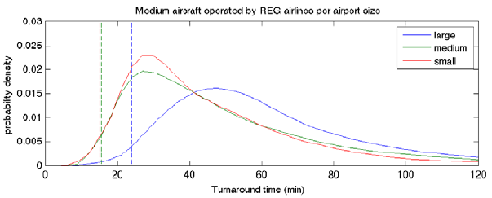
Figure 1- Turnaround times - medium aircraft, regional airlines (SESAR, 2013)

Dataset Management
This section explains the changes that need to be made to the datasets to keep track of the changes made so the process can be repeated acquiring the same results. The methodologies presented will transform all flights into the paradigm presented in the project including air and groundside improvements.

Calculation of SESAR trajectory improvements

Methodology for implementation
In order to modify the flight list as if aircraft flew with direct free routing, we took the following assumptions:
- Free routing will occur on all phases of flights.
- The new trajectories will be calculated using average ground speed of the original flight plan.
The methodology to calculate the new flight time will be the following:
CLIMB
- Add distances of all climb segments.
- Calculate the time difference between the first cruise segment entry point and the take-off time.
DESCENT
- Add distances of all descent segments.
- Calculate the time difference between the last cruise segment exit point and the arrival time.
CRUISE
- Calculate the time difference between the last cruise segment exit point and the first cruise segment entry point.
- Add distances of all cruising segments.
- Calculate average ground-speed dividing (2) by (1).
- Calculate orthogonal distance between airports.
- Subtract the CLIMB and DESCENT distances from (4) to obtain cruise distance.
- Divide 5 by 3 to obtain cruise time.
TRIP
- Add climb, descent and cruise times to obtain new trip time
- This new trip time should be less than the original.
The flights will be modified in the following manner:
- Arrival flights to hub airport - The departure time will be modified in such a way that the arrival time remains the same.
- Departure flights - The departure time will not be affected by this process, however, the departure time will depend on ground processes improvements. The arrival time at destination will be modified depending on cruise distance savings.

Sample case
This section explains the calculation of the trajectory for the flights, implementing SESAR expected improvements.
The following is a sample containing a single flight with the different segments as described in the original flight plan.
FltNum | Segment identifier | FL begin | FL end | Lat begin | Lon begin | Lat end | Lon end | Length | Date time begin | Date time end
DLH_UGTBEDDM01 | UGTB_DF | 0 | 159 | 2500.15 | 2697.28 | 2515 | 2673.93 | 22.88 | 20/08/2010 0:10 | 20/08/2010 0:23
DLH_UGTBEDDM01 | DF_GIMUR | 159 | 221 | 2515 | 2673.93 | 2521 | 2647.93 | 20.24 | 20/08/2010 0:23 | 20/08/2010 0:26
DLH_UGTBEDDM01 | GIMUR_*BT1 | 221 | 268 | 2521 | 2647.93 | 2525.38 | 2619.01 | 21.91 | 20/08/2010 0:26 | 20/08/2010 0:29
DLH_UGTBEDDM01 | *BT1_LOBIN | 268 | 315 | 2525.38 | 2619.01 | 2530.9 | 2586.43 | 24.78 | 20/08/2010 0:29 | 20/08/2010 0:33
DLH_UGTBEDDM01 | LOBIN_KTS | 315 | 360 | 2530.9 | 2586.43 | 2530.41 | 2547.36 | 28.95 | 20/08/2010 0:33 | 20/08/2010 0:37
DLH_UGTBEDDM01 | KTS_IBERI | 360 | 360 | 2530.41 | 2547.36 | 2529.65 | 2503.3 | 32.67 | 20/08/2010 0:37 | 20/08/2010 0:42
DLH_UGTBEDDM01 | IBERI_BANUT | 360 | 360 | 2529.65 | 2503.3 | 2579.38 | 2399.11 | 91.42 | 20/08/2010 0:42 | 20/08/2010 0:56
DLH_UGTBEDDM01 | BANUT_UNAMI | 360 | 360 | 2579.38 | 2399.11 | 2595.8 | 2326.9 | 55.2 | 20/08/2010 0:56 | 20/08/2010 1:04
DLH_UGTBEDDM01 | UNAMI_PIRIL | 360 | 360 | 2595.8 | 2326.9 | 2598.5 | 2314.4 | 9.49 | 20/08/2010 1:04 | 20/08/2010 1:06
DLH_UGTBEDDM01 | PIRIL_*DIGR | 360 | 360 | 2598.5 | 2314.4 | 2602.1 | 2298.1 | 12.38 | 20/08/2010 1:06 | 20/08/2010 1:08
DLH_UGTBEDDM01 | *DIGR_LURAS | 360 | 360 | 2602.1 | 2298.1 | 2608.7 | 2267.2 | 23.39 | 20/08/2010 1:08 | 20/08/2010 1:11
DLH_UGTBEDDM01 | LURAS_LODBI | 360 | 360 | 2608.7 | 2267.2 | 2610.7 | 2257.5 | 7.31 | 20/08/2010 1:11 | 20/08/2010 1:13
DLH_UGTBEDDM01 | LODBI_REDMA | 360 | 360 | 2610.7 | 2257.5 | 2617.4 | 2224.6 | 24.76 | 20/08/2010 1:13 | 20/08/2010 1:16
DLH_UGTBEDDM01 | REDMA_TISOM | 360 | 360 | 2617.4 | 2224.6 | 2624.5 | 2189.5 | 26.35 | 20/08/2010 1:16 | 20/08/2010 1:20
DLH_UGTBEDDM01 | TISOM_KULEM | 360 | 360 | 2624.5 | 2189.5 | 2636 | 2131.1 | 43.66 | 20/08/2010 1:20 | 20/08/2010 1:27
DLH_UGTBEDDM01 | KULEM_LASOR | 360 | 360 | 2636 | 2131.1 | 2642.3 | 2098 | 24.63 | 20/08/2010 1:27 | 20/08/2010 1:31
DLH_UGTBEDDM01 | LASOR_KOLIG | 360 | 360 | 2642.3 | 2098 | 2647.1 | 2071.3 | 19.77 | 20/08/2010 1:31 | 20/08/2010 1:34
DLH_UGTBEDDM01 | KOLIG_LUNAT | 360 | 360 | 2647.1 | 2071.3 | 2657.6 | 2011.2 | 44.34 | 20/08/2010 1:34 | 20/08/2010 1:41
DLH_UGTBEDDM01 | LUNAT_DESEL | 360 | 360 | 2657.6 | 2011.2 | 2666.15 | 1959.55 | 37.9 | 20/08/2010 1:41 | 20/08/2010 1:47
DLH_UGTBEDDM01 | DESEL_BOMKI | 360 | 360 | 2666.15 | 1959.55 | 2672.1 | 1921.8 | 27.58 | 20/08/2010 1:47 | 20/08/2010 1:51
DLH_UGTBEDDM01 | BOMKI_OGATA | 360 | 360 | 2672.1 | 1921.8 | 2688.76 | 1807.85 | 82.72 | 20/08/2010 1:51 | 20/08/2010 2:04
DLH_UGTBEDDM01 | OGATA_TLC | 360 | 360 | 2688.76 | 1807.85 | 2699.55 | 1724.18 | 60.23 | 20/08/2010 2:04 | 20/08/2010 2:13
DLH_UGTBEDDM01 | TLC_SIRVA | 360 | 360 | 2699.55 | 1724.18 | 2708.21 | 1688.11 | 26.9 | 20/08/2010 2:13 | 20/08/2010 2:17
DLH_UGTBEDDM01 | SIRVA_NAVOD | 360 | 360 | 2708.21 | 1688.11 | 2715.31 | 1657.81 | 22.5 | 20/08/2010 2:17 | 20/08/2010 2:20
DLH_UGTBEDDM01 | NAVOD_URARA | 360 | 360 | 2715.31 | 1657.81 | 2717.53 | 1648.21 | 7.11 | 20/08/2010 2:20 | 20/08/2010 2:22
DLH_UGTBEDDM01 | URARA_URELA | 360 | 360 | 2717.53 | 1648.21 | 2729.8 | 1593.66 | 40.22 | 20/08/2010 2:22 | 20/08/2010 2:28
DLH_UGTBEDDM01 | URELA_ERGAT | 360 | 360 | 2729.8 | 1593.66 | 2739.15 | 1550.43 | 31.67 | 20/08/2010 2:28 | 20/08/2010 2:33
DLH_UGTBEDDM01 | ERGAT_MOBRA | 360 | 360 | 2739.15 | 1550.43 | 2751.86 | 1489.16 | 44.59 | 20/08/2010 2:33 | 20/08/2010 2:40
DLH_UGTBEDDM01 | MOBRA_AMIKU | 360 | 360 | 2751.86 | 1489.16 | 2754.7 | 1475.08 | 10.2 | 20/08/2010 2:40 | 20/08/2010 2:41
DLH_UGTBEDDM01 | AMIKU_ABEGO | 360 | 360 | 2754.7 | 1475.08 | 2765.71 | 1418.58 | 40.76 | 20/08/2010 2:41 | 20/08/2010 2:47
DLH_UGTBEDDM01 | ABEGO_DEROT | 360 | 360 | 2765.71 | 1418.58 | 2772.91 | 1380.05 | 27.64 | 20/08/2010 2:47 | 20/08/2010 2:52
DLH_UGTBEDDM01 | DEROT_EVRIK | 360 | 360 | 2772.91 | 1380.05 | 2781.11 | 1334.53 | 32.5 | 20/08/2010 2:52 | 20/08/2010 2:57
DLH_UGTBEDDM01 | EVRIK_BAXER | 360 | 360 | 2781.11 | 1334.53 | 2785.45 | 1305.16 | 20.71 | 20/08/2010 2:57 | 20/08/2010 3:00
DLH_UGTBEDDM01 | BAXER_DEGET | 360 | 360 | 2785.45 | 1305.16 | 2789.61 | 1276.03 | 20.49 | 20/08/2010 3:00 | 20/08/2010 3:03
DLH_UGTBEDDM01 | DEGET_BABOX | 360 | 360 | 2789.61 | 1276.03 | 2813.75 | 1180.98 | 69.51 | 20/08/2010 3:03 | 20/08/2010 3:14
DLH_UGTBEDDM01 | BABOX_SUBES | 360 | 360 | 2813.75 | 1180.98 | 2845.26 | 1045.6 | 97.29 | 20/08/2010 3:14 | 20/08/2010 3:29
DLH_UGTBEDDM01 | SUBES_ARSIN | 360 | 345 | 2845.26 | 1045.6 | 2854.03 | 1005.21 | 28.65 | 20/08/2010 3:29 | 20/08/2010 3:33
DLH_UGTBEDDM01 | ARSIN_SITNI | 345 | 300 | 2854.03 | 1005.21 | 2883.25 | 890.08 | 82.65 | 20/08/2010 3:33 | 20/08/2010 3:45
DLH_UGTBEDDM01 | SITNI_BAGSI | 300 | 280 | 2883.25 | 890.08 | 2883.46 | 857.38 | 21.85 | 20/08/2010 3:45 | 20/08/2010 3:48
DLH_UGTBEDDM01 | BAGSI_MATIG | 280 | 195 | 2883.46 | 857.38 | 2883.51 | 812.48 | 30.01 | 20/08/2010 3:48 | 20/08/2010 3:52
DLH_UGTBEDDM01 | MATIG_AMADI | 195 | 180 | 2883.51 | 812.48 | 2885.48 | 774.83 | 25.23 | 20/08/2010 3:52 | 20/08/2010 3:57
DLH_UGTBEDDM01 | AMADI_NAPSA | 180 | 115 | 2885.48 | 774.83 | 2888.65 | 740.73 | 22.98 | 20/08/2010 3:57 | 20/08/2010 4:00
DLH_UGTBEDDM01 | NAPSA_MUN | 115 | 110 | 2888.65 | 740.73 | 2890.81 | 708.96 | 21.29 | 20/08/2010 4:00 | 20/08/2010 4:05
DLH_UGTBEDDM01 | MUN_EDDM | 110 | 0 | 2890.81 | 708.96 | 2901.23 | 707.16 | 10.48 | 20/08/2010 4:05 | 20/08/2010 4:15
Table 2 - Flight sample.
Step 1: identify climb, and descent times and distances:
CLIMB
Looking at the “FL end” we can identify when each flight has reached its last climbing segment.
Flt Num | Segment identifier | FL begin | FL end | Length | Date time begin | Date time end
DLH_UGTBEDDM01 | UGTB_DF | 0 | 159 | 22.88 | 20/08/2010 0:10 | 20/08/2010 0:23
DLH_UGTBEDDM01 | DF_GIMUR | 159 | 221 | 20.24 | 20/08/2010 0:23 | 20/08/2010 0:26
DLH_UGTBEDDM01 | GIMUR_*BT1 | 221 | 268 | 21.91 | 20/08/2010 0:26 | 20/08/2010 0:29
DLH_UGTBEDDM01 | *BT1_LOBIN | 268 | 315 | 24.78 | 20/08/2010 0:29 | 20/08/2010 0:33
DLH_UGTBEDDM01 | LOBIN_KTS | 315 | 360 | 28.95 | 20/08/2010 0:33 | 20/08/2010 0:37
CLIMB TOTAL |  |  |  | 118.76 | 0:27
Table 3 - Flight sample climb segments.
DESCENT
Looking at the “FL end” we can identify when each flight has reached its top of descent segment.
Flt Num | Segment identifier | FL begin | FL end | Length | Date time begin | Date time end
DLH_UGTBEDDM01 | SUBES_ARSIN | 360 | 345 | 28.65 | 20/08/2010 3:29 | 20/08/2010 3:33
DLH_UGTBEDDM01 | ARSIN_SITNI | 345 | 300 | 82.65 | 20/08/2010 3:33 | 20/08/2010 3:45
DLH_UGTBEDDM01 | SITNI_BAGSI | 300 | 280 | 21.85 | 20/08/2010 3:45 | 20/08/2010 3:48
DLH_UGTBEDDM01 | BAGSI_MATIG | 280 | 195 | 30.01 | 20/08/2010 3:48 | 20/08/2010 3:52
DLH_UGTBEDDM01 | MATIG_AMADI | 195 | 180 | 25.23 | 20/08/2010 3:52 | 20/08/2010 3:57
DLH_UGTBEDDM01 | AMADI_NAPSA | 180 | 115 | 22.98 | 20/08/2010 3:57 | 20/08/2010 4:00
DLH_UGTBEDDM01 | NAPSA_MUN | 115 | 110 | 21.29 | 20/08/2010 4:00 | 20/08/2010 4:05
DLH_UGTBEDDM01 | MUN_EDDM | 110 | 0 | 10.48 | 20/08/2010 4:05 | 20/08/2010 4:15
DESCENT |  |  |  | 243.14 | 0:46
Table 4 - Flight sample descent segments.
Step 2: calculate great circle distance distance between airports
This JavaScript uses the Haversine Formula (shown below) expressed in terms of a two-argument inverse tangent function to calculate the great circle distance between two points on the Earth. This is the method recommended for calculating short distances by Bob Chamberlain of Caltech and NASA's Jet Propulsion Laboratory as described on (U.S. Census Bureau, 2014).
$$dlon=lon2-lon1$$
$$dlat=lat2-lat1$$
$$a= {\left(sin\left(\frac{dlat}{2}\right)\right)}^{2}+cos\left(lat1\right)·cos\left(lat2\right)·{\left(sin\left(\frac{dlon}{2}\right)\right)}^{2}$$
$$c=2·{\left(atan⁡\left(\sqrt{a},\sqrt{1-a}\right)\right)}^{2}$$
$$d=R·c$$

Where R is the radius of the Earth, lat is the latitude, lon the longitude, 1 for the departure, 2 for destination.
Note: this formula does not take into account the non-spheroidal (ellipsoidal) shape of the Earth. It will tend to overestimate trans-polar distances and underestimate trans-equatorial distances. The values used for the radius of the Earth (3961 miles & 6373 km) are optimized for locations around 39 degrees from the equator.
Great circle distance | 2,687.81 | km
Great circle distance | 1451.299122 | NM
Cruise groundspeed | 389.83 | knots gs
Table 5 - Sample case distance and speed.
Step 3: Find new climb, cruise and descent times and distances
 | Distance (NM) | Time (h)
Flight | 1451.299122 | 4.02
Climb | 118.76 | 0.46
Cruise | 1,089.40 | 2.79
Descent | 243.14 | 0.77
Table 6 - Sample case segment distances and times.
Step 4: Modifying departure times for arrivals
The flights will be modified in the following manner:
- Arrival flights to hub airport - The departure time will be modified in such a way that the arrival time remains the same as in the original flight plan.
- Departures from hub airport – The departure time will remain the same (only modified by ground operations improvements), reducing the arrival time at destination.

Implementation of ground improvement processes

Methodology for implementation
Given the passenger connection information, we can build a connection pax matrix as shown below:
Connex pax | Outbounds
Inbounds | 1 | 2 | 3 | 4 | 5
1 | 0 | 3 | 0 | 1 | 0
2 | 5 | 0 | 0 | 3 | 0
3 | 7 | 3 | 2 | 4 | 0
4 | 0 | 0 | 20 | 5 | 4
5 | 1 | 10 | 0 | 6 | 0
Table 7 - Pax connecting matrix.
This matrix shows the amount of pax that connect between flights.
In order to identify the new departing time for departures, it is necessary to take the following steps:
- For each column it is necessary to find all non-zero values.
- Find the arrival time and connecting time for each of these non-zero values.
  - Find the arrival time: Search the arrival time for the inbound flight of the value (same row).
  - Find the connecting times: Add the MCT to each arrival time found in 2a.
- Find turnaround time:
  - Find previous flight with same aircraft using the registration details.
  - Add minimum turnaround time using aircraft type and airline information.
- Change departure time to the maximum of (2) and (3).

Sample case
Following the process described in the previous section, we analyse the connecting pax file to obtain a 257 X 266 passenger connection matrix. For simplicity we have numbered the arrivals and departures. A subset of the matrix is shown below:

Connecting pax | Departures
Arrivals | 1 | 2 | 3 | 4 | 5 | 23 | 24 | 25 | 26 | 27 | 28 | 29 | 30 | 31 | 32 | 33
21 |  |  | 4 |  |  |  | 1 |  |  | 1
22 |  |  |  |  |  | 3 |  |  |  |  |  |  |  | 1
23
24 |  | 11 |  |  |  |  |  |  |  |  |  | 1 |  |  | 7
25 |  | 12
26
27
28 |  |  |  |  |  |  | 7
29 |  |  |  |  |  |  |  |  |  |  |  |  | 1
30 |  | 1 |  |  |  |  |  |  |  | 2
31
Table 8 - Pax connecting matrix extract from sample case.
Consider departure number 2.
- For each column it is necessary to find all non-zero values: In this case flights 24, 25 and 30.
- Find the arrival time and connecting time for each of these non-zero values.
  - Find the arrival time: Search the arrival time for the inbound flight of the value (same row). Consider the following arrival times: 10:00, 10:30, and 10:40.
  - Find the connecting times: Add the MCT to each arrival time found in 2a. Consider MCT to be 40 min. The pax connecting limiting times would be 10:40, 11:10 and 11:20.
- Find turnaround time:
  - Find previous flight with same aircraft using the registration details. Let's say it was flight 21, arriving at 9:45.
  - Add minimum turnaround time using aircraft type and airline information. Consider that given the aircraft type and airport the turnaround time was 30 min, hence ready time due to turnaround would be 10:15.
- Change departure time to the maximum of (2) and (3). In this case, new departure time would be 11:20.

Ground improvement issues
One of the major difficulties of implement the ground improvement is that by doing it, we are modifying the airlines schedules, including their buffers.
As presented in section 4.1.2 airports connections are complex and buffers are required as uncertainty is always present in the system even in nominal operations. If the departure times at the hub are modified as suggested in section 3.2.1, we would be able to compute the minimal gate-to-gate time; however, by minimum disruptions linked with nominal operations will lead to missed connections and/or delayed departures for waiting for passengers increasing the total cost of the solution.
Some benefits could be obtained by reducing the connections times but that implies modifying the buffers at the airport. The optimisation of connections and buffers, ensuring fast connectivity and robustness is out of scope of this project. Therefore, for DCI-4HD2D we will analyse the scenarios without modifying the departures times at the hub.

Aircraft weight, flight level and fuel model
When assessing speed variation strategies, it is paramount to estimate the aircraft weight and flight level as those parameters will impact the fuel consumption and the aircraft performance bounds. (Fuel calculation is achieved through the use of EUROCONTROL’s BADA 4.0, which requires the input of a singular cruising flight level).

- Flight level estimation

The methodology suggested for the estimation of the flight level consist on the analysis of the flight altitudes that are used by aircraft based on the data available in the DDR2 database:

- From DDR2 the flight level as a function of flight plan distance is extracted for all the aircraft types that operated to-from the hub under study.
- If one or several climb steps are realised during the flight, an average altitude is computed weighed by the distance used in each of the flight levels.
- The average flight levels are rounded to the nearest flight level.
- The distances are grouped by 100 NM and the mean computed. The distances are then divided in segments and an average FL is selected, sampling in this way the distance and assigning FLs to them (see Figure 2). Figure 3 presents the fitting of flight level and flight plan distance with respect to the total number of flights.
- The number of divisions in the flight plan distance is aircraft type dependent.

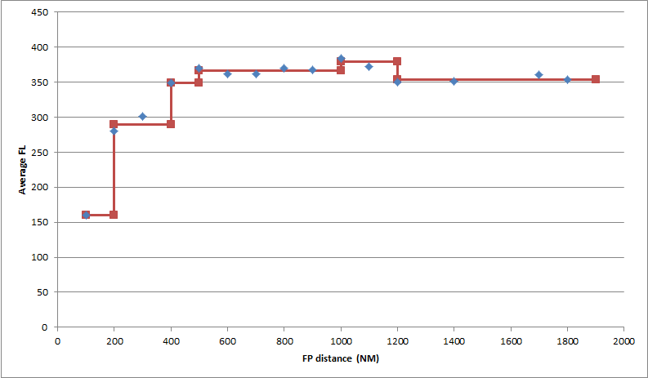
Figure 2- Mean average altitude as a function of flight plan distance grouped by 100 NM and altitude fitting for A320 aircraft types

.

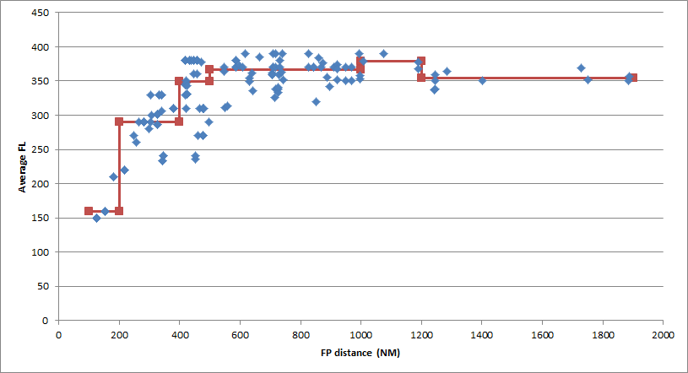
Figure 3- Mean Average altitude as a function of flight plan distance and altitude fitting A320

- Weight estimation
- From an aircraft performances point of view, for each aircraft weight there is an optimal altitude. This optimal altitude is defined as the altitude that maximises the specific range (NM/kg fuel) for the aircraft at the nominal speed. Using this definition flight level-optimal weight charts are computed per aircraft type, as presented in Figure 4.
- For each altitude considered, the optimal weight is computed using the previously defined tables. Linear interpolation is considered when defining the weight-flight level relationship.
- The hypothesis considered is that, if an aircraft requested to be at a given flight level (information from the flight level estimation), it was because that was the optimum flight level for that flight, and therefore its weight must had been the optimal one for that altitude.
- If the altitude requested is lower than the minimum flight level computed, the reference weight is assumed to be used. Low flight levels are used by short flights, but in those cases the selection of a low flight level is probably related with operational constraints (e.g. not time enough to climb to the optimal FL) rather than weight.
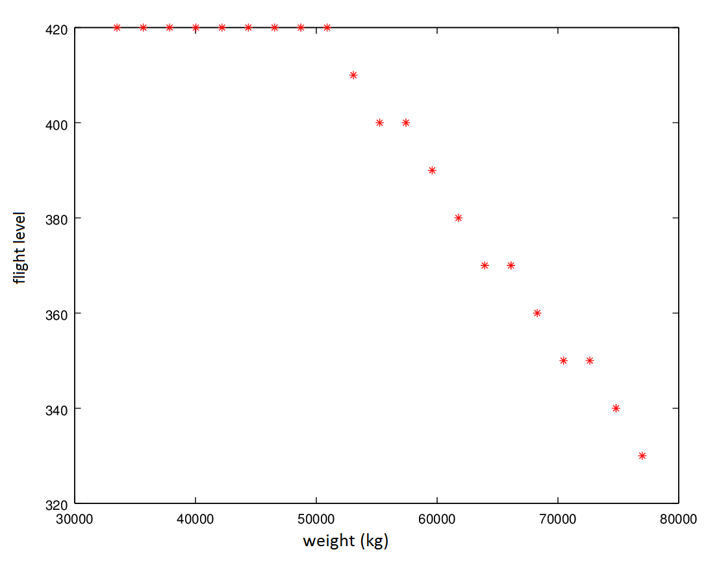
Figure 4- Flight level-weight relationship for twin-engine aircraft

- Fuel estimation

With the previously computed altitudes and weights, we are able to estimate the fuel consumption and to compute the aircraft performance limitations (minimum and maximum speed).

Case Study design

Problem description
This section will explore the problem complexity. This will allow us to have a deeper understanding of the computational requirement and help us to define adequate working hypothesis and simplifications if required.
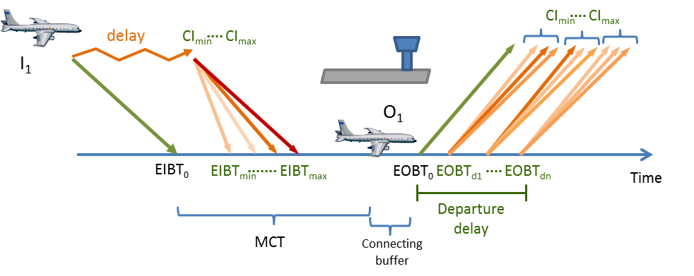
Figure 5 – DCI-4HD2D connection scheme
Figure 5 represents the different options available to meet a given connection once the inbound flight has been delayed and the time between the EIBT and the EOBT is lower than the MCT leading to a miss connection. In that case, the inbound flight can select one of n cost indexes and the outbound flight can delay its departure and then select among n different cost indexes in its turn. As presented in the following points the complexity of the problem, the nature of the connections and the margin to recover delay should be considered when assessing the overall problem.

Complexity of the problem

a) One inbound flight with one connection
Table 9 presents the different options available when an inbound flight is delayed and a connection might be missed with a further outbound flight assuming a total of n different cost indexes that can be used.

 | Option | Inbound | Outbound
Connection made | 1 | CI_{nom} | delay | CI₁
 |  |  |  | …
 |  |  |  | CI_{max}
 | 2 | CI₂/Rec₂ | delay – Rec₂ | CI₁
 |  |  |  | …
 |  |  |  | CI_{max}
 | n | CI_{max}/Rec_{max} | delay – Rec_{max} | CI₁
 |  |  |  | …
 |  |  |  | CI_{max}
Connection missed | n+1 | CI_{nom} | don’t wait | CI_{nom}
Table 9 – Single inbound – outbound case: options available
If an inbound flight is delayed, the best strategy might be to try to realise the connection of passengers. In this case, the first option would be to maintain the flight as initially planned (CI_{nom}) and delay the outbound flight, waiting for the passengers, for the total amount of the delay. Then for the outbound flight there are a total of n different cost indexes that could be selected.
It is possible to speed up the inbound flight (from CI_{nom} to CI_{max}) recovering part of the delay. In this case, the waiting time for the outbound flight is reduced by the amount of minutes recovered by the inbound flight. And as in the previous case, for each delayed departure there are a set of n different cost indexes that can be used.
Finally, the best strategy might be to do not wait for the passengers and rebook them in a different flight. In that case, the delayed inbound flight is not speeded up and the outbound flight will realise its flight as initially planned.
Thus, considering n different cost indexes for each flight, there are a maximum of n²+1 options when a flight is delayed and a single connection is considered.

b) One inbound flight with more than one connection
As depicted in Figure 6, a given inbound flight might be carrying passengers that will connect with c outbound flights.

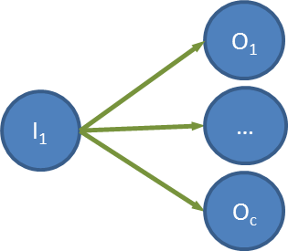
Figure 6 – Diagram relating one inbound feeding c connecting outbound flights
Therefore, if that inbound flight is delayed, for each cost index that might be used by the inbound flight, each outbound flight can decide if the best option is to wait or not for the flight and if waiting then which cost index to use in its turns (i.e., each outbound flight can select between (n+1) options for each inbound speed). The option where the inbound flight speeds up but no outbound flight waits should not be considered and the option when the best strategy is not to wait for any of the inbound passengers should be added. Therefore there are a total of n((n+1)^{c}-1)+1 options.

c) Several inbound flight with one connection
In this case we have a set of inbound aircraft that are delayed (i) and they are carrying passengers that are realising a connection with one flight at the airport as depicted in Figure 7.
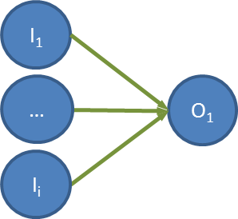
Figure 7 – Diagram relating i inbound feeding a connecting outbound flight
For each inbound flight and for each possible speed there is an amount of delay that the connecting flight should do in order to meet the connection. Notice that with a given delay, the connection can be achieved by several inbound aircraft flying at different cost indexes. It might be also possible that a given delay ensures the possibility of connecting with some of the delayed aircraft but not others. The following table shows these options with an example with three inbound delayed flights each of them with 6 different possible cost indexes.
Inbound flight 1 cost indexes | Inbound flight 2 cost indexes | Inbound flight 3 cost indexes | Outbound flight delay
CI1_{nom} | CI2_{nom} | CI3_{nom} | D₈
CI1_{nom} | CI2_{nom} | CI3_{n-4} | D₇
CI1_{nom} | CI2_{nom} | CI3_{n-3} | D₆
CI1_{nom} | CI2_{n-4} | CI3_{n-2} | D₅
CI1_{n-4} | CI2_{n-3} | CI3_{n-1} | D₄
CI1_{n-3} | CI2_{n-2} | CI3_{max} | D₃
CI1_{n-2} | CI2_{n-1} | - | D₂
CI1_{n-1} | CI2_{max} | - | D₁
CI1_{max} | - | - | D₀
Table 10 – Several inbound flights with one connecting outbound flight.
In this case, if the outbound flight is waiting for the third flight, which is flying at its nominal cost index, then the outbound flight will realise D₈ minutes of delay, and there is no incentive for flight one or two to speed up. In some cases, if the outbound flight waits only for a short period of time, some flights might not be able to make the connection even if flying at their maximum cost index (e.g. flight 3 if outbound flight is delayed by D₁ minutes).
In other cases, some flight might reach the connection if they speed up at different speeds (e.g. outbound flight delayed by D₃ minutes, the three inbound can achieve the connection). But it might be worth for some of them not to use extra fuel and just miss the connection. Therefore, for each delay of the outbound flight there are a maximum of O(2^{i}-1) options; and for each delayed departure, the outbound flight can select n different cost indexes. Thus, the complexity of i flights arriving delayed at an airport with one connecting flight is O(n²(2^{i}-1)+1).

d) Several inbound flight with several connection
In this case for each speed considered, there are O(n(2^{i}-1)+1) options of aircraft speeding up and ((n+1)^{c}-1) options of aircraft delayed on ground. Therefore the problem is O(n(2^{i}-1)((n+1)^{c}-1)).
In a busy hub, an outbound connecting flight has an average of 12 inbound flights feeding it; and an inbound flight is feeding passengers to 13 outbound flights. Considering 10 possible CIs per flight, there are in the order of 10¹⁸ possible options per average connection group.

Hub airport connections analysis

a) Connecting times allowed for flights and passengers
Figure 8 represents the number of passengers and flights connections scheduled as a function of time since the inbound flight reaches the hub. The majority of the passengers connect with their outbound flights earlier than 140 minutes since the flight is scheduled to arrive to the airport.
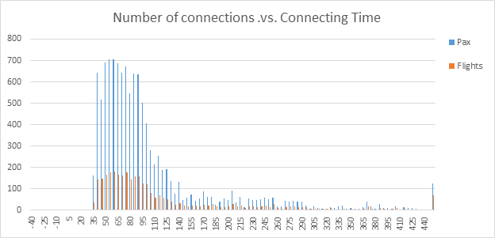
Figure 8 - Connections for passengers and flights as a function of time after inbound flight arrival.
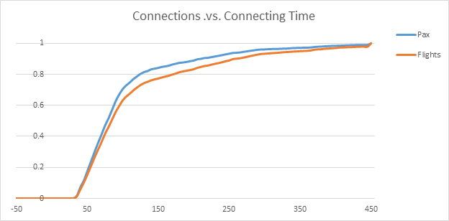
Figure 9 - Connections for passengers and flights as a function of time after inbound flight arrival (probability function).
Figure 9 represents the information depicted in Figure 8 but as an aggregated probability function of connections planned by passengers and by flights as a function of time after the arrival of the inbound flight. 75% of the passengers have connections before 115 minutes since the inbound flight arrives to the airport. The same threshold of 75% of connecting flights is achieved after 135 minutes since the arrival of the flight. This means that there is a slight difference between aircraft connections and passenger connections. As appreciated in Figure 10. A given inbound flight has connections with several outbound flights at the hub, but more passengers are expected to be connecting with the earliest connections of the flight.
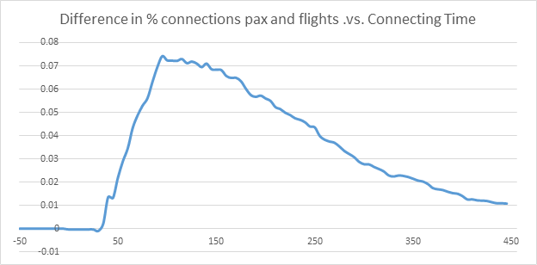
Figure 10 - Difference between passengers and flight connections as a function of time after inbound flight arrival.

b) Connection buffer allowed for flights and passengers
The previous figures shown the connections of passengers after the inbound aircraft arrives, however, different connections might have different minimum connection times (MCT). By subtracting the MCT to the connection times we are able to analyse the buffer that the passengers and the flights have at the airport. Therefore, the time will indicate what the maximum possible inbound delay is before the connection is missed.
Figure 11 presents the results in absolute value and Figure 12 as probability function for the passengers and the flights. Notice that for some passengers (188 (1.6%)) and flights (48 (1.5%)) have a negative buffer (i.e. the MCT is shorter than the time allowed between the inbound and the outbound flights). In theory this cases would represent passengers that even if there were not delay in the system they would not be able to meet their connection. A detailed analysis of the data shows that those connections are from the hub carrier and probably by business passengers (flex tickets), which would be able to do the connection potentially faster than the published MCT.
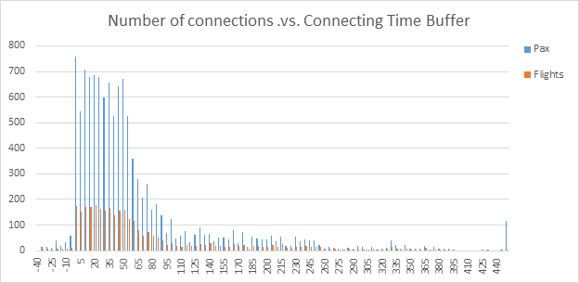
Figure 11 - Connections for passengers and flights as a function of buffer time after inbound flight arrival.
As shown in Figure 12, approximately 30% of the passenger have a buffer smaller than 20 minutes, 75% of the passengers have a buffer of 70 minutes or less.
In this case, when the difference between flights and passengers is analysed (Figure 13), we can appreciate that the difference is smaller than if the connecting time is solely considered (Figure 10).
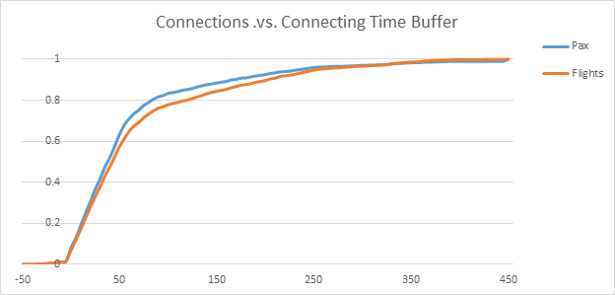
Figure 12 - Difference between passengers and flight connections as a function of buffer time after inbound flight arrival.
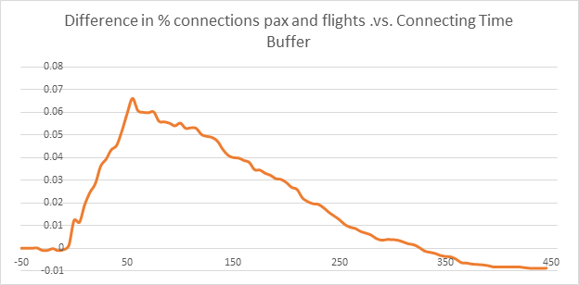
Figure 13 - Difference between passengers and flight connections as a function of buffer time after inbound flight arrival.

c) Number of connections and flights and passengers' connectivity distribution
In the day of operations of the hub studied in this project, an inbound flight with connections has, in average, 13 connecting outbound flights, being the maximum number of links of 39 connections. Each outbound flight is in its turn fed by 12 inbound flights in average with a maximum of 43 inbound flights.
For each flight, it has been computed how many connecting flights and how many passengers are connected with respect to the connection number (see Figure 14). The information is presented as probability function in Figure 15. 50% of the flights have less than 12 connections, but 50% of the passengers are connected in the first 9 connections, 75% of the flights have 19 or fewer connections, the same percentage of passengers are connected in the 14 first connections. Once again, it is clear how even if a given flight can have many connecting outbound flights, the majority of passengers are connecting with relatively short connecting times.
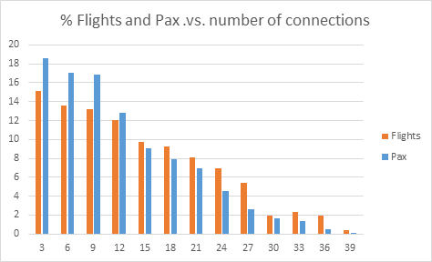
Figure 14 - Flights with given number of connecting outbound flights and passengers using the connection.
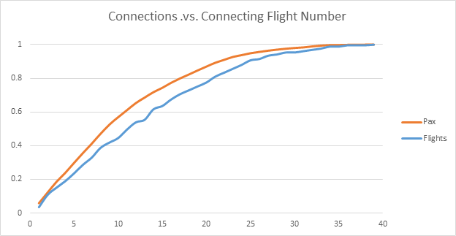
Figure 15 - Probability function of flights having a given number of connections and passengers using a given connection.

d) Location of connecting flights
As previously stated, an inbound flight has an average of 12 connecting outbound flights. However, it is interesting to note that at the scheduled time of arrival of the inbound flight not all those connecting flights will already be at the hub airport. This has an impact on the computation of the connections and the delay recovery strategy, as those connecting flights, if they are not at the airport, might be also subject to delays. Figure 16 presents where the outbound connecting flights are located when the inbound flight is scheduled to arrive to the hub. There are three possible categories:
- The outbound connecting flight is scheduled to be already at the airport on ground when the inbound flight arrives (48% of all the outbound flights).
- The outbound connecting flight is scheduled to be flying towards the hub when the inbound flight arrives (41% of all the outbound flights).
- The outbound connecting flight is scheduled to be flying a different leg (not to the hub) when the when the inbound flight arrives (11% of the outbound flights).

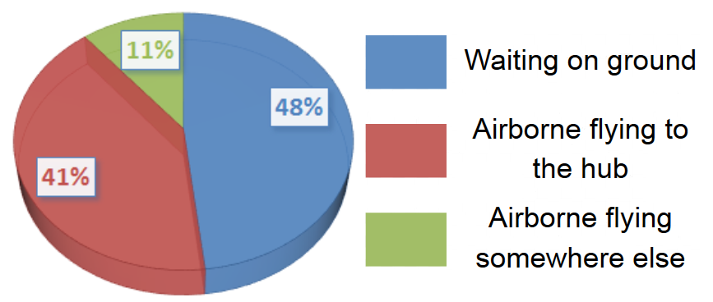
Figure 16 - Location of connecting outbound flights when inbound flight is scheduled to arrive.
With the previous percentage, it is shown how the majority of the flights (52% of all the connections) are not at the airport when the inbound flight arrives to the hub. However, this clearly depends on how close is the connection with respect to the arrival time of the inbound flight. Figure 17 shows the number of outbound connections and the location of the flights based on the number of connection with respect to the inbound. As the connection is further the number of flights already on-ground at the arrival time diminish, and the number of flights that are airborne or flying a different leg increases. This can be observed in Figure 18 where the percentage between the categories is given. For example, the first 71% of the first connections of the inbound flights are already on-ground, 24% are flying towards the hub and only 5% are flying somewhere else. These values change to 35%, 45% and 20% respectively when considering the 17th connection.

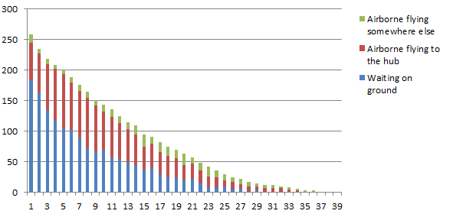
Figure 17 - Location of connecting flights as a function of connection number.
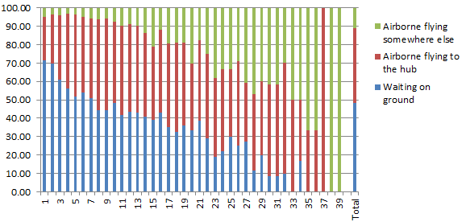
Figure 18 - Percentage of location of connecting flights as a function of connection number.
Figure 19 and Figure 20 present the same results but as a function of the time elapsed since the inbound flight is scheduled to arrive at the airport.
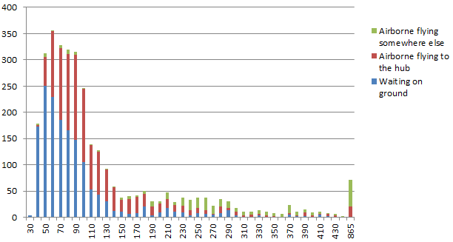
Figure 19 - Location of connecting flights as a function of time after inbound flight arrival time.
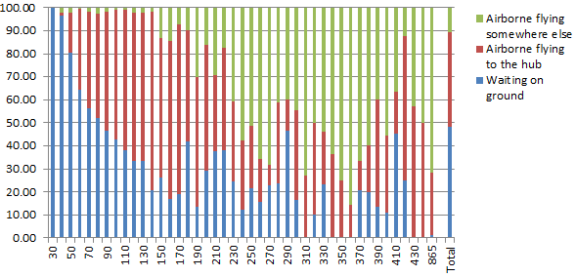
Figure 20 - Percentage of location of connecting flights as a function of time after inbound flight arrival time.
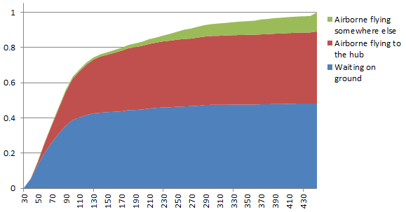
Figure 21 - Accumulative percentage of connecting flights by category as a function of time after inbound flight arrival time.
Figure 21 presents the probability function of the location of the outbound flight as a function of elapsed time after the scheduled arrival of the inbound flight.

Maximum delay potentially recovered and realised
When applying DCI, by just modifying the aircraft speed, a maximum amount of delay can be recovered and a maximum amount of delay can be realised. These limits are bounded due to aircraft performances and its operational envelope. In 4HD2D-DCI only speed changes are considered and it is assumed that the nominal flight is operated at the BADA's reference speed the whole trip. Assuming that the aircraft is flying at the maximum possible speed the minimum flight time is presented. In a similar manner, it is possible to compute the longest flight by considering that the aircraft is flying at the minimum possible speed. These results allow us to assess what the bounds on delay recovery that can be achieved with this speed variation strategy are.
Figure 22 represents the reference, fastest and slowest trip time needed for a flight with a typical twin jet engine aircraft. The discontinuities are due to the fact that the flight levels and weights used are modified as defined in section 3.3. As it can be observed, there is more potential to slow the aircraft rather than to speed it up. One of the main reasons is that BADA reference speed is already relatively fast.
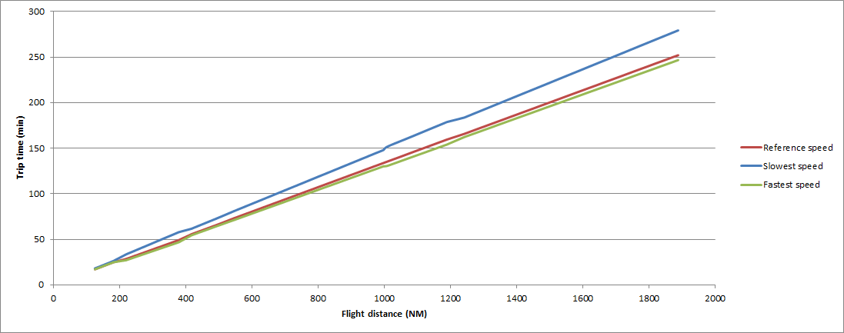
Figure 22 - Twin jet engine aircraft trip times.
As depicted in Figure 23, the maximum delay that can be recovered by increasing the speed is, as expected, aircraft and flight dependent; and as previously mentioned, there are highest opportunities to realise delay during the flight instead of recovering it (by slowing down) as shown in Figure 24.
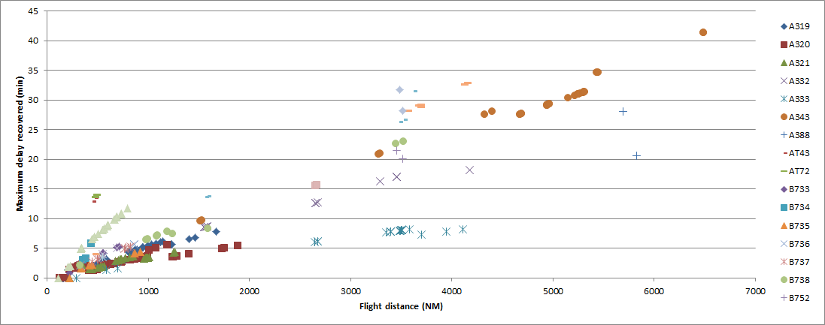
Figure 23 - Maximum delay recovered by increasing speed.
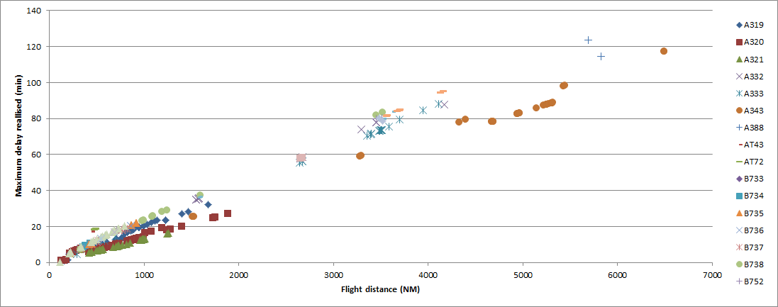
Figure 24 - Maximum delay realisable by reducing speed.
There is a relationship between the flight distance and the amount of delay that can be recovered. However, there is usually a relationship between aircraft type used and flight distance. Figure 25 and Figure 26 present the delay that can be recovered and realised by aircraft type. Thus, for short and medium haul flights (A319, A320, A321, B733, B734, B735, B736, B737, B738), in general, the amount of delay that can be recovered is lower than 5 minutes, for long haul (A332, A333, A343, A346, A388, B752, B762, B763, B764, B7WW) the bound is closer to 30 minutes, and for turboprop and aircraft with engines located in the rear side (AT43, AT72, F100, MD82, MD87) around 10 minutes.
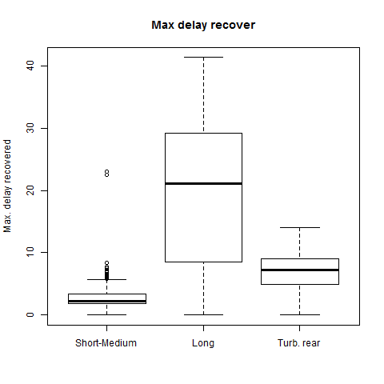
Figure 25 - Maximum potential delay recovered by aircraft family.
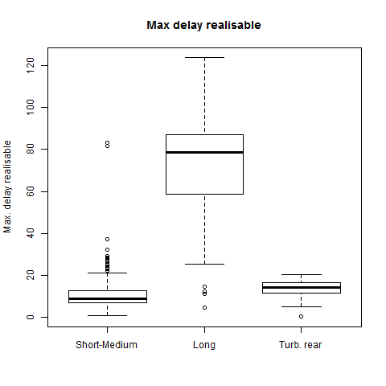
Figure 26 - Maximum potential delay realisable by aircraft family.
Finally, Figure 27 presents the frequency of the maximum delay that can be potentially recovered by just applying an increase on the speed. As shown in Figure 28, a high percentage of flights can potentially recover a relatively small amount of delay (71.4% of the flights can recover less than 10 minutes), this is highly related with the available flight distance (see Figure 29).
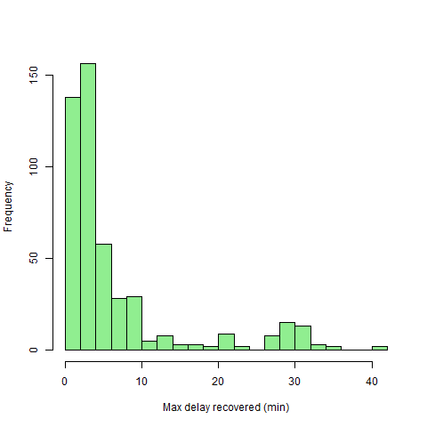
Figure 27 - Frequency of maximum potential delay recovered by flights from-to hub.

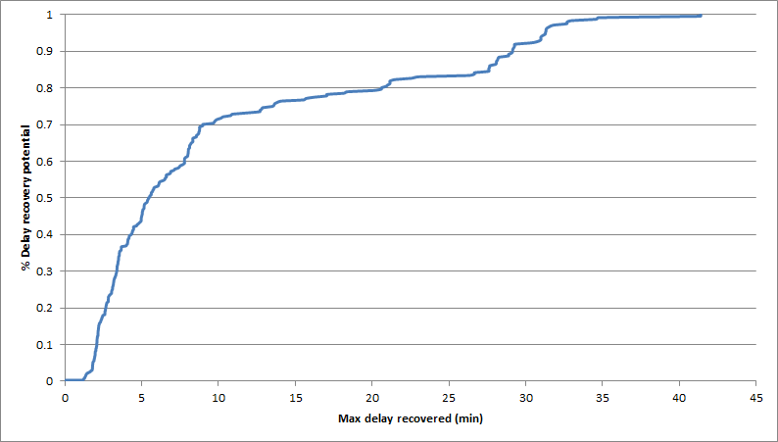
Figure 28 - Probability function of maximum potential delay recovered as a function of the potential delay recovered.
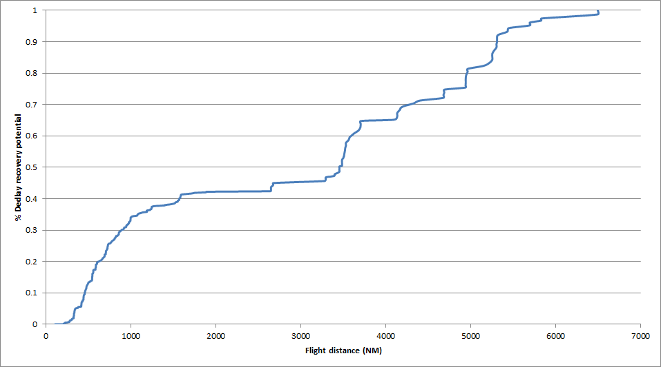
Figure 29 - Probability function of total potential delay recovered as a function of the flight distance.

Problem description summary
Applying DCI technique to recover part of the delay and increase the number of connections realised at the hub minimising the cost is a complex task. As it has been described in the previous sections, analyse all the possible options to ensure that the total optima implies a high computational cost as the problem grows very fast. Therefore, agent base modelling techniques will be implemented to generate a global intelligent behaviour based on relatively simple rules as explained in the next section.

As has been described in section 4.1.2, the location of the outbound flights and the characteristics of the current connections at the hubs can help us to identify situations where the problem can be simplified. For example, it might not be necessary to consider if the best option is for an outbound flight to wait for connecting passengers if that outbound flight is still flying to a different airport and will not arrive to the hub until several hours. The uncertainty on that flight is probably high enough that its inclusion in the solution might not be necessary.

As defined in section 4.1.3, the maximum amount of delay that can be recovered by just modifying the cruise speed is relatively small. This will, on one hand, simplify the space of search of the problem, only some minutes of delay can be considered, but on the other hand shows the importance of other activities such as the coordination with the arrival manager. It is not advised to speed up to recover a few minutes if then high delays are imposed upon arrival due to runway congestion. Finally, implementing SESAR solutions, such as a more direct route, will reduce the total flight time, but also reduce the amount of delay that can be recovered by just speeding up, as the total flight distance available will be shorter.

Logical architecture
They following diagram shows the different processes that compose this model, and its changes compared to Case Study 3 of the first CASSIOPEIA project:
Figure 30 - Differences in algorithms between DCI-4HD2D and CASSIOPEIA CS3

Overall processes
The following figure shows the tactical processes that are triggered by the different times or points reached by each aircraft:
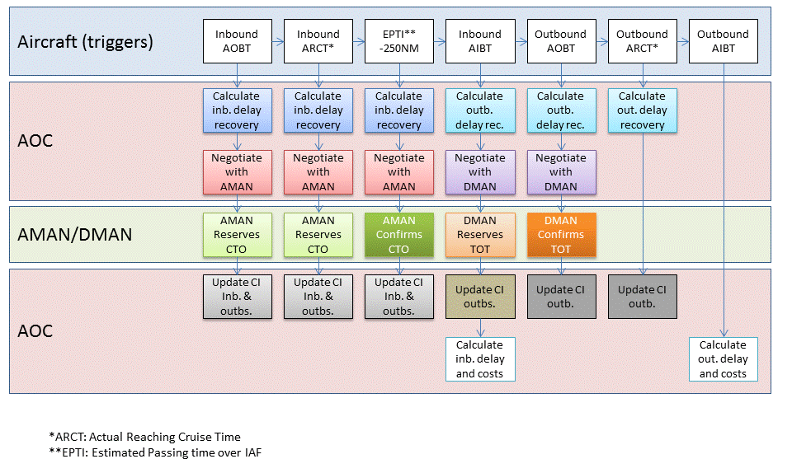
Figure 31 - Processes and triggers of the model.
The following figure defines the interaction between the agents:
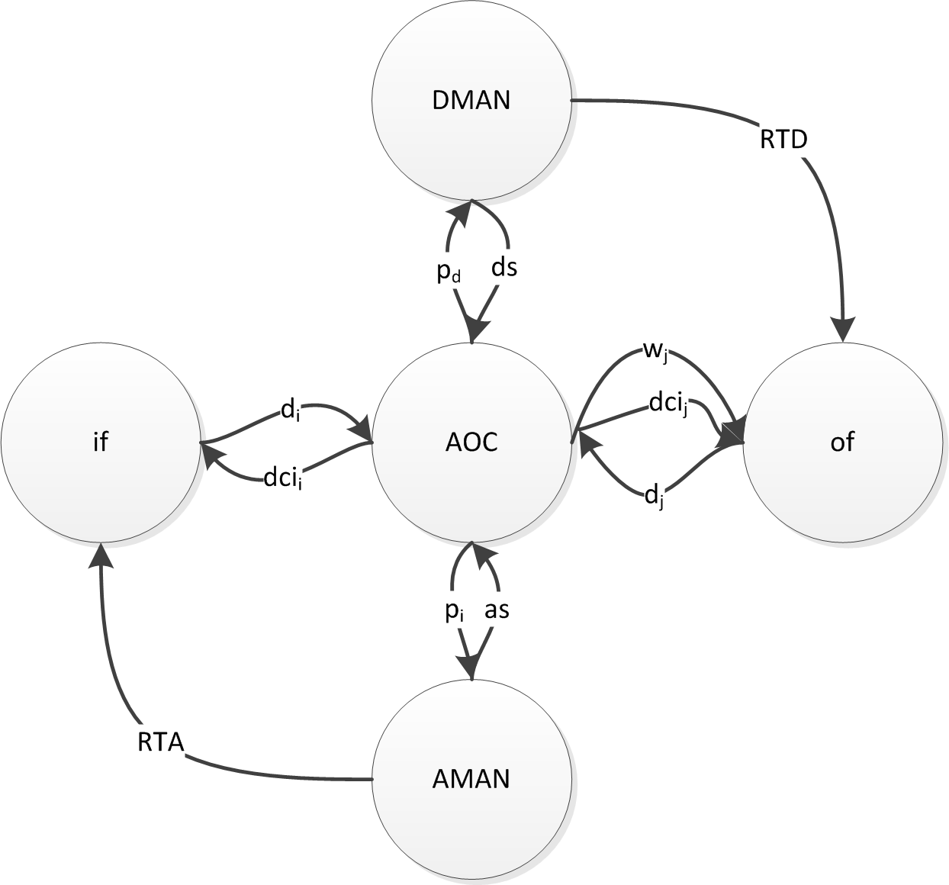
Figure 32 - Interaction among agents.

The inbound flight (if) interchanges messages with the AOC communicating the delay (d_{i}) at different stages of the flight (i.e., before departure, at departure, when reaching the TOC, etc.). The AOC will reassess the situation and communicate to the inbound flight the best cost index to use (dci_{i}).
- When the aircraft enters the radius of action of the AMAN, the AMAN will assign a slot (RTA) based on the demand at the airport (arrival slots) and the priority defined by the AOC (messages as and p_{d} respectively).
- For outbound flights (of), the flights might experience delay which would be communicated to the AOC (d_{j}), in its turn; it will receive if delay for waiting for connecting passengers is needed (w_{j}) and what would be the optimum cost index to use (dci_{j}).
- The AOC will negotiate the departure slot with the DMAN for the flight considering the prioritisation of the departure flights (p_{d}) and the departure slots (ds). This will generate a departure time for the flight (RTD) which might trigger a new better cost index (dci_{j}).

Aircraft processes
The aircraft processes will vary depending on whether the aircraft is inbound or outbound, as shown in the following figures:
Flight process (inbound)
Inbound flight
FPL activation at EOBT -20 min
EOBT: request departure delay to airport
Departure delay
Inform AOC of delay and request CI
ARCT: Inform AOC of delay and request CI
Trigger inbound delay recovery
Trigger inbound delay recovery
AMAN horizon
(PTI-250NM)
AIBT: Inform airline of delay

Aircraft subject to AMAN changes
Taxi out delay
Climb delay
Trigger outbound delay recovery
(w/ DMAN negotiation)
Approach & Taxi in delay
Trigger inbound delay recovery
with AMAN negotiation
Cruise delay
IAF-250NM Inform AOC of delay and request CI
Figure 33 – Inbound flight process.
The following diagram shows the outbound aircraft processes:
1st Inbound AIBT or EOBT-20 min:
Outbound FPL activation
EOBT: request departure delay to DMAN
Departure delay
Inform AOC of delay and request CI
ARCT: Inform AOC of delay and request CI
Trigger outbound delay recovery
Trigger outbound delay recovery
AIBT: Calculate delay costs and emissions
Taxi out delay
Climb delay
Approach & Taxi in delay
Flight process (outbound)
Figure 34 - Outbound flight process.

AOC Processes

Inbound delay recovery
When an inbound aircraft is delayed, it will inform its AOC at certain times:
- AOBT
- ARCT
- EPTI-250NM
The inbound delay recovery process is then triggered. The airline will analyse the cost and passenger delay for different airspeeds within the total range of airspeeds considered in the project (from 0.95*Vn to 1.05*Vn, or limited by aircraft performances bounds). Different estimated in-block time will be obtained with these different airspeeds. For each of these EIBTs, the model will calculate costs, emissions and passenger delay. Depending on the strategy selected in the scenario, a Wait-for-pax time and CI will be selected for the inbound, related outbound flights, and indirectly affected inbounds. At the same time, a pre-selection of AMAN slot is made for negotiation in case the aircraft is at EPTI-250NM, or it is an indirect affected inbound within the AMAN horizon.
The following figure shows different EIBTs and how it affects the connecting passengers. Notice that even at the maximum Cost Index (CI_{max}) passengers connecting with Flight 1 would miss their connection. The model will calculate if it is worth it for the airline to delay Flight 1 to wait for those passengers or to reassign them to the next flight with the same destination.
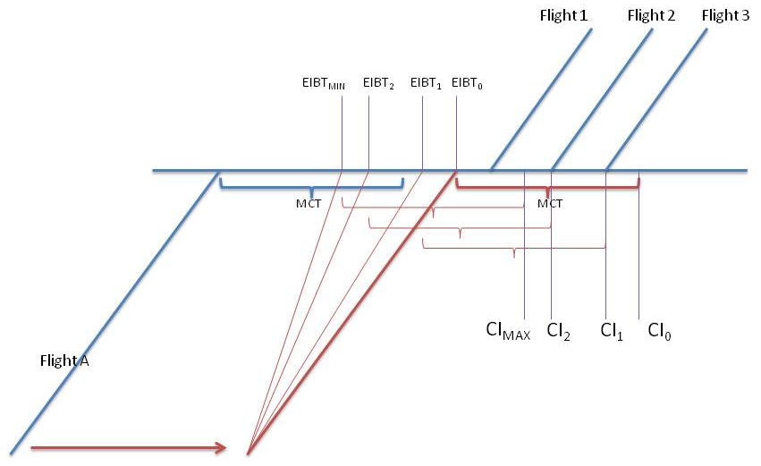
Figure 35 - Estimated In Block Times (EIBTS) that need to be considered for rescheduling.
When an outbound flight is delayed by the company (waiting for passengers), the algorithm will calculate if any inbound flight can be improved to save costs or delay. The following diagram shows the different positions where the affected flights may be:
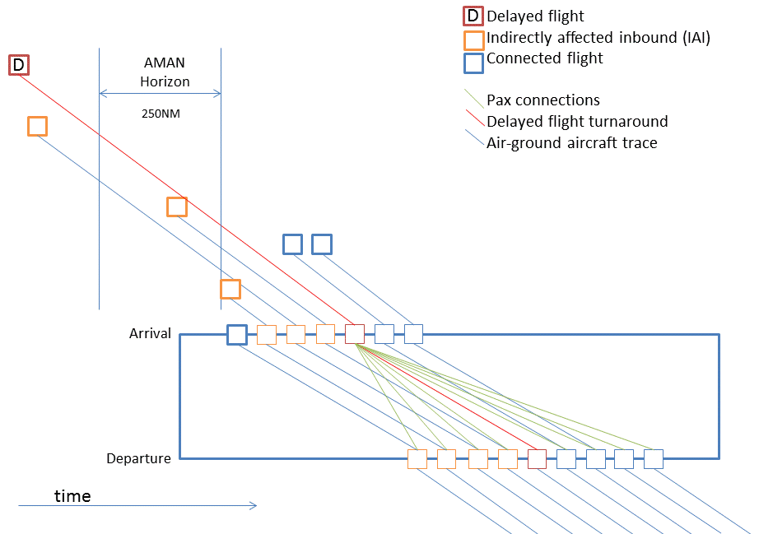
Figure 36 - Affected aircraft by single delay.
The following are the strategies that can be selected in the different scenarios:
- No CI: All flights fly at their nominal cruise airspeed.
- Economic optimum: Find minimum combination for inbound CI + outbound flights + IAI.
- Reduced delay: Find combination where cost is equal or less than CI that minimizes delay.
The following is the preliminary algorithm description to be implemented in the model.
Schedule recovery algorithm:

For each delayed inbound airspeed from Vn, to Vhigh or the V to recover delay (whichever is minimum) {
Calculate inbound costs
Calculate inbound emissions
Calculate inbound pax delay
Identify slot in AMAN
For each outbound with connecting pax{
For each “wait for pax” time to meet connections {
For each outbound airspeed (from Vn, to Vhigh or the V to recover delay (whichever is minimum) {
Calculate costs
Calculate emissions
Calculate pax delay
Note WFP time and CI
}
Note results for the 3 strategies; No CI, optimum, reduced delay.
For each strategy result {
Identify indirectly affected inbound (IAI) aircraft in cruise phase before AMAN horizon (>250NM).
For each IAI {
Identify buffer between arrival and next connection.
For inbound airspeed from current arrival time to buffer limit {
Calculate inbound costs
Calculate inbound emissions
Calculate inbound pax delay
Note CI
Identify slot in AMAN
}
Note results for the 3 strategies; No CI, optimum, reduced delay.
}
}
}
}
Add costs, emissions and pax delay of outbounds and AIA to inbound results.
}
With the strategy selected, negotiate with AMAN the slots for the inbounds.

Outbound delay recovery
This process takes place at several times. Usually, every time an inbound flight is delayed, the AOC will recalculate the costs of the inbound and related outbound flights. Also, there are certain phases of the outbound flight in which this is calculated:
- Outbound AOBT
- Outbound ARCT
Each time an inbound with delay reaches AIBT, each outbound aircraft with connecting pax will start the outbound delay recovery process.
The wait for pax time to be calculated each time can be done in several manners:
- Regular intervals- Calculate costs for waiting 5, 10, 15 minutes or so until a given threshold (all passengers connected)
- Calculate costs for the different connecting times. As shown in the figure below this can reduce the computational effort of the system.
Figure 37 - Estimated Off Block Times (EOBTs) that need to be considered when rescheduling.
The process to complete the outbound recovery will be the following:
Figure 38 - Outbound recovery process.

Non-pax costs

Maintenance costs
For all maintenance cost a stochastic probability function is used to calculate costs
~N(base, [high-low]/4),
Where:
Low, base, high= (√MTOW)*m + c,
Where:
(i) At-gate maintenance costs
All aircraft | Low | Base | High
m | 0.04 | 0.05 | 0.06
c | -0.14 | 0.04 | 0.12
(ii) Taxi maintenance costs (including baseline fuel burn)
All aircraft | low | base | high
m | 1.31 | 1.88 | 2.46
c | -3.61 | -4.12 | -5.24
(iii) En-route maintenance costs
All aircraft | low | base | high
m | 0.32 | 0.37 | 0.43
c | -0.86 | 0.35 | 0.87
(iv) Arrival management maintenance costs
All aircraft | low | base | high
m | 0.32 | 0.37 | 0.43
c | -0.86 | 0.35 | 0.87
(v) Crew costs on arrival
All aircraft | low | base | high
m | 0.00 | 0.72 | 2.24
c | 0.00 | 2.29 | -0.42

Fuel costs
Fuel consumption has been recalculated taking advantage of BADA 4.0. The fuel consumption is approximated with a 4th degree polynomial.
For each aircraft we obtained the following information:
- Type: AC model.
- FL: Flight level assumed to be used by the aircraft.
- W_{ref}: Reference weight of the aircraft.
- % used to compute: in order to compute the fuel flow, we have computed the values around a given percentage from the nominal speed (e.g., -15% nominal speed, +15% nominal speed). This helps to ensure fitting the values around realistic speeds.
- M_{ref}: Mach of reference for the aircraft type
- K_{mminRef}: Mach of reference in km/min
Then for each aircraft we have computed the envelope where the aircraft can fly ensuring that they are not flying faster than the maximum allowed by the thrust nor too slow causing the aircraft to stall. These are the set of airspeeds for each aircraft:
- M_{min}: minimum possible Mach.
- M_{max}: maximum possible Mach.
- S_{min}: minimum possible speed in km/min.
- S_{max}: maximum possible speed in km/min.
The above mentioned aircraft envelope has been computed assuming a load factor of 1.3 g. This is in accordance to the regulation and ensures manoeuvrability when flying at low speeds.
Using as flight level FLmax-2000 ft as an approximation of optimal flight level and the weight used is the W_{ref} provided by BADA can lead to some unrealistic results. In some cases, and in particular for long-haul flights, the fact that they execute cruise-steps might lead to non-realistic weights at too high altitudes. This might have an impact on the flight envelope; being too small because, in reality, the aircraft would not be at that altitude with such a high weight. Therefore, the weight and flight level have been estimated as described in section 3.3.
BADA 4.0 contains around 65% of all the traffic in the sample. For the other models either we do not have their performances or the flights are excluded from the DCI (e.g. freight), so, for them, we will keep using the fuel estimations from CS3 of CASSIOPEIA.

Rotary delay

Soft costs
Soft costs due to rotary delay are calculated by reducing the final delay of the delayed flight by a standard buffer between operations, and consider that the next flight will be affected by such reduced delay with the similar amount of passengers. For inbound flights, the rotary soft costs are calculated directly from the connection information that we have from the outbound flights. In the case of the outbound flights we apply the buffer estimation and depending on the time of the day extend the calculation for different amount of rotations.

Hard costs
As for soft costs, the first rotation for the inbound flights is known. Unfortunately for the outbound there is no information available in the data to calculate passenger or non-passenger hard costs.

Pax costs
The following figure shows the different delays of a flight:
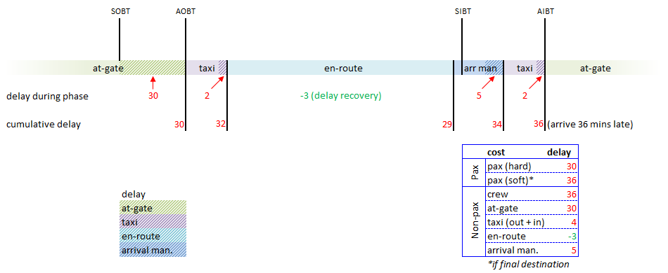
Figure 39 - Types of delay.
Pax fare assignment update:
- Every pax is assigned their own fare and whether their ticket is flexible or inflexible.
- For connecting pax, the inbound flight determines whether the whole ticket is flexible or inflexible and the fare is split to cover the inbound and outbound flights (i.e. connecting pax have two fares).
- Only FSC pax can have flexible tickets (approximately 10%).
AO type | Flexible tickets | Inflexible tickets
FSC (full service) | ≈10% pax | ≈90% pax
REG (regional) | - | 100% pax
LCC (low cost) | - | 100% pax
CHT (charter) | - | 100% pax
Table 11 - Types of tickets.
All fares and ticket flexibility are supplied as input data files.
The inbound costs are calculated as shown in the figure below:
Inbound delay costs
Non connecting
NC Soft costs (no hard costs)
Connecting missed connection (CMC)
CMC Hard costs
CMC Soft costs
Connecting pax making connection = 0€
Figure 40 - Inbound delay costs.

Hard cost calculation
The hard costs are based on the departure time of the next valid connecting flight
Delay per connecting group=
AOBT-SOBT missed
Split fares
Hard costs provisions
AO type
Ticket type
Cost scenario applied
Low, base, high table depends on delay
Inbound
Hard cost transfer fare
Provision per pax
Hard cost provision=
Delay * Σ (provision per pax per minute )
Outbound
Outbound same alliance?
0 €
Σ outbound fares
yes
no
CMC Hard costs

Figure 41 - Hard costs calculation process.

(i) hard cost provisions
These provision costs are based on the AO type and ticket flexibility:
AO (& ticket) type | Cost applied
FSC (flexible) | Average of high & base
FSC (inflexible) | Base
REG, LCC, CHT | Average of low & base
Table 12 - Cost applied per ticket type.
Based on the inbound flight, FSC cost scenario is applicable - use a blend of high and base hard costs for a >=180 to <300 minute delay (Table 13).
Note: over all flights, 90% of inbound connecting flights are FSC.
Minutes of delay | Minutes of delay | high | base | low
90 | 120 | 2 | 1.7 | 0
120 | 180 | 9.4 | 7.7 | 4.7
180 | 300 | 23 | 19 | 12
300 | 480 | 26 | 21 | 13
480 | Overnight | 100 | 83 | 51
Table 13 - Provisions costs.

(ii) hard cost fare transfer
There is a cost of rebooking connecting pax onto alternative flights – this is the outbound fare, which would be transferred to the alternative flight.
However note: the fare transfer is cost neutral if the re-accommodated pax are rebooked onto flights operated by the same carrier or same alliance.
e.g. intended connection: Swiss1 > Swiss2
if connection with Swiss2 is missed, then SAS2 is cost neutral (both Star Alliance)
if connection with Swiss2 is missed, then Iberia2 (different alliance) results in a cost to Swiss1
(Alliance coding is being assigned to each inbound/outbound flight)
Note: we are only considering the cost to airlines and are not treating fare transfers as income to the other carrier.
The reallocation process is done calculating hard and soft costs for pax on whichever is cheaper: next flight with different alliance or next flight of same alliance. For those passengers not accepted (i.e. not enough free seats in the flight considered), the process is recalculated for the next flight until all pax are reallocated or the day is finished as shown below.
Reallocation of pax process
Find next flight same alliance and same destination
Delay
Hard costs per pax
Soft costs per pax
Total costs per pax
Selection of transfer
Unallocated pax
Find next flight different alliance and same destination
Delay
Hard costs per pax
Soft costs per pax
Total costs per pax
Figure 42 - Reallocation process.

Soft cost calculation
The soft costs calculation is completed as shown in the figure below:
delay per connecting group=
AIBT-SIBT missed (final destination)
AO type
Methodology
Soft Costs
low, base, high interpolation
(€/min·pax)
FSC pax per min:
fN x high + [1 – fN] x base
Regional, LCC, charter
~N ([base + low]/2, [base – low]/4)
Soft costs outbounds
Normalization of fares (1 is max) (fn)
soft costs=
delay*Σpax per min
soft costs=
delay*Σpax per min
FSC
REG, LCC, CHT

Figure 43 - Soft costs calculation process.
Soft cost assignments by airline type are calculated as follows:
AO type | Method type | Summary of method
FSC | deterministic | f_{N} x high + [1 – f_{N}] x base
REG, LCC, CHT | stochastic | ~N ([base + low]/2, [base – low]/4)
Figure 44 - Soft cost assignments by airline type.
The soft costs can be calculated using this equation:
$$SC=\frac{p\left(t_{ID}-\frac{d}{V_{N}}+\frac{d}{V_{TAS}}\right)z\left(e^{x{\left(t_{ID}-\frac{d}{V_{N}}+\frac{d}{V_{TAS}}\right)}^{y}}-1\right)}{e^{x{\left(t_{ID}-\frac{d}{V_{N}}+\frac{d}{V_{TAS}}\right)}^{y}}+e^{x}}$$
Where:
Definition | Variable | Example | Units
Cruise distance | d | 1000 | km
Fuel cost | f | 0.7 | €/kg
SC a | w | 3 | n/a
SC b | x | 0.1 | n/a
SC c | y | 0.9 | n/a
SC d | z | 0.097 | n/a
Standard airspeed | n | 13.9 | km/min
Pax | p | 200 | pax
Initial delay | t_ID | 30 | min
True airspeed | V_TAS |  | km/min
Nominal airspeed | V_N |  | km/min
Table 14 - Soft costs variables

AMAN-DMAN Processes
AMAN and DMAN will be treated as a single agent that performs the slot assignment for arrivals and departures at the same time.
Different ideas have been considered for optimisation algorithms for the AMAN and DMAN:
a. RBS
We can consider the use of a pure ration-by-schedule algorithm.
b. Ration-by-Priority
We can apply a rationing based on a given priority, e.g., passenger delay, aircraft delay, cost. To a RBS in order to decide between overlapping slots based on those criteria.
c. RBS + CDM
In this case the RTAs are assigned based on a RBS but then a CDM is allowed. In this phase, airlines can suggest swap of flights belonging to the same airline or alliance and the AMAN will accept them as long as feasible.
This idea is presented by the EUROCONTROL's A-CDM team via euro-cdm: "European CDM - Collaborative Optimisation of Arrivals" (Airport Council International, Eurocontrol, IATA, 2014).
d. DA-CDM
With a deferred acceptance CDM (DA-CDM), airlines submit a list of slots ordered by preference for each of its arriving flights. The arrival manager uses this information to assign the slots considering the airlines preferences. In case of similar preference for a slot by different airlines a prioritisation policy can be implemented (e.g., RBS). The idea of the deferred acceptance algorithm is presented in (Arruda Junior, Weigang, & Nogueira, 2014).

Due to the difficulty to implement CDM algorithms, and the fact that this is not the main scope of the project, a decision was made to use DA-CDM.
The following processes will be implemented for this agent:
AMAN-DMAN
AOC
Request info:
PTI
Delay
Pax
Cost estimation
Reserve new slot
Strategy
Reduce pax delay
Reduce costs
Similar
Lower
Higher
Try next slot
Is new slot empty
Priority of slot acft
Assign slot to acft with highest pax delay
Assign slot to acft with highest costs
Reserve slot
Receive slot:
Update CI
Reschedule “loser” acft
Reserve slot
Reschedule “loser” acft
yes
no
Free previous slot
Figure 46 - AMAN-DMAN Process.

References
Airport Council International, Eurocontrol, IATA. (2014). European Airport CDM. Retrieved from Collaborative Optimisation of Arrivals: www.euro-cdm.org
Arruda Junior, A. C., Weigang, L., & Nogueira, K. B. (2014). Enhancement of Airport Collaborative Decision Making throught Applying Agent System with Matching Theory. 8th International Workshop on Agents in Traffic and Transportation, (pp. 1-8). Paris.
Boeing. (2008). Improving Ramp/Terminal Operations for Shorter Turn-Times. AeroQuarterly(32), 20-23.
Boeing. (2008b). Economic Impact of Airplane Turn-Times. AeroQuarterly(32), 15-19.
Copenhagen. (2011). Airlinescard - Copenhagen Airport reduce connection time. Retrieved June 2014, from http://airlinescard.blogspot.co.uk/2011/05/copenhagen-airport-reduce-connection.html
European Commission. (2008). Regulation No859/2008 of 20 August 2008 amending Council Regulation (EEC) No 3922/91 as regards common technical requirements and administrative procedures applicable to commercial transportation by aeroplane.
Fricke, H. a. (2009). Delay impacts onto turnaround performance. 8th USA/Europe Air Traffic Management Research and Development Seminar (ATM2009).
Heathrow. (2014). Heathrow, Terminal 5 International Connecting to Terminal 5 International. Retrieved June 2014, from http://www.heathrowairport.com/heathrow-airport-guide/flight-connections/terminal-5-international-connecting-to-terminal-5-international
Iberia. (2012). The Agora Project: A high impact transformation programme. . Press kit 2012.
MEHR, B. f. (2013). DTA/// Drive through airport – Concept for increased efficiency in terminals and operations.
Munich Airport. (2014). Munich airport - European's Best "International Transit Airport" - Easy Transfers. Retrieved June 2014, from http://www.munich-airport.de/en/consumer/aufenthalt_trans/airportstop/minconntime/index.jsp
Oreschko, B. S. (2010). Significant turnaround process variations due to airport characteristics. Air transport and operations symposium, 2010.
Schultz, M. K. (2012). Dynamic turnaround management in a highly automated airport environment. 28th International Congress of the Aeronautical Sciences (ICAS2012).
Schultz, M. K. (2013). Boarding on the critical path of the turnaround. 10th SA/Europe Air Traffic Management Research and Development Seminar (ATM2013).
SESAR. (2012). European ATM Master Plan, Executive Summary – Airport operators, Edition 2.
SESAR. (2012b). E.02.06-POEM-D7.1-Results of Airline Case Study 1.
SESAR. (2013). E.02.06-POEM-D6.2-Final Technical Report.
Tourism insider. (2013). Tourism insider - Iberia Offers 1,200 New Connections from its T4 Hub in Madrid. Retrieved June 2014, from http://tourism-insider.com/en/2013/12/english-iberia-offers-1200-new-connections-from-its-t4-hub-in-madrid/
U.S. Census Bureau. (2014). U.S. Census Bureau. Retrieved June 2014, from http://www.census.gov/geo/ZCTA/zctafaq.html#Q20
Vienna International Airport. (2014). Vienna International Airport - Transfer. Retrieved June 2014, from http://www.viennaairport.com/en/passengers/arrival__departure/transfer

European airline delay cost reference values (Cook and Tanner, 2011). Final Report (Version 3.2).

