THE PORTLAND INN PROJECT
The 100 Year Plan and Portland Thinkbelt

The Portland Inn Project CIC (PIP) is a creative arts project for a community in Stoke-on-Trent, a city at the heart of the UK’s former pottery industry. PIP’s aim is “to achieve community cohesion, economic, social and cultural development by involving the community in the development of a pioneering community space, cultural hub and social enterprise.”¹ It accomplishes all this with energy, generosity, and in a spirit of fun with lots of laughter.

The project is led by artists Anna Francis and Rebecca Davies along with a wider team that includes the community of the Portland Street area of Stoke-on-Trent. The project was seeded in 2015, when Anna invited local people to create a clay map of the area and to express their hopes and concerns; the conversations generated by the activity indicated the very real need for a space to serve the community. Around the same time Anna met Rebecca, another socially engaged artist working on a UK touring project that visited the city; recognising their alignment of interests in social contexts and urban renewal, they came together, attracting funding from Arts Council England (ACE) to create a temporary community arts centre in 2016. This activity also helped test the future uses of an old pub building, the Portland Inn, which had once been a focus of the community but had been empty for years. As a result of the success of the programme of activities and with the registration of the PIP as a Community Interest Company (CIC) in 2018, backed by a strong business plan, the local council agreed the building could be given to the community as an asset.

Although the project and its activities have since attracted institutional recognition and high-profile awards,² the team are well aware that funding for such initiatives in the arts and community sectors tends to be for short term, project-based works. It is widely acknowledged that this can result in a lack of resources and opportunity for long term planning to make lasting change. Therefore, this year PIP have started to write their 100 Year Plan for the neighbourhood, within which smaller, short-term projects can be viewed as part of a wider landscape plan. It is a strategy that aims to empower communities, funders and policy makers to resist short term project-based thinking, and to begin to think more holistically and sustainably, believing that this can yield significant benefits, socially, politically and environmentally. It is also envisaged that this work can inform the development of a set of influencing tools, in order that others can also benefit from their work.
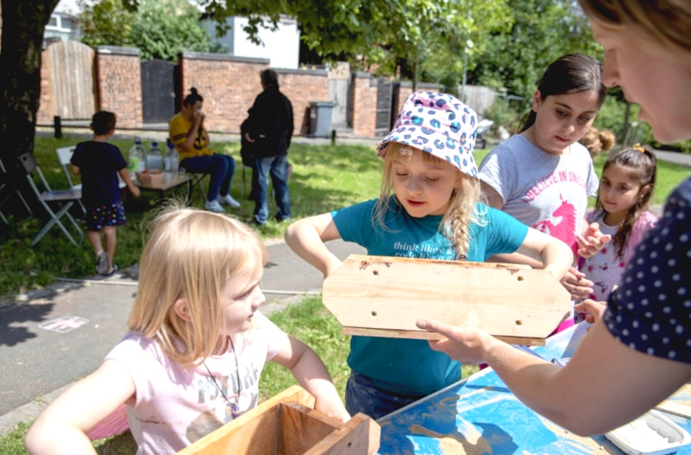
Making Fern Bricks at The Portland Inn Project, 2021.
Photo: Glen Stoker.

Creative, community-orientated activities are central to PIP’s programming. Key themes include self-representation, using methods such as film, animation, design and printing. All age groups are provided for. Learning and exchanging transferable skills is another area being developed with community members, as exemplified by some of PIP’s clay-based projects that include the making of the Portland Pigeon and Fern Bricks; these products are a social enterprise, where sales income goes back into the project to support its wider programme of developmental, social, creative and educational activities.

The Portland Pigeon was initially born out of necessity, when a ridge tile was needed to fix a hole in the community building. The design was inspired by the popular local pastime of pigeon fancying and racing, and there are now three handmade pigeon designs: the ridge tile, a sculpture and a combined tile/bird sculpture. These have proved to be popular products and become PIP mascots. The Fern Brick was developed as a result of the COVID pandemic, a time people began to take much more of an interest in outdoor spaces, and when, in the Portland St Area, the terraced house back yards became important growing plots. Ferns are shade loving plants and therefore suited to the corners of such yards.³

Events and activities associated with the writing of PIP’s 100 Year Plan are presented as part of the Look Who’s Talking project. They include Time Capsule workshops (14, 21 & 28 May, 2022) and The Portland Thinkbelt, an extensive summer holiday programme which took place throughout August 2022, incorporating numerous events and activities led by a talented and energetic group of artists and other practitioners.⁴ As well as being fun and offering the chance to learn new skills, many of these encouraged the community to look at local ecology and consider interventions that could increase biodiversity, while planning for the future of the area.

The Time Capsule was collaboratively created by local children with ceramic artist Alice Thatcher. For this, the children’s discussions were illustrated and used as decoration on the outside of a vessel, which was filled with tiny sculptures representing the project, the neighbourhood and other things of importance to the community. The capsule was buried on the Portland green space in early August, in the hope that it might be discovered at some point in the future, when PIP’s mission and values might inform and influence the future community of Portland Street.

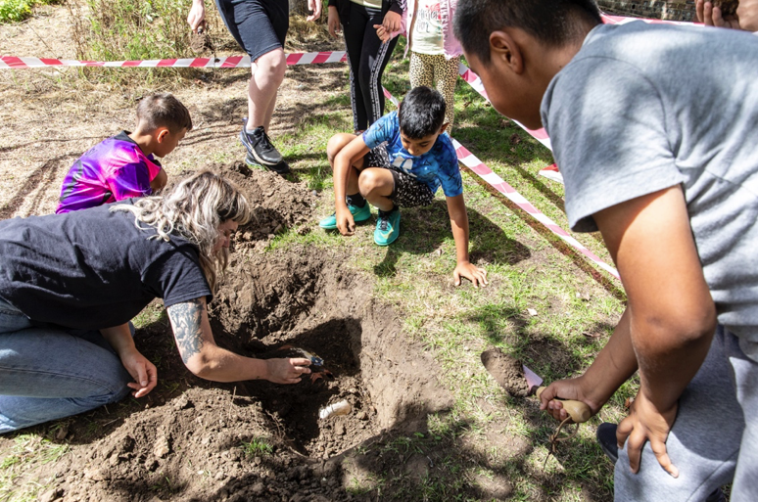
The Portland Thinkbelt 2022, Burying the Time Capsule with Alice Thatcher.
Photo: Glen Stoker

The Portland Thinkbelt’s title and approach was inspired by the work of radical British architect Cedric Price, whose ground-breaking, albeit unrealised, Potteries Thinkbelt (1964-1966) offered a critique of traditional educational facilities. Rather than conceived as a static institution, Price’s Thinkbelt was envisaged as outward-looking and extendable, so that it could foster a network of learning. By imaginatively repurposing space that had once been occupied by the Staffordshire Potteries (an industry already by then in decline), as well as aspects of its infrastructure, it was also intended to bring economic growth to the region.⁵ As a recent PIP Instagram post points out, there are parallels to be drawn between Price’s scheme and their own approach “to making education and learning accessible, cross pollinating and constantly moving/evolving and revitalising The Potteries.” ⁶

The diverse programme devised for The Portland Thinkbelt, included circus tricks and devising street cabaret acts, natural dyeing and printmaking using plants growing in the area, photography, the creation of a 100-year comic along with the development of its characters, the construction of inflatable architectural spaces and bamboo structures, as well as clay activities that included making a future clay landscape, plus sports and visits to fruit and dairy farms. In addition to regular sessions devoted to the preparation and cooking of nutritious ‘Portland Takeaway’ meals, a food highlight of the month was the fireside dinner for the community, served on specially handmade ceramics and displayed on hand-dyed fabrics.
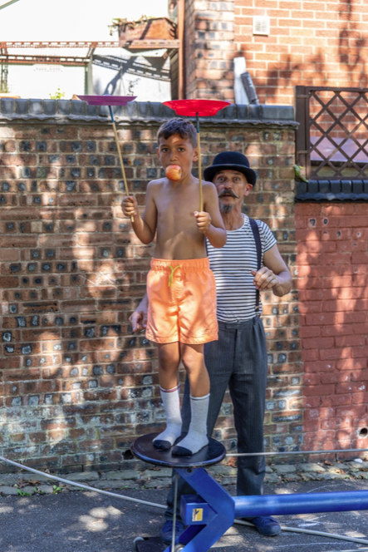
The Portland Thinkbelt 2022, Learning circus tricks with Circus in a Box.
Photo: Glen Stoker

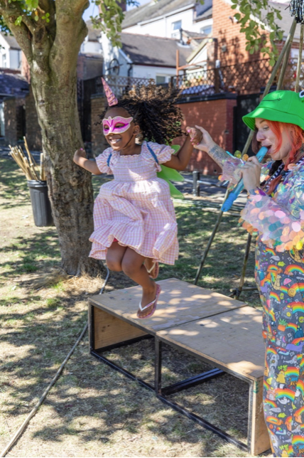
The Portland Thinkbelt 2022, Cabaret.
Photo: Glen Stoker
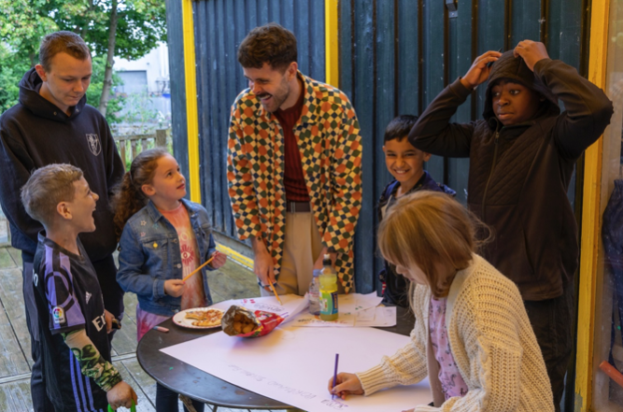
The Portland Thinkbelt 2022, Creating the 100-year comic with Kidda Kinsey.
Photo: Glen Stoker

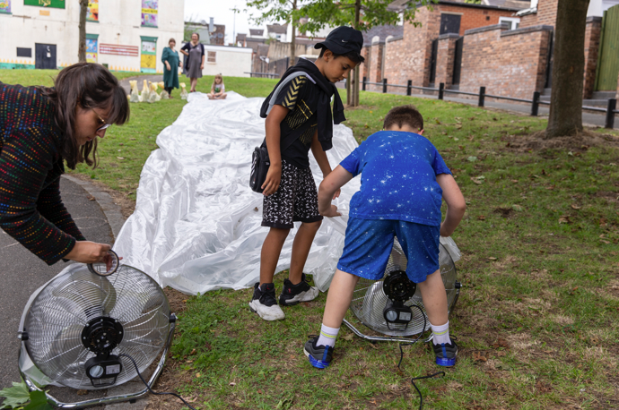
The Portland Thinkbelt 2022, Creating an inflatable galley.
Photo: Glen Stoker

In such areas of socio-economic regeneration and urban renewal, a frequently levelled criticism is that artistic and creative ventures are embraced by public authorities and private developers because they are seen to distract attention from the reality of the situation, one that really requires greater financial investment or government intervention. The argument is that art is frequently exploited to provide a kind of cosmetic cover up or temporary fix to situations of social inequality.⁷ But whereas artists are often brought in from outside, in the case of PIP, the lead artists and other team members are embedded within the community and maintain strong relationships with other stakeholders. PIP team members are just one part of a Community Decision Making Panel that is also made up of residents, partners and local services; this body meets once every two months for a meal and to discuss decisions made for the programme. It represents an example of ‘Placemaking,’ which has been described by Cara Courage as ‘an approach and set of tools that puts the community front and centre of deciding how their place looks and how it functions’ and where the community ‘is recognised and valued as the expert.’⁸ Not only does PIP’s Community Panel offer a democratic means of checking that plans are meeting local needs and interests, but it also ensures that local services understand what is going on and how they may be able to work with the community to make things happen.

In writing The 100 Year Plan and devising workshops and activities that look to the future, The Portland Inn Project is signalling long term ambitions for the neighbourhood. The initiative recognises that art and active learning can have a critical, as much as practical function in society, assisting the local community to engage actively, thoughtfully and sustainably with their environment and with one another.

Tessa Peters

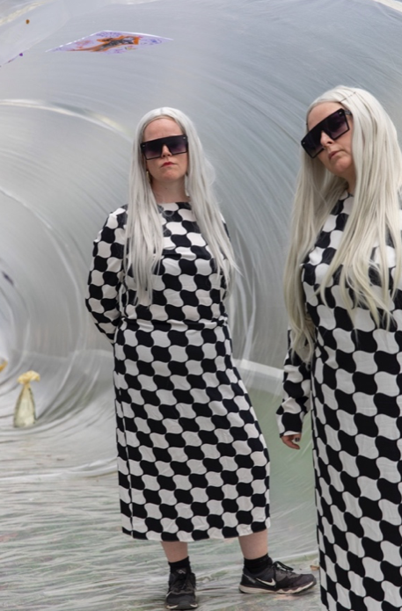
The Portland Thinkbelt 2022, Inflatable gallery curators:
Rebecca Davies and Anna Francis. Photo: Glen Stoker

https://www.theportlandinnproject.com/
@theportlandinnprojectcic

1. See The Portland Inn Project website: https://www.theportlandinnproject.com/about/

2. In 2018, The Portland Inn Project’s public art programme involved a collaboration with Baxendale architectural practice to co-build a temporary Community Hub with residents from the local area, and running a month-long programme of activity, events and performances from the temporary building. This work, funded by Arts Council England, was shortlisted for a Royal Institute of British Architects McEwen Award, an award that recognises architecture for the common good. In 2019, The Portland Inn Project was the winner of the Cultural Champions of the Year category at the BBC Stoke Make a Difference Awards.

3. The press moulded Portland Pigeon products were created by artists Anna Francis, Rebecca Davies and Alice Thatcher along with local residents. The coloured slips used for their sgraffito feathers were created in collaboration with artist Sarah Fraser. The Fern Brick design was developed by ceramic artists Joanne Mills and Sarah Fraser in collaboration with Anna Francis and is also produced by local residents.

4. Workshop and activity leaders for The Portland Thinkbelt were: artists Rebecca Davies, Anna Francis, Kidda Kinsey, Alice Thatcher, Katrina Wilde, Circus in a Box and multi-disciplinary artist and performer Eve Travis, photographer Becky Nunes, architect Maria Martinez Sanchez, Francesca Wheeler of Imagine Bamboo, caterers VIPrep, youth workers Jamal Ledoux and Zahra Hanif, supported by other members of the PIP team and community. The Portland Thinkbelt was supported by Creative Civic Change with partners Engage, AirSpace Gallery, Appetite and Stoke City Council.

5. See: Kester Rattenbury & Samantha Hardingham (eds), Cedric Price: Potteries Thinkbelt. Abingdon, Oxon & New York: Routledge, 2007.

6. See Instagram: @theportlandinnprojectcic

7. For an overview of this debate see: Claire Bishop, ‘The Social Turn’: Collaboration and Its Discontents’ in Artificial Hells: Participatory Art and the Politics of Spectatorship. London & New York: Verso, 2012, pp. 11–40.

8. Cara Courage, ‘Introduction: What really matters: moving placemaking into a new epoch.’ In Cara Courage, Tom Borrup, Maria Rosario Jackson, Kylie Legge, Anita McKeown, Louise Platt & Jason Schupbach (eds.), The Routledge Handbook of Placemaking, Abingdon, Oxon & New York: Routledge, 2020, pp. 1–8.

