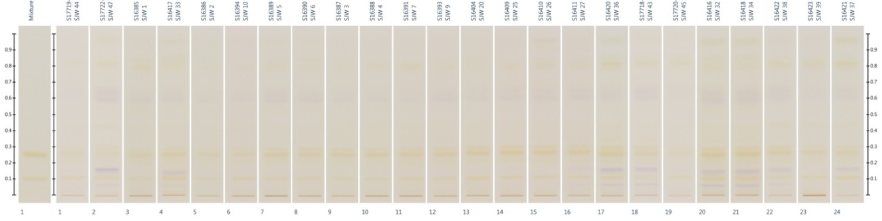

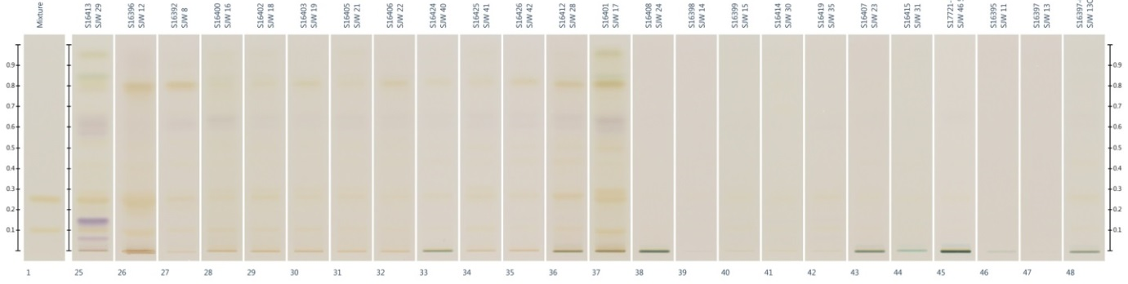

Fingerprints of 47 St. John’s Wort samples (commercial products) organised by similarities in the fingerprint under white light prior derivatisation. The standards rutin (R_{F} = 0.1) and hyperoside (R_{F} = 0.25) are shown in the first track and the rest of the tracks contain samples.

